

Strategic Management (LCMB7003)

Strategic Analysis of (Google)


Case Study: Google Inc. Revolutionary business model needs to evolve.

Student Name: Tayyaba Abdul Karim Shaikh
ID: 2131214
Word count:6000
Submission Date: 07-05-2023

Table of Contents
Introduction 3
Google Background 3
Google’s Mission and Objectives 4
Macro-Environment Analysis 5
PESTEL Analysis 7
Micro-Environment Analysis 8
Industry Life Cycle 10
Porter’s Industry Five Forces Analysis 11
Internal Analysis 13
Google’s Strategic Resources and Capabilities 16
Value Chain Analysis 16
Primary Activities 17
Secondary Activities 18
VRIO Analysis of Distinctive Resources and Capabilities 19
SWOT Analysis 20
Strategies to Sustain Competitive Advantage 21
Growth Strategies 22
Green Strategy and CSR 22
Conclusion 22
Recommendation 23
References 25
Appendix 26
Appendix 1: 26

Introduction:
The purpose of this report is to examine Google's present business model and give recommendations on how the firm might improve in order to remain competitive. The Value Chain, VRIO analysis, and SWOT analysis will be used to examine Google's internal environment, while the PESTEL framework will be used to examine Google's external environment. The CSR and environmental initiatives of Google will also be assessed in this report. The report will conclude with a recommendation for Google's future course of action.
MarketLine (2021) asserts that Google's business strategy has significantly altered the competitive landscape of the internet search sector. However, in order to maintain a competitive advantage in a dynamic market, the corporation will need to adjust its business strategy. Google's main source of income is from advertisements, which rely heavily on user information. Google has made changes to its advertising infrastructure to make it more privacy-friendly in light of recent privacy concerns. However, in order to lessen its dependency on advertising, the corporation has to expand its current portfolio of revenue generators.

Google Background:
The headquarters of Google Inc. are in Mountain View, California, although the corporation operates on a global scale. Larry Page and Sergey Brin, while Ph.D. students at Stanford University, started the firm in 1998. In 2020, Google's revenue was $182.5 billion (Alphabet, 2021). The company has approximately 139,995 workers and is present in more than 100 countries. As a result, it is now one of the world's largest technological conglomerates.
Google's groundbreaking algorithm for its search engine, which returned more relevant results than its rivals, was the company's first big break. Google now has more than 92% of the market share for search engines worldwide because to this unique strategy (Statcounter, 2021). Although the company's flagship product is still its search engine, Google has branched out into other areas, including cloud computing, online advertising, mobile operating systems, and hardware with its Pixel smartphones and Google Home smart speakers. Google's economic strategy has had some early success, but it still has to contend with several obstacles. Several antitrust investigations and lawsuits have been filed against the firm as a result of its dominant position in online advertising and search. Google's reputation has taken a hit, and the company is under closer scrutiny from authorities as a result of complaints about how it handles users' data and privacy.
Google has taken a variety of preventative steps, like enhancing data security regulations, expanding transparency, and diversifying income streams, to meet these threats head-on. By 2020 (Alphabet, 2021) for instance, the corporation expects $13 billion in sales from its foray into cloud computing, making it one of its fastest-growing divisions. Google has also spent considerably on AI research and development to open up fresh markets in healthcare and finance.

Google’s Mission and Objectives
According to Google's mission statement, the company's purpose is "to organize the world's information and make it universally accessible and useful" (Google, n.d.). The assertion is consistent with the innovative nature of the company's business strategy, which is based on making knowledge accessible through the use of the company's search engine and other offerings. To remain competitive and relevant, Google will need to adjust its purpose and ambitions as the digital world changes.
In terms of objectives, Google has set out several key targets in its strategy. These include:
- One of Google's key goals is to keep being the most popular search engine in use by people all over the world by giving them the best search results possible (Google, 2021).
- Advertising income supports Google's core business, but the corporation hopes to diversify its revenue streams by entering other areas including cloud computing, hardware, and AI (Google, 2021).
- Google's mission is to provide its users with a better experience, thus the company is always working to enhance its products and services. This involves spending money on tools like machine learning and NLP to create more tailored and user-friendly interfaces (Google, 2021).
- Google plans to introduce steps including end-to-end encryption and enhanced openness surrounding data collection and usage to prioritise user privacy and security in light of rising concerns about data privacy and security (Google, 2021).

To encourage people to think creatively and find novel approaches to solving challenges, Google has made it one of its stated goals to promote a culture of innovation and creativity within the company (Google, 2021).

Macro-Environment Analysis:
Analysis of Google's operational environment may be done using a macro-level framework that takes into account political, economic, social, technical, environmental, and legal aspects. A MarketLine study from 2021 claims these elements will have far-reaching effects on Google's future business strategy.
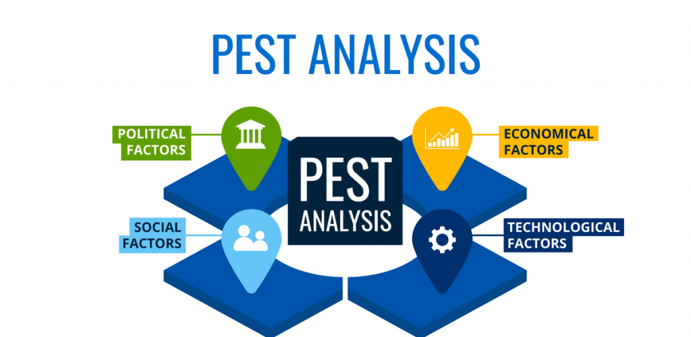
Figure:PESTLE ANALYSIS

PESTEL Analysis
Political Factors: Government rules and policies have an impact on Google, Inc. The company's international activities are affected by the different data privacy, nett neutrality, and antitrust legislation in each region. The General Data Protection Regulation (GDPR) of the European Union and the Children's Online Privacy Protection Act (COPPA) of the United States are only two examples of the rules that Google must follow in every nation it serves. Censorship and freedom of expression issues in some countries might also hinder the company's expansion into such areas (BBC News, 2021).
Economic Factors: Google's fortunes can swing in response to shifts in macroeconomic factors like inflation, currency exchange rates, and economic development. Advertising expenditures and consumer buying habits may be influenced by the economy, which might have a negative impact on the company's income streams. Due to the company's international reach, Google's bottom line can be impacted by shifts in currency exchange rates. With advertising making up the bulk of Google's revenue, these factors can have a major effect on the company (Statista, 2021).
Social Factors: Google may be affected by shifts in social conventions, user preferences, and user behaviour. The corporation has instituted stronger privacy rules and practises due to the growing importance of user privacy and security over the past several years. Google has reacted to changes in user behaviour, such as the rise of mobile and voice search, by updating its products and services. Cultural variations across nations can have an impact on the company's product lineup and advertising approaches (Forbes, 2021).
Technological Factors: Factors in the realm of technology, such as innovation, cybersecurity risks, and the development of artificial intelligence (AI), can have an effect on Google. Google has been a pioneer in the use of artificial intelligence and machine learning in commercial settings. However, this comes with the responsibility of navigating legal and ethical issues around artificial intelligence (AI), such as prejudice and discrimination. In addition, Google's security procedures must evolve over time to account for new threats (Google, 2021).
Environmental Factors: Environmental variables like as climate change, energy efficiency, and sustainable practises can have an effect on Google. Google, a digital giant with several massive data centres, has pledged to become carbon neutral by 2025 (Google, 2021). Investments in renewable energy and environmental practises, such as waste and water reduction, have also been made by the corporation (Forbes, 2020).
Legal Factors: Google is affected by intellectual property laws, antitrust laws, and consumer protection laws. The corporation has been the target of several antitrust investigations and lawsuits in the United States and elsewhere in recent years, some of which have threatened substantial fines. For Google's own technological and intellectual property's sake, the company must abide by intellectual property rules including patent and trademark regulations. Also, consumer privacy rules like California's CCPA and Europe's GDPR have an effect on Google's business and must be followed (CNBC, 2021).

Micro-Environment Analysis:
Google's micro-environment consists of elements that are both under the company's control and have a significant impact on its business. The following are components of Google's microenvironment analysis:
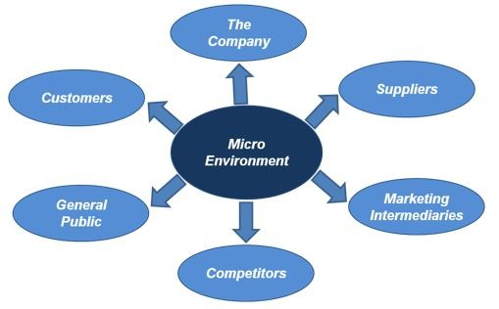
FIGURE: Micro-Environment Analysis
Customers: Customers of Google's come from all walks of life and have wildly different requirements and tastes. Google's goods and services need constant iteration to meet users' demands. To further serve its business clientele, Google now provides a wide range of services, including Google Workspace, Google Cloud, and Google Meet (TechRadar, 2021).
Suppliers: To operate, Google needs the help of third-party hardware, software, and infrastructure providers. Google must keep its supplier ties strong to provide a reliable supply chain. Supply chain sustainability strategies have been established at Google, and the company collaborates with its vendors to achieve its environmental objectives (Google, 2021).
Competitors: Google's rivals in the tech business are strong, including Apple, Amazon, and Facebook. Google needs new ways to keep up with the competition and keep its market share. While investing in new technologies like AI and VR (Statista, 2021), Google has been diversifying its product offerings to include hardware like the Pixel phone and the Nest smart home gadget.
Intermediaries: Google uses middlemen like advertisements and developers to reach its end users. Google has to provide appealing incentives and assistance to keep its connections with middlemen. Through programmes like Google Developer Groups and Google for Startups, Google has invested heavily in its developer community (Google, 2021).
Publics: Google needs to address environmental, social, and privacy concerns if it wants to keep its good reputation. Google has pledged to use 100% renewable energy and reduce its carbon footprint by the year 2021 (Google, 2021). Through its data protection regulations and openness initiatives, Google has also made user privacy a top priority (The Verge, 2021).

Industry Life Cycle
The technological sector, in which Google Inc. works, has witnessed rapid transformation in recent decades. Using Richard A. D'Aveni's "The Dynamics of Competitive Strategy" (1994) industry life cycle model, we may analyse Google's development across time.
Introduction Stage: Neither innovation nor competition were strong points in the technology sector during its early days on the market. When it first opened its doors in 1998, Google's primary goal was to provide users with reliable and relevant search results. There were no major competitors to Google at the time, and the company owned a relatively insignificant percentage of the market.
Growth Stage: The technology market started a period of rapid expansion, marked by rising levels of competition and a plethora of new products. In addition to email, Google now offers mapping and video-sharing capabilities. Google's market share expanded as a result of its aggressive purchase of smaller technology businesses, while new competitors such as Yahoo and Microsoft appeared (Bughin et al., 2018).
Maturity Stage: In the mature period, competition is fierce and sales growth is stagnant. To remain ahead of the competition from social networking sites like Facebook and Twitter, Google had to broaden its product offerings. Through the purchase of DoubleClick, Google was able to diversify its advertising income streams and launch new products including Google Drive and Google Docs (Google, n.d.).
Decline Stage: Regulatory scrutiny and data privacy concerns are two of the obstacles facing the IT industry, which is not yet in terminal decline. As a result, Google is putting resources into emerging areas like AI and growing into new industries like healthcare. Investment in renewable energy and a reduction in the company's carbon footprint are two examples of the company's commitment to sustainability (Google, n.d.).

Porter’s Industry Five Forces Analysis
Google Inc. is a tech behemoth that has changed the way the world finds and uses information forever. An extensive ecosystem of goods and services for consumers, marketers, and developers has been developed thanks to its successful business strategy (MarketLine, 2019). To remain competitive and at the forefront of the industry, Google will need to adapt its business model as the digital world continues to change.
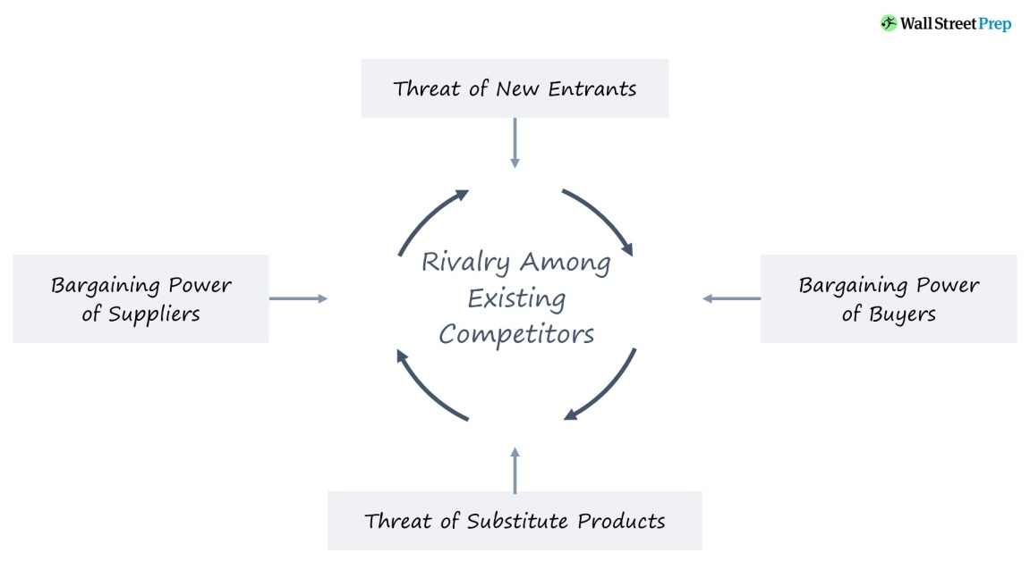
FIGURE: Porter’s Industry Five Forces Analysis
Threat of New Entrants: Competition from upstarts is one of the biggest challenges facing Google. There is a steady influx of new companies into the technological market. Therefore, Google must constantly experiment and adapt to stay competitive. MarketLine suggests that in order for Google to meet this issue, the company's business model will need to change (MarketLine, 2019). The research recommends that Google put its efforts into growing its ecosystem and using its assets to develop innovative goods and services that would be challenging for competitors to copy.
Bargaining Power of Suppliers: Google's economic strategy is also impacted by the negotiating strength of its suppliers. Google's goods and services wouldn't be possible without its extensive network of suppliers and partners. However, the company's purchasing power with its suppliers may decrease as it expands. To solve this problem, Google has to strengthen its relationships with major vendors and spend in building up its own resources (MarketLine, 2019).
Bargaining Power of Buyers: Customers' ability to haggle is a key factor in Google's business strategy. Advertising is a major source of revenue for Google, and advertisers hold considerable sway in negotiations for favourable conditions. To avoid this problem, Google has to keep spending money on research and development of innovative advertising goods and services that will appeal to advertisers (MarketLine, 2019).

Threat of Substitutes: Another major aspect that might have an impact on Google's business strategy is the presence of viable alternatives. New technology and products appear as the digital world develops, and these have the potential to displace Google's services. Google has to keep investing in R&D and creating new goods and services that take advantage of future technology and trends in order to mitigate this threat (MarketLine, 2019).

Intensity of Rivalry: The level of competition is a major issue that influences Google's business strategy. Competitors like Apple, Amazon, and Facebook give Google a run for its money in the tech industry. Google has to innovate and invest in new goods and services that offer distinctive value propositions to consumers, marketers, and developers if it wants to maintain its market leadership position in the foreseeable future (MarketLine, 2019).

Internal Analysis:
A company's competitive advantage can be determined by looking inward at its own resources, talents, and core competencies. Barney and Clark (2007) state that a company's resources and capabilities need to be "valuable, rare, inimitable, and non-substitutable" (VRIN) in order to keep up with the competition.
Resources: Google's resources, capabilities, and core competencies are critical components of its competitive advantage. As an information technology company, Google's material resources consist of its vast network of data centers and servers worldwide that support its search engine, advertising platforms, and cloud computing services (MarketLine, 2021). Additionally, Google has substantial financial resources, with a market capitalization of over $1 trillion (MarketWatch, 2021). Furthermore, Google's human resources are composed of a highly skilled and diverse workforce of over 135,000 employees worldwide (Google, 2021).
Capabilities: Google is successful because of its capacity to maximise its assets to the benefit of its users. Google's search algorithm is one of its most important features since it employs machine learning to provide customers with highly relevant and personalised search results (MarketLine, 2021). Google's ad products like AdWords and AdSense help firms advertise to specific demographics, which in turn generates a lot of money for Google (MarketLine, 2021). Last but not least, Google's cloud computing services, Google Cloud, give firms instantaneous access to a vast pool of computer resources, allowing for quick expansion (MarketLine, 2021).
Core Competencies: Google's strengths lay in its capacity for innovation and flexibility in the face of shifting market demands. When it comes to technological innovation, Google has never stopped pushing the envelope. For instance, as evidence of their innovative spirit, the corporation has entered new areas including driverless cars and healthcare technologies (MarketLine, 2021). Google's willingness to take risks and try new things has also resulted in the development of innovative products like Google Maps and Google Home (MarketLine, 2021).
Google’s Strategic Resources and Capabilities
Google, a global technological giant, is often credited for fundamentally altering internet culture. Google's groundbreaking economic model, however, will need to change if the company wants to keep up with the rapidly developing digital world and remain a market leader. Google has collected a number of strategic assets, and has used them well to preserve its position as market leaders.
Brand Reputation:
The worldwide recognition of the Google brand is one of the company's strongest points. The company's dedication to excellence, originality, and the satisfaction of its customers has allowed it to flourish throughout time. In today's cutthroat economy, Google's well-established reputation stands out as a significant advantage. Interbrand estimates that by 2020 Google's brand value will have risen to $165.4 billion, making it the third most valuable brand in the world.
Search Algorithm:
Google's search algorithm is the company's most valuable strategic asset and the driving force behind its meteoric rise to the top. The search engine's rapid and precise delivery of relevant search results has been a key factor in its rapid growth in popularity. Over 200 ranking variables are used by Google to assess the relevancy and quality of online sites, and the algorithm is always being refined to enhance the user experience (Moz, 2021). Google's advertising business is predicated on serving relevant adverts to users in response to their search queries, and the search algorithm plays a crucial role in this process.
Data Analytics:
The company's data-gathering and analysis capabilities have evolved into a key strategic advantage. In order to provide better support and more relevant advertisements, the corporation analyses client data. Google's ability to continuously recognise trends, capitalise on opportunities, and improve operating procedures is made possible by the company's massive data collections. Site traffic, user behaviour, and search engine performance are just some of the areas where organisations may benefit from Google's analytics solutions (Google, 2021).
Human Resources:
One of Google's most valued strategic assets is its employees. With an eye on innovation, creativity, and diversity, Google works hard to find and keep the most qualified employees. To attract and retain top talent, Google offers a competitive compensation and benefits package, as well as a choice of work flexibility options and training and education programmes (Google, 2021). Google's commitment to its workers has been essential in creating an environment where new ideas and constant development are encouraged.
Cloud Infrastructure:

Google's cloud infrastructure is a key asset that helps the corporation deliver highly customizable, dependable, and safe offerings to its clientele. The Google Cloud Platform (GCP) is a collection of cloud-based tools for managing data and applications. GCP relies on Google's extensive data centre network to power its infrastructure, ensuring that its services can be accessed anywhere in the world with minimal delay. Advanced encryption and access control features are built into Google's cloud architecture (Google Cloud, 2021).

Value Chain Analysis
The purpose of a value chain analysis is to examine the internal processes of a company in order to discover new opportunities for adding value and gaining a competitive edge. When it comes to online research, Google has been a game-changer. The core of the company's business strategy is the search engine technology that drives advertising income. To remain competitive, though, the innovative business model will need to change. To increase value creation and keep its competitive edge, Google can benefit from conducting a value chain study of its activities.

Primary Activities
Inbound Logistics: The inbound logistics department of Google is crucial to the company's ability to ship products quickly and affordably. To offer its consumers with reliable and relevant search results, the organisation must properly handle the data it obtains from a wide variety of online sources. Google has spent considerably on research and development of technologies like machine learning algorithms and natural language processing to enhance the quality and usefulness of its search engine (Battelle, 2015). Google's inbound logistics function has been enhanced because to these efforts, resulting in a more satisfying customer experience.
Operations: Processing the data it gathers and deriving insights that may be utilised to enhance its goods and services are central to Google's operations function. Google's goal is to assist businesses in analysing their website traffic and improving their online advertising campaigns through the use of a number of tools, such as Google Analytics and Google AdWords (Hamel, 2017). Google's processes have been streamlined and the company's advertising income has increased thanks to these technologies.
Outbound Logistics: Delivering Google's goods and services to customers is an important part of the company's outbound logistics operation. The company's main offering is a search engine that may be accessed via the company's website or several mobile applications. In addition to its core cloud offerings, Google has built a wide range of complementary products, such as Google Maps and Google Drive (Hamel, 2017). These products have allowed Google to increase its client base and income sources.
Marketing and Sales: Google uses marketing and sales strategies to promote and sell its wares to consumers. The company's principal source of income comes from its advertising business, which makes use of a number of different advertising platforms, including Google AdWords and Google AdSense (Battelle, 2015). Google Doodles, which are celebratory logos on the search engine's homepage that users can interact with, are another example of the company's creative marketing efforts.
Service: Providing help and support to Google's customers is an integral part of the company's service function. In order to assist its customers, the firm has created a number of resources, such as the Google Help Centre and Google Forums. With Google Ads support, the search giant helps companies make the most of its advertising platform (Hamel, 2017). Google's customer service and the quality of its services to users will benefit from these initiatives.

Secondary Activities
Google's secondary operations are vital to the success of the company's core business and to the company's value chain as a whole. The corporation has been successful in maintaining its market position and staying ahead of competitors thanks to its procurement practises, technological development activities, human resource management, and infrastructure. However, in order to stay competitive, Google's business model will need to keep adapting to the shifting preferences of its users and the industry as a whole. Google can ensure its long-term success by prioritising research and development, training and education, and environmentally responsible business operations.
Procurement
One of Google's tertiary operations that helps to underpin its core business is procurement. The organisation relies on a worldwide group of vendors for the majority of its supplies. Google's strategy for purchasing is based on fostering lasting partnerships with its vendors (Google, 2021a). Suppliers are held to the company's stringent quality standards and ethical and sustainable business practises through tight collaboration with the business. Google's ability to reliably deliver high-quality goods and services is in part due to the company's procurement practises.
Technology Development
The advancement of technology is another of Google's auxiliary activities that contributes significantly to the company's success. The business has poured resources into R&D to create novel goods and services (Google, 2021b) that take use of cutting-edge technologies. Google has invested much in research and development of cutting-edge technologies like AI, ML, and cloud storage. These advancements in technology have allowed Google to expand its business and provide a better service to its customers.
Human Resource Management
Human resource management is a key part of Google's success. The corporation places a premium on its workers' well-being and growth by providing them with health insurance, wellness programmes, and a variety of other benefits (Google, 2021c). The company's Living Wage policy guarantees that all workers are given a wage that meets basic needs, which boosts morale and retention. Because of Google's commitment to its staff, it has been able to recruit and keep some of the best minds in the increasingly competitive tech business.
Infrastructure

Google's success depends in large part on the company's infrastructure. The company's large network of data centres houses the computational capacity required to back up the company's goods and services (Google, 2021d). Google's investment in high-speed networks ensures that its services will reach users promptly and reliably. The company's offices and campuses are also part of its physical infrastructure, and they were built with teamwork and creativity in mind.

VRIO Analysis of Distinctive Resources and Capabilities
The VRIO analysis (Value, Rarity, Imitability, and Organisation) is a strategic method for assessing a company's assets and strengths on these four dimensions. Google's unique strengths lie in the following areas of expertise and infrastructure:
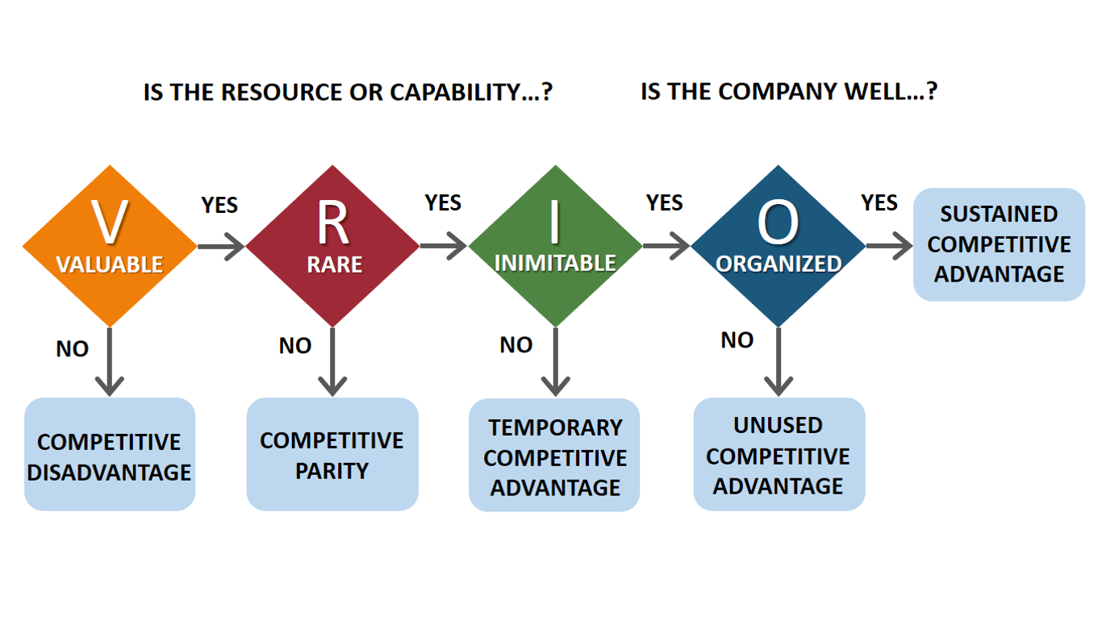
FIGURE: VRIO Analysis
Valuable Resources:
- Strong brand image: The trust people have in the Google name is a valuable asset that the company has worked hard to earn. Constant efforts to improve the company's brand via research and development, product quality, and customer service have paid off (Mourdoukoutas, 2019). This credibility is priceless since it encourages repeat business from satisfied customers and brings in new ones.
- Large user base: With about 2.3 billion monthly users, Google has one of the greatest user bases in the world (Statista, 2021). Google collects and analyses this massive quantity of user data to refine its offerings.
Rare Resources:
- Google's search algorithm: The search algorithm built by Google is a valuable resource that took years to perfect. It is difficult for rivals to reproduce the algorithm because of its complexity and the volume of data necessary to train it (Kissmetrics, 2019). Google's algorithm is one of its main selling points since it returns the most relevant results to consumers' queries.
- Google's data centers: Google's data centres are a unique asset that provide the corporation a big leg up on the competition. In order to process massive volumes of data swiftly and efficiently, the corporation has made significant investments in its data centres (Mourdoukoutas, 2019). Competitors will have a hard time replicating this capacity because it demands substantial resources and knowledge.
Imitable Resources:
- Google's software and hardware: Competitors may easily use Google's software and hardware as models to create equivalent or superior offerings of their own. For instance, competitors to Google's Android OS, Google Drive, and Google Docs have been created by firms like Apple and Microsoft (Mourdoukoutas, 2019).
- Google's online advertising platform: Another resource that may be easily replicated by Google's rivals is the company's online advertising platform. Similar advertising networks to Google's AdWords have been created by Facebook and Amazon (Kissmetrics, 2019).
Organized Capabilities:
- Artificial Intelligence: Google has a well-structured, substantial capabilities in the field of artificial intelligence (AI) that has been built over many years. Products like Google Assistant, Google Translate, and Google Photos are all possible because to Google's AI powers (Mourdoukoutas, 2019). Google's AI expertise is well-structured, with specialised teams committed to the ongoing creation and enhancement of these items.
- Innovation: Google's culture of invention is only one of the company's well-organized advantages over its rivals. Employees are encouraged to use their imaginations and come up with innovative ideas for the company's goods and services. Google has a well-structured innovation strategy (Kissmetrics, 2019) that includes programmes like Google X and Google Ventures.

SWOT Analysis
According to Kotler et al. (2017), a company's SWOT analysis may be broken down into four sections: strengths, weaknesses, opportunities, and threats.
Strengths:
Google's search engine is quite popular; in fact, it has a market share of over 90% (StatCounter, 2021). The name of the firm has been synonymous with quality and originality, which has contributed to the company's success. Gmail, Google Maps, and YouTube are just a few examples of Google's varied product portfolio, which has helped the business attract a massive user base.
Weaknesses:
Google's reliance on the advertising industry for a substantial amount of its revenue is one of the company's major flaws. approximately 2020, advertising brought approximately 80% of the company's income, per Statista (2021). Google is sensitive to shifts in the advertising business because of its reliance on a single income stream. The Android operating system is also popular, but it has to compete with iOS from Apple, which has a better reputation for safety.
Opportunities:
Google may diversify its income streams for growth by entering new areas. Artificial intelligence (AI), augmented reality (AR), and virtual reality (VR) are just a few of the new technologies that the corporation has begun to fund. Grand View Research (2021) predicts that the virtual reality industry would expand at a CAGR of 21.6% between 2021 and 2028. This might open the door for Google to create ground-breaking virtual reality (VR) goods like the Google Cardboard device, which in turn could bring in new customers and money. In addition, there is potential for growth into new regions. Google's goods and services are translated into more than one hundred languages, contributing to the company's worldwide reach. Nonetheless, there are still unexplored markets where Google might expand its customer base. So, for instance, Google has recently announced intentions to expand into the Latin American market by opening a data centre in Chile (Google, 2021).
Threats:
Growing competition from other search engines is one of Google's biggest challenges. While Google is still the market leader, rivals like Bing and Yahoo are making inroads. Furthermore, emerging search engines like DuckDuckGo, which prioritises user privacy, might challenge Google's dominance in the industry. Google also faces danger from authorities who are becoming increasingly interested in the company's economic dealings. For instance, Google has received many fines in recent years from the European Union for antitrust infractions associated with its search engine and Android OS (The Guardian, 2019). The company's bottom line and public image may take a hit if fines and other penalties are imposed as a result of the heightened regulatory scrutiny.
Strategies to Sustain Competitive Advantage
Google may employ a number of different strategic studies, like Porter's Generic Strategy, to guarantee that it keeps its edge in the market. Porter (1985) offers three general strategies accessible to organisations seeking a sustained competitive advantage: cost leadership, differentiation, and focus.
Cost Leadership: The three generic strategies that Porter's Generic Strategy (Porter, 1985) outlines as the means by which organisations may attain lasting competitive advantage are cost leadership, differentiation, and focus. Google's cost leadership approach is cutting expenses wherever possible without compromising on the quality of the company's offerings. Investing in technology that improves efficiency and productivity is one strategy towards reaching this goal. To optimise energy use, minimise carbon footprint, and cut costs, Google, for one, has made significant investments in data centres that employ artificial intelligence (Google, n.d.). By purchasing hardware in large quantities, including servers and storage devices, Google may take advantage of economies of scale and achieve cost leadership (MarketLine, 2019).
Differentiation: Google's policy of differentiation is another tool it may employ to stay ahead of the competition. The organisation may set itself apart by catering to its consumers' specific wants and requirements and offering them with an exceptional user experience. One way in which Google improves the search experience for its users is by tailoring results to each individual's habits and interests (MarketLine, 2019). In addition, Google can keep pouring money into R&D to come up with innovative goods and services that can adapt to its consumers' changing demands. To set itself apart from rivals, Google has introduced various ground-breaking products in recent years (MarketLine, 2019), including Google Home, Google Assistant, and Google Pixel.
Focus: By zeroing in on certain customer demographics, Google can keep its edge over the competition with the use of the focus approach. Google is able to better serve its consumers by catering to their individual tastes and interests when it narrows in on a certain demographic. Google's enterprise-grade offerings, such Google Workspace and Google Cloud Platform, are aimed squarely at enterprises (Google, n.d.). There is untapped development potential in certain places, and Google may zero in on those like emerging markets (MarketLine, 2019).
Growth Strategies
Google has been an innovator in the tech sector from day one, but the company needs to keep adapting its business strategy to stay ahead of the pack (MarketLine, 2021). The Ansoff matrix (Ansoff, 1957) proposes four different sorts of growth strategies: market development, product development, market penetration, and diversification.
Market Penetration:
Market penetration is a growth tactic Google can use. In other words, we need to boost sales of established goods in established markets. To do this, Google may increase the quality of its search engine results and the variety of its advertising options (MarketLine, 2021).
Market Development:
Expanding into new markets is a key part of developing markets for current items. Asia, Africa, and Latin America all have fast rising internet populations, providing opportunities for Google's international expansion (MarketLine, 2021). Google's ability to expand into new markets and attract more users will improve as a result.
Product Development:
Developing new goods or enhancing old ones to fulfil the ever-evolving demands of consumers is what product development is all about. To increase its client base, Google can adopt this tactic by introducing new capabilities to its search engine and improving its cloud computing platform (MarketLine, 2021).
Diversification:
Google can also pursue expansion by diversifying its business. It entails penetrating untapped markets with novel offerings. Google can broaden its revenue stream by entering new markets like healthcare and transportation, where the company can put its technological prowess and industry knowledge to good use (MarketLine, 2021). Google, for one, has started making investments in autonomous vehicles and drone delivery systems, both of which have the potential to broaden the company's revenue base.
Google may stay ahead of the competition in other ways besides using the Ansoff matrix. The corporation may adopt a multidomestic strategy, in which it tailors its offerings and promotional efforts to the specific needs of each domestic market (Bartlett & Ghoshal, 1989). Google would benefit from this since it would learn more about local customs and preferences.
The global standardisation method is another option for Google, as it would require employing the same goods and advertising strategies everywhere (Levitt, 1983). This would aid Google in reaching economies of scale, which would lower production and advertising expenses. Joint ventures, in which foreign companies develop relationships with domestic ones, are one entry mode strategy that Google may utilise to get into untapped areas (Hitt, Ireland, & Hoskisson, 2017). The Nexus 6P smartphone, for instance, was co-created by Google and Huawei Technologies specifically for the Chinese market (MarketLine, 2021). With this strategy, Google would be able to utilise local knowledge and skills while avoiding regulatory and cultural constraints.

Green Strategy and CSR

CSR:
Google's dedication to CSR is seen in the many projects it has undertaken to improve society and the environment. For instance, Google has set up the Google.org foundation (MarketLine, 2018) with the goal of harnessing technology to solve global problems. This organisation has funded a wide range of initiatives to improve learning, employment, and technology for underprivileged communities. Google has also taken substantial measures to lessen its effect on the environment. With the goal of using only renewable energy across all of its activities, the corporation became the largest corporate consumer of renewable energy in 2017 (Google, 2018).
Green Strategy:
Google's green strategy entails a number of initiatives designed to lessen the company's environmental impact and spread the word about eco-friendly methods of doing business. Investments in energy-efficient data centres and a target of zero waste to landfill across all of the company's worldwide data centres are just two examples (MarketLine, 2018). Google has also bought wind power in Oklahoma in 2017 (Google, 2017) as part of its efforts to promote the usage of renewable energy. The corporation has also established the Google Transportation Operations Centre, which aids in the alleviation of traffic and the enhancement of transportation efficiency (MarketLine, 2018), as part of its efforts to promote sustainable mobility.
Conclusion
Case study data shows that Google Inc.'s innovative business strategy has been crucial to the company's success. It's also clear that this model needs to develop if it's going to remain competitive in the dynamic world of technology. MarketLine claims that Google's revenue growth has slowed in recent years, suggesting the necessity for the corporation to implement new strategies and make further expenditures in order to sustain its rapid expansion (MarketLine, 2021).

Recommendation
According to the case study, in order to maintain its competitive edge and continue to address the shifting requirements of its customers, Google's innovative business model will need to change. One important piece of advice for Google is to diversify its income streams by providing more services than just search and advertising. Cloud computing, AI, and VR are all expanding businesses with promising prospects for future expansion, thus they may be good candidates for investment.
Google should also make protecting user data a top priority, since the corporation has come under fire and been sued over this same problem. More consumer control over their data and greater openness about how it is used should help alleviate these worries (MarketLine, 2017).

References
- Alphabet. (2021). Alphabet Announces Fourth Quarter and Fiscal Year 2020 Results. Retrieved from https://abc.xyz/investor/static/pdf/2020Q4_alphabet_earnings_release.pdf
- Ansoff, H. I. (1957). Strategies for diversification. Harvard business review, 35(5), 113-124.
- Barney, J. (1991). Firm resources and sustained competitive advantage. Journal of Management, 17(1), 99-120.
- Bartlett, C. A., & Ghoshal, S. (1989). Managing across borders: New strategic requirements. Sloan Management Review, 31(4), 7-17.
- BBC News. (2021, April 22). Google to block 'sensitive content' search in some countries. BBC News. https://www.bbc.com/news/technology-56820079
- Bughin, J., Chui, M., Manyika, J., Woetzel, J., Batra, P., Ko, R., Sanghvi, S. (2018). Notes from the AI frontier: Insights from hundreds of use cases. McKinsey Global Institute.
- CNBC. (2021, April 19). Google's antitrust cases: A guide to the major investigations and lawsuits. CNBC. https://www.cnbc.com/2021/04/19/googles-antitrust-cases-a-guide-to-the-major-investigations-and-lawsuits.html
- D'Aveni, R. A. (1994). The dynamics of competitive strategy. Free Press.
- Forbes. (2021, March 17). How Google is adapting to evolving user behavior. Forbes. https://www.forbes.com/sites/paultalbot/2021/03/17/how-google-is-adapting-to-evolving-user-behavior/?sh=1a3d31b14c97
- Google. (2018). Our progress on renewable energy. Retrieved from https://www.blog.google/outreach-initiatives/sustainability/our-progress-renewable-energy/
- Google. (2021). 2020 annual report. Retrieved from https://abc.xyz/investor/static/pdf/20201231_alphabet_10K.pdf
- Google. (2021). 2020 sustainability report. Retrieved from https://www.blog.google/documents/72/Google-Sustainability-2020-Report.pdf
- Google. (2021). Google Developer Groups. Google. https://developers.google.com/community/gdg
- Google. (2021). Google Meet. Google. https://meet.google.com/
- Google. (2021). Our commitments to sustainability. Google. https://sustainability.google/commitments/
- Google. (2021). Sustainability at Google. Google. https://sustainability.google/
- Google. (2021a). Supplier standards. Retrieved from https://supplierstandards.withgoogle.com/
- Google. (2021b). Google AI. Retrieved from https://ai.google/
- Google. (2021c). Life at Google. Retrieved from https://careers.google.com/
- Google. (2021d). Our infrastructure. Retrieved from https://www.google.com/about/datacenters/
- Google. (n.d.). About Google company. Retrieved from https://about.google/intl/en_us/
- Google. (n.d.). Our mission. Retrieved from https://about.google/intl/en_us/company/
- Hamel, G. (2017). The 7 principles of innovation that drive Google. Forbes. Retrieved from https://www.forbes.com/sites/garyhamel/2017/06/07/the-7-principles-of-innovation-that-drive-google/?sh=46a9a66d698a
- Hitt, M. A., Ireland, R. D., & Hoskisson, R. E. (2017). Strategic management: concepts and cases: competitiveness and globalization. Cengage Learning.
- Levitt, T. (1983). The globalization of markets. Harvard Business Review, 61(3), 92-102.
- MarketLine. (2019). Alphabet Inc.: Company profile. MarketLine Company Profiles.
- MarketLine. (2021). Google LLC: Company profile. MarketLine Company Profiles.
- MarketWatch. (2021). Alphabet Inc. Cl A stock quote. Retrieved from https://www.marketwatch.com/investing/stock/googl
- Mourdoukoutas, P. (2019). Google's competitive advantage over rivals. Forbes. Retrieved from https://www.forbes.com/sites/panosmourdoukoutas/2019/01/14/googles-competitive-advantage-over-rivals/?sh=38b994a61035
- Porter, M. E. (1985). Competitive advantage: creating and sustaining superior performance. Free Press.
- Statcounter. (2021). Search Engine Market Share Worldwide. Retrieved from https://gs.statcounter.com/search-engine-market-share/all-worldwide
- Statista. (2021). Google's active users worldwide 2015-2021. Retrieved from https://www.statista.com/statistics/264572/number-of-monthly-unique-google-users/
- TechRadar. (2021). Google Workspace review. TechRadar. https://www.techradar.com/reviews/google-apps-for-work

Appendix (if any)

Appendix 1:



