Assessment 2 Written Assessment
ACCA4019
David Veater 2520276
Content Table
1. Introduction
2. Deconstructing the Problem

2.1 Breaking down the problem
2.2Requirements and constraints using the Moscow Analysis

2.3 Variables
3. Solution proposal

3.1 Flowchart

4. Reflection and justification

4.1 Techniques for problem solving used
4.2 Justification for approach
4.3 Limitations and assumptions
5. Conclusion
6. Bibliography
Introduction
This report will be discussing GrocerQuick using logistical solving problem techniques. The company faces problems with inefficient management of delivery routes; this has caused an increase in fuel consumption and delays in deliveries. This report will be deconstructing the businesses problem through MoSCoW, propose a structured logistical solution using abstract thinking and problem-solving techniques such as using a Flowchart. The report will then reflect and justify the chosen approach.
Deconstruct the problem
Computational thinking, a problem-solving process involving various techniques and thought processes borrowed from computer science, enabling individuals to solve complex problems by breaking them down into more manageable parts. [1] In 2006 Jeanette M. Wing stated that computational thinking “Represents a universally applicable attitude and skill set everyone, not just computer scientists would be eager to learn and use.”. [2]
Using decomposition, this report will break down the problem of GrocerQuick into smaller more manageable parts. [2]
Using Decomposition, here are the following parts:
1. What are the delivery locations and routes?
2. What is the time window for delivery?
3. What is the fuel usage and travel distances?
4. What is the order intake?
5. What is the number of delivery vehicles and drivers?
MoSCoW technique
The MoSCoW technique created in 1994 by Dai Clegg at Oracle is a method that prioritises expectations of shareholders in project management. This method categorises tasks by urgency levels providing a concise structure for prioritising features and is used frequently in the product design and functions planning process. These are filtered and organised based on impact and objectives of the organisations and its constraints. This technique grants flexibility in managing less urgent initiatives, when they have the time and resources. This report will be using the MoSCoW method as it improves roadmap management. [3]
MoSCoW Priority Categories
Must Have
All orders to be allocated a delivery route
All deliveries must be within the desired 30 minutes
Total travel distance managed and minimalised

Should have
Clustering orders that are within a close proximity of each other
Balanced Workload for drivers

Could Have
Real time adjustments to traffic alterations
Rerouting changes during deliveries
Won’t have
Expansion on product storages and delivery vehicles

(Must have) They are the key requirements and constraints which are required within the business aims such as, 30 minutes restraints for deliveries, and all orders be allocated a delivery route.
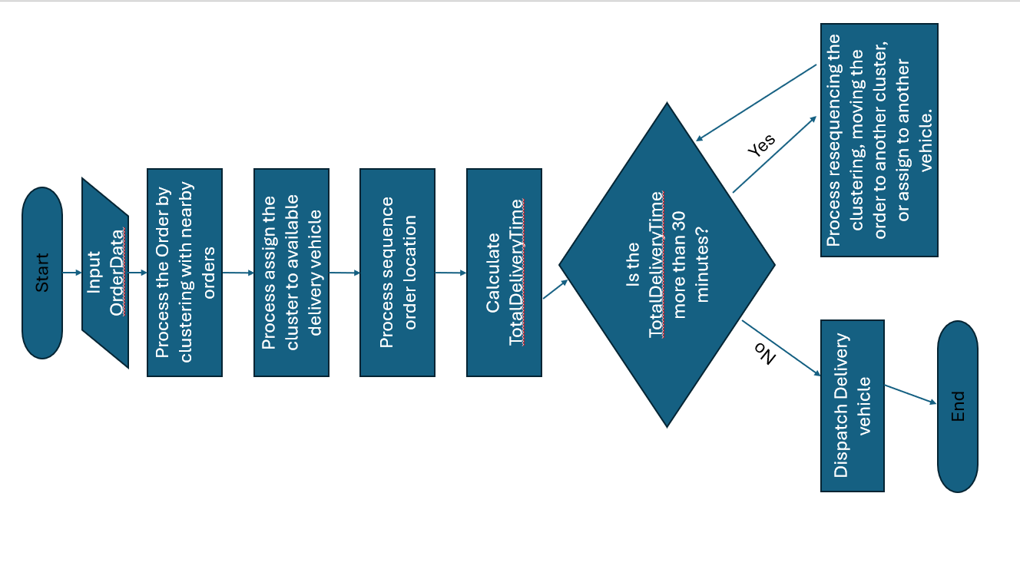
(Should have) while balanced workloads can improve staff wellbeing and motivation, and clustering deliveries helps supports travel distance reduction, they don’t prevent the system from functioning without them.
(Could have) whilst they improve accuracy on delivery times and responsiveness, they require complex systems which will increase resource consumption.
(Won’t have) whilst expansion will provide opportunities, more vehicles, and staff. This may increase efficiency and allow the organisation to grow however; this will require investment in time and resources.
Variables
The key relevant variables in this problem are;
Delivery location
Delivery time limit
Vehicle Capacity
Fuel consumption
Propose a solution
By looking over the MoSCoW priorities and breaking down the problem it is clear that this is a vehicle routing problem (VRP), VRP is an optimization issue which seeks to find and determine the most efficient and optimised routes for delivering customers products using the organisations delivery vehicles. [4] Alongside using this method of problem solving the solution uses the clustering of orders based on geographical locations, this is done by grouping orders that are within a close proximity of each other in order to be delivered in the same delivery vehicle. [5] Routes will be created and analysed to minimise the total travel distance. Delivery times are to be assessed against the given time constraint, if the delivery time does not meet these time constraints, routes must be adjusted repeatedly until they meet the expected criteria.
Flowchart
Demonstrated below is a visual and simplified solution using a flowchart.
Step one shows the start of the solution, which inputs the orders data, such as the products of GrocerQuick, and the address of the customer.
Step two is the clustering of orders with locations that are within a close proximity of each other
Step three is the process of assigning the cluster of orders to a delivery vehicle with the capacity to carry all the ordered products.
Step four is the process of optimising the route which will be to sequence the delivery locations in order to create the most efficient route for the delivery vehicle to travel from one delivery location to the next, until all deliveries have been completed.
Step five is the process in which the system assess the start time of the delivery, and the end time of the delivery. The system then calculates the total expected time of the delivery. This is where the Decision point in the flowchart will assess that the total expected time of delivery meets the required time limit of 30 minutes, if the route then fails to meet the time constraint the system must reassess and re-adjust either by resequencing the orders, moving the order to another cluster, or assigning the order to another delivery vehicle, these steps are crucial and will need to be repeated until the delivery time meets the strict time constraints.
Finally, once the route has been calculated to meet the required time limit, the delivery vehicles are then dispatched to deliver GrocerQuick’s products.
This solution meets the required aims and objectives of GrocerQuick through a multitude of factors. Firstly, by clustering multiple orders that are within close proximity of each other, GrocerQuick will reduce the travel distance that the delivery vehicles must make from one location to the next location, as a result of this, it will reduce fuel consumption and is a good standard of practise in delivery management. The next factor is to ensure the delivery vehicles have the capacity to load and carry the cluster of delivery orders which may then ensure service reliability by reducing factors that could lead to last second errors in order allocation, which in turn gives GrocerQuick the ability to reassign the order to another cluster and continue with the system process.
Another factor that makes the solution achieve the aims and objectives of GrocerQuick is that by optimising and sequencing the locations of the orders to be delivered GrocerQuick is able to create the most efficient route from location to location, thus reducing the total travel distance. By doing this GrocerQuick can manage the fuel consumption. The final factor is using the decision point to calculate and analyse the total travel time, making sure that the expected delivery time meets the required 30 minutes time constraint.
This solution does follow and use assumptions, these being, that GrocerQuick has the necessary number of delivery vehicles, and drivers required to be able to deliver the number of orders that they receive to the extent they are able to achieve their aims and objectives. Another assumption is that the roads and environments are predictable, calculating expected travel times based on standard road, and weather predictions.
Reflect and justify
Problem solving techniques used
The problem solving techniques used in the report such as, computational thinking using decomposition and abstract thinking, which allowed for the problem to be broken up into smaller and simpler problems and to be solved individually while focusing on the key details of the problem. The report using the MoSCoW method was able to align and establish the priorities and expectations of GrocerQuick. Through using the Flowchart tool this report is able to visually show and provide the solution step by step in a simple and clear diagram.
Justification of approach used
Through breaking the problem down and using the MoSCoW method and applying logical optimization in clustering orders and sequencing them in the solution, the reports solution is able to balance the fuel efficiency the constrained time limit and the order allocation effectively. By using this solution GrocerQuick can ensure service reliability as a result of prioritising the time constraint whilst also limiting the distance travelled through efficient route selections, This will reduce its fuel consumption, which will reduce the organisations operational costs.
Assumptions and limitations
Furthermore a factor that weakens this report is the assumptions made within the solution. The solution relies on traffic conditions remaining consistent and predictable, for example no weather conditions effecting the road surface, which would cause the delivery drivers to slow down. This may result in delays in delivering GrocerQuick’s products at the expected time. Another assumption is that the customers are available at the delivery time, if the customer is not at their address or able to receive the delivered products then this will cause delays affecting setting off times to deliver to other addresses. Other assumptions within this report are that Grocerquick have the capacity and number of vehicles and staff to be able to deliver the volume of orders requested by its customers.
Additionally, another factor that weakens this report are the limitations such as the solution requires accurate location and time estimates, if any of the information is incorrect this could cause errors in finding the address and delays in the delivery. Another limitation on the solution is that it doesn’t account for real-time traffic changes as the solution only follows predictable traffic conditions, thus if the conditions were to change this could be due to sudden road accidents or road blockages, these would not be calculated into the route which may cause delays in the delivery vehicles journey, resulting in a later delivery time and not meeting the required time limit.

Bibliography

[1] | “Hexaly,” Hexaly, [Online]. Available: https://www.hexaly.com/templates/clustered-vehicle-routing-cluvrp. [Accessed 22 January 2026].
[2] | “Learning.com,” 24 August 2024. [Online]. Available: https://www.learning.com/blog/defining-computational-thinking/. [Accessed 21 01 2026].
[3] | J. M. Wing, “Computational thinking,” Communications of the ACM, vol. 49, pp. 33-35, March 2006.
[4] | S. Chohan, “Lemon learning,” Lemon learning, 2004 April 2025. [Online]. Available: https://lemonlearning.com/blog/moscow-method-prioritize-features-and-projects#h-what-is-the-moscow-method. [Accessed 21 January 2026].
[5] | B. Aghaabdollahian, B. Javadi and A. Aazami, “An overview of vehicle routing problems: A commprehensive classificationand description of types,” Transportation Research Interdisciplinary perspectives, vol. 36, March 2026.

