Student Name: Jay Johnson – Student ID: 1920319

Module code: (BMSW6104_BIRM)

Strategic Management for SMEs

Lecturer's name: Dr Sampath Liyanage

Table of contents

Introduction

For this report a specialist has been hired to design a strategic plan and strategy for Delicious food restaurant to expand the business throughout the UK. The report will cover various models and theory that will support what analysis and research should be carried out before any strategy is implemented. Strengths and weaknesses of the business will be fundamental to the decision-making process based on risk analysis, sustainability, competitive advantage, and continued sustainability. The report will show the advantages of using analysis tools and models and why SME’s and conglomerates consider these tools as successful applications to us before making strategic decisions, organisational change, or large investments. These analysis tools will be used to focus attention on key aspects of the business such as strengths, weaknesses, further opportunities and potential threats or uncertainty. The report will demonstrate that new initiatives, vision, and strategic planning can be achieved by innovation and competitive advantage. According to (M. Harker, R. Brennan, P. Kotler, and G. Armstrong, 2009), by establishing the emergence of competitiveness and effective ideas, this will draw strong focus to new creativity.

.

Establishing strategic direction considering Goals, Mission and Objectives for Delicious
For this report, A business specialist has been hired to formulate a strategic plan to expand this delicious food business throughout the UK. The business has had success as a respected food establishment with positive feedback through customers. The owner has over 20 years’ experience within the food industry but very little experience with other business areas. This section of the report will consider varying elements that take on board environmental factors and their impacts on the economy and the business that are either good or bad. This report will also look at the best possible choices to consider extending the business throughout the UK with as little negative impact to the company, shareholders, stakeholders, and the economy at large with the ability to hold a competitive advantage and remain sustainable. Based on Mr James’s request to extend his business within the food industry over a 2-year span and the vision of supplying customers with unique foods across the UK. one must consider his current position now and the strength of that position in the market. Other key areas will need to be reviewed such as strategic planning and strategic management. Internal and external analysis is also key to environmental understanding and reviewing the appropriate action that will consider cost, time, impact, and possible threats. Opportunities could also be a possibility for the business. Below is an example of a strategic management framework where all components will need to be fully explored to gather a good understanding of the environmental factors, risk, competitive advantage, opportunities and mission and outcome.

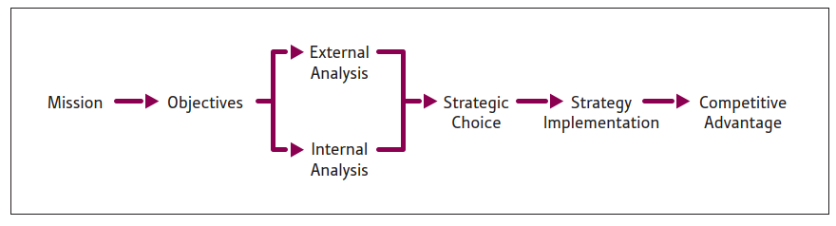
According to (Cole, 2003), Strategic management is the setting the purpose and objectives of the organisation and having the knowledge to choose the appropriate goals working to meet the aims to achieve both the purpose and objective over a set period of time

Utilising the strategic management framework above, one would need to consider what the mission and mission statement will be. Mr James had confirmed that his mission is to extent his business throughout the UK, however there was no mention of a mission statement to outlay the organisational purpose. A recommendation to Mr James is to put together a mission statement to demonstrate to stakeholders, shareholders, and investors the purpose of the company in a quick and easy way that will provide a general idea of what the organisation stands for. Strategic management is a planning and direction focused framework of any organisation on a long-term basis. Due to Mr James request for business expansion over 2 years, this will fall under the strategic management process. Within the strategic management process there will need to be a strategy. Strategy is based around competitive advantage and reviews key fundamentals such as how to achieve the mission, planning over a long term, analysing competitive advantage, and reassessing managing and allocation processes. To gain a competitive advantage, Mr James will need to deliver a product or service that holds an edge over their competitors with more added value to customers and the organisation to be sustainable and with increased revenues. The mission will need to highlight the purpose and the values with all objectives being very specific and measurable to enable the desired target to be met. According to (Davenport et al., 2010), (Fleisher and Bensoussan, 2007), (Jarzabkowski and Spee, 2009), and (Rigby and Bilodeau, 2011), Many key decision-makers are utilising strategic management tools and techniques to mitigate uncertain times when conducting business and competitive analysis. They go on to say that the key reason for strategic tools is to allow key decision makers to make sound decisions that directly lead to better products and services with better processes to boost organisational performance. Below is the mission and the objectives.

Mission: Expand the Delicious restaurant across the UK.
Objective:
- Drew up strategic management and strategy process for organisational expansion.
- Conduct internal and external environmental checks.
- Review strategy choices and planning to go ahead based upon Micro and Macro environment.
- Consider the best route for strategic implementation that mitigates uncertain impacts.
- Proceed with a clear strategy whilst strongly moving toward sustainability.

External Analysis utilising PESTLE & Scenario based analysis.
Based on the above information it is highly recommended to conduct an internal and external environmental check to mitigate risk and impact to the organisation, shareholders, and stakeholders. This would consist of revenues, employees, law, technologies, establishments, and politics etc. Having a good understanding of the current economy and possible changes or uncertainties will help map the best route for organisational change or expansion. Due to strategic change, consideration is required when making high profile decisions where major investment or changes are to be made. There are tools available to assess micro and macro environments. According to (Martin, R. 2007), Due to increasing and complex uncertain environments, decision makers are expected to recognise and embrace a more complex understanding of this emerging world, with access to techniques and tools to make the best decisions possible. For this report a PESTLE – Political, Economic, Social, Technological, Legal, Environmental, analysis will be carried out scanning over the external environment for any threats or opportunities. This will provide a view of the current position of the external environment and what is happening now, what has already happened, for example is the Covid-19 pandemic, what might happen, and what opportunities present themselves to take advantage of. This pestle in figure 1 was conducted on the delicious restaurant.

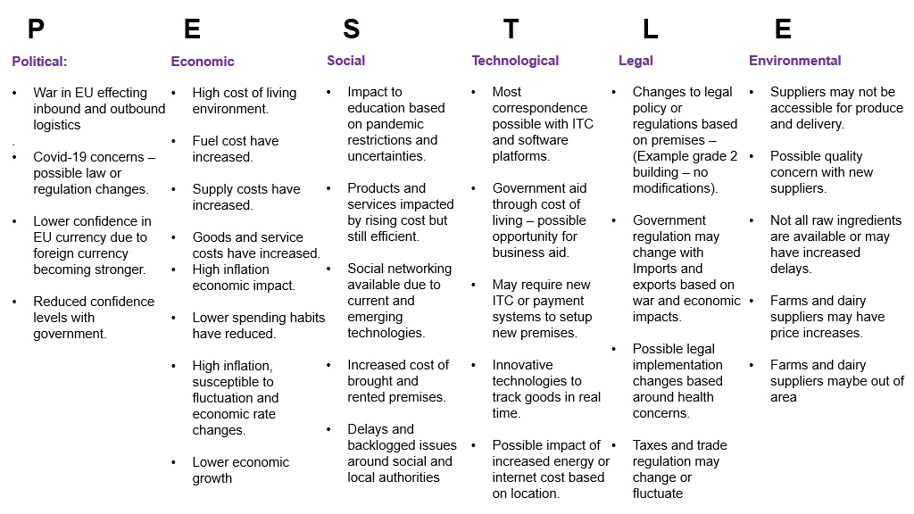
Pestle has given key areas to consider to help formulate a strategy but also highlighted areas of possible investment. Pestle has outlined concerns with political agendas and regulation and tax changes that can impact the new venture. There are also concerns regarding supply of raw produce and delivery locations due to new costings and unfamiliarity of locations. Pestle has given possible opportunity for new food delivery options to streamline the business into a more convenient fast food establishment with new vegan and fresh food establishments on an positive increase seen over the last 5 years with more access to delivery services such as, Just eat, Deliveroo etc. This opportunity would give Mr James a choice to invest in a small establishment to prepare food for delivery only via software applications such as the above, minimising spending on larger establishments with many employees, and dinning facilities and taking advantage of the easy-to-use mobile technologies and delivery services. This choice would split the business into two segments, one for dinning and the other for delivery, similar to a Chinese takeout. (Martin, 2007) states that strategic tools are helpful in providing many perspectives for the organisation and competitive analysis. The advantages of using PESTLE, is easy functionality and an understandable purpose of the analysis broken down into columns that provide many aspects of the macro environment and will aid in correct decision making. Now pestle has been reviewed there is another tool that will help in providing options of strategic planning for future events and possible uncertainties. Scenario analysis considers key aspects of the business to help with planning for future opportunities or uncertain events providing greater depth into the decision making process.

Scenario analysis
Data gathering.
- Delicious business is doing well and sustainable in current position.
- Capital is sustainable for 2 years for business expansion.
- No data on ideal locations for new establishment
- Require data on competition within chosen area.
- Require data on restaurant sales within chosen area.
- Confirm suppliers can commit to Mr James’s desired aspirations for business success.
Consider all historic business experience.
- Positive sales and good customer feedback regarding products and service. Loyal supply line with no issues or concerns. Logical choice for expansion.
Certainties:
- Delicious holds the capital with an option for expansion.
- Over 20 years’ experience within the food industry.
- Unique foods with positive customer feedback
- Excellent suppler in local area
Uncertainties:
- Do not hold data on competitors.
- No data on pricing, suppliers, locations
- No data on sales of SME within the same industry based in chosen location.
Best case scenario:
- Successful transition to new location with heavy footfall and dinning locations.
- Excellent customer interest in Unique foods on offer.
- Increased revenues and customer awareness
- Strong competitive advantage due to strong imitable products.
- Excellent supply lines and pricing
- Strong security in place
Base case scenario:
- Successful transition to location with unpredictable footfall or customer interest
- Other competitors offer the same or similar products at the same price mark.
- Steady business with no increase in sales but enough to maintain premises.
- Produce price increase due to new location.
- Supplier prices increase due to new location.
- Minimal security in place
Worst case scenario:
- Poor transition and setup of premises
- No customer awareness of new food establishment nor interest
- Outmatched by competitors either by quality, price, or uniqueness.
- Prices rises on premises to unsustainable levels if not meeting profit generation goals
- Very poor security in this location.
As (Whittington 2004), has highlighted that a more depth in the understanding of how new strategic tools have been developed, been tested and marketed and how these tools are to be utilised in practice.
SWOT analysis
This next part of the report is based around an internal environmental check. The SWOT can be used for both internal and external Strengths, Weaknesses, Opportunities and threats. The SWOT will be used to analyse core factors of delicious dinning business that include strategy, formulation, and evaluation and help with the decision-making process. SWOT will give MR James a visual reference of how the business is doing and help build on the strengths of the business, Mitigate, or minimise any weaknesses, highlight potential opportunities and show existing or impending threats. According to (Al‐Mubaraki and M. Busler, 2010), SWOT analysis is used to examine the internal and external aspects of an organisation’s strengths, weaknesses, opportunities, and dangers. (H. M. Al-Mubaraki, A. H. Muhammad, and M. Busler 2015), states that to overcome any perceived weaknesses, it is highly recommended to take advantage of external opportunities. Below is the SWOT analysis carried out on delicious restaurant that provides solid internal analysis that will aid Mr James to come to a decision on what type of strategy will be used and how the business could move forward with strategy implementation.

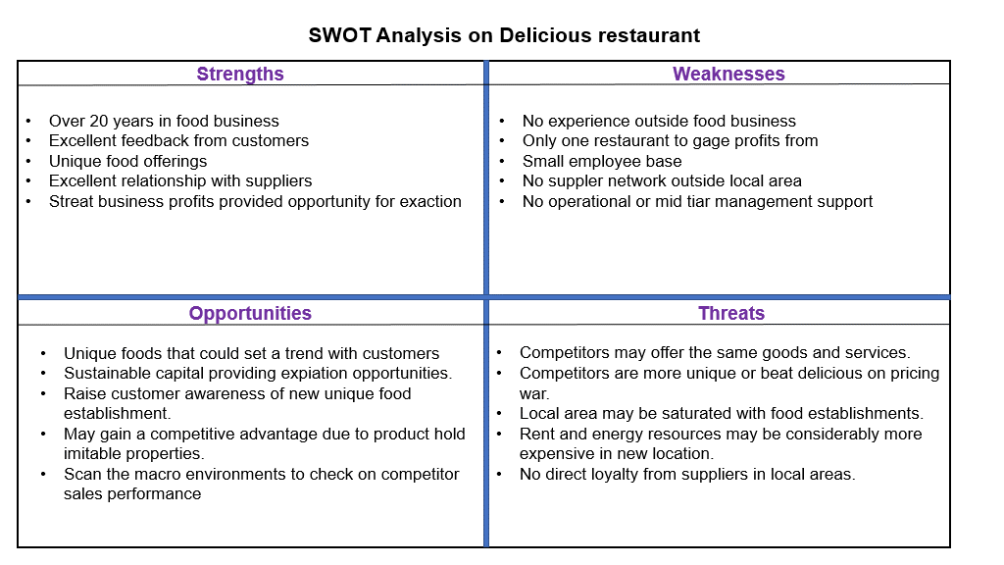
According to (Grant, 2003, Orndoff, 2002, Gray, 2007, Jarzabkowsji, 2004 and (Wilson and Jarzabkowski, 2004), Strategic tools are described as psychological tools of thinking that aid the strategist to generate meaning within their own complex surroundings.

The advantage of using SWOT it to provide a clear view of internal and external factors that help with decision making and risk to reward decision. To find the value of the delicious establishment, Value chain analysis can be used to measure primary and secondary functions.

INCOMPLETE assignment – requesting a rework please.

