ACBA4027_Skills for Professional Practise
Hayley Haughey
2412597
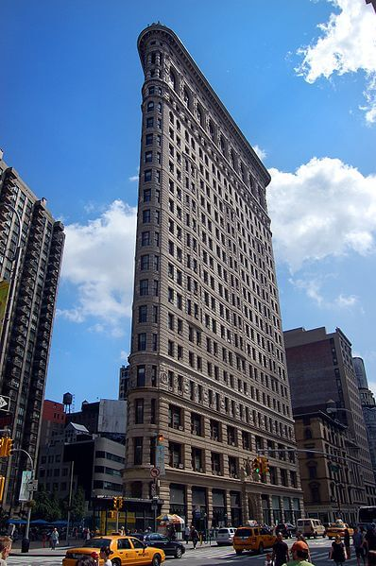
Portfolio
Table of Contents

Part 1 – page 2-7
Introduction:
Description of subject:
Design and Engineering:
Construction Process:
Conclusion

Part 2: page 7-13

Bibliography: page 14

Introduction
Subject Choice
The subject chosen for this report is the Fuller Building, more widely known as the Flatiron Building. Located on 175th Street, Manhattan, New York, it is regarded as one of the most significant skyscrapers on the planet.
Subject Relevance
There are a number of reasons why this building is held in such high regard, namely its innovative design, method of construction, and its subsequent and long-lasting cultural impact. As the brief for the report requires the subject to be ‘significant’, there could arguably be no more iconic a choice, due to the above-mentioned reasons.
Purpose of Report
The purpose of this report will be to delve into a variety of aspects regarding the Flatiron Building, such as providing detailed background information of the building itself, as well as information with regards to its key stakeholders.
The report will also present an analysis of the design of the building, as well as the materials, and any innovative construction methods that were employed. Any difficulties that hampered the construction timeline will also be explored.

The Flatiron Building: A Description
The Fuller Building (more popularly known as the Flatiron building) is found on 175th street in Manhattan, New York. Completed in 1902 in a city already rapidly becoming famous for its skyscrapers, it garnered much attention immediately on completion due to the fact that it was one of the tallest buildings in the city.
Although this was the case, the location also presented an aesthetic benefit, due to the fact that there was only one other skyscraper in that part of the city (The Metropolitan Life Insurance Company Tower) located roughly one block away. This meant that the Flatiron Building did not have to vie for visual attention with many other buildings.

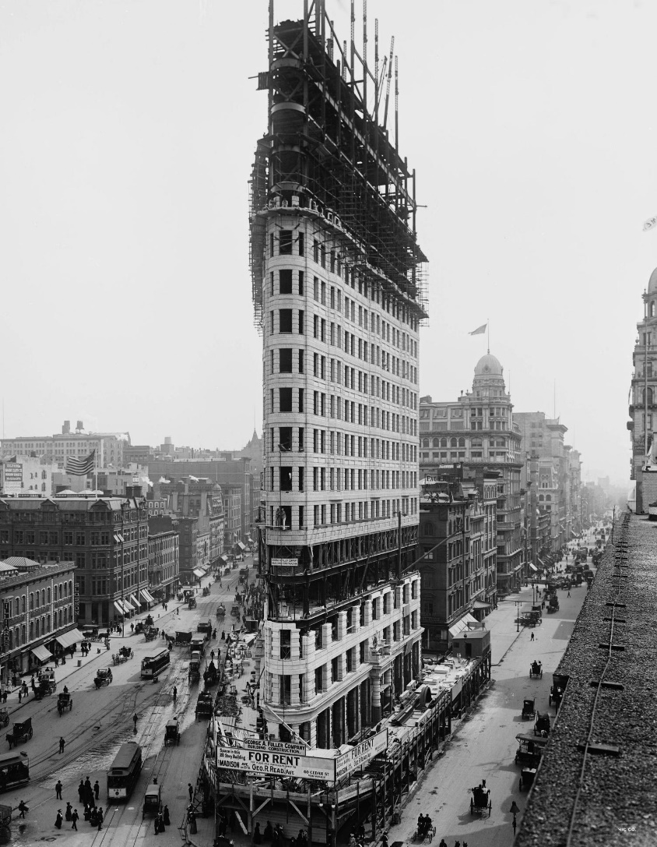

The Flatiron Building – photo taken in 1912

Design and Engineering:
The Flatiron building was designed by a Chicago-based architect called Daniel Burnham. What would set the look of this building apart from all others in the city would be the fact that a ‘steel skeleton’ structure would be employed in its construction, as opposed to a squatter, sturdier, masonry-based design. This meant that a tower could be designed to rise directly from street level, rather than from a block structure.
During the design process of the Flatiron Building there was much scepticism within the wider industry as to whether the nature of its general shape would be able to withstand wind loading. This is due to the fact that the surface area of the side and height of the building would be substantial when compared to its width. This scepticism with regards to the project reached such a degree that within certain circles it was jokingly referred to as ‘Burnhams Folly’,
The flatiron was designed to be 22 storeys tall, at a height of 93 metres. Although this wouldn’t make it the tallest building in the city, it would certainly make it the most striking to look at, due to the previously mentioned steel skeleton rising from the ground. What would also make it stand out from the rest of the city, would be how narrow the point or ‘prow’ of the building would be, measuring only 1.8 metres, and dictating an angle between these two faces of the building of only 25 degrees.
Although modern techniques were employed in the construction of the Flatiron Building, Burnham still wanted it to maintain a classic look, suggesting the great edifices of Ancient Rome and Greece. To this end, designed it to become more slender as it rises from base to summit, evoking the feeling of a column of antiquity.
As an architect, Burnham also took great interest in French and Italian architecture from the Renaissance period. With this influence in mind, he wished to hide the steel skeleton structure beneath a terracotta and limestone front, sporting a ‘Beaux Art’ design.

Construction Process
As mentioned, the ‘Steel Skeleton’ design was a fairly modern technique at the time of the construction of the Flatiron Building. There are many benefits to this method of construction when compared with a more standard, masonry block method of construction.
One such benefit is the fact that this skeleton type frame is far more durable in the face of adverse weather conditions such as high winds and earthquakes. This is due to the fact that the skeleton structure, whilst incredibly strong, also has a certain amount of ‘give’, enabling it to move with the elements rather than fight them, reducing the risk of a build up of energy and potential collapse/damage. A steel skeleton structure has an excellent weight/strength ration, meaning that though lightweight when compared to a masonry structure, the strength is still substantial.
One other benefit of the steel skeleton design is the speed with which it can be erected. The Flatiron building was notable for the speed of its construction. Although the foundations did take some time to be laid, once this was done, the structure was erected at a pace of one floor per week. Once this frame was erected, it took only four moths for the rest of the building to be completed. If a building of this size were to be constructed using predominantly masonry blocks instead of steel, the construction time-frame would have certainly ran into the years as opposed to months.
Another interesting aspect of the Flatiron building was the elevator system. This was powered using water. Although seen as cutting edge contemporarily, it did pose many problems. One of these was the fact that it took a very long time for the elevators to rise, needing ten minutes to ascend from the lobby to the 20th floor. Another issue was that the system was prone to flooding, forcing denizens of the building to make the long climb to their destination via the stairs when the elevators were out of service.
Although the majority of the building was constructed rapidly, it wasn’t until another four years later the an added 21st floor was completed. This floor was reserved for the elite and wealthy of society, containing penthouses, and was accessed by a second special elevator from the 20th floor.
Summary
There are two key points that can be gleaned from this report. One is the fact that modern/contemporary techniques can aid the construction process. If the tried and tested method of using a masonry block structure had been used to build the Flatiron building, it would have taken years longer to construct. It is also arguable that it may have been too dangerous to erect the building in this way. Due to its narrowness when compared with its height, it may have been dangerously susceptible to damage caused by strong winds.
Another point this report makes is that any novel technique or idea will often be met with scepticism. The fact that a building referred to as ‘Burnhams Folly’ is still standing strong over a century after its completion, and is now a world-renowned symbol of the city in which it was built, is more than testament to this.

Task 2
Introduction
In this task Microsoft Excel will be utilised to analyse a given data set. Excel will first be used to calculate the mean, mode, median, and range of chosen aspects of the data set.
Certain key findings in the data well then also be represented in the form of varied graphs, such as bar graphs, pie charts and histograms. From these findings, summary statistics will also be presented.

Mean function
Below are several images from the excel workbook capturing how program functions can be used to calculate the mean on a data set. Using formula AVERAGE(B4:B12) the result shows that the average number of total employees across construction firms in England in 1997 is 73.733
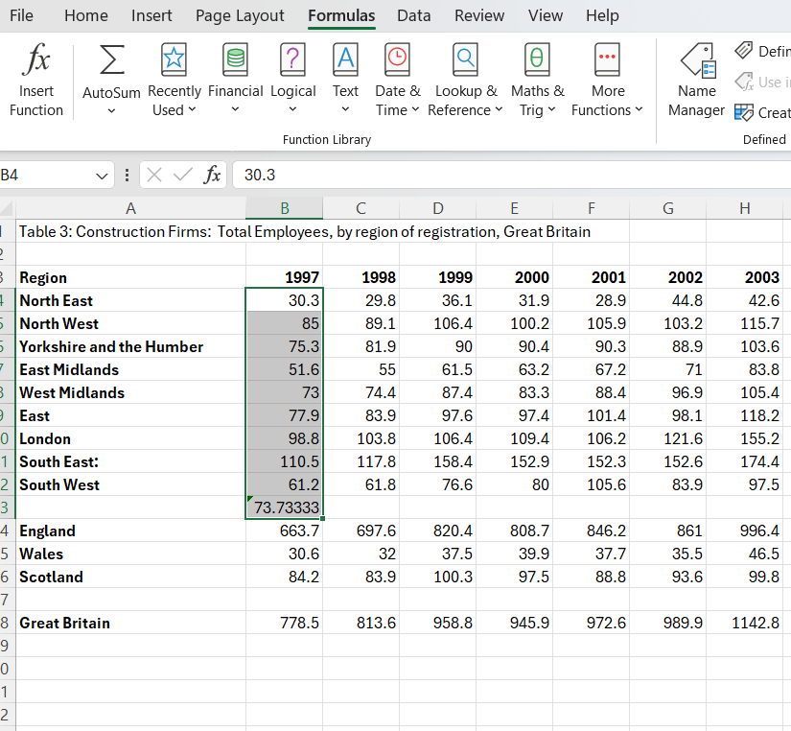
This finding becomes interesting when compared with the same calculation for the year 2022. Here we can see the mean number has risen to 139.5222 for that year
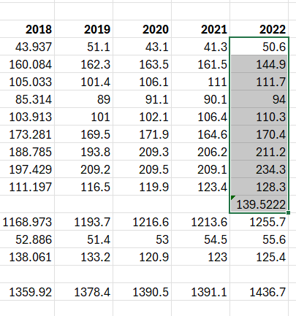

Mode function
Below is an image presenting mode calculations of chosen points from the given data set using MODE(NUMBER:)
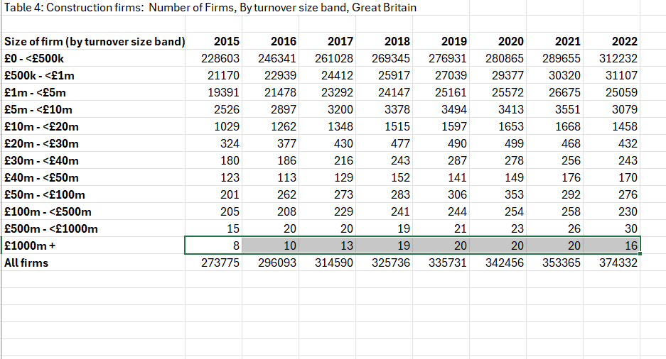

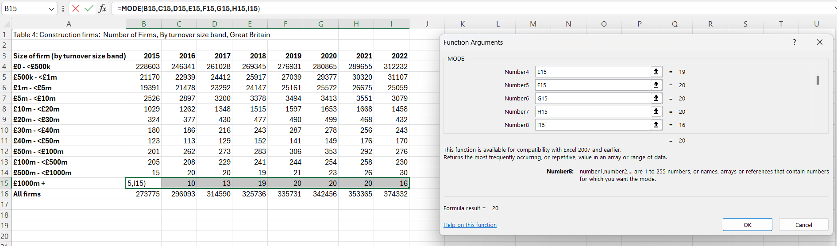

Using this function we can see that the most common value for number of firms over £1000 million between 2015 and 2022 is 20. By adding each number into the formula across each year, the most common value is calculated by Excel.
Median
The below image captures the use of the median function in excel. This will represent the middle point of the given data set. This is done by choosing the median function in excel and applying it to the chosen parameters.

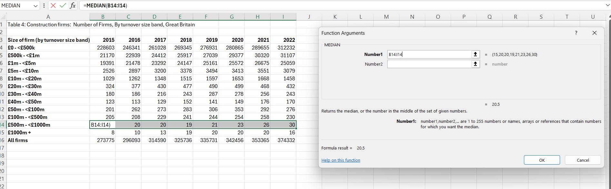
By inputting the Median function from B14 to I14 we can see that the median value for number of firms between £500million and £1000 million is 20.5 between 2015 and 2022.
Range
The range is calculated by subtracting the lowest value from the highest value in a chosen data set. Excel can be used to calculate this. The below image will show the range formula being applied. So in the case of calculating the range of values of number of firms generating a turnover >£1000 million between 2015 and 2022 the formula =MAX(B15:I15) – MIN(B15:I15) will need to be inputted
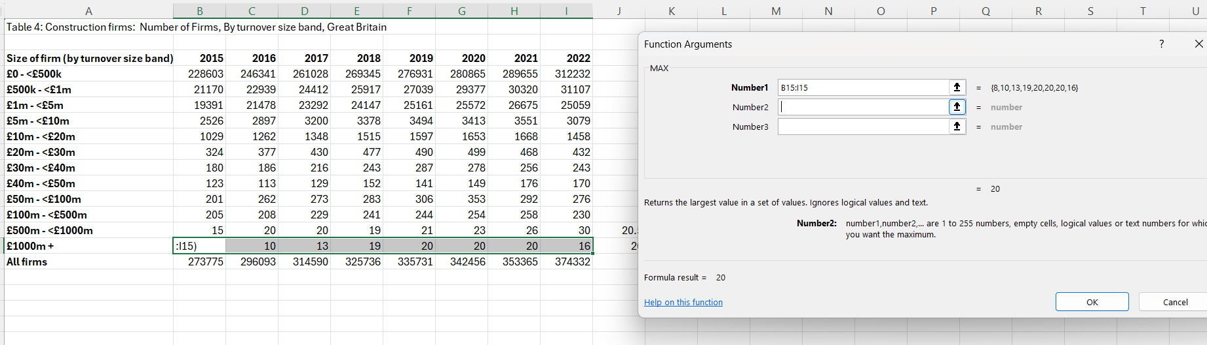
Above the maximum number of 20 has been calculated
With the minimum of 8 being calculated in the same way but using MIN instead of MAX the range can be calculated as 12.
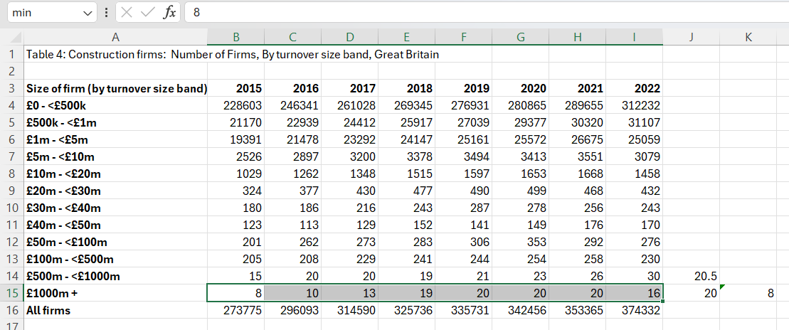

Standard Deviation
The standard deviation refers to the general deviation of values from the mean of the set. This can be calculated in excel by choosing the STDEV function and inputting it in the chosen data set. Here this was again done with business with a turnover of over £1000 million between 2015 and 2022. The result is 4.86 as shown in the image below.
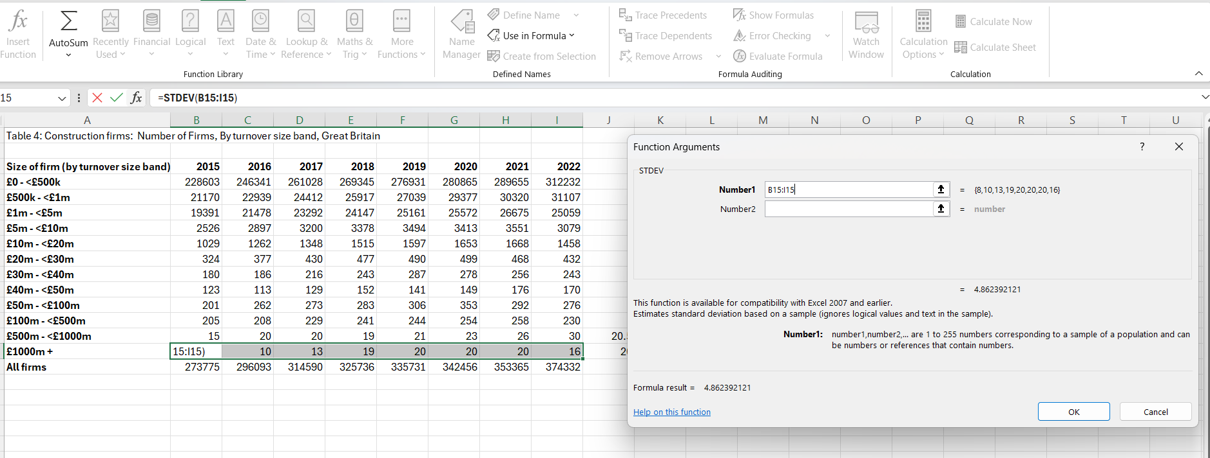

Graphs
Below are various graphs that having been created with Excel, using the given data set.

The above bar graph represents the number of employees in each region of England in 1997 on average. Different types of graph represent different data sets more effectively, depending on the data type.
Pie charts are another effective way of presenting data. The blow pie chart clearly illustrates how the vast majority of businesses in 2015 had a turnover of less than £500k

A line graph is another form of graph that is useful in showing how a variable may change through time, as demonstrated in the image below.

Bibliography

https://ephemeralnewyork.wordpress.com/tag/burnhams-folly/ - Article published in 2011, referring to author - Alice Alexiou – and her book ‘The Flatiron’

https://www.architecturaldigest.com/story/flatiron-building-everything-you-need-to-know#:~:text=The%20building's%20triangular%20shape%20is%20its%20most%20notable%20design%20feature.&text=Architect%20Daniel%20Burnham%20and%20his,recently%20embraced%20on%20other%20projects. – Rachel Davies – Architectural Digest Article – Published September 2024

https://www.designingbuildings.co.uk/wiki/Flatiron_Building - Dan Rigamonti - DesignBuildings Article – 2021

https://www.doublestonesteel.com/blog/architecture/the-flatiron-building-originally-the-fuller-building-designed-by-daniel-h-burnham-and-built-in-1902/ - John Desmond - article – 2016
https://www.newyork.co.uk/flatiron-building-in-new-york/ - 2011 – newyork.co.uk online article – Eric Waller

https://www.britannica.com/topic/Flatiron-Building - Britannica article - David Taylor - 2025

https://ephemeralnewyork.wordpress.com/tag/burnhams-folly/ - Article published in 2011, referring to author - Alice Alexiou – and her book ‘The Flatiron’
https://www.architecturaldigest.com/story/flatiron-building-everything-you-need-to-know#:~:text=The%20building's%20triangular%20shape%20is%20its%20most%20notable%20design%20feature.&text=Architect%20Daniel%20Burnham%20and%20his,recently%20embraced%20on%20other%20projects. – Rachel Davies – Architectural Digest Article – Published September 2024
https://www.designingbuildings.co.uk/wiki/Flatiron_Building - Dan Rigamonti - DesignBuildings Article - 2021
https://www.doublestonesteel.com/blog/architecture/the-flatiron-building-originally-the-fuller-building-designed-by-daniel-h-burnham-and-built-in-1902/ - John Desmond - article - 2016
https://www.newyork.co.uk/flatiron-building-in-new-york/ - 2011 – newyork.co.uk online article – Eric Waller
https://www.britannica.com/topic/Flatiron-Building - Britannica article - David Taylor - 2025

