Adam Yahya

The purpose of this report is to investigate the security risks that based on Dark Web/Deep Web

Dark Web/Deep Web
Research Proposal Report

Contents
Section 1 2
1.1 Introduction 2
1.2 Research Title 2
1.3 Background 2
1.4 Understanding the field 3
1.5 Industry / Organisation 3
1.6 Defining one overarching aim of the study 3
1.7 Expected outcomes 4
Section 2 4
2.1 Research and development Methods 4
2.2 Research Methodologies 8
2.3 Identifying Risks, Limitations, Ethical and Legal issues 10
2.4 Evaluation of the data 10
Section 3 11
3.1 Resources and Planning 11
3.2 Resources required 11
3.2 Conclusion 11
3.2 Contract of Gantt chart 12
3.3 References 13

Figure. 1 Comparison of Deep web and Visible web [8] 6
Figure. 2 outbound and inbound tunnel [15] 8
Figure. 3 Gantt chart project plan 12
Figure. 4 Gantt chat data in graph 12

Section 1

1.1 Introduction
This report discussion is based in the network security that going to be undertaken by the author which based on dark web/deep web for the major project for postgraduate degree portfolio. The purpose is to conduct research on previous studies in the field of dark web/deep web to understand what methods and techniques are used to attacks digital currencies during the exchange in the dark web/deep web. After understanding both methods then identify how the combination of dark web/deep web security implemented to allows do unlawful activities. Due to the most criminals use dark web/deep web to commit offenses by hiding their identity to be untraceable. This let the author to investigate on this particular subject for the research proposal to understand how criminals use these sites to do illegal things. In completion of this report, the author is aiming to understand more vigorously about dark web/deep web to allow conduct an experiments successfully.

1.2 Research Title
The project proposal report focussed on security risks based in the Dark Web/Deep Web for the university MSc degree portfolio in computer networks and security. The aim is to investigate the security risks in the dark web/deep web. The author aims to provide protection to DDoS attacks during a user in the dark web/deep web to secure privacy and services anonymously from hackers.

1.3 Background
Increase of internet users brought challenges to the network security experts to keep up with it to provide protection to the end users when connected to the internet. Most criminals use dark web to do damages to the organizations. The Dark Web is part of World Wide Web (WWW) and it’s only accessible through special software to keep website user identity stay anonymous. Dark web is representing part of internet which hosted on hidden servers whereas, deep web is not indexed by search engines such as google and yahoo. The dark web sites are look same as other sites during the illegal activities. The only different of dark web site is that, it ends with onion whereas, others end with .co or .com. This because it is a top level of domain which used to keep services and user data anonymous. The Dark Web is hidden part of internet security which used to protect the privacy of internet users when they are in the site. It is basically, prevent user traffics to be analysed by attackers. Who use dark web/deep web? It is used to facilitate the most of drug smugglers, terrorist organizations, money laundering, gun trafficking, human trafficking and any other illegal activities. Dark web is also known as darknet or deep web [1].

[1] Deep web is part of hidden web that, use technology in more complex to hide confidential information from unauthorized accesses. However, there are various types of information cannot be accessed by using a web browser in general or hyperlinks, because it is not indexed which means search engine cannot identify or find it. However, criminals use special software tools to allow hackers to gain access into unauthorized information without the knowledge of a user. According to the study findings, “deep web is usually referring to resources and data that are available on the internet” [1]. When it comes to categories, the dark web is the third. First is Surface web which allows everything can be found through google search, second is the deep web which is portion of the internet that hidden from conversional search web and it contains such as medical records, government resources, legal documents, scientific reports, subscription information and academic information. The third is dark web and it’s intentionally hidden from search web and only can be accessed through special software.

1.4 Understanding the field
The author’s main target of this project is to conduct research on previous studies to understand how criminals use dark web/deep web to do illegal activities. To provide security or recommendations to protect end user data, various methods and techniques used by criminals must be identified to allow provide some solutions for future improvements. Offenders use available data on the internet to do damages to confidential information. It is difficult to catch them because their IP addresses are hidden from being reachable by the support of special software tools in the dark web/deep web. This challenges the network experts to protect end user data from hackers. The author is going to use combination of physical and logical components to analysis traffics that going through network applications between the devices. Physical is referring to such as computers, laptops, firewall and etc, whereas, logical is refers to special software such as intrusion prevention system, security software tools and its techniques.

1.5 Industry / Organisation
Due to the significant use of dark web/dep web to do illegal activities by criminals such as drugs dealing child pornography by using available data on the internet. With the request of Tevel Cyber Corps Private Limited company to do an investigation on how the cryptocurrency mined using available computing capacity in the dark web/deep web by Distributed Network Attack (DNA). Due to the significant DDoS attack on digital currencies, network security experts aiming identify how criminals use available computing capacity in the dark web to do damages.

Defining one overarching aim of the study
The purpose of this research proposal is to understand how Distributed Digital of Service (DDoS) attacks to cryptocurrency by using available computing capacity in the dark web/deep web. In order to provide protection to the internet user’s data from unauthorized access when connected to the internet, it requires intensive understanding of dark web/deep web. The author will investigate the previous and current network security methods and techniques to achieve targets. Previous methods will strengthen the knowledge of the author to provide recommendations for future improvement to protect confidential data from being lost by criminals. This is by outlining recommendations for end users to reduce the risks of losing their confidential.

1.7 Expected outcomes
The author aims to conduct an experiments to complete successfully to achieve targets. This is by identifying, how criminals use dark web/deep web to do illegal activities and how digital currencies use available computing capacity in the dark we/deep web. Distributed Digital of Service (DDoS) attacks take place based on these methods to attack networks. This let the author to investigate DDoS attacks while a user in the dark we/deep web to provide solutions to protect end user data from their confidential data being compromised by hackers. In addition, the author should provide detailed report on what is dark web/deep web, how criminals hide their identity and what solutions out there to secure from these vulnerabilities, threads and provide recommendations for future improvements.

Section 2

2.1 Research and development Methods
In this part, an investigation of dark web/deep web will be conducted regarding past researchers to understand how illegal activities take place to make it easy to carry out analysis [2]. Specially, when it comes to DDoS attack hackers/criminals use dark web to infect communication of transactions between source and destination to do damages to end user confidential information. Based on previous study findings, the author aims to learn some special software tools with its techniques to identify how criminals are using these methods to do illegal activities in the dark web/deep web. According to the report, “internet can only be accessed through specialized dark web browsers or technologies”[3]. The dark web users can only access resources and contents through particular protocols and network, so that the users cannot be identified or traced back. Most dark web users use The Onion Router (TOR) network to hide their activities from being identified or traced. This because the Tor network provides anonymity by routing traffic when other users use specialized web browser it shows them as nodes. The TOR network use these methods to hide a dark web user from being traced. This provides “certain secrecy and anonymity by passing messages and requests through network of connected Tor relays” [4]. This has special configured computers which is encrypted in a way that each relay only knows the machine sent the message and machine that going to send to [4].
Nowadays, cryptocurrency use dark web to do trade of exchanging. Use of algorithm to allow virtual currencies to evade detection based on block chain technology. Today’s Distributed Digital of Service (DDoS) attack based on this concept by using unused computing capacity and this need to take into consideration seriously. Dark web is representing encrypted part of the internet which hosted on hidden servers in comparison with deep web. Deep web services cannot be indexed through traditional search engines such as Facebook and google [4].

Dark web is collection of websites and it is publicly visible. They are purposely hidden and cannot be accesses via standard web browsers at all. However, it hides the servers IP addresses that run through it [5]. Dark web sites are hard to be identified when the users visited them such as who and where they are hosted [5]. Many dark web users use the site to do unlawful activities. Even highly profiled govern bodies use this site to do forged such as documents online, working with drug dealers and money laundering to make money as long as their identity is hidden and not traceable. According to the research study findings, “the practical security solutions have focused on protecting endpoint devices such as desktop, laptop, tablets, point of sale terminals, bar-code readers, and smartphones form attack when connected to the internet and other networks” [6]. This means that, the author thinks its network security expert’s responsibility to educate end users to behave in accordance with principles of policies and procedures that provided by security experts to reduce the risks from being hacked easily when connected to the internet. With that being said, it is user responsibility to keep their password and username secure from other in case of someone impersonalize them. Whereas, security managements are responsible for making sure maintaining such as antivirus software, applications, device managements, intrusion detection and prevention systems, network access control, encryption level and any other network sources to protect end user privacy [6].

This section discussion is based on procedures of dark web used to hide privacy and anonymity of those who willing to do unlawful things on black markets. The analysis of dark web requires automated system to perform it. This because, manual will take a lot of time and it will not be efficient due to the large number of availability in the vulnerable forums [7]. In order to stay secure from hackers when browsing dark web sites, it is important to use Virtual Private network (VPN) through TOR browser. The way the transactions of illegal underground procedures works in the dark web between the source and destination is, it consist of five steps which are [4].
- Advertisement
- Discovery
- Negotiation
- Payment
- And fulfilment
These procedures are used to maintain the service of illegal activities on dark web/deep web. The advertisement is advertising the products by using different approaches from promoting legal products or services by the surface web [4]. Surface web does not index content on the dark web unless dark web is created for sales then this information must be registered [4]. Discovery is when buyers use similar methods of approaches to discover suppliers that selling illegal products on dark web search engines. Negotiation is used to proceed transaction with a seller according to the type of product to complete the deal in order to be send to a buyer. Payment is on dark web has two options depending on the existence of third party [4]. The third party will mediate the payment between seller and buyer. It basically, make agreements with both parties to receive from seller and send to a buyer. Finally, the fulfilment is step of seller used to send physical product according to the agreed delivery method which through e-commerce services of the dark web. All the transactions carried out with bitcoin.
Significant number of internet users do not aware of criminal activities. The dark web is part of deep web. According to the study findings, “ninety sex percent of web is considered as a deep web this because it is hidden” [8]. This means that, four percent of internet is used by internet users. Figure. 1 shows comparison of deep web and visible web. This figure shows part of internet used which is only 4% whereas, unused 96%. Internet users cannot imagine that four percent of internet only used despite the significant increase of Internet of Things (IoT) on daily basis [8].
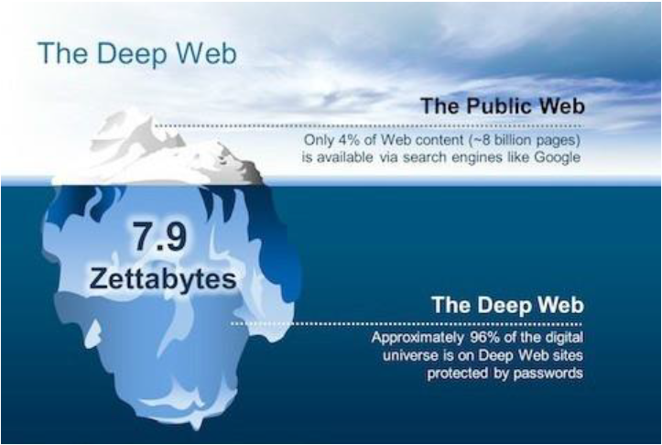
Figure. 1 Comparison of Deep web and Visible web [8]
- Distributed Digital of Service Attacks
The focus of this section is to identify, how Distributed Digital of Service (DDoS) attacks impact cryptocurrency exchange markets through dark web/deep web during digital exchange process. Significant increase of global crypto-currency markets which brought challenge to the security experts to protect digital currencies. According to research findings, “markets has increased from $19 billion in the beginning of 2017 to $602 billion by the end of 2017” [9]. The network security experts aim is to put measures in place to perform an event analysis to evaluate to see whether the DDoS attacks impact the volume of exchange during the trade. In the recent years DDoS has infect large number or internet user’s data through dark web/deep web to collect confidential information. This brought more challenge to the network security engineers to secure end user data from outsiders. The purpose is to find out what change has been made during the transactions between the source and destination. This is all about evaluation of DDoS attacks on cryptocurrency exchange. Without knowing how attacks gain access to the network, as a security expert cannot provide protection to a user or a network. Security experts works with computer system to ensure high level of security and privacy maintained. The attacks brought challenges to the network security experts, due to the complexity of software and multiplicity of layers [10].

Previous study findings said that, one serious problem which still remain unsolved which is cloud forensic problem. This is the barrier to achieving robust level of security and privacy for any organization [10]. Most DDoS attack perpetrated through surveillance cameras to compromise a system. Most researchers said that, the attacks come from infected machines or systems of end users. This because, when infected users access in the dark web then hackers find a way to sneak through that root to do damages. This means that, it is very important to secure end devices first. Securing devices could be form of educating users to be aware of danger when connected to the internet. The security expert’s responsibilities to ensure security mechanisms implemented on the network to alerts any unusual activities to provide protection before do intensive damages. According to the previous study findings, “spidering programs are developed to collect the web pages from online forums that contain jihadist related content identified by domain experts” [11]. The aim of spidering is to gather relevant information to see if the post is new or updated, if updated when and to ensure keep the data more efficient [11].
Developers also use a framework to analysis threats in the dark web. In order to gain access to dark web, specialized tools required such as The Onion Router (TOR). TOR is special software that allows accessing the web anonymously. It enable users to access to anonymous web server and other services [1]. In addition, Freenet and Invisible Internet Project (I2P) also are the popular methods that used to gain access to dark web through TOR software tool. Freenet is self-continued network and it cannot allow to connect to the services such as google. Freenet has life-sharing, websites, chat which are all hosted within the Freenet and it’s anonymous. It is only allowing access to content that uploaded to Freenet.

- The Onion Router (TOR)
Due to the TOR network is used in almost every past researcher’s papers in the dark web to keep anonymity of a user data. This let the author to investigate more about TOR to understand the methods and techniques that used to protect a user data in the dark web. A network security experts are responsible for providing policies and procedures to secure end users data from being hacked due to the vulnerabilities that could have already been infected a user device or a system and then when a user access dark web sites it will be easy to be hacked. The TOR network come in place to keep privacy of a user anonymously by connection to the internet through Virtual Private Network (VPN). The TOR use various principles behind its communication between users and servers through multiple routers with encrypted communications to hide identity [1]. The way the TOR framework works is that, it uses two different encryption key between any two user communications therefore there is no one can able to trace the real identity of a user or a server. This method allows anonymity of web serving to be guaranteed [1]. Dark web is relay on TOR protocol accessible via the TOR browser.

- Freenet
Freenet is self-continued network and it cannot allow to connect to the services such as google. Freenet has life-sharing, websites, chat which are all hosted within the Freenet and it’s anonymous. It is only allowing access to content that uploaded to Freenet. This paper is discussing about tracing back an attack that happened [12]. The Freenet support two operational modes which are Dark-net and Open-net. In dark-net only trusted friends can get connected to each other whereas, in Open-net anyone can get connected to Freenet [12]. The process of trace back on Freenet has two important components. Connecting an attack node to a suspect node in Freenet and querying a neighbour to determine if the content request message with particular Unique ID (UID) value [12]. An effective method has been developed to carry out this task. In Freenet, each node has pre-specified maximum number of neighbours in default to announce when a message arrives at the node. If node does not have enough neighbours yet, then requesting node will automatically accept as new a neighbour, if not then node will check a key condition to determine if an existing neighbour can be replaced by the requesting node [12]. The query component is used to determine if a neighbour has seen a message with particular UID associated with request message that the node has not finished processing form reply has not come back and a queue of UID associated with request messages that the node has finished processing form reply has come back. The purpose is all about determining if a neighbour has seen a content request message with same UID value then it send a request message with same UID value, if not then message should not be forwarded any further by the neighbour. The author chooses these two papers of Freenet, because its method techniques could be used to conduct experiments for major project to achieve targets.
- Invisible Internet Project (I2P)
The I2P is designed to keep anonymity when accessing resources that within the I2P network [13]. It is services are not limited to browsing. I2P communication between the source and destination data knowledge build during the inbound and outbound tunnels [13]. Figure. 2 shows an example of I2P outbound and inbound message tunnelling. This particular paper is used to provide details of crawler/spiders software that has been developed to collect dark web/deep web contents that identified by domain experts. This related to the author project, because it provides details of allowing to access to the password protected sites. According to the report, “spiders are provided with adequate training to fetch all dpf, word files, HTML, PHP, CGI, links, images, ASP files, videos and audios in a web site” [14]. The spider is developed to collect postings from a particular forum when the contents are related to a specific domain which identified by experts. “Spidering is software programs that traverse the World Wide Web information space by following hypertext links and retrieving web documents by standard HTTP protocol “ [11]. It main purpose is to provide accessibility, collection type, content richness, URL ordering features, URL ordering techniques, and collection update procedure of spider programs [11]. This method might be used during the experimentation of this project.
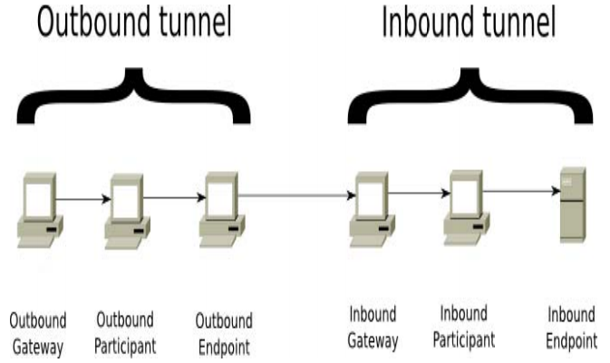
Figure. 2 outbound and inbound tunnel [15]

2.2 Research Methodologies
- Research philosophy
This research philosophy is used to investigate information based on dark web from previous study findings to gain knowledge to protect user’s privacy when a user connected to the internet in the dark web. This based on both passivism and realism. The positivism is used to measure security mechanism gained through previous studies such as quantitative but also could be used for qualitative. Whereas, realism is used to ensure chosen methods are fits to the subject matter. This can be testing a software that developed to gather information from a website or any other relevant data that need to be gathered during the experiments.

- Research Approaches
The author will use both inductive and deductive approaches to complete the proposed project. Inductive method is used to allow the author to measure security issues on a network to see if there is links between particular theories. Whereas, deductive method is used to analyse the research findings to ensure the process of experiments maintained as effectively as possible.

- Research Strategy
The research strategy is used to help to choose different methods during experiment process. The author is going use combination of hardware and software to complete security experiment based on dark web. Investigation of past researchers to identify the relevant of this topic to ensure provide details of positive and negative of using dark web/deep web. After that, the author should have provided solutions and recommendations for future improvements to keep user anonymity when a user in the dark web/deep web.

- Data collection methods
The data will be collected through special software that identified throughout the research on the proposed field. In term of hardware, there will be computers/laptops used to allow conduct experiment to identify security risks when a user in the dark web/deep web. On the other hand, how network security experts put measurement in place such as encryption and password to keep integrity and confidentiality of end user’s data. The main point is that, how end user data secure before even a user connect to the internet which is the important part that must take into consideration seriously. When a user device or system is secure, it’s protected by being hacked easily and if even hacked it would not be infected as those whom do not have any method of protections.

- Reliability and validity
Its significantly important to ensure the reliability and validity of the data maintain as effectively as possible. When it comes to data quality, software components and applications must be up to date to maintain the operations within a reasonable time to provide the services to the users as efficiently. Keeping up to date software is method of preventing a network from being severely damaged by hackers, unauthorized access and any other vulnerabilities.

- Security solutions
To secure a user confidential information while a user in the dark web, it requires number of methods and techniques to allow protect it. Firstly, ensure end devices keep up to date with latest one’s software to prevent any suspicious activities. In addition, determining the structure of the dark web marketplace also one the method that enable the author to provide security to the network.
- Implement firewall to defend vulnerabilities as it is the backbone of the network.
- Enable authentication to deter unauthorised access into a system / a computer or reduce possible threats.
- Intrusion detection/prevention systems
- Use Virtual Private network (VPN) to maintain one-to-one communication

2.3 Identifying Risks, Limitations, Ethical and Legal issues
- Security Risks
There are number of risks involved in the dark web. This can lead to some of the most dangerous cyberattacks propagate in the dark web to do damages to organizations, personal information, credential exchange, phishing attack coordination, trade secrets and sensitive assets. This let the author to use security risks as requirements to be aware of risks that could occur during this project. This includes, such as damages to university computers, system, sensitive data or any other risks will be handled carefully.

- Limitations
The limitations in dark web is that how could a developer develop a system to have ability protect a user data when a user on site while criminals are doing unlawful activities. There could be limited software tools to allow conduct the project with success. The author aims to use simple way to progress then build into complex to provide recommendations for future improvement. In addition, the author might not get enough time to provide more complex system that allows to finish the project proposal report with success to meet the user’s requirements to achieve targets.

- Ethical and Legal Issues
The ethical issue is foundation of securing a system in an organization. This is professional standard that involved to ensure a user privacy stay anonymous. Use of it is to educate the users to be aware or prevent from a system being misused as well as reduce system abuse from internal users. The ethical issues are put in place to keep the privacy of data confidentiality, integrity and availability. It is methods techniques of keeping private and sensitive from unauthorized accesses.

Whereas, legal issue is method of ensuring the accuracy and privacy of a data maintained at all time. This means that, its procedures which used to maintain the access control, individual authentication and monitors any suspicious activities to make sure all users stay within that particular network policies. Legal issue also method of identifying group members to ensure such as who access to specific documents, read/write, delete or do modifications. These methods of techniques must be mentioned in legal issues to maintain the privacy of data within the network.
In addition, the author use PG2-E1-Ethics application for ethical approval for UWTSD to minimise risk of harm and create environment to conduct ethically to complete this project.

2.4 Evaluation of the data
Overall, security issues facing digital currencies are increasing on daily basis in the dark web. Use of dark web has advantages and disadvantages. The advantages are that, there are special tools used to keep a user data anonymity, allow buy cheap item from a site and use Virtual Private Network (VPN) to hide the identity from being traced back. The disadvantages are, criminals use site to do damages to a user privacy, illegal activities, require special software tools to gain access into the site, there is no specific law to protect a user, requires internet connectivity and VPN to allow access in the dark web. Based on research findings, the author would educate users to keep the integrity of end user data when a user in the dark web site. In completion of this research proposal project, the author aims to achieve targets.

Section 3

3.1 Resources and Planning
All resources and planning for the research proposal will be provided on this section. There are various methods techniques would be used to complete research proposal. Combination of hardware and software to complete proposed project. Some of resources are mentioned below bullet points. There could be more added to the listed below to allow complete the project experiment to provide protection to end user privacy and confidential information.

3.2 Resources required
In term of hardware, the author might use some of the listed below bullets points to help to complete the proposed project.
- Routers
- Computers
- Switches
- Laptops
- Physical Books

In term of software, there are various software would be used to conduct proposed experiments for this project. The author provides some of software that would be used to help to provide success in completion of it.

- Online sources such as electronic books, journals, IEEE
- Microsoft word
- Virtual Machine/ Kali Linux
- Internet connectivity
- Virtual private Network (VPN)
- Network security software tools
- Tor browser
- Freenet
- I2P

3.2 Conclusion
In conclusion, there is advantage of using dark web/deep web is to hide a user identity when in the dark web sites. This prevent a user from being tracked by hackers because any two routers have different encryption key during the process in the dark web. This encryption key is used to allow even the router can know from receiver and need to send to it only. During the process, many routers are used in order to make it untraceable and keep a user confidential data anonymous. However, the disadvantage of using dark web is that enables criminals to do illegal activities to damages by taking advantage of keeping their identity from being untraceable. In completion of this project, the author aims to identify some network security risks within the dark web/deep web to provide some recommendations for future improvement.

3.2 Contract of Gantt chart
This section provides the details of project plan to ensure the author complete on time with success. Figure. 3 shows project plans task name, duration, start and finish time and resources names.
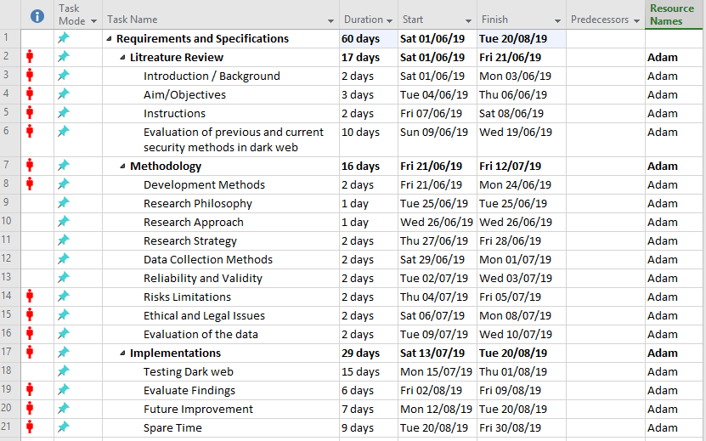
Figure. 3 Gantt chart project plan
Figure. 4 shows figure. 3 data into graph. This also shows in red which is the spare time which are nine days so that if anything goes wrong then use these to complete the project.
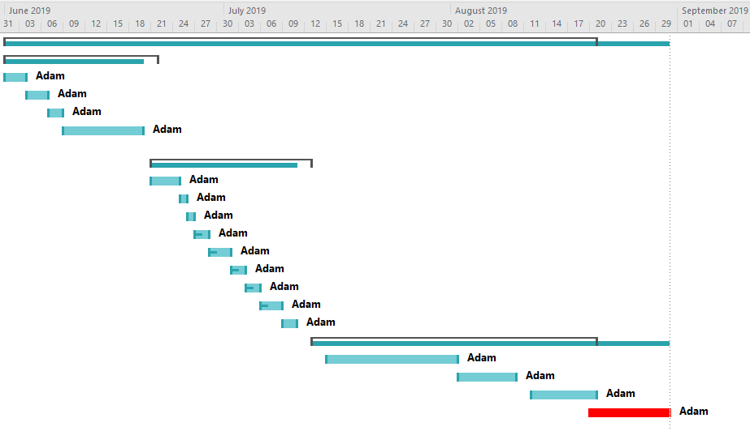
Figure. 4 Gantt chat data in graph

3.3 References
References
[1] X. Zhang and K. Chow, “A Framework for Dark Web Threat Intelligence Analysis,” Int. J. Digit. Crime Forensics, vol. 10, no. 4, pp. 108–117, 2018.
[2] M. F. Bin Rafiuddin, H. Minhas, and P. S. Dhubb, “A dark web story in-depth research and study conducted on the dark web based on forensic computing and security in Malaysia,” IEEE Int. Conf. Power, Control. Signals Instrum. Eng. ICPCSI 2017, pp. 3049–3055, 2018.
[3] A. T. Zulkarnine, R. Frank, B. Monk, J. Mitchell, and G. Davies, “Surfacing collaborated networks in dark web to find illicit and criminal content,” IEEE Int. Conf. Intell. Secur. Informatics Cybersecurity Big Data, ISI 2016, pp. 109–114, 2016.
[4] S. Lee, Y. Kim, and Y. Kim, “Cybercriminal Minds : An investigative study of cryptocurrency abuses in the Dark Web,” Netw. Distrib. Syst. Secur. Symp., no. February, 2019.
[5] A. Baravalle, M. S. Lopez, and S. W. Lee, “Mining the Dark Web: Drugs and Fake Ids,” IEEE Int. Conf. Data Min. Work. ICDMW, pp. 350–356, 2017.
[6] G. Hurlburt, “Shining Light on the Dark Web,” Computer (Long. Beach. Calif)., vol. 50, no. 4, pp. 100–105, 2017.
[7] A. Sachan, “Countering terrorism through dark web analysis,” 2012 3rd Int. Conf. Comput. Commun. Netw. Technol. ICCCNT 2012, no. July, pp. 1–5, 2012.
[8] H. Alnabulsi and R. Islam, “Identification of illegal forum activities inside the dark net,” Proc. - Int. Conf. Mach. Learn. Data Eng. iCMLDE 2018, pp. 30–34, 2019.
[9] A. Abhishta, “Impact of Successful DDoS Attacks on a Major Crypto-currency Exchange,” 2019 27th Euromicro Int. Conf. Parallel, Distrib. Network-Based Process., pp. 379–384, 2019.
[10] Y. Zhao and B. Duncan, “The impact of crypto-currency risks on the use of blockchain for cloud security and privacy,” Proc. - 2018 Int. Conf. High Perform. Comput. Simulation, HPCS 2018, pp. 677–684, 2018.
[11] Y. Zhang et al., “Developing a Dark Web collection and infrastructure for computational and social sciences,” ISI 2010 - 2010 IEEE Int. Conf. Intell. Secur. Informatics Public Saf. Secur., vol. 978, pp. 59–64, 2010.
[12] G. Tian, Z. Duan, T. Baumeister, and Y. Dong, “A traceback attack on freenet,” IEEE Trans. Dependable Secur. Comput., vol. 14, no. 3, pp. 294–307, 2017.
[13] K. Shahbar and A. N. Zincir-Heywood, “Effects of shared bandwidth on anonymity of the I2P network users,” Proc. - 2017 IEEE Symp. Secur. Priv. Work. SPW 2017, vol. 2017-Decem, pp. 235–240, 2017.
[14] B. A. Abduljalil, “Critical Analysis of the Emerging Dark Web,” no. April, 2017.
[15] A. Ali et al., “TOR vs I2P: A comparative study,” Proc. IEEE Int. Conf. Ind. Technol., vol. 2016-May, pp. 1748–1751, 2016.

