Tour Guide Application Development
Software Engineering Principles
Jonathan Evans
P151713

24/4/18

Collaborators:
Robbie McIntyre, Naomi Jones
Contents
1. Introduction 2
2. Stakeholders 3
3. Team structure 4
4. Functional and non-functional requirements 5
5. Use cases 6
6. First iteration requirements 10
7. 2nd Iteration plan 11
8. Legislation, ethical issues, sustainability issues 12
9. Design 14
9.1 Static Design 15
9.1.1 Class Diagram 15
9.1.2 Collaboration and Responsibilities Diagrams 16
9.2 Dynamic Design 19
9.2.1 Sequence Diagrams 19
9.3 User Interface Designs 21
10. Testing 25
11. Version Control 26
12. Contributions & Teamwork Discussion 27
13. Requirements matrix 28
14. References 29
15. Glossary 30
16. Appendices 31

Introduction
The aim of this project is to create a tour guide application for mobile phones. The process of creating the first iteration will be carried out with a team. The following sections will document the process along with documents that have been produced during the process.

Stakeholders
This section will outline the stakeholders of the project. All of which will be categorised as clients, developers, organisations, and communities. This list was created collectively with the team.
- Client
  - Gordan Dickers
  - Andrew Baker
- Organisations
  - Organisers of tourist attractions (museums, historic monument walks, and other attractions)
  - University
- Developers
  - Myself (Jonathan)
  - Robbie
  - Naomi
- Communities
  - Tourists

Team structure
This section will show the team structure along with our responsibilities.
Developers:
- Jonathan
- Robbie
- Naomi
Responsibilities
In our group, work was divided amongst us at every stage where possible – such as splitting up a list of use cases to create more in-depth ones. Where this was not possible, we collaborated using the same computer – this would consist of tasks such as coming up with a class diagram together (as this is something that may be hard to split up).
The group itself had no leader, as a result, we would all have to trust that each of us would deliver a given piece of work before the next meeting was arranged.
The collaboration process mostly consisted of us having a meeting, deciding what we needed to, dividing the work-load, and recording the minutes. At the following meeting, we would present our work and repeat this process until we have created all the work shown in this document.

Colour codes
Font colours and coloured borders will be used with the following key to illustrate who is responsible for what:
Purple | Blue | Red | Black
Jonathan | Robbie | Naomi | Anything in black means that we have worked on it collectively on one computer. This was done by collectively coming to a consensus on decisions that have been made.  This is only done on tasks that are hard to divide, such as class diagrams (as this was a task that is hard to fragment as we all need to know what we are all planning to add to our classes and how they will relate).

Functional and non-functional requirements
At this stage, we all collaborated on a document that details what we thought should be included in the system, and what should not be included. This information was collectively agreed upon at one of our meetings.
System Requirements
MUST
- Allow a staff user to input information about a location
  - Basic layout of the location (Floor plan of a museum/cathedral, etc.)
  - Identify and catalogue places of interest within a location
    - Artefacts/items of interest
    - Specific parts of the location, e.g. room, part of a building
- Allow a staff user to create an ideal tour route
  - Create a suggested order of seeing points of interest
- Have an intuitive user interface
  - Be accessible for visitors with visual/auditory disabilities
  - Have at least three buttons
    - Begin audio
    - Further descriptions
    - Move on
    - Query, scan item button?

SHOULD
- Select the correct visitor information for a location from GPS data
- Be able to work on many different systems
  - e.g. Windows tablets/phones, apple products, android devices
- Allow a visitor to access information about an artefact or place of interest by scanning a QR code or similar.
  - Implement an augmented reality overlay
- Allow an option to enforce headphones only for audio playback at certain locations

COULD
- Generate a suggested route based on a location layout and points of interest.
- Have an “Offline location” feature where a visitor can pre-download information about more rural locations that may not have internet access.

WON’T
- Cater for very young children
- Using near field communications instead of using barcodes

Use cases
This section will show the use cases that we have come up with.
From our meetings, we have decided on three primary use cases for this application – Adding the location of an item, scanning the point of interest, adding/updating a template. The picture below will show the use case diagram for this.
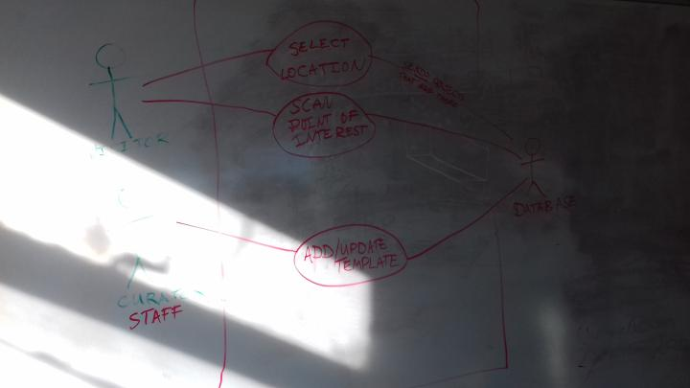
The above diagram shows three actors – a visitor, curator, and a database. It also shows how they will interact with the system. From this, three use cases have been created.
These use cases are described in more detail below. We have decided to take one use-case each and create a more detailed definition of it.
Jonathan (Myself)’s use-case (in-depth)
Use case: | Selecting a location
Context: | A user’s location is transmitted to the mobile application using GPS
Scope: | - User & Curator
Preconditions: | - User has:  - A smartphone with a working camera  - Downloaded the application  - Already scanned a QR code and has begun their tour
On Success: | The application will detect the user’s location and display information relevant to the site they are at.
On Failure: | The application will prompt the user that their location cannot be found.
Actors: | Primary:  - User, curator, and mobile application  Secondary:  - Tour institution - museum, etc  - Mobile ecosystem - Devices, operating systems, app stores  - Location services – GPS
Trigger: | Application detects user location through GPS
Description | Step | Action
 | #1 | Mobile application detects GPS coordinates are within the radius of a point of interest
 | #2 | Information pertaining to the point of interested is retrieved from the back end database – Narration (Both subtitles and audio), AR (Augmented Reality) sequences, etc.
 | #3 | Information is presented to the user accordingly
Extensions | Step | Branching action | Proposed solution
 | #2.1 | No information available as a result of neglecting to add the information, service failure, user mistakes, or any other reason. | Display a message to the user, informing them of service failure, prompting them to notify the curator of the issue. From this point, the curator can troubleshoot the issue.
Sub-variations | No | Branching Action
 | #1.1 | User may have:  - Android OS, iOS, or other operating systems.  - Hardware capabilities – phone may not have GPS.  - User may not have a mobile device
 | #3.1 | - Phone resolutions will vary  - User may not have headphones
Priority: | Top
Performance: | Information will have to be downloaded onto to a given number of mobile devices. This process should not take longer than a minute as this would delay the tour.
Frequency: | On a per-tour basis
Issues: | - Which operating systems should we target?  - How do we cater for users whose hardware is incapable of running the application? (Slow hardware, lack of components such as GPS, etc.)  - How do we deal with users without a smart phone or headphones?  - What can we do in case of downtime?
Due: | First stable release

Robbie’s use-case (in-depth)
Use Case | Scanning a point of interest
Context | The user will scan a point of interest to gain information about the object
Location:
- Object to scan
User will have:
- Barcode or Aztec code to scan
- Portable device such as a phone or tablet
- High enough quality camera to scan the barcodes.
Success condition | The application will successfully scan the object and retrieve the information from the database.
Failed Conditions | The application will eventually time out
Primary and Seconday Actors | Primary  - Users and Staff  Secondary  - Database  - Mobile permissions
Trigger | Device will scan QR/Aztec codes using the camera.
Description | Step | Action
 | 1 | User will download the application to their device
 | 2 | Application will use the camera to detect the QR/Aztec codes.
 | 3 | Information will be gathered from the database that is stored on the database. The database will include Description, Audio and other attributes.
 | 4 | Information will display appropriate information on device.
Extensions |  | There may be no information shown on the device if the system cannot find the scanned QR/Aztec code. This is either based on the
 | 2a | The system might not be able to find the relavant information from the database due to services and user error.
Sub-variation | No | Branching action
 | 1 | - The user will either have android, ios or a windows phone.  - The user may decide not to enable their GPS locations.  - The user may not have access to mobile data.  - The user might not have headphones.

Naomi’s use-case
USE CASE 1 | Add Location
Goal in Context | Allows a Curator to add a new location to the app.
Scope & Level
Preconditions | Curator is logged in.  The program is open.  The location has a floor plan/outline
Success End Condition | The new template location is added to the app
Failed End Condition | An error occurs and the new template is not added to the app
Primary, Secondary Actors | Curator, Database
Trigger | Curator selects “Add new location”
Description | Step | Action
 | 1 | The name of the location is entered.
 | 2 | The type of the location is entered e.g. Museum, Cathedral etc.
 | 3 | An outline of the location is added e.g. blueprint.
 | 4 | The user places a marker on the approximate location of points of interest (Including artefacts)
 | 5 | The GPS coordinates to the entrance of the location are added
 | 6 | A route between the point of interest is added, either by entering the data manually or by dragging and dropping lines between points of interest.
 | 7 | An overview of the data is given for confirmation of accuracy.
 | 8 | Confirmation is given
 | 9 | Information is added into the database

One important thing to note is that these use-cases suggest that GPS will be used in the current system. This is a feature that will not be implemented in the first iteration. The reasoning for this is that including GPS would introduce additional problems – such as utilising more battery power.

First iteration requirements
The first iteration will contain a basic implementation that will advance in later iterations.
After a meeting, we agreed that the following objects and functionalities should be present in the first iteration of this project.
Objects and functionalities
- MobileApplication
  - Draws interface
- Scanner
  - Gets an item
  - Checks if it is valid
- DbPointOfInterest
  - This will be a database table that will be represented in the program as an object.
  - This will store:
    - PlaceId
    - VenueId
    - ShowingDate
    - QrCode
    - Description
    - If an audio narration is available
    - If a text narration is available
- DbNarration
  - This will store:
    - Audio files
    - Duration of narration
    - Narration text
- Player
  - This will play a file (with audio or without)
Not necessary in the first iteration, but could be introduced for use in further iterations:
- WebApplication
  - This will serve a page to a website administrator
- Editor
  - Will be used for editing items

2nd Iteration plan
The plan for the second iteration is to provide more useful implementations for the application that is, implementing the functionalities to play narration audio, implementing an actual interface using QT. This may require third-party libraries such as ffmpeg, a tool for video processing, as well as a library for interfacing with QR codes, and most notably QT, which will allow us to create application interfaces that are cross-platform, thus supporting multiple mobile devices.
At this stage, GPS would not be introduced, maybe in a further iteration.

Legislation, ethical issues, sustainability issues
Unlike the rest of this document, this section is individual and is not part of the group work. This section will cover the legislation, ethical, and sustainability issues of the project.
Sustainability issues
Sustainability of an application is an issue that occurs over the lifetime of a product. As a software product ages, it could experience software rot, which is an issue that describes software as getting worse over time – this could be due to portions of code no longer being in use of some reason. This would be considerably worse if the scale of the product development is quite large, such as that of the Linux Kernel which is having legacy code removed from it frequently [1]. Having to maintain a large code-base may be a difficult task, as a result dedicating more developers to the task, or removing portions of it, may be desirable to help address this issue.
Ethical issues
A project must make sure that it is not in breach of the BCS (British Computing Society), IEEE code of conduct. If so, any membership will be revoked and an individual who has breached the code of conduct will not be able to get any of benefits of these groups (paper publications, job prospects, and other benefits) [1] [2].
In addition to this, it is crucial that a product does not have a negative ethical effect, that includes any kind of motive that implies wrong-doing – such as a functionality that may harm a user. Thankfully, this project does not include any morally questionable functionalities and is aimed to help the user through functionalities such as text to speech.
Legal issues
Product distribution
When distributing a product, the license in which it is distributed, and the licenses of the libraries used must be investigated. For example, A product will should not be distributed if part of its code’s licence mentions that it cannot be redistributed. A common license for open-source software is GNU General Public License [3].
This license states that software can be freely modified and redistributed, along with other rights afforded to the developer. By using software that uses this license, redistributing the software should not be a problem if the software that is being redistributed follows the rules of the licence (which in the case of GNU, is not very restrictive as long as the product is being released as an open-source product and is free to modify, distribute, and other rights specified in the GNU license).

Legislation
Legislation such as the Copyright, Designs and Patents Act 1988 [5] forbids using patented technologies and copyrighted material. As a result, when distributing this product, care must be taken to ensure that no copyrighted material have been used and no patented technologies have been used. As the product is quite simple at the moment, this is likely not an issue.

Design
The following pages show the designs that have been created. These will illustrate how the system will work and look.

9.1 Static Design
This section will cover the static designs that we have created. These are designs that do not show any moving parts (such as that of a sequence diagram).

9.1.1 Class Diagram
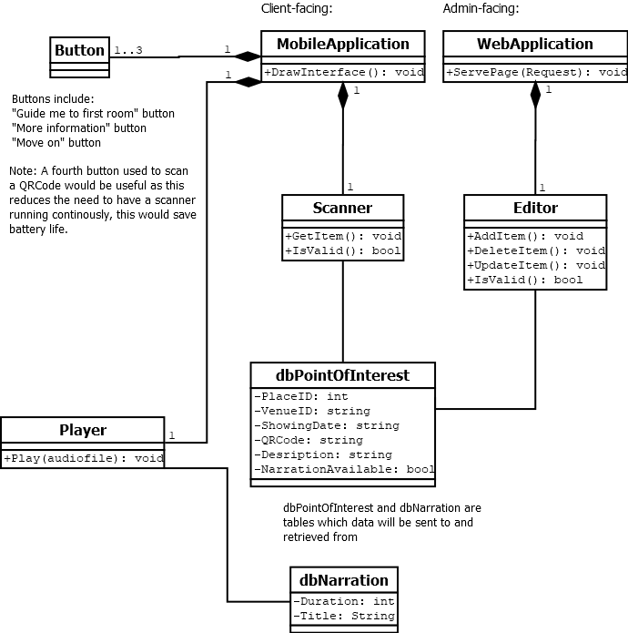
Figure 1Class Diagram

9.1.2 Collaboration and Responsibilities Diagrams
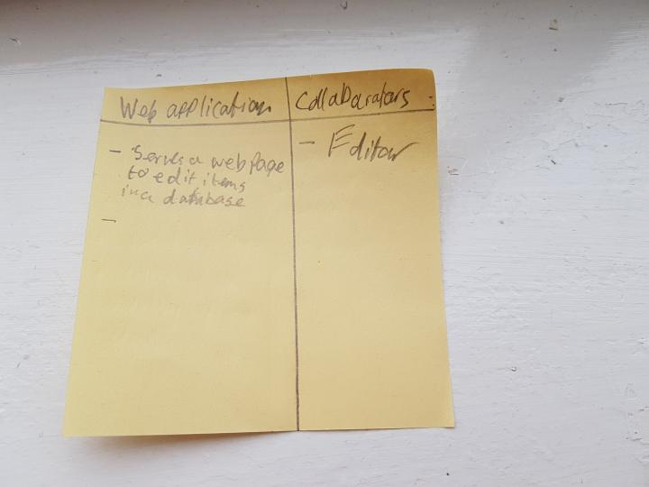
Figure 2CRC Card #1

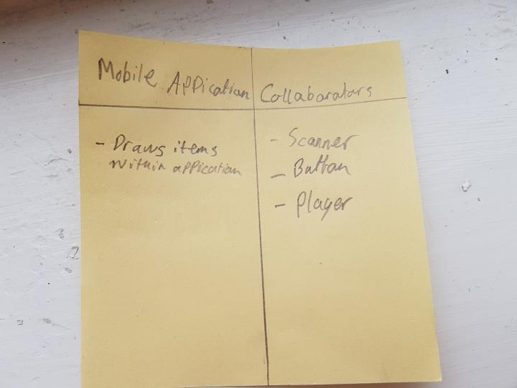
Figure 3CRC Card #2
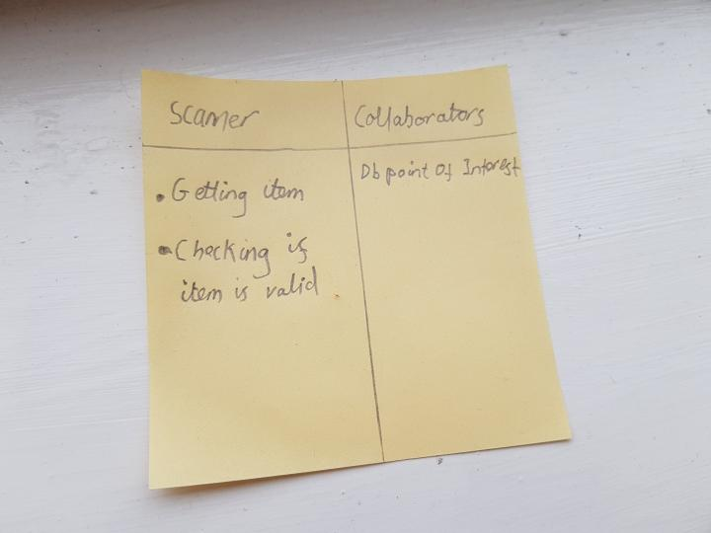
Figure 4CRC Card #3
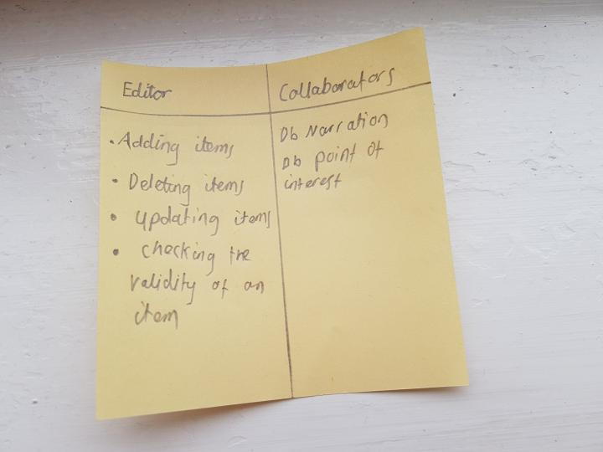
Figure 5CRC Card #4

9.2 Dynamic Design
This section will show designs with moving parts – such as a sequence diagram where a message is displayed within a timeline.

9.2.1 Sequence Diagrams
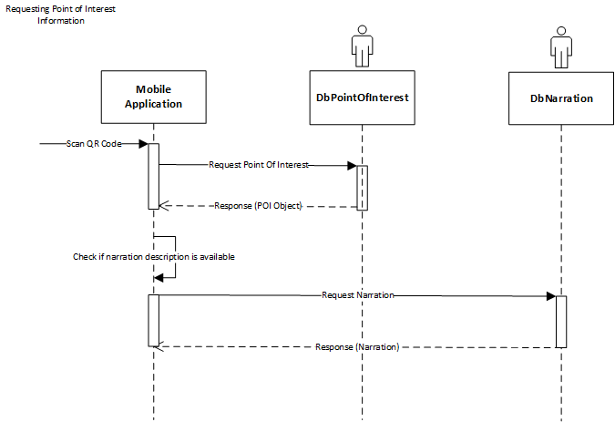
Figure 6 Sequence diagram #1

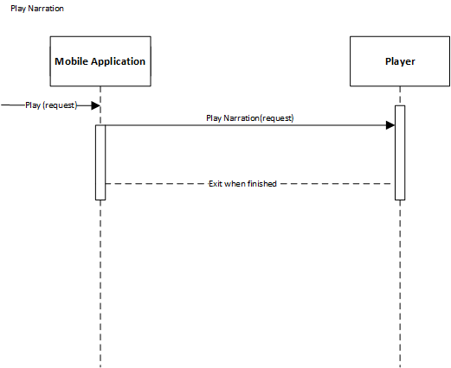
Figure 7Sequence diagram #2

9.3 User Interface Designs
These are rough, low fidelity user interface designs that will illustrate what the interface should look like.
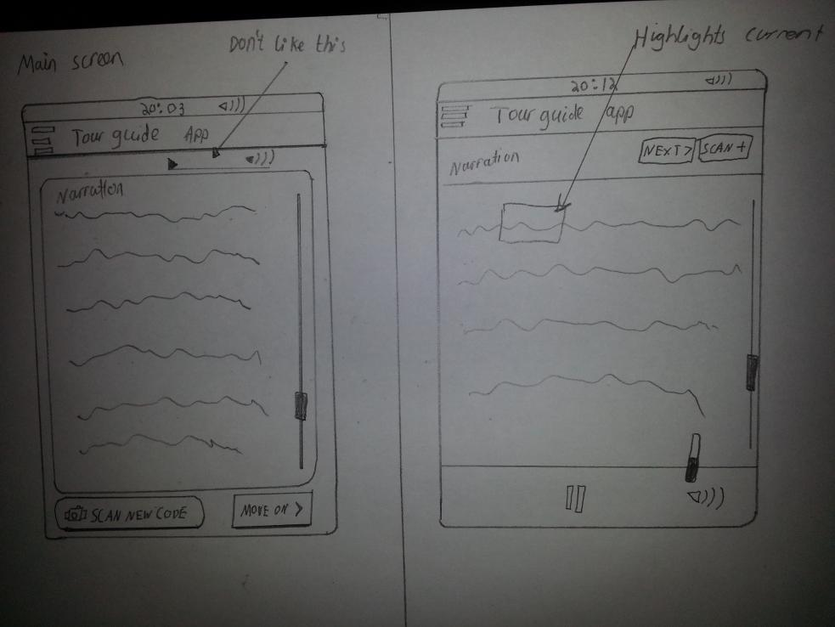
Figure 8User Interface Design #1
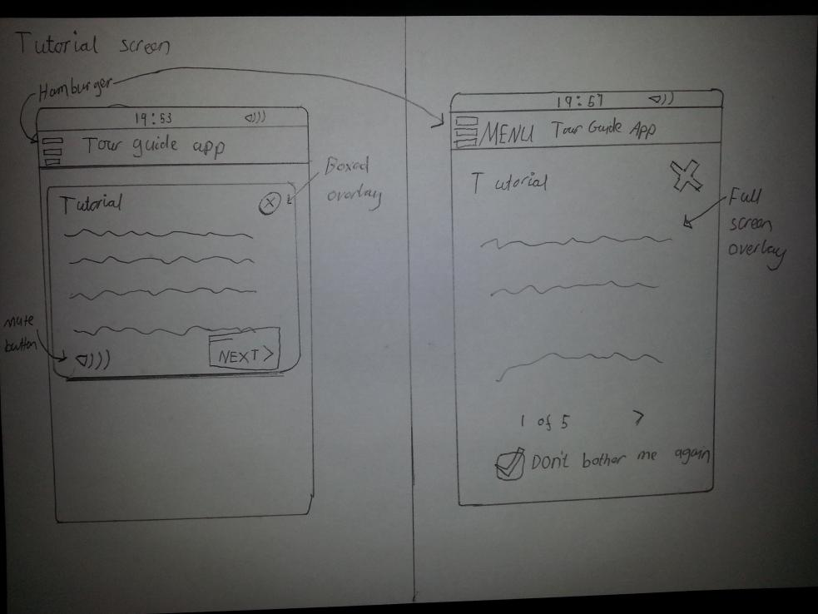
Figure 9User Interface Design #2
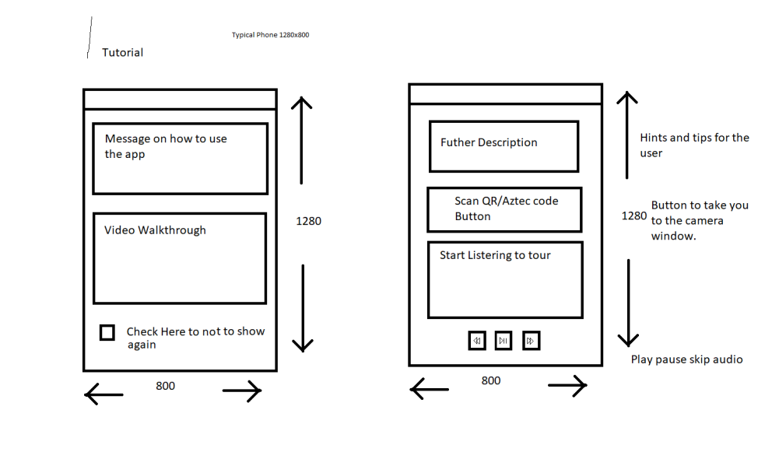
Figure 10User Interface Design #3
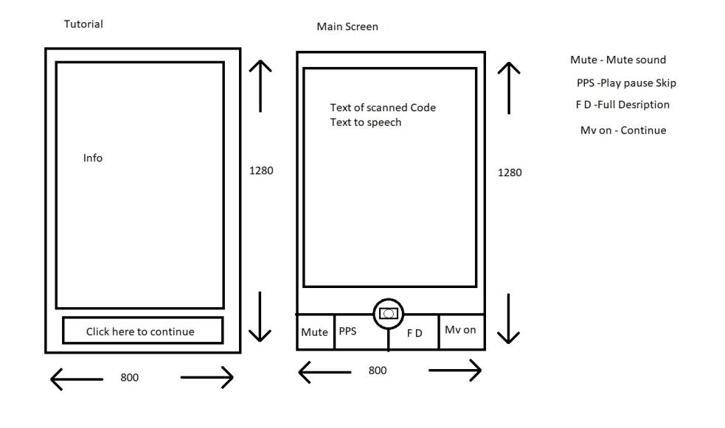
Figure 11User Interface Design #4
After coming up with multiple user interface designs, we selected our favourites for use in the final application. These are shown below.
Figure 12Introductory screen design

Figure 13Main screen design

Testing
This section will consist of brief module testing as well as the results from our internal and external testers. Given more time, we would have introduced a test harness, which is a tool created for testing units of codes automatically.
This is our test plan that we created for testing the program. It shows our tests and results.
Module testing
Test | Action | Result
In-code functionalities
Add Narration | Add an narration struct | Works – narrations have been added
Add Audio | Add an audio struct | Works – Audio struct has been added
On-screen functionalities
Play Narration | Add Narration | Works
Play Audio | Add audio | Details of the audio can be added. However an actual audio file cannot be added yet.
Draw Interface | Run the program | Works – an interface is shown
Test narration wait times | Wait for a narration text to exit | Works
Test scan function | Test scan action | Works - however, this does not actually scan a QR code.
Test exit function | Text exit function | Works

Alpha testing results (internal testers):
- Jonathan (Myself) – no bugs reported
- Robbie – no bugs reported
- Naomi – no bugs reported

Beta testing results (External testers):
- Ruadhri – no bugs reported
- Keltan – no bugs reported

Version Control
For this project we used a version control system (VCS). This a system used for managing versions of software (through snapshots in the case of Git).
The VCS we used is Git.
Git is a version control system created by Linus Torvalds (Linux kernel developer) [5]. The system works by having multiple snapshots of code with each commit.
When collaborating, use of a branch is used, which is a working tree based off the master working tree of the project. This allowed us to create our own individual branches where we can make changes. After we have submitted (pushed) our branch to the origin repository (hosted on BitBucket), one of us would have to merge the code using Git. Sometimes this caused conflicts, however they were easily removed and the code was re-committed.
Bitbucket is the website we used for hosting our Git repository. We chose this website as it allows for multiple free repositories to be created. It also has features that allow for continuous integration (CI) pipelines to be added later, which is a program that allows developers to test changes made before integrating them with the program. This is ideal for introducing later iterations of the program as it gets more complex.
Our commits:
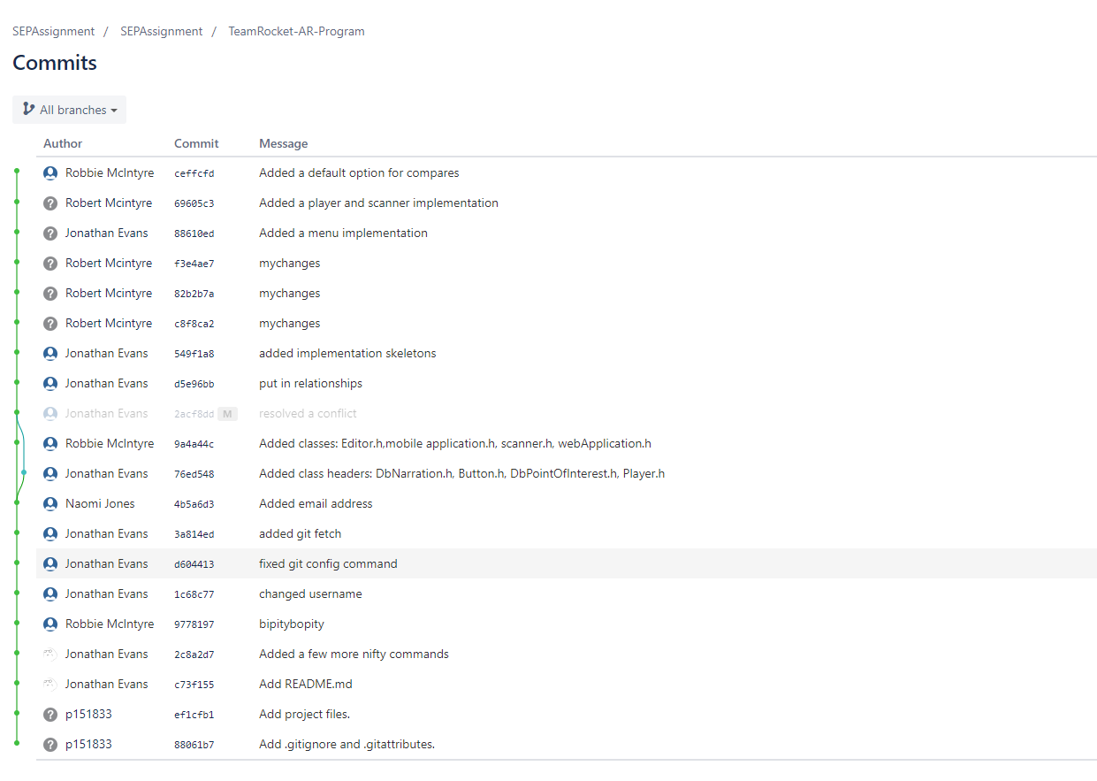

Contributions & Teamwork Discussion
Wherever possible, the workload has been divided. That has greatly improved our productivity as we have been tackling different problems at the same time. However, on some occasions, a consensus is needed on tasks such as creating class diagrams.
Git has aided us as it is useful tool for version control as well as demonstrating who is responsible for each bit of code. This is useful as it shows our individual contributions. Any commit that breaks a section of code can be blamed directly on a person – which is good as the said individual can fix their own code. In addition to this, the use of branches can be used, which allows us to simultaneously work on our own portions of code.

Requirements matrix
 | Requirement | Allow staff to input location information | Allow staff to create ideal tour route | Have intuitive user interface | Select correct visitor information from GPS data | Allow a visitor to access information on an artefact of place of Interest | Enforce headphones only at certain location
Design
Class Diagram |  | X |  |  |  | X
CRC #1 |  | X
CRC #2 |  |  |  |  |  | X
CRC #3
CRC #4 |  | X
Sequence Diagram #1 |  |  |  |  |  | X
Sequence Diagram #2 |  |  |  |  |  | X
UI Design #1 |  |  |  | X
UI Design #2 |  |  |  | X |  | X

References

[1] | Michael Larabel, Phoronix, “Linux Set To Shed Nearly 500k Lines Of Code By Dropping Old CPUs,” [Online]. Available: https://www.phoronix.com/scan.php?page=news_item&px=Linux-4.17-Gutting-Old-CPUs. [Accessed 9 May 2018].
[2] | IEEE, “IEEE Code of Ethics,” [Online]. Available: https://www.ieee.org/about/corporate/governance/p7-8.html. [Accessed 9 May 2018].
[3] | British Computing Society (BCS), “BCS Code of Conduct,” [Online]. Available: https://www.bcs.org/category/6030. [Accessed 9 May 2018].
[4] | Free Software Foundation, “GNU General Public License,” [Online]. Available: https://www.gnu.org/licenses/gpl-3.0.en.html. [Accessed 9 May 2018].
[5] | legislation.gov.uk, “Copyright, Designs and Patents Act 1988,” [Online]. Available: https://www.legislation.gov.uk/ukpga/1988/48/contents. [Accessed 9 May 2018].
[6] | B. S. Scott Chacon, “1.2 Getting Started - A Short History of Git,” in Pro Git, 2018, p. 13.

Glossary
Term | Definition
Class Diagram | Shows the responsibilities and relationships within classes
Sequence diagram | Shows the sequence of how objects interact
CRC diagram | Class responsibility collaborator – shows the responsibilities and collaborations
VCS | Version Control System (such as Git)

Appendices
Appendix 1 (Meeting times)
Meeting Number | Meeting Date | Meeting Time | Meeting Finished | Type of Meeting
No. Meeting | Date | Time – Starts | Time – Ends | How we met
1 | 1 Nov 2017 | 11:00 | 1:30 | In Person | Who was there
2 | 8 Nov 2017 | 11:00 | 1:30 | In Person | Jon, Naomi, Robbie
3 | 15 Nov 2017 | 11:00 | 1:00 | In person | Jon, Naomi, Robbie
4 | 10 Jan 2018 | 10:30 | 11:00 | In Person- met Gordon | Jon, Naomi, Robbie
5 | 14 Feb 2018 | 13:00 | 16:00 | Talked over Discord | Jon, Naomi, Robbie
6 | 21 Feb 2018 | 13:00 | 15:00 | Talked Over Discord | Jon, Robbie
7 | 6 March 2018 | 13:00 | 13:00 | Emailing Gordon | Jon, Naomi, Robbie
8 | 7 March 2018 | 11:00 | 12:00 | In Person | Jon, Naomi, Robbie
9 | 25 April 2018 | 9:00 | 11:00 | In person | Jon, Naomi, Robbie
10 | 7 May 2018 | 10:00 | 14:00 | Discord | Jon, Robbie
11 | 8 May 2018 | 9:00 | 15:00 | In person | Jon, Robbie

Appendix 2 (Minutes #1)
Meeting 1/11/17

Attendees:
- Naomi
- Robbie
- Jonathan
Agenda:
- Requirements identification
  - Outline - Augmented reality mobile application
  - Targeted OS: Android
  - Introduction screen with 3 buttons – Discuss with customer.
  - Bar code scanner (GPS could be included later)
    - Linked with the
  - Template for multiple purposes, i.e: museum artefacts, castles
    - Outline place of interest
    - Location of interest
      - BarcodeID
      - Name
      - Description
      - Media
  - Administrative backend
  - Targeted audience: Adults (~18-50)
  - Narrator
    - Subtitles for accessibility option
  - ID of Place

Chairperson: Everybody
Minute taker: Everybody
Things to ask about:
- What each button should be for
- Accessibility options
Course of action for next week
- Talk to Gordon and Andrew
- Outline of how the app will work (Upload to discord)
- Separate plans uploaded on Sunday of all the plans.

Appendix 3 (Roadmap created within meeting)
Roadmap
This is derived from the detailed requirements documents and use cases.
Preparation
Requirements detailed | ✔
Use cases | ✔
Class diagrams
Sequence diagrams
Database diagrams (ERD)

Initiation
Set up git repositories (all agreed on GitLab due to the convenience of unlimited private repositories and good CI, continuous integration support)
Work environments setup
Setup code linting (Code checking)
Clang-Tidy??
Git repositories:
Application itself
Design files
Documentation (Getting started document, etc.)
Decide on release numbering
? 0.0.1 (in order: release . beta . alpha)
Design
Wireframe designs
Low fidelity designs
High fidelity (detailed) designs

Development
Creation of interface – using QT
Other suggestions:
Java
.NET

Testing
Alpha (in-house) – Test system internals
Writing unit tests for use with continuous integration on GitLab
Test runs
Beta (user testing) – Test system itself
Get user to trial the software and report on any bugs
Documentation
Write user guide

