Cambridge Consultants reduce costs through e-procurement
Illustrates the potential benefits of e-procurement by reviewing the original and revised process and costs. The e-procurement system in this case is a direct link between the purchaser, Cambridge Consultants, and the web-based catalogue of one its major suppliers, RS Components.
Cambridge Consultants is a manufacturer offering technical product design and development services to commerce and industry.
With hundreds of projects in hand at any one time, Cambridge needs a diverse range of components every day. Purchasing is centralized across the company and controlled by its Purchasing Manager, Francis Pullen. Because of its varied and often unique requirements, Cambridge has a supplier base of nearly 4000 companies, with 20 new ones added each month. Some of these companies are providing items so specialized that Cambridge purchases from them no more than twice a year. Of the total, only 400 are preferred suppliers. Of those, just 10 per cent – 1 per cent of the overall supplier base – have been graded key supplier by Cambridge. That number includes RS Components. Francis Pullen says, ‘We charge our clients by the hour, so if a product is faulty or late we have engineers waiting for new parts to arrive. This doesn’t align with our fast time to market business proposition. RS Components’ guarantee of service and range of products fits in with our business ethos.’

The existing purchasing process
Pullen has seen many changes and improvements in the company’s purchasing process as its suppliers have used new technology to introduce new services.
The first was moving to CD-ROM from the paper-based catalogue. Next was an online purchasing card – an account card with detailed line item billing, passwords and controls. Using industry-standard guidelines from the Chartered Institute of Purchasing and Supply (CIPS), Francis Pullen analysed the internal cost of raising an order. This took into account every step, from the engineer raising a paper requisition, through processing by purchasing, the cost of handling the delivery once it arrived, invoice matching and clearance and even the physical cost of a four-part purchase order form. The whole process involved between eight and ten people and cost the company anywhere from £60 to £120, depending on the complexity of the order. The main cost is in requisitioning, when engineers and consultants spend their revenue-producing time in identifying their needs and raising paperwork. (Centralized purchasing, by contrast, is very efficient, costing around £50 an order.) Using the RS purchase card removes the need for engineers and consultants to raise a paper requisition. This makes low-value ordering much more cost-efficient. Invoice matching costs are also reduced, since the purchase-card statement lists all purchases made each month. Although the purchase card is undoubtedly an advance, on its own it does not allow costs to be assigned to jobs in the system each day. The purchase-card statement takes a month to arrive, giving rise to an equivalent lag in showing the real costs on internal project accounts.

The e-procurement process
To enable the company to order online immediately, RS put Cambridge’s pre-Internet trading records on the web server. Purchasing agreements and controls were thus automatically set up on the Internet order form, including correct pricing and special payment terms. The benefit was instantly apparent. The use of the RS purchase card when ordering from the web site meant that the complete order was automatically collated, with all controls in place. Accuracy was assured and the purchase process was speeded up, with the cost per transaction reduced significantly. Pullen describes the change this has had on Cambridge’s purchasing process. ‘For the first time in our purchasing history, our financial controllers saw the benefit of distributed purchasing because of the cost savings, reassured by the central purchasing controls as back-up. ‘This has benefited us enormously. We have allowed three department heads to have their own purchasing cards, so that they can order independently from the web site. ‘We have implemented a very efficient electronic workflow requisition system which is initiated by the purchase card holders and mailed to central purchasing. The orders are held in a mailbox and checked against physical delivery. This has cut out two layers of order activity. ‘In purchasing, we no longer spend our time passing on orders that they have raised, and there is no generation of paper during the order process. It doesn’t just save time and money – it’s also far more environmentally friendly. Passing on low-value orders each day adds very little value, so devolving this function back to our internal customers frees up our time in purchasing to work on higher-value tasks.’

Benefits for staff
Francis Pullen continues: ‘Our internal customers are also much happier. We leave at 6 p.m. but the engineers will often work late if they are on a deadline. Because they can order off the web site from their desks (everyone at Cambridge has Internet access), they can add items to the order right up until RS’s 8 p.m. deadline without our involvement. We maintain control because of the reporting functions on the site.’ Phase 2 of the rswww.com design has also made it possible for multiple orders to be opened during the day and then put against different cost centres internally.

Results
In the year to June 2014, Cambridge Consultants placed 1200 orders with RS Components, totalling more than £62,000 in value. Of those transactions, 95 per cent went via the Internet. Average order value over the Internet was £34 and accounted for £43,000 of the total business done. The remaining 60 orders were placed through traditional channels but had an average value of £317. The cost to Cambridge of raising a paper-based order was identified as being £60. Using the combination of the RS purchasing card and rswww.com, this has been reduced to £10 an order. Over a year, this represents a saving of £57,000 to Cambridge. The net effect, therefore, is that its purchases from RS Components now cost it a mere £5,000 a year! Francis Pullen again: ‘RS has demonstrated its commitment to its customers in spending time and investing money in developing a world-class purchasing system that delivers tangible customer cost savings and benefits. We have welcomed their innovative approach to purchasing and believe they are way ahead of their competition in this sector.’
Source: RS Components White Paper (www.rswww.com), courtesy of RS Components Ltd © RS Components Ltd Chapter 7 E-procurement

Questions
1 Given the scale of the purchasing operation at Cambridge Consultants, what benefits do you think e-procurement has brought?
2 Why are procurement costs currently as high as £60 to £100 per order?
3 How are procurement costs reduced through e-procurement?
4 What staff benefits accrue to Cambridge Consultants as a result of e-procurement?

Estimating e-procurement costs
To calculate cost savings from e-procurement we perform the following calculation:
Savings = No. of requisitions × (Original cost – New cost)
For Cambridge Consultants cost savings from orders placed with RS Components alone are as follows:
Savings = 1300 × (£90 – £10) = £104,000

Industry Procurement costs as a percentage of cost of goods sold
Consumer electronics 60–70%
Personal computers 50–70%
Consumer goods 50–70%
Automotive 50–60%
Pharmaceuticals 25–50%
Service industry 10–40%

Modelling cost savings and profitability arising from e-procurement

Purpose
To explore the different characteristics of purchasing in organizations that will govern the scale of savings made through e-procurement.

Activity
Imagine you are a procurement manager, IS manager or consultant who needs to demonstrate the cost savings of e-procurement to a senior management team in order to obtain approval for investment in an e-procurement system. Develop a spreadsheet model for each of two hypothetical companies to demonstrate the case as follows:
1 Cost saving calculations. Using the input parameters for the two companies in Table 7.4, develop a spreadsheet model to calculate traditional overall purchasing cost, new overall purchasing cost, percentage change in cost per order and percentage change in overall purchasing cost.
2 Profitability calculations. Using input parameters of turnover, traditional purchasing costs, other costs and a 5 per cent reduction in purchasing costs as shown in Table 7.5 develop a model that calculates the profitability before and after introduction of e-procurement and also shows the change in profitability as an absolute (£) and as a percentage.
3 Analyse the sensitivity of the models to differences in volume of orders and values of purchases (Table 7.4) and the balance between traditional purchasing costs and other costs such as salaries and capital by using the parameters (Table 7.5). Explain to the managers the typical characteristics of a company that will make significant changes to profitability from introducing e-procurement.
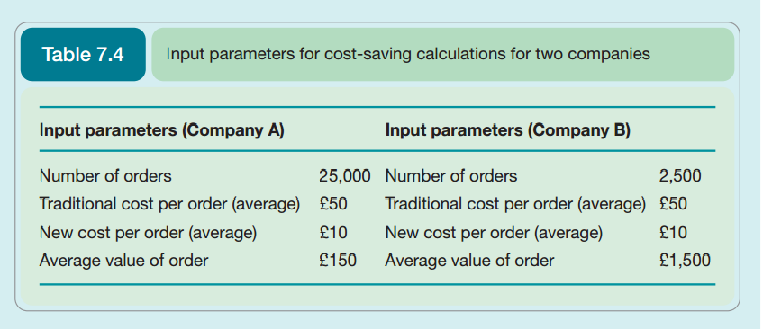
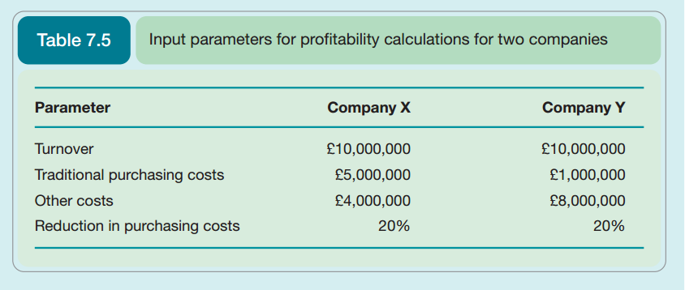

E-Procurement Case study: Jack Ma and AliBaba
http://www.businessinsider.com/the-story-of-jack-ma-founder-of-alibaba-2014-9?IR=T

