Introduction to web and database concepts

Mark Awobokun (2311796)

Contents
Learning in a Digital Era 0
Mark Awobokun (2311796) 0
Assignment task answers 2
Task 1 2
Task 2 3
Task 3 4
Task 4 5

Assignment task answers

Task 1
- Database administrators – this is either a team or a person that controls the 3 levels of the database and as well as defines the schema. They are also responsible for the security of the database and only allow authorized personnel to access the database or modify it, also responsible for security breaches and slow system response time. They provide technical support and monitor the recovery, backup and recovery of the database, also has the privilege of performing DCL (Data Control Language) operation such as GRANT and REVOKE (the ability to allow and restrict users from the database.
- Naïve or parametric user – these people have no prior DBMS knowledge but need to use it to achieve results in their daily lives such as cashier at a superstore, clerks at a bank and so on. They have no responsibility when it come to the DBMS because they have no knowledge regarding the DBMS.
- System analyst - these are users that are in place for the naïve users to make sure or analyse the requirements of the naïve users they are responsible for making sure the naïve user’s requirements are met.
- Sophisticated users – these are the users who have prior knowledge of the database such as engineers, scientists and business analysts. They ae able to design their own database as they like to but don’t write the code for it. They are responsible for send a SQL query through the query processor.
- Database designers – they make the background of the database such as its indexes, tables, stored procedures and constraints they are responsible for understanding he requirements of different user groups and meeting their requirements design wise.
- Programmers – these users are computer professionals who have a vast knowledge of the database, they are responsible for the coding of the database and can be written in various programming language such as visual basic, C and FORTRAN.

Task 2
- Marketing department they would need to database to set prices for the tour as well as make discounts or set up events to get discount codes for the tour, they are responsible for price optimization, meaning that the allow prices to fluctuate base don demand, time and competition.
- Tour operators – making sure tourists are safe and entertained on the tours they take responsible for scanning tickets of tourists.
- Risk department – these are people who need to have a contingency for anything that goes wrong on the tour like having an in-house paramedic or ambulance on standby at certain locations or bad weather.
- Travel management – responsible for setting up various methods as to which people may want to undertake the tour like a boat tour a bus tour or private tours with big families.
- Customer services department – they are responsible for being able to answer various question for customers or possible tourists like giving more information about the tour, packages available for the tour as well as verifying what days are less busy than others.

Task 3

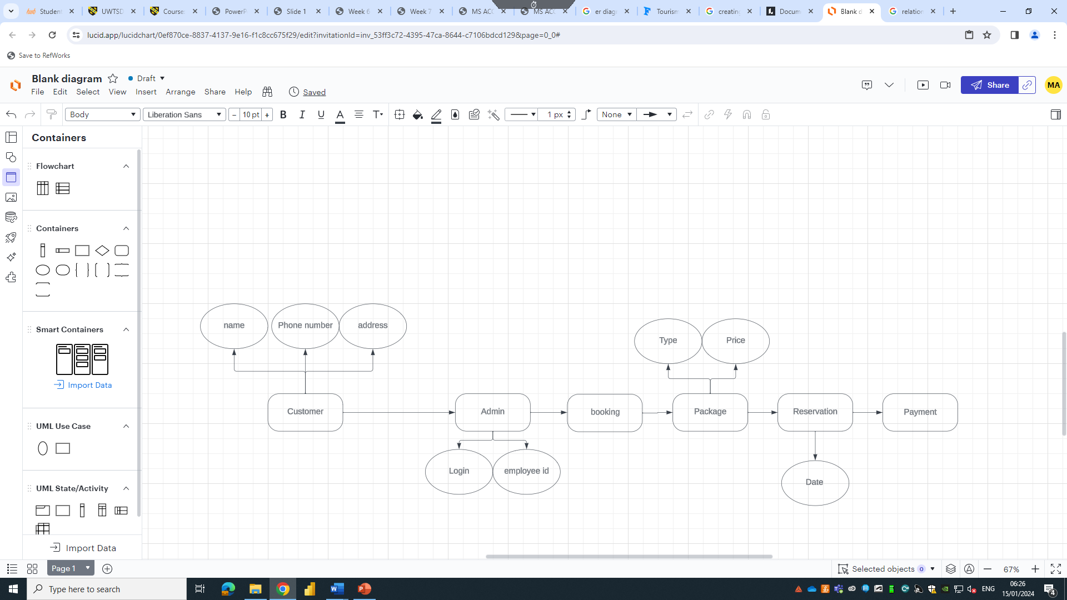
Attributes included the name, phone number and address of customer to input it in the database for future use and easier mode of contact as well as if any promotional material to be sent to the customer. Admin login and employee id is needed as it is the primary key to using and altering the database, package type and price is added because the company offers various packages in the different times of the year and the reservation date is used to match the price with the time at which the customer is available for the tour.

Task 4
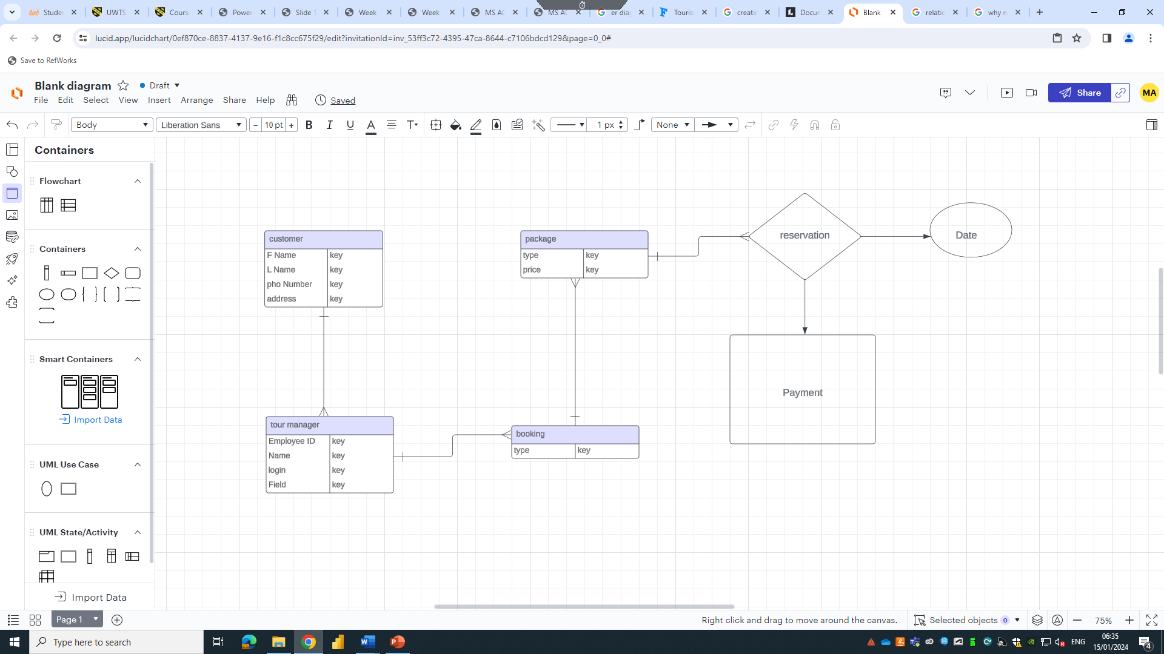

Task 5
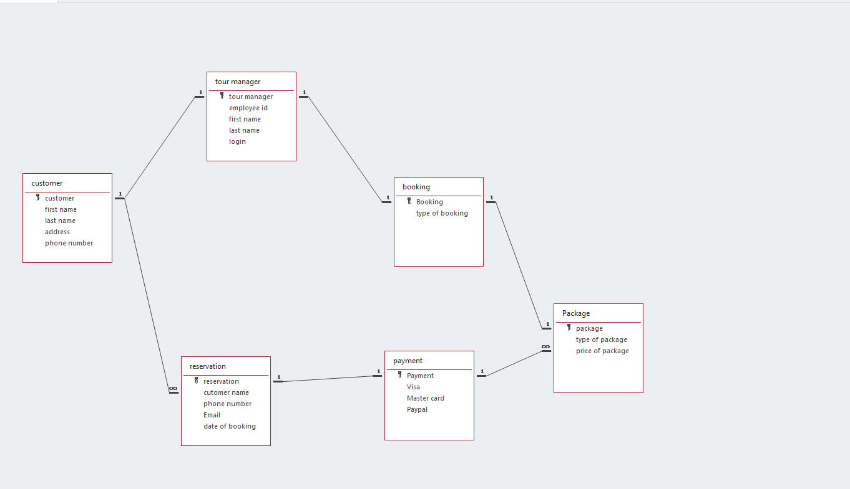

Task 6


