

Student name: Oyinkansola Jacobs
Student ID: 2439186

Module name: Introduction to health and social care
Module code: LCHS4003
Supervisor’s name: Jolly Nwankwo

History of pharmacy services |  | According to the Cambridge Dictionary Pharmaceutical refers to “the production of medicines”  Pharmacy Services started in ancient Egypt with the use of Vines, Roots, Herbs & Barks to help cure and manage illnesses.  And the First pharmacy store was built in the 17th Century with the purpose to provide safe and effective patient care, pharmacies prepare, dispense, and use medicines correctly.  Pharmacists accept and review prescriptions, look for potential drug interactions, and appropriately distribute drugs. They advise patients on how to take medications correctly, explain adverse effects, and help them maintain their health. In many cases, pharmacists provide extra clinical services such as blood pressure tests, immunizations, contraception, smoking cessation, and minor illness management through programs like Pharmacy First. Pharmacies also assist with drug supply management, ensuring storage standards, and safely disposing of expired medicines. These services play a significant role in enhancing public health, relieving demand on hospitals and GP clinics, and ensuring convenient access to professional healthcare advice.
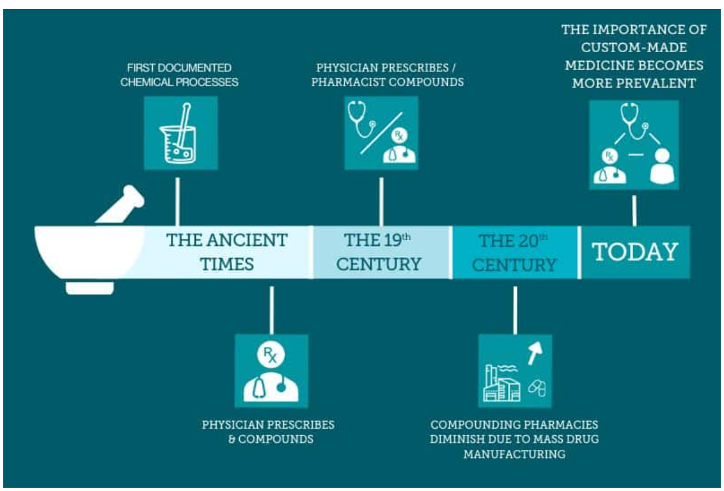 |  |  |  | 
Brief History of the pharmacy Services  Pharmacy services evolved from ancient practices in which healers made herbal cures, eventually becoming organized apothecaries in the Middle Ages. The Pharmacy Act of 1852 regulated the profession and established formal registration of pharmacists. In the twentieth century, scientific breakthroughs and public health systems broadened pharmacy activities from dispensing to therapeutic services. Today, pharmacists provide patient-centred care, including prescription management, immunizations, and health promotion, backed up by digital technologies. |  |  |  | Current functioning of Pharmacy services  •Prescription Processing - Pharmacists receive and review doctor's prescriptions to ensure their accuracy, appropriateness, and patient safety.  •Dispensing Medications - Medicines are produced, labeled, and distributed in accordance with the prescription, while adhering to safety and legal guidelines.  •Patient Counseling - Pharmacists educate patients on how to properly take their prescriptions, potential adverse effects, storage, and combinations with other drugs or food.  •Drug Management is ongoing monitoring of patients' drug regimens in order to improve outcomes, prevent side effects, and maintain compliance.  •Inventory Control include managing the stock of medicines, including ordering, storing, and reviewing expiration dates to ensure availability and quality.

Challenges facing pharmaceutical services
Financial pressures and underfunding
Community pharmacies are under serious financial stress. According to Community Pharmacy England, budget shortfalls (in real terms) have led numerous pharmacies to decrease or even close.

Medicine shortages/supply chain instability
Pharmacies are dealing with chronic pharmaceutical shortages, which increases workload (time spent seeking medicines) and poses dangers to patient care.
These shortages affect more than simply operations; the Royal Pharmaceutical Society reports that they have had a direct negative impact on patient health and led to verbal abuse of pharmacy staff.

ORIGIN OF THE NHS
The post-World War II social and economic rebuilding in the United Kingdom was a major factor in the creation of the National Health Service (NHS). After the war, Britain was resolved to confront the profound disparities that had been brought to light by the conflict and to reconstruct a more equitable society. The Beveridge Report, officially titled Social Insurance and Allied Services, was issued in 1942 by economist Sir William Beveridge and served as the model for Britain's post-war welfare state. Disease, want, squalor, ignorance, and idleness are the five main social issues that Beveridge named the "Five Giants" because they impeded both individual well-being and national advancement. Comprehensive state intervention, including a national health care system, was necessary to combat these giants.
The report’s vision came from a national evaluation of Britain after World War II, where there was a widespread of poverty, poor housing, and unequal access to health services and these had become undeniable. The battle itself had proved the significance and viability of coordinated public health provision. The Emergency Medical Service was established during the war to provide a national framework for treating military and civilian injuries, demonstrating how collaboration between hospitals and the government could efficiently administer care on a large scale. This experience bolstered the case that health care should be publicly organized and universally accessible.
Following the Labour government's victory in 1945, Health Minister Aneurin Bevan sponsored the National Health Service Act 1946, which took effect on July 5, 1948. The Act established a health system based on three fundamental principles: it would satisfy everyone's needs, be free at the point of delivery, and be determined by clinical need rather than ability to pay. This was a watershed moment in social policy, shifting away from the pre-war patchwork of private, municipal, and nonprofit health services. The NHS thus exemplified the welfare-state notion of the government's duty to safeguard citizens from "cradle to grave."
In its present form, the NHS in England has become a complicated, multi-layered system. It has been arranged around Integrated Care Systems (ICSs) from July 1, 2022, with 42 regional partnerships spanning the entire of England. Each ICS has an Integrated Care Board (ICB), which plans and funds local health services, and an Integrated Care Partnership (ICP), which brings together the NHS, local governments, and community organizations to coordinate strategies for improving population health and reducing inequalities (NHS England, 2024). This framework seeks to encourage collaboration across providers rather than rivalry, fostering a more holistic approach that connects health with social care, prevention, and community well-being.
However, the system confronts numerous problems. Critics contend that, while the ICS model aims to eliminate fragmentation, it has also added new layers of bureaucracy and blurred the lines of accountability between the national and local levels. Financial constraints, manpower difficulties, and escalating demand jeopardize the NHS's ability to stay faithful to Bevan's original vision. Waiting lists have hit new highs, while disparities in access persist across areas. Furthermore, ‘‘demographic factors, such as an ageing population and a rising prevalence of chronic illnesses, place further burden on the service’’ ( NHS England, 2023c)
In critical review, the NHS remains one of the most respected public institutions in the United Kingdom and around the world. It has lasted for 75 years as a tax-funded, widely accessible system, but its long-term viability is dependent on ongoing reform and investment. The values that prompted its formation—born out of a nation rebuilding from war and resolved to defeat Beveridge's "five giants"—are as pertinent now as they were in 1948. To fulfill its original promise, the NHS must reconcile financial realism with moral commitment, ensuring that universal care remains free at the point of need for future generations.

Refrence list
Anderson, S. (2007). Community pharmacy and public health in Great Britain, 1936 to 2006: how a phoenix rose from the ashes. Journal of Epidemiology & Community Health, 61(10), pp.844–848. doi:https://doi.org/10.1136/jech.2006.055442.
Community Pharmacy England (2024). Critical staffing pressures in Community Pharmacies hitting patients - Community Pharmacy England. [online] Community Pharmacy England. Available at: https://cpe.org.uk/our-news/critical-staffing-pressures-in-community-pharmacies-hitting-patients/.
ENGLAND, N. (2025). Then and now: a brief history of general practice and pharmacy. [online] Bing.com. Available at: https://www.bing.com/videos/riverview/relatedvideo?q=history+of+pharmacy+services+in+uk&mid=48EBB7747D5428FF9BA948EBB7747D5428FF9BA9&FORM=VIRE [Accessed 24 Oct. 2025].
England, N. (2023a). NHS England» NHS History. [online] England.nhs.uk. Available at: https://www.england.nhs.uk/about/nhs-history/.
NHS ENGLAND (2024). How pharmacies can help. [online] nhs.uk. Available at: https://www.nhs.uk/nhs-services/pharmacies/how-pharmacies-can-help/.
NHS England (2023b). NHS England» Community Pharmacy advanced service specification: NHS Pharmacy First Service. [online] www.england.nhs.uk. Available at: https://www.england.nhs.uk/publication/community-pharmacy-advanced-service-specification-nhs-pharmacy-first-service/.
NHS England (2023c). NHS Long Term Workforce Plan. [online] NHS England. Available at: https://www.england.nhs.uk/wp-content/uploads/2023/06/nhs-long-term-workforce-plan-v1.21.pdf.
Royal Pharmaceutical Society (2021). Royal Pharmaceutical Society. [online] Rpharms.com. Available at: https://www.rpharms.com/.
Royal Pharmaceutical society (2025). Workforce survey highlights strain medicine shortages place on pharmacy teams. [online] Rpharms.com. Available at: https://www.rpharms.com/about-us/news/details/workforce-survey-highlights-strain-medicine-shortages-place-on-pharmacy-teams

