Pathway Project 1: Sustainability and Global Citizenship
(EMPL4013_LON)

By

Malini Tharmalingam Ragupadi

1605386

Tutor: Husam Helmi

University of Wales
Trinity Saint David
London

Word Count:
January 2019

In this reflective assignment, I have written down and will be discussing three key skill areas that I have come across whilst working within Pathway Project 1. The three skills that I have developed are Time Management, Interpersonal communication and networking. I will also show my individual learning log of the process of developing my reflecting account. I will also be talking about the preparation and conduction of my presentation right down to the presenting date.
During the creation of the presentation, we sat down together and decided to create our presentation about Topshop. The first problem that arise during this was that it was difficult to settle on a shop to all agree on. At the start when our group was decided, we sat together and talked about a lot of different retail stores that we could use. This lead to a few disputes with each other because we didn’t know much about the shops that we are going to talk about. I was feeling very anxious as we were wasting time on deciding what retail giant we would be talking about. The tension was high because no one could settle whether the retail stores we did have was going to be good enough for us to use. As we were becoming more agitated and a bit frustrated we decided to take a break to decided what we personally wanted to do. Eventually, we sat down together and decided to settle on our retail store Topman. After we had settled on the shop we worked on researching together and different parts of the retail giant. Once we have written down everything that we need, we got on and started to delegate who does what in the presentation. Looking back on this incident, I could of step in and made the decision for the team as I was elected as the group leader. If I had used my initiative I would of have cut down the time we had spent on choosing the right retailer to talk about. If this incident were to rise again, I would let my group come up with a few suggestions that they would like to do then decided overall what we are doing.
After this incident, we had to assign research to each other and what topics we would be leading during the presentation. The problem that rose with this issue was that we lacked certain knowledge on the topics hence why we were not able to assign the jobs as soon as possible. This started to lead to disputes between each other on who to get which topic. This was getting to us as we were trying to make progress on our presentation. It left us more frustrated when we got close to figuring out what we all felt comfortable enough to do. In the end we decided to focus on the research aspect and see what we personally felt we were confident to talk about in the presentation. Once we had figured out what our topics where we got together and started to research on our own and type what we had found on our shared PowerPoint presentation. This has helped us cut down on so much time we would have needed if we did it individually and got back together to put it all together. This has really helped me with my time management skills, we had set up a little plan to help us achieve our goals on time. We wrote what was expected from us on it and what we needed to improve on it. The sense I got from this situation was that I decided to take my own initiative and took it upon myself to decide what everyone needed to do. Then on our own, we researched and got back and talked about what we had learn to the group. What we could of have done was just randomly taken a topic and worked on it, because ultimately, we had to learn all the topics to improve our own knowledge.
The main incident I had in this task was that some of the team members have not reached their target on the presentation. There would be times, where I had to chase up the other team members to do the work and make sure it was at a good standard. Other times, there would only me be working on the task at hand whilst my group members would take a more laid-back approach. This had made me felt that I had to carry their weight and make sure they were on top of all the work. This put a lot more pressure on me, especially since I had to be calm and collected when the other members would not do their work. Eventually using constructive criticism, I managed to get the group together and finish their work and on time. This has really helped me develop my conflict management and grow as a person. All in all, this was a good experience for me and have learned a valuable skill especially for the workplace. I had to manage it effectively and efficiently without lowering the morale of the group. I have done this through constructive criticism and problem solving. A different way that I could have dealt with this situation would have been to prevent the issue from coming about in the first place. By staying on top of my group members and making sure they understand what was expected of them by the time our deadline came would have helped. If the situation would off to raise again, I would make sure that I had stayed on top of them and if that was not the case, then I would use constructive criticism to make them realise what their issue was and try to talk to them and see what could be done to prevent this issue from ever coming again.
As we were in working in a group of three, we had plenty of jobs going around. I had to use my personal skills that I had picked up on this task that I would had to use in a group setting. Some skills are natural to people, but others must develop this through trial and error. The skills that I had to use was interpersonal communication. For me personally, this skill was something that I had developed. It was unnatural for me at first, but as I was using the skill more and more, I managed to develop it over this period and has really helped me overcome all the obstacles that I had faced in this task. Some of the interpersonal skills that I have developed are communication, conflict management, and empathy. As communication was very important to keep on top of the work, I had to communicate in a very clear and efficient way with my other group members. Conflict management has been really helpful for me. This might involve solving an issue between two staff members, between yourself and a colleague, or between a client and your company. You will need to be able to listen fairly to both sides and use creative problem solving to arrive at a solution. If an issue had rose during our group meeting, I had learned how to manage it effectively and efficiently without lowering the morale of the group. I have done this through constructive criticism and problem solving. Lastly, empathy was a skill that I already had but learned to develop it to a workplace standard. This is a key part to any jobs or group is to show the ability that you understand and show empathy to others. During this task, when my group members had any concerns or complaints, I would listen thoroughly to their concerns and express compassion to their problem that they are having. It is an important skill to have and very important to help you to get along with everyone else in the group or workplace.
During this time, I had kept a learning log. I recorded the development process of contributions that I had covered during the setup of the presentation. 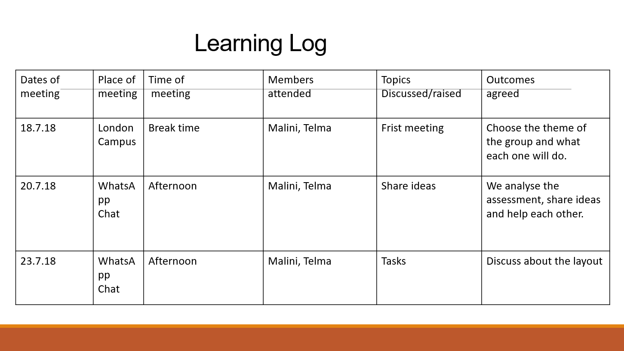
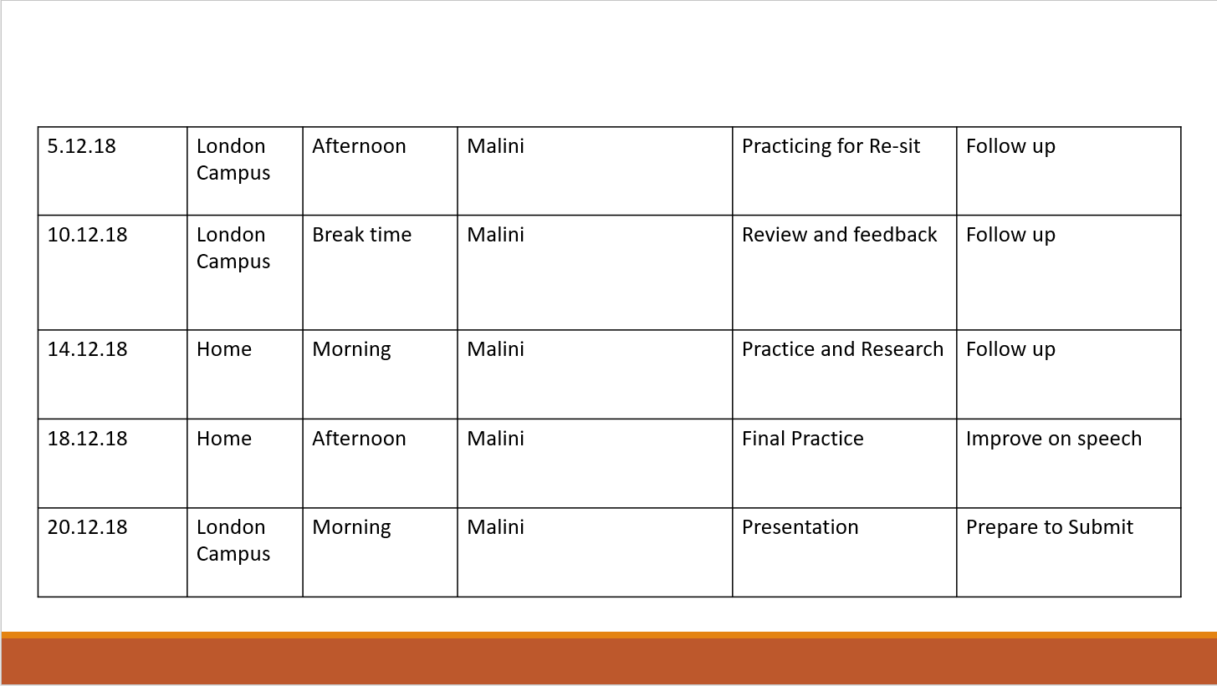

What I would differently in the future is not rely too much on my group members to finish their work. There have been times where it would only be me working on the projects and making progress whilst certain members would take a seat back which would cause more stress on the project. At times whenever we would meet up we could stray from the topic and create a waste of sometime where we could have worked on making the presentation better. This task has really helped me with deal with people at a business level which makes me more experienced to when it comes to the real world and I get put in a situation like this.

