5CO01

Level 5 Associate Diploma in
People Management

Alys Thomas
ID: 2126236
- Evaluate the advantages and disadvantages of the organisation structure in your organisation (or an organisation with which you are familiar) and evaluate the advantages and disadvantages of one other organisation structure. Within the evaluation, you should include the reasons underpinning the structure. (AC 1.1)

Hywel Dda University Health Board (HDUHB) consists of a hierarchical structure, “The Board leads, controls and directs the activities of the organisation” (HDUHB, no date a) that is complemented by a functional structure based on specialties, also known as a functional-hierarchical structure (Taylor and Woodhams, 2022a, p. 56). Some reasons underpinning this structure include (but not limited to):
- Specialisation: it allows the specialisation of healthcare professionals ensuring expertise in specific clinical functions.
- Compliance: ensures standardisation and compliance with healthcare regulations and protocols
- Patient safety: encourages conformity to standardised procedures, minimising the risk of errors and enhancing healthcare quality.

As outlined by Taylor and Woodhams (2022a, p. 56), this structure can be beneficial as both managers and staff have defined responsibilities in line with achieving operational goals, which contribute to the overall progress towards the strategic goal. However, it is possible a functional-hierarchical structure may cause silo-working as sharing learning can be more difficult, resulting in change happening at a very slow pace (Taylor and Woodhams, 2022a, p. 56). This could result in disengagement.

Virtual organisation structures enable an organisation to work digitally (Taylor and Woodhams, 2022a, p. 59). Employees can work remotely, and work is organised via digital platforms to collaborate across the globe seamlessly (StudySmarter, no date); organisations such as Automattic operate using this model (Automattic, no date). Some reasons for this structure could include:
- Global talent: organisations have access to a diverse pool of talent from anywhere and can recruit employees with specific skillsets without geographical limitation.
- Cost efficiency: organisations can save on additional costs such as office space, utilities, and overhead expenses.
- Global collaboration: bring employees together from all over the world to create and innovate.

This structure is useful as it allows employees to work together at any time of day from any location, as well as provide a 24/7 service to customers (Taylor and Woodhams, 2022a, p. 59). The flexibility of the structure also provides plenty of scope to adapt and restructure in response to fluctuating project requirements or changes in the market (StudySmarter, no date). However, issues may arise regarding a lack of human connection which could increase feelings of isolation and therefore impact team dynamics (StudySmarter, no date). The dependence on technology may also cause problems, as digital failures could critically effect operations (StudySamrter, no date).
- Analyse connections between your organisation’s strategy (or an organisation with which you are familiar) and its products or services, and customers. (AC 1.2)

Strategies will outline goals and how to achieve them, it is a crucial step “to adapt to the opportunities and challenges” (Taylor and Woodhams, 2022a, p. 43). HDUHB’s three strategic goals are (HDUHB, no date b):
      - Starting and developing well
      - Living and working well
      - Growing older well

Strategy analysis
Strategic analysis considers goals, purpose, and strategic objectives, current and future, in the wider context they operate within (Taylor and Woodhams, 2022a, p. 44). This requires analysis of data to help decision-making. HDUHB identified the current system “will not effectively deliver” the strategic goals, or their vision of “living healthy, joyful lives” (HDUHB, no date c). As a result, the analysis involved engaging with the public and staff on the future of health services. A new hospital site was deemed essential for delivery of the strategy.

Strategy development
Following consultation, HDUHB published the ‘Healthier Mid and West Wales’ strategy in 2019 (HDUHB, no date c). HDUHB’s strategy is informed by local, regional, and national needs as outlined by Welsh Government’s national plan, the Well-being of Future Generations Act, The Social Services and Well-being Act and more (HDUHB, no date b). Taylor and Woodhams (2022a, p. 45) highlight the importance of including other stakeholders in the development phase.

Strategy implementation
The Programme Business Case which highlights the specific needs to deliver the strategy was sent in 2022 and as of recent, further consultation has taken place to consider options for the new site (HDUHB, 2023).

It could be argued HDUHB’s strategy may face challenges due to evident staffing crisis which compromises achievability. Despite the strategy highlighting opportunities for job creation, complications with backfilling these roles may be challenging. NHS staff are already burned out or leaving professions due to the current pressures (Ungoed-Thomas, 2023). As more prioritise wellbeing, and with much of the workforce approaching retirement, fulfilling these objectives may be difficult. Although the decision for a new hospital site may have risen from the need to better support patients “growing older well”, the practicality may not align with geographical accessibility which impacts both patients and healthcare providers.

- Analyse three external factors or trends currently impacting your organisation (or one with which you are familiar). The impact of these factors or trends could be positive, neutral or negative, some are short-lived whilst others are long-lasting. Identify organisational priorities arising from the factors or trends analysed. (AC 1.3)

Economic: Inflation / cost of living
HDUHB grapples with the complications of inflation. The substantial strain is resulting in budgetary constraints (NHSProviders, no date); HDUHB have recently implemented a recruitment freeze as well as minimised the reliance on agencies (HDUHB, 2023). This in turn places more stress on the services and individuals as they continue to struggle with the already low staffing crisis.
Inflation is not only impacting the Health Board, but its employees too. Employers are expected to pay their employees more (Rigby, et. al 2023) however HDUHB relies on government funding and agreements to enhance pay, rather than independently managing wages. As a result, the ‘largest nursing strikes in NHS history” took place in 2023 (Reed, 2022) and Junior Doctors have began striking in 2024 (Campbell, 2024). If an agreement cannot be reached, there will be many negative impacts but particularly an increase in turnover, as staff will, and are, leave for better pay (RCM, 2022) which will raise the risk of poor patient care. In contrast, an agreement to enhance wages will result in low turnover and quality patient care.
Political: Brexit
Whilst Brexit may present few positives such as the UK “taking back control” (Cabinet Office, 2022), there are notable drawbacks. Repercussions of Brexit have been profound, with difficulties presented to the “migrant staff on which the NHS has long relied” (Nuffield Trust, 2022). With the complications on entering the UK post-Covid and distract changes to professional visas, the staffing crisis have been amplified as a result (Nuffield Trust, 2022).
Brexit is more challenging than beneficial, with long-lasting impacts. The latest changes to UK immigration policies will present further difficulties to overseas workers by needing to meet the new salary threshold income criteria, which is a minimum of £38,700 to quality for a skilled worker visa (Menendez, 2024). This is not only discouraging potential valuable talent for the UK, but for NHS organisations, adds further pressure on staffing levels as overseas staff already working in the UK may leave because of these changes (Holt, 2023).
Sociological factors: aging population
The ageing population is exerting increased pressure on services due to age-related illnesses and a growing demand for healthcare (AgeUK, 2023). Our health service is already “struggling and sometimes failing to cope with the needs of older people” (AgeUK, 2023) and without distract improvement, ill-health is only going to increase. The UK workforce is also ageing meaning that the increasing number of retirements poses additional challenges for the NHS (Government Office for Science, 2016). This highlights another layer of complexity and is mostly negative, as it heightens the demand for healthcare services while limiting supply of skilled professionals.
With support from the government, HDUHB’s priorities must focus on their strategic goal “growing older well” (HDUHB, no date b) by adapting to the changing patient demographics, investing in preventative care measures, and implementing workforce strategies to address staffing shortages, ensuring the health sector remains responsive to the evolving needs of an ageing workforce.

- When setting out its view on automation, AI and technology, the CIPD states, ‘Automation, artificial intelligence (AI) and other workplace technologies are bringing major changes to work and employment.’ Assess the scale of technology within organisations and how it impacts work. (AC 1.4)

The influence of technology is profound, marking the advent of what is now recognised as the ‘Fourth Industrial Revolution’ (World Economic Forum, no date). The scale of automation, AI and robotics has steered transformative change across many industries; automation can streamline processes, increase efficiency and productivity (Giannelis, 2022), AI is being used to enhance and tailor personalised experiences (Haan and Watts, 2023) whilst robotics is can carry out repetitive tasks particularly in manufacturing, which has massively reduced the risk in human error and injury (Universal Robots, 2022).
Given the pace of this technological shift, it has become a widely discussed topic with some fears around mass job losses (Mohdzaini, 2021) and research (CIPD, 2020) shows 57% of employees expect automation to change their job role considerably. Yet, Kande and Sonmez (2020) argue it “will create more jobs than what it automates” by 2025. Although there will be opportunities to automate job roles that consist of repetitive day-to-day tasks, there is also prospect of upskilling and development initiatives and therefore enables both business and individuals to be “more creative, strategic and entrepreneurial” (Kande and Sonmez, 2020).
The integration of AI in medical diagnostics and treatment holds the potential to revolutionise the way diseases are detected and treated (ETHWorld, 2021). With the ability to examine images and identify patterns, AI will enable medical professionals to diagnose diseases quicker and accurately; decision-making processes will become simpler for those involved as AI machines will be able to process excessive amounts of data; and modern AI algorithms will be able to produce treatment options (ETHWorld, 2021).
In conclusion, Deloitte (2015) says, “while change is the driver of prosperity, it is also profoundly unsettling.” Whilst concerns persist regarding job losses, it is clear to see these advancements not only reshape work but also hold the potential to create new, unexpected opportunities for employees and employers. To effectively navigate this transformation, there must be a balance between welcoming change for its potential to boost success and addressing concerns it may raise.

- Explain Edgar Schein’s model of organisational culture and explain one theory or model which examines human behaviour. (AC 2.1)
Edgar Schein developed a model to highlight different layers of organisational culture that span from “…very tangible, overt manifestations that you can see and feel to the deeply embedded, unconscious, basic assumptions…” (Schein, 2017). Figure A is an example of the model (Denis G, 2022).
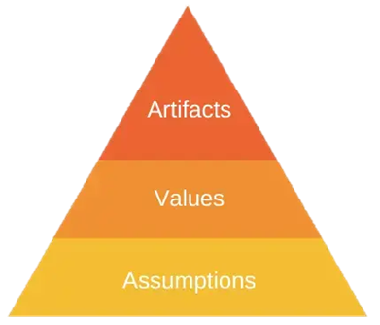
Figure A

Artifacts consist of the visible structures, environment, and processes (Schein, 2017). Sridharan (2022) states these artifacts are “manifestations” that provide insights to the underlying values. However, it may be difficult to decipher the artifacts so further analysis is necessary, through the values, to truly understand them (EPM, 2022, 2:43).
Values are espoused values and beliefs, and drivers for why people behave in a certain way (Schein, 2017). Denis G (2022) highlights values can be considered why organisations do what they do and the cause for an artifact, i.e., a specific structure. Yet, Sridharan (2022) argues there could be “a gap between espoused values and the actual behaviours exhibited within the organisation” such as staff not being provided with the correct resources to fulfil an organisational value.
Assumptions are underlying beliefs or values held within an organisation (Denis G, 2022). Assumptions form the basis of an organisation’s culture and influence individual’s behaviour, choices, and actions (Sridharan, 2022) and become so ingrained, individuals almost never question or disagree with them. Underlying assumptions are seen as the cause and facilitate the layers of the pyramid (Denis G, 2022).
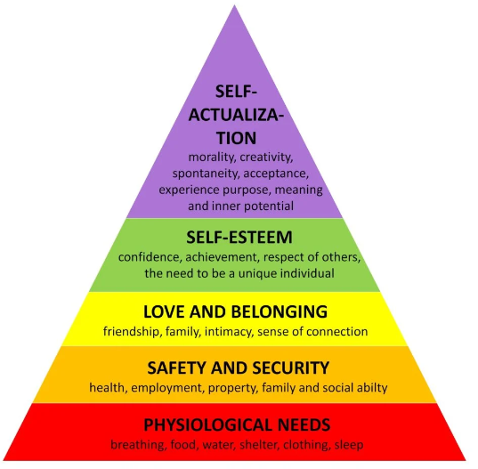
Maslow’s Hierarchy of Needs is based on five categories that motivate us (Hopper, 2020) and whilst we aim to meet the basic (psychological needs), we seek to fulfil a higher set of needs until we become the best version of ourselves (MindTools, no date a). See Figure B as an example.
Figure B
(McLeod, 2024)

This theory examines behaviour by understanding how and what motivates a person. It can be applied in the workplace to understand how to manage effectively and identify how to get the most out of employees by ensuring their needs are met (Herrity, 2022). It provides a deeper understanding of behaviours, highlighting how people are motivated by their pursuit of unmet needs. According to Bailey (2023), although Maslow first argued these needs must be met in order, in his later life, acknowledged how it can vary based on personal circumstances.
By focusing on investing in the needs of employees, this in turn will create job satisfaction and enhance engagement and motivation, which in the grand scheme will positively impact efficiency (Herrity, 2022).

- Assess how people practices in your organisation (or one with which you are familiar) impact both on organisational culture and behaviour, drawing on examples to support your arguments. (AC 2.2)

People practices are used throughout the employee lifecycle. According to ICS Learn (2021),), an organisation with a strong culture is destined to succeed since it impacts everything from everyday operations to strategic decisions, which in turn influences retention, turnover, engagement, and experience. Understanding the interplay between people practices and their impact on organisational culture and behaviour is critical (CIPD, no date).
People practices have a significant impact on culture and behaviours by influencing the norms and dynamics at work as well as creating a sense of purpose for the organisation (Komm et. al, 2021). Learning and development programmes that align with the organisational values can contribute to establishing a culture of life-long learning, continuous professional development, and skill enhancement (ICS Learn, 2021). In addition to this, embedding performance management practices promotes a culture of sincerity and honesty through robust feedback mechanisms and open communication (Adebayo, 2023). Also, HR policies serve as the guiding principles that shape and reinforce the cultural norms within an organisation as they set expectations and reward specific behaviours; they may influence “employee motivation, organisation reputation and the ability to attract and retain talent” (George, 2023a). The culture that these practices create will determine whether “employees work individualistically or as a team” (Dzhumagulov, no date).
HDUHB OD staff use specific behavioural science to identify different behavioural styles, which help employees to adapt to team dynamics and even transform any conflict into positive teamwork and collaboration (TheColourWorks, no date). At a cultural level, this form of intervention provides a safe space to improve such dynamics, help establish alignment and help teams get to know one another on a deeper level (Smart, 2024), all of which provide a sense of belonging which is considered as a basic need on Maslow’s Hierarchy (see 2.1, Figure B). A lack of teamwork could potentially lead to miscommunication, reduced efficiency, and confidence within teams as employees may not feel they can share their work (Indeed, 2023a) which reduces the sense of belonging amongst colleagues and therefore, staff will not feel they can be their best self at work.

- Peter Cheese, current CEO of CIPD asserts, ‘People professionals are a vital function in supporting businesses to adapt to rapidly changing circumstances’. Explain two different models or theories to managing change. (AC 2.3)

In today’s fast-paced world where “change is taking place at an accelerating pace”, organisations must make a conscious effort to adapt to and manage change effectively (George, 2023b). It is crucial to recognise that people are at the forefront; driving and experiencing change, so having effective change management in place can keep employees engaged.
Lewin’s Change Model consists of three steps; unfreeze, change, refreeze. The idea of this model recognises that people and organisations often oppose, react, and adapt to change (Indeed, 2023b). This could be due to the comfort of existing routine and structure. The steps enable leaders to guide an organisation through a process of change, from preparation to planning (MindTools, no date b).
Lewin’s Model is as follows (Indeed, 2023b):
Step 1: Unfreeze | - Identify the need for change  - Communicate with employees
Step 2: Change | - Manage the change by measuring progress, providing the relevant training and support, and keeping employees informed  - Introduce new practices, processes, technologies etc. and address issues as they arise  - Collate feedback
Step 3: Refreeze | - Implement the new norms through policies and procedures, and developing new training programmes  - Develop recognition and reward schemes to engage and encourage employees

Nudge theory is a concept that suggests that people’s behaviours or decisions can be influenced by indirect suggestions or positive reinforcements, “nudges”, without mandating specific actions (Tahir, 2020). Nudging enables individuals to feel they are in control of their decisions whilst maintaining freedom of choice (Imperial College London, no date). This theory focuses on designing the environment, also known as “choice architecture”, where the nudges will influence the ultimate decisions (Imperial London College, no date).

In the workplace, nudges can influence desirable behaviours and manage change (Tahir, 2020). There are three types of nudges (Tahir, 2020):
Perception nudges | Alter perceptions of certain behaviour by educating them or changing the environment in which the behaviour takes place. E.g., labelling calories on food menus to influence healthier decisions (GOV.UK, 2022).
Motivation nudges | Encourage individuals’ motivation to behave in a particular way through rewards or incentives, e.g. employee recognition programmes.
Ability nudges | Giving individuals the relevant skills, information, or resources to carry out a certain behaviour in an easier way, e.g. sending a direct link to a form, rather than the generic website (Smith, 2021).

- A variety of models have been developed to explain how change is experienced. Discuss one model that explains how change is experienced. (AC 2.4)

Kübler-Ross' Change Curve model highlights the different emotional stages an individual experiences after a change (MindTools, no date c); the model was first introduced to understand the stages of grief and has later been applied to organisational change (Roberts and Tracey, 2023). Figure C provides a visual representation of the model (EKR Foundation, no date).
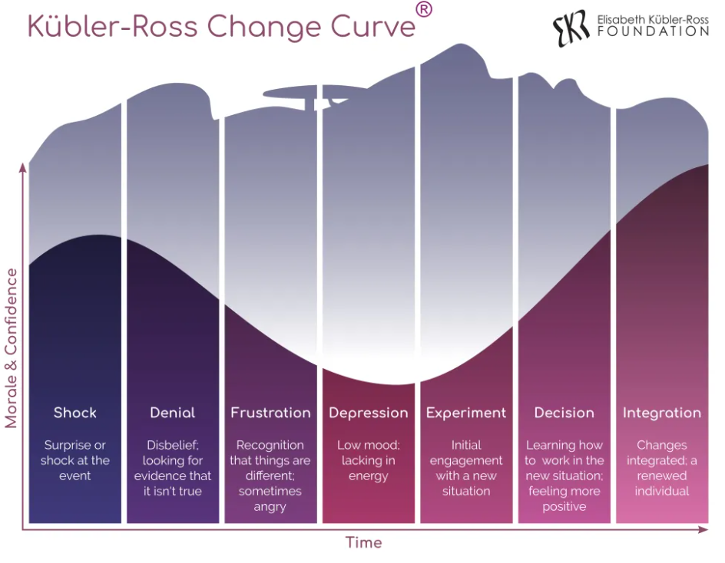
Figure C.

According to Roberts and Tracey (2023), understanding these experiences of change is imperative as it equips individuals and organisations with the insights needed to navigate the emotional complexities that accompany change. This model also emphasises on understanding and addressing emotional responses of individuals experiencing the change, rather than solely on the project (Roberts and Tracey, 2023) which provides a people-centric approach, highlighting that supporting those directly impacted is a significant aspect of change management, and not only implementing a new process/structure.

However, as Jabri (Potter, 2021) discovered, not everyone will experience change in the same way, nor will they follow the exact flow of the curve at the same pace. From this, it could be argued the Kubler-Ross change curve implies a one-size-fits-all approach as it suggests it is a linear process (Tahir, 2019). It is also difficult to measure, as it is not clear when an individual has reached the next stage, as the model does not provide actionable solutions or specific support (Roberts and Tracey, 2023).

To conclude, the Kübler-Ross Change Curve provides a thorough understanding of the emotional dimensions of organisational change. Although the model enables leaders to prepare for potential emotional responses, the linear representation combined with the varied nature of individual experiences may provide some complexities and therefore, better used to “anticipate and thereby address employees coping with change” (Roberts and Tracey, 2023).

- The CIPD’s Health and wellbeing at work survey 2022 found, ‘There is less management focus on health and wellbeing compared with the first year of the pandemic’, and goes on to remark that this is disappointing. Assess the importance of wellbeing at work and factors which impact wellbeing. (AC 2.5)

As described by Taylor and Woodhams (2022b, p. 226), wellbeing is a concept that refers to an individual’s overall physical, emotional, social, financial and career wellbeing. Felton (2015) states it is also much more than “moment-to-moment happiness” indicating that wellbeing is linked to various factors of a person’s everyday life.
Wellbeing at work extends to where the physical and mental wellbeing of employees directly influences their performance, job satisfaction and productivity (Suff, 2023). The concept of ‘good work’ is considered healthy and defined as “having a safe and secure job with good working hours and conditions, supportive management and opportunities for training and development” (Public Health England, 2019). Research shows the combined cost of sickness and absence total to approximately £100b every year, which highlights the importance of the subject and raises a case for action (Public Health England, 2019).
Line managers have a significant impact on employee’s wellbeing, with research showing 69% of individuals feeling their manager has a greater influence on their mental wellbeing, equal to their relationship. In addition to this, 70% also believe their manager has a greater impact on their mental health than their therapist or GP (Brower, 2023). The behaviours of those in leadership positions sets the tone for the underlying culture within the workplace (Bhatt, Bordeaux, and Fisher, 2023) and in turn fuel the layers of Edgar Schein’s Organisational Culture Model (see 2.1, Figure B).
Furthermore, the design of work, where employees spend most of their day on work, may also have a negative impact on wellbeing (Bhatt, Bordeaux, and Fisher, 2023). Autonomy plays a pivotal role in shaping employees’ wellbeing as it directly influences their mental wellbeing and job satisfaction (Wheatley, 2018). Acknowledging the traditional one-size-fits-all approach to work does not factor in unique preferences and needs, so enabling more autonomy where employers establish an environment where employees “feel empowered and want to give their absolute best” encourages psychological safety to be authentic which improves wellbeing (Singh and Mister, 2020). Shwartz et. al (2020) argue that employers “are missing the biggest opportunity for well-being to drive performance” when it comes to flexibility of work and autonomy, as encouraging this way of working not only helps employees “feel their best, but perform at their best, strengthening the tie between well-being and organisational outcomes and fostering a greater sense of belonging overall.”
By supporting employees’ personal needs, which in turn impacts wellbeing, employers will experience high job satisfaction, improved performance, and higher retention (Kelly, et. al, 2021).

- The CIPD Profession Map states ‘People practices are the processes and approaches that we use across the employee lifecycle’. Discuss the links between the employee lifecycle and different people practice roles. (AC 3.1)

The employee lifecycle reflects the relationship between an employee and an organisation, from the start to end (Verlinden, no date). A visual of the lifecycle is below (Figure D).
Figure D
(Avilar, 2022)
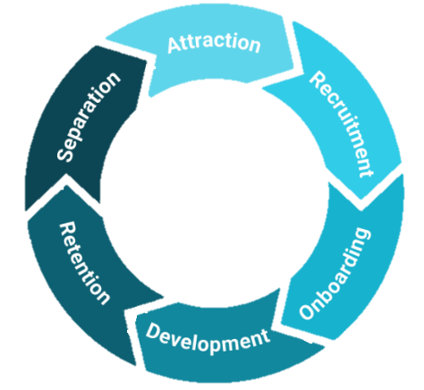

Attraction is the first stage, where an employee is first drawn to an organisation (Taylor and Woodhams, 2022a, p. 9). Specialists within OD contribute to creating and instilling values, positive working environments and better performance (Bosley, 2023). According to Dvorak and Pendell (2018), culture is a highly effective way of attracting talent and “strong cultures create employees who are brand ambassadors.”
Recruitment and selection focus on job design, advert and interviews (Fields, 2023). Recruitment specialists are responsible for establishing a fair process during this phase, so both organisation and candidate have a smooth experience (Fields, 2023). Employee Relation (ER) Specialists will also ensure the process is abiding by legal requirements under the Equality Act 2010 through organisational policies, such as removing the potential to discriminate unlawfully.
Onboarding is the transition between recruiting, induction and starting a new role. Fields (2023) states onboarding is “an opportunity to show new employees that you have their best interests at heart.” Various roles may work together at this stage, such as Recruitment, Learning and Development (L&D) Specialists, and ER to ensure a robust induction that is informative and welcoming. As stated by Taylor and Woodhams (2022a, p. 98), many businesses lose money “because people leave within six months of starting”, so “the more you can do to help new employees feel welcome and supported, the better.” (Verlinden, no date).
Development focuses on helping employees develop in their role and contributes to their professional development. According to Fields (2023), investing in development provides benefits to both the individual and organisation as it encourages engagement and retention. L&D Specialists will provide mandatory training as well as bespoke training programmes for areas of interest, and OD Specialists provide leadership development to identify learning needs for future leaders (Verlinden, no date).
Retention is what makes an employee stay and is a crucial step to retaining talent (Taylor and Woodhams, 2022a, p. 99). Specialists within OD will be responsible for creating initiatives to improve engagement, satisfaction, and well-being to better understand employees and how the organisation is operating at a cultural level; such as performance management and reward and recognition processes (Taylor and Woodhams, 2022a, p. 102)
Separation is the last step of the cycle where employees will leave the current organisation (Taylor and Woodhams, 2022a, p. 103). Fields (2023) highlights the exit stage does not “mean their relationship with the employer is over” so getting the process right is just as important, as employees can be an advocate for an organisation. OD Specialists and ER play a part in this by conducting exit interviews and managing a smooth exit for the employee (Fields, 2023).

- Analyse how people practice connects with other areas of an organisation and supports wider people and organisational strategies. (AC 3.2)

People practices shape and align the overall wider people and organisational strategies as “a good business strategy is informed by its people” (Peters, 2023). They play a pivotal role in vertical integration as they ensure seamless alignment of organisational strategies and desired performance goals, as well as the horizontal integration where people practices are internally aligned with one another and the organisational objectives (Christina et. al, 2017). To meet the goals of the Healthier Mid & West Wales strategy, HDUHB have implemented a ‘Workforce, Organisational Development & Education Strategy 2020 – 2030 (HDUHB, 2019). This strategy connects the wider organisation by upskilling, developing, and acquiring and retaining talent to fulfil the organisational objectives, and highlights the need for “expertise in workforce planning, training and development, new role design and organisational change” to do this successfully (HDUHB, 2019).
Peters (2023) highlights the importance of workforce planning as an integral area of expertise that aligns people practice with strategy. The Workforce, Organisational Development & Education Strategy refers to workforce as a critical step to achieve the aims of the Healthier Mid & West Wales strategy, as it involves anticipating future talent needs based on organisational strategies to make sure the right people are in the right roles (George, 2023c). In practice, this requires flexibility and stability; the need to be flexible to meet short-term staffing demands, and the need to meet long-term goals of talent development (LinkedIn, 2023). Balancing immediate staffing requirements for patient care with long-term talent and succession planning may pose difficulties for HDUHB; particularly with tightened restrictions on financial spending on agency workers.
As well as this, L&D practices also support the wider strategies by identifying skills gaps and designing and delivering training programmes relevant to the Health Boards objectives (As stated by Brassey, Christensen and Dam (2019). However, there are possibilities where complications may arise when employees’ workloads jeopardise their chance of fully engaging with these opportunities. Despite the rich abundance of L&D that HDUHB already offers, as well as opportunities promise within the Workforce Strategy, time constraints may impact a lack of engagement and participation; this in turn will cause a skills gap.

- Discuss processes you have, or could use, for consulting and engaging with internal customers of the people function in order to understand their needs. (AC 3.3)

Internal customers hold equal importance as external customers (Taylor and Woodhams, 2022a, p. 107). Within HDUHB, a Nurse Retention Task & Finish Group was set up in 2022 to “oversee a project to deliver a 1% reduction in turnover of nursing staff in 2022/23” (HDUHB, 2022). As a result of efforts from this T&F Group, by March 2023, turnover reduced by 1.67%, and by June 2023, by 1.83%. As part of this project, employees across from the people profession consulted and engaged with internal customers within the nursing profession as well as trade union representatives to gather valuable insights and feedback on their preferences and concerns. Employees from the nursing profession, such as Assistant Directors, Senior Nurse Managers, Senior Sisters and more, shared their knowledge and learning from a clinical perspective, whilst Trade Union representatives were able to raise concerns on behalf of the staff. During this project, a collaborative effort enabled key areas for improvement and as a result, multiple initiatives were implemented ranging from wellbeing sessions, a more flexible approach to working, enhanced communication, and an emphasis on reward and recognition. The second phase of the T&F Group is ongoing with a new focus in line with the HEIW Nurse Retention Plan in line with the organisational strategy (HEIW, no date).

Culture surveys, developed in 2023, have been implemented to provide further knowledge and understanding of employee needs; it offers the OD Practitioner an insight to the culture of a department by using a scoring mechanism on themes. The themes are derived from the People Culture Framework (HDUHB, no date e)
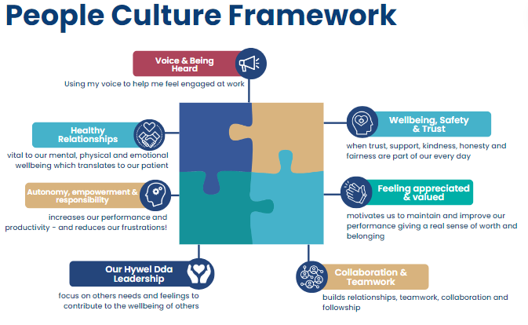

Utilising these culture surveys to identify cultural issues within a team provides a platform for employee voice and enables a deeper understanding of their needs and concerns, which in turn helps the OD Practitioner create bespoke People Culture Plans in line with the organisational strategy to achieve a healthy, collaborate and united culture (HDUHB, 2019). Results of the survey also feed into bespoke interventions which enables the OD Practitioner and internal customer to work closely together to strive for these goals. As part of this process, internal customers are also required to provide feedback on the process to ensure people professionals involved are aware of improvements and/or further needs, then 6-12 months later the culture survey is reopened again to review and reflect.

Reference List
- Abedayo, A. (2023) Importance of Organizational Culture in Performance Management. Available at: https://www.linkedin.com/pulse/importance-organizational-culture-performance-adedoyin-adebayo/ (Accessed: 24th January 2024)
- AgeUK (2023) “The crisis in the NHS is largely a crisis in older people’s preventive care, and if we’re to avoid another catastrophic winter in nine months’ time we need to act now to fix it” warns Age UK. Available at: https://www.ageuk.org.uk/latest-press/articles/2023/the-crisis-in-the-nhs-is-largely-a-crisis-in-older-peoples-preventive-care-and-if-were-to-avoid-another-catastrophic-winter-in-nine-months-time-we-need-to-act-now-to-fix-it-warns-age-uk/ (Accessed: 22nd January 2024)
- Automattic (no date) About Us. Available at: https://automattic.com/about/ (Accessed: 1st February 2024).
- Bailey, A. (2023) Maslow’s Hierarchy of Needs. Available at: https://www.verywellhealth.com/hierarchy-of-needs-maslow-s-five-categories-of-needs-5220468 (Accessed: 23rd January 2024)
- Bhatt, J., Bordeaux, C. and Fisher, J. (2023) The workforce well-being imperative. Available at: https://www2.deloitte.com/uk/en/insights/topics/talent/employee-wellbeing.html (Accessed: 17th January 2024)
- Bosley, A. (2023) Organisation development. Available at: https://www.cipd.org/uk/knowledge/factsheets/organisational-development-factsheet/#who (Accessed: 26th January 2024)
- Brassey, J., Christensen, L. and Dam, Nick van (2019) The essential components of a successful L&D strategy. Available at: https://www.mckinsey.com/capabilities/people-and-organizational-performance/our-insights/the-essential-components-of-a-successful-l-and-d-strategy (Accessed; 31st January 2024)
- Brower, T (2023) Managers Have Major Impact On Mental Health: How To Lead For Wellbeing. Available at: https://www.forbes.com/sites/tracybrower/2023/01/29/managers-have-major-impact-on-mental-health-how-to-lead-for-wellbeing/?sh=4fb8ec462ec1 (Accessed: 17th January 2024)
- Cabinet Office (2022) The benefits of Brexit. Available at: https://assets.publishing.service.gov.uk/media/620a791d8fa8f54915f4369e/benefits-of-brexit.pdf (Accessed: 22nd January 2024)
- Campbell, D. (2024) Junior doctors’ strike led to more than 110,000 patients in England having care cancelled. Available at: https://www.theguardian.com/society/2024/jan/10/junior-doctors-strike-led-to-130000-patients-in-england-having-care-cancelled (Accessed: 22nd January 2024)
- Christina, S. et. al (2017) Shut the fridge door! HRM alignment, job redesign and energy performance. Available at: https://onlinelibrary.wiley.com/doi/full/10.1111/1748-8583.12144 (Accessed: 20th January 2024)
- CIPD (no date) People Practice. Available at: https://www.cipd.org/uk/the-people-profession/the-profession-map/explore-the-profession-map/core-knowledge/people-practice/ (Accessed: 24th January 2024)
- CIPD. (2020) Workplace technology: the employee experience. London: Chartered Institute of Personnel and Development.
- Deloitte (2015) Technology and people: The great job-creating machine. Available at: https://www2.deloitte.com/content/dam/Deloitte/uk/Documents/finance/deloitte-uk-technology-and-people.pdf (Accessed: 14th January 2024)
- Denis G. (2022) Edgar Schein’s Organizational Culture Model. Available at: https://expertprogrammanagement.com/2022/09/edgar-schein-culture-model/ (Accessed: 10th January 2024)
- Dovrak, N. and Pendell, R. (2018) Culture Wins by Attracting The Top 20% of Candidates. Available at: https://www.gallup.com/workplace/237368/culture-wins-attracting-top-candidates.aspx (Accessed: 26th January 2024)
- Dzhumagulov, D. (no date) The role of HR in workplace culture. Available at: https://hrcsuite.com/the-role-of-hr-in-workplace-culture/#:~:text=An%20HR%20department%20that%20empowers%20workplace%20culture%20will,increase%20employee%20contribution%2C%20and%20enrich%20an%20organization%E2%80%99s%20value. (Accessed: 24th January 2024)
- EKR Foundation (no date) Kübler-Ross Change Curve® Available at: https://www.ekrfoundation.org/5-stages-of-grief/change-curve/ (Accessed: 8th January 2024)
- EPM (2022) Edgar Schein's Culture Model Explained with Example. 1 October. Available at: https://www.youtube.com/watch?v=HM89E6ltVOg (Accessed: 10th January 2024)
- Equality Act 2010, c. 2. Available at: https://www.legislation.gov.uk/ukpga/2010/15/contents (Accessed: 26th January 2024)
- ETHealthWord (2021) How Artificial Intelligence (AI) Aid Medical Diagnosis. Available at: https://health.economictimes.indiatimes.com/news/health-it/how-artificial-intelligence-ai-aid-medical-diagnosis/85651655 (Accessed: 14th January 2024)
- Felton, L. (2015) What is well-being, how can we measure it and how can we support people to improve it? Available at: https://www.mentalhealth.org.uk/explore-mental-health/blogs/what-well-being-how-can-we-measure-it-and-how-can-we-support-people-improve-it (Accessed: 15th January 2024)
- Fields, J. (2023) What Is The Employee Life Cycle: Optimising The 7 Stages. Available at: https://www.peoplehr.com/en-gb/resources/blog/what-is-the-employee-lifecycle/ (Accessed: 26th January 2024)
- George, S. (2023a) HR policies. Available at: https://www.cipd.org/uk/knowledge/factsheets/hr-policies-factsheet/ (Accessed: 24th January 2024)
- George, S. (2023b) Change management. Available at: https://www.cipd.org/uk/knowledge/factsheets/change-management-factsheet/#changeimportant (Accessed: 6th January 2024)
- George, S. (2023c) Workforce planning. Available at: https://www.cipd.org/uk/knowledge/factsheets/workforce-planning-factsheet/ (Accessed: 30th January 2024)
- Giannelis, G. (2022) How Businesses Can Use Automation to Streamline Processes. Available at: https://community.ibm.com/community/user/automation/blogs/matthew-giannelis1/2022/12/01/how-business-streamline-automation (Accessed: 13th January 2024)
- GOV.UK (2022) ‘New calorie labelling rules come into force to improve nation’s health’, 6 April [Press release]. Available at: https://www.gov.uk/government/news/new-calorie-labelling-rules-come-into-force-to-improve-nations-health (Accessed: 7th January 2024)
- Government Office for Science (2016) Future of an Ageing Population. Available at: https://assets.publishing.service.gov.uk/media/5d273adce5274a5862768ff9/future-of-an-ageing-population.pdf (Accessed: 22nd January 2024)
- Haan, K. and Watts, R. (2023) How Businesses Are Using Artificial Intelligence In 2024. Available at: https://www.forbes.com/advisor/business/software/ai-in-business/ (Accessed: 13th January 2024)
- HDUHB (2019) Workforce, Organisational Development & Education Strategy 2020-2030. Available at: https://hduhb.nhs.wales/about-us/governance-arrangements/freedom-of-information/disclosure-log/disclosure-log-appendices/1-bank-and-agency-staff-pdf-370kb/ (Accessed: 30th January 2024)
- HDUHB (2022) ‘ToR’s Nurse Retention Task & Finish Group’. Hywel Dda University Health Board. Unpublished.
- HDUHB (2023) ‘08/2023 - Delivering our services in challenging times: securing our financial future.’ Hywel Dda University Health Board. Unpublished.
- HDUHB (2023) Hywel Dda progresses with site selection process for new hospital. Available at: Hywel Dda progresses with site selection process for new hospital (Accessed: 25th January 2024)
- HDUHB (no date a) Class One. Available at: https://hduhb.nhs.wales/about-us/governance-arrangements/freedom-of-information/guide-to-our-information/class-one/ (Accessed; 1st February 2024)
- HDUHB (no date b) A Healthier Mid and West Wales: Our Future Generations Living Well. Available at: https://hduhb.nhs.wales/about-us/healthier-mid-and-west-wales/healthier-mid-and-west-wales-folder/documents/a-healthier-mid-and-west-wales-strategy/ (Accessed: 25th January 2024)
- HDUHB (no date c) New hospital consultation document. Available at: https://hduhb.nhs.wales/about-us/healthier-mid-and-west-wales/new-hospital-site/main-consultation-document/ (Accessed: 22nd January 2024)
- HDUHB (no date d) ‘People Culture Framework’. Hywel Dda University Health Board. Unpublished.
- HEIW (no date) Retaining and Valuing Nurse within the NHS in Wales. Available at: https://heiw.nhs.wales/files/nursing-retention-plan/ (Accessed: 1st February 2024
- Holt, A. (2023) Migration rules: What impact might the changes have on the care sector? Available at: https://www.bbc.co.uk/news/uk-67620262 (Accessed: 1st February 2024)
- Hopper, E. (2020) Maslow’s Hierarchy of Needs Explained. Available at: https://www.thoughtco.com/maslows-hierarchy-of-needs-4582571 (Accessed: 23rd January 2024)
- ICS Learn (2021) 6 Ways HR Can Influence Organisational Culture. Available at: https://www.cipd.org/uk/about/news/six-ways-hr-influences-organisational-culture/ (Accessed: 24th January 2024
- Imperial College London (no date) What is Nudge Theory? Available at: https://www.imperial.ac.uk/nudgeomics/about/what-is-nudge-theory/ (Accessed: 7th January 2024)
- Indeed (2023a) Tips for When There's No Teamwork in Your Organization. Available at: https://www.indeed.com/career-advice/career-development/no-teamwork (Accessed: 24th January 2024)
- Indeed (2023b) What Is the Lewin Change Model and How Can You Apply It? Available at: https://ca.indeed.com/career-advice/career-development/lewin-change-model (Accessed: 6th January 2024)
- Kande, M. and Sonmez, M. (2020) Don’t fear AI. It will lead to long-term job growth. Available at: https://www.weforum.org/agenda/2020/10/dont-fear-ai-it-will-lead-to-long-term-job-growth/ (Accessed: 14th January 2024)
- Kelly, E. et. al (2021) 7 Strategies to Improve Your Employees’ Health and Well-Being. Available at: https://hbr.org/2021/10/7-strategies-to-improve-your-employees-health-and-well-being (Accessed: 17th January 2024)
- Komm, A. et. al (2021) How HR can help build the organisation of the future. Available at: https://www.mckinsey.com/capabilities/people-and-organizational-performance/our-insights/the-new-possible-how-hr-can-help-build-the-organization-of-the-future (Accessed: 24th January 2024)
- LinkedIn (2023) How do you balance flexibility and stability in your workforce planning? Available at: https://www.linkedin.com/advice/0/how-do-you-balance-flexibility-stability-your-workforce (Accessed: 31st January 2024)
- McLeod, S. (2020) Maslow's Hierarchy of Needs. Available at: https://www.simplypsychology.org/maslow.html (accessed: 23rd January 2024)
- Menendez, E. (2024) What are the new via immigration rules coming into effect in weeks? Available at: https://www.itv.com/news/2024-01-30/what-are-the-new-uk-visa-immigration-rules-coming-into-effect-in-weeks (Accessed: 1st February 2024).
- MindTools (no date a) Maslow's Hierarchy of Needs. Available at: https://www.mindtools.com/a4denhh/maslows-hierarchy-of-needs (Accessed: 23rd January 2024)
- MindTools (no date b) Lewin's Change Management Model. Available at: https://www.mindtools.com/ajm9l1e/lewins-change-management-model (Accessed: 6th January 2024)
- MindTools (no date c) The Change Curve. Available at: https://www.mindtools.com/au03rgg/the-change-curve (Accessed: 8th January 2024)
- Mohdzaini, H. (2021) Technology and the future of work. Available at: https://www.cipd.org/uk/knowledge/factsheets/emerging-future-work-factsheet/ (Accessed: 13th January 2024)
- NHSProviders (no date) Rising living costs – the impact on NHS, staff and patients. Available at: https://nhsproviders.org/media/694201/nhs-providers-cost-of-living-survey-briefing-september-2022.pdf (Accessed: 22nd January 2024)
- Nuffield Trust (2022) Health and Brexit: six years on. Available at: https://www.nuffieldtrust.org.uk/sites/default/files/2022-12/1671199514-health-and-brexit-web.pdf (Accessed: 22nd January 2024)
- Peters, R. (2023) Strategic human resource management. Available at: https://www.cipd.org/uk/knowledge/factsheets/strategic-hrm-factsheet/#strategy (Accessed: 30th January 2024)
- Potter, A (2021) Putting theory into practice: Kübler-Ross Change Curve. Available at: https://www.wbs.ac.uk/news/putting-theory-into-practice-kuebler-ross-change-curve/ (Accessed: 8th January 2024)
- Public Health England (2019) Health matters: health and work. Available at: https://www.gov.uk/government/publications/health-matters-health-and-work/health-matters-health-and-work#resources (Accessed: 16th January 2024)
- RCM (2022) Four out of five NHS staff say pay is main reason they would quit their jobs. Available at: https://www.rcm.org.uk/media-releases/2022/june/four-out-of-five-nhs-staff-say-pay-is-main-reason-they-would-quit-their-jobs/ (Accessed: 22nd January 2024)
- Reed, J. (2022) Largest nursing strike in NHS history starts. Available at: https://www.bbc.co.uk/news/health-63946730 (Accessed: 22nd January 2024)
- Rigby, S. et. al (2023) How inflation threatens the NHS and what policy makers can do about it. Available at: https://www.proquest.com/docview/2819118573/fulltextPDF/70B2CE064846426FPQ/1?accountid=130472&sourcetype=Scholarly%20Journals (Accessed: 22nd January 2024)
- Roberts, A, and Tracey, H. (2023) Change management: A guide for people professionals. Available at: https://www.cipd.org/en/knowledge/guides/change-management/ (Accessed: 8th January 2024)
- Schein, E. (2017) Organizational Culture and Leadership. Available at: https://ebookcentral.proquest.com/lib/trinity/reader.action?docID=4766585 (Accessed: 10th January 2024)
- Schwartz, J. et. al (2020) Designing work for well-being. Available at: https://www.managers.org.uk/knowledge-and-insights/article/how-autonomy-affects-employee-mental-health/ (Accessed: 17th January 2024)
- Singh, A. and Mister, M. (2020) How autonomy affects employee mental health. Available at: https://www.managers.org.uk/knowledge-and-insights/article/how-autonomy-affects-employee-mental-health/ (Accessed: 17th January 2024)
- Smart, J. (2024) Organizational development (OD) interventions: examples & best practices. Available at: https://www.sessionlab.com/blog/od-interventions/ (Accessed: 24th January 2024)
- Smith, T. (2021) How HR can apply nudge theory to drive behavioural change. Available at: https://www.ey.com/en_uk/workforce/how-hr-can-apply-nudge-theory-to-drive-behavioural-change (Accessed: 7th January 2024)
- Sridharan, M. (2022) Schein’s Organizational Culture Model. Available at: https://thinkinsights.net/consulting/schein-organizational-culture/#scheins-model-of-organizational-culture (Accessed: 10th January 2024)
- StudySmarter (no date) Virtual Organisational Structure. Available at: https://www.studysmarter.co.uk/explanations/business-studies/organizational-behavior/virtual-organizational-structure/#:~:text=A%20Virtual%20Organizational%20Structure%20is%20a%20modern%2C%20flexible,the%20organization%20to%20manage%20and%20coordinate%20work%20seamlessly. (Accessed: 1st February 2024)
- Suff, R. (2023) Wellbeing at work. Available at: https://www.cipd.org/uk/knowledge/factsheets/well-being-factsheet/#what-is-wellbeing-at-work (Accessed: 16th January 2024)
- Tahir, U (2019) Kubler Ross Change Curve Model. Available at: https://www.wbs.ac.uk/news/putting-theory-into-practice-kuebler-ross-change-curve/ (Accessed: 8th January 2024)
- Tahir, U (2020) Nudge Theory in Change Management. Available at: https://changemanagementinsight.com/nudge-theory-in-change-management/ (Accessed: 7th January 2024)
- Taylor, S. and Woodhams, C. (2022a) Studying Human Resource Management. 3rd edn. London: Kogan Page.
- Taylor, S. and Woodhams, C. (2022b) Human Resource Management. 3rd edn. London: Kogan Page.
- TheColourWorks (no date) Insights Discovery. Available at: https://www.thecolourworks.com/profiles/insights-discovery/ (Accessed: 24th January 2024)
- Ungoed-Thomas, J. (2023) Revealed: record 170,000 staff leave NHS in England as stress and workload take toll. Available at: https://www.theguardian.com/society/2023/jul/01/revealed-record-170000-staff-leave-nhs-in-england-as-stress-and-workload-take-toll (Accessed: 25th January 2024)
- Universal Robots (2022) Impact of Robotics in Manufacturing. Available at: https://www.universal-robots.com/in/blog/impact-of-robotics/#:~:text=Robotics%20in%20manufacturing%20is%20being%20used%20in%20multiple,robotic%20automation%20for%20an%20increased%20number%20of%20tasks. (Accessed: 13th January 2024)
- Verlinden, N. (no date) Employee Life Cycle: The Ultimate Guide for HR. Available at: https://www.aihr.com/blog/employee-life-cycle/#Stages (Accessed: 26th January 2024)
- Wheatley, D. (2018) Autonomy in the workplace has positive effects on wellbeing and job satisfaction. Available at: https://hrzone.com/autonomy-in-the-workplace-has-positive-effects-on-wellbeing-and-job-satisfaction/ (Accessed: 17th January 2024)
- World Economic Forum (no date) Fourth Industrial Revolution. Available at: https://www.weforum.org/focus/fourth-industrial-revolution/ (Accessed: 13th January 2024)

