

Title: AI-Assisted Skin Cancer Classification from Dermoscopic Images
Program: MSC Data and Artificial Intelligence
Student Name: Prexakumari Maganbhai Ahir
Student ID: 2431449
Supervisor Name: Dr. Abida Perveen

The Thesis submitted in partial fulfilment of the requirements for the degree of Master of Science in Data and Artificial Intelligence

Academic Year: 2025/2026
DECLARATION

I Prexakumari Maganbhai Ahir, declare that I am the sole author of this Project, that all references cited have been consulted, that I have conducted all work of which this is a record, and that the finished work lies within the prescribed word limits.
This work has not previously been accepted as part of any other degree submission.

Signed: P.M.AHIR
Date:05-05-2026

FORM OF CONSENT

I Prexakumari Maganbhai Ahir hereby consent that my Project, submitted in candidature for the M.Sc. Data and Artificial Intelligence, if successful, may be made available for inter-library loan or photocopying (subject to the law of copyright), and that the title and abstract may be made available to outside organizations.

Signed: P.M.AHIR
Date: 05-05-2026

ABSTRACT
This dissertation explored the creation of a skin lesion classification system with AI support through a small and computationally efficient skin lesion dermoscopic dataset on Kaggle. The paper met a practical priority of developing a reproducible deep learning workflow that was able to discriminate between benign and malignant skin lesions as well as with good performance and at the same time ,it can execute in Google Colab. The primary aim was to run, contrast, and assess five deep learning algorithms with identical preprocessing and experimenting parameters. The paradigm was positivist and deductive design and utilised secondary data of images exclusively and used supervised transfer learning, gradual augmentation and performance-based evaluation. It was implemented in Python using TensorFlow, Keras, scikit-learn, pandas and visualisation. The chosen dataset consisted of organised train and test directories of the benign and malignant lesion images and was cleansed, checked, and divided into training, validation, and test subsets. There were five algorithms tested: EfficientNetB0 baseline, EfficientNetB0 with class weights, EfficientNetB0 with focal loss, MobileNetV2 baseline, and ResNet50 baseline. The results indicated that EfficientNetB0 generated the greatest overall performance, whereas the class-weighted version was the most intense in ROC-AUC. The performance of MobileNetV2 was very low, and that of ResNet50 gave high precision and low recall. The dissertation contributes of a full Colab prototype; the extraction, cleaning, model training, testing, metric generation, displaying predictions, and explaining Grad-CAM. It is demonstrated that the binary skin lesion dataset required to justify deep learning testing is smaller and that it is possible to build balanced, interpretable, and computationally efficient systems to be applied in academic and early screening studies. The following work is to be done in future to attempt external validation, threshold-tuning, the wide coverage of classes and interface.

Table of Contents
1.0 INTRODUCTION 5
1.1 Background 5
1.2 Problem Statement 6
1.3 Scope and Limitations 7
1.4 Research Questions 8
1.5 Aim and Objectives 8
2.0 LITERATURE REVIEW 9
2.1 Introduction 9
2.2 Dermoscopy Datasets, Benchmarking Culture and Context 9
2.3 CNN baselines, transfer learning and "good enough" foundations 10
2.4 Lightweight and mobile-oriented models as a pertinent design dimension 11
2.5 Hybrid feature engineering, feature fusion, and multi-scale representations 11
2.6 Transformers, attention, and the shift to modelling contexts 12
2.7 Ensembles & Optimization & Training Efficiency as Engineering Decisions 12
2.8 Segmentation aided classification, dual-branch architectures, and multimodal signals 13
2.9 Explainable AI, interpretability, and trust in clinical settings 14
2.10 Research Gaps and Rationale for the Proposed Approach 15
2.11 Theoretical framework 15
2.12 Literature table 16
2.13 Conclusion and link to research questions and objectives 19
3.0 METHODOLOGY 19
3.1 Introduction 19
3.2 Research Philosophy 20
3.3 Research Approach 21
3.4 Research Design 22
3.5 Data Collection Method 23
3.6 Data Analysis Technique 24
3.7 Ethical Considerations 25
3.8 Summary of Chapter 26
4.0 IMPLEMENTATION & DEVELOPMENT 27
4.1 System Development Environment 27
4.2 Data Preparation and Preprocessing 27
4.3 Model Implementation and Algorithms Design 28
4.4 Explainability and Output Generation 30
5.0 TESTING & EVALUATION 33
5.1 Testing Strategies 33
5.2 Experimental Results and Performance Evaluation 40
5.3 Results & Discussion 44
6.0 CONCLUSION AND FUTURE WORK 46
6.1 Summary of Findings 46
6.2 Research Contributions 46
6.3 Future Work and Recommendations 47

1.0 INTRODUCTION
Skin cancer is one of the biggest health concerns as it can develop quickly and prove to be fatal if detected late. Dermoscopy is a common imaging method that is used by a clinician to view skin lesions in greater detail, beyond the naked human eye. Dermoscopic pictures reveal the colour patterns, borders and structures to assist with the diagnosis. However, it is difficult to read the dermoscopic images and it depends on training and experience. This results in a need for decision support tools to assist both clinicians to either diminish delays in the assessment process. Artificial intelligence provides a useful means of supporting this goal by learning from a large collection of labelled dermoscopic images to make consistent predictions. Recent research has revealed that deep learning can be used to obtain good results to classify skin lesions, especially when deep learning models use advanced feature extraction methods and careful training designs (Abbas and Elbehiery, 2025; Rajpoot et al., 2025).

1.1 Background
Artificial intelligence in dermatology aims at creating models capable of categorising lesions, as diagnostic categories. There is use in clinical practice - triage, early referral, monitoring of suspicious lesions. The research area is alive because information on dermoscopic images is now made available on public repositories and because deep neural networks have the capability to learn complex features in images. Many studies move now outside of simple binary tasks and deal with multi-class classification tasks as real diagnosis does involve many types of lesions that can appear close to each other. However, this study focuses on binary classification due to dataset and computational constraints.
Multi-class models have potential for broadened use in a decision support context as they can distinguish melanoma from benign lesions, as well as distinguish other disease classes whose clinical management capability requires the knowledge of disease diagnosis. Work which has used fused architectures and multi-scale features is able to show that combining information from layer to layer can be used to improve discrimination in dermoscopic images [1][2].
A major motivation for this project is practical. In many areas the specialist dermatology services are overburdened. A model that makes reliable predictions can support early screening as well as reduce the number of unnecessary referrals to prioritise high-risk cases. This is no substitute for clinicians. Instead, it contributes to consistent review and helps minimise human error because of fatigue or limited experience. Another motivation is theoretical. Deep learning models can learn good features on the dermoscopic images but have more failures in case of imbalanced classes or images from different sources. Therefore, research is required to design pipelines that can perform better to the conditions in a realistic dataset. Survey work is a way to put together weighted dataset selection, bias, and clinical use-cases have an effect on the way models should be trained and evaluated [3].
Explainable artificial intelligence is also gaining importance in this sphere. It is important for clinicians and researchers to know why a model has predicted a certain class. Explainability facilitates transparency and trust and helps to identify failure cases. Recent research has drawn attention to methods of explainability, providing heatmaps or feature attributions of what portions of a lesion have influenced this decision [4]. Some research combines the explainability itself in hybrid models combining segmentation and classification, such that the model is biassed towards lesion areas and also generates explainable outputs [5]. Hybrid approaches are also gaining momentum, which consist by a combination of modern convolutional networks and transformer-based models. These approaches are directed towards catching the texture information from the local region and the bigger clue of the image [6][8].

1.2 Problem Statement
Although using deep learning has shown effective results in classifying skin lesions, there are still a number of gaps existing in the practical and academic work. There are many studies that have obtained high overall accuracy; however, there are not necessarily high accuracy that can be explained for minority classes such as melanoma from a clinical perspective. In an unbalanced data, a model could get high accuracy as it might predict many times for the majority classes, but not for rare malignant cases. This is a risk that the model is good in the general sense but not at all in the aspects that matter. For this reason, the class imbalance is a key issue of dermoscopic classification systems.
The other problem is the real datasets may have variability in the conditions of acquisition and label confirmation. Multi-source datasets contain various imaging devices and clinical environments. This can minimise generalisation, and lead to inconsistent performance in subgroups. Research has suggested various ways towards this, including strong feature fusion, deep ensembles and optimisation-based tuning, which sometimes differs from one dataset to another and model design [9]. There is also a gap is the explainability aspect. Explainability has often been presented as an additional output but is not always employed as a part of model evaluation. If a model has a focus on image artefacts or the background, rather than lesion structures, then this prediction may not be reliable. Systematic work emphasizes the need to incorporate argueable methods from the very beginning of the study design, and not only in how the study is apparent to the end product [10].
Therefore, aims of research presented in this dissertation are developing of robust and reproducible binary dermoscopic skin lesion classification model with proper handling of class imbalance and explainability outputs to ensure transparency of evaluation. This problem is important as it makes the connexion between the technical design of models and the practical need in decision support systems. It is also conducive to academic value, as the testing of methods under actual dataset stress conditions and the reporting of clinically meaningful patterns of performance may serve as such.

1.3 Scope and Limitations
This dissertation is concerned with binary classification of dermoscopic images. The field of expertise is the recognition of skin lesions from dermoscopy. The model will be developed using Python in Google drive (colab). The study is to focus on classification as opposed to comprehensive clinical deployment. The most important results are trained models, evaluation measurements, confusion matrices, and explainability visualisations.
The scope covers the ingestion of data in the form of images and metadata, data preprocessing, data augmentation preprocessing, train and validation split, model training by transfer learning, and evaluation. It also involves analysis of imbalance in classes and interpretation with the help of explainable AI tools. The study does not include the collection of new data, interviews or clinical trials. It does not include the prospective testing in hospitals. It also does not say that the model can replace clinicians. The system is of course designed as an academic prototype and decision support example.
The dataset consists of images gathered from various sources and in such cases, there is a chance of creating variation which is not easy to control. Also, dermoscopic images can have artefacts such as hair and lighting effects [11]. This can influence the learning of a model. The other limitation that is evaluation. The project will address this through the careful splitting and validation, but external validation is outside the scope. Some latest works exploit segmentation plus classification and enhance the focus on the lesion boundaries[12]. This dissertation will mainly focus on classification due to the time and resource limits, but it will utilise explainability tools to see if the model will be attending to the lesion regions.

1.4 Research Questions
- How accurately can deep learning models classify dermoscopic skin lesion images into benign and malignant categories?
- of the selected algorithms performs best for binary skin lesion classification on the chosen dataset?
- How do class weighting and focal loss affect the classification performance of the deep learning models?
- To what extent do explainability outputs help in understanding whether the model focuses on meaningful lesion regions during prediction?

1.5 Aim and Objectives
The aim of this research is to develop and evaluate a reproducible AI-assisted deep learning model for binary classification of dermoscopic images into benign and malignant categories.
Objectives
- To prepare and preprocess the dermoscopic image dataset through cleaning, resizing, normalization, augmentation, and train-validation-test splitting.
- To develop and implement multiple deep learning classification models for binary skin lesion classification using transfer learning in Google Colab.
- To compare the performance of the selected models using accuracy, precision, recall, F1-score, ROC-AUC, and confusion matrix analysis.
- To examine the effect of class weighting and focal loss on model performance in the benign versus malignant classification task

2.0 LITERATURE REVIEW

2.1 Introduction
Dermoscopic skin lesion classification has become one of the major areas of application in computer vision medicine because it is the intersection point between pattern recognition and early cancer detection. Dermoscopy: this is widely used in dermatology, as it shows the network of pigment, vascular and border patterns that are difficult to see on standard photography. However, unlike that, the reading of dermoscopy is not easy. Diagnostic accuracy is dependent upon experience, workload and availability of specialist review. This leads to a very practical motivation behind automated classification system that can be used for triage and second reading of routine care. A second motivation is technical in nature. Dermoscopy dataset is typically unbalanced, noisy and multisource, thus model performance relies on a delicate selection in preprocessing, learning strategy and evaluation process. These dataset traits are typical in dermoscopy research and they form the methods appropriate for robust multi-class classification. The literature indicates three general directions. The first is the shift from classical machine learning to deep learning, where the most frequent baseline is transfer learning due to the reduction in the need for very large labelled medical datasets. The second is the transition from single model pipelines to hybrid designs combining fused features or fused architectures or with segmentation being added as a previous step of classification (previous segmentation) with the intended outcome to enhance the discrimination between visually similar lesion types.

2.2 Dermoscopy Datasets, Benchmarking Culture and Context
A key driver of the advancements in dermoscopy AI has been the shared datasets and open benchmarking challenges, which have enabled comparative evaluation of research groups. The International Skin Imaging Collaboration (ISIC) challenges are a real-world event in this field that is rather well known given that they provided a common platform for model comparison and contributed to standardisation such as classification and segmentation tasks. The availability of Malignant vs benign images dataset in Kaggle is also an illustration of the general culture of open research tooling in which Google Colab notebooks and public leaderboards influence the orientation to methods adopted by students and practitioners. In this environment, selections about the type of model used often depend on what is efficient and reproducible to train and reproduce. Light-weight architectures, efficient training schedules and clear evaluation scripts come to the forefront, not the side. This is important because reproducing is also a quality of research. A model which reports high accuracy but cannot be reproduced, inspected and tested with imbalance is less useful both for academic and applied purposes [11][12].
The form of the dataset is also an influence on what "good performance" means. For applications such as triage, where a system with weak performance on the majority classes fails to detect melanoma is not acceptable. This is why recent research adds more importance to per-class recall and clinically sensitive patterns of error besides only overall accuracy. The literature also demonstrates that multi-class classification is more difficult than binary classification because class boundaries overlap and that there are class types of lesion that share visual features. At the same time, multi-class models are closer to real diagnostic settings because clinicians do not only take the decision "cancer or not". They often provide a narrowing of differential diagnosis across a number of families of lesions. Studies that pose the question as multi-class classification are therefore more in tune with dermoscopy practise, even though they are more difficult to train and evaluate [13].

2.3 CNN baselines, transfer learning and "good enough" foundations
The convolutional neural network is presently the most popular backbone for a dermoscopy classification system because they are good at identifying the textures, edges, and colour that translate into clinical visual cues. In the pipeline of practical research, transfer learning is more likely to be the default approach because of the use of pretrained weights from a large rational image corpus and then pastes the dermoscopic pattern by fine-tuning [14]. Transfer Learning Aided Automated Detection and Classification when Medical Datasets have limited Size. The practical value of transfer learning is that it will provide good baseline functionality with a smaller number of epochs and less chance of unstable training, important in Google Colab contexts with time-limited compute sessions.
However, the weaknesses of CNN baselines can be concealed. They are able to learn features of the image such as the artefacts of the background or device specific patterns in place of structure of the lesion. They can also overfit for dominant classes. It is for this reason that several studies propose richer representations of things or careful control over training. Shetty et al. present work from bridging machine learning and CNN approaches which highlights that an important aspect for students and practitioners to consider is that the modelling pipeline isn't only the architecture, but the feature treatment, preprocessing or validation choices [15]. In this dissertation, transfer learning is considered a controlled foundation and not a final answer. It is taken as a baseline which is reinforced by methods of imbalance and interpretability analysis.

2.4 Lightweight and mobile-oriented models as a pertinent design dimension
A separate dimension in the world of dermoscopy research is the drive for dermoscopy models that can operate on the constrained devices or in limited compute budget scenarios. This is not only about speed. It is also about accessibility and deployment in environments that do not have high end GPUs. Aldhyani propose a lightweight dynamic kernel CNN for multi-class classification which is the larger trend towards the design of small architectures with high accuracy and low computation [16][18]. This trend has a direct relevance to student projects because the constraints to resources are real in Google Colab but in typical academic settings as well.
Mobile Dermoscopy is also another real-world scenario where lightweight models are important. Studies also present MobileSkin using images obtained through mobile phone attached handheld dermoscopes [19]. This emphasizes an important reality in applied applications of the data: the quality of data and other acquisition conditions differ from device to device. A model based on good quality clinical images might get stuck on mobile acquired images because of changes in lighting, focus, and field of view. The implication to this study is that the importance of robustness should be taken into consideration even if the data set is fixed.

2.5 Hybrid feature engineering, feature fusion, and multi-scale representations
As the research in dermoscopy matured, many research works shifted focus from single backbone CNNs to hybrid systems which fuse multiple feature sources. The motivation is clear. Lesions are patterned on a variety of scales ranging from fine networks of pigment to more gross irregularities around the border. Single feature level may not have critical information. It is proposed that hybrid deep feature selection using the extreme learning machine classifier, which provides a coaching via deep features and enhancing in place with mixed style of the final classifier can be different than the finishing end-to-end training [20].
It also makes use of fused features and multi-model analysis for multi-class skin lesion early detection [21]. This approach is consistent with the notion that different CNNs will pick up different visual biases, and fusion will minimise the risk that a blind spot of one model outweighs the decision. Rajpoot et al. in particular underlines the multi-scale feature map fusion which is directly related to multi-class classification since it is useful for discriminating between lesions for which global structure is shared, but local texture differs [22][23]. In practical terms, these studies are a good reason for the design logic of this dissertation.

2.6 Transformers, attention, and the shift to modelling contexts
Other big area of research in the field is the application of attention mechanism and transformer-based components. The motivation here is that transformers are able to capture long-range dependencies and global context which might be important in dermoscopy where lesion borders and overall symmetry is important. There is a need to introduce a CNN-transformer hybrid model with focal loss, which attributes it to two important ideas, namely, a hybrid model and imbalance-aware learning [23]. The focal loss choice is particularly relevant as it makes the training focus more on hard and minority examples that are critical when melanoma is underrepresented.
Attention-based feature aggregation is also presented as a way to improve representation quality so as not to replace completely the CNNs. Studies propose attention-based deep feature aggregation network, which is based on an approach in which attention is useful in combining features from layers or branches [24]. One study introduces a hybrid symmetry aware and soft attention model versions, which is meaningful from a clinical point of view since symmetry and border regularity are important in evaluation of lesions [25][26]. These studies have suggested that attention mechanisms could incorporate clinically relevant priors into the representation even if the model is data driven.

2.7 Ensembles & Optimization & Training Efficiency as Engineering Decisions
Besides architecture, research also focuses on training strategy. Ensembles are useful to help mitigate issues with variance and noise: Data may be tricky and imbalanced, so using an ensemble strategy can help to smooth things out. Thwin et al. and Park et al. represent the literature on applying deep ensemble learning for skin lesion classification, demonstrating that various parameters can be combined to enhance the reliability. Ensembles can iron out some of the rough; they are more compute expensive. This results in a practical trade-off for a Colab-based project, for which time and memory are limited.
Another bunch of studies are focused on optimisation, hyper parameter tuning, and time of training. There is a need to offer a framework for using variance-controlled Marine Predator optimisation, thus showing the tendency of metaheuristics for tuning parameters and the improvement of results [27]. SkinNet-14 with optimised training time on low-resolution dermoscopy images which is a practical contribution since in many practical-going pipelines one needs to minimise accuracy while keeping the efficiency reasonable is proposed by [28][29] as baseline comparisons of CNN and VGG16 also illustrate the importance of baseline comparisons, even when evaluating the novelty is unnecessary for the sake of novelty. Studies also modify and fine-tune VGG19 for skin cancer classification proved the concept that use of old architectures is also useful, and it depends on the adaptation [30].
The implication of this for this dissertation is that performance gains must be assessed in conjunction with compute feasibility. A complex method that cannot be trained reliably in the project environment is less useful than a slightly simpler method that has stable results, that is easily evaluated, and that has an interpretive error analysis.

2.8 Segmentation aided classification, dual-branch architectures, and multimodal signals
Segmentation is many times used to draw the model into the lesion area, and away from the background of the area. This is appealing from a theoretical point of view as it corresponds to what clinicians do when they look at an image before deciding on the patterns of the lesion. Manzoor et al. propose a two-stage segmentation and classification approach, which can be seen as a typical one where segmentation generates the lesion mask, followed by classification using masked or cropped parts [31]. Yasir and Kim has also proposed a dual stream approach using histopathological-inherited and vision-based features [32]. This hints at another emerging trend of pipelines moving away from image-only sources of further enriched features that can represent additional diagnostic cues.
Laouarem et al. introduce a dual-branch framework for segmentation and classification, which enhances the feasibility that two-streams insert the various subtasks to be handled at parallel [33]. Yılmaz et. al describe multimodal learning suggesting that metadata features can be used in classification in addition to images [34]. In the actual dermatology practise, such context has an impact on differential diagnosis. Yet multimodal models present an ethical and methodological challenge to the fairness of the learning process: they can learn about the demographic short-cut and make unfair recommendations if not evaluated

2.9 Explainable AI, interpretability, and trust in clinical settings
Explainable AI has now become an optional add-on no longer, but an expected part of A.I. in medical imagery research. The basic reason for this is that clinical decisions need accountability and human oversight. If a model is giving a prediction of melanoma, a clinician must know whether the model was concentrating on lesion structure or irrelevant artefacts. Youssef et. al. emphasise the interpretable deep learning in the classification of skin lesions describing how interpretability can support trust and auditing [35]. Shaheen et al. present a framework for the use of deep learning and explainable AI, which is the trend towards the ability to embed interpretability functions in the reporting pipeline, rather than at the end [36].
Other research demonstrates interpretability together with complicated modelling. Automated classification of method CNN computer vision methods often uses visual explanation outputs to aid in interpretation [36]. A similar approach of deep learning for early diagnosis and classification appears in the work of Dillshad et al. where such a deep learning approach, in practical terms, implies the role of a triage, where explainability would assist in the justification of the use of clinical support [37]. Sundari et al are concerned with the simpler binary classification problem but are still prone to overconfident errors [38]. The value of explainability is high even in the case of binary since it helps to understand if the model is learning true lesion signals.
A way of making interpretability a realistic goal in the real world is considering interpretability as a tool for error analysis, and not persuasion. If a confusion matrix revealed that melanoma is being often confused with benign keratosis-like lesions, then explainability maps can be used to test whether the model is focusing on clinically plausible patterns or is in fact confusing background texture. This dissertation follows that logic by taking the idea of explainability as part of model evaluation and gap identification not as something that is produced for marketing purposes.

2.10 Research Gaps and Rationale for the Proposed Approach
Looking throughout the literature that has been reviewed, there are many gaps that have not been addressed when considering the idea of a reproducible project of a dissertation based on datasets. First, many studies introduce complex fusion issues, attention issues, optimisation issues, but not always clear about what gain is from architecture and what gain is from training protocol, preprocessing protocol, and evaluating protocol. This lowers the comparability and makes it more difficult to replicate the results in student environments. Second, multi-class performance is often reported as a single number of accuracy whereas the sensitivity for each class, in this case melanoma and other minority classes, receives less attention. In contrast, this study focuses on binary classification, which is more suitable for early screening systems[39]. This is a pragmatic weakness since class imbalance is an established cause of deceptive accuracy. Third, explainability is sometimes done without explaining what goal of evaluation it seeks, which can give a false sense of confidence when no transparency is promised [40].
The novelty of this dissertation is not boasted as a new architecture that is superior to all previous models. The approach concurs with the research questions in terms of binary classification accuracy, imbalance strategy comparison and explainability usefulness. It also fits in with the practical requirements for decision support systems, where it is as much important to have stable performance and error patterns as it is to have good accuracy in a specific case.

2.11 Theoretical framework
This dissertation is driven by a socio-technical and learning-theoretic framework, that represents the interrelation of three elements: representation learning, risk sensitive evaluation, and human interpretability. Representation learning is based on the concept that CNNs and hybrid attention models will learn features at a hierarchical level that will map from raw pixels to class discriminative patterns. Multi-scale fusion and attention mechanisms can be regarded as the helping of representations so that both local structures and global lesion context coding is included, and this is agreed with the architectural logic expressed in multi-scale and attention-based research [38][40]. Lightweight dynamic kernel methods are a constraint-aware representation strategy in which the representation model is affected by deployment realities [37]. In this framework, the choice of the model is about not only accuracy, but also even feasibility and stability.
Risk-sensitive evaluation is a statement of the clinical reality that errors are not all equally costly. In the case of dermoscopy, failing to identify melanoma is more serious than labelling a lesion that is not cancer as suspicious. This suggests that evaluation should involve recall and confusion patterns per class and not just looking at overall accuracy. Focal loss and imbalance-aware training approach may be viewed as an effort to rebuild the learning process to favor more typical uncommon clinical cases, with the loss function as a (different) representation of the learning goal [38]. The weight ensemble methods and optimisation strategies can be considered similar to variance reduction tools which enhances reliability when the data has noise and is unbalanced [40].
Last but not least is human interpretability. Explainable AI is put forward as a mechanism to aid audit and trust but is not suggested as being substituted for clinical expertise. In socio-technical terms, the system is a decision support tool that needs to be understandable enough by a clinician or reviewer to ask questions and even override it. Interpretable outputs (modelling and explainability) offer a bridge between the learned model representation and human reasoning about visual features, which is one of the key arguments in an interpretive lesion classification research [39].This theoretical framework underlies the dissertation's focus on the uses of explainability outputs to inspect failure cases and verify that learning is lesion and not artefact centred.

2.12 Literature table
Author(s) and year | Core method | Main contribution | Key limitation or challenge | Implication for this study
Aldhyani et al. (2022) | Lightweight dynamic kernel CNN | Efficient multi-class classification | Trade-off between compactness and peak accuracy | Prefer efficient backbones that fit Colab limits
Afza et al. (2022) | Hybrid deep feature selection + ELM | Feature-driven classification control | Pipeline complexity and comparability | Use controlled baselines before hybrid add-ons
Shetty et al. (2022) | ML and CNN comparison | Shows value of pipeline choices | Risk of weak external validity | Use clear metrics and disciplined validation
Nie et al. (2022) | CNN-transformer hybrid + focal loss | Handles imbalance via focal loss | Higher compute and tuning needs | Compare focal loss vs class weighting
Fraiwan and Faouri (2022) | Transfer learning | Strong baseline with limited data | May learn shortcuts | Use explainability for auditing
Yılmaz et al. (2022) | Mobile dermoscopy classification | Realistic acquisition variability | Domain shift risk | Discuss robustness and generalisation limits
Ahmed et al. (2023) | Multi-model fused features | Improved multi-class analysis | Fusion may increase complexity | Consider feature fusion only if feasible
Ahmad et al. (2023) | DL + explainable AI | Links prediction to explanation | Explanation can be superficial | Treat explainability as evaluation tool
Dillshad et al. (2023) | Optimisation-driven DL framework | Better tuning via metaheuristics | Risk of overfitting through tuning | Limit tuning and document decisions
Tahir et al. (2023) | Deep multi-classification models | Strong multi-class focus | Dataset dependence | Use HAM10000 as controlled benchmark
Sönmez et al. (2023) | DL classification of dermoscopy | Practical DL pipeline | Limited detail in some reports | Keep reproducible code and reporting
Shaheen et al. (2023) | DL image classification | Demonstrates DL effectiveness | Needs strong evaluation design | Report per-class metrics, not accuracy only
Sundari et al. (2023) | DL detection methods | Broad DL application | Often high-level | Focus on measurable comparisons
Chapa et al. (2023) | DL for skin cancer classification | Reinforces feasibility | Often limited generalisation | Acknowledge constraints and scope
Alharbi et al. (2024) | Deep feature extraction framework | Feature-based improvements | Risk of complexity | Balance improvements with reproducibility
Thwin and Park (2024) | Deep ensemble | Improves stability | Higher compute cost | Use single strong model, discuss ensemble as extension
Mahmud et al. (2024) | Efficient low-resolution framework | Faster training with accuracy | May trade detail for speed | Consider image resizing carefully
Ramamurthy et al. (2024) | Localised + contextual + hierarchical features | Rich representation design | Architectural complexity | Use transfer learning with careful fine-tuning
Ingle and Faiz (2024) | CNN vs VGG16 on HAM10000 | Clear baseline comparison | Limited novelty | Use as baseline logic for this dissertation
Yasir and Kim (2025) | Attention-based aggregation | Better feature integration | Needs tuning | Consider attention blocks if stable
Al-Waisy et al. (2025) | Automated diagnosis framework | End-to-end diagnostic support framing | Real deployment not proven | Keep claims limited to prototype support
Kumar et al. (2025) | CNN + computer vision | Practical classification approach | Depends on dataset | Use HAM10000 and report limitations
Oyedeji et al. (2025) | Interpretable deep learning | Highlights interpretability importance | Explanation quality varies | Include explainability-based error analysis
Kahia and Kallel (2025) | Binary classification approaches | Simpler clinical framing | Oversimplifies multi-class reality | Justify multi-class focus as closer to practice
Manzoor et al. (2025) | Dual-stage segmentation + classification | Better lesion focus | Needs segmentation support | Discuss as future work due to scope
Nase and Arthanareeswaran (2025) | Symmetry-aware soft attention | Clinically meaningful priors | Complexity | Use conceptually for design justification
Naeemah and Kamil (2025) | Modified VGG19 | Shows value of fine-tuning | Architecture age limitations | Use efficient modern backbones where possible
Laouarem et al. (2025) | Lightweight multi-class architecture | Efficient classification | Dataset dependence | Align with compute-aware design
Almutairi (2025) | Dual-stream feature extraction | Rich feature signals | Data and ethics complexity | Treat as extension, not baseline
AbdulmateenAdebiyi et al. (2024) | Multimodal learning on HAM10000 | Uses metadata + images | Bias and fairness risks | Treat multimodal carefully and ethically
Rajpoot et al. (2025) | Multi-scale feature fusion | Strong discrimination logic | Implementation complexity | Use transfer learning, discuss fusion as extension

2.13 Conclusion and link to research questions and objectives
This literature review indicates that dermoscopic skin lesion classification has progressed in terms of improved architectures, representations of features and increased focus on interpretability. CNN transfer learning is a good baseline and advanced studies are giving value on feature fusion, attention and hybrid designs to capture lesion patterns in different scales. Layout of a class imbalance is also evident from the review: It's not a minor technical detail. It is a fundamental challenge in which evaluation can be distorted and clinical use reduced, which is why ways to focal loss, optimisation methods and ensembles are explored throughout the literature. Explainable AI is increasingly a requirement due to its role in aiding audit and making AI output non-conflictual with human supervision requirements.
These results directly relate to the goals of this dissertation. The first objective, to create a reproducible pipeline in Python on Google Colab, is in line with the practical needs of having stable baselines as well as transparent reporting. The second objective, to assess imbalance handling strategies, is warranted by the reiteration of the imbalance aware learning and the clinical relevance that minority class recall provides. The third objective, to produce explainability outputs and analyse model attention, stems from the interpretability literature in which transparency is considered as a requirement for medical AI.

3.0 METHODOLOGY

3.1 Introduction
In this chapter, the methodological decisions which were made to construct and test the proposed skin cancer image classification system are explained. This research was wholly based on secondary image information, and it was not associated with interviews, questionnaires, or any other source of the primary data collection exercise. The chapter provides a smooth linkage between the philosophical stance, method of research, design, data manipulation, model formulation procedure, the analysis method, and the protection of human ethics. Research methodology is significant because it relates the research problem with the research methods applied in responding to the research problem in a consistent and justifiable manner [41][44]. The problem was quite computational and experimental in nature in this work hence the formulation of the methodology was based on quantitative testing of deep learning models on a publicly available image data. The chapter further describes the data preparation process, the organization of the experiments in Google Colab, and the metric used to measure the performance of the model by using objective evaluation indicators.

3.2 Research Philosophy
Research philosophy are beliefs governing the methods of knowledge generation, testing, and interpretation in a study [41][42]. Some of the common philosophical standpoints are positivism, interpretivism, realism and pragmatism. Positivism presupposes the objectivity of observations, measurement and analysis of reality. Interpretivism lays more emphasis on meaning, perception and human experience. Realism does not deny that reality is there even without the researcher though it acknowledges that the reality can be flawed in its knowledge. Pragmatism lays stress on the practical problem solving and allows the methods to be chosen based on usefulness [41][44].
The positivism approach was adopted in this study due to the nature of the research questions which needed to be measured and repeatable instead of being subjective. The analysis was not aimed at comprehending the views, feelings, and lived experiences. Rather than that, it investigated the possibility of computer vision models to classify dermoscopic images of benign versus malignant skin lesions with reasonable performance. Positivism was thus suitable in that fact it promotes objectivity, empirical testing, quantification and replication. These factors were in accordance with the nature of the dataset, training model process and evaluation system. The research questions were about the quality of prediction, cross-comparison of algorithms, and loss functions and weighting strategy suitability. Numical observation, controlled experimentation, and analysis based on metrics are the most suitable ways to respond to such questions [41][42].
The key components of positivism consist of disengagement of the researcher with the information, dependence on observable facts, organization of data of data collection and systematization of the relationships or outcomes [43][44]. All these aspects were consistent with the current research. This was public, fixed, and already labelled dataset. The picture content and the classes were not manipulated by the researcher. The training and testing phases were based on a preset computation process where reference input conditions were subjected to all the models with exception of the controlled alterations in the algorithms. This rendered the philosophy sufficient in the research since it enabled the system to be tested using accuracy, precision, recall, F1-score, ROC-AUC, confusion matrices and training curves as opposed to assessing the system using human comprehension.
Positivism also has disadvantages in spite of its merits. It has an ability to make a healthcare issue measurable in numerical terms and can ignore the wider clinical context. Even a model with good scores on a benchmark dataset can cause problems in actual clinics since the history of patients, lesion progression, lighting variations and clinician biases are not entirely represented in the data. Positivism may as well foster too much faith in labels despite their derivation through various confirmation channels or as kept by a simplified binary framing. These restrictions still did not render the positivism inapplicable, however. This was nothing but to say that the findings should be cautiously interpreted. Positivism was the most appropriate philosophy in the present study since the research problem was non-expert, the evidence included numbers and the objective of the assessment of the performance of models in a structured and reproducible manner [41][44].

3.3 Research Approach
The research was conducted in a deductive manner. Deduction starts with the knowledge or theory and already known facts and works backward and forth through the specific research environment to deduce them [45][47]. The other major approaches are induction and abduction which derive theory based on observations and data respectively and offer explanations based on seeming patterns respectively. This was a deductive study since the research was not trying to formulate a new human behaviour or clinical interpretation theory. Instead, it experimented on the ability of known deep learning tricks, including transfer learning, weighted classes and focal loss to work on a chosen dermoscopic image dataset.
This is a decision that was applicable in the context of the research. The research fell under the digital health and artificial intelligence domain, which is computer-aided skin lesion screening. It was an ISIC archive dataset obtained through Kaggle, so the work was put in a wider international medical imaging perspective and not within a specific provider region healthcare organization. Nevertheless, the relevance of the industry was evident. In most areas, the capacity of healthcare systems to manage dermatological specialists is insufficient, and effective AI-driven screening algorithms can be used to prioritize the suspicious ones. The deductive methodology justified this setting since it enabled the work to begin by enshrined facts to machine learning and then experiment with those concepts by means of computations. According to Basias and Pollalis, deductive logic normally enhances quantitative technology studies when the investigator aims to compare objects objectively and engage in their validation by means of measurement [47]. This was what has happened in the current study.

3.4 Research Design
The research was quantitative, experimental, and secondary-data based research design. Research design is used to describe the generic plan in which evidence is going to be produced and concluded [49][52]. The quantitative designs are also adopted when the data is measurable and can be compared on numerical basis. Experimental designs are suitable whereby various conditions are experimented under a controlled study. The use of secondary-data designs is used when an already available data source is analysed as opposed to freshly collected data on a participant. All three properties were integrated in the current research due to the use of a downloaded set of images to work with, multiple algorithms to train with similar conditions and the numerical evaluation of performance.
The qualitative or phenomenological design was not suitable since the research did not focus on personal meaning or experience. According to Greening, the phenomenological design is more applicable in situations where a researcher aims at establishing how individuals can experience a phenomenon [48]. Here this was not the case. The study aimed at algorithmic behaviour and not human experience. The quantitative experimental design thus fit better into the research problem since it was possible to compare the performance of five approaches to deep learning in a similar preprocessing, augmentation, and evaluation environment.
Also applied in the design was the iterative development, which was Agile inspired. During the initial phases, the pipeline baseline was created to ensure that the data could be loaded, cleaned, and trained in a consistent manner. Subsequent phases brought about improvements like transfer learning, fine-tuning, weighted classes, focal loss and visual explanation output. Such a design was suitable since the development of machine learning tends to enhance via controlled iteration, but not with a fixed build. According to Kumar and Kumari et al., a sound design should provide a clear sequence of activities and at the same time leaving the researcher to refine the procedures when evidence necessitates the refinement [51][52]. The overall design thus incorporated dataset validation, constructing the model, training, fine-tuning, testing, metric generation, ROC analysis, and sample prediction and Grad-CAM output visual inspection. This framework gave it the methodological rigour as well as feasibility in terms of practicality [49][52].

3.5 Data Collection Method
The research employed the use of secondary data collection. There were no interviews, surveys, focus groups and observations. A researcher should collect secondary data in case he/she has a currently available set of data which must be utilized through a new analysis [51][52][54]. The chosen dataset in this case was the Kaggle dataset on the topic of skin cancer which was developed as malignant and benign. It had processed dermoscopic images of benign and malignant skin moles based on the ISIC archive. Based on the description of dataset, the primary data were two folders of training pictures and an independent test directory, the source intention of images was balanced, and the file size was manageable to test on Google Colab. The images in support of binary classification were suitable in that they were easier to execute as opposed to the bigger HAM10000 that at least needed being relevant to the problem of skin cancer detection.
The preparation of data started with the extraction of the compressed data in the Colab environment known as a file path format i.e. /content/ archive.zip. This folder was then turned into data frames containing the image path, file name, the class label and the source split. The stratified sampling to select a validation set towards the original training folder was such that the distribution of classes between train, validation, and test sets was kept constant. This was then followed by checking every image file to break or identify files that were not readable. The cleaning phase determined that there were no broken pictures that had to be taken out. The data were then cleaned and checked to determine that the data was still applicable to binary classification.
The final split of clean images, was 2,241 training images, 396 validation images and 660 test images. There were 1,224 benign and 1,017 malignant images in the training set. In the validation set, the proportion of benign and malignant was 216 and 180 respectively. There were 360 benign and 300 malignant in the set of the test. Even in cases where the researchers use an existing data, Mahuika and Mahuika underscore the importance that the context and integrity of the source remain honored [53]. That principle was followed in this study by retaining the original folder-based labels, checking all images before analysis, and keeping the evaluation process transparent.
Data element | Description
Dataset name | Skin Cancer: Malignant vs. Benign
Source | Kaggle dataset by Claudio Fanconi derived from the ISIC archive
Archive file used in Colab | /content/archive.zip
Problem type | Binary dermoscopic image classification
Classes | Benign and malignant
Final train split | 2,241 images (1,224 benign; 1,017 malignant)
Final validation split | 396 images (216 benign; 180 malignant)
Final test split | 660 images (360 benign; 300 malignant)
Image size used in training | 224 x 224 pixels
Cleaning result | 0 broken images removed from all splits
Main preprocessing | Resize, model-specific normalisation, staged augmentation
Table 3.1: Summary of the dataset and final cleaned data splits used in the study.

3.6 Data Analysis Technique
The method of data analysis was a quantitative, computational, and experimental method. The nature of the data, as well as the questions posed during the study, necessitated learned image labelling instead of qualitative domain [42][54][56]. Preprocessing was the initial step of the analysis. Images were scaled to size 224 x 224 to enable pretrained deep learning backbones to work with its images. Normalisation of pixel values was then done using model-specific preprocessing functions. The training was also done using staged augmentation, which included horizontal and vertical flip, rotation, contrast, and zoom. These transformations were nonradical to ensure that the structure of underlying lesions was not altered, and that density of data got enhanced.
The analysis process was reduced to a general training of five algorithms in individual experimental cells in Google Colab. EfficientNetB0 was the basis of transfer learning Deployed as an algorithm in Algorithm 1. In algorithm 2, EfficientNetB0 and weights of classes were applied. The other algorithm was EfficientNetB0 focal loss in algorithm 3. MobileNetV2 was used as a baseline behind Algorithm 4. Algorithm 5 resorted to the use of ResNet50. Here, the backbone of both cases was initially frozen, and a binary classification head was trained with the use of signed-marx type of activation and binary cross-entropy. Then, fine-tuning to a lower learning rate was performed by selectingively unfreezing the upper layers. This is a two-step training plan, which was used to stabilise learning and minimise the possibility of the destructive weight changes in early epochs. Mishra and Alok explain that methods of analysis are to be chosen depending on the form of the research objective and the data structure [54]. This was fulfilled since the models, the loss functions and even the metrics used to evaluate it are all applicable in binary image classification.
The metrics were used to evaluate it through accuracy, precision, recall, F1-score, and ROC-AUC. Each algorithm was run to produce confusion matrices and ROC curves were plotted to demonstrate the independence of discrimination ability on threshold. The measure of accuracy was the percentage regarding correctly classified images. Precision reported the frequency of the malignant images which were predicted as malignant. Recall indicated the number of malignant cases that were able to be detected. Balanced precision and recall were used by F1-score, which was handy since clinical screening systems ought to prevent both false alarms and false alarm. The reason why ROC-AUC is utilized is due to it being an effective measure of ranking quality with respect to decision thresholds. Mukherjee points out that a good analysis must not be disordered with the actual research task but only with innovativeness towards the method [56]. This was done here since the technique adopted directly answered what was the best model, what weighting scheme to use and whether the system could offer balanced performance on the screening.
Viz. explanation was the last step in the analysis. Grad-CAM heatmaps of a sample of the test images that were correctly identified with the highest-performing model were generated. These visual products proved helpful as they demonstrated that the network was paying attention to the lesion itself or irrelevant patterns of background. In this instance, the discussion of qualitative research by Mohajan comes in handy due to its emphasis that qualitative research is not suited when the interest is a metric-driven system comparison [55]. The experiment was thus entirely quantitative yet permit visual model emphasis with explainable AI outputs [41][42][54][56].

3.7 Ethical Considerations
The consideration of ethics was significant despite the fact that the study was not directly associated with people being involved. The data was secondary and publicly available, which was based on the ISIC archive, and therefore, the project level did not require any interviews, consent gathering, or recruiting participants. Nevertheless, the ethical research did not eliminate the need to be responsible in the use of the images, report properly and treat the findings with care [41][42][54]. The provider of dataset did not warn of the commercial monetisation, thus the study was purely academic. The processing of data in Google Colab was not designed to solve a problem, so one had to provide the results in aggregate format, which did not relate to an individual. The model was not introduced as a substitute of the clinicians. Rather, it was presented as an image support research prototype. This was critical since methodology literature emphasizes that even secondary research should not contain exaggerated conclusions and see the limitations and impairment in the source data and the methodology [43][51][54].

3.8 Summary of Chapter
This chapter was a description of the way the research was planned and implemented. The philosophy chosen in the study was positivist since the issue needed to be measured and tested repeatedly as opposed to dealing with subjective evaluation. The deductive approach was suitable since the existing knowledge about deep learning was experimented within a specific context of skin lesion groups classification. It is a quantitative, experimental, secondary data research design with the Agile-like incremental working process, which allowed the iterative computational pipeline to be slowly enhanced. The data were Kaggle, which is the Skin Cancer: Malignant vs. Benign collection, and it was already in Google Colabs using structured cleaning, validation in the folder, stratified splitting, and image validation. The final splits of the train, validation, and test were also found to be appropriate in a binary classification, and no broken files were found. The analysis technique was also appropriate to the research problem as demonstrated in the chapter. Transfer learning was used to implement five algorithms which were tested in terms of accuracy, precision, recall, F1-score, ROC-AUC, confusion matrices and visual explanation results. This mix of approaches enabled the comparison of the performance of the models in a transparent way and the determination of the most applicable models to the selected data set. To ensure ethical practice, the dataset was used in a responsible way, the source was reported and exaggerated claims related to real clinical application were avoided.

4.0 IMPLEMENTATION & DEVELOPMENT

4.1 System Development Environment
This was also implemented in Python on Google Colab due to the reason that Colab provided an easily accessible GPU-enabled platform and restricted the whole workflow to be run on a single notebook. The project files could be loaded just by simple Colab paths like /content/archive.zip that made the notebook simple to run and reproduce. TensorFlow and Keras were used as the primary libraries in training models, scikit-learn in evaluation metrics, pandas in working with tabular data, NumPy to perform arithmetical operations, PIL to validate images, and Matplotlib and Seaborn to provide visual representations. The environment appropriate to use was this one since it offered the balance of speed, accessibility, and reproducibility. The notebook was divided into distinct cells to be installed, extracted, cleaned, descriptively analysed, trained and evaluated, compared, predicted, and generated Grad-CAM. This hierarchical design was related to the presented system architecture and allowed testing any of the stages separately [23][30].
Its implementation was done in an Agile inspired process. The original version concentrated on simple data mining and validation. The second version produced the train, validation and test data frames. The third version applied the baseline transfer learning model by means of EfficientNetB0. Subsequent versions introduced class weighting, focal loss, MobileNetV2 and ResNet50. The outputs (class counts, training curves, confusion matrices, and ROC curves) with each iteration were visible and assisted in determining what should be improved. Such an iterative design helped since the project was not merely training a single model; but rather a few solutions under the same experimental settings were to be compared.

4.2 Data Preparation and Preprocessing
The program was implemented by starting with unzipping of the dataset and checking of the folder structure. The code contained a directory structure, i.e., content/data/train/ benign, content/data/train/ malevolent, content/data/test/ benign, and content/data/test/malevolent. A helper assisted in transforming the folder structure into a pandas data frame, which contained image paths, file names, and class names, with the labels and the original split source. A stratified sampling was then done to separate the initial training set into training set and validation set ensuring both classes were present in the same proportion. This was done since the downloaded dataset did not give a distinct validation folder.
Any run of training included data cleaning prior to its run. The images were opened one by one and checked using PIL to ensure that the broken files were eliminated. The outcome of the cleaning revealed that there were no broken images in the train, validation and test folders which proved that the set was ready to be experimented with directly. The distribution of the classes was again checked after cleaning. The last dataset was trained on 2,241 and then 396 images and tested on 660 images respectively. The balance of the classes was rather similar in the three subsets. Photos were then scaled to 224 by 224 pixel since this input dimension was supported by the choice of pretrained backbones. The pixel values were changed to float data and then the appropriate preprocessing function applied per backbone. Some conservative data augmentation methods were used during the training process; these are horizontal and vertical flip, small rotations, small zoom, and contrast shift. These changes were selected since they enhanced differentiation without altering the medical character of the lesion [11][13][23].
A simplified code segment from the implementation is shown below.
IMG_SIZE= (224 , 224)
BATCH_SIZE= 32
augmentation = keras.Sequential([
layers.RandomFlip('horizontal_and_vertical'),
layers.RandomRotation(0.05),
layers.RandomContrast(0.10),
layers.RandomZoom(0.05)
])
A smaller dataset runs quicker in Colab, yet it may as well create an overfitting risk. Controlled augmentation was thus an effective approach towards bettering model generalisation without significantly augmenting training time.

4.3 Model Implementation and Algorithms Design
There were five different algorithms that were applied in different notebook cells to facilitate a clean comparison. The analytical design was the transfer learning since the transfer learning is a well-known effective and viable option in dermoscopic classification [11][23][30]. In the Algorithm 1, the EfficientNetB0 served as the baseline model. It had convolutional backbone loaded with ImageNet weights but frozen during its first phase and then, it contained a global average pooling layer, dropout and a single sigmoid output node. The use of weights on classes in the training was applied in Algorithm 2 in which the same backbone was utilized. The backbone in the Algorithm 3 was trained using focal loss in order to emphasize harder examples. MobileNetV2 as a less heavyweight baseline model was used in Algorithm 4. The deeper comparison employed in Algorithm 5 was the ResNet50. The models were all evaluated equally by similar input size, batch size, train-validation-test split and evaluation framework.
This training logic had two phases. During the first step, the pretrained backbone was frozen such that the additional classification head could learn data specific patterns without destabilising the pretrained features. The second phase entailed the unfreezing and training part of the upper backbone with a reduced learning rate. This fine-tuning step was used to adapting the pretrained representation to the dermoscopic appearances. The poor epochs would not linger because of early termination and reduction of learning-rate. This was significant to Colab practical runtime control. A custom binary focal loss function and a class-weight generator implemented based on scikit-learn were also used to ensure that implementing the imbalance-handling strategies did not require refactoring the rest of the pipeline.
Some system components were created because of the implementation instead of final labels. It generated a clean data frame, breakout summary, training history, confusion matrix, ROC curves, comparison plots, prediction panels of test, and Grad-CAM heat maps. The training and validation curves of Algorithm 1 are presented in figure 4.1. The chart below 4.2 shows the general comparison chart of five algorithms. The use of these figures was handy as they would put the behaviour of each system component in the limelight and not only the end outcome metrics.
The most successful of the experiment was then stored as an .h5 file in such a way that the model could be used again in further testing and prediction presentation. Findings were also stored on CSV format. The system artefact was achieved by this output stage since it transformed the notebook into an experimental machine learning prototype that would be brought into use again.

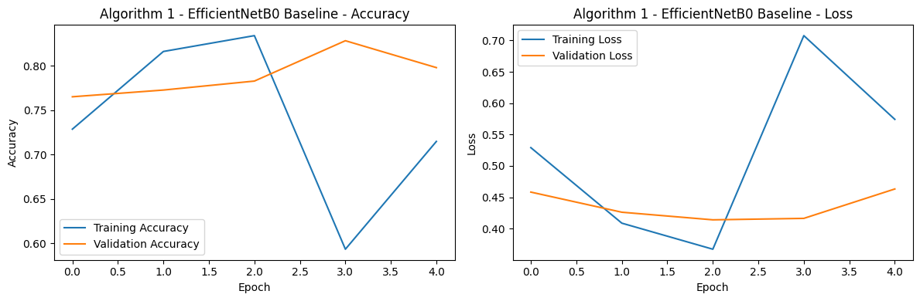
Figure 4.1: Training and validation curves for Algorithm 1 - EfficientNetB0 baseline.

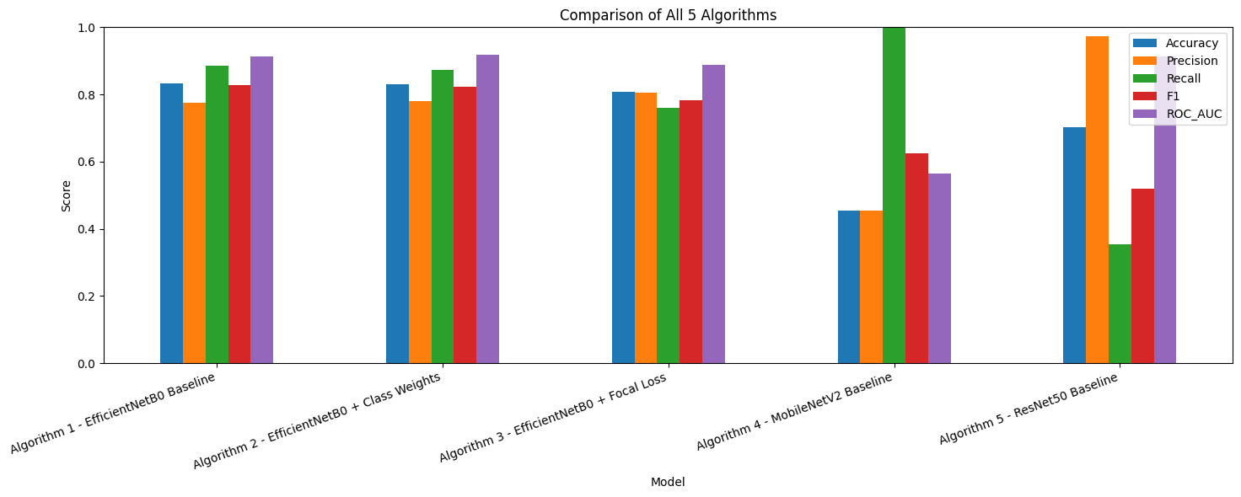
Figure 4.2: Comparison of the five implemented algorithms across key performance metrics.

4.4 Explainability and Output Generation
The last element of implementation was aiming at output generation and elucidation. Once every algorithm was trained, a complete classification report would be printed, and a confusion matrix and a ROC curve were generated. A comparison table containing all the results was then compiled and a grouped bar chart visualised. This enabled the user to make simultaneous comparison between model behaviour in accuracy, precision, recall, F1-score, and ROC-AUC. Another prediction cell was also generated at the notebook. A set of small test images were then loaded in that cell, and a set of images were processed with the best-chosen model and the true label, predicted label and the confidence score returned. This feature was a user facing result panel within the Colab environment.
The explainability methodology was Grad-CAM since it was a lightweight model that is easily applied to the CNN backbones chosen [10], [27]. The last convolutional layer of the optimum model was determined in the implementation, and the gradient of the prediction in that layer was calculated and the resulting heatmap was superimposed on the input image. This provided the possibility of visual observation of whether the focus on interest was the model or the background that was irrelevant. Figure 4.3 represents a display of predictions in the last notebook whereas Figure 4.4 exhibits a sample output of ROC. Collectively, these numbers indicate that the implementation was not limited to classification alone, the process also produced outputs that can be interpreted and ready to be reported to facilitate evaluation, discussion and reuse in the future.
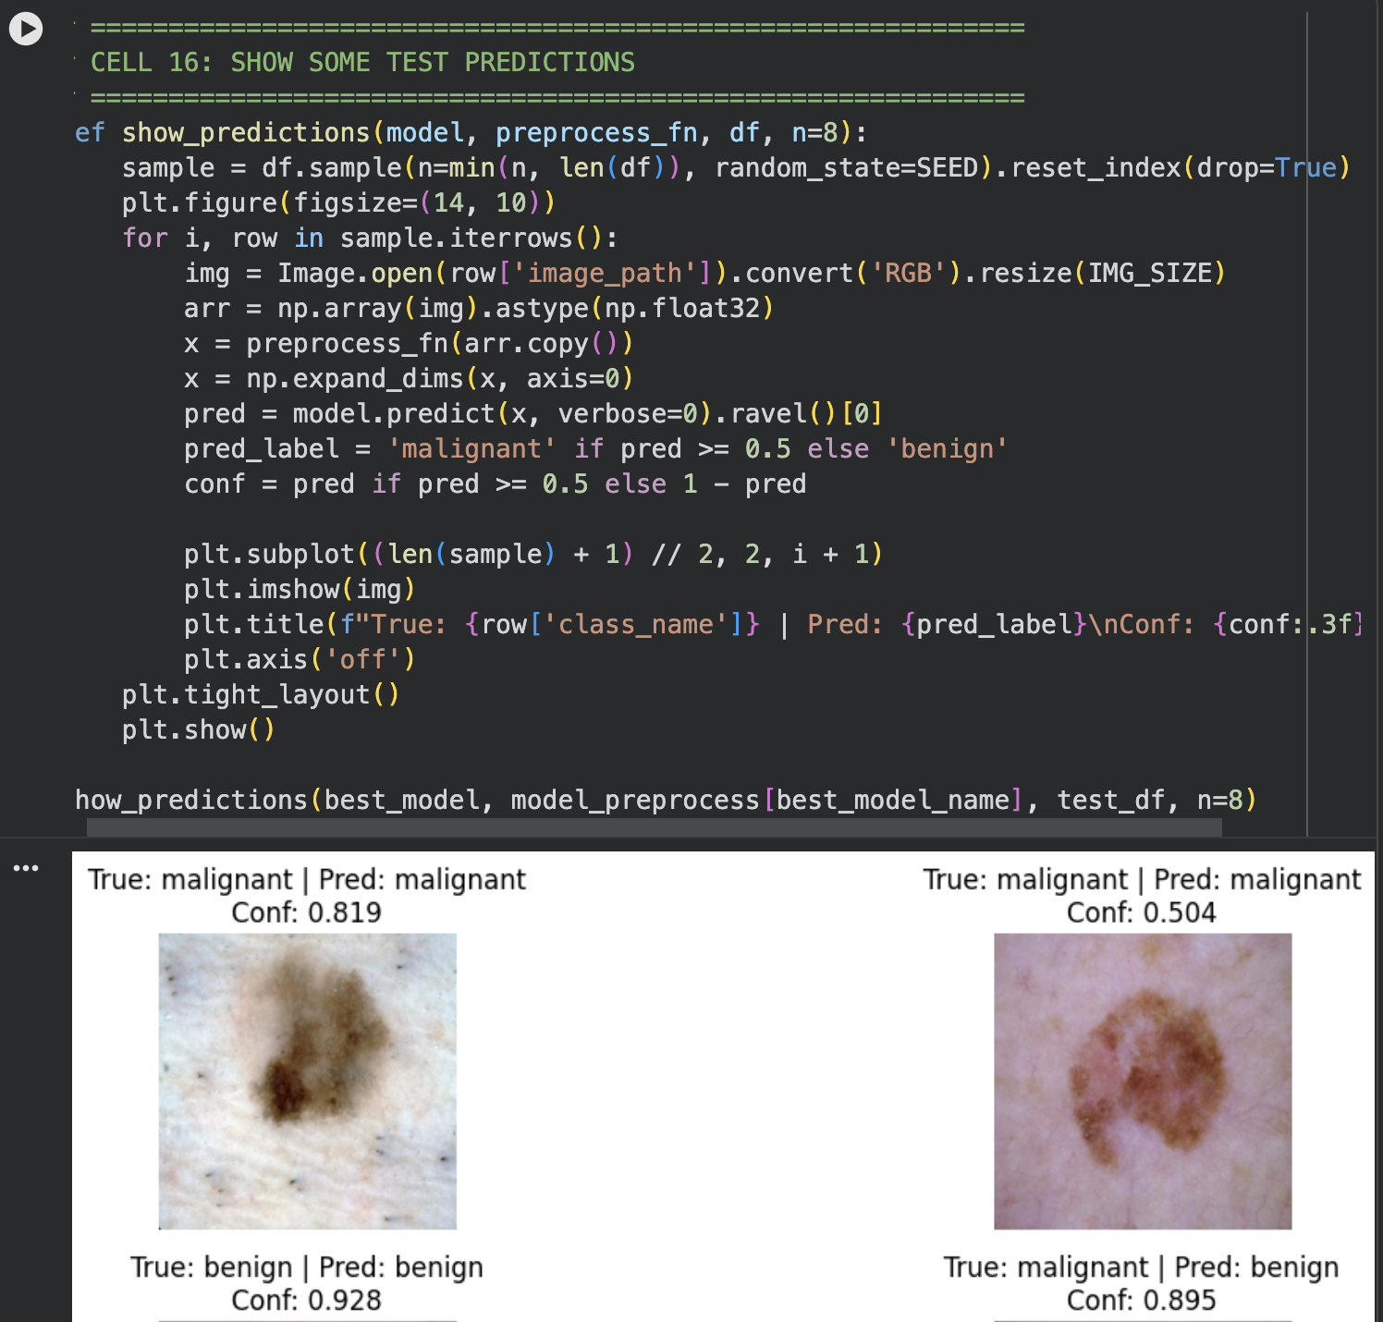
Figure 4.3: Prediction display from the final Colab system showing true class, predicted class, and confidence.
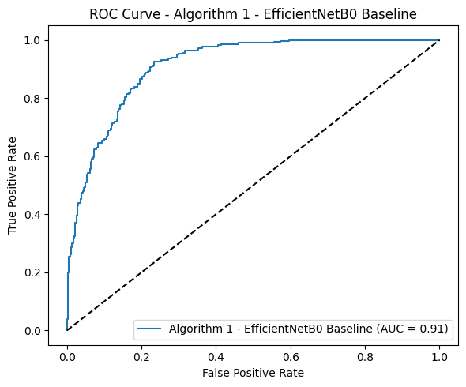
Figure 4.4: ROC curve for Algorithm 1 - EfficientNetB0 baseline.

5.0 TESTING & EVALUATION

5.1 Testing Strategies
Functional testing, integration testing, and performance testing were combined to achieve testing. Individual functions like image extraction, image verification, label assignment and metric calculation were conducted with unit-style checks. Integration testing also found out that the components worked in harmony with each other since file extraction to prediction output. Performance testing was comprised of testing of quality of models, stability of training, and discriminative ability. This was an appropriate strategy since the end artefact was not a web-based application or a mobile interface. This was a machine learning pipeline notebook, and therefore the most significant test query was whether every computational step performed properly and whether the entire pipeline generated reliable results.
There were 5 core behaviours on which a test plan was developed. The initial behaviour was the dataset extraction, split validation. Image cleaning and integrity checking was the second. The third one was training and generation of the results on the successful baseline model. The fourth was proper treatment of weighting and loss-based variants. The fifth was prediction and visual explanation output. The tests were passed where the notebook generated the expected output without file errors, label matching, or failure of the metrics. Table 5.1 provides the test cases that will be utilized in the main part of the project.

Test Case ID | TC001
Test Case Title | Dataset extraction and folder validation
Objective | Verify that the archive is extracted correctly, and that train and test folders are recognised by the notebook.
Preconditions | archive.zip uploaded to /content and unzip cell ready.
Test Steps | Run the extraction cell and confirm that /content/data/train and /content/data/test exist.
Test Data | archive.zip
Expected Result | Folder extraction completes and both class folders are available.
Pass/Fail | Pass
Comments | The system extracted the dataset correctly and created the expected directory structure.

Test Case ID | TC002
Test Case Title | Image verification and cleaning
Objective | Verify that the cleaning function checks image readability before training.
Preconditions | Folder paths available and data frames created.
Test Steps | Run the image verification function on train, validation, and test data frames.
Test Data | All image files in the dataset
Expected Result | Broken image count is reported and invalid files are removed if found.
Pass/Fail | Pass
Comments | The output showed zero broken images across all three splits.

Test Case ID | TC003
Test Case Title | Baseline training and metric generation
Objective | Verify that the EfficientNetB0 baseline trains successfully and outputs evaluation metrics.
Preconditions | Prepared data pipeline and preprocessing functions available.
Test Steps | Run Algorithm 1 cell and inspect training curves, classification report, and confusion matrix.
Test Data | Training, validation, and test image batches
Expected Result | Model trains and produces valid scores above random performance.
Pass/Fail | Pass
Comments | Algorithm 1 completed training and returned strong balanced results.

Test Case ID | TC004
Test Case Title | Weighted and focal-loss comparison
Objective | Verify that weighting and focal-loss variants run correctly under the same pipeline.
Preconditions | Baseline pipeline already functioning.
Test Steps | Run Algorithm 2 and Algorithm 3 cells and compare performance outputs.
Test Data | Same image splits as baseline
Expected Result | Both variants complete training and generate comparison-ready outputs.
Pass/Fail | Pass
Comments | The class-weighted model slightly improved ROC-AUC, while focal loss reduced overall balance.

Test Case ID | TC005
Test Case Title | Prediction and explainability output
Objective | Verify that the best model can generate final predictions and Grad-CAM visualisations.
Preconditions | Best model selected and saved after evaluation.
Test Steps | Run the prediction display and Grad-CAM cells on sample test images.
Test Data | Sample benign and malignant test images
Expected Result | Notebook displays predicted labels, confidence scores, and heatmap overlays.
Pass/Fail | Pass
Comments | The final system displayed prediction panels and interpretable heatmaps successfully.

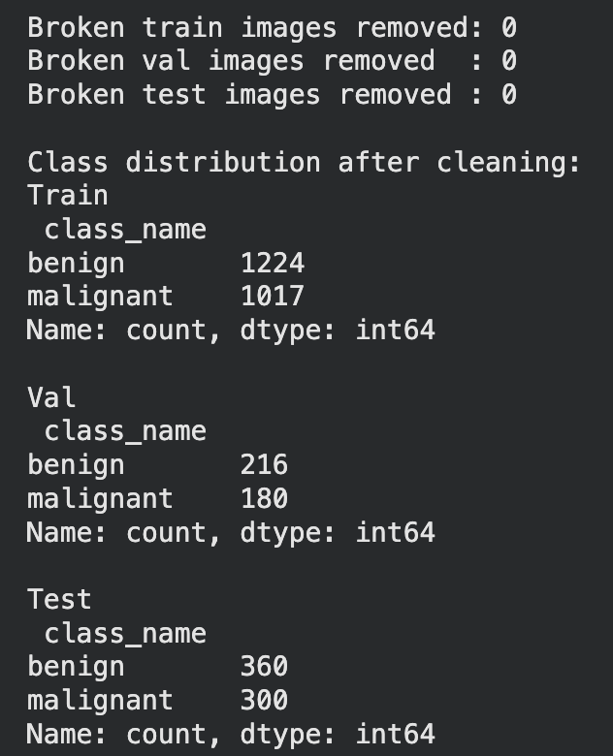
Figure 5.1: Screenshot evidence for TC001 and TC002 showing split creation and class verification.
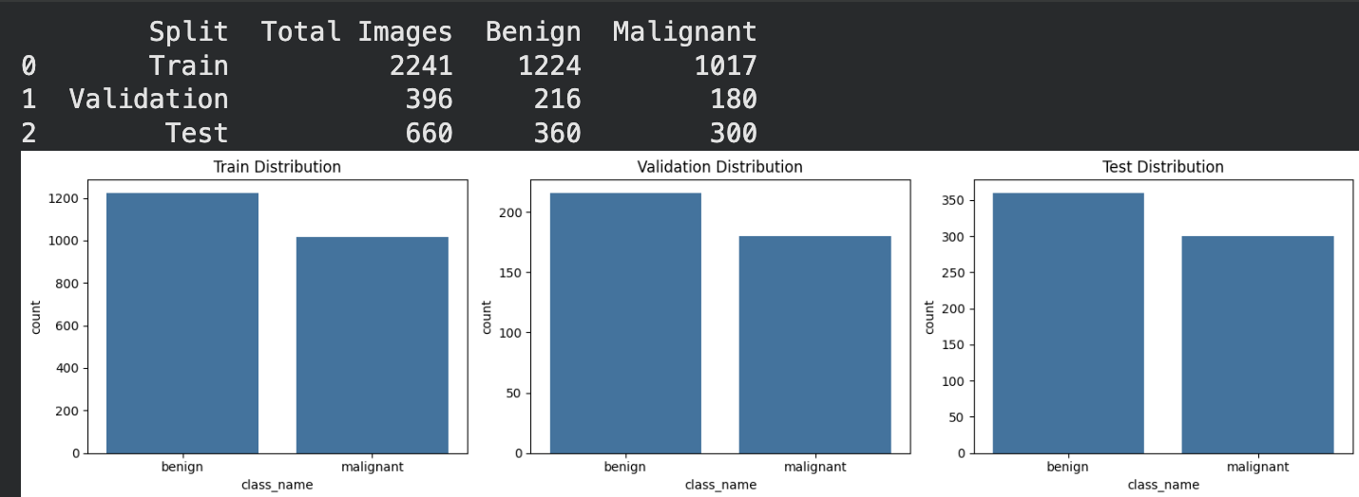
Figure 5.2: Screenshot evidence for TC003 showing baseline evaluation output and confusion matrix.
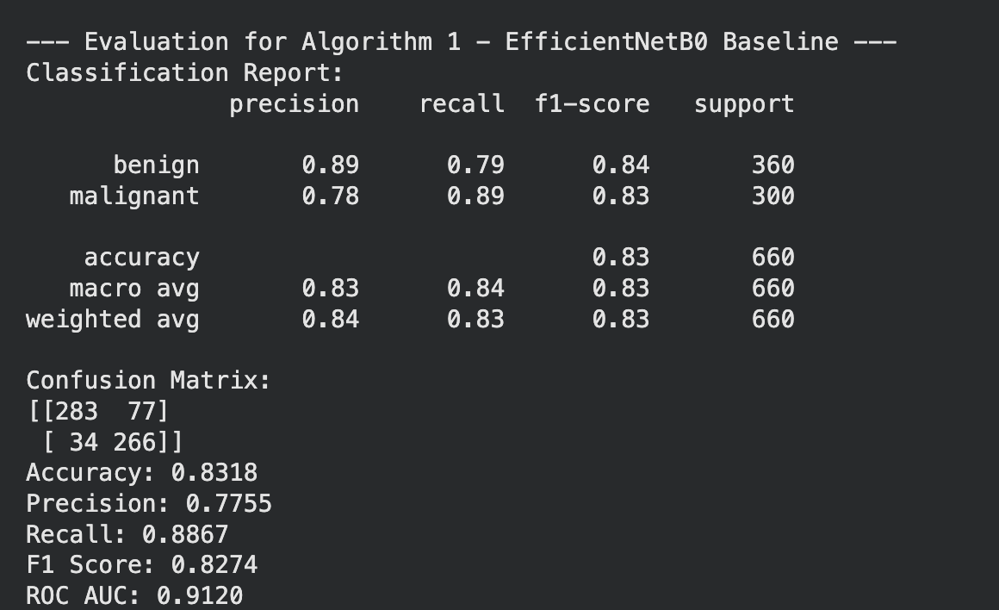
Figure 5.3: Screenshot evidence for TC004 showing the class-weighted EfficientNetB0 output.
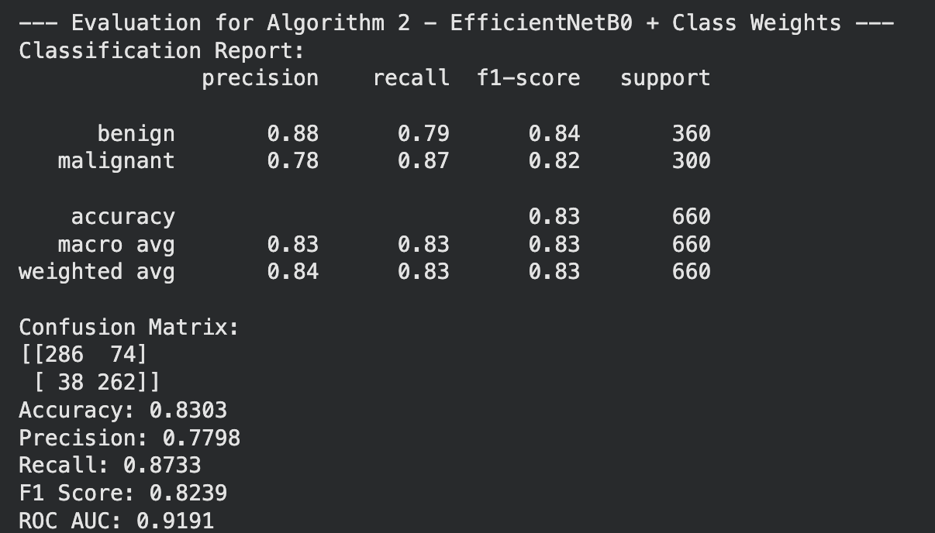
Figure 5.4: Screenshot evidence for TC004 showing the focal loss model output.
Figure 5.5: Screenshot evidence for TC005 showing the final prediction panel.

5.2 Experimental Results and Performance Evaluation
The last experiments resulted in the distinct difference between the algorithms. Algorithm 1, the EfficientNetB0 baseline, achieved an accuracy of 0.8318, precision of 0.7755, recall of 0.8867, F1-score of 0.8274, and ROC-AUC of 0.9120. The confusion matrix indicated 283 benign images were correctly classified, 77 benign images were erroneously classified as malignant, 266 malignant images were correctly classified and 34 malignant images were erroneously classified as benign. This model thus was recalled strongly on malignant lesions which is critical in a screening environment since false alarms on the minor cases is less critical than false alarms that missed malignant cases.
Algorithm 2, EfficientNetB0 with class weights, produced an accuracy of 0.8303, precision of 0.7798, recall of 0.8733, F1-score of 0.8239, and ROC-AUC of 0.9191. This model was not more accurate or had higher F1-score than the baseline, but it had the highest ROC-AUC of all the five algorithms. The finding indicated that there was a modest enhancement of threshold-independent discrimination by class weighting, although the balanced binary data set did not require one formidable imbalance correction. Algorithm 3, EfficientNetB0 with focal loss, reached an accuracy of 0.8076, precision of 0.8057, recall of 0.7600, F1-score of 0.7822, and ROC-AUC of 0.8891. Focal loss in this instance was not better than the baseline. Probably the reason was that the selected dataset was already fairly balanced, and the further attention on harder cases might have caused the decrease in the overall stability of the model.
Baseline algorithm MobileNetV2 Algorithm 4 did not achieve good results. It achieved an accuracy of 0.4545, precision of 0.4545, recall of 1.0000, F1-score of 0.6250, and ROC-AUC of 0.5656. The confusion chart indicated that the model had almost all false negatives as malignant in the model, which had zero benign detection counts. Such conduct was only a breakdown in one direction to a correct decision and not a true division between classes. MobileNetV2 was not the best under the given training settings to train this dataset because it is not efficient and is quite lightweight. Algorithm 5, ResNet50 baseline, produced an accuracy of 0.7015, precision of 0.9725, recall of 0.3533, F1-score of 0.5183, and ROC-AUC of 0.9135. The trend of this model was the reverse of MobileNetV2. It was very accurate in making predictions of malignant, yet it was a low hit when compared to malignant cases. This rendered its use less helpful in screening since the recall was too low.
The standard formulae that were needed in binary medical classification were used to derive the evaluation measures. The computation of accuracy was made as (TP + TN)/(TP + TN + FP + FN), where TP represented the cases of malignancy that were correctly predicted being malignant, TN represented the cases of malignancy that were correctly predicted being benign, FP represented the cases of malignancy that were not correctly predicted and FN represented the cases of malignancy that were not correctly predicted. Precision has been computed as TP / (TP + FP). Recall or Sensitivity was TP /(TP +FN). F1-score has been calculated 2 (Precision Recall)/Precision + Recall). The rationale behind the use of ROC-AUC to rank performance across thresholds is that it gives the performance information even limited to the classification threshold shifts.
It was observed in the comparison chart that Algorithms 1 and 2 were the best in all aspects. The balance between the accuracy, recall, and F1-score was best provided by algorithm 1 only. The Algorithm 2 has shown the highest ROC-AUC and it is also very close to the Algorithm 1 on the rest of the major indicators. The algorithm 3 was acceptable and had lesser strength. The selected configuration failed in Algorithm 4 and Algorithm 5 displayed high precision and unreasonable sensitivity in a screening-based task, respectively. Figure 5.1 to 5.5 show curves of the training and ROC plots of the five algorithms. These visuals were beneficial since they did not only display the final results but also the training behaviour prior to the results. Relatively steady validation performance existed in the EfficientNetB0-based models and more problematic generalisation patterns occurred involving MobileNetV2 and ResNet50.
Accuracy = (TP + TN) / (TP + TN + FP + FN)
Precision = TP / (TP + FP)
Recall = TP / (TP + FN)
F1-score = 2 × (Precision × Recall) / (Precision + Recall)
ROC-AUC measures the ability of the model to separate benign and malignant cases across thresholds.

Algorithm | Accuracy | Precision | Recall | F1-score | ROC-AUC
Algorithm 1 - EfficientNetB0 Baseline | 0.8318 | 0.7755 | 0.8867 | 0.8274 | 0.9120
Algorithm 2 - EfficientNetB0 + Class Weights | 0.8303 | 0.7798 | 0.8733 | 0.8239 | 0.9191
Algorithm 3 - EfficientNetB0 + Focal Loss | 0.8076 | 0.8057 | 0.7600 | 0.7822 | 0.8891
Algorithm 4 - MobileNetV2 Baseline | 0.4545 | 0.4545 | 1.0000 | 0.6250 | 0.5656
Algorithm 5 - ResNet50 Baseline | 0.7015 | 0.9725 | 0.3533 | 0.5183 | 0.9135
Table 5.2: Final performance evaluation of all five algorithms.

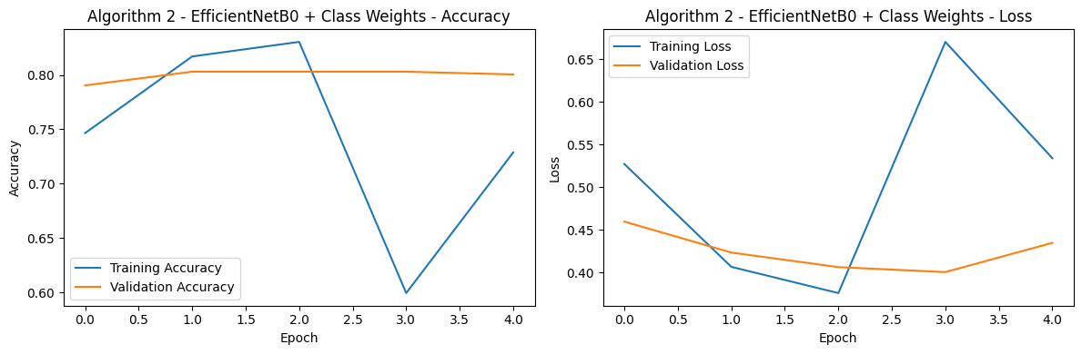
Figure 5.6: Training and validation curves for Algorithm 2 - EfficientNetB0 with class weights.
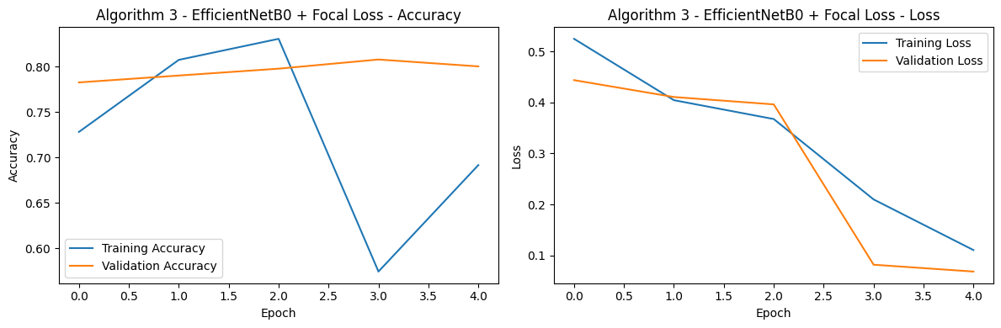
Figure 5.7: Training and validation curves for Algorithm 3 - EfficientNetB0 with focal loss.
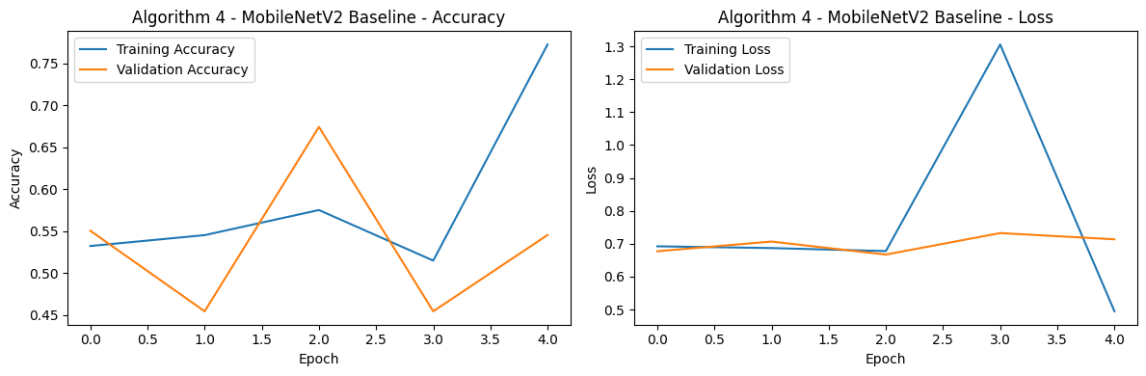
Figure 5.8: Training and validation curves for Algorithm 4 – MobileNetV2 baseline.
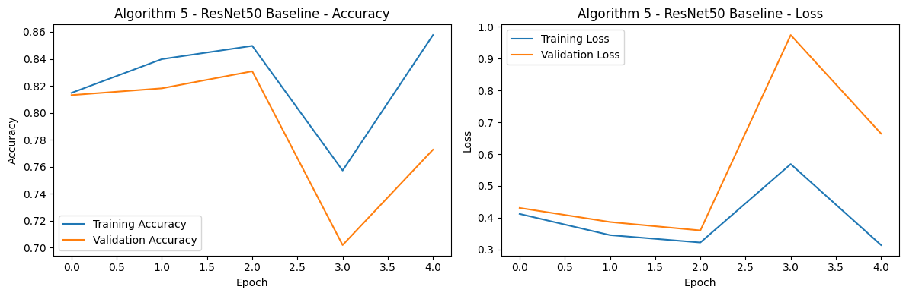
Figure 5.9: Training and validation curves for Algorithm 5 - ResNet50 baseline.
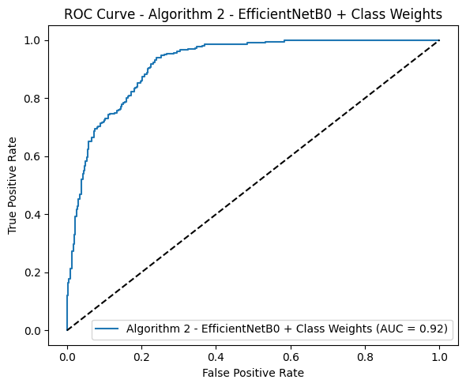
Figure 5.10: ROC curve for Algorithm 2 - EfficientNetB0 with class weights.

5.3 Results & Discussion
The last artefact was the full Google Colab pipeline that classifies binary skin cancer pictures. The developed system was able to extract the dataset, authenticate images, generate train, validation, and test splits, trained five transfer learning models, generated performance measurements, presented comparison charts, and presented prediction examples and visual explanations using Grad-CAM. This equated to the fact that the system achieved its practical development objective. It was initially failing to provide a hospital-ready clinical platform, although it created a practical, reproducible research prototype capable of running statistically through to the end, in a cloud notebook setting.
A number of features applied in it worked. The process of data processing was constant and showed no dislocated photographs. The augmentation strategy was not so big that the identity of the lesions would be affected but rather was light enough to enable generalisation. EfficientNetB0 was the best backbone in the chosen runtime constraints particularly when applied with class weights or with a baseline. The prediction display feature was also effective as it provided a simple user-friendly interpretation of model output, and the Grad-CAM module was interpretable at little additional expense. The grouped bar chart and the ROC curves proved particularly useful to be discussed since the algorithmic differences could be easily interpreted with their help.
It also indicated the results that not all apparent advanced variations lead to an improvement. Class weights provided a limited ROC-AUC edge which did not enhance primary accuracy or F1-score. This dataset was impaired by focal loss. It implies that loss engineering should be aligned with the data instead of being done on a routine basis. MobileNetV2 with its appealing low computational footprint was unable to learn meaningful class separation in the experiment. ResNet50 had a very high accuracy but low recall, which was inappropriate when it was required in the screening aspect of the research. These results reinrolled another general lesson of the literature: the most appropriate model is not one with the biggest architecture or the most complicated modification, but the one which works well on realistic conditions with balanced, reliable and more understandable performance [11][23][27][35].
The project goals were met, to a high extent. The pipeline was developed in Python on Google Colab to be replicated. The various algorithms were put against each other under similar conditions. The test was performance according to other weighting and loss strategies. Outputs were made by visual explanation to be exploited in the process of interpretation. The research thus had a working system artefact and a systematic analysis of the behaviour of several deep learning selections on a manageable binary skin area dataset. Simultaneously restrictions still existed. The sample size was also quite small, and it may not have reflected the overall spectrum of clinical dermoscopy. The non-existence of the outside validation implies that the findings are to be taken as encouraging yet rough. The finished system then will need to be considered as a solid academic prototype and not a complete diagnostic product.

6.0 CONCLUSION AND FUTURE WORK

6.1 Summary of Findings
The aim of the project was to design and test an AI-assisted skin lesion classifier pipeline on a smaller and simpler to compute dermoscopic image dataset. The latter system realized that objective. The entire Google Colab workflow was created, which extracted the dataset, cleaned and verified files, trained five transfer learning models, generated metrics, displayed sample predictions, and generated Grad-CAM explanations. Then the study was able to come up with a reproducible technical artefact and organised assessment of model behaviour.
The empirical results indicated that EfficientNetB0 created the best overall performance with the test binary dataset. The EfficientNetB0 baseline model produced the optimal accuracy, recall, and F1-score whereas class-weighted EfficientNetB0 produced the maximum ROC-AUC. The two models were the sole models that had a high level of discrimination with clinically valuable sensitivity. The findings have indicated that it can be possible to achieve good screening-style performance with a rather small workflow, provided that the size of the dataset is manageable and an experimental design is controlled. It was also indicated that complexity alone does not necessarily translate to improvement. The loss of focus was not even as better than a baseline in this balanced environment. MobileNetV2 was not good at splintering classes, whereas ResNet50 is excellent in the precision, yet it missed a large number of malignant cases not to be suitable in the context of a screening goal.
The other significant discovery was that output interpretation is the key to success as much as final measures. The confusion matrices, ROC curves, sample prediction panels, and Grad-CAM outputs were used to identify the strengths and weaknesses of the model in a very clear way. They demonstrated that the project was not only able to justify scores but that they could get a more abundant interpretation of how the system would behave. This proved useful since medical image research ought to complement the transparent reasoning rather than un-cooked numbers of predictions.

6.2 Research Contributions
The paper had both scholarly and practical contributions. The scholarly value is portrayed in demonstrating how deep learning experiment can be conducted on a smaller dataset on the binary skin lesion when well planned. Much of the literature on skin lesion generally focuses on massive datasets, multi-class task or complicated hybrid schemes. In this project, it was shown that even using a smaller Kaggle dataset, it is possible to compare algorithms, weighting strategies, and explainability outputs in a methodologically coherent manner. It is handy amongst students and researchers of early stage who require a project, which is computationally viable but also methodically valid.
The practical contribution is the building of a working artefact. The notebook is not only a set of some isolated experiments. It was an inseparable mini system. It dealt with the extraction of files, cleaning of data, division of data set, training of model, assessment of model, storage of results, prediction in words and Grad-CAM visualisation. This is useful in a teaching or prototype environment such as it gives a complete end-to-end demonstration of the implementation of an AI skin lesion screening workflow. Reuse and extension is also possible without significant redesign to the system. The other valuable input was the comparison of five algorithms in the same conditions of data. That allowed demonstrating what design decisions were really useful and which of them were not. Results were indicative that EfficientNetB0 was a more satisfactory trade-off between performance and efficiency than the lightweight MobileNetV2 or the heavyweight ResNet50 under these conditions.
The other contribution to the practice in the study was that interpretation of the study can be put into a manageable pipeline. Introduction of Grad-CAM outputs to the main notebook made it more transparent and provided a more stable foundation to discuss the focus of the model. This increased the validity of the system as a research prototype and put the work on par with the contemporary expectations of explainable medical AI.

6.3 Future Work and Recommendations
The project led to several recommendations. First, the most effective model should be tested on a bigger and more heterogeneous data in the future. The dataset chosen was appropriate in terms of quick experimentation although it was rather small and could not probably include the entire range of appearance of the lesion in a real clinical setting. Next natural validation with larger sets like HAM10000 or other Utilization screens based on the ISIC would then be a rational step. Second, binary classification should be extended in case computational resources are available to the project. The binary framing in use was convenient due to its ability to run in fewer steps and assessments, though in reality dermatology choices are typically not limited to two categories. A subsequent implementation of the project may then proceed to adjust the identical pipeline to a multi-class problem.
Third, further studies need to be conducted on threshold tuning instead of default classification boundary of 0.5. A slightly lower threshold can maximise sensitivity to malignant lesions, whereas a higher threshold can minimise false alarms in a clinical screening sort of situation. This would add some practical value to threshold optimisation based on the clinical role of the model that the model is expected to play. Fourth, additional explainability techniques need to be experimented. The reason why Grad-CAM was such a good first option was that it was implemented lightweight and graphically user-friendly but other image-based methods like integrated gradients or SHAP have the potential to be able to give more insight into how the models think.
Fifth, the notebook would be refined by making the user interface lightweight and could serve in demonstration purposes. The current implementation of the interface was the Colab output itself, which is good with researchers, but not non-technical users. The optimal model might be embedded in a straightforward web-based interface that a user may upload a dermoscopic image and get a prediction regarding the classification, a confidence score, and a map of explanations in a future project. This would make the system stronger in its practical display. Lastly, further work in the area should consider more control of bias and analysis of fairness. Although the chosen dataset was convenient and it was easy to run, it lacked a rich demographic structure. Medical AI systems ought to be later tested as to their performance in terms of various groups of patients, in different light, and in various acquisition devices.

References
Dataset link: https://www.kaggle.com/datasets/fanconic/skin-cancer-malignant-vs-benign
[1] M. B. Jan, M. Rashid, R. Vavekanand, and V. Singh, “Integrating explainable AI for skin lesion classifications: A systematic literature review,” Studies in Medical and Health Sciences, 2025.
[2] H. A. Owida, I. Abd El-Fattah, S. Abuowaida, et al., “A deep learning-based dual-branch framework for automated skin lesion segmentation and classification via dermoscopic images,” Scientific Reports, vol. 15, 2025.
[3] M. AbdulmateenAdebiyi, M. S. NaderAbdalnabi, E. Hoffman Smith, J. Hirner, E. J. Simoes, M. Becevic, and P. Rao, “Accurate skin lesion classification using multimodal learning on the HAM10000 dataset,” 2024.
[4] K. Ramamurthy, I. Thayumanaswamy, M. Radhakrishnan, D. Won, and S. Lingaswamy, “Integration of localized, contextual, and hierarchical features in deep learning for improved skin lesion classification,” Diagnostics, vol. 14, 2024.
[5] A. S. Al-Waisy, S. Al-Fahdawi, M. I. Khalaf, et al., “A deep learning framework for automated early diagnosis and classification of skin cancer lesions in dermoscopy images,” Scientific Reports, vol. 15, 2025.
[6] F. Afza, M. Sharif, M. A. Khan, U. Tariq, H.-S. Yong, and J. Cha, “Multiclass skin lesion classification using hybrid deep features selection and extreme learning machine,” Sensors, vol. 22, 2022.
[7] M. Fiaz, M. B. S. Khan, A. H. Khan, A. Bilal, M. Abdullah, A. A. Darem, and R. Sarwar, “An explainable hybrid deep learning framework for precise skin lesion segmentation and multi-class classification,” Frontiers in Medicine, vol. 12, 2025.
[8] S. B. U. Meeran, “AI-powered skin lesion diagnosis using Whale Optimization Algorithm enhanced ResNet 50 for cancer prediction,” Asian Pacific Journal of Cancer Prevention, vol. 26, no. 8, pp. 2919–2928, 2025.
[9] Y. S. Ingle and N. Faiz, “Deep learning for skin cancer classification: A comparative study of CNN and VGG16 on HAM10000 dataset,” Communications on Applied Nonlinear Analysis, 2024.
[10] N. Ahmad, J. H. Shah, M. A. Khan, J. Baili, G. J. Ansari, U. Tariq, Y. J. Kim, and J. Cha, “A novel framework of multiclass skin lesion recognition from dermoscopic images using deep learning and explainable AI,” Frontiers in Oncology, vol. 13, 2023.
[11] A. Abbas and H. Elbehiery, “A robust skin cancer classification using deep learning,” Sustainable Machine Intelligence Journal, 2025.
[12] M. Raihan and K. Talukder, “Fuzzy Gompertz-based deep ensemble with explainable AI for skin lesion classification,” International Journal for Multidisciplinary Research, 2025.
[13] Y. Nie, P. Sommella, M. Carratù, M. O’nils, and J. Lundgren, “A deep CNN transformer hybrid model for skin lesion classification of dermoscopic images using focal loss,” Diagnostics, vol. 13, 2022.
[14] S. M. Thwin and H.-S. Park, “Skin lesion classification using a deep ensemble model,” Applied Sciences, vol. 14, 2024.
[15] H. Alharbi, G. A. R. Sampedro, R. A. Juanatas, and S.-J. Lim, “Enhanced skin cancer diagnosis: A deep feature extraction-based framework for the multi-classification of skin cancer utilizing dermoscopy images,” Frontiers in Medicine, vol. 11, 2024.
[16] A. F. Sönmez, S. Çakar, F. Cerezci, M. Kotan, I. Delibasoglu, and G. Cit, “Deep learning-based classification of dermoscopic images for skin lesions,” Sakarya University Journal of Computer and Information Sciences, 2023.
[17] A. S. Rajpoot, R. Dixit, and A. Shukla, “Skin cancer classification in dermoscopic images using multi-scale feature map fusion,” International Journal of Imaging Systems and Technology, 2025.
[18] T. H. H. Aldhyani, M. H. Al-Adhaileh, and D. Koundal, “Multi-class skin lesion classification using a lightweight dynamic kernel deep-learning-based convolutional neural network,” Diagnostics, vol. 12, 2022.
[19] C. N. Kanani and P. Jadeja, “Skin disease diagnosis: A comprehensive survey of models, datasets, and clinical applications,” Cureus Journal of Computer Science, vol. 2, 2025.
[20] K. Chapa, K. Varsha, M. V. Krishna, M. V. Bhavitha, and K. L. Deepak, “Deep learning model for accurate classification of skin cancer using dermoscopic images,” International Journal of Advanced Research in Science, Communication and Technology, 2023.
[21] A. S. Arshad, M. A. Khan, N. Almujally, A. Alasiry, M. Marzougui, and Y. Nam, “Multiclass skin lesion classification and localization from dermoscopic images using a novel network-level fused deep architecture and explainable artificial intelligence,” BMC Medical Informatics and Decision Making, vol. 25, 2025.
[22] M. Kahia and F. Kallel, “New deep learning approaches for binary skin cancer classification,” International Journal of Computational and Experimental Science and Engineering, 2025.
[23] M. Fraiwan and E. Faouri, “On the automatic detection and classification of skin cancer using deep transfer learning,” Sensors, vol. 22, 2022.
[24] M. R. Naeemah and M. Y. Kamil, “SKINVGG-NET: A modified and fine-tuned VGG19-based deep learning architecture for skin cancer classification,” International Journal of Advances in Signal and Image Sciences, 2025.
[25] H. S. R. Kumar, C. N. G. Babu, C. P. Vijay, et al., “Deep learning-based automated classification of skin lesions using CNN and computer vision,” SN Computer Science, vol. 6, 2025.
[26] S. A. Almutairi, “A dual-stream deep learning framework for skin cancer classification using histopathological-inherited and vision-based feature extraction,” Scientific Reports, vol. 15, 2025.
[27] M. Oyedeji, E. Okafor, H. Samma, and M. Alfarraj, “Interpretable deep learning for classifying skin lesions,” International Journal of Intelligent Systems, 2025.
[28] A. A. Mahmud, S. Azam, I. U. Khan, S. Montaha, A. Karim, A. Haque, M. Z. Hasan, M. Brady, R. Biswas, and M. Jonkman, “SkinNet-14: A deep learning framework for accurate skin cancer classification using low-resolution dermoscopy images with optimized training time,” Neural Computing and Applications, vol. 36, pp. 18935–18959, 2024.
[29] I. A. Ahmed, E. M. Senan, H. S. A. Shatnawi, Z. M. Alkhraisha, and M. M. Al-Azzam, “Multi-models of analyzing dermoscopy images for early detection of multi-class skin lesions based on fused features,” Processes, vol. 11, 2023.
[30] B. Shetty, R. Fernandes, A. P. Rodrigues, R. Chengoden, S. Bhattacharya, and K. Lakshmanna, “Skin lesion classification of dermoscopic images using machine learning and convolutional neural network,” Scientific Reports, vol. 12, 2022.
[31] K. Manzoor, N. U. Gilal, M. Agus, and J. Schneider, “Dual-stage segmentation and classification framework for skin lesion analysis using deep neural network,” Digital Health, vol. 11, 2025.
[32] Y. S. M. Yasir and H. Kim, “Attention-based deep feature aggregation network for skin lesion classification,” Electronics, 2025.
[33] A. Laouarem, C. Kara-Mohamed, E. Bourennane, and A. Hamdi-Cherif, “JILDYA-Net: An efficient lightweight multi-class classification architecture for skin lesions,” International Journal of Imaging Systems and Technology, vol. 35, 2025.
[34] A. Yılmaz, G. Gencoglan, R. Varol, A. A. Demircali, M. Keshavarz, and H. Uvet, “MobileSkin: Classification of skin lesion images acquired using mobile phone-attached hand-held dermoscopes,” Journal of Clinical Medicine, vol. 11, 2022.
[35] A. A. Youssef, E. Badr, N. Veraldo, and D. Hamza, “A comprehensive analysis of hybrid ConvNeXt and Vision Transformer architectures for skin cancer classification,” International Journal for Research in Applied Science and Engineering Technology, 2025.
[36] M. Shaheen, U. Saif, S. Awan, F. Ahmad, and A. Anum, “Classification of images of skin lesion using deep learning,” International Journal of Intelligent Systems and Applications, 2023.
[37] V. Dillshad, M. A. Khan, M. Nazir, O. Saidani, N. Alturki, and S. Kadry, “D2LFS2Net: Multi-class skin lesion diagnosis using deep learning and variance-controlled Marine Predator optimisation,” CAAI Transactions on Intelligent Technology, vol. 10, pp. 207–222, 2023.
[38] S. Sundari, D. Ak, and M. Islabudeen, “Skin lesions detection using deep learning techniques,” International Journal for Research in Applied Science and Engineering Technology, 2023.
[39] M. B. Tahir, A. Naeem, H. Malik, J. Tanveer, R. A. Naqvi, and S.-W. Lee, “DSCC_Net: Multi-classification deep learning models for diagnosing skin cancer using dermoscopic images,” Cancers, vol. 15, 2023.
[40] G. Nase and A. Arthanareeswaran, “Multiclass skin lesion classification using a hybrid symmetry-aware and soft attention (HSASA) model,” KSII Transactions on Internet and Information Systems, vol. 19, pp. 1792–1807, 2025.
[41] J. K. Nayak and P. Singh, Fundamentals of Research Methodology Problems and Prospects. SSDN Publishers and Distributors, 2021.
[42] M. Patel and N. Patel, “Exploring research methodology,” International Journal of Research and Review, vol. 6, no. 3, pp. 48–55, 2019.
[43] M. A. Ragab and A. Arisha, Research Methodology in Business: A Starter’s Guide, 2018.
[44] H. Snyder, “Literature review as a research methodology: An overview and guidelines,” Journal of Business Research, vol. 104, pp. 333–339, 2019.
[45] R. Acharyya and N. Bhattacharya, Eds., Research Methodology for Social Sciences. Taylor & Francis, 2019.
[46] V. Bairagi and M. V. Munot, Eds., Research Methodology: A Practical and Scientific Approach. CRC Press, 2019.
[47] N. Basias and Y. Pollalis, “Quantitative and qualitative research in business and technology: Justifying a suitable research methodology,” Review of Integrative Business and Economics Research, vol. 7, pp. 91–105, 2018.
[48] N. Greening, “Phenomenological research methodology,” Scientific Research Journal, vol. 7, no. 5, pp. 88–92, 2019.
[49] A. Gupta and N. Gupta, Research Methodology. SBPD Publications, 2022.
[50] R. Kapur, Research Methodology: Methods and Strategies. Department of Adult Education and Continuing Extension, University of Delhi, 2018.
[51] R. Kumar, Research Methodology: A Step-by-Step Guide for Beginners. Sage, 2018.
[52] S. K. V. Kumari, K. Lavanya, V. Vidhya, G. A. D. J. S. Premila, and B. Lawrence, Research Methodology, vol. 1. DARSHAN Publishers, 2023.
[53] N. Mahuika and R. Mahuika, “Wānanga as a research methodology,” ALTERATIVE: An International Journal of Indigenous Peoples, vol. 16, no. 4, pp. 369–377, 2020.
[54] S. B. Mishra and S. Alok, Handbook of Research Methodology. 2022.
[55] H. K. Mohajan, “Qualitative research methodology in social sciences and related subjects,” Journal of Economic Development, Environment and People, vol. 7, no. 1, pp. 23–48, 2018.
[56] S. P. Mukherjee, A Guide to Research Methodology: An Overview of Research Problems, Tasks and Methods. 2019.
[57] N. Codella et al., “Skin lesion analysis toward melanoma detection 2018: A challenge hosted by the International Skin Imaging Collaboration (ISIC),” 2018.
[58] P. Tschandl, C. Rosendahl, and H. Kittler, “The HAM10000 dataset, a large collection of multi-source dermatoscopic images of common pigmented skin lesions,” Scientific Data, vol. 5, 2018.

