Random number generation applied in Turtle

1. Draw a standard circle, 30 radius, with Turtle:

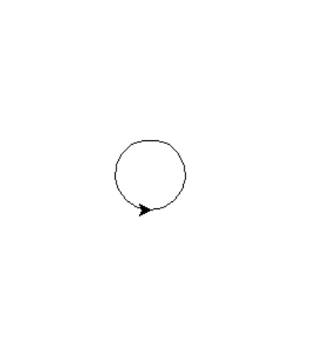

2. Make the width of the circle random, between 10 and 100. Generate the random number and then feed it in to the circle:

Sample output:
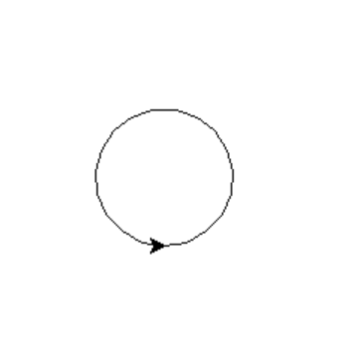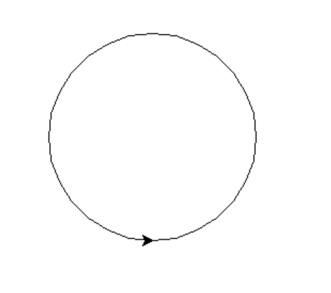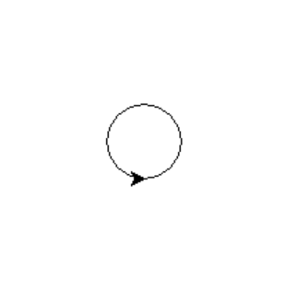

3. Change the start point for the circle randomly, generating co-ordinates within a 500 x 500 square:

Sample output:
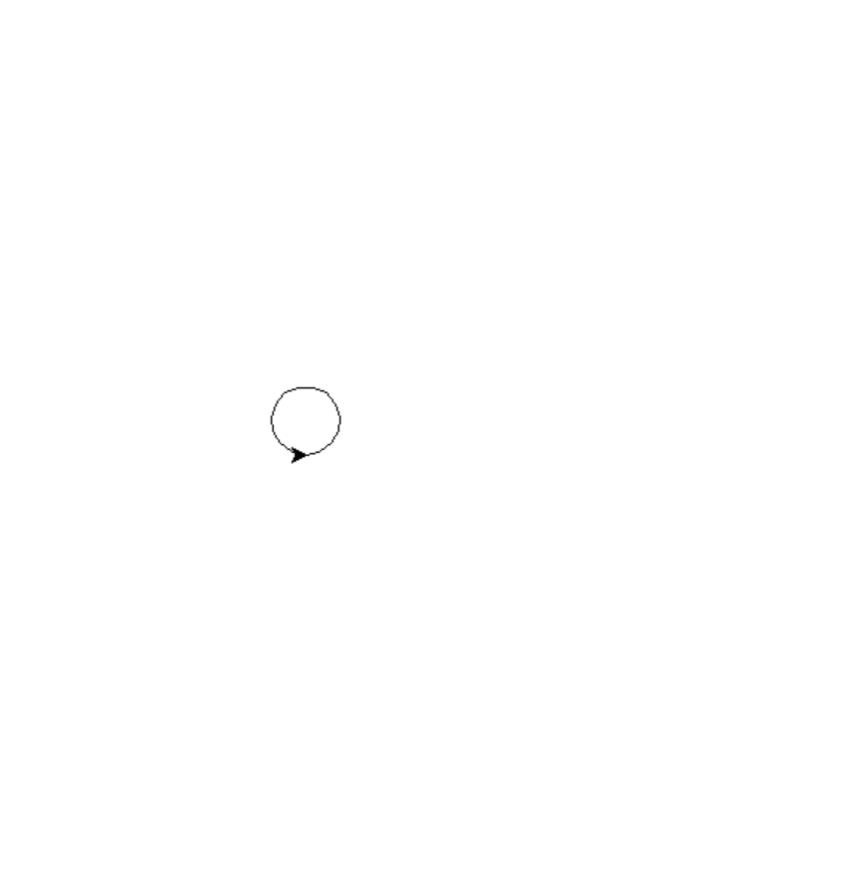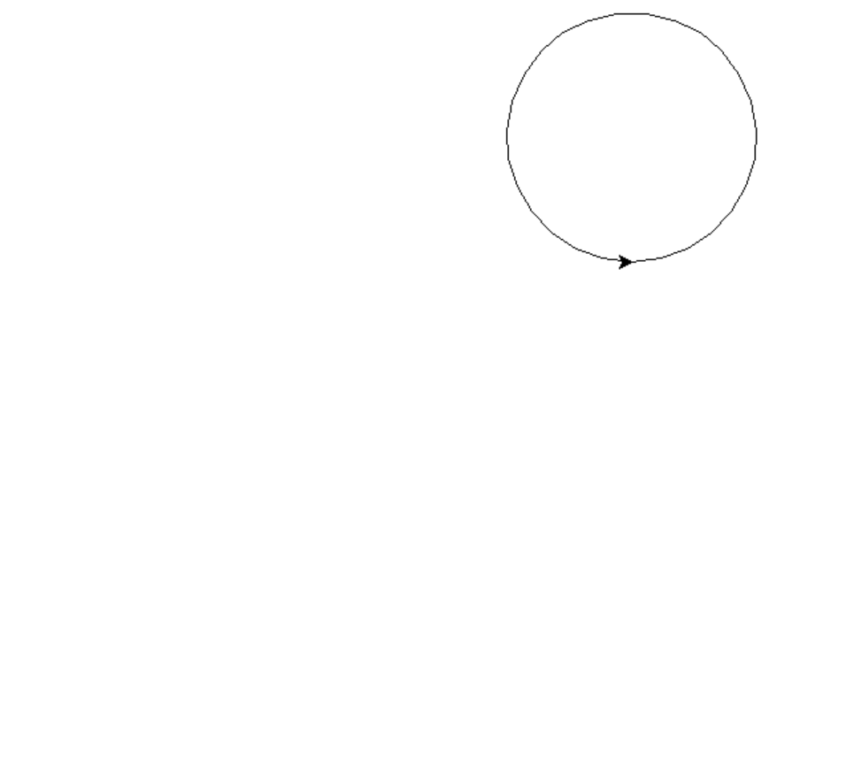
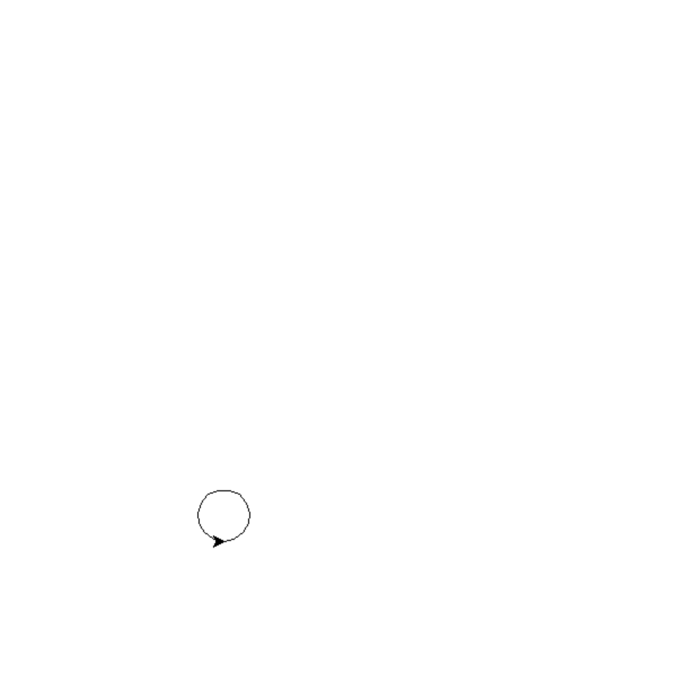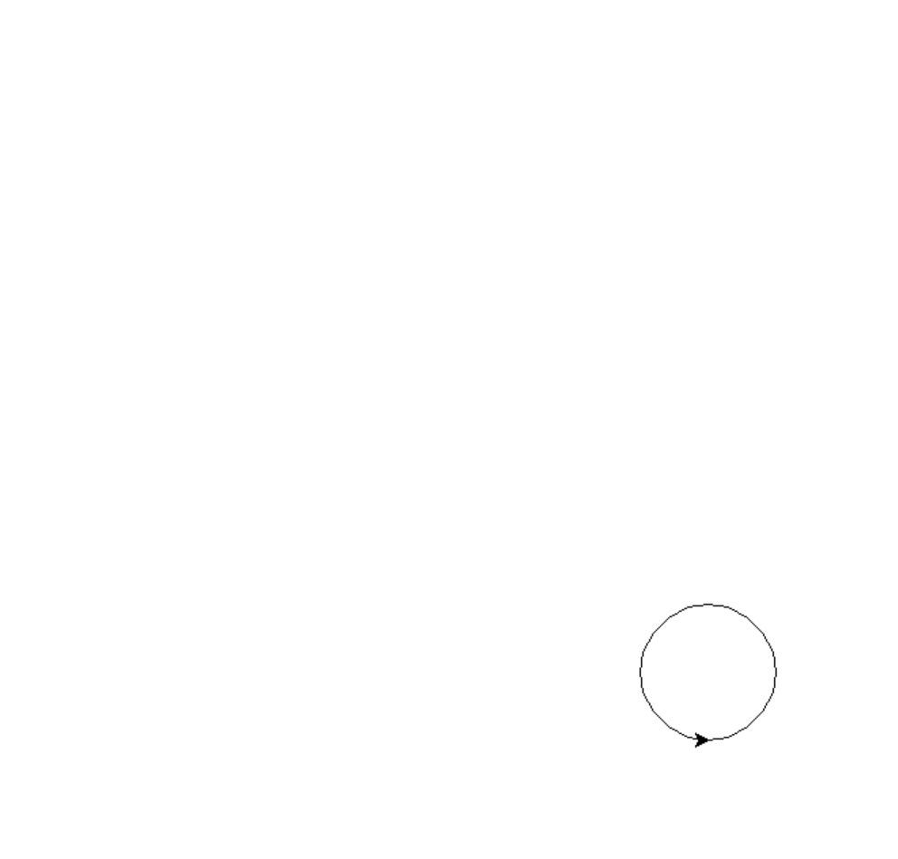

4. Loop the code 10 times:

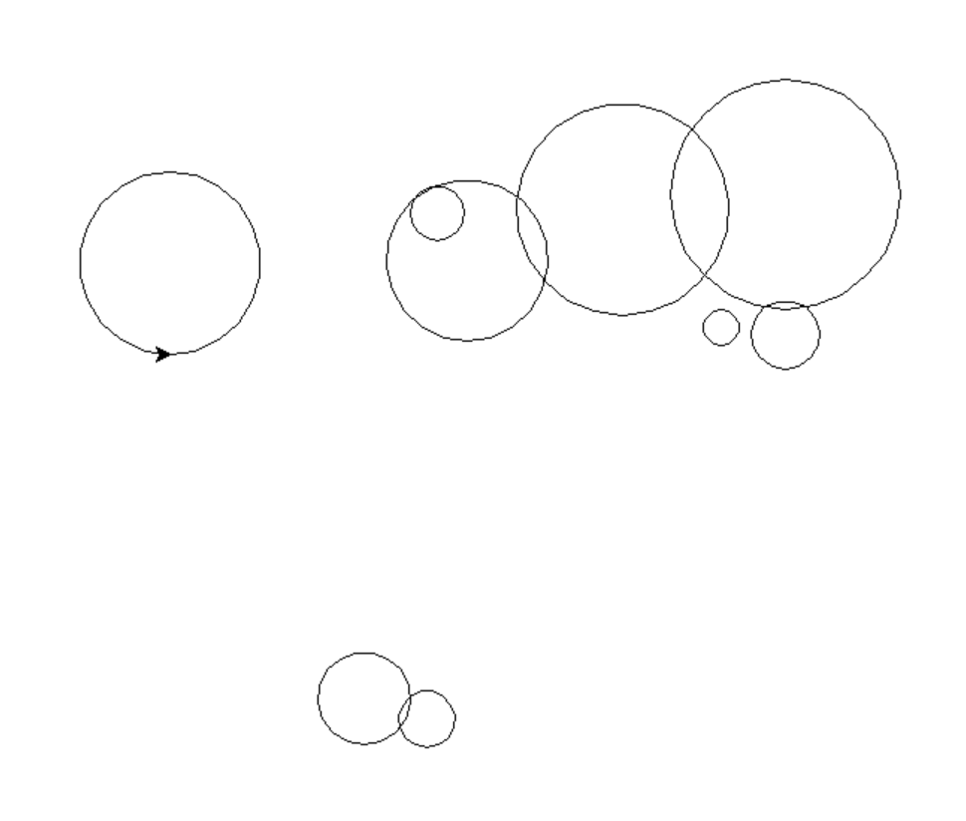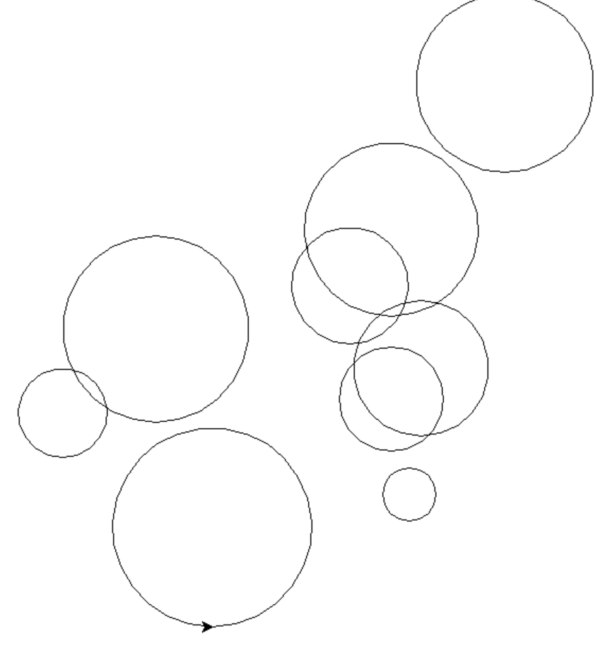

5. Loop the code a random number of times, between 5 and 100:

Sample output:

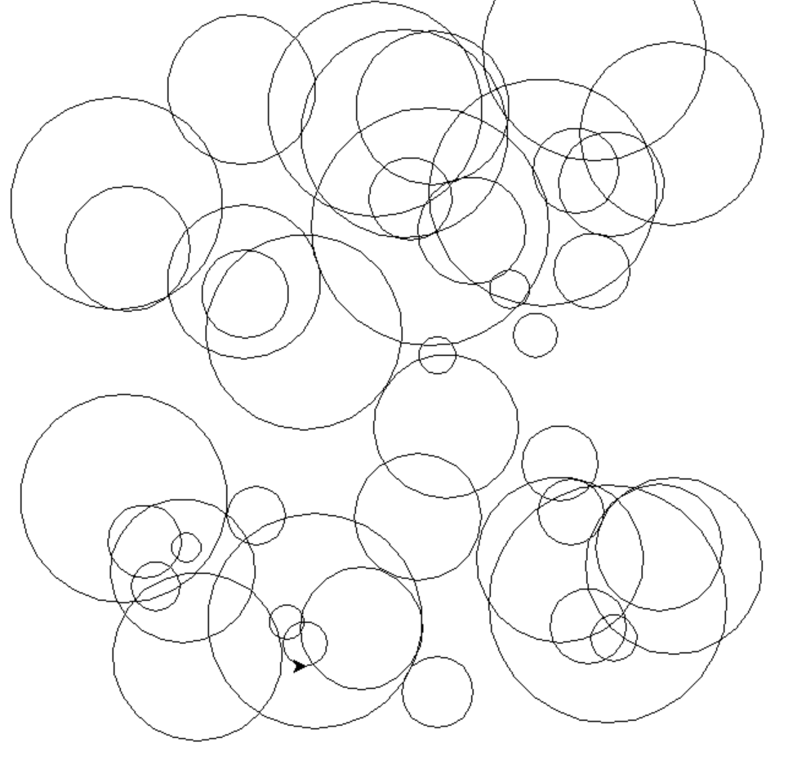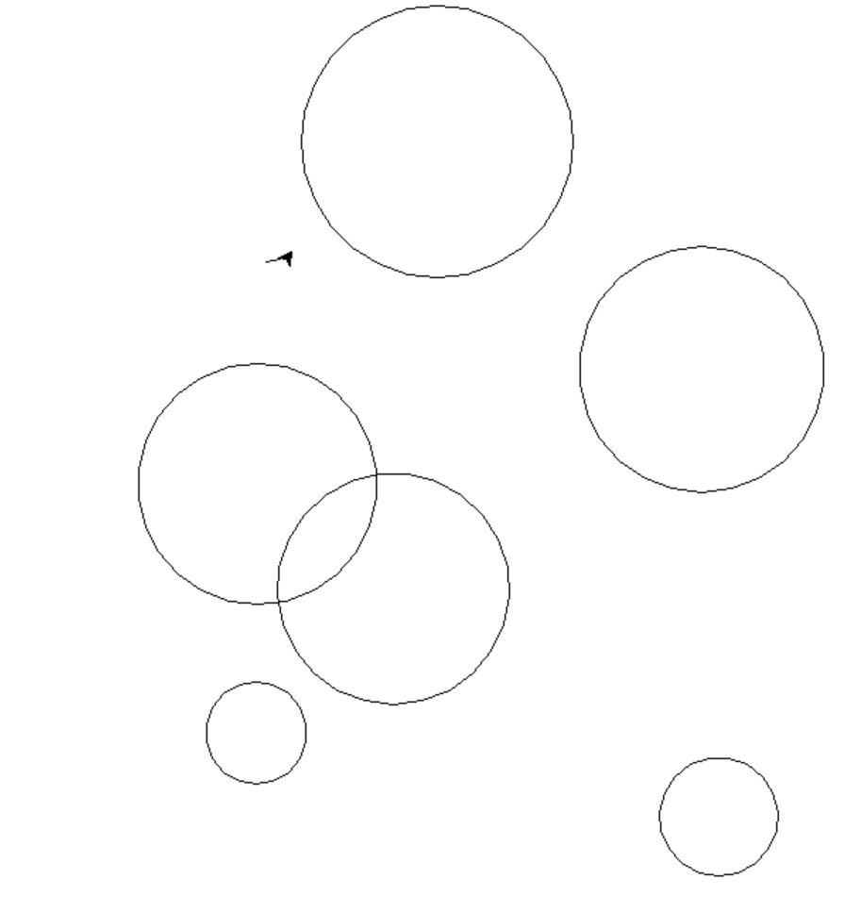

0…34 0…6
6. (Harder) Randomise fill colours for the circles.
Note: To use colour with Turtle, use the following commands:
myTurt.fillcolor("blue")
myTurt.begin_fill()
# draw whatever shape you require here
myTurt.end_fill()

OR – you can set your own RGB colour (ie 255, 255, 255)
turtle.colormode(255)
myTurt.fillcolor(255, 0, 255)
myTurt.begin_fill()
# draw whatever shape you require here
myTurt.end_fill()

Be careful that the code contains the American spelling of “color”!

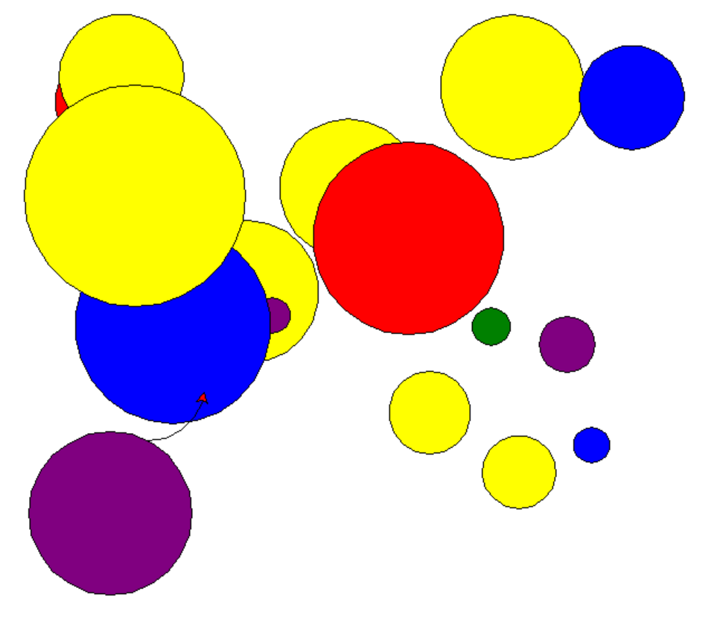

Or 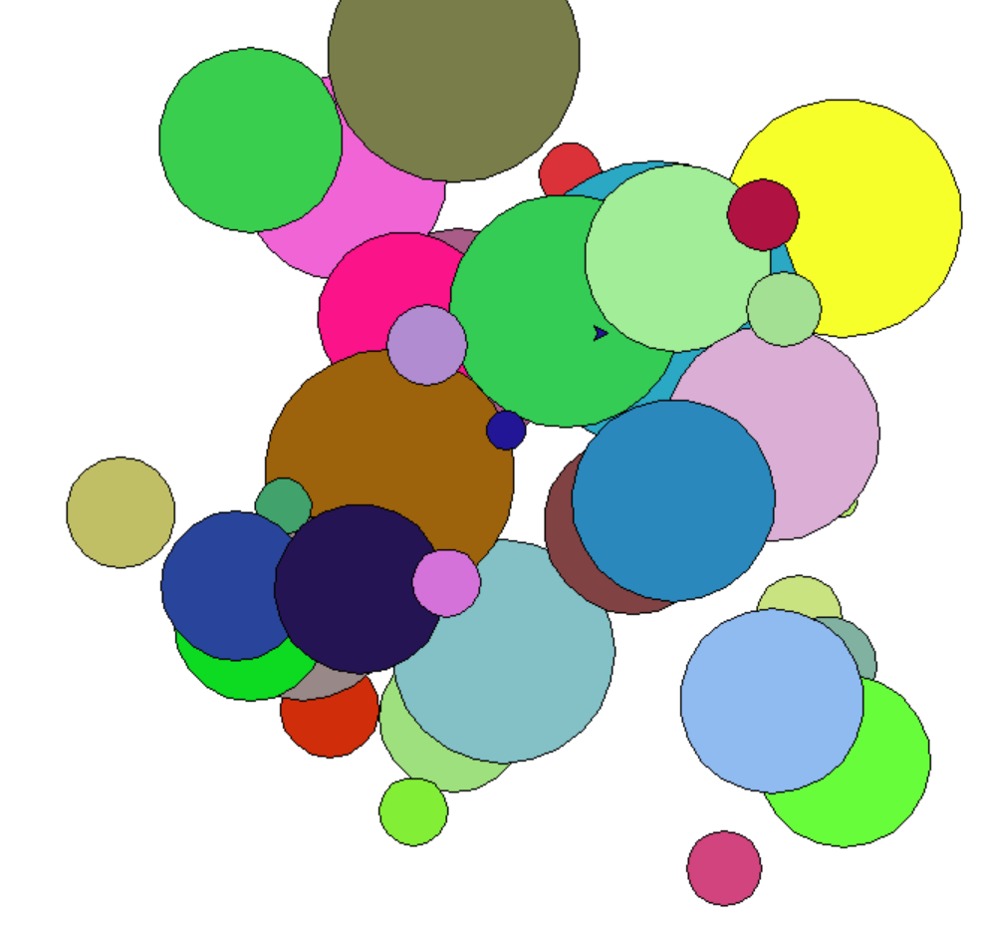

7. You could also experiment with different shapes:



