Cover Page

Component 1: E-Portfolio (3 Elements)

Study Skills for Psychology (ECPS4018)

Contents page
Contents page 2
Task 1: Summary 2
Task 2 3
Task 3 4
Library Search Screenshots 4
References 4

Task 1: Summary
Article title: How does music make you feel?
The article ‘How does music make you feel?’ by Zoe Nendick (2022), discusses how music can influence our emotional well-being and if there could be a link between. Within the opening paragraph of this article, it explains how music is such a “powerful” and apparent thing within our everyday lives. Depending on if the music was major or minor sounding, it could result in a person feeling happy or sad. Zoe goes on to discuss how certain music can influence a person’s emotions, in relation to memories of an event, a certain time in their lives, a person or a place. Focusing on the work done by Patrik Juslin, who was the lead researcher in emotional responses to music and with his colleagues tried to put multiple theories into one framework (Nendick, 2022). It goes on to discuss how Patrik Juslin and his colleagues then went on to develop a theoretical framework, using eight acronyms for psychological mechanisms, BRECVEMA. Within the section of an evolving area, Zoe goes on to discuss how there are different factors that can influence emotions caused by music, these are social context: the social and physical environment, if the music was selected by the person and internal factors: the emotional state, attentiveness and the motive behind listening to the music (Nendick,2022). Finally, discussing how emotional responses is quite close to music therapy, it can be seen how well music has helped people with relieving stress, memory recall for those with Alzheimer's disease and having a helping hand in helping in relieve pain after surgery (Nendick, 2022). Overall, Zoe has everyone thinking about the different ways music can have an effect on our emotional well-being, depending on the type of music the person is listening to, while considering the different factors.

Task 2: Infographic
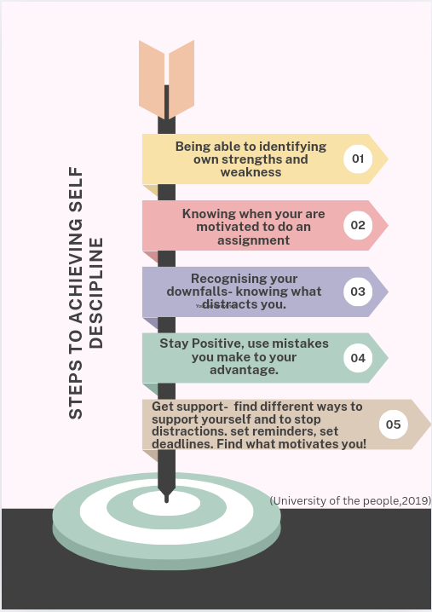

Task 3: Essay Outline/ Plan
Describe and discuss the psychological, social, and physical benefits of owning a pet.
Introduction:
- Using 5-10% of word count to write the introduction.
- Introduce what the assignment is going to be about.

Main body:
Discuss the different benefits of how owning a pet:
Having a pet can help an individual in a variety of different ways, it can benefit an individual psychologically, socially and physically.
- Paragraph 1: How does owning a pet benefit a person psychologically?
- Key points – Having a pet has been shown to help reduce loneliness, mood boost and social support feelings being increased. (Wein, 2018).
- According to the mental health foundation (2022) can reduce anxiety – pets being able to help to ease
- Increase self-confidence - your pets will not judge you and will just show you love
- Create new relationships with people – dog owners
- Creating a daily routine (mental health foundation,2022)
- Reduce stress, anxiety and depression

- Paragraph 2: How does owning a pet benefit a person socially?
- Pet food institute (2020) - mentions how owning a pet can reduce loneliness and social isolation and emotional support or having companionship being provided.
- Create new relations- dog owners

- Paragraph 3: What are the physical benefits of owning a pet?
- Owning a dog can be very beneficial to one’s health:
(Sykes, 2024) – Screenshot 1
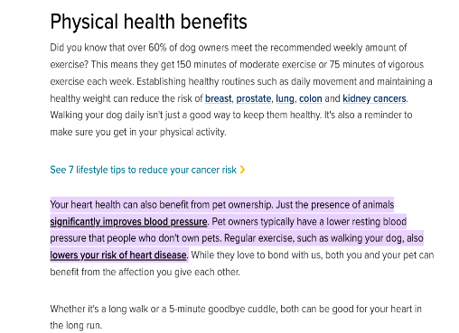

(Tak and Graft, 2023) – Screenshot 2
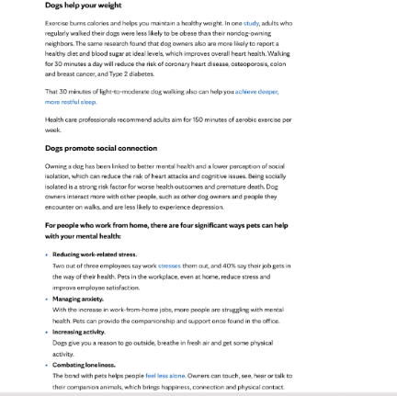

- Can help individuals lose weight as when it comes to walking a dog – it is exercise
- Increase of the amount of exercise an individual will do – compared to someone who does not own a pet.
- Can lower blood pressure – diastolic and systolic
- A cat study – significant decrease in risk of death from: strokes and heart attacks (Heeckeren, 2021)

Conclusion:
- Summarise what has been said and how the owning a pet is a benefit to an individual’s health and well-being.

Library Search Screenshots/ screenshots
Screenshot 1
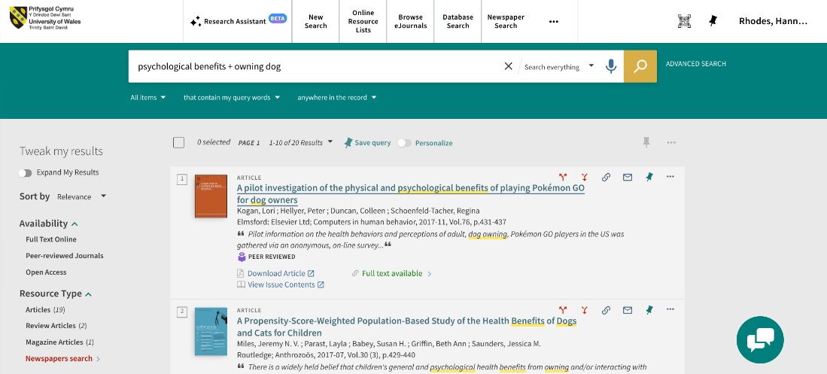

References
Escapehatch. (2020, May 21). Social Benefits of Pets - Pet Food Institute. Pet Food Institute. https://www.petfoodinstitute.org/social-benefits-of-pets/
Heeckeren, A. (2021, February 23). 10 Mental & Physical Health Benefits of Having Pets. Www.onehealth.org; One Health Organization. https://www.onehealth.org/blog/10-mental-physical-health-benefits-of-having-pets
Mental Health Foundation. (2022, February 15). Pets and Mental Health. Www.mentalhealth.org.uk; Mental Health Foundation. https://www.mentalhealth.org.uk/explore-mental-health/a-z-topics/pets-and-mental-health
Nendick, Z. (2022, September 12). How does music make you feel? - The British Psychological Society. Www.bps.org.uk. https://www.bps.org.uk/psychologist/how-does-music-make-you-feel
Sykes, J. (2024, April 11). Health benefits of pets: How your furry friend improves your mental and physical health. Cultivating-Health. https://health.ucdavis.edu/blog/cultivating-health/health-benefits-of-pets-how-your-furry-friend-improves-your-mental-and-physical-health/2024/04
Tak, T., & Grafft, H. (2023, May 24). Dogs are good for your health. Mayo Clinic Health System. https://www.mayoclinichealthsystem.org/hometown-health/speaking-of-health/dogs-are-good-for-your-health
University of the People. (2019, December 2). Self Discipline For Students: Strategy to Success. University of the People. https://www.uopeople.edu/blog/self-discipline-for-students/
Wein, H. (2018, February). The power of pets. NIH News in Health. https://newsinhealth.nih.gov/2018/02/power-pets

