

Module name: Changemakers: Building your Personal Brand for Sustainable Employment
Module code: BMHP5015
Student name: Margaret Landim
Student ID: 2335559
Lectuure’s name: Christopher Mafuva
Word count: 2000 words
Assignment title: Component 2: Assignment (Report)

I acknowledge that I have used AI (Microsoft word proofreading) to proofread my work and make some correction.

Table of Contents
Component 2: Personal Employability and Professional Development Report 3
Introduction 3
Analysis of Personal Employability Skills Required 3
Evaluation of My Own Skills 5
Building a Personal Brand and Professional Identity 6
Action Plan and Timeline 6
Conclusion 7
References 7

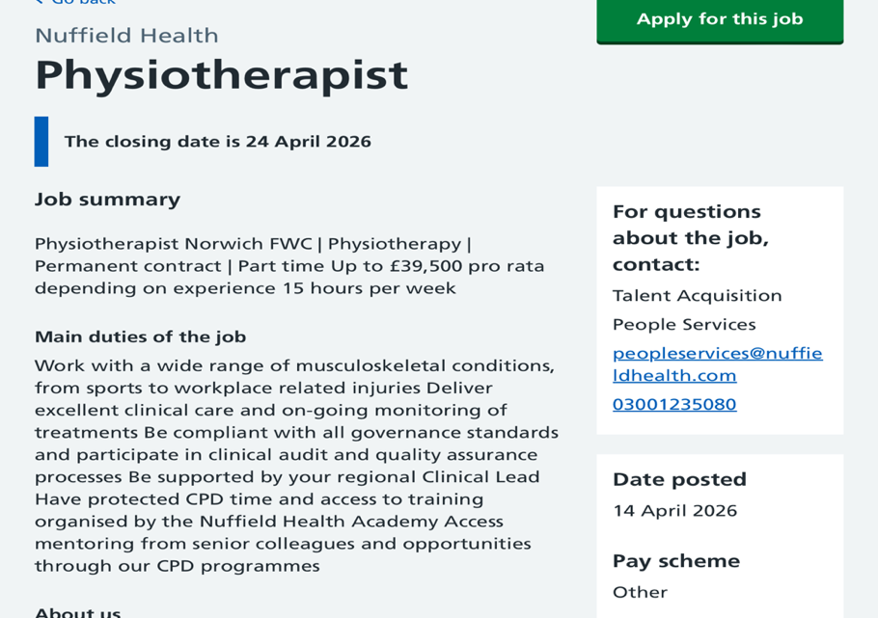

(NHS Jobs, 2026)

Component 2: Personal Employability and Professional Development Report

Introduction
Physiotherapy is a key profession within the Health and Social Care sector, supporting individuals to restore movement, reduce pain, and improve their overall quality of life. This report is based on a current job vacancy for a Physiotherapist at Nuffield Health in Norwich, which outlines the essential qualifications, skills, and behaviours needed for professional practice (NHS Jobs, 2026). The role involves assessing patients with musculoskeletal conditions, delivering evidence-based treatment, maintaining right clinical records, and contributing to multidisciplinary care. Essential requirements include a BSc in Physiotherapy, HCPC registration, effective communication skills, and the ability to manage a varied caseload.
My interest in physiotherapy is driven by a desire to empower individuals to regain independence and achieve meaningful improvements in their daily lives. This aligns with the NHS commitment to person-centred care, which emphasises understanding individual needs and promoting active involvement in treatment (NHS England, 2023). This report will analyse the employability skills required for the physiotherapy role, evaluate my current skills in relation to these expectations, explore how I can build a strong personal brand and professional identity, and present a structured action plan outlining the steps needed to achieve my long-term goal of becoming a qualified physiotherapist.

Analysis of Personal Employability Skills Required
The Nuffield Health job description highlights several essential employability skills needed for physiotherapy practice. One of the most important is clinical reasoning, described in the advert as the ability to “deliver excellent clinical care and ongoing monitoring of treatments.” Clinical reasoning enables physiotherapists to assess patient needs, interpret findings, and adapt interventions based on progress. Higgs et al. (2019) emphasise that clinical reasoning is central to safe and effective decision-making. Without this skill, practitioners risk providing inappropriate treatment, which may compromise patient outcomes and safety.
Another key requirement is communication, with the person specification saying that candidates must be “confident communicators.” Physiotherapists must explain treatment plans clearly, motivate patients, and build therapeutic relationships. This is particularly important in musculoskeletal rehabilitation, where patient engagement directly influences recovery. O’Keeffe et al. (2016) found that effective communication improves adherence to treatment, meaning physiotherapists must show empathy, clarity, and active listening. Poor communication can lead to misunderstanding, reduced motivation, and delayed recovery. The job advert also emphasises the ability to manage a varied workload, reflecting the fast-paced nature of healthcare environments. Physiotherapists often work with multiple patients presenting with diverse needs, requiring strong organisational skills and the ability to prioritise effectively. The HCPC (2023) states that healthcare professionals must manage their workload safely to keep high standards of care. Inadequate time management may result in missed appointments, rushed assessments, and increased stress.
Professionalism and adherence to clinical governance are also essential. The role involves taking part in quality assurance processes, maintaining accurate documentation, and following organisational policies. The Department of Health and Social Care (2023) highlights that professionalism and accountability are crucial for patient safety and service improvement. Physiotherapists must therefore understand legal responsibilities, ethical guidelines, and organisational policies. The job description also highlights the importance of continuous professional development (CPD), with opportunities for mentoring and training. This reflects the expectation that physiotherapists engage in lifelong learning to maintain competence. Kolb’s Learning Cycle explains how professionals develop through experience, reflection, and application. For example, reflecting on a challenging case may lead to improved practice in future situations.
Another essential employability skill highlighted in the job description is digital literacy, which is increasingly important in modern healthcare. Physiotherapists are expected to use electronic patient record systems, digital outcome-measurement tools, and online platforms for CPD. According to the NHS Long Term Plan, digital competence is now a core expectation for all healthcare professionals. Without strong digital skills, physiotherapists may struggle to document accurately, access clinical guidelines, or communicate effectively with multidisciplinary teams. This could lead to delays in treatment, errors in documentation, or reduced quality of care. The job description also implies the need for problem-solving skills, as physiotherapists must adapt treatment plans when patients do not respond as expected. This requires creativity, flexibility, and the ability to interpret clinical evidence. Problem-solving is closely linked to clinical reasoning and is essential for delivering personalised, effective care.

Evaluation of My Own Skills
Comparing my current skills to the expectations outlined in the job description allows me to show both strengths and areas for development. One of my key strengths is communication, which I developed during my placement at Whipps Cross Hospital. Supporting patients with daily activities helped me build empathy, active listening, and the ability to adapt my communication style. This aligns with the requirement to be a “confident communicator,” as I can engage effectively with individuals from diverse backgrounds. Another strength is teamwork. Through academic group work and practical experience, I have demonstrated the ability to collaborate, contribute ideas, and support others. Feedback from lecturers has highlighted my reliability and positive attitude, which are essential qualities in healthcare settings. This aligns with the multidisciplinary nature of physiotherapy practice.
However, I also recognise several areas for development. A significant weakness is my lack of physiotherapy-specific clinical experience. While I have general healthcare experience, I have not yet developed the ability to assess or treat musculoskeletal conditions independently. This limits my ability to meet the requirement of delivering “excellent clinical care.” Smith et al. (2020) emphasise that clinical competence is developed through theoretical knowledge and practical experience, highlighting the need for further training.
Another area for development is my knowledge of advanced anatomy and rehabilitation techniques. Although I have a basic understanding, I need deeper knowledge to apply clinical reasoning effectively. This gap affects my confidence in making clinical decisions. Using Gibbs’ Reflective Cycle, I can recognise this as an area requiring further exposure, such as shadowing physiotherapists or completing relevant training. I also need to improve my time management in clinical environments. While I manage academic tasks effectively, healthcare settings require rapid prioritisation and adaptability. Developing this skill will be essential for managing a varied caseload. Despite these weaknesses, I am highly motivated to improve. Maslow’s Hierarchy of Needs suggests that achieving personal goals contributes to self-actualisation, and becoming a physiotherapist is a meaningful goal that drives my development. By acknowledging my strengths and weaknesses, I can create a targeted action plan to support my progression.

Building a Personal Brand and Professional Identity
Developing a strong personal brand is essential for standing out in the competitive physiotherapy field. My personal brand is built around compassion, reliability, and a commitment to continuous improvement. These values align with the expectations of the Health and Social Care sector, where empathy and professionalism are central to high-quality care. One of my unique selling points is my combination of healthcare experience and strong interpersonal skills. My placement experience has strengthened my ability to understand patient needs and build rapport, which is essential for physiotherapy practice.
Effective communication and empathy help create trust, which supports patient engagement and recovery. To strengthen my professional identity, I will develop a high-quality CV and a LinkedIn profile that clearly highlight my skills, experiences, and career goals. My LinkedIn profile will include a professional headline such as: The summary section will highlight my values, experience, and motivation for entering the profession. I will also connect with physiotherapists, join professional groups, and share relevant content to build visibility. Holland’s Theory of Career Choice suggests that individuals are more likely to succeed in careers aligned with their interests and personality. My interest in helping others and working in healthcare aligns strongly with physiotherapy, reinforcing my career choice. Social Capital Theory highlights the importance of networking in accessing opportunities. By connecting with physiotherapists, attending events, and joining online professional groups, I can build valuable relationships that support my career development.

Action Plan and Timeline
To achieve my goal of becoming a physiotherapist, I have developed a structured action plan based on the SMART framework. According to Bandura (1977), self-efficacy develops through experience and practice. By gradually building my skills and gaining exposure to clinical environments, I will increase my confidence and ability to succeed in my future role as a physiotherapist. In addition, perseverance plays a key role in achieving long-term goals, as consistent effort and resilience are key to overcoming challenges within healthcare careers.
Timeframe | Action | SMART Link | Expected Outcome
Short-term (0–6 months) | Research physiotherapy courses and entry requirements | Specific & Relevant | Clear understanding of career pathway
Improve academic skills (biology, communication) | Achievable & Measurable | Better academic performance
Update CV and apply for part-time/voluntary healthcare roles | Measurable & Time-bound | Gain at least 1 relevant experience
Start networking with professionals | Relevant | Build professional connections
Mid-term (6 months – 2 years) | Enrol in relevant course or access programme | Specific & Time-bound | Progress towards qualification
Gain practical experience (care assistant/volunteer) | Measurable | Develop real-life skills
Develop communication and teamwork skills | Relevant | Improved patient interaction
Reflect on experiences to improve confidence | Achievable | Increased self-awareness
Long-term (2–5 years) | Complete physiotherapy degree | Specific & Measurable | Achieve qualification
Undertake clinical placements | Relevant | Gain hands-on experience
Apply for physiotherapy roles (e.g. NHS) | Time-bound | Secure employment
Continue professional development | Achievable | Maintain career growth

Conclusion
This report has analysed the employability skills needed for a physiotherapist role, critically evaluated my current strengths and development needs, and set out a detailed, evidence-based plan to achieve professional qualification and employment. I already have strong communication, teamwork, and reflective skills; to reach the required standard I will prioritise physiotherapy-specific clinical experience, deepen anatomical knowledge, improve clinical time management, and develop digital competencies. By implementing the SMART action plan, building a consistent personal brand, and engaging with professional networks, I will progressively close the gap between my current profile and the expectations of employers in the Health and Social Care sector.

References
Asthma + Lung UK (2024) Asthma statistics. Available at: https://www.asthmaandlung.org.uk (Accessed: 17 April 2026).
Aveyard, H. (2019) Doing a Literature Review in Health and Social Care: A Practical Guide. 4th edn. London: Open University Press.
Bandura, A. (1977) ‘Self-efficacy: Toward a unifying theory of behavioural change’, Psychological Review, 84(2), pp. 191–215.
Bandura, A. (1997) Self-Efficacy: The Exercise of Control. New York: Freeman.
Chartered Society of Physiotherapy (2024) What is physiotherapy? Available at: https://www.csp.org.uk/public-patient/what-physiotherapy (Accessed: 17 April 2026).
Department of Health and Social Care (2023) Integration and innovation in health and social care. Available at: https://www.gov.uk/government/publications (Accessed: 17 April 2026).
Health and Care Professions Council (HCPC) (2023) Standards of proficiency: Physiotherapists. Available at: https://www.hcpc-uk.org/standards (Accessed: 17 April 2026).
Higgs, J., Jones, M., Loftus, S. and Christensen, N. (2019) Clinical Reasoning in the Health Professions. 4th edn. London: Elsevier.
Holland, J. (1997) Making Vocational Choices: A Theory of Vocational Personalities and Work Environments. 3rd edn. Odessa, FL: Psychological Assessment Resources.
Kolb, D. (2015) Experiential Learning: Experience as the Source of Learning and Development. 2nd edn. New Jersey: Pearson Education.
Maslow, A. (1987) Motivation and Personality. 3rd edn. New York: Harper & Row.
NHS England (2023) The NHS Constitution for England. Available at: https://www.gov.uk/government/publications/the-nhs-constitution-for-england (Accessed: 17 April 2026).
NHS Jobs (2026) Physiotherapist – Nuffield Health Norwich FWC. Available at: https://www.jobs.nhs.uk/candidate/jobadvert/E0302-26-0287 (Accessed: 17 April 2026).
O’Keeffe, M., Cullinane, P., Hurley, J., Leahy, I., Bunzli, S., O’Sullivan, P. and O’Sullivan, K. (2016) ‘Patient–therapist interactions in physiotherapy’, Physiotherapy, 102(2), pp. 146–152.
Reeves, S., Pelone, F., Harrison, R., Goldman, J. and Zwarenstein, M. (2017) Interprofessional Teamwork for Health and Social Care. London: Wiley.
Smith, J., Brown, L. and Clarke, A. (2020) ‘Developing clinical competence in physiotherapy students’, Medical Education, 54(2), pp. 123–130.
Tomlinson, M. (2017) ‘Forms of graduate capital and their relationship to graduate employability’, Education + Training, 59(4), pp. 338–352.
Bandura, A. (1997) Self-Efficacy: The Exercise of Control. New York: Freeman.
Holland, J. (1997) Making Vocational Choices: A Theory of Vocational Personalities and Work Environments. 3rd edn. Odessa, FL: Psychological Assessment Resources.
Tomlinson, M. (2017) ‘Forms of graduate capital and their relationship to graduate employability’, Education + Training, 59(4), pp. 338–352.

