.

BA Leadership Management skills for the workplace

UNDERSTANDING AND ENGAGING IN THE CUSTOMER EXPERIENCE
Moodle number: BMSK 5003

Student Name: Shopik Ali
Student ID: 1604735

Table of Contents
1.0 Introduction 2
2.0 Critically analyze the factors that influence McDonald’s ability to maximize customer value 2
2.1 Understanding customer changing needs and expectations 2
Research and development 2
Developing touchpoint 4
Customer retention and loyalty 4
Defining customer segments and customer buying behaviors 4
2.2 Core Competency 5
2.3 Employee satisfaction and motivation 5
Employee motivation 5
Employee satisfaction 6
Employee training and training 6
Employee feedback 7
Innovation and creativity in product and design 8
2.4 Customer Relationship Management 8
2.5 How McDonald can improve CRM in its business 10
3.0 Critical understanding of McDonald’s quality processes and its effectiveness in meeting customer requirements 12
3.1 Quality process in a business 12
3.2 How McDonalds is ensuring quality in its business process 13
Business process of McDonalds 13
Quality management process of management 14
McDonalds quality management in competitive market 15
Service quality of McDonalds 16
Quality programs of McDonalds 16
How McDonalds is doing Benchmarking 17
Customer and employee feedback for McDonald’s quality improvement 17
4.0 Conclusion 18
References 19

1.0 Introduction

According to Meyer and Schwager (2017), a business organization offers different types of aspects including the customer care’s quality, product’s packaging and advertising, several features of products and services, and the reliability of products are encompassed by customer experience. In addition, experiences of customers are shaped by a successful brand by inserting essential value proposition. The chosen organization for this assignment is McDonald. McDonald is well-known and the largest fast food company around the world. McDonald serves more than 70 million customers in a day over 100 countries and it has 36,900 outlets around the world. Around 375,000 employees are working in McDonald as of 2016. McDonald sells several types of fast food items where hamburger is very special. It also offers breakfast items, cheeseburgers, French fries, wraps, chicken items, deserts, soft drinks and milkshakes (McDonald Annual Report, 2017). This assignment is divided into two sections. The first section is critically analysed the factors that influence the ability of McDonald to develop the value of customer. On the other hand, the second section is discussed about the understanding of the quality processes of McDonald and its effectiveness to meet the requirements or needs of the customers.

2.0 Critically analyze the factors that influence McDonald’s ability to maximize customer value

2.1 Understanding customer changing needs and expectations
It is essential for a business organization to identify the needs or requirements of the customers (Kotler et al., 2014). In case of McDonald, it follows several steps to identify the needs of the customers.

Research and development

Research and development can significantly influence a business like McDonald to maximize their customer value. As part of research and development program, a business can take several steps. First, automatic capture system can be developed. This system can capture the calls’ length types such as call recordings. Secondly, Observation and listening to quality supervisor can be ensured. The calls of the employees can be taken to assess the standards. On the other hand, this analysis must be fair. Then, customer survey can be conducted on regular basis. This can be done through emails, direct mails and calls can be carried out to establish satisfaction level of the customers. Following this, employee feedback can be taken from time to time. Employees can feel free to give feedback about any matter. The feedback of the employees can support the business organization to understand their policies about the customer service.

Developing touchpoint

Nowadays business organization including McDonalds uses touchpoints to gather the information of the customers. However, TV, Newspapers and Radio are not effective to collect customer data. The customer information includes purchase date, age and gender of the customers that can be gathered by using touchpoints as well as kept on the computer systems. As Kelly (2015) notes, wants and needs of the customers, lifecycle and buying behavior of the customers, interaction process of the customers and the profile of the customers are analyzed or collected by the touchponits in many organizations.

Customer retention and loyalty

Corporations including McDonalds need to make positive experience to retain and make loyal its target and potential customers. Such as, discounts of a business organization can be reached to its customers. As Mullick (2015) notes, corporation is to keep its customers for a long time. On the other hand, customer value can be made by the business organization to encompass positive experience from every of the customer. This becomes very helpful for both the customers and the organization.

Defining customer segments and customer buying behaviors

For understanding customer buying behaviours, McDonald creates the profiles of the customers in that it includes name, contact details, address, purchase history, habits, occupation, and lifestyles to easily identify the needs of the customers. Then, McDonald identifies the lifecycle of the customers. It is essential for a business organization to predict the lifecycle of the customers properly to identify the needs of the customers. Following this, McDonald conducts the customer segmentations. This segmentation supports a business organization to recognize what exceptional services are provided to the particular customer group. Next, McDonald creates the development in the internal procedure of its business. A business organization can minimize the customer services’ cost as well as can make sure that its internal procedures are very much effective. Then, customer services can build in the internal processes of the company (McDonald Annual Report, 2017).

2.2 Core Competency

Core competency is very important for a business organisation. Organizations can expand their services. It helps a business organization to gain the competitive advantages in the market (Nichols, 2016). In case of McDonald, McDonald follows the core competency strategy to gain the competitive advantages in the marketplace (McDonald Annual Report, 2017).

2.3 Employee satisfaction and motivation

Employee motivation

A business organization motivates its employees by giving better compensation, good supervision and proper training that helps to reduce the staff turnover. The supervisors give their best to satisfy its employees if they face any kind of problems and that helps to develop the staff motivation. According to Robinson (2017), it is essential for a business organization to recruit the right people in the right position. For example, it is not appropriate to recruit a person in the customer service section who is not capable to handle the customer service. Then, it is necessary to recruit the person who has the positive attitude and friendly mind because he/she can easily handle any type of emotional situation comfortably. If a person does not handle the situation than the business organization must not hire that person (Robinson, 2017). The recruited person may be the students so it is essential for the business organization to value their income of part time. On the other hand, the business organization must recruit the experienced and skilled person who are very expert in customer service and also give effective training to their staffs. In terms of McDonald, McDonald always recruits the experienced and skilled person in the right position. Then, McDonald conducts the proper interview and is fair to hire the right person (McDonald Annual Report, 2017). Moreover, it gives proper training and better wages/salaries to its staffs to create the CRM successful.

Employee satisfaction

A business organization motivates its employees by giving better compensation, good supervision and proper training. The employees of a business organization leave the jobs because they are not pleased with their work and supervisor’s attitude (Kruse, 2017). First of all, better compensation helps to improve the staff motivation that helps to create the successful CRM in the business organization (Kruse, 2017). In case of McDonald, it gives better salaries to its employees that help to create successful CRM (McDonald Annual Report, 2017). Secondly, good supervision helps to develop the staff motivation and reduce the staff turnover (Kruse, 2017). In terms of McDonald, McDonald’s supervisors give their best to supervise its employees if they face any kind of problems and that helps to develop the staff motivation (McDonald Annual Report, 2017). Thirdly, proper training is the essential matter to develop the staff motivation (Kruse, 2017). McDonald gives proper training to its customers about the products and services of it. Thus, it helps to improve the staff motivation and reduce the staff turnover.

Employee training and training

The employees of a business organization are always prepared to provide solutions to any kind of problems of the customers. If the employees are unable to give the answers of the customers’ problem than any senior person of this organization provide the answers to the employees or direct to the customers (Mills and Seifert, 2016). On the other hand, business organization must train up to its customers and the employees must discuss with the customers about any kind of problem they faced from the customers. In case of McDonald, it trains up its employees about the customer service and the employees of the McDonald always get suggestion or help from the senior management of McDonald (McDonald Annual Report, 2017). By giving the proper training to the employees is necessary to create the successful CRM. According to Noe (2016), the employees have to be trained effectively which can motivate them to the workplace. The better training of the employees supports the business organization to target the potential customers. When the staffs are fully developed their knowledge/skills by training that helps the business to develop the financial status (Noe, 2016). A business organization must give training to the employees on the products and services, selling opportunities, questions asked by the customers and other activities of the business organization. On the other hand, business organization gives training on several soft skills such as listening skill, problem solving skill and communication skill (Beebe and Roach, 2015). These soft skills are very significant to create the successful CRM. Moreover, remedial training supports the organization’s CRM while they have not successful to sort out the questions of the customers. However, the customer services which are very poor do not support a business organization to create the brand value and brand awareness of the business organization as well as develop the marketing strategies. In terms of McDonald, McDonald gives proper training to its employees to interact with the customers effectively and that helps to develop the business strategies of McDonald (McDonald Annual Report, 2017).

Employee feedback

As Paauwe (2016) notes, staffs are the internal stakeholder of a business organization who has the great impact on the success of a business organization. Thus, it is essential for the business organization to train its staffs properly. On the other hand, the business organization must motivate its staffs by giving better salaries/wages and value their work by praising them. In addition, the feedback form the staffs are very important for the business organization to do its business successfully because staffs feedbacks (including positive and negative feedback) are very authentic and genuine source for the business organization. The staff feedback helps the business organization to develop its business policies and performance. Moreover, it helps the business to fix any type of problems quickly because staffs are closely related to the customer service and they know about the needs or requirements of the customers. In case of McDonald, McDonald always prior its staffs a lot. It gets the feedback from its staffs and analyzes the feedback and base on the feedback it develops its business or sort outs the problems it faces (McDonald Annual Report, 2017).

Innovation and creativity in product and design

Innovation is the effective matter for a business organization. The technology is developed day by day. Thus, a business organization must think how to make its business innovative. If business organizations fail to create any type of creativity in the business, than they do not go long in the future because without innovation the business cannot go with the trend of the current business world. McDonald always tries to create creativity in its business.

2.4 Customer Relationship Management
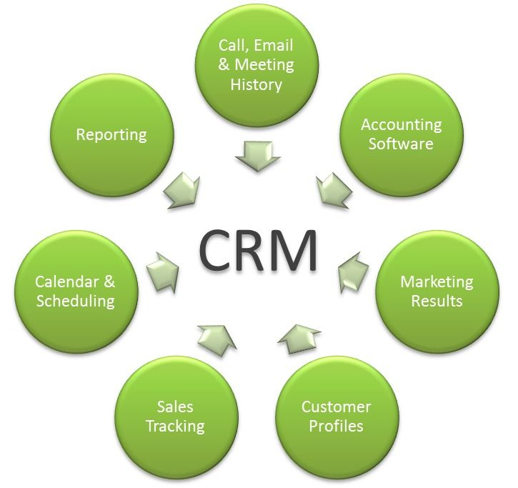
For maintaining customer relationship management, business should apply a number of technologies that show in the following diagram. As Johnson and Paulen (2017) notes, CRM means customer relationship management. Customer Relationship Management is the effective strategy for a business organization to manage every of the relations with the potential and targeted customers. Then, CRM supports the business organization to increase the business profit. CRM technologies include accounting software, sales tracking, calendar and scheduling, call, e-mail and meeting history etc. As Kumar and Reinartz (2016) notes, it is very essential to keep and recruit the right people in the right position, empower the employees, motivate the staffs by giving proper wages/salaries and continually give them training to make the CRM successful. As William (2015) notes, frontline CRM must have the significant channel for co-operating the experiences to make sure the procedures can be developed, the proper training can be given and so on. It is not essential for the business organization to look for the skilled/experienced staffs always that can drive the business strategy. However, the business organizations have to focus on the additional investment which is not necessary for the organization and the staff turnover can be reduced because if these are not managed organization fails to conduct the customer service including several functions (such as sales/marketing) (William, 2015). In case of McDonald, McDonald always tries to give proper training and attractive salaries to its customers to reduce the staff turnover and develops its customer service effectively (McDonald Annual Report, 2017).
Then, the business should apply a number of steps shown in the following diagram:
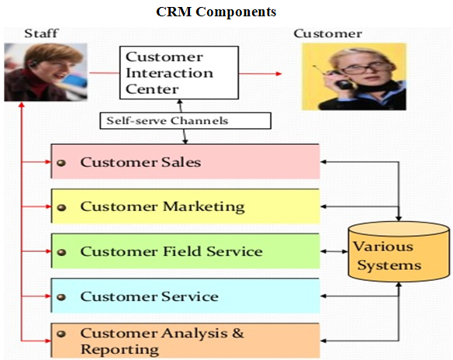
Diagram: CRM components Source: Mills and Seifert (2016)

As Hansen (2016) notes, relationship marketing is to create the relationship between the business organization and the customers for a lengthy time. The main goal of the relationship marketing is to create better relation with the customers. As McDonald Annual Report (2017), McDonald is the organizations which made success in creating effective relation with the customers by collecting the opinion of the customers. Firstly, McDonald’s relationship marketing has established several activities. Survey on the customers of McDonald, customers’ feedback as well as advertising through social media is included by these methods. McDonald’s activities created their customers feel important or valuable to their brand (McDonald Annual Report, 2017). Second, to retain their customer for the lengthy period as well as make them pleased, they have established several activities. This method informs the buying behaviors of the customers. According to McDonald Annual Report (2017), McDonald has operated several systems to meet the target of the potential customers. Third, McDonald has been providing lots of effort to evaluate the information database of the customers. In this case, McDonald has connected with different third party companies who evaluate the customers’ information. As McDonald Annual Report (2017), McDonald can develop its revenue and sales to target the customers to increase its brand value. On the other hand, effective training is given by McDonald to the employees to attract the customers. Moreover, McDonald tries to focus on the faith and loyalty of the customers as well as make its marketplace position stronger (McDonald Annual Report, 2017).
Fourth, McDonald focuses on its online marketing to develop the relationship marketing with their customers. This online marketing helps McDonald to identify the needs or requirements of the customers. Fifth, McDonald is very famous for its affordable and quality products and better customer service. They have been the most renowned fast food retailer in the world. Moreover, McDonald has friendly relation with its local community. As McDonald Annual Report (2017), to create revenue or profit from diverse countries including China, EU and US they have established different activities. Sixth, McDonald tries to develop its online delivery process by creating or operating its website successfully. This helps to connect with its customers easily and gets feedback from the customers directly. Last of all, McDonald provides its customers several customized magazines and promotional brochures to attract them. Moreover, McDonald has conducted several campaigns to develop its customer value. On the other hand, McDonald has established different programs for the customer loyalty (McDonald Annual Report, 2017).

2.5 How McDonald can improve CRM in its business
The practice of relationship marketing in McDonald has supported its business in different ways. First of all, relationship marketing has developed the marketing sales of McDonald. Then, online platform of McDonald has increased about 450,000 transactions per week (McDonald Annual Report, 2017). After that, McDonald has been capable to extend its customers. The effective communication with the customers has supported McDonald to satisfy its potential customers. Furthermore, McDonald has been able to follow or identify the present trend of the marketplace. In addition, McDonald has established several campaigns to attract its customers and gain the customer loyalty that helps to develop the marketing strategies. Every of these aspects are possible just because of the McDonald’s relationship marketing (McDonald Annual Report, 2017). Finally, McDonald has gained its popularity over the world and been able to beat with its competitors in the marketplace.
Nowadays, the whole world is focused on the technology. Technology is the effective part for a business organization. It is essential for both organization and customers to interact with each other. Customers of a business organization always want the speed of the technology to interact with the business organization effectively (Kelly, 2015). After that, technology affects the efficiency, relations or culture of an organization. Moreover, it affects the information security of the business organization. In addition, an organization which has an effective capacity of technology to research on the advanced topics will go ahead in future. In case of McDonald, McDonald uses different technologies in its business to develop the business operations (McDonald Annual Report, 2017). McDonald uses high speed technology to interact with its customers through its website and get feedback from the customers easily from email, messages and comments.

There are different types of technologies which are used in a business organization. First, Interactive voice response is very effective when any information is given to the customers about shipment details, credit card, payment details or loan details etc. Emails and chats are used by a business organization to interact with the customers effectively as well as company gives promotional activities or offers to its customers through email or chat (Postman, 2016). A website is the very effective part of the business in this modern technology. A business organization can give details about the products; give the details about payment and delivery systems and get positive or negative feedback from the customers through its websites. For example, McDonald gives the products details and gets the feedback from the customers from its website easily (McDonald Annual Report, 2017). As Postman (2016) notes, a business organization can utilize the mobile or internet to connect with its customers to deliver the answers of the inquiries of the customers. On the other hand, this communication process cannot be used by many organizations.

3.0 Critical understanding of McDonald’s quality processes and its effectiveness in meeting customer requirements

3.1 Quality process in a business
There are different types of factors that influence the satisfaction level of the customers. These are service quality, time, product quality, situational factor, personal factor etc. If the quality of products and service are poor of a business organization, the customers become dissatisfied (Lucas, 2016). Thus, the business organization must focus on several things that help them to gain the customer satisfaction.
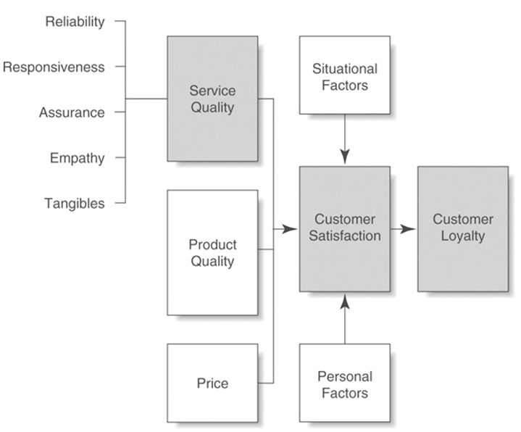
Diagram: Customer perceptions of quality and customer satisfaction Source: Kotler et al. (2014)
As Peppers (2015) notes, every customer of a business organization expects the products with better quality, affordable price and quick service in time. A business organization competes with the Quality, Price and Time with other business organization. A successful business organization always focuses on these things to compete in the marketplace.
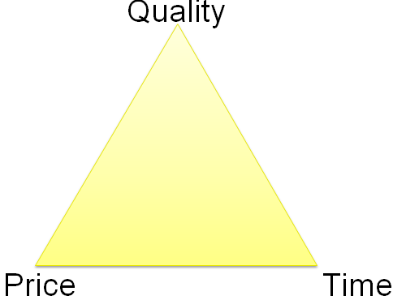
Diagram: Customer expectation Source: Kotler et al. (2014)

3.2 How McDonalds is ensuring quality in its business process

Business process of McDonalds

Different internal and external factors are necessary to gain the customer satisfaction level. McDonald always focuses on the quality of products and services as well as quick services. The key concerns that help McDonald to meet the customer satisfaction are given as below:
Supply chain management: McDonald always discusses with the environmental experts and the food safety experts about the production process and takes advice from them to make quality products. McDonald also takes information about the production process from its suppliers to meet the standards of the products (McDonald Annual Report, 2017). Moreover, it is essential to understand the customer needs. In this case, McDonald must be innovative and energetic to identify the needs of the customers, apply different techniques to value its customers and try to connect with them to understand their needs or requirements. McDonald’s safety or welfare of the staffs is the important factor. McDonald expects the suppliers to encompass the honest or fair contact to its staffs and to all the persons they conduct the business. Then, McDonald has developed the new strategy for its technical managers to increase ethical issues’ awareness and welfare of the employees in the supply chain. After that, it will train every of its technical managers continually like this (McDonald Annual Report, 2017). McDonald is managing its several labor standards to do its business successfully around the world.
Quality: McDonald takes several initiatives to make the quality of its products that attract the customers. Every of the product of McDonald meets the biological standards that ensure the product’s safety. McDonald takes different legal requirements (including compositional standards) to meet the customer satisfaction (McDonald Annual Report, 2017).
Customer expectation: Products of the business organization will be traded if there is the need of the customers on those products. McDonald always focuses on its customers need and by focusing on the customer’s needs it must create its products
Product standards- The product standards make sure that the food items of McDonald have the great standards of quality or safety of the products. Moreover, it recognizes the environmental as well as labor standards to meet the customer satisfaction.
Produce Codes of Practice- From the staring of the production it is essential to select the proper raw materials to create the quality products. McDonald is very much concern to select the raw materials. Then, employees’ training is essential to produce several products (McDonald Annual Report, 2017).

Quality management process of management

According to Kiran (2017), Quality Management Process is a type of process that develops the quality of the business organization. A business organization can develop the deliverables’ quality as well as gain the success by utilizing the quality management in the organization. The quality management process is the formal process which develops procedures, processes or tasks for gaining the quality objectives or policies.

McDonald’s aim is to give better service to its customers without any kind of defect. Each of the products of McDonald has the better quality that attracts the customers (McDonald Annual Report, 2017). The product quality is evaluated through the supply chain. The operational management does not manage the whole business organization. The major concern of operational management is the great production of the business organization. Moreover, it engages several activities to distribute or make the services/products. Quality management process is the effective concern for McDonald. McDonald does not manage the quality of the services or products. It also manages the whole operation of its business. This helps to achieve the customer satisfaction (McDonald Annual Report, 2017). However, McDonald’s main motto is to satisfy its customers by giving quality products and better services. Customers can be two types including external customers and internal customers. McDonald deals with the total quality management (TQM) concept in different approaches which are described as below:
McDonald always prevents defected products which are made in manufacturing process instead of avoiding the defects in the products. The main motto of McDonald is to create quality products with zero defects to attract the customers (McDonald Annual Report, 2017). McDonald always focuses on creating the quality products instead of creating the defected products. As McDonald Annual Report (2017) notes, McDonald gives priority on the quality. McDonald thinks the quality of the products can only involves the customers in its business. McDonald always goes with the trend of the current business world and tries to develop its products, services and policies of business continuously. McDonald engages its staffs who are engaged with the manufacturing or production processes to get feedback from them. Thus, McDonald can develop is business processes (McDonald Annual Report, 2017).

McDonalds quality management in competitive market

There are six parts of the competitive priorities which are quality, low cost, flexibility, delivery time, dependability and speed (Porter, 2016). McDonald has gained competitive advantage in the marketplace as well as fulfils customers’ needs by focusing on six components. McDonald always tries to give products to its customers with low price that the customers can afford its products. McDonald deals with its suppliers and offers its products to the customers with better quality and low price (McDonald Annual Report, 2017). McDonald is the well-known fast food retailer in the world. Thus, McDonald focuses on the quality of its food products to gain the competitive advantages in the marketplace. As McDonald Annual Report (2017), McDonald is very concern with the speed of the work and delivery time. In the every corner of any country McDonald is situated. McDonald delivers its products to its customers in very short time that helps to gain the satisfaction of the customers. McDonald applies differentiation policy and the economic scale policy to develop their food products and give several promotional activities to its customers that helps to get the customer dependability. Moreover, McDonald tries to make something different from its competitors and gain the competitive advantage in the marketplace. In addition, it provides online shopping facility and refrigerated delivery for its customers to fulfil the needs of the customers. McDonald has developed its brand image because of its working efficiency as well as it has financed a lot in the technology system to control its every of the system. Moreover, McDonald gives the large amount of stock, better facilities to its customers, introduces latest items that gives the flexibility in its business (McDonald Annual Report, 2017).

Service quality of McDonalds

Every customer of a business organization always wants the quality products with an affordable price. As Berry (2015), there are mainly five aspects of the service quality which helps to gain the competitive advantages in the marketplace. The five aspects are assurance, reliability, empathy, tangibles, and responsiveness. The ability of the business organization to give the quality of service properly is known as reliability. Then, assurance is the employees’ courtesy or knowledge that helps to make them confident. After that, tangibles are the personnel appearance and physical facilities. Next, empathy means the attention or caring of the organizations to its customer. Finally, responsiveness is the inclination to support the customers by giving proper services. In case of McDonald, McDonald always focuses on these components to assure the quality services to its customers and gain the competitive advantages in the marketplace (McDonald Annual Report, 2017).

Quality programs of McDonalds
McDonald always tries to achieve the business goal not only giving the quality products and better service to its customers but also making sure the safety of food over the world because it serves 25 million customers per week (McDonald Annual Report, 2017). The best practice of the quality programs is the Cs (including customer, culture, communication, collaboration, and continued improvement) for McDonald. McDonald focuses on the needs of the customers, makes communication with them, keeps in the mind to the culture of the customers and tries to develop its products continually. Thus, McDonald is very much concern about its quality programs.
Training and development is the key program of a business organization (including McDonald). Training is the essential part that helps to develop the staffs of a business organization and helps to develop the customer services continually. As McDonald Annual Report (2017) notes, McDonald helps the customers by providing better customer service through the core skills workshops such as effective meeting with the staffs, presentation skills of the staffs, root cause analysis, communication skills or personal efficiency of the staffs. Every of staff discusses on the PDP (personal development plan) to their managers that helps the staffs to do their job effectively. McDonald always gives proper training to their employees that help McDonald to gain the satisfaction level of the customers and find out the feedback from the customers through employees (McDonald Annual Report, 2017).

How McDonalds is doing Benchmarking

As Camp, 2016) notes, the measurement of the quality the products, policies/strategies or programs of a business organization as well as the difference and similar factors of the standard measurements with its peers is known as benchmarking. McDonald uses the benchmarking process to measure the quality of its products, services, business policies, strategies of programs to compare its standard measurement with its competitors. Thus, it helps McDonald to retain in the marketplace and gain the competitive advantage (McDonald Annual Report, 2017).

Customer and employee feedback for McDonald’s quality improvement

Customer and employee feedback are essential to ensure quality in a business. Success of the business is depended on the feedback of the customers. Thus, the feedbacks of the customers are the key factor of a business organization. As Gitomer (2015) notes, customer and employee can give positive and negative feedback about the quality of products and services of an organization. This helps the business organization to improve its negative sides to do its business successfully and gain the competitive advantages in the marketplace. In case of McDonald, it always gets or looks for the feedback of the customers and employees in its websites or the review sections. That helps McDonald to identify the needs or requirements of the customers (McDonald Annual Report, 2017).

4.0 Conclusion

McDonald is well-known and the largest fast food company around the world. McDonald serves more than 70 million customers in a day over 100 countries and it has 36,900 outlets around the world. Around 375,000 employees are working in McDonald as of 2016. The first section of this assignment is critically analysed the factors that influence the ability of McDonald to develop the value of customer. On the other hand, the second section of this assignment is discussed about the understanding of the quality processes of McDonald and its effectiveness to meet the requirements or needs of the customers. A business organization must focus on the factors that analyse the value of the customers and understand the quality process to meet the needs or requirement of the customers. That helps to successfully create the CRM in the business organization and gain the competitive advantages in the marketplace.

References
Meyer, C. and Schwager, A. (2017) Understanding Customer Experience. Available at: https://hbr.org/2007/02/understanding-customer-experience. [Available at: 15 April 2018]
Kumar and Reinartz (2016) Customer Relationship Management: Concept, Strategy and Tools. 2nd Ed. London: Oxford University Press.
Robinson, A. (2017) The Best Team Wins: Build Your Business Through Predictive Hiring. 3rd Ed. Boston: Bloomsbury.
William, D. (2015) Connected CRM: Implementing a Data-driven, Customer-centric Business Strategy. 2nd Ed. Milan: Pac McMillan.
Mills, Q. and Seifert, D. (2016) Collaborative Customer Relationship Management: Taking CRM to the Next Level. 3rd Ed. London: Prentice Hall.
Noe, R. (2016) Employee Training and Development. 3rd Ed. Harlow: John Wiley and Sons.
Beebe, S. and Roach, D. (2015) Training and Development: Enhancing communication and leadership skill. 2nd Ed. Boston: Sage Publication.
Kruse, K. (2017) Employee Engagement. 2nd Ed. Harlow: Random House.
Hansen, p. (2016) Relationship Marketing. 3rd Ed. New York: Oxford University Press.
Johnson, P. and Paulen, B. (2017) CRM Fundamentals. 2nd Ed. UK: John Wiley and Sons.
Kelly, K. (2015) What Technology Wants. 3rd Ed. Paris: Random House.
Postman, N. 92016) Technopoly. 2nd Ed. London: Pearson Publication Limited.
Mullick, N. H. (2015) Customer Relationship Management. 3rd Ed. Milan: Penguin Books.
Nichols, Q. (2016) Connecting Core Competencies. 2nd Ed. London: Prentice Hall.
Camp, R. (2016) Benchmarking: The Search for Industry Best Practices. 3rd Ed. Boston: Random House.
Gitomer, J. (2015) Customer Satisfaction is Worthless, Customer Loyalty is Priceless. 2nd Ed. New York: Sage Publication.
Paauwe, T. (2016) HRM and Performance. 2nd Ed. London: Prentice Hall.
Peppers, D. (2015) Managing Customer Relationship: A Strategic Framework. 2nd Ed. New York: Random House.
Lucas, R. (2016) Customer Service Skills for Success. 3rd Ed. Paris: Pearson Publication.
Porter, M. Competitive Advantage: Creating and Sustaining Superior Performance. 3rd Ed. UK: Sage Publication.
Berry, L. (2015) Delivering Quality Service: Balancing Customer Perceptions and Expectations. 2nd Ed. Harlow: Oxford University Press.
Kiran, D. (2017) Total Quality Management: Key Concepts and Case Studies. 1st Ed. Paris: Macmillan.
McDonald Annual Report (2017)

