Build, deploy, configure and manage a Type 2 Hypervisor platform based Virtualised network

Worksheet 3 – Managing and Maintaining Network Resources Using Network Policy and Security Practices

Donna Wright
Network Operating Systems and Services
1808260@student.uwtsd.ac.uk

Contents
Introduction 3
Task 1 4
Task 2 5
Task 3 6
3a 6
3b 6
3c 6
Annex A 7
Annex B 23

Introduction
The purpose of this assignment is to create local drive/file and folder (NTFS) permissions and to manage network environment settings through Group Policy.

Task 1
For task 1 the author was tasked with setting NTFS and share permissions for an administrator and a standard user. Screenshots evidencing the work undertaken can be found in annex A.

Task 2
For this task the author was tasked utilising Group Policy Management Console to enforce a range of Group Policy Objects (GPO). Screenshots evidencing the work undertaken can be found in annex B.

Task 3

3a
The main difference between a file share and local permissions is how it is shared, one is over a network whilst the other in local.
A file share allows one of more users to access and read a file. For example, a shared folder may contain an excel spreadsheet detailing work activity. Instead of each user having a local copy of the file that then needs to be updated by all when a change is made, a file share allows all required users to access and potentially amend the single file. File shares can be accessed via NTFS, SMB and SFTP amongst others.
Local permissions provide a user with the ability to potentially access, read and modify files and folders. It could allow the user to create and modify files in a shared folder. Alternatively, local permissions could also dent a user the ability to modify folders but allow read only access. This would allow the user to access the folder but not create any new files within it or alter it in any way.

3b
Group policy management allows an administrator to manage the configurations of users and computers. This is accomplished through active directory. Examples of the various policies that can be deployed include allowing remote access, password complexity, providing/denying access to folders, end point lockdown – restricting ability to use external media such as USB’s and restricting log on times.

3c
Minimum length – stating a minimum password length
Combination of letters, numbers and other characters – enforcing a rule whereby passwords must contain at least one of each
Unique passwords – removing ability to reuse the same password when it expires
MFA (multi factor authentication) where possible – requiring 2 or more types of authentication, for example a password and secure code (possibly sent to a mobile phone or created with an authenticator)

Annex A
The author chose to use their account for this task.
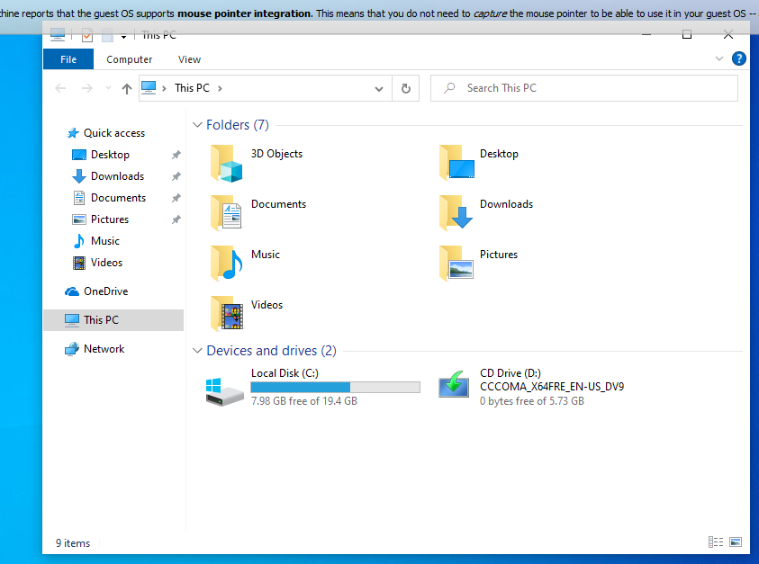
The new folder was created within C:
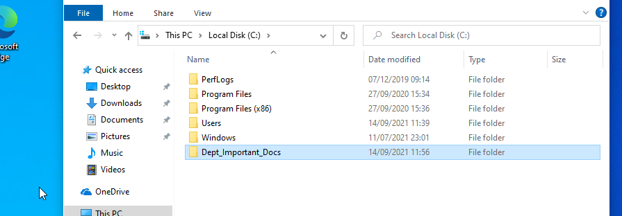
Then a text file created within it.
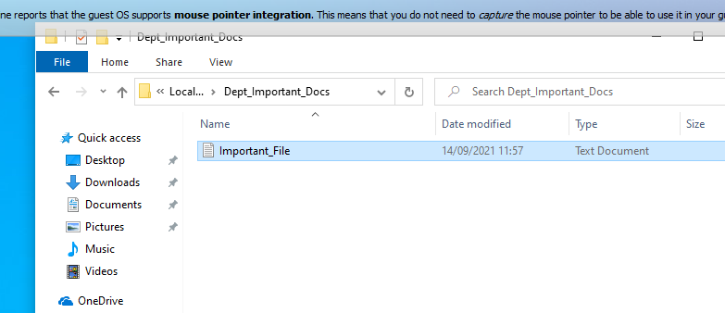
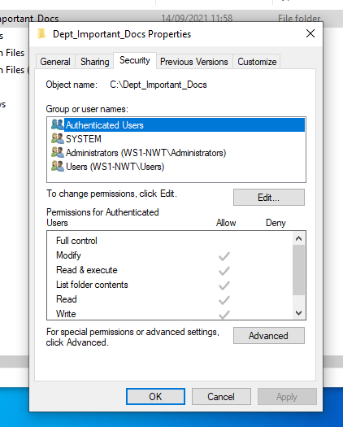
The author attempted to remove authenticated users however the following error message occurred:
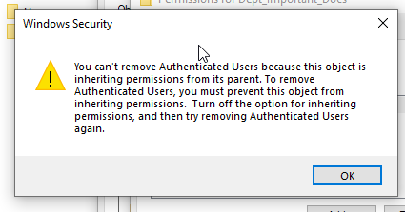
So the author disabled inheritance from the object
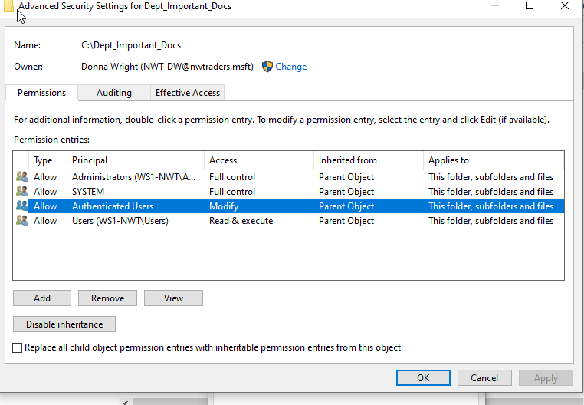
The author was then able to assign permissions
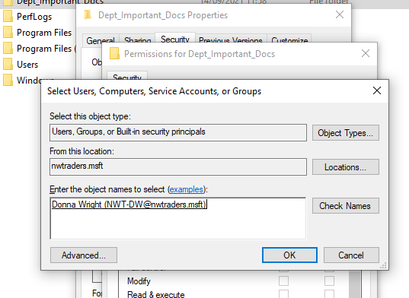
Full control was given to the admin account being used
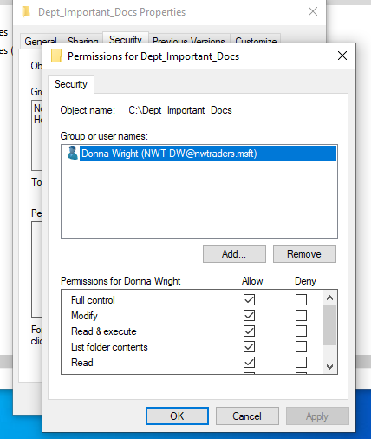
The user verified that the permissions were inherited by the file within the folder
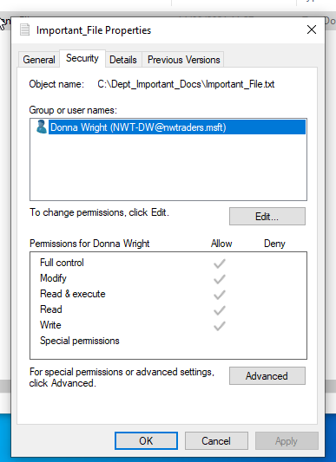
The author then looked to grant another user restricted access.
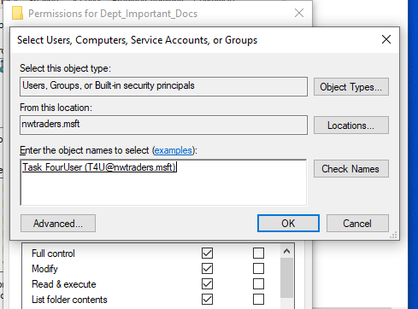
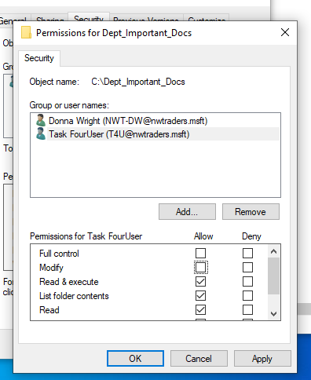
The author modified the data on the text file and logged out with the admin account. They then logged in as the restricted user and attempted to open and modify the folder and then open and modify the text file.
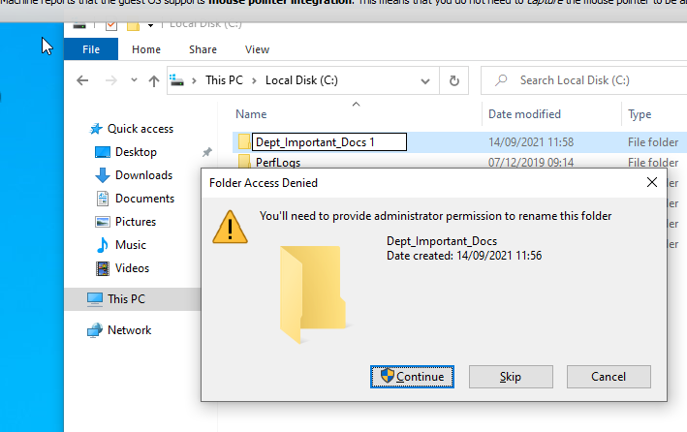
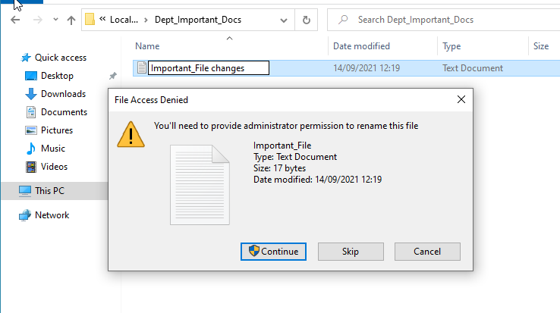
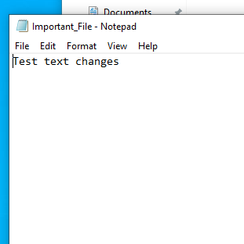
The user was able to access the folder and file but was not allowed to modify them. However they were able to change the content within the text file.
The restricted user could access the folder and file but was not permitted to modify them.

The next part of this task required the author to createt share permissions. The author started by accessing file and storage services in server manager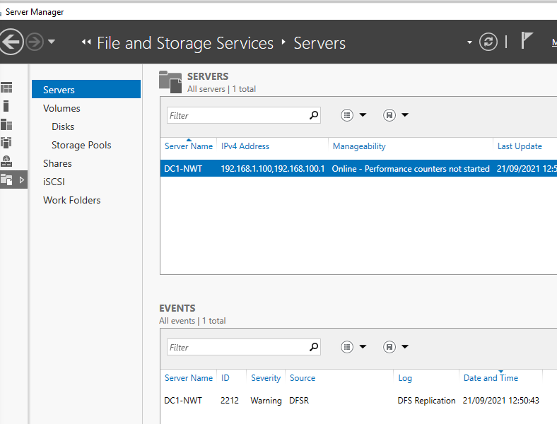
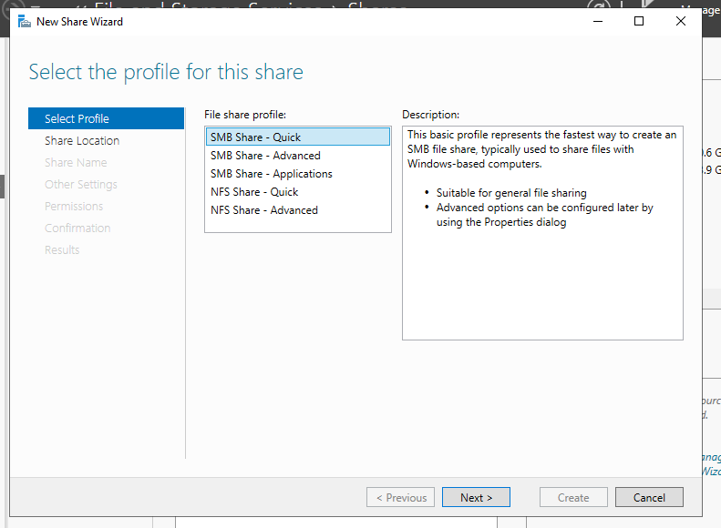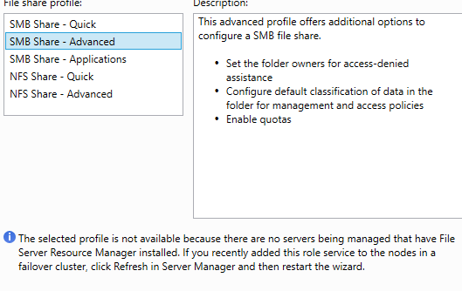
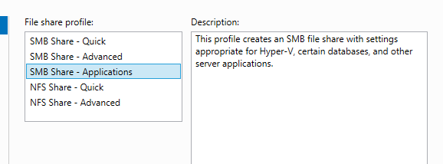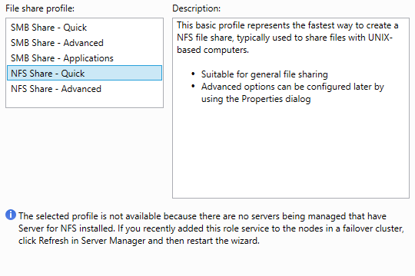
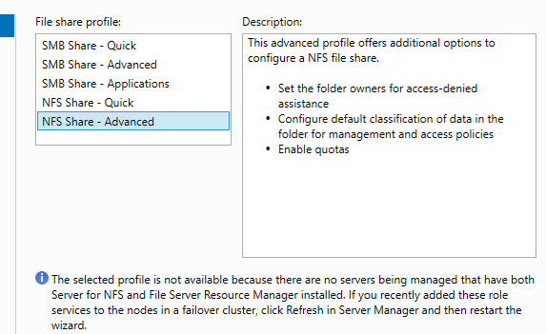
The author selected SMB Share – Quick as instructed in the worksheet.
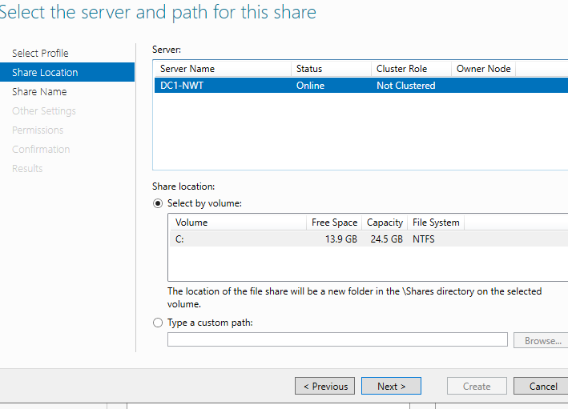
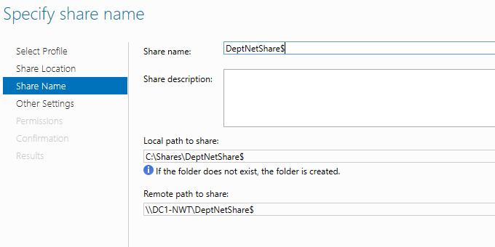
The 2 new paths are:
Local: C:\Shares\DeptNetShare$
Remote: \\DC1-NWT\DeptNetShare$
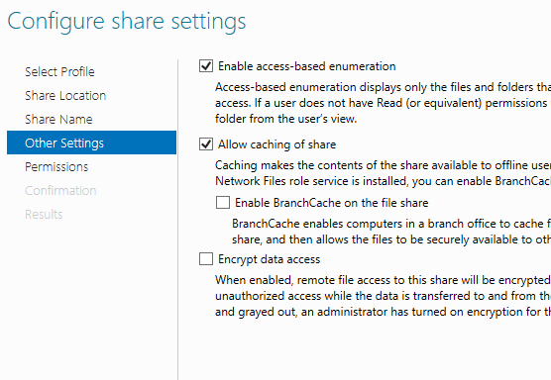
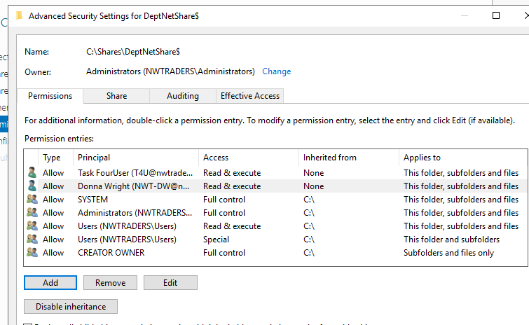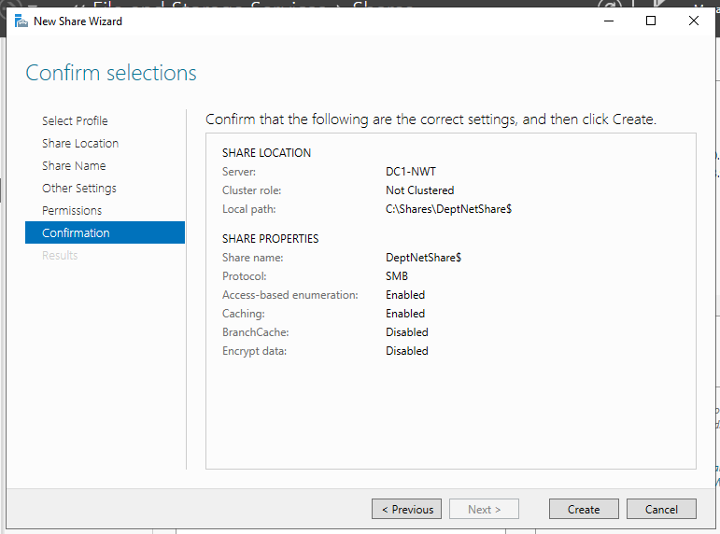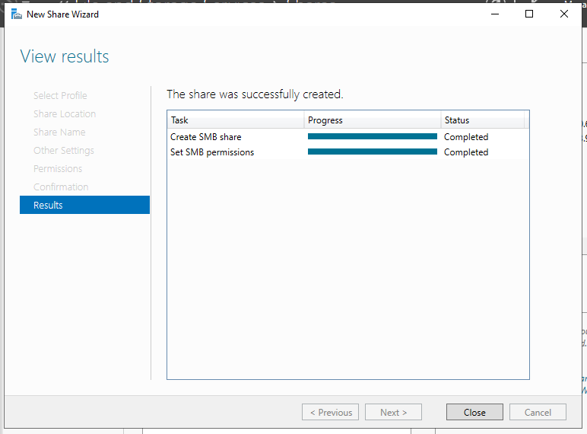
The final stepis to map the drive on the client
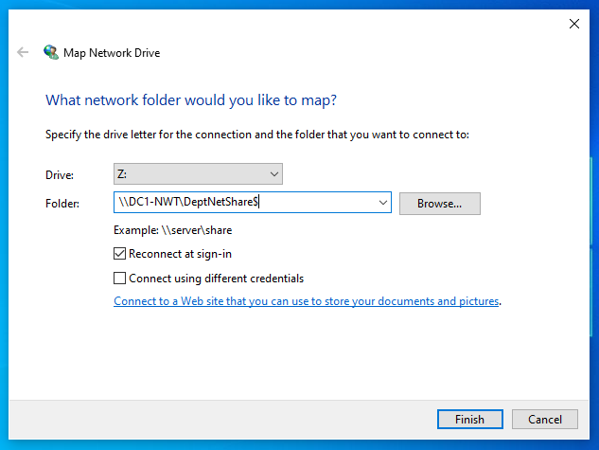
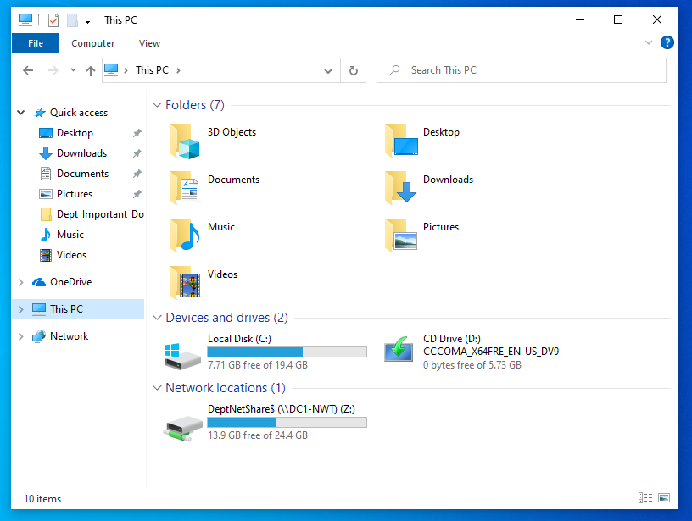

Annex B
Task 2
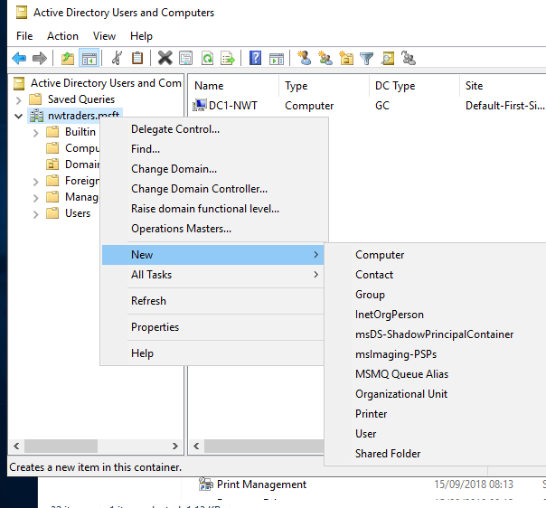
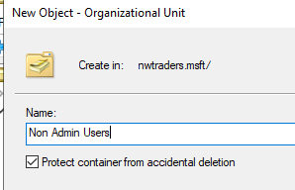
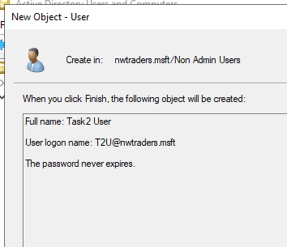
For ease the password has been set to never expire and is P@ssw0rd
First GPO is no remove access to control panel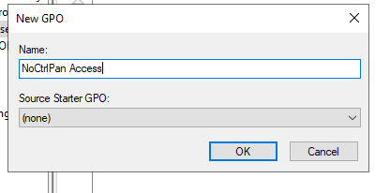
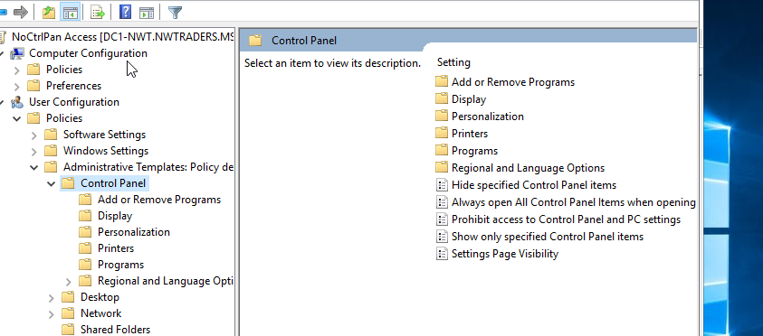
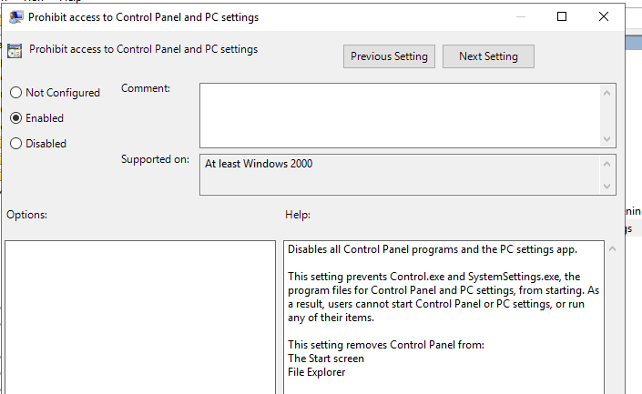
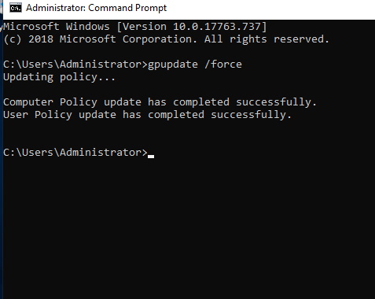
T2U is now unable to access control panel and receives the following error message when an attempt to access is made
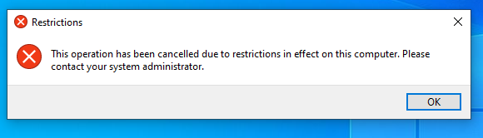
The second GPO is to remove access to command prompt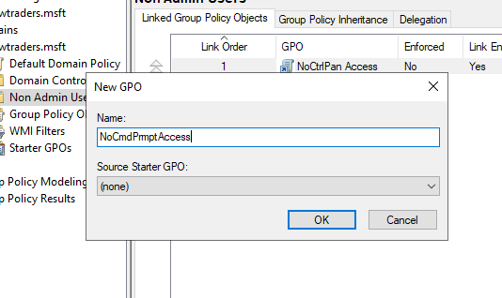
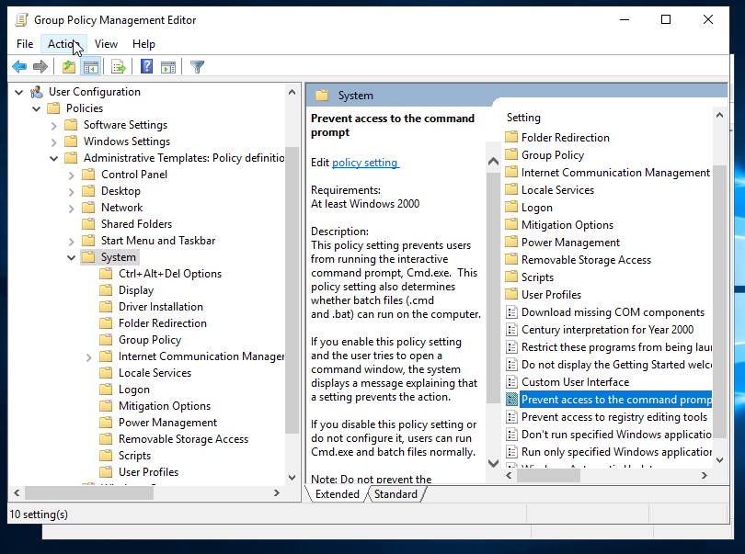
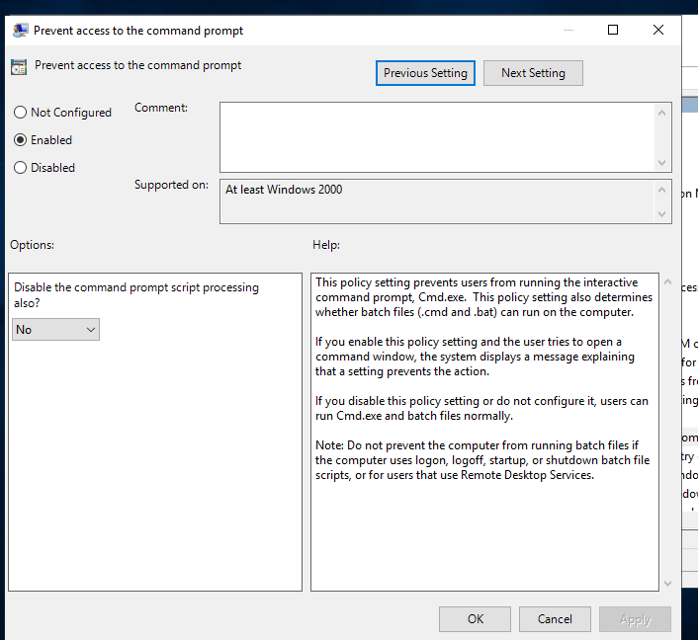
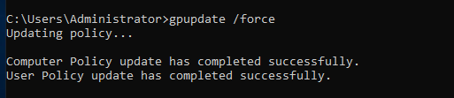
T2U now gets the following message when attempting to access command prompt
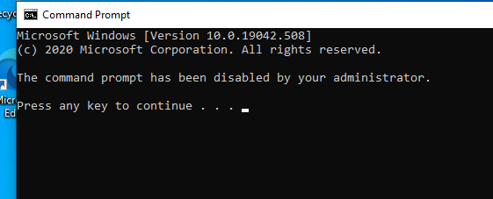
The third GPO is to remove access to removable drives 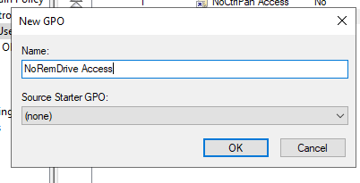
The fourth GPO is to restrict software downloads
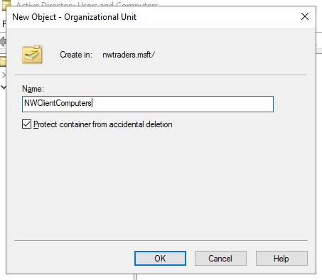
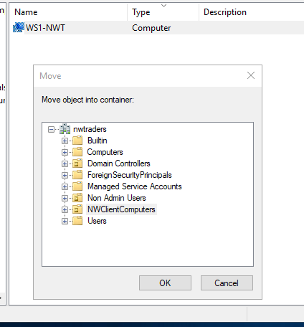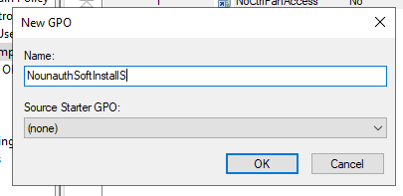
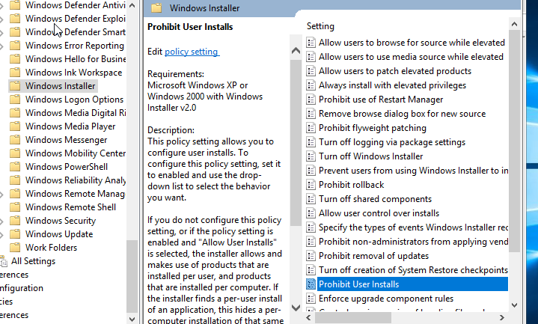
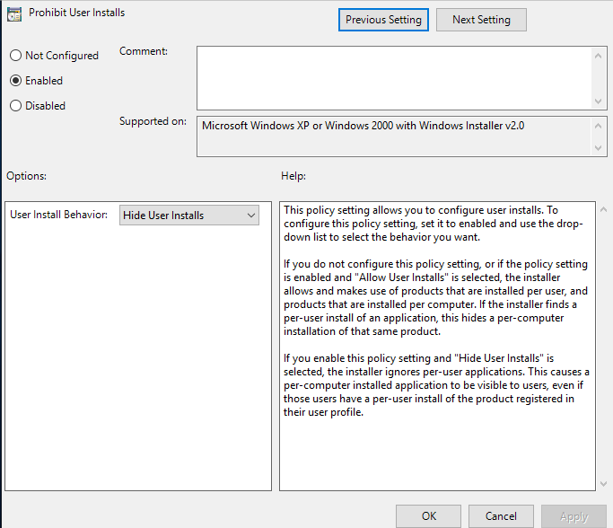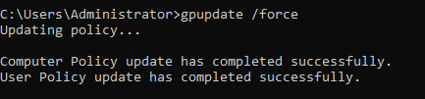
The final GPO is to enforce password policy on nwtraders.msft domain


