

LOCATION: Swansea | LLEOLIAD: abertawe
LEVEL 3 | LEFEL 3
EXAMINATION PERIOD | CYFNOD ARHOLIADAU
JULY 2018 | Gorffennaf 2018

MODULE CODE: m3x01513
SCIENCE - RESIT

TIME: 2 HOURS
answer all questions

Equipment or materials required – calculator
Adnoddau neu ddefnyddiau sydd eu hangen - cyfrifiannell

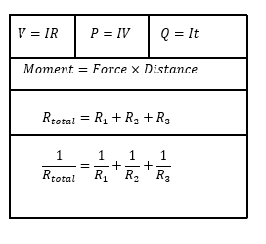
ANSWER ALL QUESTIONS

- Write down the units for the following: [5]

a) Current
b) Resistance
c) Velocity
d) Force
e) Weight

- Given that the equation for momentum can be written as;

$$moment=force×distance$$

Write down the units of a moment [2]

- A body of weight 750N rests on a rough inclined plane which is at an angle of 26⁰ to the horizontal.

a) Draw a free body diagram in your answer booklet showing the weight, normal reaction, friction and the component of weight that acts down the slope [2]

b) Calculate the magnitude of frictional force [4]
c) Calculate the magnitude of the normal reaction to the surface. [4]

- By considering figure 1

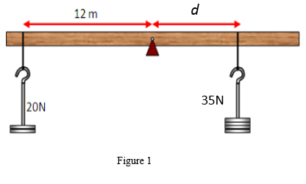

Calculate the value of the distance d so that the object is in equilibrium [4]

- Figure 2 shows a 14m uniform beam of weight 3.5KN which is at rest. The beam is supported by two pillars. Pillar X is positioned 0.70m from the left hand side of the beam, pillar Y is positioned 1.8m from the right hand side of the beam.

X
Y
Figure 2

a) Copy this diagram on your answer booklet, showing all forces. [2]

b) Determine both support forces. [6]

6. Define the following electrical characteristics. [2]

a) Resistance
b) Power

7. The current in a certain wire is 0.5A. Calculate the charge passing a point in the wire in i) 15s and ii) 15 minutes. [4]

8.
a) State Ohm’s law [2]
b) Calculate the current that flows through a wire of resistance 12.5Ω when the potential difference across the wire is 1.5V [4]

9. The circuit shown in figure 3 shows three identical resistors placed in series.

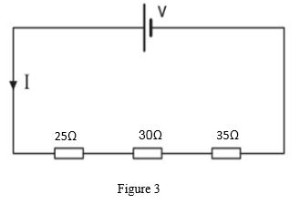

a) Using Ohms law, calculate the voltage of the cell if a current of 0.5A flows.
b) What value of I would you expect if the cell has a voltage of 12V [4]

10. Two 20Ω resistors are connected in series with each other. The series combination is connected in parallel with a 40Ω resistor and a 6V battery of negligible internal resistance, as shown in figure 4.

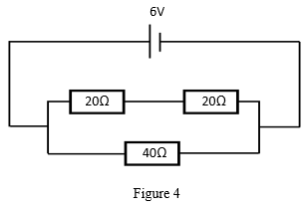

Calculate:

a) the total resistance of the circuit [2]
b) the current leaving the cell [2]
c) the power supplied to each resistor [3]
d) the power supplied by the battery [2]

Diwedd/End

