  Component One: Student Journal (learning log)  Contribution to Overall Module Assessment: 25% | Student No: | 2232322
 | Module Title: | Hotel Placement – Hotel Administration &  Front Office Operations
 | Module Code: | BMIH-4004
 | Lecturer: | LISA-MARIE BASSLER

Introduction
In the quick-paced, service-oriented hotel business, taking robust client facility skills is vital for accomplishment. More than impartial a cash transaction, providing outstanding purchaser provision is an art form that includes making permanent impressions, developing brand reliability, as well as endorsing optimistic word-of-mouth recommendations. Trades in the hotel business need to highlight the growth and use of larger purchaser facility capabilities if they want to continue competitive as well as maintainable in the face of ever-evolving customer demands.
This essay inspects the comprehensive topic of client service as well as the vital skills desirable to be positive in the hospitality business. These qualities include the ability to interrelate civilly as well as competently with visitors in totalling to having strong communication, administrative, as well as problem-solving assistance. Using a complete inspection and consideration of these important workings, experts in the hospitality subdivision can proficiently manage the details of visitor communications, safeguarding supreme levels of purchaser satisfaction as well as service excellence.

Overview of the organisation
Hilton UK is a well-known hotel chain that offers upscale accommodation options around the United Kingdom. At its several locations in well-known cities and picturesque surroundings, Hilton UK provides luxurious amenities, stylish lodging, and excellent service to accommodate both business and leisure travellers. Every hotel has facilities that cater to a variety of needs and preferences, such as state-of-the-art meeting rooms, superb dining options, and modern amenities. Hilton UK offers a wide range of experiences, from attractive rural locales to well-known destinations, catering to guests seeking coastal retreats, metropolitan sophistication, or country escapes. Hilton UK, which is renowned for its commitment to warmth and excellence, consistently gives visitors amazing stays and personifies the finest aspect of British hospitality (Hilton, 2024).

Component One: Student Journal (Learning Log)
The Gibbs Model of Reflection offers a systematic framework that helps individuals to critically assess their experiences, identify opportunities for personal and professional growth, and make action plans. This technique consists of six steps: description, feelings, assessment, analysis, conclusion, and action plan. Methodically going through these stages might help people comprehend their experiences better and gain important insights for personal development (Mulryan-Kyne, 2021).

Description of Placement Experience at Hilton Garden Inn Brindleplace
I ensured that guests were made to feel extremely welcome and that check-in and check-out procedures ran well while I worked as a receptionist at the Hilton Garden Inn Brindley Place. I was in charge of making reservations, responding to inquiries from guests, and assisting with various office duties. The fast-paced environment of the hotel sector presented me with many opportunities and challenges for learning (Ashworth and Saxton, 2020).

The feeling of Reflection on Challenges Faced and Lessons Learned
Throughout my placement, I encountered a lot of challenges that tested my adaptability and problem-solving skills. One major challenge was managing the expectations of visitors during peak times when an influx of people sometimes meant long lines and heightened anxiety. However, these challenges were invaluable teaching opportunities that enhanced my ability to remain composed under pressure and prioritise my work (Johnstone and Wilson-Prangley, 2021).
Interacting with guests from many origins enhanced my ability to communicate and navigate different cultures. Every interaction was a unique opportunity to get to know guests on a personal level and develop rapport and trust. Collaborating with colleagues in different areas also let me realise how important good teamwork and communication are to deliver exceptional customer service.

Evaluation of analysis of skills developed and their application in practice
My placement experience equipped me with a range of skills that are essential for success in the hospitality industry. These skills include:
Customer service: Because of my location, I am now better able to anticipate and promptly meet the needs of guests, ensuring that their stay is memorable and pleasurable. This intended paying close responsiveness to their requirements as well as assignment concerns an optimistic depiction of the hotel's obligation to provide outstanding client facility (Tueanrat et al., 2021).
Communication: During my placement, I enhanced my communication abilities by being careful to communicate as well as briefly with both companies and operations. As importance, there were fewer miscommunications as well as more effectual processes, which improved complete hotel facility delivery as well as ensured continuous teamwork.
Organisational Skills: Through my work, my structural skills enhanced as I proficiently managed a range of accountabilities as well as tasks, safeguarding ideal efficiency even in hectic periods. My capability to accomplish a diversity of tasks well improved my ability to meet goals and deliver exceptional service to companies at the Hilton Garden Inn Brindleyplace (Griffin et al., 2020).
Problem-Solving: In my position, I developed my problem-solving abilities by quickly assessing visitor problems and putting customised solutions in place, which helped to defuse tensions and anticipate complaints. This skill in handling problems has a big impact on keeping the Hilton Garden Inn Brindleyplace's guests happy and creating a good atmosphere.

Action Plan for Further Skills Enhancement
To enhance my skills and function effectively in my role, I have devised the below action plan:
Continuous Learning: I commit to regularly attending training sessions and seminars to stay up to speed on developments in the field and continue to progress. I want to be adaptable in the ever-evolving hospitality industry and broaden my knowledge by continuously seeking out new possibilities to develop my abilities (Sahi et al., 2021).
Seek Feedback: I am aware of the significance of constructive criticism for my professional growth. I thus pledge to actively seek out feedback from superiors and peers. By embracing feedback and implementing personalised growth strategies, I want to refine my skills, rectify mistakes, and progress in my role within the hospitality industry (Ashworth and Saxton, 2020).
Expanded Skill Set: To further my talents, I'm eager to take on more responsibility and work on cross-functional initiatives. By actively seeking out unusual experiences and tasks, I hope to increase my versatility, get a deeper understanding of many aspects of the hospitality industry, and be able to contribute to my team's and company's success more successfully (Hansen, 2021).
Self-Reflection: I frequently analyse my experiences and evaluate my performance using the Gibbs Model of Reflection to encourage ongoing improvement.
I gained invaluable information and skills during my internship at the Hilton Garden Inn Brindleyplace, which has changed my life and will help me in my future career in the hospitality industry. I'm resolved to embrace new challenges and strive for professional excellence via self-reflection and proactive skill improvement (Ashworth and Saxton, 2020).

Component Two
Contribution to Overall Module Assessment: 25%

Trip Advisor Review Response
In response to positive Trip Advisor reviews such as this one, it is important to acknowledge the guest's satisfaction and express gratitude for their wonderful experience. Emphasising the significant aspects of their stay—such as the comfortable lodging, excellent service, and delectable breakfast—confirms the hotel's commitment to ensuring that its customers are satisfied. Resolving any concerns brought up, such as the restaurant's outrageous prices, also shows a dedication to taking criticism to heart and improving. The hotel has strengthened its relationship with the guest who wrote the review by being kind and appreciative throughout the response, demonstrating its commitment to providing exceptional service to all guests (Zhang et al., 2022).

Screenshot of referenced Trip Advisor review used:
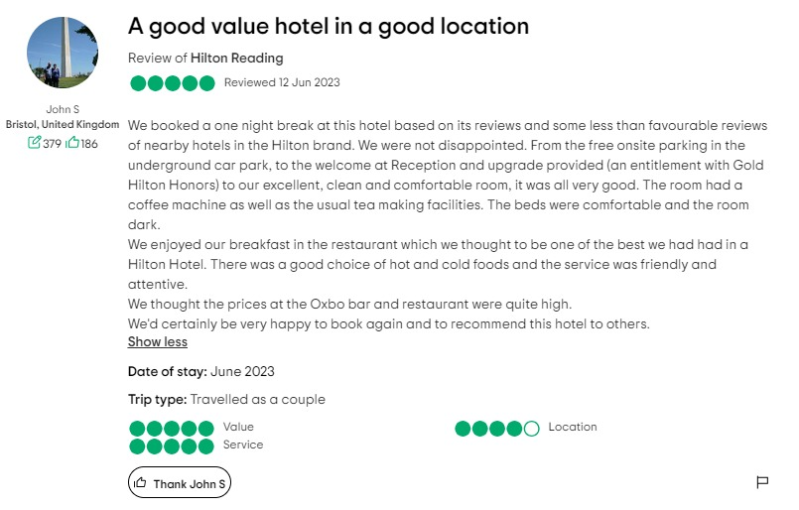
(Source: Tripadvisor, 2023).

Letter of complaint response
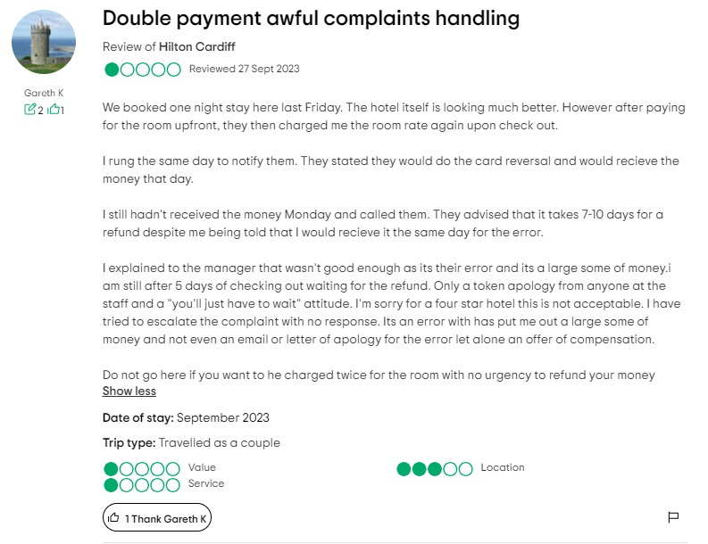
(Source: Tripadvisor, 2023).

Dear (Gareth K),
Subject: Response to Your Recent Stay Experience
I hope you are well and reading my letter. To begin with, let me sincerely apologise for any inconvenience or annoyance you had during your most recent stay at the Hilton Cardiff. We sincerely thank you for your feedback and apologise if we did not meet your standards.
As soon as we heard about your billing issue, we looked into it in great detail. I regret any confusion or inconvenience that the two payments for your stay may have caused. I insist that this inaccuracy was not supposed to occur and that we are captivating aggressive events to address the difficulty as soon as possible.
You may be assured that the identical payment repayment has been administered, and over the subsequent three to five business days, the reserves must be in your account. I recognise the importance of the problem and honestly make an apology for any problem this has initiated. You may be sure that we are inspecting our internal events to ensure that our visitors have a supreme involvement and to stop such incidences in the future.
I make an apology for the apparent insignificance and lack of communication from our operating supporters. Since safeguarding the consummation of our guests is our priority, I make an apology for our inability to address your apprehensions in a rapid and considerate method. We would want to offer extra training meetings to our staff to strengthen the significance of practical communication as well as problem-solving assistance.
We would like to acknowledge you for your concern and prevention during your visit by contributing a complimentary one-night stay at our hotel. This comprises breakfast as well as access to our best services. I am satisfied to give you a 25% discount on your next vacation with us as a thank you. Please contact our reservations department to arrange your complimentary stay. We'll make sure everything about your next visit exceeds your expectations.
We greatly appreciate your feedback and are committed to applying what we've learned to improve our services going forward. I want to reassure you that we are aware of your worries and am acting now to prevent such incidents in the future.
Again, I deeply regret the inconvenience and aggravation this has caused. We appreciate your business and look forward to seeing you at Hilton Cardiff once more so you may once again put your faith in our friendly service.
Warm regards
Hilton

Component Three:
Contribution to Overall Module Assessment:

Key Skill 1 – Customer Service Skills

Excellent customer service skills are crucial in the hotel industry because they have a direct impact on the satisfaction and loyalty of guests. These abilities—empathy, problem-solving techniques, and attentiveness—all work toward ensuring that visitors have a fulfilling and unforgettable experience (Dominguez and Herrera, 2020).
During my employment at the Hilton Garden Inn Brindley, I was able to hone my customer service skills via frequent interactions with guests. I developed the capacity to anticipate their needs, react promptly to any problems, and, wherever possible, go above and above. I placed a great value on offering personalized service to make a lasting impression, whether it was assisting with check-in procedures or responding to inquiries from visitors.
When a guest's key card malfunctioned and made it impossible for them to reach their room, it was a noteworthy instance of good customer service. I quickly worked with the maintenance crew to repair the problem and guarantee the guest's comfort and happiness while being composed and sympathetic. In addition to immediately resolving the problem, this proactive effort showed our dedication to providing top-notch service (Hudson and Hudson, 2022).
By carefully considering and adapting to the input I received from visitors, I was able to tailor my service delivery to meet individual needs and beyond their expectations. These occurrences showed how important having good customer service skills is to gaining repeat business from customers and enhancing the hotel's reputation overall.

Key Skill 2 – Communication Skills

To ensure seamless operations and satisfied guests, effective communication is crucial for those working in the hospitality industry. It enables staff to interact productively and positively with customers, colleagues, and management. Transmitting accurate information, resolving issues promptly, and maintaining positive relationships all depend on concise and clear communication (Musheke and Phiri, 2021).
During my work at Hilton Garden Inn Brindleyplace, I had several opportunities to practice and refine my communication abilities. Smooth service delivery required effective communication in all situations, including supervising cleaning staff, engaging with management, and greeting customers at the reception desk.
Effective communication is essential for individuals in the hospitality sector to maintain smooth operations and happy visitors. It makes it possible for employees to communicate effectively and amicably with clients, coworkers, and management. Concise and straightforward communication is essential for sharing correct information, handling problems quickly, and upholding goodwill (Mohammad et al., 2021).
Working at Hilton Garden Inn Brindleyplace gave me many chances to hone and improve my communication skills. Effective communication was necessary for all aspects of smooth service delivery, including managing cleaning crews, interacting with management, and welcoming clients at the front desk.

Key Skill 3 – Organisational Skills
Organizational skills are critical to sustaining output, effectiveness, and faultless service in the hotel sector. In the busy hotel industry, efficient organisation is essential for managing several responsibilities, setting priorities, and delivering excellent customer service (Margherita et al., 2021).
I developed my organisational skills while working at the Hilton Garden Inn Brindleyplace by taking on a range of tasks and responsibilities. For example, managing guest bookings requires demanding attention to detail, precision, and timeliness to prevent overbooking and ensure visitor satisfaction. Prioritising room turns and meeting guest expectations while collaborating with cleaning staff also requires effective planning and communication( Margherita et al., 2021).
When the hotel experienced a surge in the number of visitors visiting over a busy holiday weekend, effective organising skills were displayed in the hospitality industry. Through efficient coordination and resource allocation, the front desk team managed the influx of guests, minimised wait times, and maintained service standards. This illustrated how proactive planning may be used to recognise and manage differences in demand (Garavan et al., 2021).
The meticulous planning, meticulous attention to detail, and faultless coordination that ensured the success of several conferences, events, and functions further highlighted the hotel's exceptional organization in its event management technique. The hotel consistently delivered excellent customer service by demonstrating exceptional organisational skills, which raised customer satisfaction and loyalty.

Key Skill 4 – Problem-Solving Skills

In the hospitality industry, problem-solving skills are essential as unforeseen problems and visitor complaints might arise at any time. Maintaining guest satisfaction and ensuring seamless operations need the ability to evaluate the situation, identify the root causes, and implement workable remedies (Maksum et al., 2021).
I encountered several circumstances at the Hilton Garden Inn Brindleyplace that required effective problem-solving strategies throughout my employment. For example, a guest arrived early during peak check-in hours and expected to be shown to their room immediately. Despite the restricted number of rooms available, I talked with housekeeping as soon as possible to expedite room turnover, and to lessen any inconvenience, I gave the guest free refreshments in the lobby. This response not only satisfied the visitor's urgent need but also enhanced their entire experience.
In another instance, a guest's billing issue was settled because they had inadvertently been billed for items from room service that they had not requested. After attentively reviewing the guest's bill, confirming it with order records, and corresponding with the F&B department, I quickly fixed the issue, issued a refund to the visitor, and offered a complimentary lunch. This proactive approach not only promptly resolved the issue but also exceeded the visitor's expectations, fostering loyalty and positive word-of-mouth (Marcos and Coelho, 2022).
Hotels in the industry that have implemented robust guest recovery strategies serve as excellent models for problem-solving techniques. For instance, offering timely fixes, sincere apologies, and just compensation in the event of poor service demonstrates a commitment to customer satisfaction and loyalty. Furthermore, proactive measures that promote a culture of problem-solving and excellent customer service in hospitality environments include anticipating potential issues, allowing staff the latitude to make decisions on the spot, and implementing continuous improvement programs (Migdadi, 2020).

Reference List
Ashworth, P. and Saxton, J. (2020) Managing work experience. Routledge.
Domínguez, G. and Herrera, A.F. (2020) Learning framework for the development of key skills in the hospitality industry. International Journal of Hospitality and Tourism Studies (IJHTS), 1(2), pp.127-139.
Garavan, T., McCarthy, A., Lai, Y., Murphy, K., Sheehan, M. and Carbery, R. (2021) Training and organisational performance: A meta‐analysis of temporal, institutional and organisational context moderators. Human Resource Management Journal, 31(1), pp.93-119.
Griffin, R.W., Phillips, J.M. and Gully, S.M. (2020) Organizational behavior: Managing people and organizations. CENGAGE learning.
Hansen, A. (2021) The purposes of performance management systems and processes: a cross-functional typology. International Journal of Operations & Production Management, 41(8), pp.1249-1271.
Hilton (2024) About Us. Hilton [Online]. Available from https://www.hilton.com/en/corporate/. [Accessed: 13/02/24].
Hudson, S. and Hudson, L. (2022) Customer service for hospitality and tourism. Goodfellow Publishers Ltd.
Johnstone, R. and Wilson-Prangley, A. (2021) The relationship between mindfulness and individual adaptability in dynamic work contexts.
Maksum, A., Widiana, I.W. and Marini, A. (2021) Path Analysis of Self-Regulation, Social Skills, Critical Thinking and Problem-Solving Ability on Social Studies Learning Outcomes. International Journal of Instruction, 14(3), pp.613-628.
Marcos, A.M.B.D.F. and Coelho, A.F.D.M. (2022) Service quality, customer satisfaction and customer value: holistic determinants of loyalty and word-of-mouth in services. The TQM Journal, 34(5), pp.957-978.
Margherita, A., Sharifi, H. and Caforio, A. (2021) A conceptual framework of strategy, action and performance dimensions of organisational agility development. Technology Analysis & Strategic Management, 33(7), pp.829-842.
Migdadi, M.M. (2020) Knowledge management, customer relationship management and innovation capabilities. Journal of Business & Industrial Marketing, 36(1), pp.111-124.
Mohammad, T., Darwish, T.K., Singh, S. and Khassawneh, O. (2021) Human resource management and organisational performance: The mediating role of social exchange. European Management Review, 18(1), pp.125-136.
Mulryan-Kyne, C. (2021) Supporting reflection and reflective practice in an initial teacher education programme: An exploratory study. European Journal of Teacher Education, 44(4), pp.502-519.
Musheke, M.M. and Phiri, J. (2021) The effects of effective communication on organizational performance based on the systems theory. Open Journal of Business and Management, 9(2), pp.659-671.
Sahi, A.M., Khalid, H., Abbas, A.F. and Khatib, S.F. (2021) The evolving research of customer adoption of digital payment: Learning from content and statistical analysis of the literature. Journal of Open Innovation: Technology, Market, and Complexity, 7(4), p.230.
Tripadvisor (2024) A good value hotel in a good location Tripadvisor [Online]. Available from https://www.tripadvisor.in/ShowUserReviews-g186363-d1438816-r894654931-Hilton_Reading-Reading_Berkshire_England.html. [Accessed: 12/02/24].
Tripadvisor (2024) Double payment awful complaints handling Tripadvisor [Online]. Available from https://www.tripadvisor.in/ShowUserReviews-g186460-d187981-r918649642-Hilton_Cardiff-Cardiff_South_Wales_Wales.html. [Accessed: 12/02/24].
Tueanrat, Y., Papagiannidis, S. and Alamanos, E. (2021) Going on a journey: A review of the customer journey literature. Journal of Business Research, 125, pp.336-353.
Zhang, X., Yang, Y., Qiao, S. and Zhang, Z. (2022) Responsive and responsible: Customizing management responses to online traveler reviews. Journal of Travel Research, 61(1), pp.120-135.

