Homework sheet
- practise your handwriting
jī
chicken
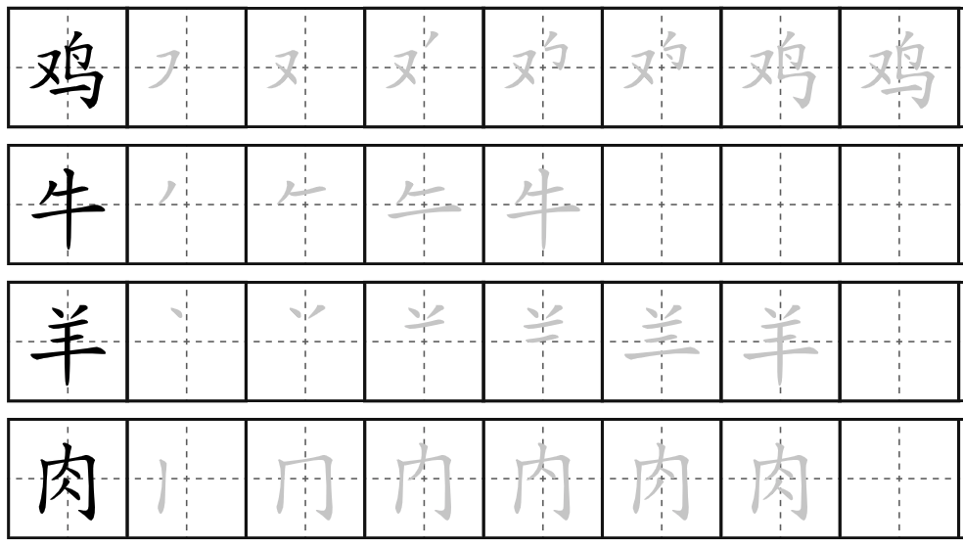
ròu
meat
niú
cow
yáng
sheep
lamb

- Answer the following questions
- Q: 你要吃什么? (Nǐ yào chī shénme?) What do you want to eat?
A: Wǒ yào chī niúròu chǎo miàn 。(Dw i eisiau bwyta nwdls cig eidion wedi’i ffrio. - I want to eat fried beef noodles)
- Q: 你要喝什么? (Nǐ yào hē shénme?) What do you want to drink?
A Wǒ yào hē hóngchá。(Dw i eisiau yfed te coch. - I want to drink red tea)
- Q: 妈妈要吃什么? Māmā yào chī shénme? What does mum want to eat?
A Tā yào chī chǎo yangròu fàn。(Mae hi eisiau bwyta reis cig oen wedi’i ffrio. - She wants to eat fried lamb rice)
- Q: 爸爸要喝什么? (Bàba yào hē shénme?) What does dad want to drink?
A: Tā yào hē nǎichá。(Mae e eisiau yfed te gyda llaeth. - He wants to drink tea with milk)

- Translate the following sentences
- Mae coffi yn blasus iawn! – The coffee is very tasty!
Kāfēi hěn hǎohē
- Dydy te du ddim yn flasus. – the black tea is not tasty !
Hēichá bù hǎohē
- Mae nwdls wedi’i ffrio yn blasus. – The fried noodles are delicious.
Chǎo miàn hǎochī
- Dydy reis wedi’i ffrio ddim yn blasus. The fried rice is not tasty.
Chǎo fàn bù hǎochī
- Mae nwdls cig eidion mor blasus. - Beef noodles are so delicious.
Niúròu miàn tài hǎochī le.
- Describe whether the food or the drink in the picture is delicious or not.
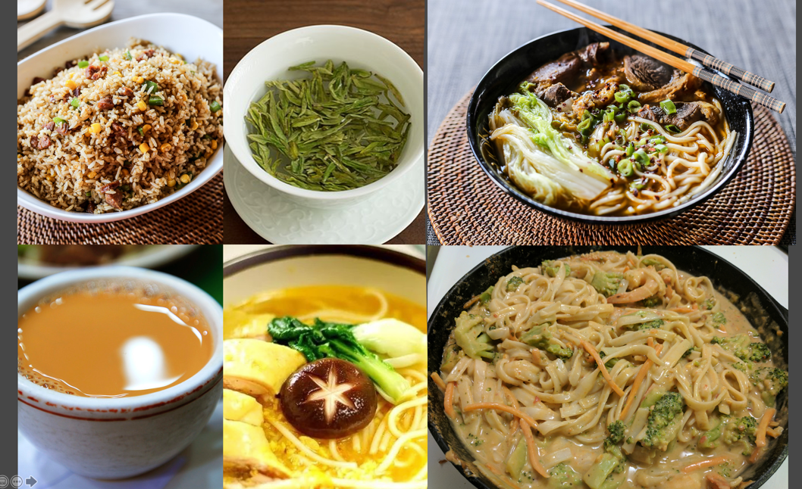

1. chǎo fàn hěn hǎochī
2. lǜchá bù hǎohē
3. cài hé ròu miàn bù tài hǎochī le (? Not sure I can say that?!?)
4. nǎichá hǎohē
5. jīròu miàn hǎochī
6. cài miàn tài hǎochī le
- Type a paragraph to introduce yourself and your family. Then recording yourself reading it afterwards. (Please feel free to look up the words you are not sure about, e.g.: jobs and adjectives that are not included in our lesson. I will give you some feedback on that afterwards.)
you can talk about:
- your name
- your nationality
- your age and birthday
- your job and location
- the subject you teach
- people in your family (What are they like? What are their jobs?)
- your pet
- Chinese food you want to eat
- Chinese tea that you would like to drink

1. Ní hǎo, wǒ jiào Francoise
2. Wǒ shì Fàguó rén
3. Wǒ wǔshí suì. Wǒ de shēngrì qī yuè shí wǔ hào
4. Wǒ shì lǎoshī. Wǒ zài xuéxiào gōngzuò
5. Wǒ jiào fǎ yǔ lǎoshī hé shùxué lǎoshī
6. Wǒ méiyǒu xiōngdì jiěmèi
7. Wǒ yǒu liǎng zhī māo. Tāmen de míngzì shì Luna hé Pablo.
Wǒ de māo Pablo pàng bù cōngmíng
Wǒ de māo Luna piàoliang hěn cōngmíng
8. Wǒ yào chī yángròu chǎofàn
9. Wǒ yào hē bīng kāfēi
Zàijiàn

