Module: BMSW 4001
Academic and Employability Skills
Andrea Nankova Eduardo Barros dos Santos
Student number: 2019914
Lecturer Name: Yohan Mendis

Reflective review on Employability skills


The concept of employability
this is a concept that makes us understand how someone gets a job. because we have to keep in mind the requirements such as having a good preparation. because it exists every time but we have competition in the job market.

Today I know how important and fundamental this concept is throughout life because it is not about quality or quantity but about good preparation. because the more prepared I am, the more likely I am to find the ideal job for me.
With this module I learned to keep myself trained and updated with new innovations and in different ways to take courses, lectures, books and publications to obtain better results.
nowadays with everything i learned in this module the job i have will depend on my knowledge.

Table contents

- Introduction 3

- Time Management skill 4

- Presentation skill 5,6

- Team working skill 7

- Planning and organisation 8,9

- Conclusion 10

- References 11



In this report I come to demonstrate how this module came to help me process and improve my employability skills. I aim to give examples of how to get a job and how to stay in the job. I also explain how our experiences with others can influence the competitive world of work and being a student sometimes has an introduction to how to work in a group and help others with their difficulties.

Time Management skill

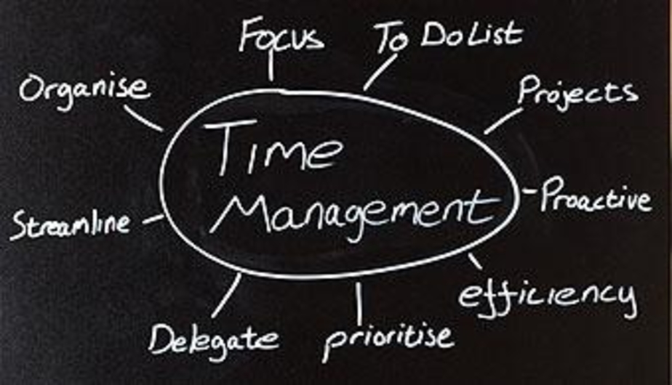

In this module I learned skills and ways of managing my time, managing my time in my daily life.
it was difficult at first because changing my life habits like going out with friends among other things were put aside because I learned to prioritize the ability to say no, for example to a party or trips before the holidays because they could disturb my focus of study. I didn't stop living, I just learned to organize myself by making a schedule of appointments because what was a party during the week could be scheduled for the weekend and so I didn't lose my classes or the focus of the subject. I had to determine some study goals such as prioritizing the delivery time of my works so that they would not be accumulated and putting everything in order of arrival or importance of time.

Presentation skill



For me having good presentation skills is very valuable to me individually or in my future in a job or even in my business and this module taught me to see the reality of a job interview and how to prepare for an interview and how to behave, how to dress, how to talk etc. he also showed me how to work in a team and how it is not easy but it can also be very pleasant and challenging to deal with different personalities for a common project. I personally also learned how to present myself to others without the fears and fears that I had before. Now I can deliver any work presentation both individually and in a team.

1-I had a group work formed by 4 colleagues and the work would have to be presented in class. I had the initial idea of ​​separating the work by points, and then dividing them by each one so that everyone had something to contribute to the final work.
my group at first was very connected but then there was a lot of disorganization, because they didn't keep the appointment times even if by video conference, I found myself completely frustrated because even with 4 children and with the housework I tried to help everyone my colleagues sometimes reminding them that they were delaying the delivery of the points that each one chose because I was responsible for making the structure of all the slides in the end in the end everything worked out because I helped some and I had patience and respect for each one of them.
2- I learned that working in a group is not easy at all because on many occasions I felt frustrated because I told myself how I have so much to do, children, home, among other things, I can answer all of them in the end but that in this contest being a work of group the final work would be common and not individual.
I learned to impose myself and to respect the time of each one because some people have more difficulties than others for the housework and others for the work because we all have a social life and duties to buy.

3- I took tips like separating important points, doing research, and adding some of my skills, sending summaries and always putting my thoughts on the agenda but always with a little humour and relaxation.
4-What was the feedback?
my group for me was very challenging for everything I mentioned in the points above but nevertheless we had a good presentation. because we were all relaxed, and we made a calm and clear presentation.

Team working skill

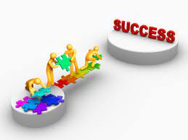
teamwork has brought me some benefits, as sometimes working with multiple people for a common set of benefits is likely to develop very well.
which became a big challenge for me, as I am used to working individually. in all the jobs that I worked in a team, I learned to have some points as a basis to have a better productivity for myself and for my teammates.

1. I had a group activity in which it was a presentation in slides, it was difficult to deal with different personalities but one of the things I learned in this module was to wait for my moment to speak, always respect the other's time and respect others so that everything runs well and ran.
2. always trying to have a solution to problems that may appear during work and having attitude because I learned that showing that being there and not being shy or even thinking that others are better than me would not be good and would only harm me in the future So I started to not be afraid to expose my ideas.
I realized that working in a group has its benefits and one of them is that as the work is divided, its production would be faster and more accurate.
3. have good communication, as I started to speak with my colleagues more clearly and to be more objective in everything I said, always maintaining respect for my colleagues.
4. I also learned that having self-knowledge helps a lot, even if it is with my life experiences in which respect for others has always been and will be very important to me.
5. have more flexibility to adapt to any need that my team may face, with changes and difficulties, especially with people.
6. I learned to expose my experiences and turn them into valuable moments of my own growth.
7. have confidence and convey the people that were around me, sharing information and staying away from problems that could distract me.

All this I learned in this module.

Planning and organisation
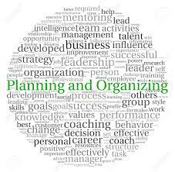

I have the principle that in order to have a good result it is necessary to have organization. and this module shows me very exact ways of how to do it, because having an organization made my ideas better organized with the creation of rules and processes. in this I transformed my thoughts and information and action.
The benefits that having a good organization brought me:
- decreased workload and reduced my stress
- I created processes to have more agility in the execution of any work imposed.
- to have an ease of my habits
- and making work plans
- Types of planning and their characteristics

- Strategic planning
they are the vision and values, as well as internal and external factors of a business.
- tactical planning
transformation of goals and action
- operational planning
determines delivery times, quality and services.
- marketing planning
Works on results and the coordination of financial and human resources, communication and marketing for the desires of consumers.
- Product and service planning
determines the mix of products and services that best suits the target audience.
- 5 steps I learned to develop a good plan:
- What is wanted.
- Why do you want to?
- How will it be done.
- What will it take?
- What can go wrong.

In this module I also learned to use some tools to organize myself, which are:
- SWOT Analysis

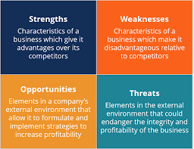
example

- Diagram

example
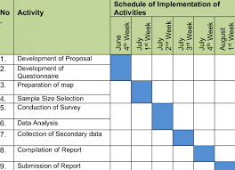

These are just two of the many tools that have been passed on to me, but with them it was possible to better plan and organize my work plans and help me to achieve success in different sectors.



thanks to this module I see myself with more improved skills. I can take doubts without shame, I'm more didactic. I learned to show my qualities and difficulties to others. I am more open to accepting the opinion of others for my benefit. Concluding that if I don't know how to work among other people, I won't know how to adapt to the work environment.



- Costa, C., Panyik, E. and Buhalis, D. eds., 2013. Trends in European tourism planning and organisation (Vol. 60). Channel view publications.

- Green, F., Ashton, D. and Felstead, A., 2001. Estimating the determinants of supply of computing, problem‐solving, communication, social, and teamworking skills. Oxford Economic Papers, 53(3), pp.406-433.

- Nowrouzian, F.L. and Farewell, A., 2013. The potential improvement of team-working skills in Biomedical and Natural Science students using a problem-based learning approach. Journal of Problem Based Learning in Higher Education, 1(1), pp.84-93.

- Pedder, D. and Opfer, V.D., 2010. Planning and organisation of teachers' Continuous Professional Development in schools in England. The curriculum journal, 21(4), pp.433-452.

- Sainz, M.A., Ferrero, A.M. and Ugidos, A., 2019. Time management: skills to learn and put into practice. Education+ Training.

- Saito, K., Tanida, A., Kashihara, A. and Hasegawa, S., 2010, October. A Framework for Developing Presentation Skill with Presentation Schema. In E-Learn: World Conference on E-Learning in Corporate, Government, Healthcare, and Higher Education (pp. 2696-2703). Association for the Advancement of Computing in Education (AACE).

- Trueman, M. and Hartley, J., 1996. A comparison between the time-management skills and academic performance of mature and traditional-entry university students. Higher education, 32(2), pp.199-215.

- Widyaningrum, L., 2016. Pecha Kucha: A way to develop presentation skill. Vision: Journal for Language and Foreign Language Learning, 5(1), pp.57-74.

