Judith Walton 2315393

A Reflection Cast At Abaty Ystrad Fflur.

The feeling of eager anticipation grew as I progressed down the long and winding road. The twists and turns akin to a steadily creeping grey snake, cutting impolitely into the landscape to lead me to my destination. The deeper I journeyed into the past, the ancient amber trees with their sparse branches, shielded me from the low autumnal sun. Like the travellers of days long ago, I made my way to Ystrad Fflur to be held in her warm serenity and rich literary roots. As I drew closer, the grand sculpted figure of a pilgrim could be seen standing high atop the hill overlooking the Abbey, a guardian for the buried and a beacon for the new.
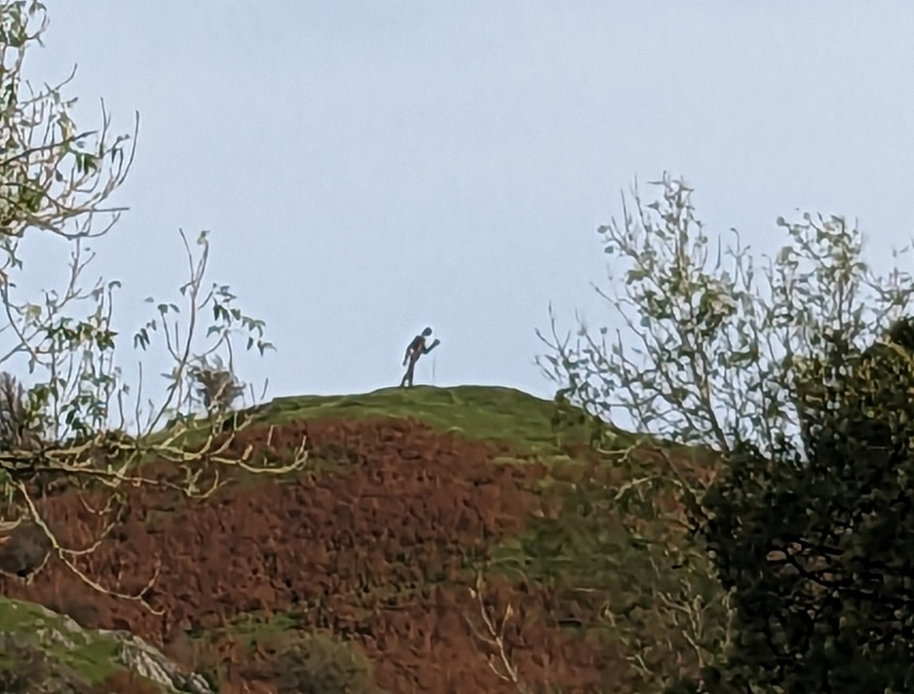

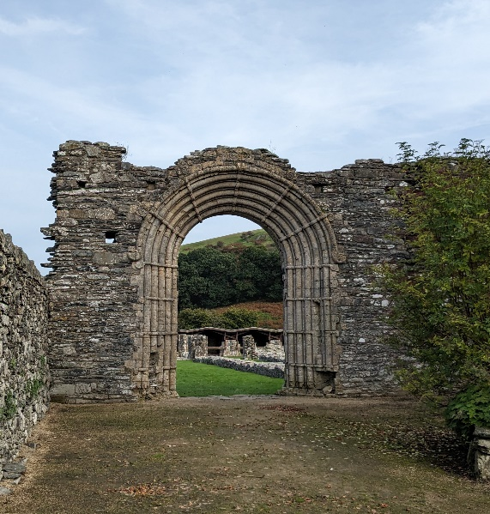
The air was warm and filled with the earthy scent of the previous days’ rainfall. The lush green grass, deep and soft underfoot, still holding the glistening wet drops. I was taken by the calm stillness surrounding me, the only sounds to be heard were that of the majestic solitary red kite soaring overhead and the lowing of cattle in the surrounding fields. A cyclist sat on a nearby bench, his backpack by his feet as he took a long drink from his water bottle. A welcome rest, no doubt, from his uphill pedalling. He appeared faraway in thought and quite unaware of my presence as I made my way through the gates towards the abbeys’ remaining archway. I did not glance back to see whether the creaking of the heavy metal hinges, a distinct objection at being stirred, jolted him from his pondering. Apologetically, I closed the gate behind me with more gentle care.

Stopping to stand a while under the great entrance, I placed my hand upon the stone with a longing to feel the touch of the craftsmen’s hands who had originally worked the masonry into such magnificence. I listened to the whispers of those who had also walked beneath this arch over the centuries, their words and stories captured and held within the decaying rock now echoing into my imagination. My attention is drawn to a recently painted pebble placed at the foot of the arch, a reminder of the ebb and the flow of old and new artistic creativity merging and evolving with this site.
I feel a warmth in my heart centre as I acknowledge the significance of standing amongst these medieval ruins. Here where the Hendregadredd Manuscript, The White Book of Rhydderch, and The Mabinogion are believed to have originated. The first records of Welsh medieval literature immortalised by the hands of the Cistercian Monks who had resided here since its founding in 1164. Had it not been for their hours of tedious work in the abbey’s scriptorium we may not have been gifted the knowledge of our Welsh literary heritage, nor be able to read the mythical tales, poems, and prose of the day.
I continue to make my way among the eroding remains of what was once such a prominent central position of the community. I feel the energies that remain in the earth, that of the busyness of daily medieval life, the battles, the political debates, contrasted with the tranquillity of poetry, song, and chanting, alongside the bells that would have once rung out across the valley. I sit beside the graves of the Welsh princes and bow my head in respect. So much history has happened since they were given their final resting place in these grounds. I question, what they would make of the changes that have taken place?
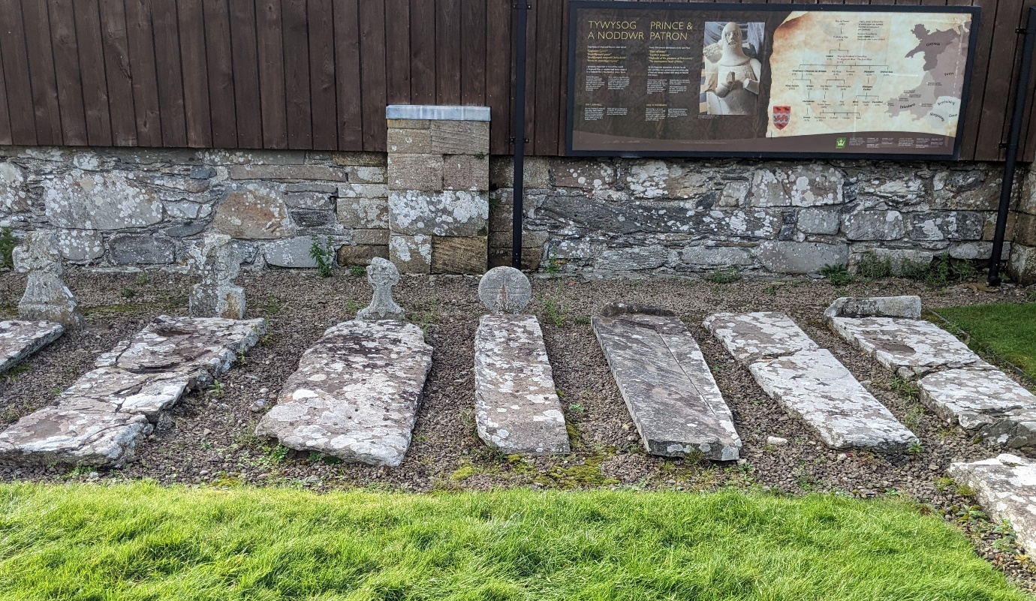
Hours pass without notice as I enjoy taking in the beauty of the site. The strong compulsion to touch the walls and intricate carvings that remain visible, a yearning to connect with the past as this abbey has already connected so many before me. Artists, poets, and writers are attracted to this place as a source of inspiration, to create their works of art inspired by the beauty and heritage they find themselves within. Medieval tiles from as far back as the early 14th century, which had remained hidden until discovery in the 1880’s, still holding their original form. What a privilege to witness these glimpses into the past. Again, I long to touch them, feeling the rough edges and carved patterns that had been created with skill and care.
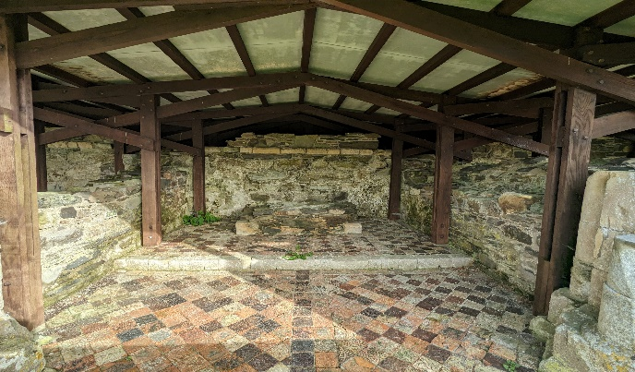
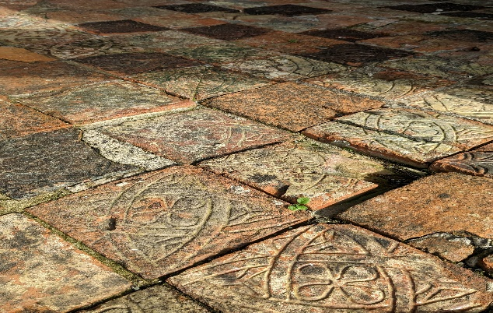
I make my way towards St Mary’s church, built using the remains of the abbey. Although more recent in history, it still retains the elements of its ancestral origins. I am suddenly startled by a dog racing past me in the cemetery, an abrupt reminder of the present to snap my mind from its engagement in the past. The animals’ owner follows it along the path, she smiles as she approaches, and we exchange pleasantries about the day before continuing our opposite directions. I am soon able to allow my mind to resume its’ former immersion into the imagery of the past.
In the grounds of the church, I find myself before an ancient yew, beneath which is believed to be the resting place of Dafydd ap Gwilym. I am moved with emotion to be beside the memory of such an innovative poet, whose words of love and the natural world have survived to be enjoyed and allow us to take a glimpse into his life and during the 14th century.
‘But tell me, best beloved of men,
Will you come again? Will you come again?”
“Gwen, you know I’m your nightingale,
And I’ll be with you, without fail,
When the cloud is cloak, and the dark is sky,
And when the night comes, so will I.’

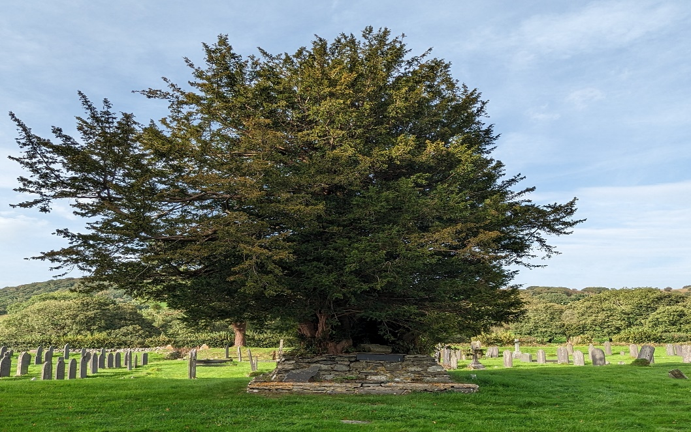
The sun starts its descent towards the horizon, a signal that I must say my farewell to this place that has held me captivated for much of the day. I bid farewell to the echoes of those from long ago, to the birds who mark the day’s close with their evensong, and to the trees who have stood strong and tall through the ages, I thank them all with a vow to return.
Word Count: 1025.
Bibliography
Gwilym, Dafydd ap, ‘Aubade,’ trans. by Rolfe Humphries, Poetry Foundation [n.d]
<https://www.poetryfoundation.org /search?query=Dafydd+ap+Gwilym> [accessed 11 October 2023]
Johnson, Ben, ‘The Mabinogion,’ Historic UK [n.d] <https://www.historicuk.com/HistoryUK/HistoryofWales/The-Mabinogion/> [accessed 8 October 2023]
Carradice, Phil, ‘Strata Florida Abbey,’ BBC Cymru Wales 23 July 2012. <https://www.bbc.co.uk/ blogs/waleshistory/2012/07/strata_florida_abbey.html> [accessed 8 October 2023]
Johnstone, Dafydd, The Poetry Of Strata Florida (Ceredigion: The Strata Florida Trust, 2023)

Dafydd ap Gwilym, ‘Aubade’, trans. by Rolfe Humphries, Poetry Foundation [n.d] <https://www.poetryfoundation.org /search?query=Dafydd+ap+Gwilym> [accessed 11 October 2023}

