

Personal Development Portfolio

LCHS4009
Professional Development within Health and Social Care

Student Name: Michelle Mamonong
Student ID: 2512950

Lecturer: Olubukola Adegbite

Table of Contents

Introduction 3
Task 1: Two Page Professional CV 3
Task 2: Personal Statement 6
Task 3: SWOT Analysis and Personal Development plan 7
SWOT Analysis 7
Strengths 7
Weaknesses 8
Opportunities 8
Threats 8
Personal Development plan (PDP) 9
Task 4: Critical Reflection 10
Stage 1: Description 10
Stage 2: Feelings 10
Stage 3: Evaluation 10
Stage 4: Analysis 11
Stage 5: Conclusion…………………………………………………………………………………………………………………….11
Job Advert 12
Reference…………………………………………………………………………………………….13

Introduction

Professional career development report details the employability skills, experiences, and career aspirations (Siddiqui, 2021). This report has also been prepared with the same aspect with the focus of health and social care sector. The report will demonstrate self-awareness, critical thinking, and a commitment to lifelong learning qualities which are essential for any healthcare professional.

Task 1: Two-Page Professional CV

MICHELLE JACINTO MAMONONG
West Bromwich
📞 07873841751
✉ Mitchel_mamon510@yahoo.com

PERSONAL PROFILE
Dedicated and polished results-driven professional with hands-on experience in premium customer service, and operational efficiency in fast-paced environments. Currently pursuing a CertHE in Health and Social Care, with a genuine passion for supporting vulnerable individuals. I am committed to delivering seamless, high-quality care service that aligns with my professional values and standard-setting practice. My focus is on excellent communication skills, crisis management, and a meticulous approach to health and safety. Seeking a rewarding role in health and social care where I can apply my transferable skills with empathy, dignity, and respect and continue to develop clinically.

KEY SKILLS
- Leadership & Team Management: Led shift teams and achieved production targets and maintain service standards.
- Customer Service Excellence: Resolved issues promptly, and ensured customer satisfaction.
- Health & Safety Compliance: Understanding of occupational health safety, and quality assurance.
- Cash Handling & Administration: Managed till reconciliation and and payment processes with accuracy.
- Crisis Handling & Problem Solving: Coordinated with teams to maintain smooth operations.
- Interpersonal, Communication Skills and Care & Compassion: Practical experience in personal care.

PROFESSIONAL EXPERIENCE
- Shift Manager | Endeavour Restaurants Ltd / McDonald’s | January 2016 – Present
Job Responsibility:
- Led shift teams while maintaining consistently high standards of customer service.
- Managed cash handling and coordinated seamlessly between kitchen and front-of-house teams.
- Enforced strict health, safety, and hygiene protocols and Conducted quality checks throughout production phases.
- Handled customer complaints and operational issues etc.

- Family Driver | Mr. Alameri, Abu Dhabi, UAE | March 2009 – May 2015
Job Responsibility:
- Transported family members, safely escorted children to and from school with constant supervision and care.
- Liaised with household staff to coordinate daily routines and effective communication.
- Adapting various driving style and demonstrated reliability.

VOLUNTARY EXPERIENCE
- Personal Caregiver 2003
- (Family Member) Deceased
- Provided full-time care for my grandmother following her dementia diagnosis.
- Assisted with all personal care needs, including feeding, bathing, nail care, and companionship.
- Ensured her comfort, safety, and dignity at all times, developing patience, empathy, and observation skills.

EDUCATION
CertHe in Health and Social Care ( on going )
University of Wales Trinity Saint David
Relevant modules: Communication in Health Care, Safeguarding, Health Promotion, Person-Centred Care

CERTIFICATIONS & ADDITIONAL INFORMATION
First Aid at Work: Certified.
Health & Safety Compliance: In-depth knowledge of occupational safety standards.
Availability: Flexible - open to various shift patterns, including weekends.
Driving Licence: Full UK driving licence (with access to own vehicle).
Right to Work: Full right to work in the UK (status to be confirmed).
References: Available upon request.

Task 2: Personal Statement

Career goal - I want to have a career that has purpose and significance within the health and social care sector in end of life and palliative care. I am passionate about helping people with life-threatening conditions to live their lives with dignity, comfort and respect at home, with their family. I wish to be a competent Health Care Assistant, who can really be of service to patients and their families in their hour of need.
The path I have taken into healthcare has been both through the classroom and through my own experiences in the field. I am currently studying in University of Wales Saint Trinity David, CertHE in Health and Social Care Level 4 and in the process of taking up Level 5 & 6, a degree in Health and Social Care. These skills are directly relevant to the healthcare environment, where effective use of resources, communication and ethics are crucial. The educational system that I have gone through has also taught me to be professional, responsible, and a lifelong learner.
My work experience in the food industry has provided me with transferrable skills that are very relevant to the healthcare sector. Responsibilities of being a shift manager involve maintaining stringent hygiene and food safety measures, following infection control procedures, providing assistance for special requests by vulnerable customers, and handling stressful situations with professionalism and composure. All of these experiences have helped build my emotional strength, attention to detail, and team and individual work skills (van Wijngaarden, Scholten, & van Wijk, 2012).
I am a good listener, empathetic, compassionate and emotionally strong. I am trustworthy, on time and dedicated to providing person centred, dignified care. I have a good ability to observe the patient and understand when their condition has changed and the confidence to report my observations to the multi-disciplinary team.
I would be a significant asset to an employer as I have all of the above but in a unique combination. I will really enjoy working in palliative care, have flexibility with working hours and am dedicated to the principles of the NHS and hospice care. I look forward to being part of a special team and positively impacting patients' and families' lives (Gretzky, 2010).

Task 3: SWOT Analysis and Personal Development plan

SWOT Analysis
As a strategic planning tool helps individual self-evaluation which has been given below:

Strengths
- Empathy and compassion: Authentic, skilful expression of empathy and share of feelings of patients and their families, establishing a sense of atmospheric and trusting environment.
- Good Communication and Interpersonal Skills: Good verbal and written communication, listening, and rapport- building skills with various people.
- Emotional Resilience: Able to remain calm and composed during the end-of-life scenarios that are emotionally charged.
- Knowledge: Good knowledge of COSHH, hand hygiene, PPE use and safe disposal of waste acquired through hospitality experience.
- Reliability and Punctuality: Demonstrated attendance of 100% and dedication to being reliable (Abedi et al., 2018).
- Academic Foundation: Level 4 Health and Social Care student, currently, who proves to have analytical thinking abilities, ethical essential decision-making, and leadership potential.
- Transferable Skills: Learning in the food industry in terms of serving people and dealing with stressful customer’s attitude, attentive listening, and observing details.
- Voluntary Experience: Practical experience where you would be targeted to offer company and support to patients with life-limiting illnesses (Gough et al., 2003).

Weaknesses
- Poor Clinical Experience: No formal clinical training in vital signs, medication administration and clinical documentation.
- No Formal Care Experience: Although I have no formal care experience, my empathy and compassion to the elders will help me gain the ability to be an effective healthcare worker.
- Poor Understanding of NHS Systems: Does not know new NHS electronic record-keeping systems (e.g. SystmOne, EMIS).
- Lack of Experience with Structured Clinical Tools: No or minimal exposure to slide sheets, slide sheets, and other movement/handling machinery within a care environment (Bintani, 2020).
- Knowledge in End-of-Life Care: As much as I was raised in the world of companionship, the last offices and symptoms management were not completely trained yet.

Opportunities
- Rising Demand of Hospice at Home: More job opportunities through rising preference to get end-of-life care at homes.
- Free Training and Development: Facility of NHS-funded training, such as Care Certificate, NVQ qualifications, and palliative training.
- Career Pathways: Registered Nurse, Senior HCA, or Nursing Associate: Advancement opportunities, including apprenticeship and further education.
- Networking and Mentorship: Collaborating with experienced nurses and healthcare professionals that can assist and guide (Beausaert, Segers, & Gijselaers, 2011).
- Voluntary Sector Partnerships: chances to acquire more experience in hospitals, nursing homes and community organisations.
- Continuing Education: after finishing CertHe, I will pursue a degree in Health and Social Care.

Threats
- There is a lot of Competition over Band 3 Roles: The formal care qualifications and long periods of clinical experience are possessed by many applicants.
- Emotional Burnout: The threat of end-of-life compassion fatigue and emotional burnout.
- Staffing and Workload: NHS staffing difficulties may put additional burden on HCAs and cause them to lack work life.
- Altering Regulations: The constant change of the CQC standards and other safeguarding requirements that have to constantly update their knowledge and practice (Al-Mutawa et al., 2024).
- Physical Demands: There are chances of injury due to manual handling activities unless special care is taken by following the techniques.
- Funding Reduction: There is a risk of reduced funding of hospice and community care services, which has an impact on the job security and trainin

Personal Development Plan (PDP)
With the understanding of SWOT analysis, these are the three clear and achievable goals that I will include in my personal development plan with thew.
Goal 1: Enhance Clinical and Palliative Care Skills
Aspect | Detail
Goal | Developing foundational clinical skills and specialist knowledge in palliative and end-of-life care.
Specific Actions | Complete the Care Certificate and Enrol in a palliative care training course. Beside that gaining competence with slide sheets and hoists.
Resources/Support | NHS training programmes, online learning platforms, coordinator and line manager.
Timeframe | Within 12 months

Goal 2: Enhance Presentation Knowledge, Skills and Public Speaking Skills.
Aspect | Detail
Goal | Advancing my formal presentation settings and increasing audience engagement.
Specific Actions | Entertain group discussion or presentation regularly and Joining public speaking or communication skills workshop.
Resources/Support | Resources/Support: University learning resources and peer support groups.
Timeframe | Within 6 months.

Goal 3: Progress Academic Qualifications
Aspect | Detail
Goal | Advance my studies from level 4 to a bachelor’s degree.
Specific Actions | Continue my university studies to level 5 & 6. Maintaining attendance and engagement with all academic requirements.
Resources/Support | University tutors, academic advisors, library services, online learning resources.
Timeframe | Within 2 years

Task 4: Critical Reflection

It comprises the area of internalization and enabling practitioners to learn from their experiences (Clegg & Bradley, 2006).

Stage 1: Description
I have done my presentation assessment on Professional Development within Health and Social Care. This involved the submission of Power Point Presentation and being able to present in front of an audience. The topic that I chose was communication. After the assessment, my lecturer gave me feedback orally, which recognized my strengths and noted areas that need to be developed.

Stage 2: Feelings
The day before the assessment, it was a mixture of nervousness and excitement. I knew that although I had a good sense of interpersonal skills and really enjoyed talking, I was worried because I have a stage fright. I will not be able to memorise all that I am going to say in front of an audience. I was relieved when I got feedback because I know I was being compassionate, but I still need to practice more on focusing to audience than to my notes. My overall experience was motivated to work on my development needs (Ocampo et al., 2025).

Stage 3: Evaluation
What Went Well:
My lecturer was impressed with my communication skills. She said that I am good in delivering my presentation, speak well and have confidence in delivering every word I uttered. Had a time limit and I was able to finish just in time.

What Did Not Go Well:
My lecturer has given me feedback regarding my presentation to avoid looking to my notes thoroughly. I should only glance at my notes and look always to the audience when presenting a power point. Be confident in front of other people.

Stage 4: Analysis
This experience highlighted the importance of preparation, communication skills, and self-confidence. Although I had a good understanding of the topic, nervousness affected my pace and delivery. Effective presentations require clear presentation, eye contact, appropriate body language and engaging to audience. Practising more frequently and receiving feedback can improve confidence and presentation skills.

Stage 5: Conclusion
This assessment has helped and it has definitely highlighted what skills I need to develop. Compassion and communication have become a key strength now but needs to be backed up by clinical skills, self-care skills, and understanding of healthcare systems. I received positive feedback from my lecturer which was motivational and constructive; I am thankful to be able to reflect on my performance (Sundgren et al., 2021).

Conclusion and Action Plan

The report has comprehended my overview of current position, career aspirations, and development needs within the health and social care sector and identified valuable insights. It will contribute my lifelong learning due to the structured approach and enabling me to progress professional development journey.

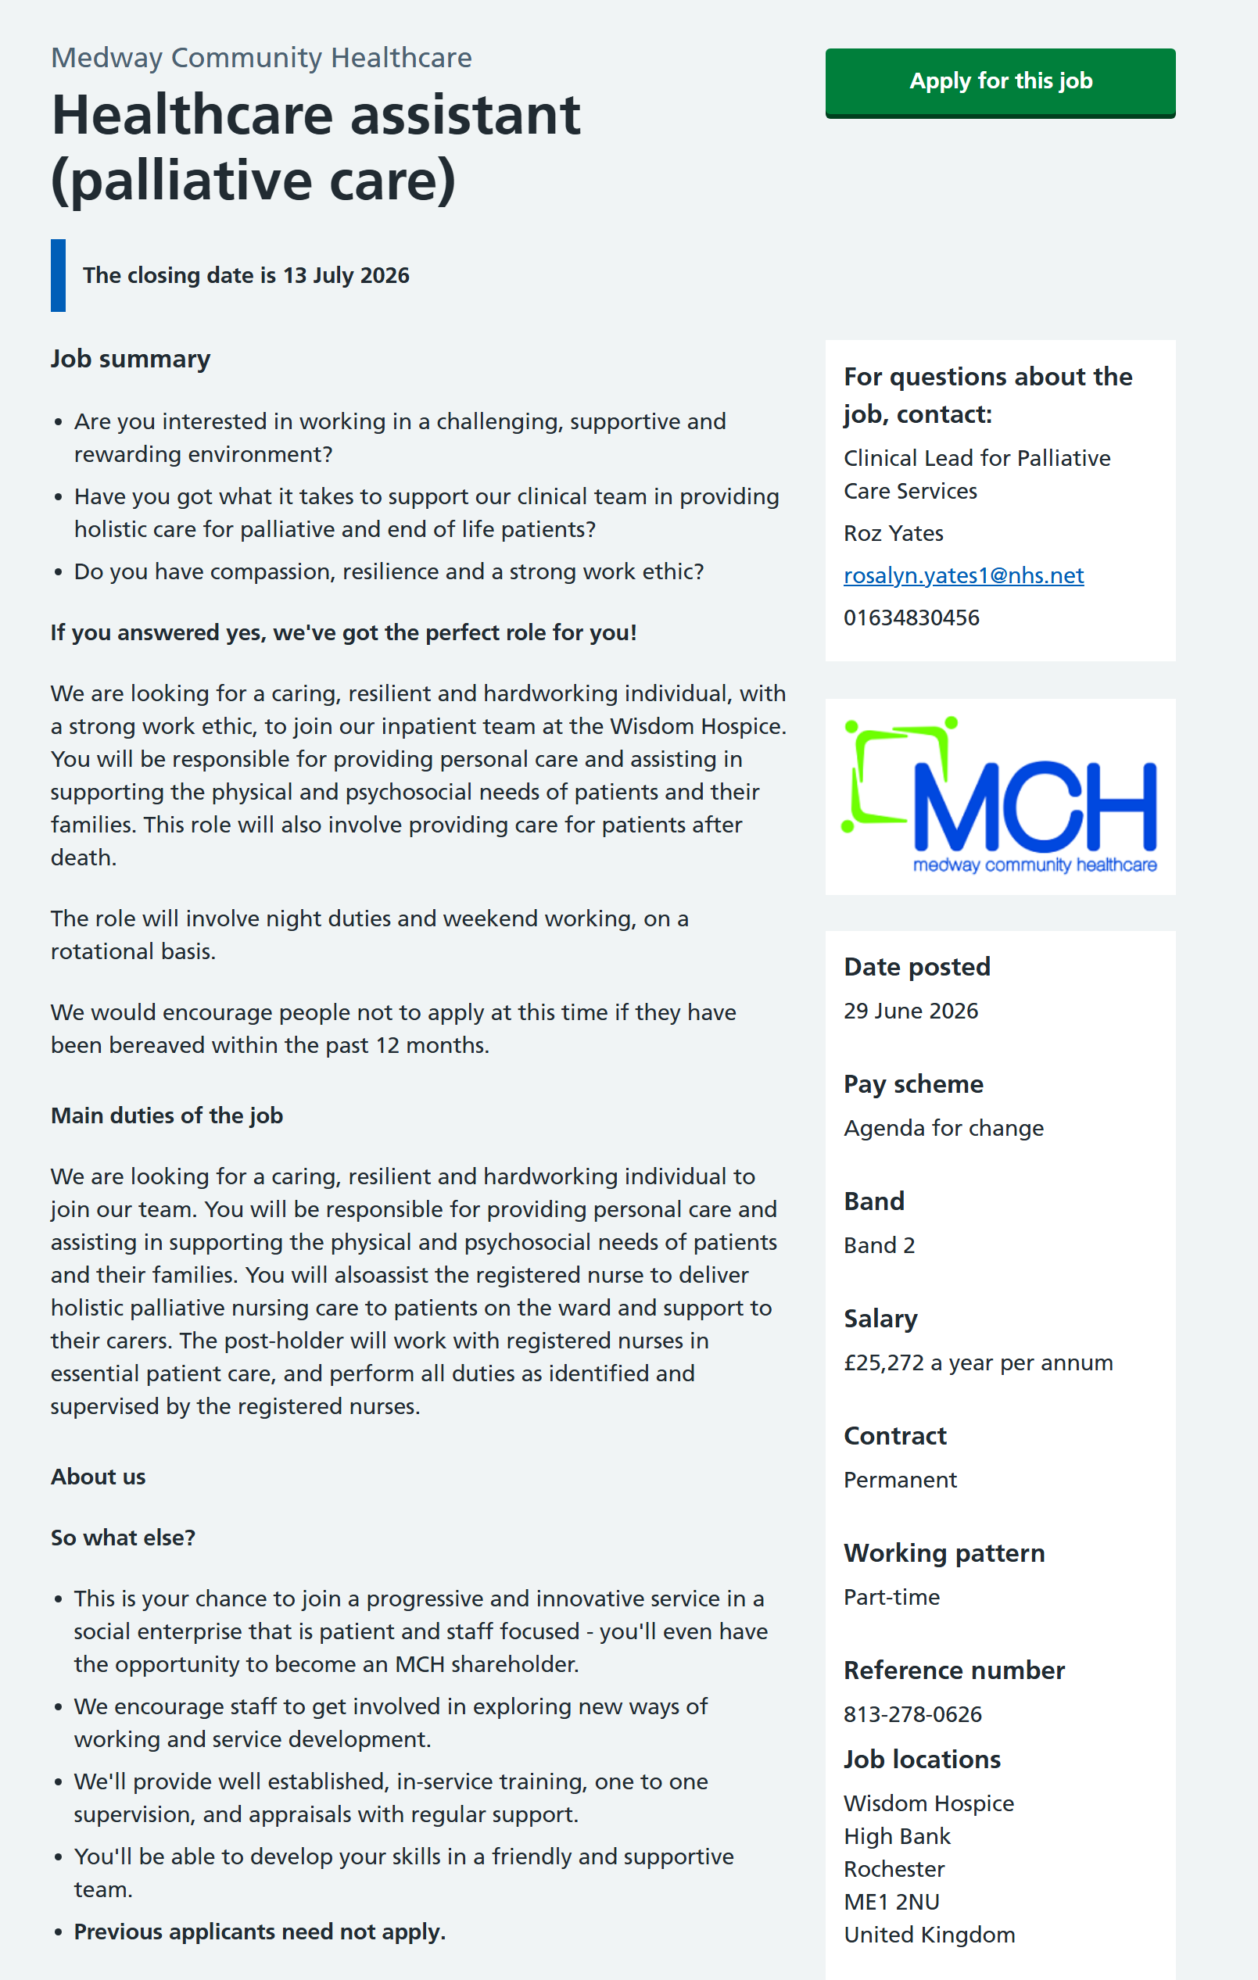

References

Abedi, G., Soltani Kontai, S.A., Marvi, A., Mazidi, S., Abedini, E. and Abbasi Chaleshtary, A. (2018) 'SWOT analysis of health reform plan on healthcare sector from the stakeholder perspective', Journal of Mazandaran University of Medical Sciences, 28(166), pp. 199–212.
Ahmadpour, N., Shariati, A. and Moghadam, M.P. (2025) 'Effect of narrative writing based on Gibbs' reflective model on the empathy and communication skills of nursing students', BMC Medical Education, 25(1), p. 10.
Al-Mutawa, N.A.A., Mahmoud, M.H., Baisa, K.G.G., Daher-Nashif, S. and Al Wahedi, Z. (2024) 'Reflective writing among healthcare practitioners in primary care: A qualitative study from Qatar', Cogent Education, 11(1), p. 2373555.
Beausaert, S., Segers, M. and Gijselaers, W. (2011) 'The use of a personal development plan and the undertaking of learning activities, expertise-growth, flexibility and performance: The role of supporting assessment conditions', Human Resource Development International, 14(5), pp. 527–543.
Bintani, K. (2020) 'Personal development plan as a guidance and counseling strategy in Higher Education', in Proceedings of the 2nd International Seminar on Guidance and Counseling 2019 (ISGC 2019). Paris: Atlantis Press, pp. 18–22.
Buttigieg, S.C., Schuetz, M. and Bezzina, F. (2016) 'Value chains of public and private health-care services in a small EU island state: A SWOT analysis', Frontiers in Public Health, 4, p. 201.
Ebrahim, E.M.A., Ghebrehiwot, L., Abdalgfar, T. and Juni, M.H. (2017) 'Health care system in Sudan: Review and analysis of strength, weakness, opportunity, and threats (SWOT analysis)', Sudan Journal of Medical Sciences, 12(3), pp. 133–150.
Gough, D., Kiwan, D., Sutcliffe, K., Simpson, G. and Houghton, N. (2003) A systematic map and synthesis review of the effectiveness of personal development planning for improving student learning.
Gretzky, W. (2010) 'Strategic planning and SWOT analysis', in Essentials of Strategic Planning in Healthcare. 1st edn. pp. 91–108.
Practice Groups: A Guide for Healthcare Professionals. Abingdon: Routledge. Kurtz, A. (2019) How to Run Reflective
Ocampo, F.A., McIntyre, B.G., Massey, D. and Saunders, R. (2025) 'Nursing student reflections on a research internship: A reflective discussion following the Gibbs' reflective cycle', Nurse Education Today, 145, p. 106481.
Reljić, N.M., Pajnkihar, M. and Fekonja, Z. (2019) 'Self-reflection during first clinical practice: The experiences of nursing students', Nurse Education Today, 72, pp. 61–66.
Siddiqui, A. (2021) 'SWOT analysis (or SWOT matrix) tool as a strategic planning and management technique in the health care industry and its advantages', Biomedical Journal of Scientific & Technical Research, 40(2), pp. 32035–32042.
Sundgren, M.K., Millear, P.M., Dawber, C. and Medoro, L. (2021) 'Reflective practice groups and nurse professional quality of life', The Australian Journal of Advanced Nursing, 38(4), pp. 49–67.
Van Wijngaarden, J.D., Scholten, G.R. and van Wijk, K.P. (2012) 'Strategic analysis for health care organizations: The suitability of the SWOT-analysis', The International Journal of Health Planning and Management, 27(1), pp. 34–49.

