

Assessment Component 1: Online Portfolio
Reflective Portfolio: Units 1–4

Student name:Momodou Lamin Demba
Student ID:2415947
Module name: Changemakers: Building your Personal Brand for Sustainable Employment
Module code:BMHP5015
Lecturer name:Brian Mashumba

Introduction
This portfolio reflects on my learning across the four units of BMHP5015 and considers how that learning can be applied within health and social care practice. The portfolio covers ambition, motivation and boundless careers in Unit 1, networking, hierarchy, and the network society in Unit 2, luck, perception and opportunity recognition in Unit 3, and wellbeing and resilience in Unit 4. I do not merely describe each session, but challenge the ideas that the module offered, subjecting them to published evidence and to the specifics of the work of care. The central argument of this portfolio is that the organising concept in the module that employability is actively constructed by individuals is really helpful; however, it falls short: it downplays the regulatory, organisational and structural limitations on who is able to access opportunities in this industry.

Task 1: Reflection on Unit 1 - Brand You
Three concepts introduced in Unit 1 significantly changed my perspective: autonomy as described by Pink, the concept of mastery and purpose within Pink's framework, and the concept of the boundaryless career; self-awareness as an element of emotional intelligence.
I learned about autonomy, mastery and purpose being the driving forces of motivation, and Ryan and Deci (2000) provide the empirical foundation that motivation is reinforced when the goals are self-endorsed and not forced. I wrote my forum post that defines autonomy and found a tension that the lecture left unspoken. Autonomy in health and social care is more the right of the service user than the worker; front-line workers work within the care plan, statutory requirements and rotas which leave little discretion. Pink's three-part model, which is a creation of knowledge work, thus does not transfer easily to all professional contexts: purpose is so full of care, and autonomy is rationed. This recognition made my career objective a concrete plan rather than an indistinct ambition, as I am now considering jobs based on the degree of discretion they will provide.
The concept of the boundaryless career also warranted critical examination. People switch careers five to seven times, but Rodrigues and Guest (2010) have reviewed mobility data of various economies and could not provide any indication of an actual increase in the movement of people between organisations. A care career is also closely circumscribed by registration, required training and qualification level. The examples provided of the gig economy, including per-diem nursing, are certainly flexible, but Vallas and Schor (2020) say that the work that platforms mediate only shifts the risk to the worker, as opposed to really expanding their freedom.
My self-awareness and emotional intelligence postings related these concepts to practice. Birks and Watt (2007) suggested that patient-centred care has been linked to emotional intelligence; however, they placed this in the form of open questions, not an established fact, and observed that enthusiasm had exceeded evidence. I thus consider emotional intelligence a professional capability to be practised and not a quality that I have or do not have.
Collectively, these notions left me doubtful about personal branding as marketing. Gorbatov, Khapova and Lysova (2018) reveal that the construct is still definitionally fragmented, and Vallas and Christin (2018) illustrate how branding discourse promotes workers to objectify their careers as a subject of corporate marketing practices, individualising responsibility for insecurity. My current concept of a brand is now seen as a minimum standard of professional competence that can be verified, and is what employers within regulated care environments can literally do.

Screenshot 1: Self-awareness
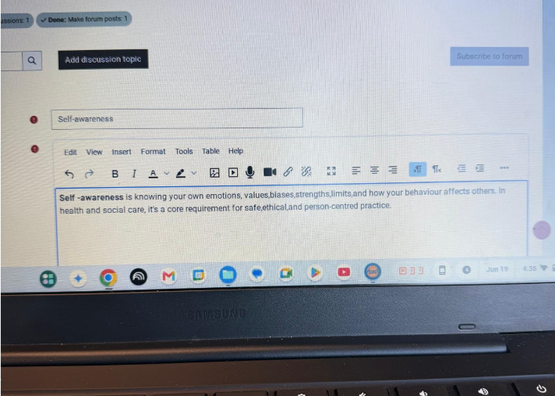

Screenshot 2: "Emotional intelligence"
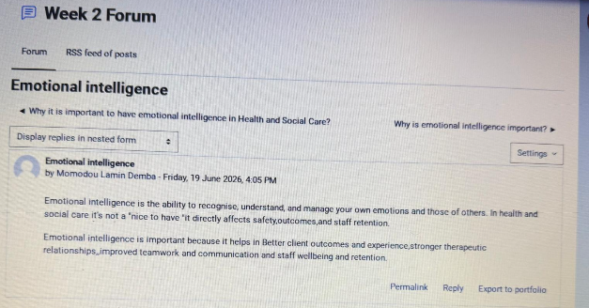

Task 2: Reflection on Unit 2 - It is a Small World
Unit 2 explored the history of networking, the bureaucratic hierarchy, network society by Castells, networks of influence, persuasion and making connections.
I started the unit by loosely defining networking on the forum. Gibson, Hardy and Buckley (2014) refined this: networking to them is goal-oriented behaviour seeking to establish, grow and leverage relationships to access career resources. That focus on purpose has challenged my previous belief that networking is merely sociability, and the reason why my subsequent, purposeful contacts yielded better outcomes than incidental ones.
The definitions of bureaucracy and hierarchy were useful in helping me to understand the information in the unit. Hierarchy was described by Weber (1978) as a rational method of coordinating. The diagrams in the lectures depicted that a junior colleague who was consulted on issues of significance rose to a position of greater influence than his formal assistant. According to Granovetter (1973), the process works as follows: the weak ties connect distinct groups of people and transfer non-redundant information. With multi-agency safeguarding, the practitioner with direct access to a housing officer can do more than the manager who does not, and I have charted my own contacts to reflect this.
I found the argument of the unit that networks and hierarchies should complement one another more convincing. Hierarchy provides accountability and scale, which discharge planning requires, and networks provide the lateral coordination, which discharge planning requires; they should not be treated as competitors. The unit observed further that networks have the ability to create cliques and over-dependence on people. I would go with the criticism a step further. Since network access is conditional upon social capital already possessed by a given individual, informal networks have the effect of reproducing exactly the exclusions that the pre-industrial section posited, which are opportunities determined by characteristics such as birth, religion, or gender. Distributionally neutral advice is thus not distributionally neutral.
The global connection was put into perspective by Castells (2009), who opined that digital communication compresses both time and space. I deviate here with the framing of the lecture. The notion of vaccine passports and the need to travel is not persuasion but coercion, and lumping the two together clouds the reason that some minority ethnicities remained hesitant because, in many cases, it was the institutional distrust that drove the reluctance to take the vaccine and not an information gap. This was taken out to service users in the Making Connections material. The Connecting People approach sees social capital as an activity that practitioners actively assist people in creating; thus, it relocates relationship work as an intervention and not a favour. The same discipline was exemplified in social prescribing. It has an intuitively strong argument, but Bickerdike et al. (2017) examined fifteen UK assessments and rated all at high risk of bias. I finished the unit believing that connection is important, and the passion to be passionate about it should not be bound to evidence.

Screenshot 3: Define networking?
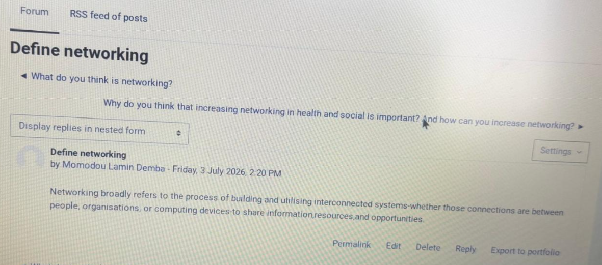

Screenshot 4: "Hierarchy"
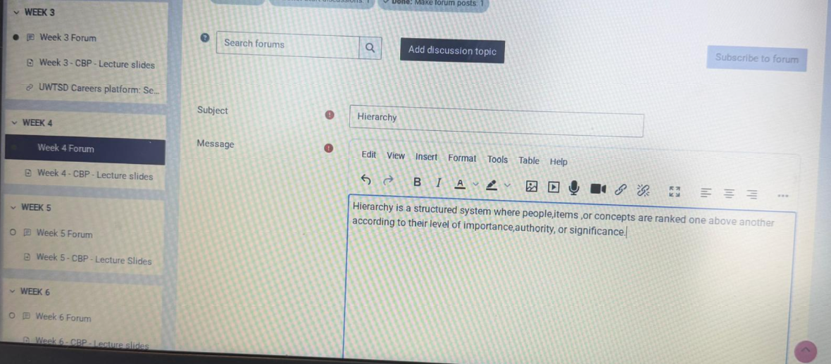

Task 3: Reflection on Unit 3 - Opportunity Knocks
The perception, success and luck, serendipity mindset, stretch goals, traditional and modern recruitment and work values were discussed in Unit 3.
The most thought-provoking aspect of the evidence was the luck included in the unit. A survey of 50 companies that made the lists of 3 management bestsellers found that 16 companies had collapsed within five years and 23 companies had turned into mediocrity. I originally interpreted this as evidence that success is largely due to chance; however, the conclusion is not as strong as it appears: the choice of firms due to their exceptionalness and subsequent regression to the mean is evidence of regression to the mean and survivorship bias. This reduced my confidence in simple formulas for success.
A more constructive perspective emerged with my serendipity mindset post. According to Busch (2020), converting blind luck into smart luck involves being mindful of unexpected events, and his subsequent systematic review concurs that serendipity involves a trigger and an act of association and that alertness can be trained (Busch, 2024). It was already being formalised by Mitchell, Levin and Krumboltz (1999) as planned happenstance, defining the skills as curiosity, persistence, flexibility, optimism and risk-taking that get events into opportunities. This put my job search into a new light. The My sweet spot post made a match between my interests and the local authority, NHS and independent providers, and now I would identify those organisations before vacancies become available instead of waiting until the adverts run, and I would consider volunteering and mentoring to be a premeditated way of creating an activation.
This was brought to focus on the comparison of traditional and modern recruitment. Resume screening is now done online, and this has made a consistent professional display as part of the application, and not a bonus. Explaining my work values also provided me with a filter: I would judge employers based on supervision, advancement and treatment of employees, rather than only pay, which makes it more expensive to change employers to an unscheduled vacancy.
Critically, by treating luck as a state of mind, one runs the risk of covering the structure in the sense that the ability to see an opportunity and the ability to take action on it are not the same. Unpaid volunteering, transport fee and availability of referral networks are not fairly distributed, and mindfulness cannot compensate. The parallel issue in my post about a change of perspective is that changing perspective to care as person-centred and not condition-focused can be helpful, but the resources available to care providers are already limited by the Care Quality Commission, and a change in perspective without a change in resources only leads to frustrated staff.

Screenshot 5: "Serendipity mindset"
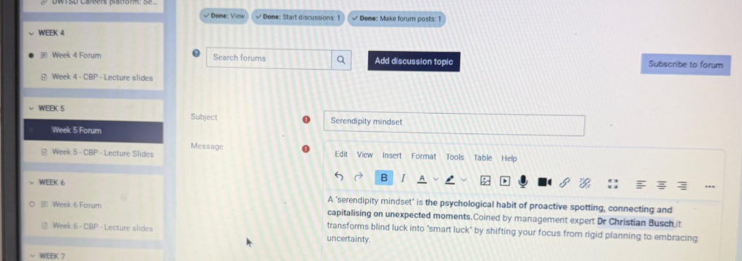

Screenshot 6: Forum post
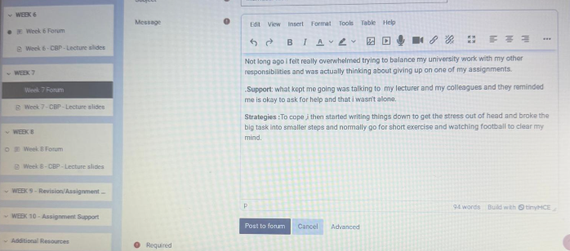

Task 4: Reflection on Unit 4 - The Pursuit of Happiness
Unit 4 covered wellbeing, limited beliefs, resilience resources and professional online presence.
The activity that I found most useful immediately was my post about transforming limiting beliefs into positive self-statements, especially reframing the limiting belief that I am not smart enough to say that I am capable of working hard and learning. The logic of self-efficacy is reasonable, as expectations determine persistence. The inspiration material of the unit went a lot further, it is true, but it claimed that belief is all that matters, and I cannot justify that; it confuses between an element and a necessary one.
The resilience activities were more significant. Tapping the four resilience resources of support, strategies, sagacity and solution-seeking transformed coping from a vague idea into a practical framework to a list that I would revisit. My examples were concrete, I used peers and a lecturer as support, planning and exercise as strategies, advice of my grandparents concerning taking things one step at a time as sagacity and seeking a solution through requesting an extension.
This was fruitfully complicated by reading Traynor (2017). His point is that the NHS has resilience training that silently shifts the burden of wellbeing upon organisations and individuals in such a way that understaffing is perceived as personal failure in coping. My personal experience is in his favour: extensions and supportive communication, which lie within the province of institutions and not within the province of hardihood, is what actually came to my rescue. Similarly, Ryan and Deci (2000) find enduring motivation in autonomy-supportive settings, and Seligman (2011) does not consider the relationships or meaning as add-ons to well-being. In the case of care work, where burnout is a disease, this is relevant: I will require employers to provide supervision and management of workload, and not just resilience on my part.
In my blog post, I linked wellbeing to professional communication, with promotion of health, creating awareness and professional reflection being valid applications. However, I would qualify this view. Writing about practice publicly presents confidentiality and boundary threats, making the professional norm that authors should reflect his/her own learning, and separate personal and professional narration. It is that qualification and not the enthusiasm that I will take with me to work.
The most lasting imprint of the module is a habit of reflective questioning as Gibbs (1988) defines it, shifting from description to analysis and action planning. My online presence final post demonstrates the practical outcome: a LinkedIn profile that proves the qualifications and interests instead of stating the qualities. I now view employability as professional competence demonstrated through practice in the conditions of an organisation beyond my control, which I can only influence.

Screenshot 7: "Talking to own self"
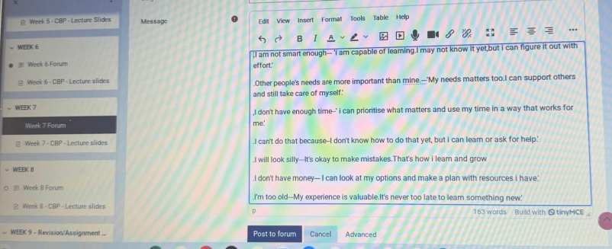

Screenshot 8: The 4-S’s
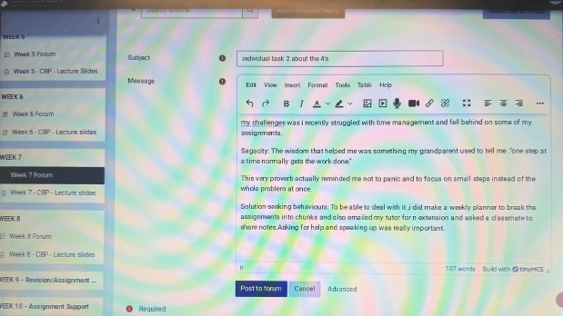

Conclusion
This portfolio has followed my learning journey in four units and applied that learning to health and social care practice. Unit 1 provided me with a language of motivation and career guidance and encouraged me to question the extent to which autonomy and boundarylessness are appropriate to characterise care work. Unit 2 helped me move beyond my loose concept of networking towards a purposeful, evidence-based practice, and it taught me both to differentiate between persuasion and coercion and enthusiasm and evidence. Unit 3 reframed the opportunity to the concept of something I can generate by being alert and making the necessary preparations while remaining aware of structural constraints. Unit 4 also provided hands-on resilience materials and a needed warning against the idea of wellbeing being a solely individual affair. The module has brought me a better idea of the direction of my future professional development, a better justifiable idea of who I am as a professional and a critical view of the guidance I take.

References
Bickerdike, L., Booth, A., Wilson, P.M., Farley, K. and Wright, K. (2017) 'Social prescribing: less rhetoric and more reality. A systematic review of the evidence, BMJ Open, 7(4), e013384.
Birks, Y.F. and Watt, I.S. (2007) 'Emotional intelligence and patient-centred care', Journal of the Royal Society of Medicine, 100(8), pp. 368–374.
Busch, C. (2020). The Serendipity Mindset: The Art and Science of Creating Good Luck. London: Penguin.
Busch, C. (2024) 'Towards a theory of serendipity: a systematic review and conceptualisation', Journal of Management Studies. doi:10.1111/joms.12890.
Castells, M. (2009) Communication Power. Oxford: Oxford University Press.
Gibbs, G. (1988) Learning by Doing: A Guide to Teaching and Learning Methods. Oxford: Further Education Unit, Oxford Polytechnic.
Gibson, C., Hardy, J.H. and Buckley, M.R. (2014) 'Understanding the role of networking in organisations', Career Development International, 19(2), pp. 146–161.
Gorbatov, S., Khapova, S.N. and Lysova, E.I. (2018) 'Personal branding: interdisciplinary systematic review and research agenda', Frontiers in Psychology, 9, 2238.
Granovetter, M.S. (1973) 'The strength of weak ties', American Journal of Sociology, 78(6), pp. 1360–1380.
Mitchell, K.E., Levin, A.S. and Krumboltz, J.D. (1999) 'Planned happenstance: constructing unexpected career opportunities', Journal of Counselling and Development, 77(2), pp. 115–124.
Rodrigues, R.A. and Guest, D. (2010) 'Have careers become boundaryless?', Human Relations, 63(8), pp. 1157–1175.
Ryan, R.M. and Deci, E.L. (2000) 'Self-determination theory and the facilitation of intrinsic motivation, social development, and well-being', American Psychologist, 55(1), pp. 68–78.
Seligman, M.E.P. (2011). Flourish: A Visionary New Understanding of Happiness and Well-being. New York: Free Press.
Traynor, M. (2017). Critical Resilience for Nurses: An Evidence-Based Guide to Survival and Change in the Modern NHS. Abingdon: Routledge.
Vallas, S.P. and Christin, A. (2018) 'Work and identity in an era of precarious employment: how workers respond to “personal branding” discourse', Work and Occupations, 45(1), pp. 3–37.
Vallas, S.P. and Schor, J.B. (2020) 'What do platforms do? Understanding the gig economy, Annual Review of Sociology, 46, pp. 273–294.
Weber, M. (1978). Economy and Society: An Outline of Interpretive Sociology. Berkeley: University of California Press.

