Circuit Build

Thomas Austin Diaper-Fox
Student ID: 2022125
Fundamentals of Electrical and Electronic Systems
Ordnances Munitions and Explosives (OME)
Level 4 Student

Table of Contents
Circuit Description and Operation 3
Astable Timer Circuit 4
Component Values: 5
R3 Resistance: 5
R4 Resistance: 5
On time, off time: 5
Period: 6
Frequency: 6
Proteus Schematic of Circuit 6
Capacitor (C1) and Output Voltage Graph (Simulated) 7
Proteus Simulation Timing Measurements Table 8
555 Timer Circuit Breadboard Build 8
Testing of 555 Timer Circuit 9
Bread Board Circuit Timing Measurements 9
Conclusion 10
References 10

Circuit Description and Operation
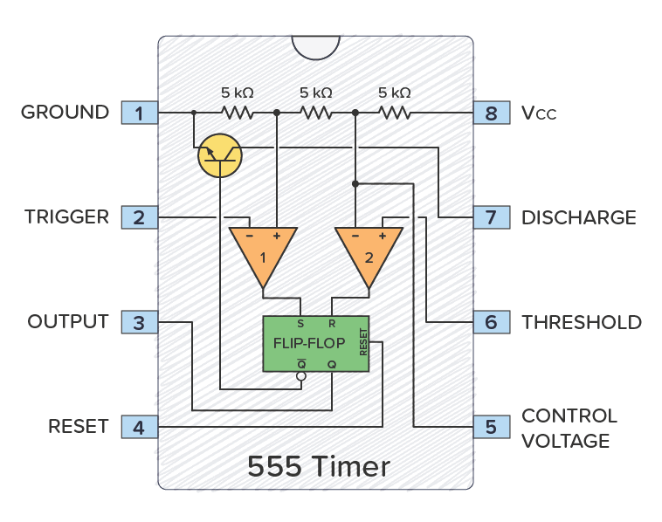
An astable 555 timer circuit was built to compare the accuracy of the Proteus simulation to a real life bread board circuit. The main component in an astable timer circuit is the 555 time chip itself which is detailed below.

Fig. 1 Schematic of the 555 time chip circuit, including pins, discharge transistor, comparators and a flip-flop. [1]
Descriptions of the pins and their functions are given below [2]:
Pin 1: Ground
The ground pin is used to earth the circuit by connecting to the negative side of the power source. Power is defined as the rate at which electrical energy is transferred by a circuit, measured in Watts (W).
Pin 2: Trigger
When the voltage measured at this pin drops below one third of the voltage seen at Pin 8 (Vcc), then the output at Pin 3 goes high.
Pin 3: Output
The voltage at the output pin can flip between low and high depending on the voltages at the trigger and threshold pins. This pin is capable of supplying or sinking 200mA of current; if more is required this can be connected to the control pin of an amplifier to control large amounts of current.
Pin 4: Reset
The reset pin resets the circuit if the voltage drops to 0V on the pin. This was not used in the circuit produced, instead the pin was connected straight to the main power rail. However, if the wiring had included a switch into the supply for this pin, it would have acted as a start-stop switch pausing the oscillating output of the circuit when the switch is open. This allows for the circuit to oscillate as intended when the switch was closed.
Pin 5: Voltage Control
This pin is grounded through a capacitor to reduce noise in the circuit. By adjusting the voltage at this pin, the frequency of the output oscillations is able to be adjusted without having to change the values of R1, R2 and C1. This can be useful in refining the circuit after building it.
Pin 6: Threshold
When the voltage at this pin reaches more than two thirds of the voltage at Pin 8 (Vcc) the output voltage at Pin 3 flips to low.
Pin 7: Discharge
This pin is disconnected when output at Pin 3 is high, and it is earthed when the output is low.
Pin 8: Vcc Supply
This is the pin that powers the chip. It causes the chip to function when a supply voltage is between 5 and 15 volts.
Astable Timer Circuit
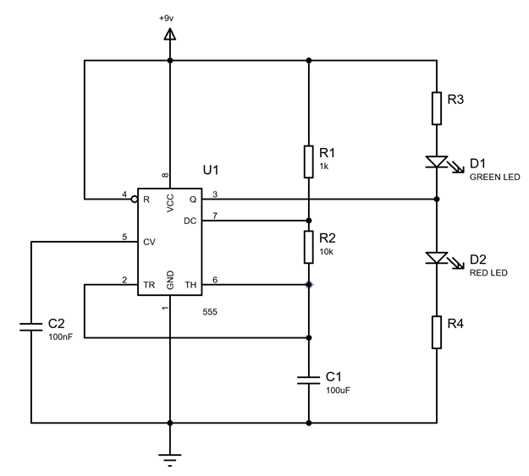
An astable 555 timer circuit shown in figure 2 below takes a continuous supply voltage and converts that into a pulsing on / off output. The rate of the output oscillations is determined by the values of resistors R1, R2 and capacitor C1. However, Pin 5 allows for some adjustment in frequency by varying the voltage.
Fig. 2 Circuit schematic for an astable timer. [3]
The circuit works by using pins two and six to compare the voltage across C1 to the supply voltage. While the capacitor is charging the output voltage is low. Once the capacitor reaches two thirds the supply voltage the output voltage at pin three switches to low and begins discharging the capacitor till the voltage drops to one third the supply voltage and then the output voltage flips to high again and the cycle repeats. The output will continue to keep switching indefinitely meaning it can be used to control many other circuits as an oscillator.

Component Values:

R3 Resistance:
To calculate the resistance for R3 Ohm’s law is used.
Ohm’s law is defined as:
Voltage (V) = Current (I) x Resistance (R)
Voltage is the electric potential or “electric pressure” which is measured in Volts (V).
Current is the flow rate of the electrical charge in a circuit which is measured in Amps (A).
Resistance is the difficulty for electric current to pass through the circuit. This is measured in Ohms (Ω).
The supply voltage for the circuit built for this experiment is 9V. The LED used has a voltage drop of 2V across it, which means that the resistor has to drop 7V. It is recommended to use a working current of 20mA for the LED [4]. All this information can be used in the aforementioned formula to calculate the size of resistor required for the circuit.
7V = 20mA x R
R = 7V / 20mA
R = 350Ω

R4 Resistance:
As the 555 timer output is 9V high and 0V when low the calculations for the resistance is the same as for resistor 3. R = 7V / 20mA. This means R4 value is also 350Ω

On time, off time:
To calculate the on and off times for the output:
$$Time Output High=\ln^{2}\left(R_{1}+ R_{2}\right)× C_{1}$$
$$Time Output Low=\ln^{2}\left(R_{2}\right)× C_{1}$$
Where R₁ is resistor 1 in kΩ, R₂ is resistor 2 in kΩ, ln is the natural logarithm, C₁ is the value of capacitor 1 in Farads.
Therefore resistor R1 only affects the time duration of the output being high whereas the value of R2 affects both the time the output is high and the time it is low.
Calculating the time the output is high:
Time = Ln2 (1KΩ + 10KΩ) x 100uF
Time = 0.76246 Seconds
Calculating the time the output is low:
Time = Ln2 (10KΩ) x 100uF
Time = 0.69315 Seconds

Period:
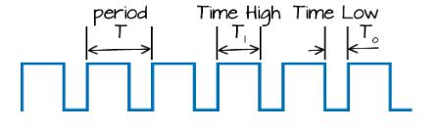
One period is the time in seconds for one complete oscillation to happen. In the case of this circuit, the period is the time the output is high (0.76246s) plus the time the output is low (0.69315s). This then give us a complete cycle time of 1.45561 seconds.
Fig. 3 Visual demonstration of square wave oscillation. [5]

Frequency:
Frequency is the number for complete oscillations in one second. This is measured in hertz (Hz)
$$f=\frac{1}{T on + T off}$$
Where f is frequency in Hz, T is period the time covered for one pulse in seconds.
For the circuit I built the frequency can be calculated by:
$$f=\frac{1}{0.76246 + 0.69315}$$
f = 0.687Hz

Proteus Schematic of Circuit
After the values for all the necessary components were calculated, the next step was to build the circuit by drawing it in the Proteus software. This is done by searching through the menus on the left hand side of the screen and selecting the required components from the component library. Then clicking to place each component onto the work plane where the circuit will be made. After all the components had been placed in their locations on the work plane, all the components were connected in the order they would be in the circuit. Once the circuit is drawn, values of the resistors and capacitors needed setting by right hand clicking on each one and changing the value in the component settings. After the circuit was finished voltage probes were added to measure Pin 3’s output voltage and the voltage across C1 as can be seen in figure 4 below.

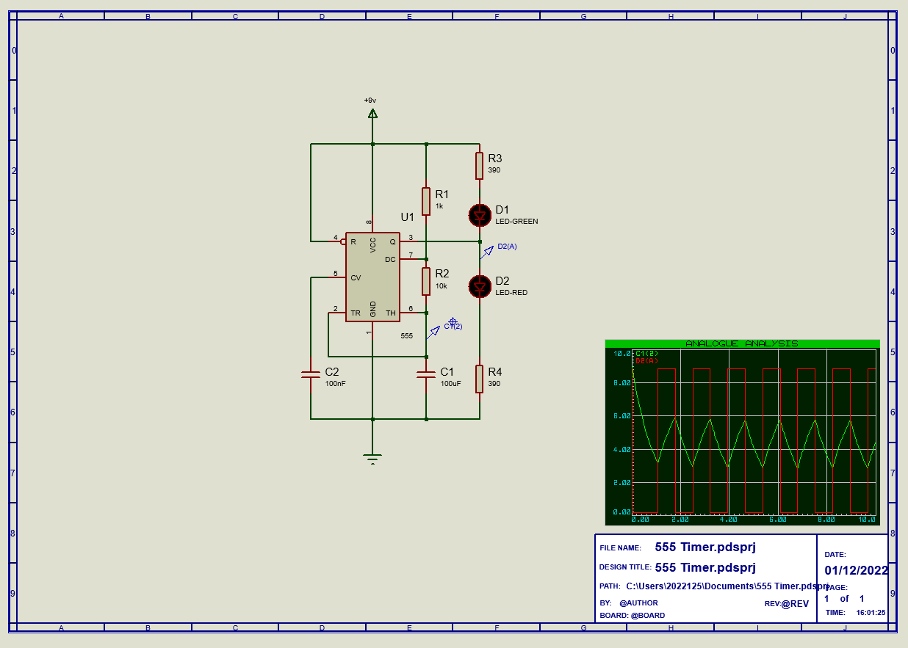
Fig. 4 Proteus schematic of the 555 timer circuit. Voltage graph seen is expanded in fig. 5

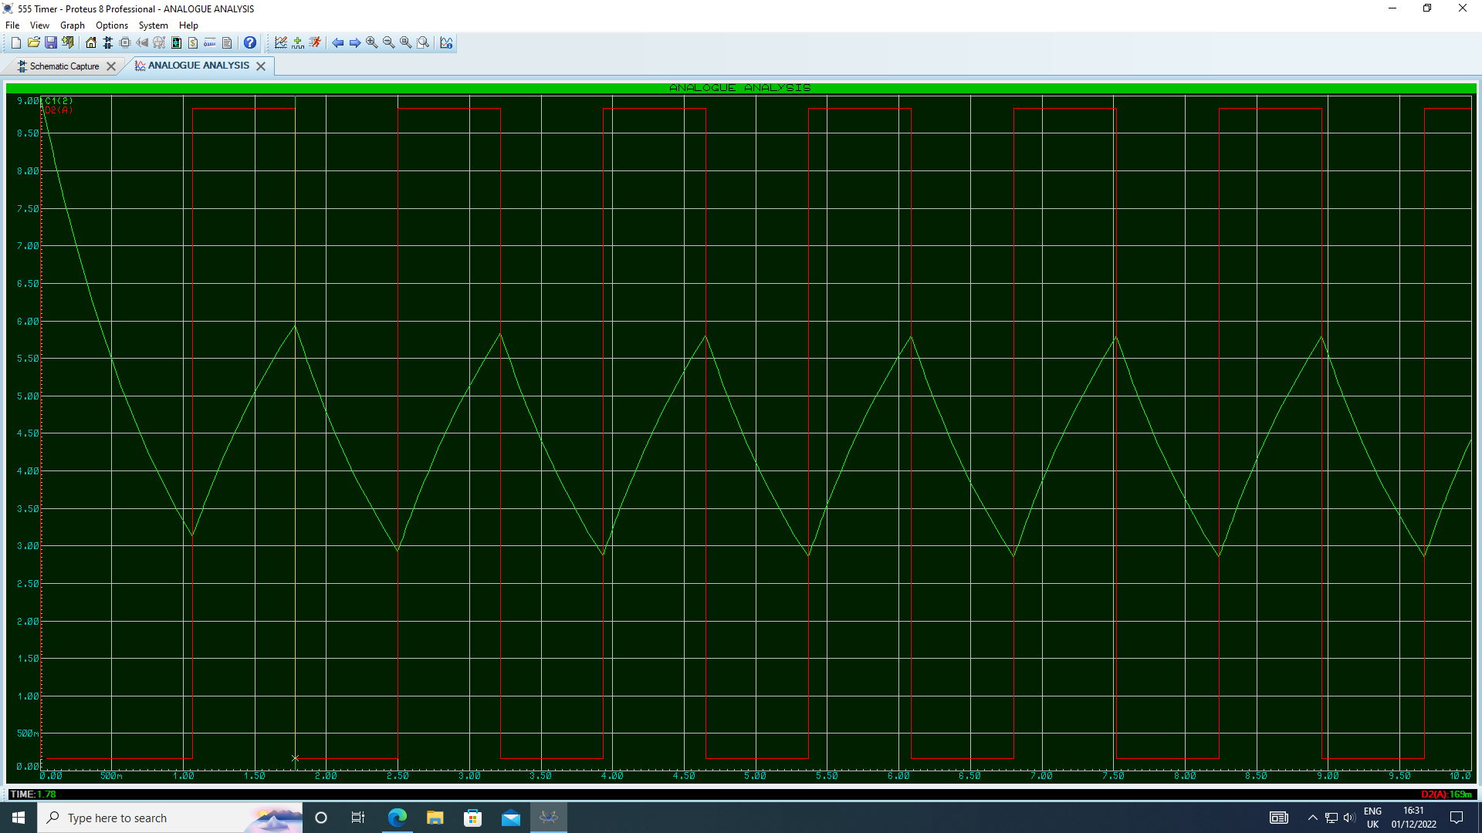
Capacitor (C1) and Output Voltage Graph (Simulated)
- Capacitor Voltage
- Output 555 Timer Voltage
Fig. 5 Capacitor (C1) voltage and output voltage graph for simulated circuit, generated using Proteus. Voltage against time.
As can be seen in the above graph the output is oscillating between high and low voltages as the capacitor is charging and discharging between 1/3 and 2/3’s the supply voltage. Therefore, this is proving the circuit is functioning as intended. The next process was to record the elapsed time for each change in state of the output voltage. From this it is possible to deduce the on and off period timing.

Proteus Simulation Timing Measurements Table
Table 1. Proteus simulation timing measurements table
State | Time Elapsed (s) | Time For Current State (s)
Start | 0 | 0
On | 1.06 | 1.06
Off | 1.78 | 0.72
On | 2.50 | 0.72
Off | 3.22 | 0.72
On | 3.93 | 0.71
Off | 4.65 | 0.72
On | 5.37 | 0.72
Off | 6.09 | 0.72
On | 6.80 | 0.71
Off | 7.52 | 0.72

The results from the experiment can be seen in Table 1. The Proteus simulation do not quite match the calculated times for on and off but instead consistently oscillate on the average time between the calculated on and off times. These results were obtained by zooming in on the graph within the Proteus software and clicking on the line showing the change in output voltage. Then the time displayed in the bottom left hand corner of the screen was read.

555 Timer Circuit Breadboard Build
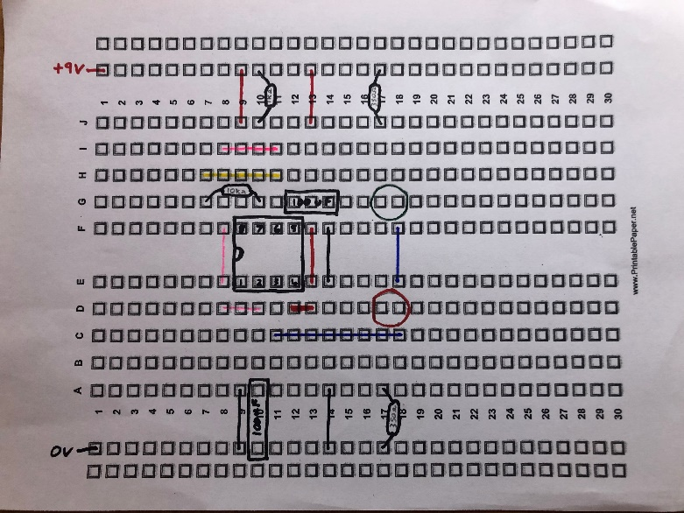
Before beginning to build the circuit on the breadboard it made sense to plan where the components where going to be placed, how they were going to be connected to avoid crossing wires and make sure everything was sufficiently spaced so all the components would fit. The best way of doing this was to print a copy of the breadboard hole arrangement on a piece of paper and draw all the components and wires in their locations.
Fig. 6 Design plan for the breadboard circuit build.
Once the paper design was finalised and optimised, it was time to start building the circuit.
Having selected the correct components from the parts drawers it was now time to build the circuit. As can be seen in figure 7 images the wires were colour coded to assist in any fault finding that may become necessary later.
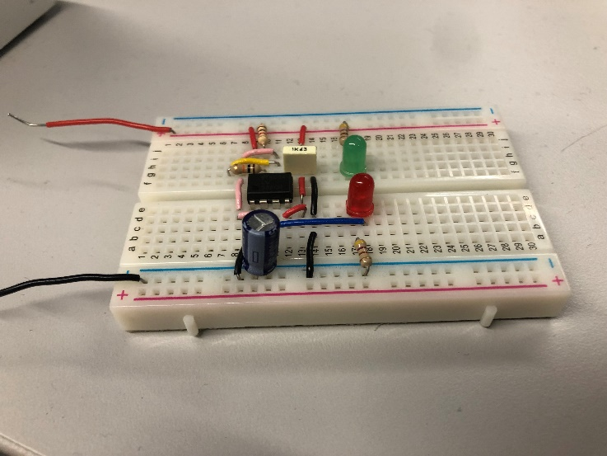
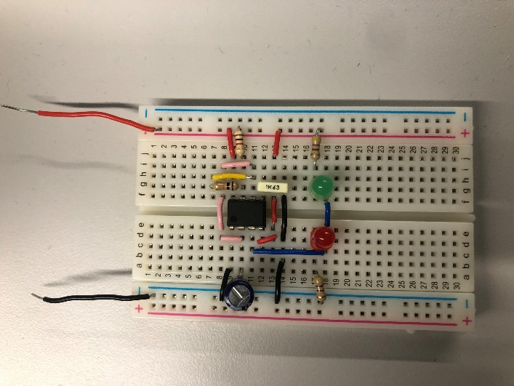
Fig. 7 Photographs of the breadboard circuit built. Wire colours represent: Red – Direct power supply; Black – Direct ground connection; Blue – Chip output; Yellow – Pin 6 and Pin 7 connection; Pink – Pin 2 and Pin 6 connection.

Testing of 555 Timer Circuit
In order to test the circuit functioned as intended the next thing to do, after the build was complete, was to connect the circuit up to a variable power supply and test the LED’s flashed. The power supply was set to 9V and 0.3A so to not overload the circuit and limit the power draw to 0.3A in case of a short circuit. These limits were chosen as under normal operating conditions this value of current should not be exceeded. As can be seen from figure 8 images, the circuit test was a success The LED’s flashed alternately as they should.
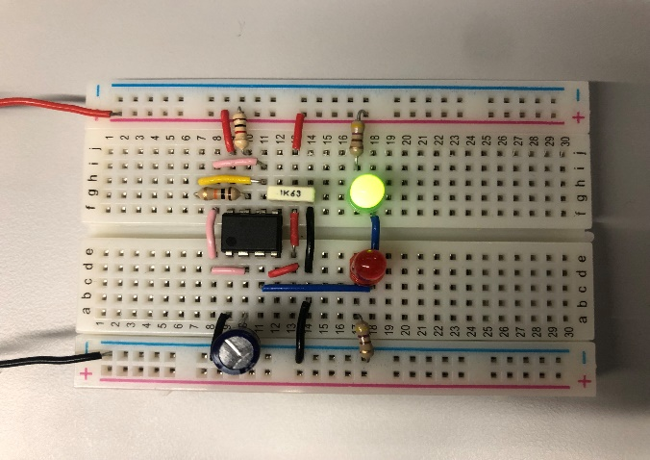
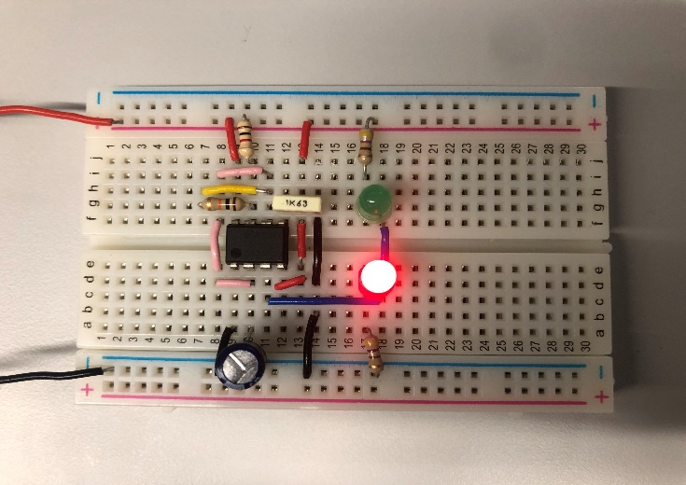
A
B
Fig. 8 Photographs of breadboard circuit with power supply connected. A) green light is on when the voltage has flipped to low; B) red light is on when the voltage has flipped to high.

Bread Board Circuit Timing Measurements
Due to time constraints, there was not time to get timing measurements for the circuit. However, if there was time the circuit would have been connected to an oscilloscope which is able to measure voltages and plot it on a graph showing the voltage change against time. The probes from the oscilloscope would be connected in the same places the probes on the Proteus software were, this way it ensures a fairer test between the two. From the graph produced by the oscilloscope the on and off time periods could have been determined which would have been used in the comparison with the Proteus table of results.
Although breadboard timing measurements were not completed due to time constraints, it is expected that they would be similar to the Proteus simulation. However, the resistors used may have a tolerance up to 5% on the resistance value, which would affect the oscillation timings and may result in deviations from the simulated values.

Conclusion
An astable 555 timer circuit was simulated using Proteus software and compared to a breadboard circuit. Timing measurements were first calculated and were then likened to the values received from the simulation. Simulated results did not match the calculated values, however the average time between on/off were consistent.
The breadboard circuit was successfully built and the LED bulbs’ voltage oscillated with the lights flipping on/off. Due to time constraints when building the breadboard, timing measurements were not taken. It would be expected though that they would be similar, depending on the tolerances of the resistors used.

References

[1] | Ø. N. Dahl, “555 Timer Tutorial and Circuits,” Build Electronic Circuits, 4 June 2021. [Online]. Available: https://www.build-electronic-circuits.com/555-timer/. [Accessed 2 January 2023].
[2] | Learning about Electronics, “555 Timer Pinout,” 2018. [Online]. Available: http://www.learningaboutelectronics.com/Articles/555-timer-pinout.php. [Accessed 6 January 2023].
[3] | S. Mosey, Assignment Brief, Topic: "LEVEL 4 ASSESSMENT SPECIFICATION Circuit Build", ACDA4018, Computer Science, UWTSD, Swansea, 2022.
[4] | R. L. J. Z. X. Long, “Development of street lighting system-based novel high-brightness LED modules,” The Institution of Engineering and Technology, vol. 3, no. 1, pp. 40-46, 2009.
[5] | All About Circuits, “555 Timer Astable Circuit,” EETech Media, LLC, 2018. [Online]. Available: https://www.allaboutcircuits.com/tools/555-timer-astable-circuit/. [Accessed 3 January 2023].

