

Business intelligence
Assignment 2

Mona Alexandra David - 2111962
Title: Business intelligence assignment 2
Module name: Data Handling and Business Intelligence
Module code: LCBB5000
Lecturer name: Xavier Matieni
Submission date: 03/05/2024

Table of Contents
Task 1 3
How was the sales trend over the months 3
What are the most frequently purchased products? 4
How many products does the customer purchase in each transaction? 6
What are the most profitable segment customers? 7
Strategic Suggestions for Enhancing Profitability in Global Markets 9
Summary 9
Market analysis 9
Strategic Suggestions 10
Task 2 12
Analysis data 12
Examination and evaluation: IBM-SPSS versus Microsoft Excel 14
References 17

Task 1

How was the sales trend over the months

The data shows a volatile pattern in sales during November and December 2019, with notable differences in daily totals across various days and countries. The following are a few observations:
Overall Sales: The overall sales for the period amount to about 524,879.89, indicating strong and active performance throughout the months.
Notable Sales Day: On November 17, 2019, there was a significant increase in sales, reaching a total of 40,763.99.
On November 22, 2019, there was a notable amount of 47,319.31.
On December 5, 2019, there was a remarkably high day total of 35,775.42 recorded.
On November 27, 2019, the total sales were much lower, amounting to 16,183.80.
On December 4, 2019, there was a decrease in the total amount, which reached 12,943.44.
Trends by Country: The United Kingdom regularly exhibits superior sales performance in comparison to other countries over the given time period.
Countries such as Ireland and Germany also have steady sales, but far lower than those of the UK.
Countries such as the USA and Japan exhibit a limited number of entries, suggesting infrequent sales activity.
End of Month Peaks: The data indicates an increase in sales totals as the month comes to a close. November 30 and December 5 have elevated cumulative figures, indicating a potential pattern of monthly surges towards the conclusion.
Variability: Sales exhibit significant fluctuations on a daily basis and across different nations. Certain days have a high level of sales concentration in specific nations, whilst others demonstrate a more dispersed distribution.

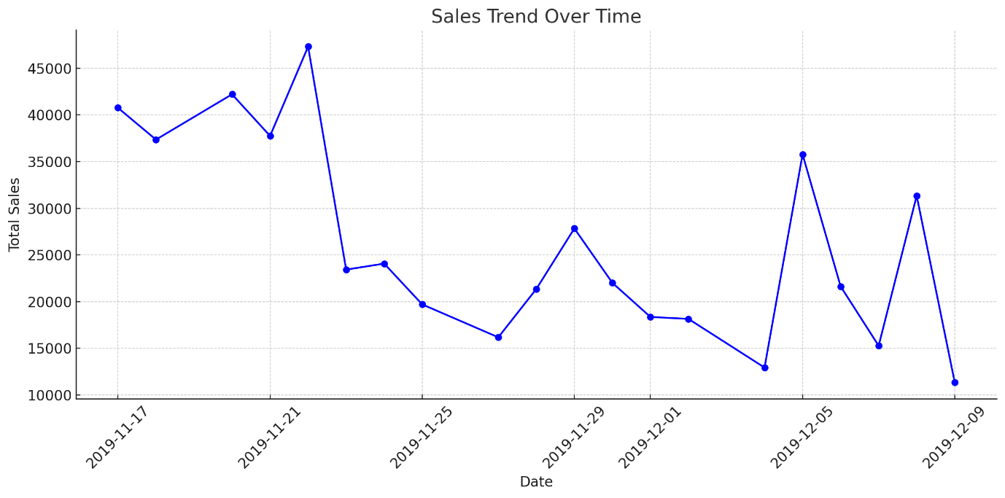

What are the most frequently purchased products?

The most frequently purchased products from your list, each with 369 purchases, are:
- 3 Hook Photo Shelf Antique White
- Star Decoration Painted Zinc
- Doorstop Football Design
- Pink Hearts Light Chain
- Embroidered Ribbon Reel Rebecca
- Brown Pirate Treasure Chest
- Wall Art Dolly Girl
- Art Lights Funk Monkey
- Charlotte Bag Dolly Girl Design
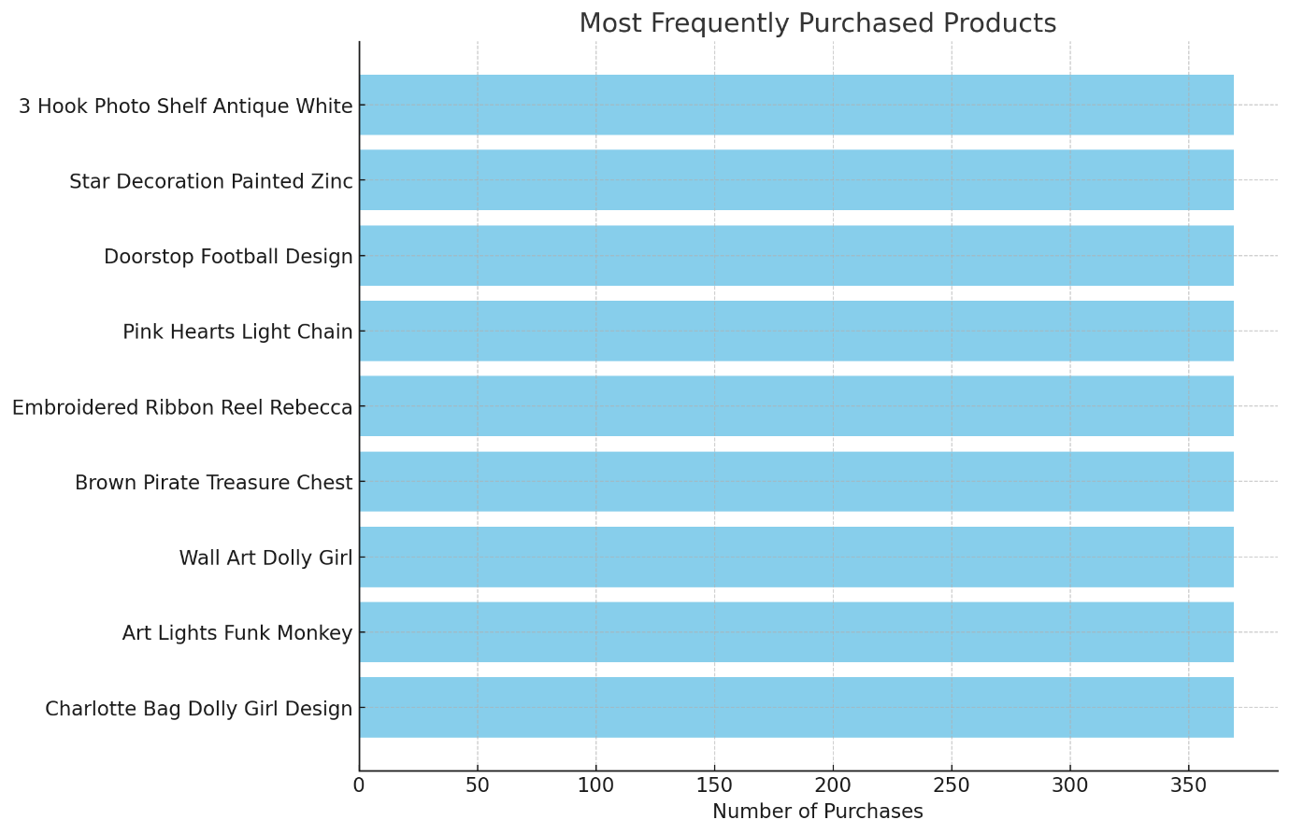

The least purchased products, each with 1 purchase, are:
- Sweetheart Wire Magazine Rack
- Pink Cat Bowl
- Wall Art Big Love
- Metal Sign Drop Your Pants
- Set 3 Wicker Storage Baskets
- Assorted Incense Pack
- Red Flower Crochet Food Cover
- Regency Cakestand 3 Tier
- Mirrored Disco Ball
- Union Jack Flag Passport Cover
- Family Photo Frame Cornice
- Fairy Cakes Notebook A7 Size
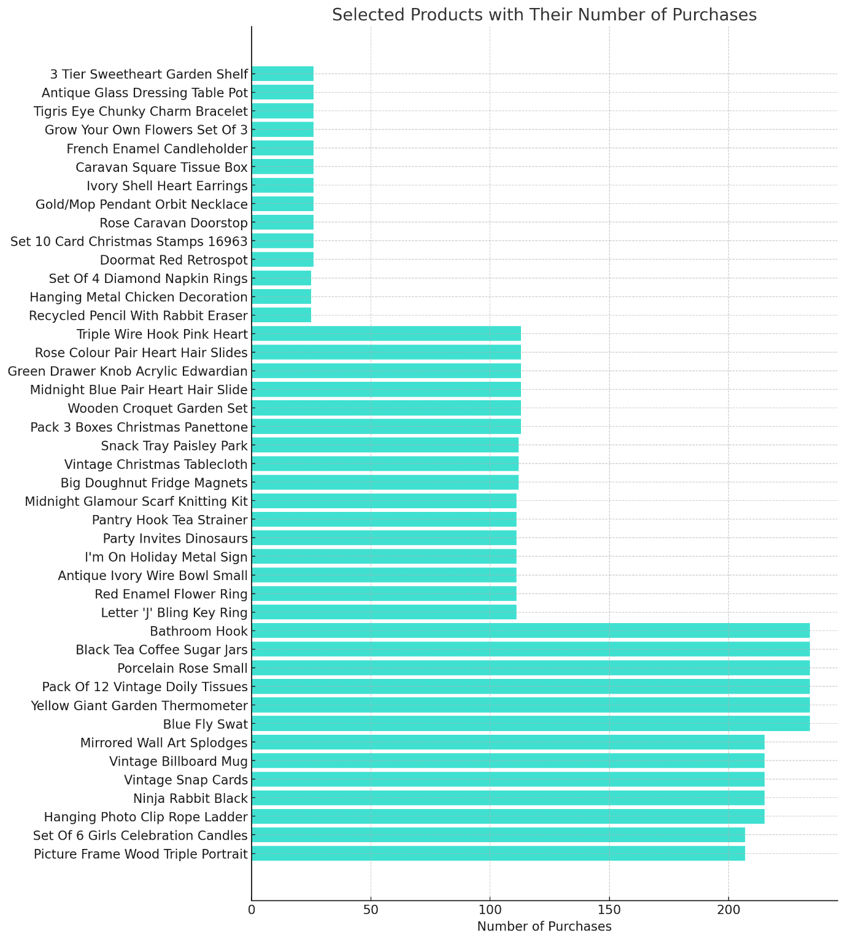

How many products does the customer purchase in each transaction?

Number of transactions | Total Products | Average products on 1 sale
2128 | 65535 | 30.8

What are the most profitable segment customers?

In order to determine the most lucrative consumer group using the available data, we may analyse both the total income (represented by the sum of prices) and the volume of items sold (represented by the sum of quantities) for each nation. The initial assessment of profitability may be made by calculating the total revenue, which is the sum of the prices.
The United Kingdom stands out as the most lucrative market, surpassing other nations in terms of both income and quantity by a wide margin.
France: Next, with a total income of 7,893.22 and a pretty large quantity sold.
Germany has similarities to France in terms of both revenue and quantity.
EIRE: Additionally demonstrating significant income and quantity.
These nations are the most lucrative consumer categories. The United Kingdom, specifically, comes out significantly as the dominant section by a substantial margin.
United Kingdom: Number of ProductName: 60,025 products
Total Price: £475,276.81
Total Quantity: 482,459 units
Product revenue: £7.92 per unit
Number of products per transaction: Large assortment of products
Observations: The market is dominant, generating the most revenue and volume. This indicates a strong demand and successful market penetration.
France: Total number of ProductName: 995 items
Total Price: £7,893.22
Total Quantity: 10,477 units
Product revenue: £7.93 per unit
Number of products per transaction: There is a moderate range of products available.
Observations: The market is substantial and generates a substantial amount of income. There is a wide range of products available, which suggests a steady client base and an effective pricing strategy.
Germany has a count of 875 goods for the specific ProductName.
Total Price: £7,369.25
Total Quantity: 10,399 units
Product revenue: £8.42 per unit
Number of items purchased per transaction: France has a greater diversity than this.
Observation: The market scale and efficiency of this country are comparable to that of France, suggesting that they likely have a similar market structure.
EIRE (Ireland): Number of ProductName: 846 items
Total Price: £7,263.28 Total Quantity: 9,578 units
Product revenue: £8.59 per unit
Number of products per transaction: Moderate range
Observation: The price efficiency is strong, with a larger revenue per product in comparison to France and Germany. This suggests the possibility of having greater pricing power or luxury items.
The Netherlands:
The number of goods with the name "ProductName" is 168.
Total Price: £1,216.1 Total Quantity: 15,944 units
Product revenue: £7.62 per unit
Number of products purchased in each transaction: Limited diversity, large quantity
Comments: This profile has an atypical pattern characterised by a significant volume for each product category, indicating either large-scale purchases or a focused demand for a limited number of product lines.
Segments with the lowest profitability
Australia:
The overall income amounts to £49.52.
The whole quantity sold is 224.
The mean price per product is £0.22.
Efficiency Indicator: The combination of low revenue and a low average price point indicates potential problems with either market penetration or pricing strategy.
Sweden: Revenue: £90.42 Quantity Sold: 113
The average price per product is £0.80.
Efficiency Indicator: Despite having a higher average price per product compared to Australia, the overall income and quantity are still relatively low, suggesting minimal market participation.
Czech Republic: Total revenue: £23.52
The total quantity sold is -39, indicating a potential data mistake or a situation where returns have exceeded sales.
Mean price per item: The negative amount indicates potential problems with operations or data recording.
Efficiency Indicator: Requires more examination owing to the presence of a negative amount, which is extremely uncommon and may suggest data inaccuracies or substantial operational issues.

Strategic Suggestions for Enhancing Profitability in Global Markets
Summary
This research examines the performance of several global markets by considering their total income, number of items sold, and average pricing. The objective is to discover tactics that might improve profitability. The primary objective is to analyse and contrast the most lucrative market sectors, including the United Kingdom, France, Germany, and EIRE, with the least profitable ones, which include Australia, Sweden, and the Czech Republic. The purpose of this analysis is to obtain practical and effective business solutions.
Market analysis
The United Kingdom has emerged as the frontrunner in terms of profitability, generating a total income of £475,276.81 and selling an impressive number of 482,459 goods. This signifies a strong market presence and an effective combination of products. In contrast, Australia, Sweden, and the Czech Republic exhibit far lower revenues and quantities sold, suggesting a lack of market penetration and potential problems with pricing or market suitability.

Analysis of revenue and pricing:
The mean cost per item in the United Kingdom is around £0.99, endorsing a strategy of selling a large quantity of products at a low price, which appears to be successful in this market.
France, Germany, and EIRE have a well-balanced strategy with moderate mean prices (£0.75, £0.71, £0.76 respectively) and significant volumes, indicating that these markets are mature and exhibit steady demand.
The markets with the lowest profitability, specifically the Czech Republic, where the amount sold is negative, bring attention to significant operational or data accuracy problems that require prompt attention.
Strategic Suggestions
Market expansion and penetration refer to strategies aimed at increasing a company's presence and market share in existing markets.
Focused Marketing in Underperforming Markets: In nations such as Australia and Sweden, intensify marketing endeavours to enhance brand prominence and foster consumer involvement. Customised marketing strategies that target specific consumer preferences and use competitive pricing can increase market penetration.
Product diversification involves the exploration of introducing new goods or variations that are especially tailored to the interests and tastes of consumers in underperforming areas. This strategy has the ability to increase the average price per product and overall revenue.
Modifications to Pricing Strategy:
Models for Pricing that are adaptable and responsive to changing conditions: Develop price strategies that accurately align with the prevailing economic conditions, consumer buying capacity, and specific market demand in every country. This may involve using premium pricing strategies in markets that are prepared to pay higher prices, while adopting competitive pricing strategies in markets that are more price-sensitive.
Promotional Offers and Discounts: Employ promotional tactics like as price reductions, bundled deals, or loyalty programmes, particularly in areas with promising development prospects like France and Germany, to enhance sales volume and foster consumer loyalty.
Efficiency in operations:
Optimising the Supply Chain: Optimise operational processes and supply chain management to save expenses and enhance efficiency in order fulfilment, particularly in markets characterised by lower price points. Streamlined supply chain processes can facilitate competitive pricing by minimising overhead expenses.
Tackle Operational Challenges in the Czech Republic: Conduct a thorough analysis of the underlying factors that have led to the decline in sales numbers and take appropriate actions to improve performance.
Data-driven decision making:
Conducting Market Research to Gain Deeper Understanding: Perform extensive market research to get profound understanding of customer behaviour, tastes, and trends in every country. This information can provide valuable insights for product development and inform effective marketing tactics.
Metrics and Key Performance Indicators: Develop explicit metrics and key performance indicators (KPIs) to systematically evaluate market success, product profitability, and consumer engagement in all markets on a regular basis.
Enhance and fortify online platforms for selling products or services.
Improving E-commerce: With the worldwide trend towards online buying, improving e-commerce platforms may access a wider range of customers, particularly in technologically sophisticated areas. (Attar,2022)
Utilise digital marketing and social media platforms to expand the reach of your marketing efforts, captivate customers with engaging content, and generate online sales, all of which are essential for achieving success in the contemporary retail industry.
Conclusion
The examination of different market sectors reveals notable discrepancies in performance that may be utilised to enhance operational, marketing, and pricing strategies. (Cavusgil ,1994) To enhance its total profitability, the corporation can concentrate on untapped markets utilising specific techniques, while also improving operations and pricing in established regions. The proposed tactics focus on both expanding market share and improving customer happiness and loyalty, which are crucial for sustained corporate success.

Task 2

Analysis data
The dataset comprises 1056 male students, representing 49.5% of the total, and 1077 female students, representing 50.5% of the total. This nearly equal distribution allows for a more equitable viewpoint when doing further gender-based analysis.

Gender 1 male/2 female
 |  | Frequency | Percent | Valid Percent | Cumulative Percent
Valid | 1 | 1056 | 49.5 | 49.5 | 49.5
Valid | 2 | 1077 | 50.5 | 50.5 | 100.0
Valid | Total | 2133 | 100.0 | 100.0

2. Proportion of Pupils Eligible for Reduced or Free meal: Among the overall pupil population, 1215 students (57%) qualify for reduced or free meal, indicating a disadvantaged socioeconomic status. Conversely, 918 individuals (43%) do not meet the requirements, indicating a noticeably elevated socioeconomic status.

Lunch
 |  | Frequency | Percent | Valid Percent | Cumulative Percent
Valid | Does not qualify | 1215 | 57.0 | 57.0 | 57.0
Valid | Qualifies for reduced/free lunch | 918 | 43.0 | 43.0 | 100.0
Valid | Total | 2133 | 100.0 | 100.0

3. Lunch Eligibility The scores for both the mean and median are as follows:
The pupils' average score is 22.80 and their middle score is 22.00, suggesting that they qualify for free or reduced meals.
Children who are not eligible for free or reduced lunch do not have their mean and median scores published in the summary right away. However, these scores can be obtained using SPSS analysis to glean specific insights.
Statistics
Student No
N | Valid | 2133
N | Missing | 0
Mean |  | 22.80
Median |  | 22.00
Std. Deviation |  | 4.229
Range |  | 17
Minimum |  | 14
Maximum |  | 31

Examination and evaluation: IBM-SPSS versus Microsoft Excel
Analysing data with SPSS
SPSS is a specialised software programme designed for statistical analysis, which makes it particularly useful for academic research. It is especially good for analysing student data, including demographics and educational results.
Benefits:
SPSS offers a diverse selection of advanced statistical tests that are crucial for efficiently analysing student performance and demographics. One such use is to utilise chi-square testing to ascertain whether there exist noteworthy disparities between male and female pupils regarding their eligibility for reduced or free meals.
SPSS is a highly efficient tool for managing large datasets, offering superior capabilities compared to Excel. Our system is capable of efficiently handling large amounts of student data without any noticeable performance issues. This involves streamlining the processing of data, including organising and refining based on various demographic factors.
SPSS generates detailed output for statistical tests, providing assessments of assumptions and interpretations. These outputs are crucial for upholding academic integrity and ensuring accuracy in reporting.
Drawbacks:
The cost of SPSS can be quite prohibitive for smaller educational institutions or independent researchers, posing a potential challenge in terms of expenses. SPSS can be quite challenging to learn due to its extensive array of statistical operations and data management features.
Analysing Sales Data with Excel
Excel is a very adaptable instrument that is extensively employed in commercial environments for financial purposes, such as monitoring sales data.
Benefits:
The layout of Excel is widely recognised for its intuitiveness, making it easy for users to input data efficiently and perform straightforward analytics, such as monitoring daily sales or comparing monthly results.
Excel offers great flexibility with its ability to create custom formulae and functions that can be customised to fit the specific needs of sales analysis. This involves the ability to calculate total sales, averages, and identify patterns over a given time frame. Excel offers robust visualisation tools that make it easy to create charts and graphs for illustrating sales patterns. These visual aids are incredibly useful for presentations and decision-making processes.
Drawbacks:
Excel has limited statistical capabilities compared to SPSS. Although Excel can perform basic statistical operations, it does not offer the same level of depth in analysis as SPSS, especially in advanced statistical testing or multivariate analysis. Managing large datasets in Excel can sometimes impact its performance and responsiveness, which can be a challenge when dealing with extensive sales data.
Comparative Analysis Table: SPSS vs. Excel
Criteria | SPSS | Excel
Data Handling Capacity | Robust capabilities for managing extensive and complex datasets. | Adequate for moderate-sized datasets; performance declines with larger volumes.
Statistical Capabilities | Comprehensive suite of sophisticated statistical tools designed for in-depth analyses, suitable for research and scientific studies. | Provides basic statistical functions; lacks support for more complex statistical analyses required in rigorous research.
Ease of Use | Features a steeper learning trajectory due to its extensive analytical capabilities. | Familiar interface and straightforward functionality enhance its accessibility for general users.
Cost Effectiveness | Higher cost associated with advanced functionalities, potentially restrictive for individual researchers or smaller institutions. | Generally more cost-efficient, making it a viable option for routine business tasks and basic data analysis.
Integration and Compatibility | Seamless integration with other specialized analytical software, supporting a comprehensive research workflow. | Excellent compatibility with other business software solutions, facilitating integrated business reporting and presentations.
Reporting and Output | Generates detailed and customizable outputs, essential for scholarly documentation and publication. | Strong in visual data representations, suitable for business analytics and decision support systems.
(Pfister,2013)
Conclusion
The selection between SPSS and Excel is primarily contingent upon the unique requirements of the project. SPSS is better suited for complicated statistical analysis, especially in academic contexts or situations where exact statistical interpretation is necessary, such as when analysing student data.(Morgan, 2019) On the other hand, when it comes to commercial applications that need adaptable data processing and direct reporting (such as examining sales patterns), Excel is frequently satisfactory and offers better value for money.(Rasmussen, 2002) Every tool possesses distinct advantages and constraints, and the selection should be in accordance with the objectives of the project and the characteristics of the data.

References

- Attar, R.W., Almusharraf, A., Alfawaz, A. and Hajli, N., 2022. New trends in e-commerce research: Linking social commerce and sharing commerce: A systematic literature review. Sustainability, 14(23), p.16024.
- Cavusgil, S.T. and Zou, S., 1994. Marketing strategy-performance relationship: an investigation of the empirical link in export market ventures. Journal of marketing, 58(1), pp.1-21.
- Morgan, G.A., Barrett, K.C., Leech, N.L. and Gloeckner, G.W., 2019. IBM SPSS for introductory statistics: Use and interpretation. Routledge.
- Pfister, R., Schwarz, K., Carson, R. and Jancyzk, M., 2013. Easy methods for extracting individual regression slopes: Comparing SPSS, R, and Excel. Tutorials in Quantitative Methods for Psychology, 9(2), pp.72-78.
- Rasmussen, N.H., Goldy, P.S. and Solli, P.O., 2002. Financial business intelligence: trends, technology, software selection, and implementation. John Wiley & Sons.

