The effectiveness of the social media on recruitment process

What is social media?
- Social media acts a medium for people to socialise by means of sharing their personal details, professional information conversational media, pictures and videos.
- Interactive presence, which allows people to participate in discussions. It includes popular sites such as Facebook, Twitter, LinkedIn, WhatsApp and Instagram
- Today Social media is gradually becoming the space where professional life happens and changes the business strategy as well as job markets.
- Now organisations deals sales, marketing, retention and recruitment over social media, as it reaches bigger audiences.
- Social media acts a major role in evaluating an individual and cannot be ignored anymore by organisations
Social Media recruiting
- Social media can provide new talented candidates and also boast the company or brand.
- With social media recruiting, HR professionals are challenged to work more with less and provides an opportunity to develop new recruitment strategy in association with marketing, resource sharing and customer relations to results in top hires.
- As per the survey of Jobvite, LinkedIn as top choice foe recruitment and leading source for successful hires. Although LinkedIn toped in the survey, Facebook and Twitter were also choice for recruitment.
- In wide range of Social media platform, talented candidates are everywhere, which makes the hiring manager and recruiters to be more proactive while engaging in the recruitment process.
- With smart social media network such as Researching blog, forums and communities in large networks provide potential pool of talented candidate for HR operations.
- It is cost-effective hiring solution and job posted in quicker way and in control of recruiter. For example, job can be tweeted in twitter and retweeted with just few clicks.

Recruitment Strategy
- Branding in social media plays a vital role in attract the candidates, therefore, HR have to work together with marketers to deliver the right message or branding out the company online.
- Branding message should be crisp and clean. Highlights the company’s value, culture and vision in online via social media.
- With social media, employees can examine their employers more than ever before. Therefore, ensuring employee retention is the major part in recruitment strategy.
- Organisation can create their own profile in LinkedIn, Facebook and Twitter to reach out the potential pool of candidates. LinkedIn has updated with new features in company pages, where allows candidates to recommend their company to their followers.
- With Social media sites, credentials of the candidate can be checked from their profiles.

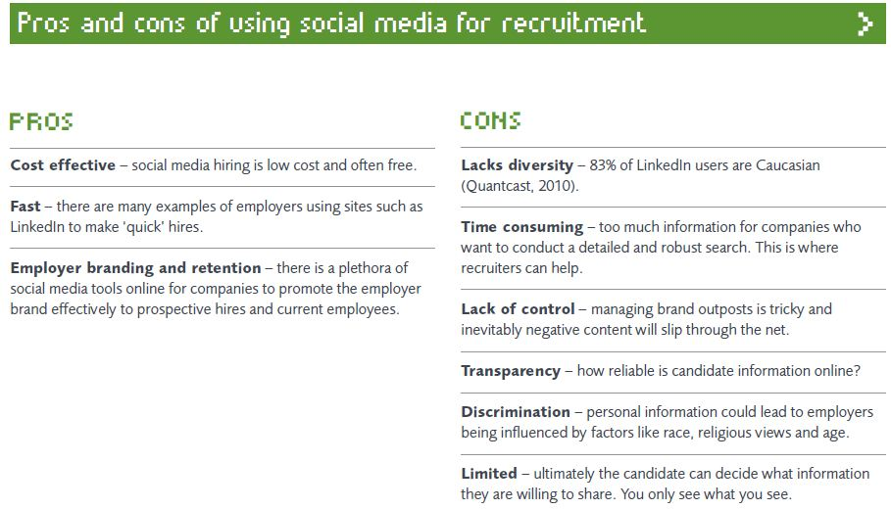

Reference:
Sherrie A. Madia "Best practices for using social media as a recruitment strategy", Strategic HR Review, (2011) Vol. 10 Iss: 6, pp.19 - 24

Nigel Wright Recruitment, “The impact of Social media on Recruitment” Report 2011

