

How did Technological and Strategic Advancements Implemented by the British Military During the Conflicts on the Western Front in 1916 Influence the Outcome of the Great War and Shape Warfare?
Alex Hales-Owen (2221576)

Supervised by Rhian Keyse

Submitted in partial fulfilment for the award of the degree of Bachelor of Arts: Conflict, War and Society

University of Wales Trinity Saint David

2025

Contents Page
Acknowledgements…………………………………………………………………………………………………………p.2.
Abstract…………………………………………………………………………………………………………………………..p.3.
Introduction (Pages 4 – 10)
Literature Review…………………………………………………………………………………………………………….p.5.
Chapter 1 - Strategy and Doctrine (Pages 11 – 17)
Doctrine of Obedience……………………………………………………………………………………………………p.11.
Training and Intelligence Gathering…………………………………………………………………………………p.12.
Learning from the Somme………………………………………………………………………………………………p.15.
Impact of British Strategy on Warfare…………………………………………………………………………….p.17.
Chapter 2 - Mk.I. Tank ( Pages 18 – 26)
Origins - The Somme, September 15th 1916…………………………………………………………………..p.18.
Production and Conditions Inside the Tanks……………………………………………………………………p.19.
Successes of the Mk.I. Tank……………………………………………………………………………………………p.22.
The future of warfare – the Challenger 2………………………………………………………………………..p.25.
Chapter 3 - Chemical Weapons (Pages 27 – 35)
The Use of Gas 1914 – 1915………………………………………………………………………………………….. p.27.
Loos, September 1915 - Britain’s Retaliation…………………………………………………………………. p.28.
British Efficiency – 1916………………………………………………………………………………………………… p.29.
Mustard Gas and Further Development of Chemical Warfare……………………………………….. p.30.
Gas after the Great War…………………………………………………………………………………………………p.35.
Conclusion (Pages 36 – 38)
Greatest Long-Lasting Development of the War……………………………………………………………..p.36.
Learning and Adapting….………………....................................................................................p.37.
War-Winning Developments…………………………………………………………………………………………..p.38.
The Critical Impact of the Great War in 1916………………………………………………………………….p.38.
Bibliography (Pages 39 – 44)
Archival Sources……………………………………………………………………………………………………………..p.39.
Printed Primary Sources.…………………………………………………………………………………………………p.40.
Secondary Sources………………………………………………………………………………………………………….p.41.
Online Sources………………………………………………………………………………………………………………..p.42.
List of Images………………………………………………………………………………………………………………….p.43.

Acknowledgements
Firstly, I would like to thank my family and my partner for their support throughout my degree and Dissertation. I would also like to thank my Dissertation Supervisor, Rhian Keyes for her support and guidance with this Dissertation. I would also like to thank all of the tutors at University of Wales Trinity Saint David for their assistance and support, especially Dr. Lester Mason for his extensive knowledge of my chosen topic in this Dissertation of the Great War and for his assistance in broadening my own knowledge on the subject.

Abstract
The Great War was a critical period of time for technological and strategic advancements, and in shaping the future of warfare. Though scholars often debate how impactful a number of advancements were throughout the war, and many also criticise the war-time leaders whom implemented such changes. Regardless of these perspectives, the point remains that the Great War was a major turning point in the manner in which warfare is fought, for better or worse. It is essential to understand the strategies and technologies implemented during the Great War, to consider whether these developments were essential in changing the course of the war for Britain and the Allied forces, and understand the context of such developments to fully acknowledge the impact that they had on warfare.
This Dissertation will consider a variety of primary and secondary sources and analyse how some technologies and strategies implemented by the British Military during the conflicts on the Western Front in 1916 influenced the outcome of the Great War, and how these shaped warfare as it is known today. This Dissertation will ask three additional questions in order to answer this. These are:
- Which of these developments had the greatest long lasting impact after the war?
- How did the British learn and adapt their strategies throughout the Great War?
- Could any advancement be considered a war-winning weapon?
These questions will provide some key insight into analysing how the British war machine advance throughout the Great War, and how it helped to shape the future of warfare.

Introduction
The Great War of 1914 to 1918 was a series of conflicts fought between two powerful coalitions. The first of these coalitions, the Allies, or Entente, consisted primarily of Great Britain and her colonies, France, and the United States. The second coalition, the Central Powers, consisted of Germany, Austria-Hungary, Bulgaria and the Ottoman Empire. Throughout the war, a multitude of inventions and advancements were made by all forces involved.
The War was primarily fought in two European theatres; the Eastern Front and the Western Front. The focus of this dissertation will be the Western Front. Specifically, the conflicts faced by the British Forces. This is because British tactics utilised on the Western Front before and during the early months of 1916 were often incredibly costly. Richard Van Emden and Steve Humphries state that in the first four and a half months of the war, ‘British casualties had totalled 92,000’ across both fronts. Throughout 1915 and into 1916, the casualty numbers would continue to rise.
The first day of the Battle of the Somme, 1st July 1916, was the bloodiest day of the war. This costly day saw a total of 60,000 British men either dead or wounded, in comparison to 8,000 German casualties. Casualty numbers at the Somme continued to increase for the British forces. In fact, the Somme, and the Western Front as a whole, were so costly to the Allied forces that when David Lloyd George was elected Prime Minister in December 1916, he was appalled by the losses on the Western Front and demanded tactics to change. He suggested sending men and artillery instead to focus on reinforcing the Italian front, though ultimately very little ever was sent. Instead, the bloodshed on the Western front would continue throughout the war. Long before Lloyd George was elected to power, changes were already implemented to strategy and technology, some of which will be discussed in this dissertation. This dissertation will focus on three main developments: strategy and doctrine, the Mk.I. tank, and chemical warfare. This dissertation will argue that these developments proved crucial to the outcome of the Great War, and influenced the conduct of later wars.
Literature Review
This literature review will consider the perspectives of scholars on military strategies and how they have changed, perspectives on the tank and its success, and perspectives on chemical warfare and how these would impact the course of the Great War.
In regards to military strategy, the Somme was generally considered a victory for the Allied forces at the time of the war. This is despite the incredibly high British casualty numbers, estimated by Sheffield and Bourne to be approximately 420,000 by the end of the battle of the Somme. The British Expeditionary Force (BEF), and their commander, Sir Douglas Haig would leave the conflict far more experienced, and more organised than before the battle. This silver lining does of course hold some weight considering the long term impacts of the conflict on the Western Front both during 1916, and in subsequent years during the Great War, and likely provides some key insights into why the Central Powers surrendered in 1918. However, it must also be noted that Haig is a highly controversial figure for his strategies during the Great War, and when one considers his later battles, such as Passchendaele, which also suffered notably high casualties, it becomes debatable as to whether Haig learned from his mistakes at the Somme. Gerard De Groot notes that Haig’s strategies in all of his major battles relied on the sole principle of defeating an enemy ‘with a bold, decisive and overwhelming stroke.’ This perspective states that wars of attrition, consisting of slowly depleting enemy morale and resources, were never at the forefront of Haig’s mind. Instead, Haig simply wanted to make all his battles hard and fast victories. Thus, soldiers serving under Haig so frequently suffered such severe casualties, as shown at the Somme. Despite these important developments on the battlefield, a General’s inability to adapt and develop their strategies to complement such inventions, will inevitably mean that casualties be higher than necessary. However, a key point still remains: the heavy losses suffered by the British, and the other Allied forces on the Western Front would affect warfare, and in some cases civilian life, even after the Great War.
Many scholars are highly critical of Haig, the Battle of the Somme, and the leaders and fighting of the British on the Western Front as a whole. Niall Ferguson states that ‘in some ways, the stalemate on the Western Front and the inconclusive results of the “indirect approach” in other theatres were inevitable consequences of military technology.’ He elaborates on this point by stating that regularly the only way in which a battle could be considered a victory in the eyes of a General on either side of the conflict, was by killing more enemy soldiers than were killed of your own. This is undeniably a callous and costly way to view warfare, or even justify heavy casualties in a conflict. However, this may not be so far from the reality. In fact, when considering the Somme, this is undeniably the truth, despite the battle being fought over control of land, specifically 25 miles in order to allow the Allies to flank the forces of the Central Powers at Verdun. Only six miles of the total 25 were ever taken by the Allies, and yet by multiple counts and reports of the battle, it is considered an Allied victory. The reason for this may be because despite the estimated 600,000 total Allied casualties, the German Landwehr (defence force) alone lost approximately 650,000 troops in the battle. Philpott argues that the Landwehr never fully recovered from the heavy losses. In contrast, Ferguson argues that these casualty numbers suggest that the battle was a draw. Additionally, the battle may well have only been reported as a victory, to somewhat justify the horrendously heavy sacrifice which the BEF, and the Allies paid for such little ground and to maintain what little morale was still present both on the battlefields of the Western Front, and at home in Britain. It is important to note that the battle for land in the Great War was always a struggle, and the Somme was no exception to this rule. Philpott notes that despite how little land was actually gained on the Somme, this was greatest territorial gain that the Allied forces had managed to successfully achieve since the battle of the Marne in 1914. Thus, in this instance it must be noted that success of any form was hard to come by during the Great War, and clearly the changes that had been implemented by the British and Allied forces must, at least to some extent, have been effective.
The Mk.I. tank was first utilised at Flers on the Somme on 15th September 1916. Though the perceived success of the tank is self-explanatory, in that the tank is still a well-utilised vehicle for many militaries today. The Mk.1 tank which was seen during the Great War was not so refined. Scholars often debate how successful tanks truly were at the time of the Great War. Philpott provides a realistic perspective on the early tank design stating that it was primarily ‘media hype’ which glorified the tank in the eyes of the British population. He argues that in reality, of the 50 tanks initially delivered, only three remained serviceable by the following day. He also notes that tanks would need more careful thought if the British military were to have them function effectively on the battlefield. Simply put, once the shock factor imposed by the tank wore off, the enemy were able to easily organise anti-tank strategies through the use of artillery and improvisation. According to Sheffield and Bourne, the events of September 15th even proved to be a disappointment to Haig himself. However, Philpott notes this did not prevent Haig from ordering another 1000 tanks. Generally, the common consensus regarding tanks provided in many sources is that their first use was premature. Paddy Griffith states that the rush to use tanks in 1916 ended up ‘sacrificing surprise without using sufficient numbers for a decisive blow.’ Griffith notes that this is not only an observation made in the modern day, but one shared by many officers throughout the course of the Great War. Even in later battles such as Passchendaele and Cambrai, the latter of which should have been a perfect opportunity to demonstrate the utility of tanks in ‘ideal conditions’, there simply were not enough tanks to make the advance fully effective. This of course does not mean that tanks were completely ineffective. George Raudzens notes that despite the low numbers of tanks used at Cambrai, the tank undoubtedly won the battle for the British. Raudzens argues that in this instance the tank did everything it was meant to do: protect troops as they moved across no man’s land and increased mobility. Ultimately, it ‘superimposed naval tactics on land warfare’. This dissertation will consider a number of additional sources relating to the tank and observe how effective it truly was during the Great War and how it has managed to remain a prominent war-machine into the modern day, and what needed to change in order for this to be the case.
This dissertation will also consider chemical warfare throughout the Great War, and its overall impact on the scope of warfare. Philpott argues that gas was one of the most effective means of silencing hostile guns whilst troops advanced, either by incapacitating them or by forcing them out of cover. The only other method which could come close to being as effective, was intensive high explosive. Gas was undoubtedly a useful tool on the frontlines of the Great War, there were many different forms for a variety of purposes, for example mustard gas types which would be used to attack the skin and was often the favoured type of gas for repelling hostile advances. However, it was sometimes just as detrimental to the military which utilised it as it was to the opposition. John Keegan acknowledges that at the battle of Loos ‘the gas hung about in no man’s land or even drifted back into the British trenches, hindering rather than helping the advance.’ This demonstrates that due to the nature of gas warfare, it could prove problematic for all sides, especially when an army prepared to advance. Philip Warner notes that gases could come in many forms, both before and during the Great War, a key advantage which some gases could provide was that they were non-lethal and could be used to ‘paralyse but not kill’ enemy forces. Though this was not necessarily the desired outcome, should one believe Ferguson’s observation that total extermination of hostile forces was the target of most Generals during the Great War, taking hostile soldiers captive was not uncommon during the Great War. Certain types of gas could be especially helpful in securing high valued targets, such as key officers, as prisoners of war, or simply just useful for inducing ‘whole armies to sit down quietly while being disarmed.’ Nonetheless, chemical warfare was used throughout and after the War. This dissertation will observe the effects, and impacts of many different gases such as Phosphorus and Mustard types and consider the subsequent changes and developments made to them, and further how they impacted future wars.
The eventual Allied victory during the Great War was the result of a variety of changes in a multitude of factors, some of which were completely new and unseen technologies, others developed from already existing British and Allied tactics, and some complete copies of weapons and tactics used on the Allies by the Central Powers. Though this Dissertation will only be able to identify some examples of these changes which were implemented on the Western Front, it must be noted that all of these changes proved crucial to how the war advanced. While some of these examples may have existed before 1916, this was the year which began the process of refining these advancements on the Western Front, in the case of many, not without their setbacks. However, in order to fully understand the advances listed above and how they impacted the events of the Great War, one must consider much more than only the Somme. Though, at least when considering the early stages of the Somme, it quickly becomes clear that changes undeniably had to be implemented in attempt to firstly reduce British and Allied casualties, but additionally, going by Ferguson’s observation regarding the theory implemented by many commanders at the time; to inflict considerably more casualties on the Central Powers if the Allies were to win the War. This Dissertation will explore the question of whether British strategies and doctrines changed throughout the war in accordance with these weapons. Furthermore, this Dissertation will question whether any of these developments could be considered war-winning for Britain during the Great War, or perhaps were they all mere accessories for soldiers on the front lines, as posed by Ferguson. Lastly, this Dissertation will ask the question of which development mentioned throughout, had the greatest impact on warfare after the war.

Chapter 1 – Strategy and Doctrine
Doctrine of Obedience
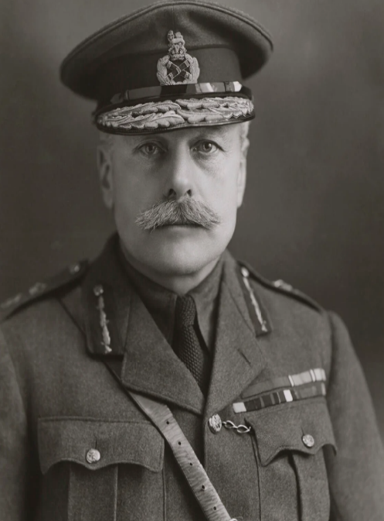
When addressing technological advancements in warfare, it is imperative to understand why they came to be created. In order to do this, one must consider the British strategy and military doctrine implemented throughout the war. Unlike the German doctrine, which prioritised adaptability and flexible strategies, the British doctrine could be considered to be much more rigid, Furguson states that it ‘discouraged initiative’ and relied solely on obedience. Whilst this is expected to be the truth for typical troops, it was not always so simple as blindly following the will of High Command. Certain officers even seemed to understand this and would make exceptions and allow breaches in official doctrine, and in some cases, would even take the lead in such breaches. One such example of a Commander who would interpret official doctrines in his own manner would be Haig, who believed that ‘a Commander must be free to command’. However, Haig himself was also rigorous when it came to ensuring that his own command was followed. With the example of Haig, one can begin to understand exactly where the flaws within the British doctrine began. When a high ranking officer considers doctrines to be mere guidelines, he shows his troops that they may not follow orders which they consider to be unimportant. Yet, in the instance of Haig he would also demand that his own lesser officers follow his every word without question- these lower ranking officers will quickly lose their creative freedom. Thus, they will be unable to make adaptive decisions when on the frontline, not solely from the unmoving nature of the British doctrine, but also as a result of their commander’s own stubbornness. The issue with Haig’s command is also hypocritical, since he was allowed to decide which official doctrines he would follow, and yet his troops had to obey his every word. Haig seemed to understand the importance of adaptability and yet would not provide his troops with the creative freedom to adapt to situations themselves. This showcases that British doctrine was flawed and counterproductive in some regard.
Fig 1: Sir Douglas Haig, often regarded as the man to blame for the high casualties suffered by Britain at the Somme and in numerous other battles throughout the Great War.
Training and Intelligence Gathering
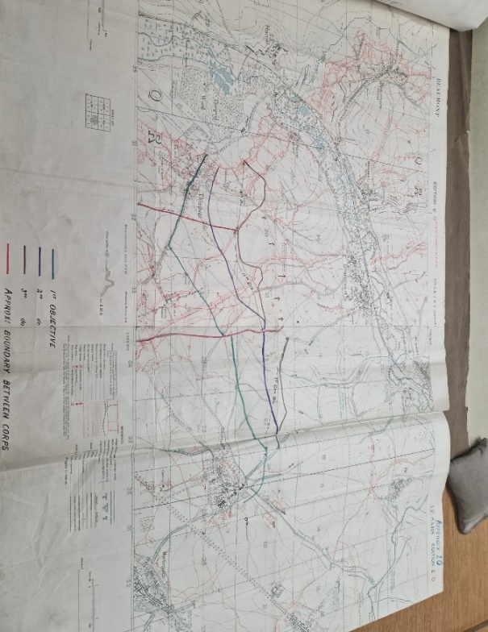
The strict regulations set out by the British High Command, in theory, would ensure that the troops were well disciplined and co-ordinated. Haig, in fact, ensured effective routine training for his troops was provided. Haig was especially thorough with his training, though, all commanders would have different training methods for their soldiers. Every commander would provide a form of basic training for their men, and specialists such as artillery crews, gas experts and machine gunners would receive more advanced training for their specialisations. Furthermore, according to Griffith, the BEF had no doubt been provided with some form of training since the very early days of the war. In this case it must be acknowledged that the casualty rates of the BEF likely was not an issue with training in any capacity. By June 1916, they were undoubtedly trained to play their respective roles well under Haig’s rigorous command. Additionally, had a soldier been required for a particular use, they would be taken further back, and provided an intensive study of resources, such as models of the terrain and maps, an example of which is shown in Fig 2. With this in mind, it must surely be noted that once again, relevant training was provided under Haig’s command. This was likely the case with many commanders at the time. Some commanders, such as Field Marshall Herbert Plumer, would go as far as sending out questionnaires to his troops in certain specialist crews to ensure the effectiveness certain scenarios- such as organising captured hostile trenches, and maintaining the efficiency of machine guns. Clearly, the officers needed to implement such measures to fully understand what the fighting on the front was like, they needed to understand what was working on the frontlines and what could be improved. This had to be understood to ensure that British strategy was continuing to adapt in accordance with developments on the front. Even if that meant in some cases interrogating anyone, including their own men which had just returned from the field, to acquire such information.
Fig 2: Map of the Somme used by the 5th Army throughout September 1916.
However, this was not often done by the commander voluntarily, instead it was done with pushing from distant high command so that they could fill in the relevant paperwork. These examples make it clear that training and understanding were not necessarily the problems which led to such high British casualties throughout the war. Even when the training was rushed, and in some cases very harsh. More likely, the issues with British military doctrine, would lie in the scenarios where the men would need to make relevant, quick and calculated decisions in unforeseen circumstances which this training had not prepared them for.
Adrian Carton De Wiart was a soldier who served on the frontlines and earned the title 'the unkillable soldier.' He noted that despite the extensive training provided to British troops and their adaptability in learning from their allies and enemies, the Germans often excelled in various roles on the front, particularly sniping. He states that the British never were truly able to replicate the marksmanship of a German sniper, even late in the war. Perhaps, then it could be noted that although British training was effective and rigorous, the German approach to the war would still prove more effective in producing efficient and skilled soldiers. Though his comments do acknowledge how the British adapted throughout the war and came out a more advanced military by the end of it.
Regardless, as the war continued, and the British became more aware of their adversary’s strategies and tactics, new counter-measures would be documented and supplied to the troops for how to best respond to these situations. Thus, by July 1916, the BEF would find themselves, at least to an extent, well prepared to respond to the tactics used by their Landwehr opponents. However, this perceived preparedness did not prevent the atrocious casualty numbers which they would suffer on the first day of the Somme. This is not to say that the BEF and their commanders failed to learn at all from the initial massacre, in fact it made the BEF a formidable force by the end of the war. Philpott states that after the first few days British strategies would change to a ‘bite and hold’ method, which would see British forces take ground one step at a time, set defences and retain the land. This tactic saw much of the ground previously lost in the initial attack, quickly recaptured by British forces. This is despite ‘bite and hold’ tactics being the very opposite to Haig’s personal doctrine, of ‘mobile warfare’, a theory shared by many commanders at the time- an endless rush toward enemy lines in hopes of killing as many hostile forces as possible. This suggests that Haig’s doctrine was, at least to an extent, adaptable and changeable, when aspects proved unsuited to trench warfare. The unfortunate reality being that in order for such change to be implemented, it would cost 60,000 British casualties in a single day. Clearly though, the ‘bite and hold’ method would prove effective, so much so that it remained a staple of British strategy throughout the war, proving especially effective in battles for higher ground in 1917. For example, Vimy Ridge which had been under the control of the Central Powers since 1914. ‘Bite and hold’ tactics are no longer used as a result of trench warfare falling out of favour towards the end of the war, and it is longer the primary way in which conflict is fought. However, aspects of such strategies may still be used today in advances of urban warfare. This shows that at least to some extent, the strategies used during the Great War impacted later conflicts.
Learning from the Somme
One must ask the question of whether British high command learned from the mistakes in its doctrine. Despite the recognition that the first day of the Somme was a tragedy, the British continued to suffer heavy casualties throughout the war. For example, Arthur John Percival Taylor stated that Passchendaele in 1917 was the ‘blindest slaughter of a blind war’, and that Haig himself was the man most responsible for it. This clearly shows that, at least as far as Taylor is concerned, British Generals, including Haig, continued to blindly throw soldiers to their unnecessary deaths all throughout the war, even after the massacre at the Somme. Ferguson notes that, at Passchendaele, both the Entente and the Central powers suffered approximately 250,000 casualties. Furthermore, according to Ferguson, even Lloyd George stated that ‘Haig does not care how many men he loses’ which undeniably supports the perspective that the casualties suffered under Haig had not changed much since 1916, neither had his doctrine. To an extent, this is shown even in Haig’s own writings in his diaries. At the time of Passchendaele it is apparent that Haig still desired a swift and decisive victory. However, Haig also notes in the same diary entry from October 1917, that ‘if the wet continues, a day or two’s delay may be advisable before we launch the next attack.’ This does at least suggest that Haig understood by November 1917 that certain delays could be made when the circumstances were not favourable. However, whether this thought was due to the potential lives which could be lost in the mud, or instead perhaps merely a matter of ensuring that they are capable of efficiently manoeuvring the difficult terrain, Haig does not elaborate.
Ferguson states that the statistics of the war indicate that Haig was possibly better at killing his own troops than he was at killing hostile soldiers. He presents a table which showcases the total casualties throughout the war which shows that the Allies clearly had much higher casualties than the Central Powers. Therefore, by the principle that the victor of the war should be the one that inflicts the highest number of casualties on the enemy, the Central Powers were the victors of the war. Later, Ferguson states that ‘the evidence seems to suggest strongly that the key to the Allies' victory was not an improvement in their ability to kill the enemy, but rather a sudden increase in the willingness of German soldiers to surrender.’ This makes it apparent that despite the common consensus among officers that the way to achieve victory is to kill more of your enemy’s troops, than they are able to kill of your own, is not the way to win a war. Perhaps it is instead, to an extent, the opposite. The more forces which one military is able to sacrifice in the war, and still bombard their opponent with overwhelming numbers is the true way to win a war; through nothing more than the complete demoralisation of the enemy forces. In this theory, Haig is the greatest commander, he could sacrifice forces at such a level that it could force an opposing military into submission. Though, in reality it is likely much more simple- the Central powers possibly were just so worn down, the war had been so costly in all aspects, that there was no longer any reason for them to continue fighting. This is despite the fact that they were ultimately the more successful killers throughout the war. This is made evident when one considers that the spring of 1918 would see the highest casualty numbers for the German army in the war, and by November of the same year the Central Powers had surrendered. This makes it evident that it was not casualty numbers, but instead a ruthless onslaught of ones own troops which won the war for Britain. Strategy, for the most part, remained the same.
Impact of British Strategy on Warfare
The British doctrine during the Great War is crucial in understanding how the war progressed. This is because it provides insight into how the war developed, it also grants some key understanding into how the British officers had to learn and adapt to the war; just like the men who served under them. Though it goes without saying that the first day of the Somme was a horrendous event which never should have unfolded the way it did. It clearly underlines the core issues with British doctrine, and the impact that the failure to adapt on the field of battle would have on the soldiers and officers. It is a clear example that a military can be well trained, and well disciplined, yet without established contingency plans, or the allowance of creative freedom for the soldiers, there will always be severe casualties, despite efficient training provided. Additionally, in the instance of strategy, it must be argued that tactics and doctrines were undoubtedly developed and reformed. However, this did not necessarily prevent the bloodshed. In some cases it may have even allowed the bloodshed to increase as new strategies were implemented, which may have been effective in theory, but not at all in practice- unnecessarily costing the British military more lives and resources through trial and error.

Chapter 2 – The Mk. 1. Tank
Origins – The Somme, September 15th 1916
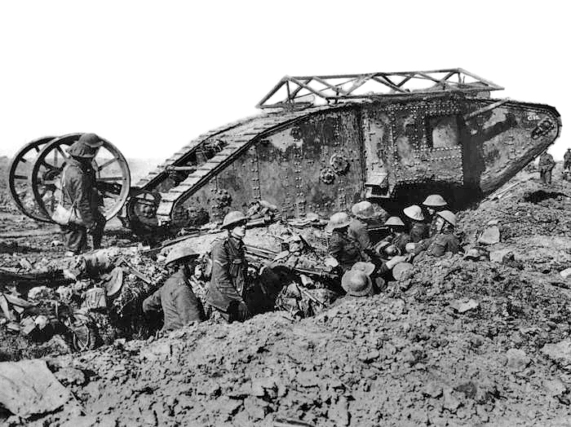
It goes without saying that throughout the Twentieth Century, the tank has been a prominent war-machine. Originating in the Great War, it has been utilised in numerous subsequent conflicts such as the Second World War. Of course, by the time of later conflicts, the tanks used would be much more developed and advanced than the Mk.I. pictured in Fig 3, which was seen at the Somme on September 15th 1916. Although the first tanks were a British design, multiple countries would later create their own, including Germany, the USSR and the United States. However, at least in the aspect of design, the Mk.I. tank had features which would be resembled by later tank designs, implemented even by the German Armies of later years. However, these resemblances are about as far as the similarities would go between the original tank and its later successors, which would refine tank capabilities, and provide them with a whole new standing on the field of battle by 1939, with the outbreak of the Second World War.
Ironically, despite the British creating the tank in the Great War, Germany and the Axis powers owe a great deal of their success in the early years of World War II to their own tank designs which it inspired. However, the question of whether German engineers would have created a tank without having seen one in combat prior remains. Despite the resemblance in the later German tanks in comparison to the British Mk.I. it is possible that they may have created a tank design regardless, since inspiration for the armoured vehicle could be drawn from elsewhere. For example, 15th Century Artist and Inventor, Leonardo Da Vinci had designed an armoured transport long before the events of the Great War, though it was never manufactured. Nonetheless, the tank seen on the Somme was little more than additional support to infantry to help keep them alive as they advanced across no-man’s land, by drawing hostile fire away from the infantry, forcing hostile machine gunners to target the tank instead. This was because the tank was only marginally faster than the foot soldiers. The Mk.I. tank, however, certainly had its uses. Once it was able to get to a hostile trench, it could roll over the barbed wire defences with ease making it much easier for the advancing infantry following behind it, to get into the trench. This complemented the aforementioned ‘bite and hold’ tactic well, since it allowed for an easier captivation of a hostile trench for the soldiers to regroup and resupply. This shows that at least to some degree the Mk.I. tank developed tactics in the Great War, and could complement other developments well.
Fig 3: An image of the Mk.1 Tank. Taken in September 1916.
Production and Conditions Inside the Tanks
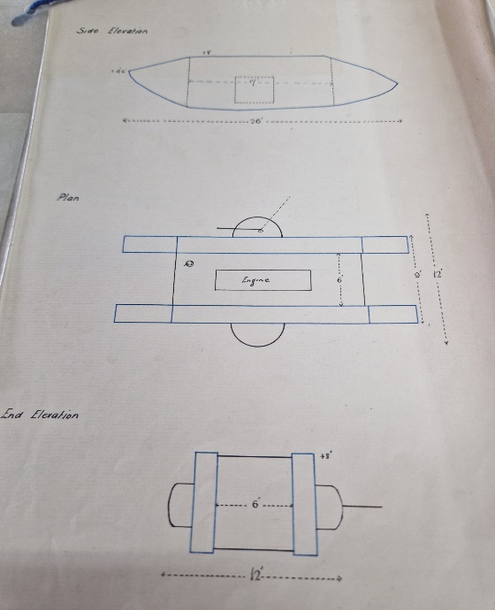
It is important to consider the conditions of being inside the Mk.I. tank. As previously mentioned the tank was very slow, though it was armoured, it was an easy target for artillery and machine guns. Andy Simpson provides some insight into how the tank felt for the men inside. He notes that the Mk.I. tanks were ‘exhausting to operate, being extremely hot, cramped and noisy and filled with exhaust fumes.’ This likely goes without saying, after all, the Mk.I. tank was, in simple terms, a hastily assembled metal box with tracks and powered by an engine. According to the documents created by the Committee of Imperialist Defence in October 1915 regarding the use of tanks, the Mk.I. was expected to hold a crew consisting of; ‘1 Commander, 2 Drivers, 2 men per gun, 2 men for the secondary armament.’ This crew was expected to operate the tank in a very cramped space which, according to the original blueprints, shown in Fig 4, the MK.I. was only 26 feet long and 12 feet wide. Accounting for the fact that the tank had two guns, with two men manning each one, this means that a total of nine men were operating a single tank at one time. This makes it apparent that the original tank certainly did not have the comfort of the men operating it in mind, instead it focussed entirely on efficiency of production, and minimal resource use possible. Which, during the Great War, was a common factor to ensure effective production chains. The documentation provided by the Committee of Imperial Defence makes this apparent when they address the three primary concerns regarding the use of the tank, which they noted as:
Fig 4: The original blueprints for the tank.
‘(a) That of the supply of machines in bulk (including armament) ;
(b) That of providing and training the personnel to man the machines ;
(c) That of Finance.’
This makes it apparent that speed of deployment and affordability of the tank was undoubtedly the priority for high command during production. It needed to be easy to mass produce, easy for the men to train and understand their role, and affordable. During the War there was very little time to consider the comfort of men, and the tank may be the perfect example of how production lines worked to mass produce and supply resources and technology to the frontlines. Despite these points being in place to ensure the mass production of affordable war-machines, the actual number of tanks available to the British military always seemed to be in short supply. This details that the Mk.I. was not only a flawed design due to production needs, but the production of the vehicle was unable to provide the necessary numbers, despite the efforts of manufacturers.
Major William Henry Lowe Watson, who served as a Tank Commander during the later years of the Great War also provides some key insight into the challenges faced by tank crews in the Mk.I. tank. Watson notes that when a tank was hit by concentrated and heavy machine gun fire, the shells from the bullets would cause little ‘flakes of metal that fly about inside a Mk.I. tank’ and slightly injure several crew members. This again emphasises how cramped the tank was, that these flakes could fly around and damage the flesh of the men inside regularly, shows that there was very little space for manoeuvrability, even for small shards of metal. He also notes in further detail the difficulties of being the target of hostile firepower at the battle of Bullecourt in 1917, where tanks were sent to aid Australian soldiers whom had come under heavy hostile firepower, of eleven tanks, nine had taken direct hits and the other two had gone missing. This shows that the Mk.I. tank was not only an easy target to hostile artillery, but in some cases completely unreliable for reaching its expected destination. These tanks that went missing likely also suffered very heavy fire, as is shown when he mentions that one returned with a large hole in its roof from where it had been hit by artillery. Griffith identifies that due to problems such as this, in many instances tanks would fail to arrive at their destination on time, if they even made it to their destination at all. Major Hugh Elles, the First Commander of the Tank Corps, in June 1915 noted in a letter to all General Staff that the primary purpose of the tank would be the element of surprise which they would have on the enemy. This is likely, to an extent, what they did. Griffith states that tanks ‘often appeared from nowhere- or at least as often failed to appear- without adequate preliminary rehearsals in tactical coordination’ Whilst this no doubt had potential to surprise the enemy, it is also possible they were just as much if a surprise to their own troops, who would likely be anticipating the arrival of tanks to save them from hostile fire, only to be greatly disappointed when the tanks failed to arrive in convenient time. Furthermore, the more adaptive German doctrine meant that anti-tank tactics were easy for the Central Powers to develop, after the tank arrived in September 1916, methods to counter it were quickly put in place, removing a large portion of the shock factor that it once possessed.
Another problem with tanks going missing, Watson states is the possibility that they may not be found until after the battlefield has been searched, and that is assuming they are still in the area, the crew could have been killed, captured, or lost somewhere. Watson also acknowledges a design issue with the tank of the placement of the petrol tanks, which were ‘placed forward on either side of the Officer’s and Driver’s seats’. He elaborates by saying that when one of these petrol tanks was hit, they could explode, killing most of the crew in one hit, and rendering the tank completely useless. This once more emphasises that the tank was unreliable on the battlefield, it could be just as much a risk to the men inside it than it was to hostile forces, and means to destroy tanks could be found blatantly even in its own design. When one considers the issues with the Mk.I. tank, it raises the question of why it has become such a prominent piece of technology in the conflicts since the Great War.
Successes of the Tank
Many ‘armchair strategists at home’ such as Lloyd George and Churchill believed that the issues with the tank were not a fault of the design itself, but how they were commanded by Generals. However, given the nature of British doctrine at the time of the Great War, it is possible that many Generals and Commanders found it difficult to understand how to best implement tanks into their strategies. This is especially plausible given that the tank was such a new design, being committed to the Front Lines only a year after its conception. Again, however, this could be attributed to the General’s inability to adapt and understand exactly how best to use the tank, often rushing preparations of the war-machine to try to secure a swift victory. This is a point raised by Watson about the battle of Bullecourt, where the decision was made by General Gough to move tanks up within twenty-four hours, leaving tank crews with very little time to make preparations before moving the few available tanks forward at dusk. This once more also makes it clear that the use of tanks was often pre-mature, even after the first use of Mk.I. tanks at the Somme. It seems that at least some Generals insisted on utilising tanks before they were fully prepared, making them less effective than they otherwise could have been, if they had more numbers and time to prepare. This could prove these ‘armchair strategists’ correct, that it was at least to an extent an issue of tanks being incorrectly used. Despite this, it must be emphasised that a strategy which is effective in theory is not always effective in practice. Individuals such as Churchill and Lloyd George were not on the front, nor directly commanding troops during the Great War. They were in Britain, away from the conflict and relatively safe. Since they were not on the front, they may have oversimplified matters. Attacks, at times, had to be made, regardless of how prepared the machinery and the men were, in other words, time did not stop on the front for the sake of convenience. Something which is easily disregarded by those at home.
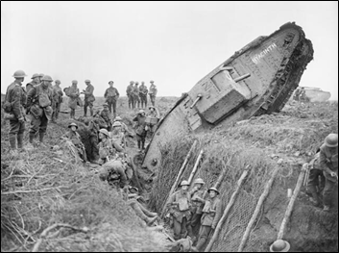
The reason that the tank became such a popular development had nothing to do with its abilities on the front line. It was propaganda which sold the tank as a devastating war machine, even despite the fact that only three of the 50 tanks used on 15th September 1916 were still functioning the following day. Newspapers still brandished the tank as a war-winning technology. It must be noted that it was not only the British newspapers which were praising the tank either. Even American newspapers on 16th September declared the tank a ‘monster’ that could ‘defy trenches, barbed wire, or craters’. However, for the soldiers, the tank was seen in a much more realistic light, despite efforts by Generals and other officers to try to glorify the vehicle. By 1917 most men failed to see the strategic value of the tank. 20th November 1917, the battle of Cambrai would see a small turning point in this perspective by soldiers. Although it was a bloody battle, would see tanks utilised to the best degree they had been all throughout the war, with the Mk.IV. model. Where troops, assisted by tanks, would cover a ‘striking advance of some 4,000 to 6,000 yards was duly registered on the first day’, with 4,000 British casualties. This was a huge improvement from Bullecourt, where all the tanks used were either devastated by artillery or went missing, and Passchendaele where tanks were being bogged down constantly by mud and breaking down as a result. However, Watson does note that despite at Passchendaele, tanks getting stuck in the mud was far from ideal, men could at least use it as a type of cover. Nonetheless, though Cambrai was the best example of tank use throughout the war, the success is not solely that of tanks. In fact, according to Griffith, weak German defences could have been the main reason for the success. Mk.IV. tanks would still suffer the same design issues the Mk.I. had suffered from previously, they were still uncomfortable for the men inside, hot, and heavy to operate, it goes without saying that even by the end of the war, the British tanks were still as questionably effective as they had been in 1916. Even at Cambrai, Watson states that tactical oversights were made by commanders which no doubt costed more lives of British troops than necessary, tactical oversights which he claims it is ‘not for a Company Commander to criticise.’ He also acknowledges that tank crews still suffered heavy losses, including a commander and several of his best drivers. Clearly in Watson’s own mind, and possibly from the mindset of any tank commander, Cambrai was no more of a success for tanks than any of the other conflicts he had seen due to poor decisions made by his superior officers.
Fig 5: even at Cambrai, tanks still faced challenges. This particular tank fell into a hostile trench at the battle in 1917.
The Future of Warfare – The Challenger 2
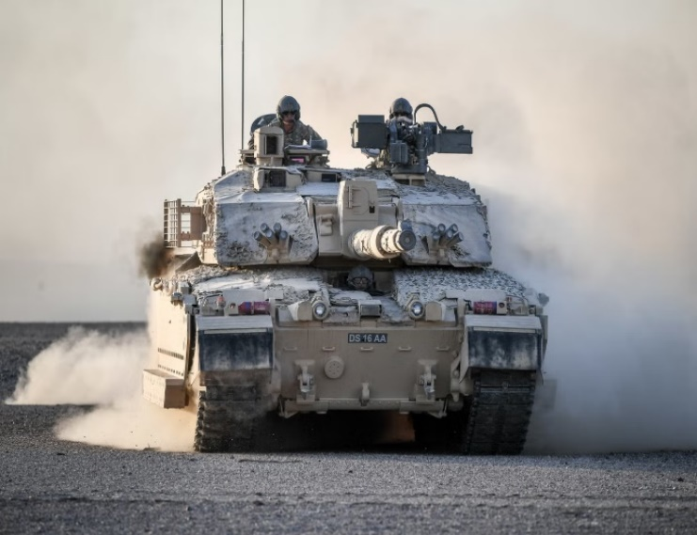
In the case of the MK.1 tank, it must be noted that it was an incredibly flawed vehicle, which in some cases, such as Passchendaele, may have proven more of a burden to their own troops on the front lines than a War-Winning weapon. However, it certainly had its uses, in instances where it worked, it had the potential to save lives. Though, unfortunately, it was never fully understood by commanders how best to utilise it, though later designs would no doubt take some inspiration from the Mk.I. even throughout the Great War, it was a piece of machinery which would need a huge amount of improvement to become truly effective. Certain features of the tank are still present. However, today this amounts to little more than that of it being an armoured war machine. This captivates how drastically the theory of tank warfare has changed since 1916. The British Army’s current main tank, the Challenger 2, shown in Fig 6, has been in service since 1994. As opposed to the Mk.I. which was designed to protect infantry and break hostile defences, the Challenger 2 is ‘designed to destroy other tanks.’ This statement shows how much of a common threat tanks are in warfare today, that main tanks are designed with the primary purpose of disabling hostile tanks. Additionally, unlike the Mk.I. the Challenger 2 has ‘never experienced a loss at the hands of the enemy’. Despite this, the Challenger 2 is still set to be replaced by a newer model. Which proves that even now warfare continues to change. The Mk. 1. tank certainly played its role in shaping the future of warfare, likely in a way which engineers at the time never would have expected. However, this development the Mk.I. provided certainly did not come without its failures, though these failures themselves likely would have helped to shape what tanks would eventually become in later conflicts.
Fig 6: the current main British tank, the Challenger 2, a clear example of how tank designs and tank warfare have developed since the Mk.I.

Chapter 3 – Chemical Weapons
The Use of Gas 1914 - 1915
De Wiart considered gas and chemical weapons to be ‘the most abominable form of warfare’. Chemical Warfare was a prominent threat on the battlefield for all sides, though some militaries found more success with chemical weapons than others. Non-lethal chemical weapons were utilised from the beginning of the War in 1914. For example, as early as one month into the war, in August 1914, the French used tear gas grenades against their German foes. Poison gas and lethal toxins were not utilised until 22nd April 1915. Where, according to Michael Freemantle a devastating chlorine gas, attack by the Landwehr would ‘kill as many as 6000 French, Moroccan and Algerian troops’ at the Second Battle of Ypres. This attack breached the conditions of the Hague Conventions, which, from 1899 had prohibited the use of ‘asphyxiating or deleterious gasses’ in warfare. This breach in the convention certainly provided the Germans with the element of surprise. This attack was likely so successful since the Allied forces were unprepared for such an aggressive weapon to be used due to their perceived protection under the Hague Convention. However, this attack had now rendered the Hague Convention void. Thus, Britain, who at the time only had a single plant capable of producing approximately ‘5 tons per week of poison gas’ understood that their tactics would need to change. 3rd May 1915, Colonel Lucius Jackson was appointed the role of ensuring that the necessary means were taken to ensure the successful offensive retaliation of chemical weapons. This would change the way Britain fought the war in the following years, chemical warfare would become a new prominent threat to the central powers, possibly even changing the outcome of the war.
Loos, September 1915 - Britain’s Retaliation
Rapidly, Winston Churchill, First Lord of Admiralty at the time, began to ‘consider the use of asphyxiating and life destroying chemical gases’ in response to the attack in Ypres. 25th September 1915, at the battle of Loos, the British carried out their first lethal gas attack. This attack, similarly to the Germans at Ypres in April, would be committed with chlorine gas. Britain’s first use of lethal gas proved to be successful, it spread panic among the German forces, allowing the British to break the German lines and capture the town of Loos in one day. However, the gas did not work perfectly, some blew back into the British trench due to the unfavourable weather conditions. This makes it apparent that the attack had not been thoroughly thought out, that Haig had not accounted for the possibility that gas could be blown about by wind. As a result, the decision was made by Colonel Foulkes, appointed to assist Jackson in the preparation of gas attacks, that the optimal use of gas would not be for large scale infantry assaults. Instead, the British doctrine stated that gas should be reserved for instances where more conventional weapons such as machine guns prove ineffective if used for offensive purposes. This means that only in very specific instances should gas be used on hostile trenches. For example, in very well fortified positions, where a hostile machine gun crew will need to be forced out from their position, so that the gun can effectively be disabled to allow more Allied troops to advance. This shows that, at least in some capacity, British commanders and men were able to adapt their strategy in accordance with previous mistakes made when using gas. Since poison gas was not a commonly used weapon in the years prior to the Great War due to the Hague Conventions, it is understandable that many gas attacks would be subject to trial and error. Therefore, tactics needed to be experimented with to ensure effective use of such weapons, the price of which would be the lives of British soldiers. Given that poison gas was once again another tactic first used by Haig, it becomes apparent that though his tactics were often risky, it is clear that he was attempting to adapt to new weapons to understand their uses on the field of battle. The battle of Loos showed how effective lethal gas could be on the frontlines, but also showed that it could be just as detrimental to British troops as it could be to their enemies- something which the British would learn from.
Other than Loos, in 1915 the British made one other chlorine gas attack in October. This attack would not have been possible were it not for the efforts of Caster Kellner Company who committed to the creation and supply of the gas for the British military. The decision to perform only two chlorine gas attacks in 1915, was a strategic choice by Colonel Foulkes, who claimed that the first chlorine gas attacks had proven successful because they had the element of surprise. Due to Britain’s low supply of lethal gas at the time, Faulkes wanted to ensure that he had a substantial amount of gas before committing the next attacks as to maintain the effectiveness of the weapon, demonstrating how British tactics would adapt during the war.
British Efficiency - 1916
In 1916, the British had greatly improved their gas programmes. Griffith states that the British were capable of pumping out ‘several tons of gas over the enemy every week’ and were ‘causing dozens, and more probably hundreds, of casualties on each occasion’. Griffith furthers this by stating that in the second half of 1916, Britain had made 110 major gas cloud attacks, in comparison to the Germans who had only managed 15 across the whole of the Western Front campaign by this time. It was not only chlorine gas which had developed over the first half of 1916. According to a report written by British Sergeant N.P. Mccleland in 1925, by the end of 1916, ‘considerable progress had been made in the development and manufacture of phosphorus’ gas to the extent where ‘special filling sheds and apparatus had been installed’. In addition to this, training had also been greatly improved on the manufacture of the gas, to the extent where, according to Jackson, it could have even been considered the successor to chlorine gas. By 1917, it would appear that the British were truly beating the Germans at their own game, or at least the very game which the Germans had started in 1915. By this point, Foulkes had ensured that gas attacks were frequent, and incredibly effective, so much so that they could target specific regiments; one regiment was hit as many as 15 times. Furthermore, Foulkes had also resolved the issues of transporting and handling the gas, with ‘gas clouds releasing directly from railway trucks, thereby obviating the laborious task of manhandling heavy cylinders forward through the trenches.’ In fact, by June 1917, one German soldier would write ‘all night we lie ready for action with our gas masks on. The wounded and gas cases are carried off in batches. There are many killed by gas. We are quite powerless against the English.’ This clearly shows the effectiveness of the British chemical weapons, and how quickly they had developed from almost completely insignificant, to a real threat to the Central Powers. In comparison, Griffith notes that German gas attacks were much less effective and could even be considered ‘clumsy’. This shows that Britain’s adaptation to the use of lethal chemical weapons was not only effective, but superior to the Germans.
Mustard Gas and Further Development of Chemical Warfare
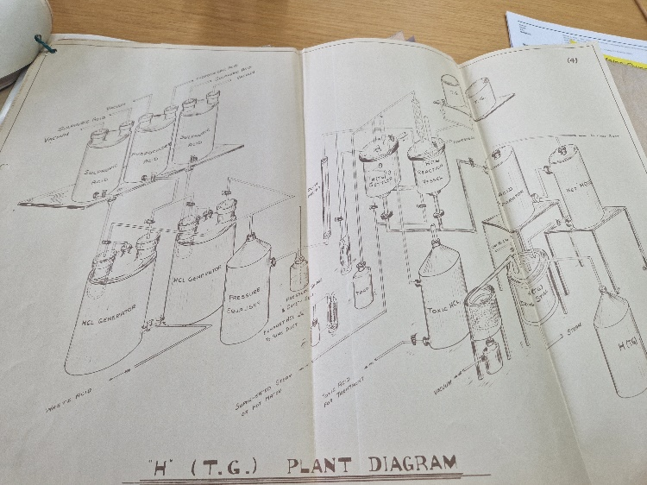
Although undoubtedly the British were proving to be the most effective military for developing and utilising chemical weapons during the Great War, both sides would continue to develop the weapons. In 1917, German Chemist and Nobel Prize winner Dr. Fritz Haber would take chemical weapons to yet another new level in the war, with the creation of mustard gas. Mustard gas was less fatal than other gases, such as the aforementioned chlorine. In comparison, reactive gases, such as chlorine were relatively easy to resist later in the war, even with improvised methods, which could cover the nose and mouth and prevent it from entering the body. The property that made mustard gas such a prominent and effective weapon was that any skin, even if protected by cloth or leather, would blister and burn, and any skin which had even been moderately exposed to the gas would peel off with any clothing which it was stuck to. This meant that dealing with the effects of mustard gas was very painful, and it could render troops unable to fight effectively for prolonged periods of time. For example, if their feet were blistered and burned, they would struggle to run and move quickly, they would possibly be unable to move at all, if their hands were blistered, they would struggle to fire a rifle. Mustard gas would not only have this effect on the outside of the body, but internally also, should the compound be inhaled. There was also the issue of disease and infection to such wounds which ran rampant in the trenches. Should a wound inflicted by mustard gas become infected, it could render a soldier ineffective for even longer periods of time. Nonetheless, quickly the British began to create mustard gas of their own. One of the processes utilised for assembling a specific mustard gas is shown in Fig 7.
Fig 7: A plant diagram which details the assembly process for H. (T.G.) Mustard Gas used by the British.
Mccleland’s report stated that mustard gas would become a prominent defensive weapon during the Great War. It would prove effective for contaminating cover against advancing forces of the Central Powers making it impossible to be used. It could also be used for harassing enemy machine guns by blocking their view of the battlefield, and in some cases, the gas could flow into bunkers, forcing machine gun crews from their position. Mccleland states that mustard gas could even be used as an improvised flare to commence a counter attack, or, due to the density of the cloud which would hang in the air to make the target more visible for allied mortar crews to target it. All of these would form a theory for the use of chemical weapons which would continue to be implemented after the Great War, should the weapons ever need to be used again. Mccleland stated that these are not the only uses for the gas, but these provide soldiers with a valuable insight to how the gas can be used. This shows a level of flexibility with strategy, which was not present in British doctrine seen early in the Great War. Suggesting that at least to some degree, the British High Command had formed a more adaptable doctrine for soldiers in comparison to earlier in the Great War.
After the creation of mustard gas, gases would be officially divided by the British High Command, into three main categories, each with different purposes and uses. These were listed as follows:
‘(a) Mustard gas type.
(b) Persistent gases other than (a).
(c) Non-Persistent gases.’
Mustard gas type, as previously mentioned, was able to target skin and eyes, and was very difficult to protect against. The slight issue with mustard gas type was that it would often take several hours to incapacitate the potential casualties. However, it is highly unlikely that this would be of any major concern, when one considers the purposes of gas as stated by Mccleland. It is unlikely that any individual would willingly remain in a cloud of any form of gas for a prolonged period of time. Thus, this is likely why mustard gas was often the favoured gas-type weapon. Persistent gases which were not mustard, would include weapons such as tear gas, which could be resisted by use of a respirator, these gases can be toxic. However, the trait all non-mustard type persistent gases share is that they are irritants which cause the eyes to water. Lastly, non-persistent gases have two separate classifications, the first of which rapidly causes casualties but needs to be of very high concentration to ensure that the gas is effective. Therefore, it is best used for the element of surprise, due to the speed by which it could affect an enemy, the best example being phosphorate gas. The second classification is that which consists of arsenic smokes which, again, could only prove effective at high concentrations. One such example of this would be Lewisite, which was produced by America late in the war. Lewisite would also cause blistering, a common feature of the mustard gas type. The reason that Lewisite could not be considered a mustard gas type was because it was much faster acting. Nevertheless, unlike official mustard gases, Lewisite could even be considered the most optimal in offensive capabilities. It was an oily substance which could remain in a trench, and continue to affect enemy soldiers who unknowingly touched it during battle, providing the substance was still hot. Lewisite also would have been dropped from an aircraft from above, soaking hostile forces in the volatile, oily substance. Lewisite, however, was never used during the Great War, primarily because the Americans did not have the time to use it, since they did not begin preparing for the war until 1917. This shows how impactful the Great War was in the development of deadly chemical weapons, something which should have never been used by law at the time. Despite this, entirely new creations were made with the sole purpose of warfare, and the killing of humans.
Ultimately, what began as a breach in a convention by the Germans in 1915 would unfold into the use of weapons which truly showcase the brutality of the Great War. Chemical warfare continued to develop throughout the war, and it would appear that the British truly were the masters of chemical warfare due to the efforts of individuals such as Jackson and Foulkes. Considering that at the beginning of the war, Britain possessed only a single factory with the potential of producing no more than 5 tons of poison gas per week. Which, by the end of the war had turned into an average of 400 tons of gas being produced per week by British factories. This showcases how quickly and effectively the British adapted to the use of chemical weapons throughout the war. In addition to this, entire factories had been established with the sole purpose of creating gas masks and other gas related countermeasures, almost entirely staffed by women due to the start of conscription for British males in 1916. Showing progress was being made not only on the front lines, but at home also. Despite this, Gary Sheffield argues that gas was not a War-Winning weapon, mostly due to the fact that protective measures against gas were frequently developing. Whilst this is undoubtedly true, if one considers the theory that the way to win the war was to exterminate more of your enemy’s troops than they kill of your own, the British certainly succeeded in this regard. Griffith states that ‘the Special Gas Brigade lost one casualty for every 40 it caused’ add to this the speed in which the British adapted and began to utilise gas, it is possible that the British may well have won the war sooner if not for the Hague convention. However, it would also have to be considered that the Central Powers also would not have been limited by the convention either. Furthermore, had lethal gases been introduced later, the war may have continued much longer, though this would be dependant on how casualty numbers piled up on each side earlier in the war, without the use of such weapons. Nonetheless, it was Germany who broke the Hague Convention in 1915. Perhaps, then, given the casualties they suffered due to gas during the Great War, it is possible that they unknowingly opened the door to their own defeat. Additionally, had the United States been able to utilise Lewisite, the Central Powers no doubt would have suffered even more severe casualties at the hand of chemical weapons, as this would have added a whole new element of surprise due to the weapon’s unique offensive use. This shows how chemical warfare developed throughout the Great War, and how it could have been utilised, had the war continued.
Gas after the Great War
When considering chemical weapons, it becomes clear that British efforts during the Great War proved instrumental in the development of warfare. Chemical weapons were possibly Britain’s greatest advancement in regards to effectiveness and capacity, and possibly even won the war for the Allies. After the Great War, lethal gases such as mustard gas were once again prohibited by the Geneva Protocol which was signed in 1925. Despite this being signed by Britain, Germany, the United States, and a multitude of other countries, many of the allied countries would use such weapons regardless during the Second World War- a clear parallel to the breach of the Hague Convention in 1915. Ultimately, it must be argued that chemical weapons were unethical and serious threats during the Great War to the extent where attempts have been made to prevent their uses, chemical weapons could still be used in warfare again.

Conclusion
Greatest Long-Lasting Development of the War
Chemical warfare changed drastically during the Great War and impacted the war, despite the fact that deadly chemical weapons should never have been used. It is responsible for developing new and inventive ways to deal with problems which arose on the Front-Line. By extension, it has developed new and atrocious ways to kill, before once more being branded a war crime, though this has not prevented its use in later wars. Thus, deadly chemical weapons have had a major impact both during the Great War and subsequent wars, though since it is illegal to use in warfare, it is not often used in more recent wars. Therefore, gas has not had the greatest long lasting impact of the war. On the other hand, the Mk.I. tank, a flawed design, far from a War-Winning weapon, and possibly even a failure during the Great War. Nonetheless, this has not prevented tanks from becoming a prominent threat on battlefields today. Ultimately, it paved the way for grander designs to come to fruition. Despite the fact that the theory of tank warfare has changed drastically since, and the Mk.I. was not produced in the years following the Great War. It has nonetheless been an imperative factor in shaping warfare today. Albeit, in a rather ironic manner. The Mk.I. was a needed to develop significantly, both in design and theory of use in order to establish itself as a truly prominent weapon. However, the distance the tank has come in design and theory are further evidence as to how it has become the greatest long-lasting development of the Great War.
Learning and Adapting
In regards to strategies, doctrine and wartime theory, it is also apparent that the Great War developed throughout the conflict. However, some officers and men were better at adapting to strategies than others, there is evidence to suggest that at least some flexibility began to develop throughout 1916. Haig, for example, though a flawed tactician, who even to this day remains a highly controversial commander. Seen by some as callous and dismissive, and by others as merely a man who followed old doctrines, and thus failed to fully adapt to the concepts of trench warfare. The truth likely lies somewhere in between, Haig may have seemed ruthless and uncaring, though the likelihood is that he was, first and foremost an administrative officer, as shown by his rigorous training exercises for his men. Given this intensive training, he must have, at least to some degree, cared for the men under his command. The downfall of such training, and Haig’s own theory, being that it did not allow his men to properly adapt. Whilst the first day of the Somme was horrendous, it is likely that many perspectives surrounding Haig focus solely on this one event. It must be noted that Haig did develop his strategies, though often with drastically varying success, and often his tactics are criticised based on casualty numbers, which possibly even won the Great War for the Allies.
It must also be noted that a number of commanders in the Great War could be considered ruthless, though Haig often gets the worst of the criticism. Furthermore, British doctrine during the Great War was very rigid. This would likely play a role in an officer’s decision making, though Haig himself claims to have not been affected by this, it is clear that some of his own flaws could be found within the chain of command collectively. Nonetheless, certain strategies such as the ‘bite and hold method’ undoubtedly worked during the Great War, and certain parts of such strategies could be implemented in conflict today to some extent. Additionally, strategy has improved greatly since the Great War. Trench warfare for example is rarely seen on battlefields today, though it does still occur in certain instances. However, it must be stated that a number of factors come into these changes, such as the environment which conflict is fought in. It must be stated that learning and development throughout the war was more often the result of trial and error than the training provided, as shown in the case of the BEF.

War-Winning Developments
It must be stated that no single development during the Great War could be considered the war-winning development. Simply put, there are far too many developments and factors to consider for this to be the case. However, the closest development to being such, mentioned in this dissertation, must be chemical warfare. This is due to the accounts from its efficiency on battlefields, and also the fact that it was so effectively implemented by Britian in such a short amount of time. It is also clear that even when gas was not so effective it could still lead to success, such was the case in Loos. Despite this, it must be noted that the success of chemical warfare, comes from the brutal nature of the weapons. Whilst it may have aided in the success of the allies in the Great War, deadly chemical weapons are far from ethical, and their use should always be avoided.
The Critical Impact of the Great War in 1916
In conclusion, 1916 was a crucial year on the Western Front for strategic and technological advancements during the Great War, not only for the Western Front, but for the war as a whole. Furthermore, some of the advancements made would remain until long after the war. Though this dissertation has been able to list only a few of these advancements in detail, their standing as effective advancements is clear. Despite the flaws, and in some cases, unethical nature of these advancements, each one undoubtedly influenced the outcome of the Great War, and impacted the future of warfare. These developments are clear evidence of how or how not to use certain technology, showing the flaws of legal statutes, proving the necessity of adaptability, or even outright showing simply how brutal warfare can be. These advancements present how 1916 was such a crucial, yet bloody year for Britain during the Great War, and how the war affected every aspect of warfare, even today.

Bibliography
Archival Sources
UK National Archives, Kew: WO 142/259 ‘Anti-gas production and work: reports: Manufacture of box respirators, by Maj Sadd’, 1919.
UK National Archives, Kew: WO 158/831 ‘the Present and Future Situation Regarding the Provision of Caterpillar Machine-Gun Destroyers or “Land Cruisers” 1st June 1915 – 30th June 1916.
UK National Archives, Kew: WO 188/143, ‘Weapons and the Use of Gas in Warfare’ 1916 – 1926.
UK National Archives, Kew: WO 188/480: ‘Manufacture’, 1930 – 1933.
UK National Archives, Kew: WO 325933: 'Admiralty Landships Proceedings and Report of a Conference', October 1915.
UK National Archives, Kew: WO: 188/480: ‘Report on the Manufacture of H.TG. by a Continuous Process.’ The Research Establishment, Sutton Oak 6th December 1932.

Printed Primary Sources
De Wiart, Adrian Carton, Happy Odyssey: The Memoirs Of Lieutenant General Sir Adrian Carton De Wiart, (Barnsley: South Yorkshire: Pen & Sword Military 2007).
Watson, William Henry Lowe, A Company of Tanks, (Edinburgh: William Blackwood, 1920).

Secondary Sources
Chasseaud, Peter, Mapping The First World War: The Great War Through Maps From 1914-1918, (Glasgow: Harpercollins, 2013).
De Groot, Gerard, Douglas Haig 1861-1928, (London: Unwin Hyman, 1988).
Ferguson, Niall, The Pity of War, (London: Penguin, 1998).
Freemantle, Michael, Gas! Gas! Quick, boys!: how chemistry changed the First World War, (Stroud: Spellmount, 2012).
Freemantle, Michael, The chemists’ War 1914-1918, (Cambridge: Royal Society of Chemistry, 2015).
Griffith, Paddy, Battle Tactics of the Western Front – The British Army's Art of Attack 1916–18, (London: Yale University Press, 1996).
Keegan, John, The First World War (New York: Vintage Books, 1998).
Philpott, William James, Bloody victory: the sacrifice on the Somme and the making of the twentieth century, (London: Abacus, 2010).
Popham, Arthur, The drawings of Leonardo da Vinci, with an introduction by Martin Kemp, (London: Pimlico, 1985).
Raudzens, George ‘War-Winning Weapons: The Measurement of Technological Determinism in Military History’, The Journal of Military History. 54 (4): (1990) 403–434.
Sheffield, Gary, The Great War 1914-1918. The Story of the Western Front, (London: Seven Oaks, 2014).
Simpson, Andy, Hot Blood and Cold Steel: life and death in the trenches of the First World War (Staplehurst: Spellmount, 2002).
Taylor, Alan John Percival, The First World War: An Illustrated History, (New York: G.P. Putnam's Sons, 1972).
Van Emden, Richard and Humphries, Steve, All Quiet on the Home Front, (Cornwall: Headline Book Publishing, 2004).
Van Emden, Richard, The Soldier’s War, (Leicester: Charnwood, 2010).
Warner, Philip Fire-power, From Slings to Star Wars, (London: Grafton Books, 1989).
Weissmann, Mikael, ‘Urban Warfare: Challenges of Military Operations on Tomorrow’s Battlefield’, Advanced Land Warfare: Tactics and Operations, 7, (2023), 125 – 151.

Online Sources
British Arny, Challenger 2, (2025) <https://www.army.mod.uk/learn-and-explore/equipment/combat-vehicles/challenger-2/> [Accessed 16/04/2025].
British Arny, Challenger 3, (2025). <https://www.army.mod.uk/learn-and-explore/equipment/combat-vehicles/challenger-3/> [Accessed 26/04/2025].
Unknown Newswriter, ‘British Pierce German Lines 2 Miles, Smash 6 Mile Front, Taking 2,300 Men; Three Towns Taken; Combles Doomed.’ New York Times 16th September 1916. <https://www.worthpoint.com/worthopedia/battle-of-the-somme-1st-use-of-tanks-1916-newspaper> [Accessed 16/04/2025].
Crutchley, Peter, ‘Adrian Carton de Wiart: The unkillable soldier’, BBC News, 6th January 2015, <https://www.bbc.co.uk/news/magazine-30685433> [Accessed 07/04/2024].
The Hague Convention, Concerning Asphyxiating Gasses, (declaration IV,2, 1919) <https://brill.com/display/book/edcoll/9789047405238/B9789047405238_s013.xml> [Accessed 17/04/2025].

List of Images
Fig 1: Bassano Ltd, ‘Douglas Haig, 1st Earl Haig’ (16th January 1917) <https://www.npg.org.uk/collections/search/portrait/mw52037/Douglas-Haig-1st-Earl-Haig> [Accessed 15/03/2025].
Fig 2: UKNA 153/590, ‘5th Army, Somme 1916 Map’, September 1916, Edition 2.
Fig 3: Pictorial Press LTD, ‘MARK 1 BRITISH "MALE" TANK’, Originally photographed by Brooks, Ernest, 26 September 1916. <https://www.alamy.com/mark-1-british-male-tank-26-september-1916-see-description-below-image67947202.html?imageid=17BA6356-6325-4631-9BF4-4FB0D4E6F37B&p=13044&pn=1&searchId=2ceb6859d9a6914cdf6d35f9cb7d8050&searchtype=0> [Accessed 16/04/2025].
Fig 4: UKNA, WO 158/831 ‘the Present and Future Situation Regarding the Provision of Caterpillar Machine-Gun Destroyers or “Land Cruisers”,’ 1st June 1915 – 30th June 1916, p. 1.
Fig 5: CBW: A Mark IV (Male) tank of 'H' Battalion, 'Hyacinth', ditched in a German trench while supporting 1st Battalion, Leicestershire Regiment near Ribecourt during the Battle of Cambrai, 20 November 1917. <https://www.alamy.com/a-mark-iv-male-tank-of-h-battalion-hyacinth-ditched-in-a-german-trench-while-supporting-1st-battalion-leicestershire-regiment-near-ribecourt-during-the-battle-of-cambrai-20-november-1917-image464720477.html?imageid=D3F7E85F-8121-42BA-87FF-BCACB0FED957&p=36552&pn=1&searchId=2ceb6859d9a6914cdf6d35f9cb7d8050&searchtype=0> [Accessed 16/04/2025].
Fig 6: PA Images, Birchall, Ben, ‘A Challenger 2 main battle tank’ (7 October 2018) < https://www.alamy.com/a-challenger-ii-main-battle-tank-on-manoeuvres-in-the-oman-desert-where-uk-forces-are-taking-part-in-a-month-long-exercise-saif-sareea-3-image221484948.html> [Accessed 16/04/2025].
Fig 7: UKNA, WO: 188/480: Report on the Manufacture of H.TG. by a Continuous Process. The Research Establishment, Sutton Oak 6th December 1932 p. 4.

Richard Van Emden and Steve Humphries, All Quiet on the Home Front, (Cornwall: Headline Book Publishing, 2004), p.172.
Niall Ferguson, The Pity of War, (London: Penguin, 1998), p.293.
Peter Chasseaud, Mapping The First World War: The Great War Through Maps From 1914-1918, (Glasgow: Harpercollins, 2013), p.64.; Gary Sheffield and John Bourne, Douglas Haig: war diaries and letters, 1914-18, (London : Phoenix, 2006), p.33.
Ibid, p.33.
Ibid, p.34.
Ibid, p.34.;
Gerard De Groot, Douglas Haig 1861-1928, (London: Unwin Hyman, 1988,) p.202. ; Paddy Griffith, Battle Tactics of the Western Front – The British Army's Art of Attack 1916–18, (London: Yale University Press, 1996), p.65.
De Groot, Douglas Haig, p.202.
Ibid, p.202.
Ferguson, The Pity of War, p.39.
Ibid, p.39.
William James Philpott, Bloody victory: the sacrifice on the Somme and the making of the twentieth century, (London: Abacus, 2010), p.70.
Philpott, Bloody victory. p.628. ; Sheffield and Bourne Douglas Haig, p.33.
Philpott, Bloody victory. p.628.
Ibid. p.628.
Ferguson, The Pity of War, p.293.
Philpott, Bloody victory. p.6.
Ibid p.364.
Ibid. p.368.
Ibid. p.368.
Ibid p.369.
Sheffield and Bourne, Douglas Haig, p.34.
Philpott, Bloody victory. p.368.
Philpott, Bloody victory. p.362 ; Griffith, Battle Tactics of the Western Front, p.168.
Griffith, Battle Tactics of the Western Front, p.168.
Ibid, p.168.
Ibid, p.168.
George Raudzens, ‘War-Winning Weapons: The Measurement of Technological Determinism in Military History’, The Journal of Military History. 54 (4): (1990) 403–434, p.422.
Ibid, p. 422.
Philpott, Bloody victory. p.148.
Ibid. p.148.
UK National Archives, Kew (Henceforth UKNA), WO 188/143, ‘Weapons and the Use of Gas in Warfare’ 1916 – 1926, p.9.
John Keegan, The First World War, (New York: Vintage Books, 1998). P.233.
Philip Warner, Fire-power, From Slings to Star Wars, (London: Grafton Books, 1989), p.177.
Keegan, The First World War, p.352.
Philip Warner, Fire-power, p.177.
Ferguson, The Pity of War, p.307.
Ibid, p.309.
Andy Simpson, Hot Blood and Cold Steel: life and death in the trenches of the First World War (Staplehurst: Spellmount, 2002).p.107.
Griffith, Battle Tactics of the Western Front, p.185.
Ibid, p.186.
Ibid, p.189.
Ibid, p.189.
Ibid, p.188.
Ibid, p.187.
Ibid, p.187.
Ibid, p.187.
Ibid, p.190.
Peter Crutchley, ‘Adrian Carton de Wiart: The unkillable soldier’, BBC News, 6th January 2015, <https://www.bbc.co.uk/news/magazine-30685433> [Accessed 07/04/2024].
Adrian Carton De Wiart, Happy Odyssey: The Memoirs Of Lieutenant General Sir Adrian Carton De Wiart, (Barnsley, South Yorkshire: Pen & Sword Military 2007), p.60.
Ibid, p.60.
Ibid, p.60.
Sheffield and Bourne, Douglas Haig, p.34. ; Griffith, Battle Tactics of the Western Front, p.65.
Philpott, Bloody Victory, p.108.
Ibid p.108.
Ibid, p.108.
Ferguson, The Pity of War, p.293.
Philpott, Bloody Victory, p.492.
Gary Sheffield, The Great War 1914-1918. The Story of the Western Front, (London: Seven Oaks, 2014), p.108.
Mikael Weissmann, ‘Urban Warfare: Challenges of Military Operations on Tomorrow’s Battlefield’, Advanced Land Warfare: Tactics and Operations, 7, (2023), 125 – 151, (p.151)
Alan John Percival Taylor, The First World War: An Illustrated History, (New York: G.P. Putnam's Sons, 1972), p.194.
Ferguson, The Pity of War, p.293.
Ibid, p.293.
Haig, War Diaries and Letters, p.337.
Ibid, p.337.
Ibid, p.337.
Ferguson, The Pity of War, p.294.
Ibid, p.295.
Ibid, p.294.
Ibid, p.311.
Ibid, p. 293.
Griffith, Battle Tactics of the Western Front, p.92.
Philpott, Bloody victory. p.364.
Griffith, Battle Tactics of the Western Front, p.92.
Ibid, p.162.
Ibid, p.92.
Arthur Popham, The drawings of Leonardo da Vinci, with an introduction by Martin Kemp, (London: Pimlico, 1985), P.80.
Griffith, Battle Tactics of the Western Front, p.162.
Ibid, p.162.
Simpson, Hot Blood and Cold Steel, p.60.
UKNA, WO 325933: 'Admiralty Landships; Proceedings and Report of a Conference', October 1915, p.12.
Ibid, p.12.
UKNA, WO 158/831 ‘the Present and Future Situation Regarding the Provision of Caterpillar Machine-Gun Destroyers or “Land Cruisers”,’ 1st June 1915 – 30th June 1916, p.1.
Griffith, Battle Tactics of the Western Front, p.168.
William Henry Lowe Watson, A Company of Tanks, (Edinburgh, William Blackwood, 1920), p.64.
Ibid, p.65.
Ibid, p.65.
Griffith, Battle Tactics of the Western Front, p.110.
UKNA WO 158/831: ‘Letter from Major Hugh Elles to General Staff’, 16th June I915.
Griffith, Battle Tactics of the Western Front, p.25.
Philpott, Bloody victory. p.369.
Watson, A Company of Tanks, p.65
Ibid, p.62.
Ibid, p.62.
Griffith, Battle Tactics of the Western Front, p.163 ; Ferguson, the Pity of War, p.307.
UKNA, WO 325933: 'Admiralty Landships Proceedings and Report of a Conference', October 1915.
Watson, A Company of Tanks, p.45.
Griffith, Battle Tactics of the Western Front, p.163.
Philpott, Bloody victory. p.368.
Ibid. p.364.
Unknown Newswriter, ‘British Pierce German Lines 2 Miles, Smash 6 Mile Front, Taking 2,300 Men; Three Towns Taken; Combles Doomed.’ New York Times 16th September 1916. <https://www.worthpoint.com/worthopedia/battle-of-the-somme-1st-use-of-tanks-1916-newspaper> [Accessed 16/04/2025].
Griffith, Battle Tactics of the Western Front, p.164.
Ibid, p.164.
Ibid, p.164.
Watson, A Company of Tanks, p.125.
Ibid p.125.
Griffith, Battle Tactics of the Western Front, p.164.
Watson, A Company of Tanks, p.183.
Ibid, p.183.
British Arny, Challenger 2, (2025) <https://www.army.mod.uk/learn-and-explore/equipment/combat-vehicles/challenger-2/> [Accessed 16/04/2025].
Ibid.
British Arny, Challenger 3, (2025). <https://www.army.mod.uk/learn-and-explore/equipment/combat-vehicles/challenger-3/> [Accessed 26/04/2025].
De Wiart, Happy Odyssey, p.62; Griffith, Battle Tactics of the Western Front, p.117.
Michael Freemantle, Gas! Gas! Quick, boys!: how chemistry changed the First World War, (Stroud: Spellmount, 2012), p. 58.
UNKA: WO 142/251 ‘Chemical Warfare Record’, p.IV.
Michael Freemantle, The chemists’ War 1914-1918, (Cambridge: Royal Society of Chemistry, 2015), p.5.
UNKA: WO 142/251 ‘Chemical Warfare Record of Chemical Supplies for Offensive Purposes 1915-1918’, p.IV.; The Hague Convention, Concerning Asphyxiating Gasses, (declaration IV,2, 1919) <https://brill.com/display/book/edcoll/9789047405238/B9789047405238_s013.xml> (1919) [Accessed 17/04/2025].
UNKA: WO 142/251 ‘Chemical Warfare Record’, p.IV.
Ibid, p.IV.
Ibid, p.3.
Ibid, p.4.
Ibid, p.46.
Freemantle, The chemists’ War, p.5.
Griffith, Battle Tactics of the Western Front, p.119.
Ibid, p.119.
UKNA, WO188/143: N. P. McCleland, Notes on the Use of Gas, September 1925, p. 9.
UKNA: WO 188/143 ‘Weapons and the use of Gas in Warfare’, 1916-1926, p.7.
UNKA: WO 142/251 ‘Chemical Warfare Record’, p.46.
Ibid, p.46.
UNKA: WO 142/251 ‘Chemical Warfare Record’, p.46.; UNKA: WO 142/251 ‘Chemical Warfare Record’, p.4.
Griffith, Battle Tactics of the Western Front, p.117.
Ibid, p.117.
UNKA: WO 142/251 ‘Chemical Warfare Record’, p.242.
UNKA: WO 142/251 ‘Chemical Warfare Record’, p.242.; Sheffield, The Great War p.35.
Griffith, Battle Tactics of the Western Front, p.117.
Ibid, p.117.
Ibid, p.103.
Ibid, p.117.
Ibid, p.117.
UKNA: WO 188/480: ‘Manufacture’, The Service of the Chemist, 1930 – 1933.
Ibid.
Ibid.
Simpson, Hot Blood and Cold Steel, p.51.
Richard Van Emden, The Soldier’s War, (Leicester: Charnwood, 2010), p.345.
UKNA: WO 188/480: ‘Manufacture’, The Service of the Chemist, 1930 – 1933.
UKNA, WO188/143, p.9.
Ibid, p. 9.
Ibid, p. 9.
Ibid, p. 9.
Ibid, p. 9.
UKNA: WO 188/143, p.2.
Ibid, p.2.
Ibid, p.2.
Ibid, p.2.
UKNA: WO 188/480: ‘Manufacture’, The Service of the Chemist, 1930 – 1933.
UKNA: WO 188/143, p.2.
Ibid, p.2.
Ibid, p.3.
Ibid, p.3.
UKNA: WO 188/143, p.3.; Freemantle, The chemists’ War, p.196.
Freemantle, The chemists’ War, p.196.
Ibid, p.196.
Ibid, p.196.
Ibid, p.196.
Keegan, The First World War, p.428.
UNKA: WO 142/251 ‘Chemical Warfare Record’, p.IV.
Ibid, p.IV.
UNKA: WO 142/259 ‘Anti-gas production and work: reports: Manufacture of box respirators, by Maj Sadd’, 1919, p.37.
Sheffield, The Great War, p.35.
Griffith, Battle Tactics of the Western Front, p.43.
Freemantle, The chemists’ War, p.229.
Ibid, p.229.
Ibid, p.229.
Sheffield and Bourne, Douglas Haig, p.14.
Sheffield, The Great War, p.108.
Griffith, Battle Tactics of the Western Front, p.65.
Freemantle, The chemists’ War, p.5.
Griffith, Battle Tactics of the Western Front, p.100.

