Reference List  Bowen, T. and Ellis, L. (2009) A Dictionary of Education. Oxford University Press. [online]. Available at: http://www.oxfordreference.com.ezproxy.uwtsd.ac.uk/view/10.1093/acref/9780199212064.001.0001/acref-9780199212064-e-81 (Accessed: 24th March, 2018).  Communication Matters (2017) Communication Passports. Available at: https://www.communicationmatters.org.uk/page/communication-passports (Accessed: 6th April, 2018).  Complex Needs (2016) Benefits of Communication Passports. Available at: http://www.complexneeds.org.uk/modules/Module-3.1-Communication---augmentative-and-assistive-strategies/All/m09p190c.html# (Accessed: 21st April, 2018).  Complex Needs (2016) image of communication passport. Available at: http://www.complexneeds.org.uk/modules/Module-3.1-Communication---augmentative-and-assistive-strategies/All/m09p190c.html# (Accessed:21st April, 2018).  Complex Needs (ND) Personal Communication Passports as a way of consulting and representing children with communication difficulties, to ensure consistent care. Available at: http://complexneeds.org.uk/modules/Module-2.4-Assessment-monitoring-and-evaluation/All/downloads/m08p040b/millar_and_aitken.pdf (Accessed: 22nd April,2018)  Faradonbeh, R.B. (ND) Communicating in a Changing World through Nonverbal Cues. http://citeseerx.ist.psu.edu/viewdoc/download?doi=10.1.1.559.5606&rep=rep1&type=pdf (Accessed:20th April,2018).  Forest Way School (2018) Image of Communication Passport. Available at: http://www.forestway.leics.sch.uk/os_comm.php (Accessed: 22nd April 2018).  Gross, J. (2013) Time to Talk: Implementing outstanding practice in speech, language and communication. Routledge: London and New York.  Knowles, G. (2010) Supporting Inclusive Practice. 2nd edn. Routledge: London.  My Compass (ND) Image of Communication passport. Welcome to my Communication Passport! Available at: http://www.mycommpass.com/ (Accessed: 6th April 2018).  NASEN (2014) SEN Support and the Graduated Approach. Available at: www.nasen.org.uk/.../download.F11A6869-BE1E-41B6-9A936F5FECDC985A.html (Accessed: 22nd April, 2018)  Personal Communication Passport (ND) Good Practice. Available at: http://www.communicationpassports.org.uk/Creating-Passports/Good-Practice/ (Accessed: 20th April, 2018).  SCOPE (2017) What is the social model of disability? Available at: https://www.scope.org.uk/about-us/our-brand/social-model-of-disability (Accessed: 6th April, 2018).  The British Association for the Person-Centered Approach (2018) What is the Person-Centered Approach? Available at: https://www.bapca.org.uk/ (Accessed: 6th April 2018).  The Play Doctors (2018) Image of Communication Passport. Available at: https://theplaydoctors.co.uk/product/i-have-adhd-fan-communication-passport/ (Accessed: 22nd April, 2018).  Welsh Assembly Government (2004) Special Education Needs Code of Practice for Wales. Available at: http://gov.wales/docs/dcells/publications/131016-sen-code-of-practice-for-wales-en.pdf (Accessed: 28th March, 2018). | A Guide to Communication Passports for Professionals in an Educational Setting  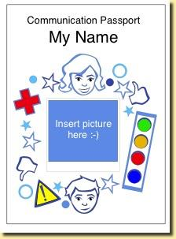  Image- my compass (ND)
Introduction  - Communication passports are a low-tech augmentative and alternative communication method that supports individuals with an impairment to communicate (Bowen & Ellis, 2009).  - This leaflet will be based on using a communication passport in an educational setting.  - This leaflet will also be based on the use of communication passports in relation to children and young people who have little to no verbal communication.  - Gross (2013) states information for everyone involved with a child who has communication difficulties is essential, this is where communication passports can be used in practice.  - A communication passport is easily accessible for people to find out information and communication needs of the individual who owns the passport (Complex Needs, 2016).  - The passport stays with the user and travels. Therefore, ensuring everyone who comes into contact has the information necessary to try and communicate effectively (Complex Needs, 2016). | 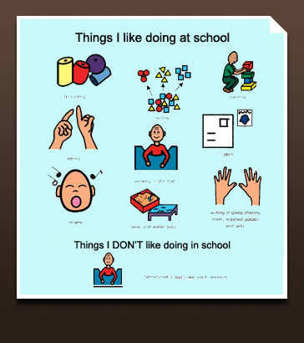  What is a Communication Passport?  - A communication passport enables professionals and anyone who meets the individual to find out information about the person who is unable to verbally communicate (Communication matters,2017).  - A communication passport uses a person-centred approach. Person-centred approach is a theory based on psychotherapy and counselling formed by Carl Rogers which believes that the individual can make decisions themselves and their care is based on their needs and beliefs (BAPCA,2018).  - It is important that the communication passport is individualised by including how the individual communicates and it is up to date (Communication matters, 2017).  - It is important to ensure the person is viewed as an individual and not by their disability (Communication matters, 2017). This statement suggests that a social model of disability is taken meaning that that society causes the issues and barriers to the individual, rather than their disability (SCOPE, 2017).  Image: Complex Needs (2016)
Creating a Communication Passport  The communication passport can be personalised to the individual in terms of style, such as laminated, a small booklet, or based on pictures (Gross, 2013).  The communication passport should include personalised information about the child or young person such as their name/nicknames, important information about their difficulties, medication, how they communicate, and what support they need to fulfil their potential (Gross, 2013).  The communication passport should include images of friends/family/activities and should be colourful.  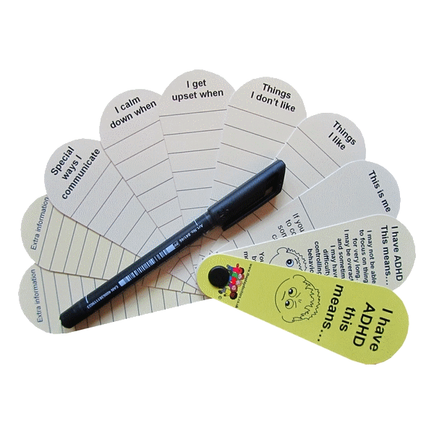  Permission must be given before creating a communication passport as it will include personal information (Personal Communication Passports, ND).  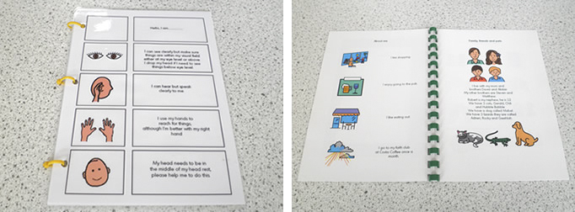  Image: The Play Doctors (2018)  Image: Forest Way School (2018) | Best practice when using Communication Passports  - The communication passport must be evaluated to ensure it is working effectively. It should be self-evaluated when the passport is completed. Although, it should also be evaluated by an external individual who has no information about the child or young person who uses the communication passport, to ensure it is working effectively and can be used by individuals who have no information about the child or young person (Personal Communication Passports, ND)  - The owner of the passport should be involved in the creation of the passport, as it is a person-Centered tool (Personal Communication Passports, ND).  - The communication passport must be reviewed regular and amended if necessary (Personal Communication Passport, ND).  - Faradonbeh (ND) states that non-verbal communication can accent, compliment, contradict, regulate, repeat, or substitute verbal communication. A communication passport may compliment verbal communication if the individual has some level of communication, a communication passport is not a substitute for non-verbal communication (Faradonbeh, ND). It is not effective enough for an individual to communicate their needs and wants as well as interacting with friends, family, peers, and school staff.
Using Communication Passports as a method when transitioning from services  Communication passports can be used a positive and effective method to support individuals with communication difficulties across transitions.  - A communication passport can show the individuals personality and views.  - A communication passport ensures all information about an individual is included in a clear and positive way and is presented in a person-centred manner.  - The communication passport benefits staff to gain an understanding of the individual who is transitioning and ensures all staff have the information so communication between agency’s is consistent.  - As the communication passport is regular reviewed and updated, information should be clear and correct.  - A communication passport enables multi-agency working, which Knowles (2011) believes is key to best practice. As the passport is shared between professionals, all individuals will be involved in information sharing to ensure the needs of the child are met.  - A communication passport also gives transition staff the information needed about the child’s communication difficulties.  Complex Needs (ND)  Knowles (2010) | SEN Code of Practice  - The SEN Code of Practice Wales (Welsh Government, 2004) state children and young people should be involved in the planning of their education, regardless of if they have communication difficulties. As the Personal Communication Passport (ND) states, the owner of the passport should be involved in planning and creating.  - The Welsh Government (2004) also state that schools should provide provisions that support individuals to communicate and interact. These provisions may include AAC technology, such as communication passports.  Under the SEN Code of Practice, pupil passports are also created which may include information regarding a child’s communication needs (NASEN, 2014). Pupil passports include:  - A photograph and name of the student.  - Information the student believes is important to staff involved in their education and care.  - Areas that are difficult for the student, such as communication.  - Strategies to overcome the difficulty, such as a communication passport.  NASEN (2014).

