Summary of own learning linked to PDP

I went into my level four placement at The Wallich young person’s homeless project having spent four years working there full time as a support worker and senior support worker. Therefore, I knew all of the staff very well and had already established good relationships with most of the clients. I already had a lot of experience with facilitating activities such as cooking sessions, running the football team in the street football Wales leagues, budgeting sessions which included taking them shopping and establishing a healthy meal plan, taking clients go carting and places like Heatherton and Oakwood. I had experience supporting clients with multi-agency meetings, court appearances, Benefit medicals, advocating on behalf of the clients with phone calls to the DWP and other agencies. I also had a lot of experience with creating support plans, risk assessments which the clients had a say and input in as well as managing the projects finances when the manager was off on annual leave.
What I have learnt in level four is that although I had all of that experience, I was never looking at it through the eyes of a youth worker and honestly didn’t see myself as a youth worker. What I have learnt in my time at the Wallich as a youth work student is that I can now see how all of my previous practice as a support worker and senior support worker relate to the five pillars of youth worker. I can now see how all of the activities I have facilitated in the past such as budgeting, cooking, driver theory test workshops, support sessions and risk assessments, Heatherton and Oakwood etc. relate to youth works five pillars as I was enabling the clients to gain skills and knowledge which they could take and use for the rest of their lives. I was helping the clients to be able to express themselves through different opportunities. I was encouraging the young people I was supporting to participate and take an active role in their support. I included all clients regardless of their race, social identity and diversity. I was also helping to empower the young people to take control of their lives and futures whilst supporting them with personal and social issues.
I can also see how all of my previous and current practice relate to the National occupational standards of youth work by enabling the young people to develop holistically, working with them to facilitate their personal, social and educational development and enabling them to develop their voice, influence and place in society helping them to reach their full potential (CLD Standards Council Scotland, 2019). I have learnt a lot in my time as a level four youth work student and can now see the difference between someone who works with young people without youth work training and a professionally trained youth worker as a professionally trained youth worker works in accordance with the five pillars of youth work and the National Occupational Standards therefore seeing things through a different lens.

CLD Standards Council Scotland, (2019) Youth Work National Occupational Standards, London: CLD Standards Council Scotland.

Observation of the work placement

In this observation the author will discuss their fieldwork placement at the Wallich young person’s homeless project which is called Clos Sant Paul and is based in Llanelli.
This is a twenty-four hour supported project for young people aged between sixteen to twenty-five. These young people come with an array of issues and adverse childhood experiences including alcohol and substance misuse, learning difficulties such as ADHD and autism, crime, childhood abuse and dysfunctional family settings. Many of them come with very limited life skills and don’t know how to cook, clean, budget or even iron their clothes. Some young people come to the project with criminal proceedings hanging over them which can include sexual offences, drug crime and general petty crimes such as shoplifting and criminal damage. Once a referral for a young person is accepted a senior support worker will carry out a face to face assessment adhering to COVID 19 guidelines from the government and Wallich risk assessment. If there is a vacancy the young person can move in straight away but if there are no vacancies the young person will be contacted when one is available. Of course, the young person has a choice whether they want to take the vacancy or not and if they decide to take it an induction will take place which is an information gathering process which will enable the project to support the young person as effectively as possible. The induction process also informs the young person of the rules and expectations of them such as engaging with the support provided and following the visitor policy and procedure as well as what is expected of their behavior whilst at the project.
The staff base is made up of the project manager, assistant manager, four senior support workers, two support workers and two-night support workers. The staff have an array of different skills and experience including life experience with homelessness and alcohol and substance misuse and crime to experience raising their own children sometimes with similar issues as the young people at the project. This makes the team very dynamic and effective when supporting the young people and helps them to build positive working relationships most of the time. When a young person enters the project, they are assigned a key worker who is a senior support worker and is responsible for providing support to that young person via weekly support sessions which can include things such as budgeting, cooking, cleaning, applying for relevant benefits, attending appointments with outside agencies and referring the young person to any relevant agencies. These are all added to the young person’s support plan which are monitored for progression weekly and reviewed and updated regularly. The support workers role is to provide support to the senior support worker by way of delegation to help ease the pressure with workloads. Support workers can carry out support sessions with young people with the outcomes handed over to the senior support worker responsible for the young person’s support and recorded accordingly.
The project tries to exercise the five pillars of youth work and provides a communal area for clients which is based in the staff kitchen area and has a communal computer with internet access so that the young people can access social media, YouTube and carry out job searches etc. the communal area is also used to carry out support sessions/activities with clients which can include cooking sessions, arts and crafts, workshops to name a few and can be carried out on a one-to-one basis or as a group. This area can also be used for young people to just sit and have a chat with other young people and staff. Outside agencies such as Iechyd Da can also use this communal area to provide workshops such as sexual health, healthy relationships and sexual exploitation either as a group activity or on a one to one basis or both if necessary. Young people also use this area to have resident meetings where they can have their say and input on the running of the project. All of this is done on a voluntary basis and the young person can choose whether to participate or not and all of them are included if they choose to be. This area of the project has been affected greatly during the national lockdown with only one young person being allowed in the communal area at one time and only for necessary support under strict COVID 19 safety guidelines such as wearing face masks and sitting or standing two meters apart. There have also been no activities taking place as a result which has led to young people feeling quite isolated as a result. Young people have also had to limit their visits to one at a time with a maximum of three as part of their bubble.
In the author’s time on placement, He has experienced a number of different issues such as substance misuse (mostly cannabis), young people fighting each other, he has been verbally abused and threatened by young people. The staff and management at the project are very supportive of each other and spend time reflecting on issues which the author feels have been beneficial in helping him to deal with the issues encountered effectively as part of the team. The project has also followed strict guidelines in regards to COVID 19 with the project being cleaned three times daily with anti-bacterial spray and wipes with all door handles intercom systems, communal areas and staff offices being regularly disinfected. The project also provided medical face masks and alcohol-based hand wash in all areas of the project for staff and young people. This helped the author to feel safer whilst on placement which otherwise would have been a very anxious time.
To sum up the author feels that projects like the one that his placement took place at have a very important role to play in the community by supporting the homeless housing departments by providing crucial support for young people to develop life skills which will help them to be able to live in independent accommodation in the community. The project also aims to adhere to the National occupation standards purpose which is to enable young people to develop holistically, working with them to facilitate their personal, social and educational development. To enable them to develop their voice, influence and place in society and to reach their full potential (CLD Standards Council Scotland, 2019).

Community profile

Tyisha Ward, Llanelli
Community profile
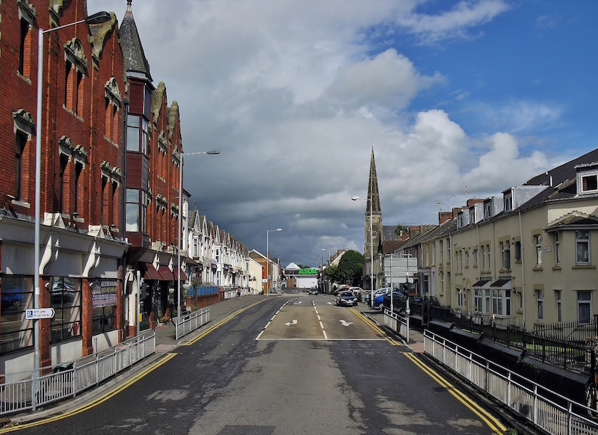
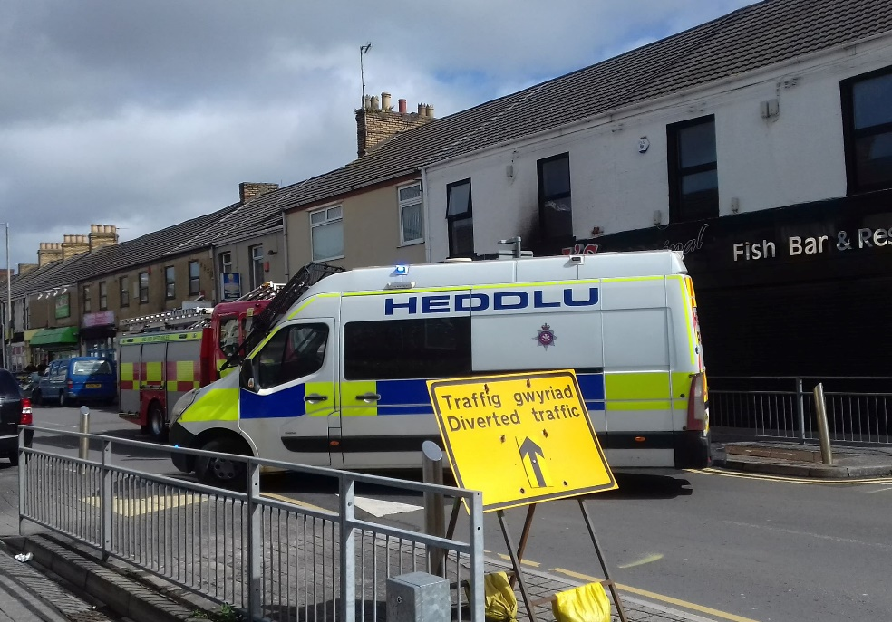
This is the authors attempt at creating a community profile of Carmarthenshire’s Tyisha Ward in Llanelli. I chose the Tyisha Ward as it is where I live and my level 4 placement at the Wallich is in the heart of this area.
History of Tyisha
Llanelli railway station which is situated in the heart of Tyisha Ward was where the Llanelli riots occurred on the 19/08/1911. The cause of the riots was the very first railway strike and it lasted for two days and resulted in the death of 6 people. According to (Thomas, 2020) in the 1940’s the Tyisha was a bustling community filled with business owners including traders, seamstresses, jewellers and grocers and was a close-knit community hub where residents didn’t usually lock their doors. In the 80s & 90s Station Road in the Tyisha Ward was known for its busy nightlife with many clubs and pubs and was notorious throughout Wales being compared with Wind Street in Swansea attracting thousands of people each week.
Where is Tyisha?
The Tyisha ward is an electoral ward in Llanelli, Carmarthenshire with boundaries going from Llanelli train station up to Queen Victoria Road across Murray street, down Pottery Street through Bigyn Road, across Tyisha Road and Fron Terrace back to the train tracks by Langland Road (see appendix A). In 2019 the Tyisha Ward was voted the most deprived area in Carmarthenshire and the 17th most deprived in Wales out of 1,909 wards in terms of income. Employment, health, education, and community safety (Thomas, Wales online, 2020). Tyisha ward is located approximately 35km from Carmarthen town (see appendix B) and location wise is excellent as it is close to the M4, train station as well as Llanelli town centre and other local amenities and is also within ten-minute walking distance of the beach. It is also easily accessible by train, bus, and car.

Who lives in the Tyisha ward?
According to the 2017 mid-year population estimates the population of the Tyisha ward is 4,149 with the highest percentage being aged between 45–64 at 29.2% followed closely by 25–44-year-olds at 24.4%. The lowest percentage of people in the Tyisha ward at 6% are aged between 0-4 followed closely by people aged 75 and over at 7.3%. People aged between 65-74 come in at 8%. 11.7% of the population are aged between 5-14 and 13.5% aged between 15-24 (see appendix C). The majority of the population were born in wales at 76.2% but only 21.5% of these people can speak Welsh. 11.4% of the population were born outside of the UK (see appendix D). The Tyisha ward has developed a bad name over the years with long-time residents complaining about the rise in drug use and crime and according to Thomas, (2020) Many residents refer to the area as a 'dumping ground' for people with substance abuse issues and say housing in the area as well as drug availability has been attracting ex-criminals and drugs users there (Thomas, 2020).

Where do they live?
The majority of the population live in terraced houses at 62.3% with 25% living in flats, maisonettes or apartments. The lowest percentage live in detached houses at 4.8% followed closely by semi-detached houses at 8.1% (see appendix E). The area also consists of two homeless young people’s projects called the Wallich and the Foyer (see appendix F) which houses sixteen- to twenty-five-year-old males and females who are afflicted by homelessness and which are situated in the heart of the ward on Station Road. This area also consists of a number of different temporary homeless accommodation flats known as temps which are managed by the Wallich Carmarthenshire temporary accommodation project (CTAP).

What are the primary and secondary schools?
The Tyisha ward used to consist of three primary schools called Copper works infant school, Bigyn C.P school, Lakefield C.P school which are all council owned but in 2018 Lakefield C.P and Copper works C.P merged into one school with a new school being built on Copper works road called Ysgol Penrhos (Roderick, 2018). Meaning that from 2018 there are only two schools in the Tyisha ward Bigyn C.P and Ysgol Penrhos. The population of Ysgol Penrhos is four hundred pupils, sixty nursery children and fifty staff. Although there are no secondary schools situated in the Tyisha ward there are four that are easily accessible in the surrounding areas including Coedcae school, St John Lloyd’s, Ysgol Bryngwyn and Ysgol Gyfun Y Strade. Tyisha ward also consists of two child nurseries called Childs play and Once upon a time day nursery.
What crime takes place there?
According to Thomas, (2020) 102 crimes were committed in the Tyisha ward in one month June 2020 and the area has the highest crime rate in the whole of Llanelli town area. According to statistics from the police.uk website in the space of one year from February 2020 to January 2021 there were five thousand, one hundred and seventy-nine crimes committed in that year in the Tyisha ward and surrounding areas of Llanelli town centre with anti-social behaviour being the highest at one thousand, eight hundred and forty, violence and sexual offences came in close behind with one thousand , five hundred and twenty four followed by arson and criminal damage at three hundred and fifty two (see appendix G). Due to the high rate of crime in the Tyisha ward and Glanymor ward the police and crime commissioner has secured two hundred thousand pounds from the Home Office’s safer street fund with the aim of making the community safer. The money will go towards measures proven to cut crime, and will include employing two Community Wardens; purchase of Selecta DNA kits, Community crime prevention activity support, Environmental improvements and Community Crime Prevention kits (2020).

What does the future look like for the Tyisha ward?
The future of the Tyisha ward looks bright with plans to completely transform the area. A brand new one hundred-thousand-pound park area with brand new play equipment for children to use as well as a purpose-built dog walking area for local pet owners has been built and is located on Ann Street Llanelli (see appendix H). The park is being patrolled regularly by local neighbourhood policing team as well as new community wardens. The park is just the tip of the iceberg for the deprived ward with a nine point three million pound regeneration plan which will include approximately one hundred and ten mixed tenure housing units,Boulevard landscaping with better links to the town centre and the new Pentre Awel development, New shops and offices within the area, Improvements to the railway station and promoting greener travel with new accessible cycle routes and Turning the old goods yard into offices and potential community facilities. According to Youle, (2019) It wants to create a vibrant community by delivering mixed-use housing, improving the environment, tackling crime and anti-social behaviour, developing more community facilities, bringing vacant business premises back into use and providing education, training and employment opportunities (Youle, 2019).

Appendix

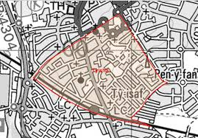
Appendix A.

Appendix B.
Location: Approximately 35km from Carmarthen Town ⇒ Area: 0.63km2 ⇒ Population Density: 6,586 people per km2 ⇒ Population Change: 2011-2017: +70 (+1.7%) ⇒ Major Employers: Carmarthenshire County Council (schools and leisure)
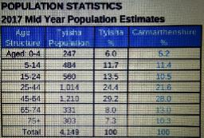
Appendix C.

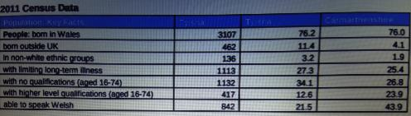
Appendix D.
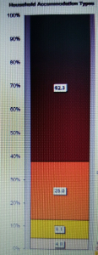
Appendix E.
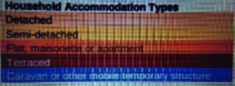

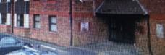
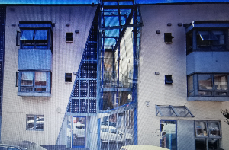
Appendix F.

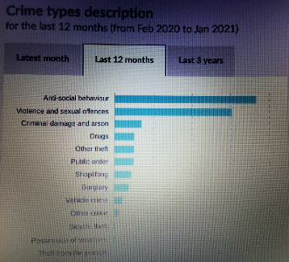
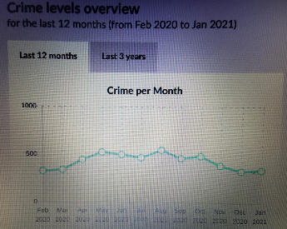
Appendix G.

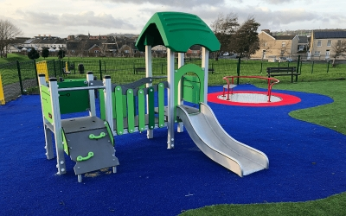
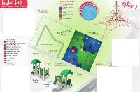
Appendix H.

Reference list.
Dyfedpowys-pcc.org.uk. 2020. Police and Crime Commissioner secures funds of £200k from Home Office’s Safer Street Funding, to work with local partners to cut crime and make communities safer in the Llanelli area. [online] Available at: <http://www.dyfedpowys-pcc.org.uk/en/news/press-releases/police-and-crime-commissioner-secures-funds-of-200k-from-home-office-s-safer-street-funding-to-work-with-local-partners-to-cut-crime-and-make-communities-safer-in-the-llanelli-area/#site-content> [Accessed 20 March 2021].
Roderick, O., 2018. The first look inside the new £10m super-school with a difference. [online] WalesOnline. Available at: <https://www.walesonline.co.uk/news/local-news/first-look-inside-new-10m-14565369> [Accessed 20 March 2021].
Thomas, B., 2020. Life in one of Wales' most deprived areas taken over by drug dealers and strangers. [online] MSN. Available at: https://www.msn.com/en-gb/money/other/life-in-one-of-wales-most-deprived-areas-taken-over-by-drug-dealers-and-strangers/ar-BB18h2wf [Accessed 20 March 2021].
Thomas, B., 2020. Residents describe living in one of Wales' most deprived areas. [online] WalesOnline. Available at: <https://www.walesonline.co.uk/news/wales-news/life-one-wales-most-deprived-18792606> [Accessed 20 March 2021].
Thomas, B., 2020. Inside one of UK's most deprived towns 'taken over by drug dealers'. [online] mirror. Available at: <https://www.mirror.co.uk/news/uk-news/inside-one-uks-most-deprived-22566760> [Accessed 20 March 2021].
Youle, R., 2019. One of Wales's poorest areas set to be transformed with £9.3m investment. [online] WalesOnline. Available at: <https://www.walesonline.co.uk/news/wales-news/llanelli-station-road-carmarthenshire-regeneration-17092259> [Accessed 20 March 2021].

