LCBB4013: STAKEHOLDER MANAGEMENT
A Stakeholder Management Plan for the Chantry House (Malthouse View) Housing Regeneration Scheme, Kirkgate, Wakefield
Word count: 3100 (excluding references)
Student ID: 2509298

Contents
Element 1: Introduction 3
1.1 Project Overview 3
1.2 Project Rationale 3
1.3 Key Stakeholders 4
Element 2: Application – Stakeholder Engagement Strategies 4
2.1 Power, Interest and Salience 4
2.2 Applying the Salience Model Critically 6
2.3 Communication Strategy and its Bounds 7
2.4 Critical Evaluation 9
2.5 Funding Conditionality as a Hidden Stakeholder Constraint 10
Element 3: Ethical Considerations in Stakeholder Consultation, Participation and Feedback 10
3.1 Consultation Methods and Their Limits 10
3.2 Ethical Responsibilities: Data, Honesty, Conflicts of Interest 11
3.3 Equality, Diversity and Inclusion 11
3.4 Feedback Collection and Continuous Review 12
Element 4: Conclusion and Reflection 12
4.1 Conclusion 12
4.2 Reflective Account (Gibbs, 1988) 12
Description: 12
Feelings: 13
Evaluation: 13
Analysis: 13
Conclusions: 13
Action Plan: 14
Reference List 14

Element 1: Introduction

1.1 Project Overview

This report presents a Stakeholder Management Plan for the live redevelopment of the site of Malthouse View (previously Chantry House) it is a site of live brownfield development in the city centre of Wakefield. Wakefield Council bought this site in 2020 and the former office building and the Snooty Fox public house were demolished in 2021, Vico Homes (formerly Wakefield District Housing) submitted its planning application in 2023, which was then granted in 2024. Caddick Construction started on the site in 2025, with completion expected in autumn 2026 (Wakefield Council, 2026). The scheme provides 50 fully affordable homes (26 townhouses and 24 apartments) funded with Section 106 (commuted sum) grant funding from Wakefield Council, alongside funding from Homes England (Housing Digital 2026). The site was not occupied housing, but vacant commercial land, as is common in this type of regeneration, unlike many regeneration schemes where the direct displacement risk dominates much of the regeneration literature (Nelson and Lewis, 2021) this is a point this assignment takes as an analytical point.

1.2 Project Rationale

This project was chosen because it fulfills the assessment criteria of using a real project within my own local authority and because I have firsthand experience of this project. The site has been a regular transit point for me during my travel from home to Wakefield for university and it was mainly this exposure (not a conscious look for a case study) that led me to the site and the regeneration works. It was curiosity as to what they were constructing, then analytical when I looked up the planning application for the site and then went to Wakefield Council's web site to research the planning application instead of relying on secondary sources of information. After reading the main planning documentation, it became obvious that my perception of how stakeholders were managed for this particular project has changed, it shows planning and technical decisions in elaborated details, and not much about how, or how meaningfully, the residents and neighbouring businesses were consulted before these decisions were made. The imbalance that I am investigating in this report in Element 2 is what is decided, compared to who influences the decision, and I had to come to that conclusion myself after checking the primary source, not taking it on their word from the fine documentation in council and developer press releases.

1.3 Key Stakeholders

According to Freeman (1984, p.46) a stakeholder is any group or individual who can either influence, or be influenced by, an organisation's goals or decisions, which means it will include those who make decisions, as well as those who are impacted by the decisions. If it is applied here, at least six groups can be identified:

- The developers: The local planning authority
- Vico Homes: developer and long term landlord, providing affordable housing offer
- Caddick Construction: main contractor for safe & on programme delivery.
- Homes England: co-founder with the obligation to fund in line with national affordable-housing targets.
- Local residents, and neighbouring businesses: Vulnerable to disruption in the construction without formal approval role.
- Long-term tenants and long-term utility providers: future tenants or technical delivery partners

These interests are not just different, but several are in conflict, with Vico Homes and Caddick Construction looking to stay on schedule, and residents' priority (minimising disruption) looking for the opposite. Simply providing updates to stakeholders is unlikely to resolve these differences. Instead, the project team needs to listen to concerns and respond to them throughout the project.

Element 2: Application – Stakeholder Engagement Strategies

2.1 Power, Interest and Salience

Table 1 assigns each stakeholder a score for power and for interest; the last column of the table assumes that the limitation which Mendelow's (1991) matrix is recognized for is assumed power, but not demonstrated influence. Mitchell, Agle and Wood (1997) go directly to the heart of the issue here, claiming that power, legitimacy and urgency, together, create stakeholder salience. It's a 20-year-old model, but Wood, Mitchell, Agle and Bryan (2021) confirm it has survived this period because it fails to capture real influence and Aaltonen, Kujala and Oijala (2008) showed that in practice, local stakeholders in global construction projects, who were formally powerless, were repeatedly able to create real delay and cost through legitimacy and urgency driven pressure that was not picked up by mapping of power and interest alone.

Stakeholder | Power | Interest | Justification
Wakefield Council | High | High | Site owner, planning authority and Section 106 funder controls both approval and viability funding.
Vico Homes | High | High | Developer and future landlord; commercial and reputational stake in delivery and post-completion tenancy.
Homes England | High | Medium | National funder whose grant conditions shape design/tenure mix, but with little day-to-day visibility (PMI, 2021).
Caddick Construction | Medium/High | High | Controls programme and site safety; reputational stake as a Wakefield-headquartered firm (Efficiency North, 2025).
Local Residents/Businesses | Low | High | No approval role, yet able to generate reputational and political pressure through complaint (Mitchell, Agle and Wood, 1997).
Future Tenants | Low | High | Currently silent stakeholders with no consultation channel until allocation, despite carrying the longest-term interest.
Utility Providers | Medium | Medium | Technical dependency risk: delays here cascade into programme risk for all higher-salience stakeholders.

Table 1: Power/Interest Assessment, Chantry House / Malthouse View
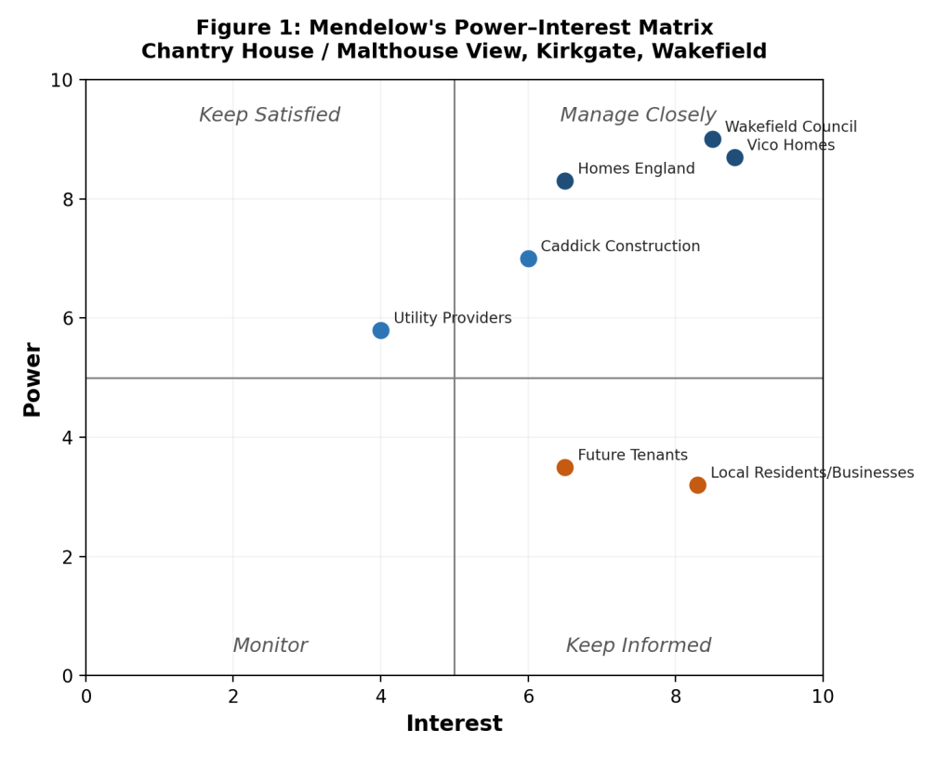

2.2 Applying the Salience Model Critically

In Figure 2, the same stakeholders are reclassified based on power, legitimacy and urgency. Wakefield Council and Vico Homes are currently Definitive (all three attributes), but Local Residents and Businesses enter into the lower power/higher interest quadrant of Mendelow and are in the high legitimacy or high urgency quadrant of Mitchell et al. (1997), there is a high level of urgency and legitimacy in their concerns, but no power to perform. Future Tenants are ambivalent between Dependent and Discretionary as they have a legitimate claim, which becomes increasingly urgent, but there is no way to register it currently, which would be a genuine gap and not a modelling artefact.

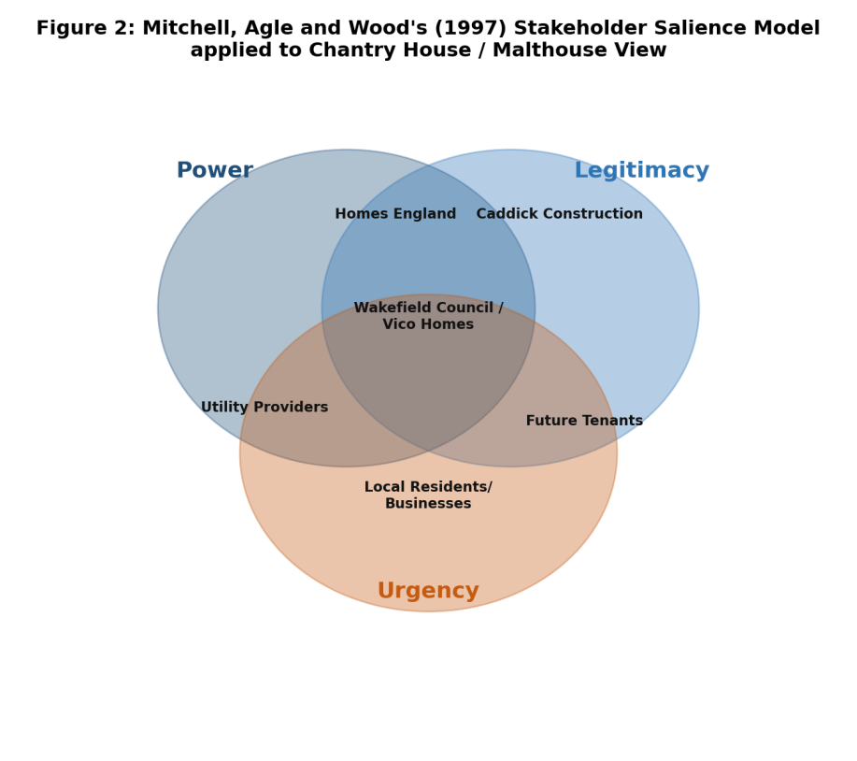

2.3 Communication Strategy and its Bounds

Table 2 outlines a communication plan based on PMBOK's (Project Management Institute, 2021) communications management knowledge area and corresponding guidance from APM (2019), which represents the project process of communicating with stakeholders, rather than a side issue. In this context, this means that funder and contractor communication (rows 1 and 2) is planned and logistical, and resident communication (row 3) is multi-channeled to avoid excluding residents who do not have access to good internet connections, in line with Homes England (2025) community engagement guidance.

Stakeholder | Information | Timing | Medium | Justification
Wakefield Council / Homes England | Section 106 compliance, funding drawdown, planning conditions | Scheduled to funding/planning milestones | Formal reporting, planning correspondence | PMBOK's (PMI, 2021) communications-management guidance treats funder reporting as a fixed, auditable cadence, not an ad hoc update.
Vico Homes / Caddick Construction | Programme, budget, risk register, quality | Regular joint progress meetings | Formal meetings, progress reports | Reflects APM's (2019) view of stakeholder communication as a defined, resourced project process.
Local Residents/Businesses | Construction schedule, access/disruption, complaints route | Ahead of noisy/disruptive works; ongoing | Newsletters, noticeboards, drop-in events, website | Multi-channel to offset digital exclusion; matches Homes England's (2025) own community-engagement guidance.
Future Tenants | Allocation process, handover, aftercare | Pre-occupation and at handover | Registered-provider correspondence, sign-up events | Currently the weakest link in the plan – no engagement channel exists before allocation.
Utility Providers | Connection schedules, technical constraints | Throughout groundworks/installation | Technical liaison meetings | Coordination failure here has the highest programme-risk multiplier of any stakeholder relationship.

2.4 Critical Evaluation

According to Akotia and Sackey (2018) survey of 193 UK regeneration practitioners the greatest motivation for engagement practice was reputational benefit rather than legal obligation, followed by legislative requirement and least of all was the involvement of other stakeholders from the built environment. Akotia et al (2020) found the same, when they surveyed built environment practitioners. To Chantry House, this is uncomfortable but useful, there is public facing communication, not because a Dependent stakeholder's legitimacy is enforced on it, but because a Definitive stakeholder's reputation is at stake. This does not revise the plan, only restate the claims, and Table 2 stands as a defense of the plan on instrumental grounds, even when the normative case Mitchell et al. suggests one which implies residents should have a voice even if it damages their reputation is never tested particularly.

Interestingly, this study of community enterprises in UK regeneration by Earley (2023) raises a point of contrast. It suggests that engagement can extend much further towards actual shared influence when the people involved have or run some sort of asset, rather than just a consultation seat. No such process is evident on Chantry House as there is no community asset, no delegated decision making process or residents association on the site that has had similar impact on the terms of rehousing as described at Woodberry Down by Nelson and Lewis (2021). The comparison indicates that, despite its good intentions, Chantry House's engagement is closer to Arnstein's (1969) consultation rung than to partnership which is discussed directly in Element 3.

2.5 Funding Conditionality as a Hidden Stakeholder Constraint

Funding conditionality was identified as a hidden stakeholder constraint. The second stakeholder constraint identified was funding conditionality. Moreover, Mendelow's matrix does not fully explained is the Homes England's influence earlier in the project, which is delivered to the project through grant conditions placed before work starts, not through ongoing power (PMI, 2021 refers to this as external influence, delivered via key approval stages rather than power that is carried out ongoing. Regardless of the quality of Table 2, the ability for residents to influence the terms for delivery and property affordability (tenure mix, delivery timescale, affordability definitions) that are agreed to by the Government is already severely limited by terms of the grant.

A good communication plan, however, may be needed but not enough the basic contours of the scheme were established at the funding agreement stage, before anyone resident had had a chance to say anything. Caddick Construction is similarly becomes involved later in the project during the construction stage. The company has considerable influence on the delivery of the project in terms of safety, quality and programme management, although it will not have much influence on the original design and objectives of the development. This means that the influence of stakeholders will vary during the course of the project, which a power interest matrix may not capture.

Element 3: Ethical Considerations in Stakeholder Consultation, Participation and Feedback

3.1 Consultation Methods and Their Limits

Consultation for city centre regeneration usually involves planning-portal notices, public exhibitions and newsletters. The most widely used critical tool for assessing whether this is real democracy or tokenism informing, consulting and placating while not giving any real power over the decision is Arnstein's (1969) Ladder of Citizen Participation. Indeed, the five decades of literature surveyed by Varwell (2022) shows that the ladder is still analytically valid because most of the engagement is to be found at the tokenism rungs and not beyond them which is indeed what Element 2 has uncovered at Chantry House: lots of informing, no evidence of redistributed decision rights.

This critique needs precision. It does not assert that Wakefield Council or Vico Homes did not act in good faith, it is their point that informing, no matter how well intended, is tokenism if it does not entail shared decision-making rights. Also, the lack of an existing community of residents does not mean that the exclusion was intentional as in Woodberry Down, the site was not a site of pre-existing residential use. This is a fair part of the answer, but it doesn't answer the partial question of the future: Will Vico Homes repeat the process of engaging, or will it falls back to informing once the construction is over and has become reputation sensitive.

3.2 Ethical Responsibilities: Data, Honesty, Conflicts of Interest

All information obtained from surveys or consultations should be compliant with UK GDPR and the Data Protection Act 2018. The need for obtaining the information, how long it will be retained and its intended use must be disclosed. Any information collected in the consultation process must not be used in marketing shared ownership houses without the permission of the residents. Likewise, honesty entails the disclosure of both the advantages of the development and the inconvenience associated with construction.

There is a conflict of interests in structure here, Wakefield Council is the landowner, planning authority and funder and the planning authority is also the body that decides whether consultation was appropriate or not a conflict this plan should identify, not ignore. A partial mitigation alongside APM's (2019) governance guidance would be an independent community liaison role, reporting to outside the Council's own regeneration team.

3.3 Equality, Diversity and Inclusion

Wakefield Council as a public authority has a duty to have due regard under the Equality Act 2010 for the impact of its decisions on individuals with different protected characteristics. A scheme that is 100% affordable is, by its nature, more defensible on equity grounds than a mixed-tenure scheme that is criticised for diminishing the social-housing proportion, as has happened in Woodberry Down as demonstrated by Nelson and Lewis (2021). While equity in outcome (fully affordable homes) is likely to be a precursor to equity in process (via accessible formats, translated materials and non-digital channels), this is unlikely to be a given; it is an active process that requires resources to be put in place to support older people and those with limited digital access.

3.4 Feedback Collection and Continuous Review

Feedback should not simply be counted; rather it must be recorded thematically so that the smaller number of concerns to which it is given are not washed out in the larger number of low level responses. The more basic problem, however, is structural, not procedural if there is no resident channel like the Woodberry Down residents' association (Nelson and Lewis, 2021), then feedback at Chantry House has nowhere to be recorded to see if it was acted upon across the multi-year build the exact situation in which consultation turns into Arnstein's placation.

Element 4: Conclusion and Reflection

4.1 Conclusion

The three frameworks do not converge but rather diverge upon application to a real scheme currently under construction in Wakefield, as tested against evidence: using Freeman (1984), Mendelow classifies residents as low power; however upon testing the evidence, using Mitchell, Agle and Wood (1997) they are identified as Dependent, and not in the Positivo class, and if they were in the Positivo class, why does the resultant communication plan exist, as revealed by Akotia and Sackey (2018). The three models in combination do not adequately account for Chantry House; taken together with a critical eye, it is clear that there is instrumentally satisfactory engagement here, but normatively less engagement that is defendable, but not the same as the engagement that Arnstein's (1969) model counts as the real thing.

4.2 Reflective Account (Gibbs, 1988)

Description: I did not set out to find a case study. Passing through the Kirkgate area is a regular occurrence for me when studying in Wakefield and it was by seeing the regeneration works on site and not actively looking for an example that I became interested in the site. I only felt the interest become analytical after I went beyond the observation and read the actual planning application in Wakefield Council's web page. In doing so, I had changed my expectations: I was anticipating evidence that there had been consultation, but instead planning and funding decisions had been well documented, and resident influence on planning and funding decisions almost entirely absent from the same record.

Feelings: This gap proved disturbing to me at first because it restricted my ability to present evidence of it directly. Going back over Arnstein (1969), it became clear to me that this very frustration was my result: If the scheme in question had been truly participatory, it would have left behind evidence of itself.

Evaluation: Comparing Chantry House with the Woodberry Down case from Nelson and Lewis (2021) was the most helpful analytical step in this portfolio as it provided me with a practical counter-point to much more than the abstracted higher rung on Arnstein's ladder. I do not have access to Wakefield Council's own consultation documents as an external observer and cannot exclude the possibility of important consultation taking place, but was not publicised.

Analysis: What I take from the findings of Akotia and Sackey (2018) is that I need to read each communication channel in Table 2 with a different lens, as it was not about listening but about rational reactions to reputational exposure. That's a more important, but less comfortable, reading, and I think it is a more accurate one. It also made me think differently about Mendelow's matrix because although it does anticipate that the influence of residents is lower than the formal power of an organisation, it leaves out of the picture the question of why an organisation in a scheme with high formal power communicates at all, which proved to be a more interesting question given that no one in this scheme has meaningfully compelled Wakefield Council's hand.
Conclusions: I now consider engagement exists and engagement redistributes influence as two distinct points that need to be proven separately and I'm less convinced by stakeholder plans (including previous drafts of my own) that merge the two together. I also want to make it clear that there is a limit to what I can say here, because of my own experience: I see the planning application regularly as I pass through Kirkgate and I can say that I have a genuine first-hand experience of this particular project, but I haven't been at any consultation event and I haven't spoken to any resident affected by the works, so don't take my word for it that I have that direct relationship, though the planning application should be read with that distinction in mind.

Action Plan: I will look for a recorded example for any consultation exercise where a decision has actually changed as a result in the case of the Woodberry Down rehousing-terms example, the example should be that of a change in a decision. Where possible, I will also try to get direct access to a scheme's community liaison function, as well as published press coverage, as both elements 2 and 3 demonstrate that the most important evidence (whether feedback made a difference) isn't made public by any of the parties with a vested interest in the scheme's reputation.

Reference List
- Aaltonen, K., Jaakko, K. and Tuomas, O. (2008) 'Stakeholder salience in global projects', International Journal of Project Management, 26(5), pp.509–516.
- Akotia, J. and Sackey, E. (2018) 'Understanding socio-economic sustainability drivers of sustainable regeneration: an empirical study of regeneration practitioners in UK', European Planning Studies, 26(10), pp.2078–2098.
- Akotia, J., Manu, E., Opoku, A. and Sackey, E. (2020) 'The role of built environment practitioners in driving the socio-economic sustainability aspects of sustainable regeneration', Construction Economics and Building, 20(2), pp.89–108.
- Arnstein, S.R. (1969) 'A Ladder of Citizen Participation', Journal of the American Institute of Planners, 35(4), pp.216–224.
- Association for Project Management (APM) (2019) APM Body of Knowledge. 7th edn. Princes Risborough: APM.
- Data Protection Act 2018. London: HMSO.
- Earley, A. (2023) 'Achieving urban regeneration without gentrification? Community enterprises and community assets in the UK', Journal of Urban Affairs. doi:10.1080/07352166.2023.2229459.
- Efficiency North (2025) Work begins on new affordable housing in Wakefield city centre. Available at: efficiencynorth.org (Accessed: 20 July 2026).
- Equality Act 2010. London: HMSO.
- Freeman, R.E. (1984) Strategic Management: A Stakeholder Approach. Boston: Pitman.
- Gibbs, G. (1988) Learning by Doing: A Guide to Teaching and Learning Methods. Oxford: Further Education Unit, Oxford Polytechnic.
- Homes England (2025) Using community engagement to understand and deliver 'locally relevant' social value outcomes. Available at: gov.uk (Accessed: 20 July 2026).
- Housing Digital (2026) Wakefield MP tours Vico Homes' city centre housing scheme. Available at: housingdigital.co.uk (Accessed: 20 July 2026).
- Mendelow, A.L. (1991) cited in Johnson, G., Whittington, R., Scholes, K., Angwin, D. and Regnér, P. (2020) Exploring Strategy: Text and Cases. 12th edn. Harlow: Pearson.
- Mitchell, R.K., Agle, B.R. and Wood, D.J. (1997) 'Toward a theory of stakeholder identification and salience: Defining the principle of who and what really counts', Academy of Management Review, 22(4), pp.853–886.
- Nelson, S. and Lewis, J. (2021) 'Resident engagement in the regeneration of social housing: the case of Woodberry Down, London', International Journal of Housing Policy, 21(1), pp.48–69.
- Project Management Institute (PMI) (2021) A Guide to the Project Management Body of Knowledge (PMBOK Guide). 7th edn. Newtown Square, PA: PMI.
- UK General Data Protection Regulation (UK GDPR), as retained in UK law under the Data Protection Act 2018.
- Varwell, S. (2022) 'A Literature Review of Arnstein's Ladder of Citizen Participation: Lessons for contemporary student engagement', Exchanges: The Interdisciplinary Research Journal, 10(1), pp.108–144.
- Wakefield Council (2026) Chantry House, Kirkgate. Available at: wakefield.gov.uk (Accessed: 20 July 2026).
- Wood, D.J., Mitchell, R.K., Agle, B.R. and Bryan, L.M. (2021) 'Stakeholder Identification and Salience After 20 Years: Progress, Problems, and Prospects', Business & Society. doi:10.1177/0007650318816522.

