Digital Surveying & Highway Design – Building Survey

Written by Seren Adams
Student ID: 2502932
Date: 02/07/2026
Word Count: 2190

Table of Contents

Title Page………………………………………………………………………………………………….1
Table of Contents……………………………………………………………………………………….2
Survey Plan……………………………………………………………………………………………….3-5
Site Assessment…………………………………………………………………………………………6-7
Risk Assessment & limitations………………………………………………………………………8
Practical…………………………………………………………………………………………………….9
Measurement & Analysis………………………………………………………………………………10-12
Comparison with traditional methods……………………………………………………………..13

Survey Plan
Introduction
On the 25th of June 2026, a measured building survey was carried out on the first floor of the IQ building at the University of Wales Trinity Saint David (UWTSD). The survey formed part of the practical element of the Digital Surveying and Highway design module and was intended to develop an understanding of both traditional surveying techniques and modern surveying methods. By combining manual measurements with laser scanning technology, the exercise provided practical experience of planning and undertaking a measured building survey within a real working environment.
The survey was originally scheduled to take place within the Dylan Thomas Centre; however, following a review of site conditions and the exceptionally high temperatures experienced during the UK heatwave, the location was changed to the IQ Building. This decision provided a safer and more suitable working environment while ensuring the learning outcomes of the practical exercise could still be achieved in accordance with good surveying practice.
The survey involved obtaining accurate dimensional information of the internal building layout through manual measurements, a laser measurer and terrestrial laser scanning. The data collected would later be used to extract building measurements, compare traditional and digital surveying methods, and evaluate the effectiveness of each approach. Throughout the planning process, consideration was given to survey methodology, site access, equipment requirements and health and safety to ensure the survey could be completed safely (RICS).

Purpose of the Survey
The aim of the survey was to capture accurate dimensional information from the first floor of the IQ Building using a combination of traditional measurement techniques and laser scanning technology. The survey formed part of a practical exercise to develop an understanding of measured building surveys and demonstrate how digital surveying methods can be used to capture reliable spatial data.
The survey included measuring rooms, corridors, walls, doors and windows to produce an accurate building layout. This information could be used to support floor plan production, refurbishment projects and future building alterations, where reliable survey data is essential for reducing design errors and improving project efficiency.
The use of both manual measurements and laser scanning also allowed the two methods to be compared. Manual measurements provided a simple way to verify key dimensions, while laser scanning captured a much greater volume of information that could be reviewed later. This comparison helped to demonstrate the advantages and limitations of each approach and highlighted the growing use of digital surveying in construction.

Survey Area Definition
The survey was undertaken on the first floor of the IQ Building at the University of Wales Trinity Saint David (UWTSD). The area surveyed included circulation corridors, open workspaces, internal walls, door openings and windows. The scope of the survey was limited to the internal layout, as external elevations and architectural detailing were outside the objectives of the task.
The required level of detail was appropriate for measured building survey purposes. Sufficient information was collected to support the preparation of floor plans and enable measurements to be compared with those obtained using traditional surveying methods. Defining the survey area before work commenced helped ensure the data met the project objectives without capturing unnecessary information.

Survey Methodology
To achieve the projects objectives, a combination of traditional and digital survey methods were used. Using more than one method also provided an opportunity to verify key measurements and improve confidence in the recorded data.
Manual Measurement
Steel tape measures were used to record shorter distances and verify critical dimensions throughout the survey. This method was straightforward and allowed measurements to be checked immediately; however, it relied on clear access to the feature being measured and was more time – consuming for larger spaces.

Laser Distance Measuring Equipment
A laser distance measurer was used to record room dimensions, corridor lengths and other internal features more efficiently than a tape measure. This device enabled longer distances to be measured accurately with reduced physical effort and improved productivity, particularly where direct access was restricted.
Laser Scanning
The original survey plan included the use of a terrestrial laser scanner to capture a comprehensive three- dimensional record of the building. However, due to equipment issues encountered on the day, a handheld laser scanner was used instead. The scanner was operated alongside an iPad, allowing survey data to be captured continuously whilst moving through the building. This produced a digital point cloud that could be reviewed after leaving site, reducing the risk of omitted measurements.
To ensure the survey could still go ahead if problems occurred, contingency planning included the use of handheld laser scanning and additional manual measurements. Having an alternative approach available reduced delays and ensured that the survey objectives could still be achieved despite the equipment failure.

Site Assessment
Access
Before the survey commenced, the survey area was assessed to confirm that access could be gained safely and without disrupting the normal use of the building. Access to the first floor was gained via the main entrance and designated circulation routes. The practical exercise was supervised by the module lecturer, and permission to undertake the survey had been arranged in advance. Emergency exits and escape routes remained unobstructed throughout the survey in accordance with safe working practices.
Scanning Positions
Scanning locations were chosen to maximise coverage of the survey area whilst reducing blind spots. Where possible, scan positions were planned to provide sufficient overlap between datasets, improving the quality of the final point cloud and reducing the chance of missing information during processing afterwards. Although the planned terrestrial scanner could not be used on the day, the same survey principles were applied when using the handheld scanner.
Lighting Conditions
The survey was completed under a combination of natural daylight and artificial lighting. Although laser scanning is generally less affected by lighting conditions than photographic surveys, adequate lighting improved visibility when recording manual measurements, producing sketches and identifying internal building features. The IQ Building also provided a more comfortable working environment than the original survey location due to its modern air – conditioning system.
Environmental Conditions
Environmental conditions were considered before the survey began. Potential obstructions included other occupants moving through the corridors, furniture restricting access and general activity within teaching spaces. These factors had the potential to interrupt data capture or temporarily obstruct measurements, so the survey team worked systematically and adapted movements where necessary to minimise disruption while maintaining survey accuracy.
Equipment Required
The following equipment was required to complete the survey:
- Handheld laser scanner with iPad
- Laser distance measurer
- Steel tape measure
- Clipboard and sketch paper
- Mobile phone for site photographs
- Pencil and ruler
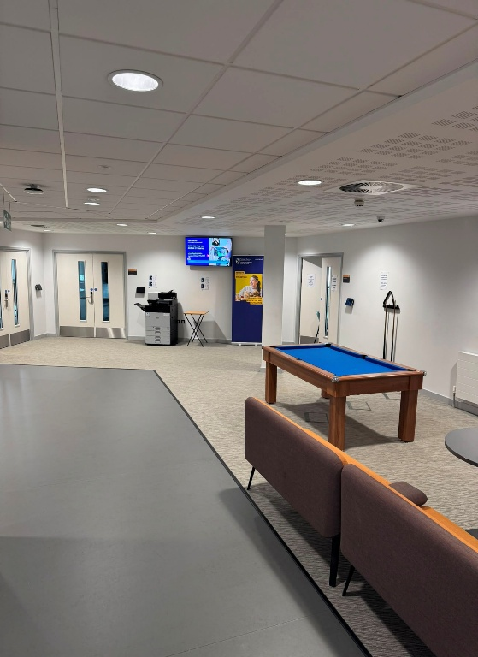
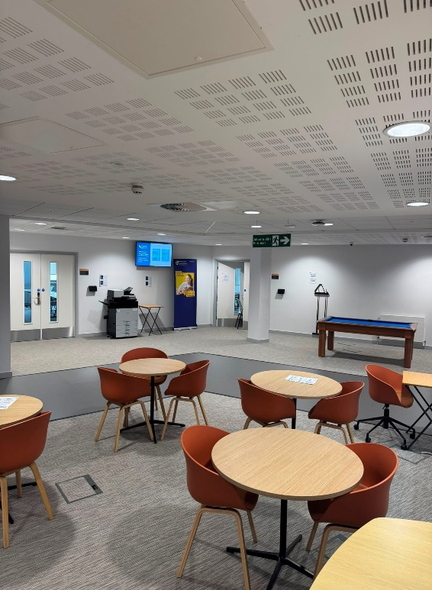
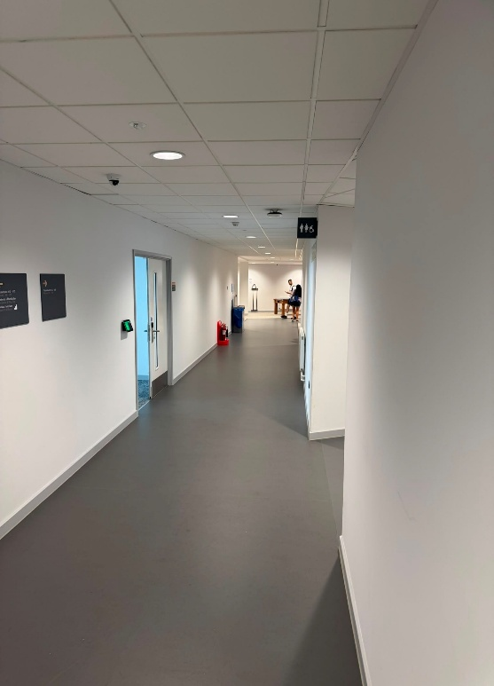
Sketches were produced to record measurement locations and map out the area.
Figure 1. Survey area within the IQ Building.

Risk assessment
A risk assessment was completed before the survey commenced to identify potential hazards and implement appropriate control measures. Although the survey was considered low risk, effective planning was essential to protect both the survey team and the other occupants while ensuring safe working.
Hazard | Risk | Mitigation
Trailing equipment | Minor trips or falls. | Keep equipment organised and avoid blocking walkways.
Slips and trips | Falls and injuries | Check floors before beginning work and remove any obstacles
Building occupants | Interruptions to scanning process. | Allow occupants to pass safely and work systematically to minimise disruption.
High temperatures | Fatigue and dehydration | Moved to an alternative cooler building, maintain hydration and take regular breaks.
Manual handling | Muscle strain | Use correct lifting methods and share loads between other students.
Emergency evacuation | Delays caused by equipment | Keep escape routes clear and follow building’s emergency procedures.
Table 1. Risk Assessment
Survey limitations
Several limitations were identified before the survey commenced. These included furniture, occupied areas and the movement of building users could temporarily obstruct measurements and reduce visibility. In addition, the survey was limited to the internal areas of the building, meaning external elevations and building features were outside of the scope.
The planned use of a terrestrial laser scanner also had to be revised following equipment issues during the practical. Although the handheld scanner allowed the survey to be completed successfully, adapting the methodology highlighted the importance of contingency planning. To minimise the impact of these limitations, multiple scan positions and manual measurements were used to verify key dimensions.

Practical
Survey Execution Summary
The practical survey was undertaken on the first floor of the IQ Building at the University of Wales Trinity Saint David. Before data collection began, the survey team familiarised themselves with the building layout and confirmed the areas to be measured in accordance with the survey plan.
Initial measurements were taken using steel tape measures and a laser distance measurer to record the dimensions of rooms, corridors and door openings. These measurements were recorded on field sketches to provide a reference for later comparison with the digital survey data.
The original survey plan proposed using a terrestrial laser scanner to capture the building in three dimensions. However, due to equipment issues on the day, a handheld laser scanner was used. Although this required a different data capture method, the survey objectives stayed the same. The handheld scanner was moved throughout the building to achieve complete coverage and produce a digital point cloud.
Overall, the survey was completed successfully with minimal disruption to the building users. Combining manual measurements with digital data provided enough information to complete the practical exercise and compare the effectiveness of traditional and modern surveying techniques.
Changes to original plan
Two changes were made to the original survey plan. The survey location was changed from the Dylan Thomas Centre to the IQ Building due to the exceptionally high temperatures experienced. In addition, the planned terrestrial laser scanner became unavailable on the day, so a handheld laser scanner was used to complete the survey. Even though the data collection method changed, the survey objectives remained the same and sufficient information was collected to complete the exercise.
Problems Encountered & Response
The main issue encountered during the survey was the failure of the planned terrestrial laser scanner. Rather than delaying the survey, a handheld laser scanner was used as an alternative, allowing data collection to continue with minimal disruption.
Using the handheld scanner required a more systematic approach to ensure all areas were captured. This was supported by the manual measurements and field sketches, which were used to verify key dimensions and check that adequate survey data had been collected. Although the survey method changed, the practical exercise was completed successfully and the required information was obtained.
Measurement and Analysis
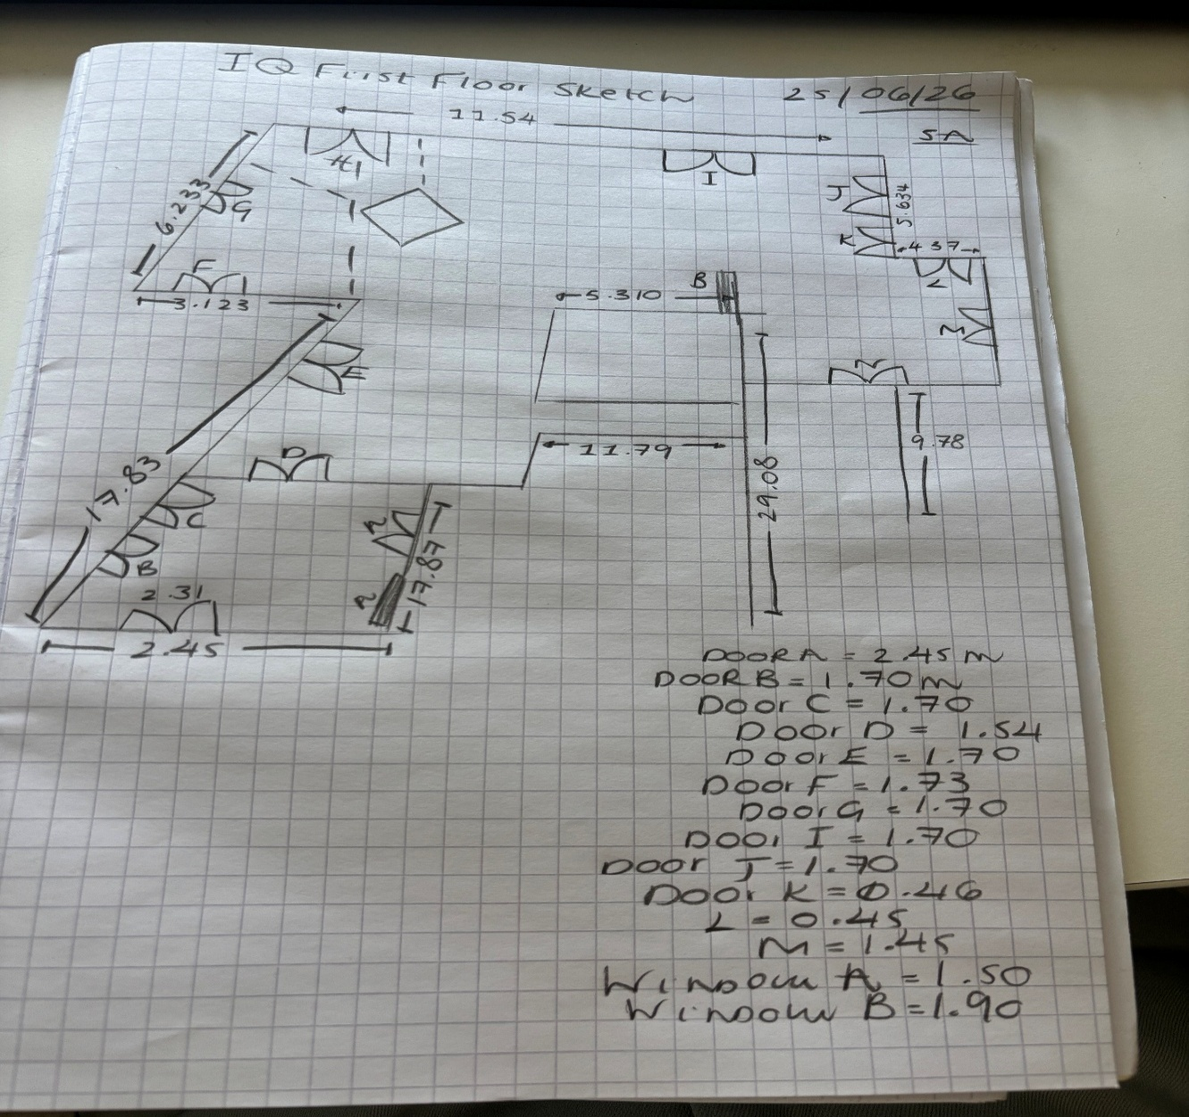
Following completion of the site survey, dimensions were extracted from the processed laser scan and compared with measurements recorded manually during the practical exercise. This allowed the accuracy and practicality of both surveying methods to be assessed.
Figure 2. Manual field sketch completed during the site survey (not to scale).
Figure 2 shows the original field sketch completed during the survey. The sketch was used to record wall lengths, door and window locations and other key dimensions required for later comparison with the processed laser scan. Recording measurements on site provided a useful reference and allowed important dimensions to be verified.
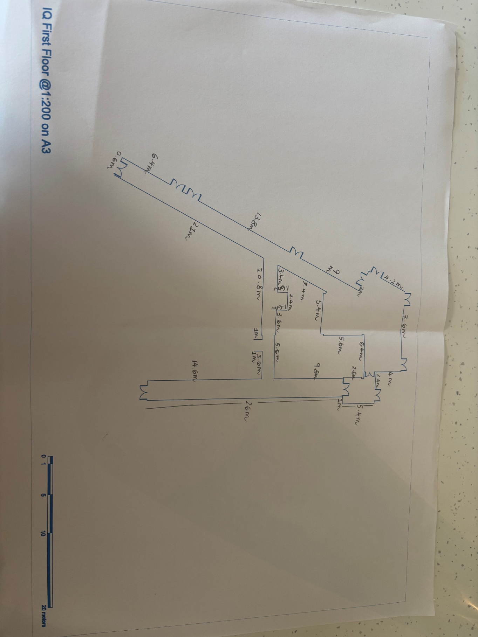
Figure 3. Dimensions extracted from the processed laser scan.
Figure 3 shows the dimensions extracted from the processed laser scan using the supplied scaled drawing. In addition to overall room and corridor dimensions, selected door openings were measured to demonstrate the level of detail that can be obtained from the digital survey. The processed scan allowed additional measurements to be extracted after leaving site without requiring another site visit (RICS).
Table 2. Comparison of Selected Measurements
Feature | Manual Survey (m) | Laser scan (m)
Corridor width | 2.45 | 2.40
Internal room width | 5.31 | 5.40
Internal room depth | 9.78 | 9.80
Small internal wall | 5.63 | 5.60
Door opening | 1.70 | 1.70

Table 2 compares a selection of measurements obtained from the manual survey and the laser scan. The results are generally consistent, with minor differences between the two methods. Most measurements differed by less than 0.10m, with the largest variation being approximately 0.17m.
These differences are considered reasonable for a practical measured building survey and are likely to reflect normal manual measurement tolerances and interpretation of the scaled drawing. The laser scan also provided a permanent digital record, allowing additional measurements to be extracted after the site visit without returning.
Overall, both methods produced reliable results in different ways for this exercise. Manual surveying was effective for recording key dimensions, while laser scanning provided a quicker and more comprehensive method of capturing building information.

Comparison with Traditional Methods
The survey provided an opportunity to compare traditional measurement techniques with laser scanning in terms of efficiency, accuracy and the level of information collected. Traditional methods, including steel tapes and laser distance measurers were effective for recording individual dimensions but were more time consuming as the size and complexity of the survey increased. Each measurement had to be taken and recorded separately, increasing the chances of omissions or recording errors.
In comparison, laser scanning captured a comprehensive digital record of the survey area relatively quickly. Once processed, the point cloud allowed additional measurements to be extracted without returning, improving efficiency and reducing the risk of missed information. Whilst the accuracy of both methods depends on correct use of the equipment, digital surveying reduces many of the transcription errors associated with manual recording and provides a permanent record that can be revisited if necessary (RICS).
Overall, the practical exercise demonstrated that traditional measurement remains valuable for checking key dimensions, and laser scanning offers a quicker, more complete method of capturing building information. The use of both methods together improved confidence in the survey data and highlighted the benefits of integrating digital technology into measured building surveys.

References
Royal Institution of Chartered Surveyors (RICS) (2023) Measured surveys of land, buildings and utilities: RICS Professional Standard. Available at: https://www.rics.org/profession-standards/rics-standards-and-guidance/sector-standards/building-surveying-standards/surveying-safely Accessed: 20 July 2026.

