Lucy Beckett
Documentary Photography and Visual Activism
2000251
Ways of Thinking
ADAD4018
Ryan Moule

Tasks in the order I receive them:
Task One: Observational Writing= 522
Task Two: Exhibition Writing= 536
Task Three: Manifesto Writing= 494

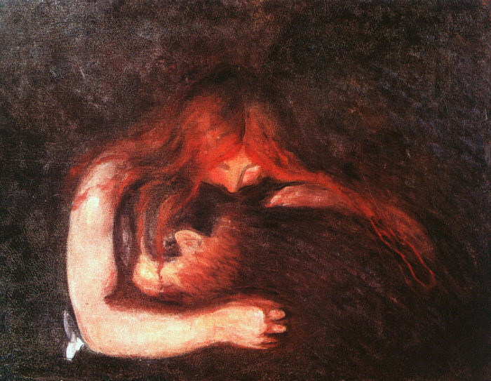
Semiotics
Semiotics is the process of generating meanings through the use of signs proving that there is much more to art and photography than what first meets the eye. Semiotics was defined as ‘the life of signs within society’ by its founder Ferinand de Saussure, who worked close (Britannica,1998). The study of semiotics is valuable for demonstrating in-depth ideas and provoking feelings without explicitly displaying them. When we consider a piece of artwork or an image, we must take the time to consider all aspects of the work to ensure the absorption of all the meanings, whether they are denoted or connoted. The present time and society that we live in is saturated by images that contain obscured meanings in order to present information to us in a way that is far more digestible within the fast-paced environment of clickbait (Geiger,2006) fake news and social media. This proves that semiotics is not an ancient art that we look back upon and reflect with admiration, it is an active process that continues to present itself cloaked amongst everything thing we see around us. Intricate tales can be woven within images by the use of hidden signs and meanings which is why this technique is an extremely important part of art and photography to understand and therefore is a practise that should not be overlooked.
Love and Pain by Edvard Munch, also commonly known as The Vampire (Gallardo,2019) is a piece of art than be delved very deeply into when considering hidden or alternative meanings. The painting depicts two figures embracing which denotes affection between the two and implies that this is a pair of lovers. We are able to see that the background of this work is dark which puts the focal point on the couple and eliminates any distractions, there are a number of interpretations that can be connoted from this. It may be that they are experiencing a tragic event and therefore the use of darkness is to demonstrate the pain or depression that they may be feeling. The couple seem illuminated against the blackness which suggests that they may be the hope for each other. Another interpretation is that the darkness could be used to symbolise that the pair are so engrossed in each other and their embrace that they do not feel as though anything else exists. The embrace is also an interesting point to consider and may not be as simple as first thought, if we consider the second title of ‘Vampire’ then we can begin to see a connoted meaning that perhaps the woman is devouring the man and that they are simply clinging together. This could also link with the idea of the darkness and depression perhaps suggesting that the man wants to be taken by the vampire and therefore depicts a generous act of self-sacrifice. Colour also portrays various meanings as the red within the woman’s hair can be seen to symbolise the love and passion she feels within this relationship (Pastoureau,2016) however, on the contrary it could be being used to display a sense of danger and a lust for blood that is being quenched.

Bibliography
Britannica, T. E. o. E., 1998. Britannica. [Online]
Available at: https://www.britannica.com/science/semiotics
Gallardo, G., 2019. Painful Love Explained In 6 Works Of Art By Edvard Munch. [Online]
Available at: https://culturacolectiva.com/art/edvard-munch-love-art-paintings
Jay, G., 2006. [Online]
Available at: http://www.jaygeiger.com/index.php/2006/12/01/definition-of-click-bait/
Pastoureau, M., 2016. Red The History of a Color. Illustrated ed. s.l.:Princeton University Press.

Exhibition
The exhibition that this piece of writing is in response to is the ‘Within and Without: Body Image and the Self’ which was on display in Birmingham Museum and Art Gallery. This particular exhibition captivated my attention as there are many different aspects to the space and many thoughts provoked. The purpose of the exhibition was to challenge ideas surrounding sexuality, gender and stereotypes through strong and colourful interpretations of thought. The works in the exhibition are hung at a number of different heights, many of them being eye level which allows the audience to be drawn in, as well as quite a few being hung with more of a traditional salon hang inspired by the Salon des Refuses (Polk Museum of Art,2017) look to them, inviting you to look up and have an experience. This gallery space was a temporary exhibition which was on display for a number of months between 2018-2019, the show was created collaboratively with a number of curators as well as many community and volunteer groups such as the Birmingham LGBTQ+ refugee group. The work is presented through many different forms, there are a number of prints (a mix of framed and unframed) that are hung on a grey wall. The use of grey instead of the ‘modernist white-cube gallery’(Kwun,2018) empowers the artwork as the colours seem to become far more vibrant which works very well with this shows as colour is a very prominent aspect. Throughout the exhibition there is also a frequent use of a colour scheme including pinks and yellows which gives the whole room a sense of togetherness. There is also a mixture of sculptural work in the room ranging from a hot pink desk to a yellow rocking chair and also a wide selection of masks and totems. Using these physical objects in the exhibition has really opened it up and it made it feel as if the audience are part of and potentially creating the space. In addition to the more sculptural pieces there is also a wide range of seating throughout the space which invites the audience to immerse themselves into the work ‘Seating is an explicit invitation to stay, either with others or by oneself'(Baker,2011)
To me this work feels as if it breaks against the traditional expectations of a gallery space as it seems so freeing and even includes interactive elements which further the audience’s engrossment in the work and helps to boost the escapism that artwork can create. This particular space makes me feel very strong within myself and also sparks my creativity. The use of colours is something that really captures my imagination and I think it is a really clever tool which has been used to pull all of the pieces together. Even if some of the pieces seem random or out of place, within the context of the show they increase the strength of the exhibition. This particular show has a virtual tour online and this has further allowed me to understand the ideas. Each section of the room feels as if it has its own space to breathe yet the room is not too spaced out so that the feeling of connection between the works is lost.
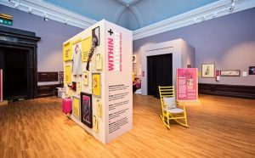

https://my.matterport.com/show/?m=cPXiPrtVxL2

Bibliography
Art, P. M. o., 2017. Faces in the Crowd. [Online]
Available at: https://polkmuseumofart.org/media/salon-style-essay
Baker, T., 2011. Seating and sitting in the V&A: An observational study. V&A Online Journal, Issue 3.
Kwun, A., 2018. The Secret Paint Colors That Renowned Art Museums Love. [Online]
Available at: https://www.artsy.net/article/artsy-editorial-secret-paint-colors-renowned-art-museums-love

Manifesto Writing-Lucy Beckett
- Only produce work that I feel is an authentic representation of my artistic expression
- Challenge ideas or notions that make me angry or uncomfortable. Make work in response.
- Experiment a lot, progress will only come from trying.
- Trust and enjoy the process as much as I can, things will work out in the end.
- Don’t get caught up in click-bait news- seek independence from outlets and do my own research
- Absorb more work from other creators-immersion can inspire
- Be an active advocate for women within art
- Use negative situations and emotions for the better

Challenge ideas or notions that make me angry or uncomfortable.

Make work in response.
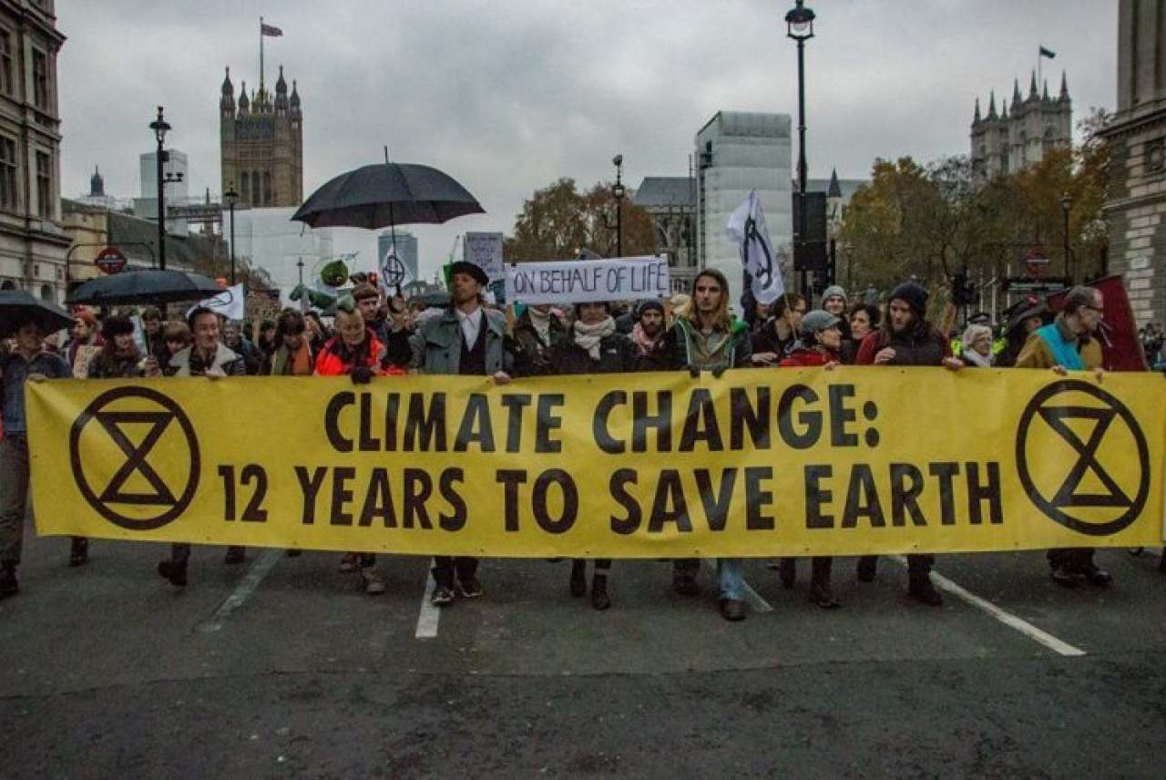
With the many protests and movements, we have seen recently surrounding Black Lives Matter or Extinction Rebellion it is clear to see we are living in a time where people are ‘waking up’ (Extinction Rebellion,2020) and not standing for ideas that anger them anymore. ‘Theory should be tied to action’(Perry,2020) reflects on involvement in various BLM and LGBTQ+
protests and this is an idea that I want to implement into my own working practices. Art and photography are very powerful methods of activism and I want to ensure that I do not waste the opportunity I have and speak up about what I think is right and arguably more importantly what I think is wrong. There is no excuse for me to sit back and feel discontent when I am able to produce work that speaks my thoughts and can hopefully contribute to a positive change.

Don’t get caught up in click-bait news- seek independence from outlets and do my own research
‘Click-bait’ refers to use of language generally in a title of a news article, gossip magazine or videos which draw in an audience by creating a false narrative or idea (Geiger,2006). It is not enough to simple click on the source and briefly read it to find the real truth, ‘they aren’t interested in you, they just want your clicks (Hooker,2016). ‘The unescapable nature of this media genre is
overwhelming and often well disguised within part-truth which is why is why it
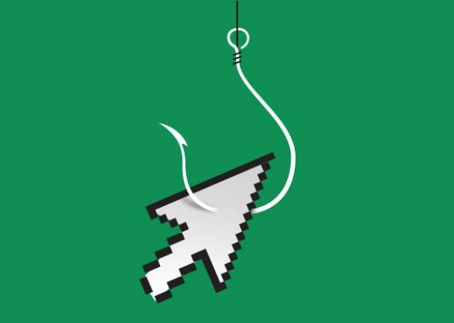
is even more important than ever to make a conscious effort to avoid the consumption of it.

It is empowering to see and click-bait title and then conduct my own further in-depth research into the topic in order to acquire the accurate and truthful information. It has become even more important to find out the real information amongst the situation we are facing in 20202 as click-bait surrounding Coronavirus proves just how dangerous this false reality can be.
Be an active advocate for women within art

As a woman within art, I feel I have a responsibility to be active and display strong advocacy for feminism within my work. Increasingly the art world is seeing an emergence of strong feminist movements which are working hard to rewrite the male and whitewashed history of art. ‘We believe in an intersectional feminism that fights discrimination and supports human rights for all people and all genders.’(Guerilla Girls,) is a statement that encapsulates my inspirations behind this manifesto point and helps to drive my thoughts to a more direct place. 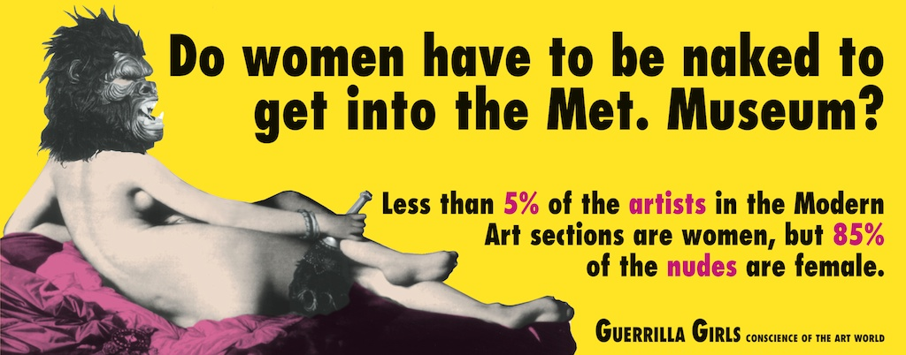
Undoubtably, there is strength in collective movements however, there is also strength within personal movements. It is no longer acceptable in the times we are living to be passive about issues that directly affect us, each personal creation of protest contributes to the greater cause. Often, it can feel like young, women are overlooked and their voices and seen as unimportant, this is something I feel very passionate to change.

Bibliography
Geiger, J., 2006. [Online]
Available at: http://www.jaygeiger.com/index.php/2006/12/01/definition-of-click-bait/
Girls, G., n.d. [Online]
Available at: https://www.guerrillagirls.com/
Hooker, C., 2016. Don't Fear The Clickbait. Tech & Learning, 37(3).
Perry, M., 2020. Black Lives Matter, Intersectionality, And LGBTQ Rights Now. Volume 18.
Rebellion, E., 2020. Extinction Rebellion. [Online]
Available at: https://extinctionrebellion.uk/

