Instrumentation and Control – CIWS Control System

Author: Joseph S. Rula (2317963)
Wales Institute for Science and Art
University of Wales Trinity Saint David
Course Code: ACDB 5011
Instructor: Stephen Mosey
Due: 12th December 2025



Contents
Abstract 4
1.0 Introduction 4
1.1 What is a Close-In-Weapon-System (CIWS) 4
1.2 What is a Control System? 5
1.3 The difference in Open and Closed Loop Systems 5
1.4 What are Sensors & Actuators? 6
1.5 Proportional Controllers 6
1.6 Proportional Integral Controllers 6
1.7 Proportional Derivative Controllers 7
1.8 Proportional Integral Derivative Controller 7
1.9 Mathematical Modelling 7
2.0 Digital Modelling 7
2.1 Transfer Functions G(s) 8
2.2 Simulink Simulation of Control System 9
2.1 Pole-Zero Plots 16
2.2 Inferring Information from the Pole-Zero Plots 17
2.3 Root Locus and Nyquist Plots 17
Conclusions 19
Bibliography 19
Appendices 19

Table of Figures
Figure | Text
1 | Phalanx Close In Weapon System (CIWS)
2 | Differential Equation for System Transfer Function (SystemTF)
3 | A Closed Loop system designed to control the CIWS
4 | The Simulink Oscilloscope showing the waveforms of the signal across figure 3, top; Input signal. Middle; Subtract Logic, Bottom; PID Controller.
5 | The PID Controller Parameters
6 | Multiplying the values obtained from the PID tuning and the transfer function.
7 | Calculating the forward path transfer function. And assigning graphing plots to the variables.
8 | Original PID values.
9 | System TF and beginning to graph values.
10 | Graphing remaining values.
11 | Final System Transfer Function.
12 | The tuned output of the PID controller.
13 | Plotting the Pole-Zero Diagram
14 | Pole - Zero Plot Diagram for PlantProc, Controller, Forward TF (G), and SystemTF
15 | Root Locus for the above system.
16 | Nyquist Diagram for the System Transfer Function.

Table of Equations
Equation | Text
1 | Proportional Controller (PI) Equation
2 | Proportional Integral (PI) Controller Equation
3 | Proportional Derivative (PD) Controller Equation
4 | Proportional Integral Derivative (PID) Controller Equation.
5 | G(s) equation to give unique transfer function.

Table of Tables
Table | Text
1 | Table of the values obtained from the PID tuner.

Table of Abbreviations
Abbreviation | Text
CIWS | Close in weapon system
RADAR | Radio, Detection and Ranging
GNC | Guidance, Navigation and Control;
PID | Proportional Integral Derivative Controller

Abstract
This report details a use case where a CIWS turret needs to have a control system created to serve its rotation capabilities, the transfer function given from the RADAR, to serve as the location the turret needs to position itself towards is served by the student’s unique identification number. After controller selection the transfer function is used and fine tuned before validating if the system transfer function is stable, and if any oscillations occurred, they would eventually shrink before ceasing.

1.0 Introduction
This report details how a control system may be implemented for a Close-In-Weapon-System (CIWS) to quickly rotate the weapon system and stop, pointed at a target indicated by another system, with minimal overshoot and correction time.

What is a Close-In-Weapon-System (CIWS)
A Close-In-Weapons-System (CIWS) is a weapon system designed as a final line of defence against incoming aerial threats, from planes, unmanned drones and even incoming rockets and mortar bombs. CIWS’ short range but high rate of fire creates sufficient protection for a small operations base or naval vessel. [1]
The Phalanx CIWS, manufactured as a combined effort between General Dynamics and Raytheon [1], was designed for use as a land-based system and as a Naval defence turret on warships, and excels at its designed purpose. Its 20mm cannon sits on two rotating axes (horizontal and vertical) and when combined with a search and track radio, detection and ranging (RADAR) system, the Phalanx CIWS can automatically follow tracked targets, giving the appropriate amount of lead, so that when or if the 20mm projectiles are fired, they have sufficient time to make it the distance to the target. [1]
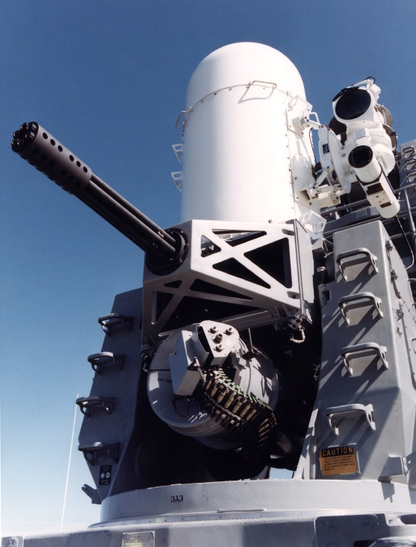
Figure 1 - Phalanx Close in Weapon System (CIWS) [1]

1.2 What is a Control System?
Control systems are designed to take an input, modify it, and output that modification. In the case of this assignment. A CIWS takes an input from RADAR and automatically points the CIWS at the target detected by the RADAR. The electrical control system needs to be designed as part of this assignment.
The requirements detailed as part of the assignment calls for a maximum time for the targeting system to be on target of two seconds and a minimum overshoot percentage of 5%.

1.3 The difference in Open and Closed Loop Systems
The difference between an open and closed loop system is the return of information from the output to the input, sensors confirming the actual value of the output is the same value given to the input.
Whereas an open loop system does not rely on sensors, creating a simpler, reliable system, though with less accuracy and prone to falling out of line should any disturbances disrupt the outcome when compared to the input.

1.4 What are Sensors & Actuators?
A sensor in a closed loop system, detects the output, these types of sensors can be temperature, positional encoders (useful for the CIWS), Pressure, or gas and smoke detectors. Each has their own use for different scenarios.
An actuator, when part of a closed loop system, is the output providing a type of force, motors provide rotational force and torque, whereas linear actuators provide a linear displacement force. Both may be required by a CIWS, though a motor will be used for the CIWS example.

1.5 Proportional Controllers
A proportional controller (P) is a type of controller in a closed loop system that scales the output and the input directly, proportionally. If a discrepancy, e(t), is detected in the output, u(t), it adjusts the input to achieve the desired output, Kp. This proportional scaling, increases the output flow rate when the true value is not at the set point and, decreases the output flow rate as the value approaches the desired setpoint. This often causes the Steady State error, the controller slows the input to a point where it never achieves the desired output, the set point.
$$u\left(t\right)=Kp*e(t)$$
Equation 1 - Proportional Controller (P) Equation

1.6 Proportional Integral Controllers
Whereas a proportional integral (PI) controller uses the integral (I) to accumulate the past errors. By doing this it controls the output, using corrective action, whether it be increasing or decreasing the output, to achieve the setpoint.
$$u\left(t\right)=Kc* e\left(t\right)+\frac{Kc}{ℸ1}\int_{0}^{t}{e(ℸ)dℸ}$$
Equation 2 - Proportional Integral (PI) Equation

1.7 Proportional Derivative Controllers
A proportional derivative controller (PD) is a type of controller in a closed system that includes a damping element, the derivative, to smooth the rate of change of output, dampening overcorrection oscillations. Steady state errors may still occur.
$$u\left(t\right)=Kc\left(r\left(t\right)-y\left(t\right)\right)-Kc* ℸD*\frac{dyf\left(t\right)}{dt}$$
Equation 3 - Proportional Derivative Controller (PD) Equation

1.8 Proportional Integral Derivative Controller
Proportional Integral Derivative (PID) Controllers combine the above PI and PD controllers to use account for previous errors and adjust the input as necessary (PI) and then dampen the input as needed to prevent overshoot of the setpoint (PD).
$$u(t)=Kce(t)+\frac{Kc}{ℸ1}\int_{0}^{t}{e\left(ℸ\right)dℸ+KcℸD*\frac{de\left(t\right)}{dt} }$$
Equation 4 - Proportional Integral Derivative (PID) Controller Equation.

1.9 Mathematical Modelling
With the closed loop controller equations known, it is possible to calculate the required transfer function manually, as a singular large differential equation, when it is converted via the Laplace Transform.
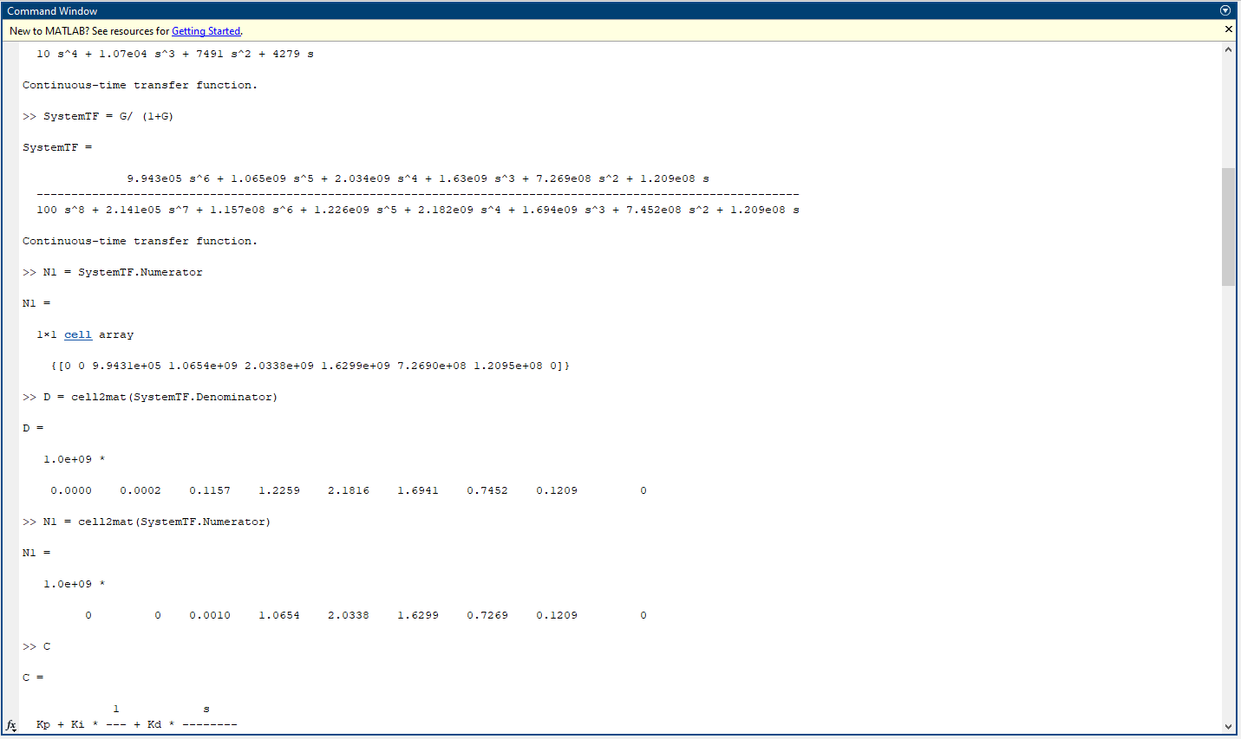
Figure 2 - Differential Equation for System Transfer Function (SystemTF)

2.0 Digital Modelling
To model and program this control system, the software MATLAB Simulink is used. MATLAB is no stranger to the CIWS use case, as it has pedigree in aerospace and defence for Guidance, Navigation and Control Systems (GNC)
The particular MATLAB software used is MATLAB Simulink, used for drafting and creating programs in a flexible digital domain before moving to the more restrictive physical hardware.
Part of the issue with physical hardware that MATLAB Simulink does include, is the lag between physical hardware’s outcome and the effect that caused it. Like for the CIWS where a motor turns the several tonne weapon systems and it needs to stop accurately and with precision onto the intended location. This is known as Hysteresis.
The rotational aspects of the CIWS will be controlled via some form of gearing, the teeth in gears are not perfectly aligned and there will be some play in the gearing, this will also affect the final result, as a result of the use case, an open loop system is not recommended, and a closed loop system should be used.

2.1 Transfer Functions G(s)
This transfer function G(s) for this assignment is based upon the student’s unique identification number, in this case the number is “2317963” each student is to take the last three digits, assign a letter, and increase each of these digits by one, resulting in the unique combination of integers being, “a = 10”, “b = 7”, & “c = 4”.
These integers are inputted into the below equation:
$$G\left(s\right)=\frac{1}{as^{2}+bs+c}$$
Equation 5 - G(s) equation to give unique transfer function.
This equation returns the transfer function for the angular positioning system to our theoretical CIWS turret.
Next, a closed loop system is designed in Simulink to control this CIWS process. The closed loop design chosen is the PID controller, due to the aforementioned difficulties with precision and a potentially fatal margin of error.
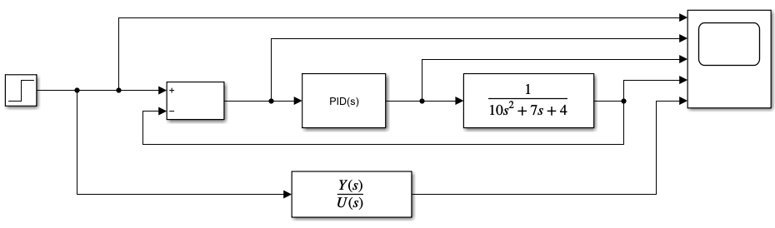
Figure 3 - A Closed Loop system designed to control the CIWS
This closed loop system, detailed in figure 3, is the control system for our CIWS turret, it takes the input through the Proportional-Integral-Derivative (PID) controller, and will output that command to the CIWS turret.
In this system, there is an input that moves into a subtractor logic element before moving to the PID controller, before moving into the transfer function defined by the student ID. All of these components move into an oscilloscope for viewing purposes, and below is another transfer function, which will be used for tuning purposes.
Another part of the assignment is the controller for this system much achieve the goal of turning the CIWS turret to its end position in under two seconds with an overshoot of less than 5%.
The controller’s response curve can be tuned to either more or less aggressive and more or less robust.

2.2 Simulink Simulation of Control System
Constructed in Simulink as per Figure 3, the simulation is run at first to gain a control baseline of the response of the system.
The graph displayed by the oscilloscope, would display the signals as per received by the oscilloscope in figure 3,
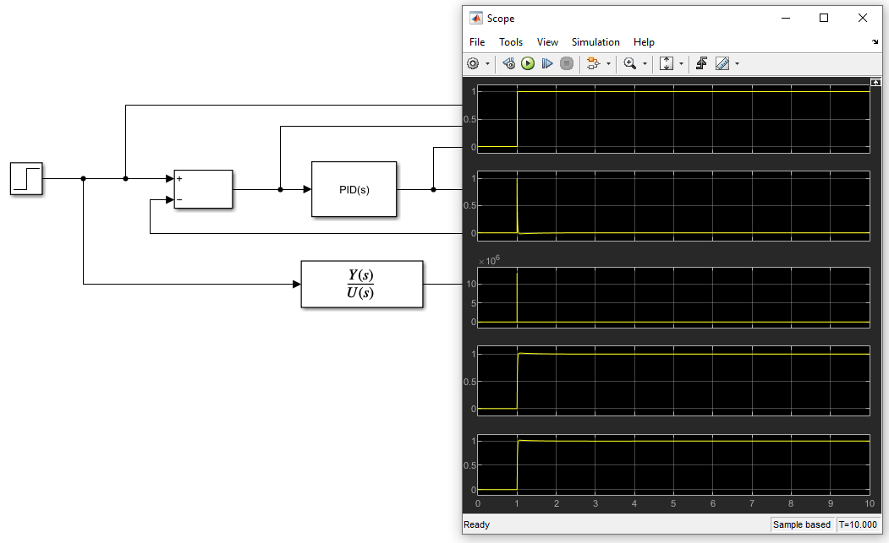
Figure 4 - The Simulink Oscilloscope showing the waveforms of the signal across figure 3, top; Input signal. Middle; Subtract Logic, Bottom; PID Controller.
The other oscilloscope displays would display the original waveform of the PID controller before any fine tuning can be made to change the waveform.
The default waveform would show a long reaction time of over a second before reaching the final value of 1 but overshooting it before overcompensating and falling back below the setpoint, before slowly raising back up and settling at the setpoint a few seconds later.
This default waveform does not meet the criteria of less than a 5% overshoot and fully settled in under 2 seconds. The response curve will have to be adjusted. This is done by changing the parameters in the PID controller.
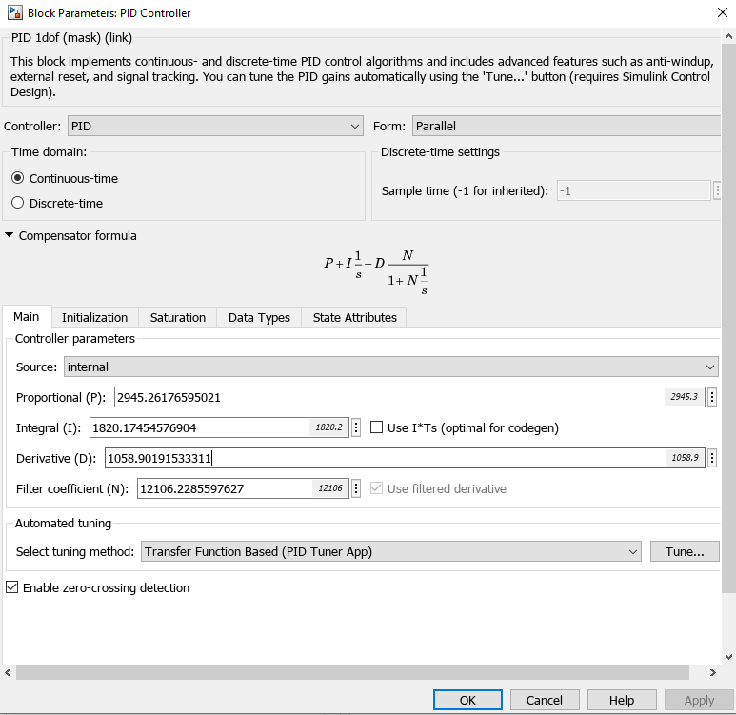
Figure 5 - The PID Controller Parameters
These controller parameters affect the algorithm of the PID controller and its response. Helpfully when selecting the “tune” button within Simulink, it displays an amplitude/time graph, and two sliders that may be use to adjust both the response time and the transient behaviour of the response curve. It suggests a response curve for a generic scenario, though it does not meet the time nor overshoot criteria.
Tuning the graph manually will achieve the criteria.
Once the tuning has been completed the transfer function of the system can be taken and multiplied with the existing transfer function of the process.
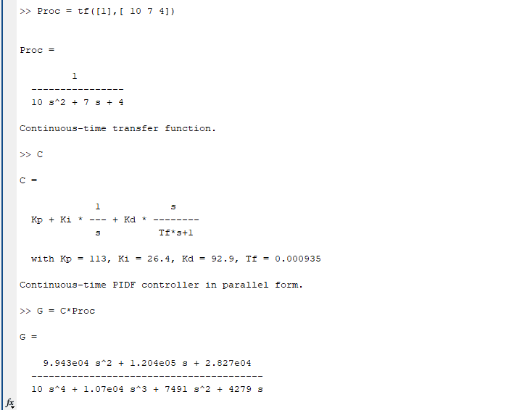
Figure 6 – Multiplying the values obtained from the PID tuning and the transfer function.
The values obtained from the PID tuner were:
Kp | 113
Ki | 26.4
Kd | 92.9
N (TF) | 0.000935
Table 1 - Table of the values obtained from the PID tuner.
These values are multiplied by the existing transfer function of the process (Proc), resulting in calculating the forward path transfer function (G).

Figure 7 – Calculating the forward path transfer function. And assigning graphing plots to the variables.
The forward path transfer function, or “SystemTF”, is the transfer function of the whole system, and it is now expressed currently as a single equation. Though I will assign graphing plots to it to express it as points on a graph.
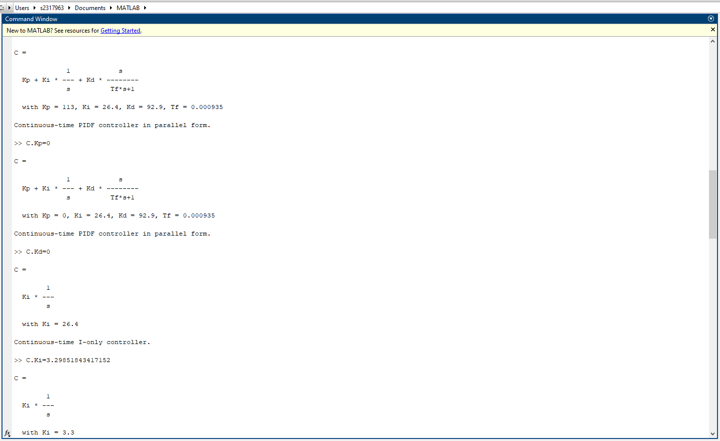
Figure 8 – Original PID values.

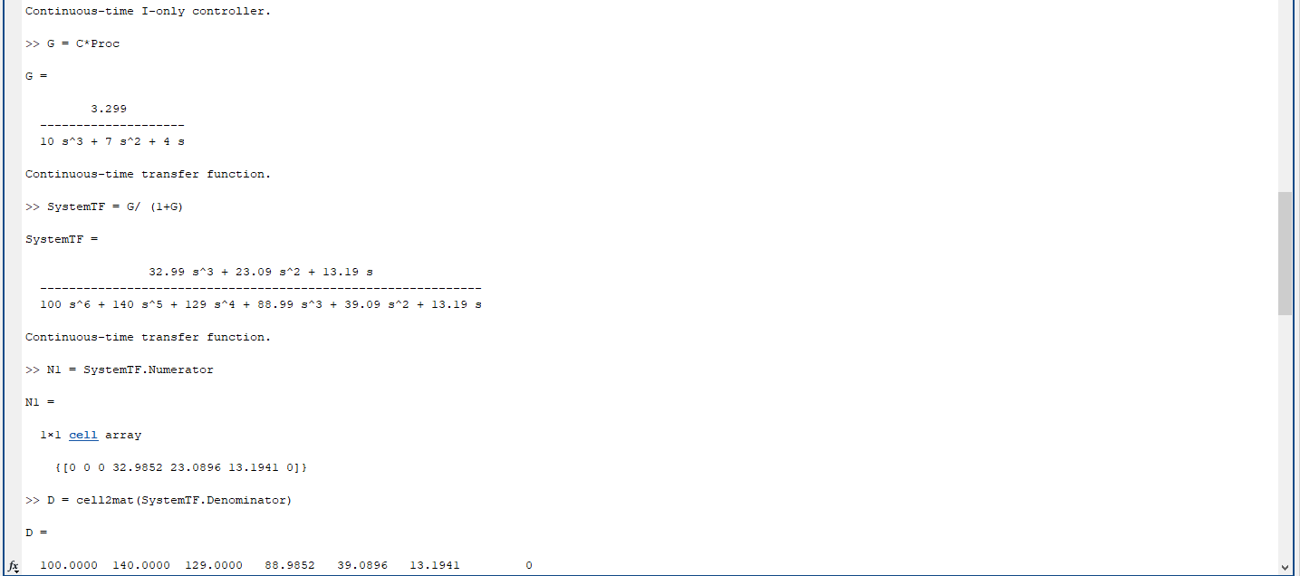
Figure 9 – System TF and beginning to graph values.

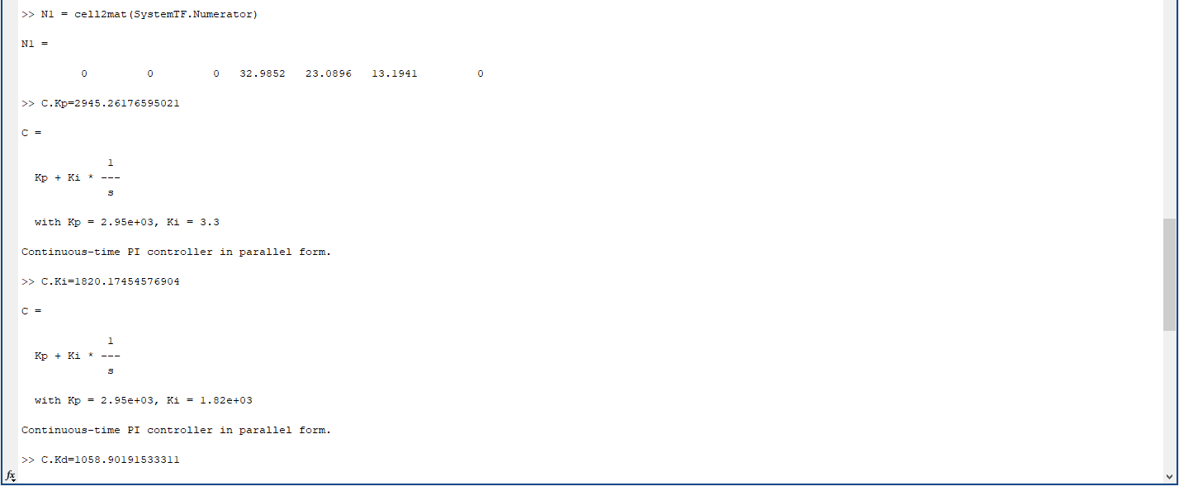
Figure 10 – Graphing remaining values.

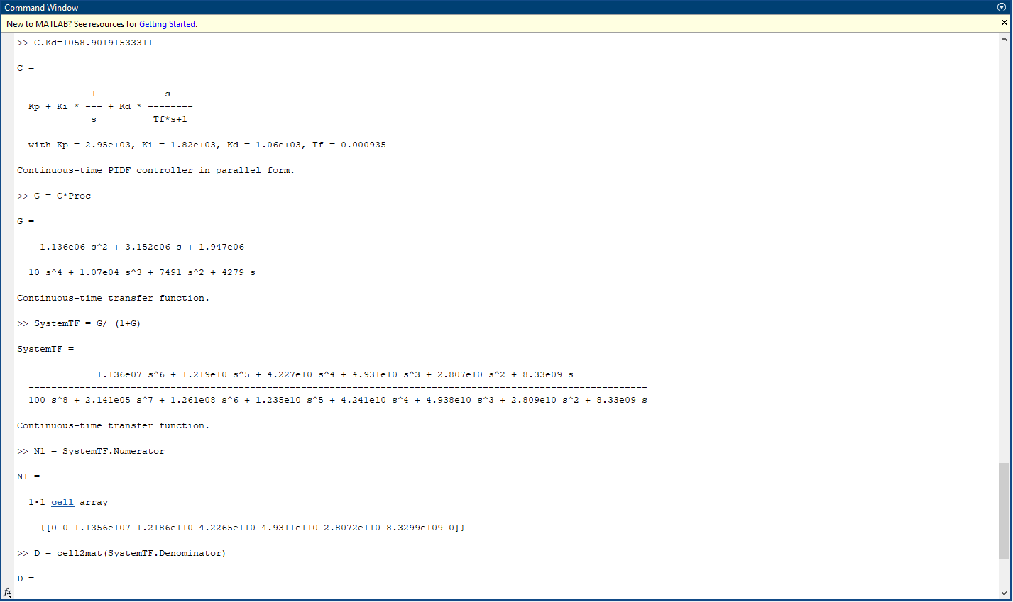
Figure 11 – Final System Transfer Function.
Now that the new transfer function has been obtained it is to be inserted back into the PID to produce the tuned output.
Figure 12 - The tuned output of the PID controller.
The tuned output, seen in Figure 12, in the bottom two oscilloscopes, show a rapid increase of amplitude, before slowing its rate of increase and levelling out with a minimal overshoot before settling at the setpoint well before the 2 second threshold.

2.1 Pole-Zero Plots
Pole-Zero Plots, where poles are positive responses, and zeroes negative responses, show the stability of the created system transfer function (SystemTF), it reveals potential fallouts with the transfer function and areas on the plot where stability issues would occur, such as at the pole, where a potentially infinite value would be observed, or zero, where a null value would be observed. [2]
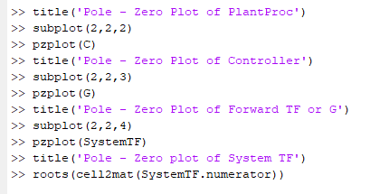
Figure 13 - Plotting the Pole-Zero Diagram
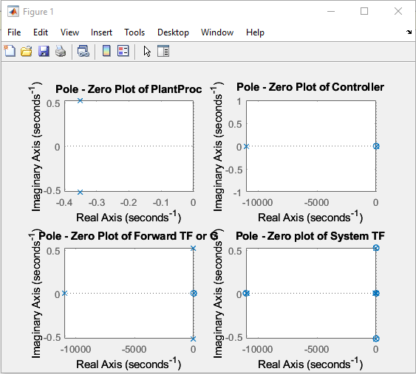
Figure 14 - Pole - Zero Plot Diagram for PlantProc, Controller, Forward TF (G), and SystemTF

2.2 Inferring Information from the Pole-Zero Plots
The information inferable from the Pole-Zero Plots, show that the systems are suitably created for the use case and no excessive oscillation is notable as all the graphs are shown to be in the negative real axis. Should an oscillation occur, it will be dampened and shrink before being eradicated.

2.3 Root Locus and Nyquist Plots
The root locus shows the root locations for a close loop system such as the one created above.
The green region shows an overdamped system indicating a sluggish system, whereas the red indicated underdamping where the system would overshoot the setpoint and oscillate before resulting on the setpoint.
The system shows markers on both ends of the real axis, in the over and under damped regions. Though the criteria for less than 5% overshoot and achieve the set point in under two seconds was achieved.
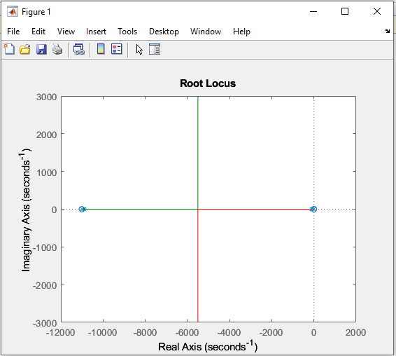
Figure 15 - Root Locus for the above system.
A Nyquist plot also shows the stability of the system. In the plot an anti-clockwise encirclement is visible, though the graph is zoomed in, indicating that the system is stable, if a clockwise encirclement or no encirclement was visible it would indicate that the system was only partially or completely unstable. [3]
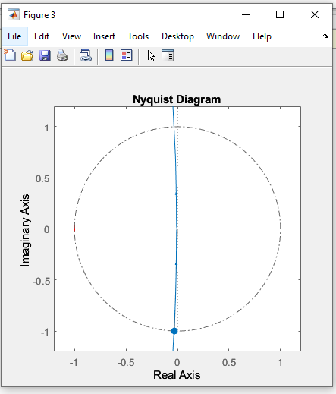
Figure 16 - Nyquist Diagram for the System Transfer Function.

Conclusions
The system created met the desired criteria outlined in the brief, though the chosen PID values and specific tuning may not work for the real scenario. The CIWS turret weighs several tonnes and rotating and stopping the turret will require significant levels of power draw and create significant stress on internal components that may not be desirable or feasible for the level of construction and power draw available.
This system also currently only works with the transfer function defined by the student identification, should another student identification number be used, the system would no longer work, nor does it have any redundancy. Since the student identification system was a stand in for a RADAR, integration with the real-world system would be difficult with the current system transfer function and would need to be improved.

Bibliography

[1] | “Phalanx Close In Weapon System,” General Dynamics Ordnance Technical Systems, [Online]. Available: https://www.gdots.com/armaments/naval-platforms-system/phalanx/. [Accessed 10 01 2026].
[2] | J. Santiago, “S-Domain Analysis: Understanding Poles and Zeros of F(S),” in Circuit Analysis for DUMMIES, Wiley, 2016.
[3] | N. Nise, Control Systems Engineering; International Student Version - 7th Edition, New Jersey: John Wiley, 2013.

Appendices
Appendix A


