Hotel Trinity Employee Engagement and Talented Workforce Retention Strategy

Student no: 2012445 Module BMIH5005
Name: Sibell Andrei Personnel Resourcing & Development
Lecturer: Emily Williams

Table of contents Page number

Executive summary 3
Introduction 4
Employee Engagement 5
Maslow’s Hierarchy of Needs 5
Mental Health 6
Financial Concern 7
Job Insecurity 7
The Importance of Employee engagement 7
Employee Engagement Strategy 8
Employee Retention Strategy 9
Conclusions 10
Reference list 11

Executive Summary
This report analyses the level of Hotel Trinity employee engagement and the importance of a strategy focusing on retaining talented workforce within the hotel. Hotel Trinity is a 5* hotel located in central London, and it employs at the moment 300 workers, 15% less than before Covid19 pandemic.
The discussion within the report will be based on the anonymous online questionnaire created by the HR team and filled by 95% of the current staff and conclusions will be drawn by corelating questionnaire finding with employee engagement theoretical models and strategies.

Introduction
Hotel Trinity is a 5* hotel located in central London with a current 300 permanent workforce. The hotel employs temporary staff during peak hours, but they are not considered within this report. The discussion and conclusions of the report are based on the findings of an anonymous online questionnaire created by HR and filled in by 95% of the permanent staff. The results of the questionnaire corelated with employee engagement and retention theoretical models are the base for the strategy to improve employee engagement and retain talented workforce within Hotel Trinity.
Hotel Trinity, as the whole hospitality industry, has suffered the consequences of the Covid19 pandemic. Tourism and hospitality sector, clearly sensitive to serious shocks just like the Covid19 pandemic, are suffering a sharp drop in demand (Chang et al., 2020). The hotel industry in particular has experienced dramatic sales losses as occupancy rates have largely dropped due to social distancing and the drastic decline in the number of tourists (Sobieralski, 2020).
Employee involvement and satisfaction are vital to the overall performance of any organization. A happy employee builds appropriate relationships alongside their environment to enhance their productivity. The ongoing COVID-19 virus has changed the entire workplace. Each human resource within the working scene endeavours to alter their needs with the necessities of the surrounding environment. Remote working has become very important for the employee to get tuned to this new situation (Prasad et al., 2020). People must live in social isolation and emotional and social distancing due to the lockdown. Industries and companies were forced to keep business alive while Working from Home (WFH) with the help of various online virtual systems such as Hangout Meet, WebEx, Webinars, Zoom cloud, telegram, and many more.
According to Emily Holbrook (2020) the pandemic has led to the growth - or exacerbation of - intellectual health problems along with anxiety and depression. Employees who flee their rooms or workplaces at home spend extra hours, deal with more responsibilities, and deal with the burden in every often-unhealthy way. This can inevitably lead to decrease in employee engagement, cheerfulness, and productivity - and, conversely, to a loss of business for the employer as well.

Employee engagement
Employee engagement has been defined in many ways over the years but what links all the definitions is that the employee engagement goes down to the physiological state experienced by the employees in relation to their job (Bailey, C. et al, 2015). Another definition states that a engaged employee will feel energised, enthusiastic and absorbed by their work, rather than burned out (Schaufeli, W.B. and Bakker, A.B., 2004).

Maslow’s Hierarchy of Needs
Maslow’s Hierarchy of Needs can also be used to explain employee engagement as seen in the picture below:
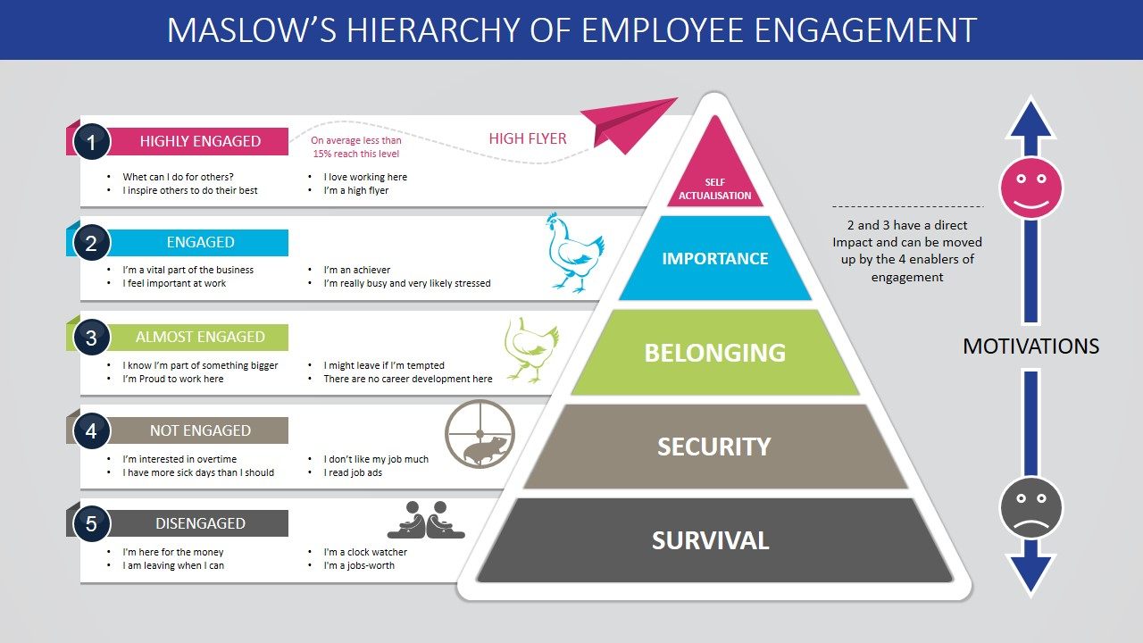
Employees need to have all five levels of needs fulfilled in order to become engaged with their job and maximise the added value to the company. This approach towards employee engagement can be used by the HR department to create coherent staff engagement and retention strategies.
Hotel Trinity HR department takes employee engagement into account when submitting yearly budget proposals and implementing employee related strategies. After reopening in April 2021, the HR department conducted an online survey that all permanent employees were asked to complete in order to have a clear overview of the current employee engagement level. The Covid19 pandemic, lockdown and other personal circumstances have had an important impact on the employees’ mental health and wellbeing resulting in a decrease of the engagement levels within the workplace.
The employee engagement survey complies with the GDPR regulations as Hotel Trinity is committed to ensuring the security and protection of the personal information that is processed, and to provide a compliant and consistent approach to data protection. Any query regarding GDPR compliance can be addressed by the Data Protection Officer or it can be submitted as a Data Subject Access Request.
The results of the survey have shown a 15% decrease in employee engagement level compared to 2019 level focusing on three main areas of concern: mental health, financial concern and job insecurity.
Mental Health
Since last year, 2020, the world has faced a new, uncertain and complicated situation characterized by long-term risk, isolation, unemployment, and financial instability. The pandemic has changed the way we all work or study. Employees have to switch work from home or have been on the furlough scheme which brings a lot of change to their schedule and affects their mental health.
90% of Hotel Trinity employees have been on furlough scheme over the last 18 months, 5% of the employees have been on Work from Home schedule and 5% have been made redundant in the second half of 2020. The uncertainty around the furlough scheme, the new WfH environment and the redundancy of colleagues and friends had a significant impact on the Hotel Trinity employees increasing awareness around the mental health concerns.

Financial concern
Covid-19 has influenced many elements of employee’s lives and financial affairs. Employees are worried about healthcare costs, daily expenses, and how the pandemic will impact their retirement.
The furlough scheme paid 80% of the employee wage being caped at £2,500 which translated into a lower income for 90% of Hotel Trinity employees while all expenses stayed around the same level.
Job insecurity
The pandemic leads people to think about their mortality, which will understandably make them more stressed and are less engaged at work. Employees are concern about their job security as 5% of the Hotel Trinity employees were made redundant during the second semester of 2020. The furloughed employees lived with concern about their own jobs while colleagues, friends and family members lost theirs.

The importance of employee engagement
Employee engagement is important for both employees and employers. Companies have started investing time and money into programs focused on raising the employee engagement level as it is closely linked with the business success or failure.
UK overall employee engagement figures are as follows according to various statistics companies like Qualtrics, Statista or PeopleMetrics:
- UK employee engagement level is 50%, half of the employees the survey done by Qualtrics have said they feel engaged at work. The highest level of employee engagement is attained by France with 55%.
- A study conducted by Statista has found that 73% of UK employees are happy with their job making them more engaged and willing to go the extra mile
- 50% of employees questioned by Qualtrics have agreed that involved managers and support with career progression increases employee engagement
- Companies taking real steps into addressing employee feedback will have an 80% employee engagement rate (Qualtrics)

Benefits of employee engagement
- Engaged employees drive profit for the business, as a research done by PeopleMetrics has revealed that highly engaged employees sell with 20% more than teams with a low engagement rate
- Unengaged employees tend to be late, have more sick days or a lower productivity that can cost the business from $3,000 to $10,000 a year (PeopleMetrics)
- Burned out employees are 63% likely to take sick days (Gallup, 2020)
- Improves productivity through collaboration and communication
- Improves trust and relationships and empowers the employee
- Reduces company turnover
- Improves employee wellbeing and increases job satisfaction

Employee engagement strategy
As seen above, employee engagement has a great impact on the success of a business. Hotel Trinity has seen a drop in the levels of employee engagement after reopening for business in April 2021. The Covid19 pandemic has impacted the hotel employees both on a professional and personal level.
The employee engagement survey conducted by the HR department has revealed three main reasons for concern that have impacted the employees engagement level: mental health, financial concern and job insecurity.
The mental health and wellbeing of Hotel Trinity employees have always a priority for the company. On top of the benefits that were offered before Covid19 pandemic, like free gym and spa access and healthy lunch, the employees will be offered free counselling from trained psychologists and life coaches through webminars and seminars organised every quarter. Also, employees will have a discounted price for accessing 1-2-1 counselling sessions with a private practice within the area.
Financial concern has an important impact on the happiness of the employees and in the end on the engagement level. To address this concern Hotel Trinity will add a 2% to the voluntary pension contribution, will offer a loan for annual ticket allowing employees to spend less on transport and will provide free financial counselling through the HR department. The PR team together with Sales team have negotiated discounted rates for Hotel Trinity employees, with a large number of high street supermarkets and shops.
Hotel Trinity as a business cannot exist without employees but unforeseen circumstances, just like Covid19 pandemic and Brexit, will force the company to make difficult decisions like redundancy. The company cannot guarantee that jobs that are today will still be needed in the future, but it will make sure that all employees are kept up to date will all the law changes and government announcements that have an impact on their jobs. The HR team will send a weekly newsletter to all staff with information regarding the economic climate, changes and updates throughout 2021 and first semester of 2022, it will be reviewed in June 2022. Also, on the staff intranet will be introduced a chat box, managed by a dedicated team, where employees can address all issues related to their job status.

Employee retention strategy
Employee turnover refers to the percentage of employees leavening the business during a period of time, usually 12 months term, regardless of the reason (retirement, redundancy, voluntary or involuntary leavers). A high level of employee turnover will translate into higher costs for the employer therefore retaining talented workforce has become a priority for Hotel Trinity, especially in the context of Covid19 pandemic and Brexit.
The Covid19 pandemic and Brexit had a great impact on UK workforce. Hotel Trinity has lost valuable employees as a consequence of Brexit EU employees leaving UK during lockdown period and redundancy as an effect of the pandemic.
When reopened in April 2021, Hotel Trinity has faced the same issues as the whole hospitality industry: a smaller workforce and less candidates to fill in the job openings. As a result, a strategy for retaining the workforce was created and planned to be put into action during the next 12 months.
Alongside fair pay meeting the average for the industry in London area, Hotel Trinity will offer flexible working hours creating different schedule patterns to fit in most of the employees needs, as an example an F&B employee could cover a four hours shift in the morning for the breakfast rush and another four two hours in the restaurant in the evening, this way creating a balance between job requirements and childcare needs.
A feedback chatbox will be available on the staff intranet and employees will be encouraged to leave any type of feedback and a HR team member will address the issue. The action taken on the back of the employee feedback will be included into the weekly newsletter.
Hotel Trinity will enable employees to have cross skilling training days every quarter and encourage managers to discuss employees’ expectations and desires towards career progression and development during the monthly 1-2-1 meetings.
An important impact on retaining employees has the care for their wellbeing. Hotel Trinity offers its employees access to the hotel gym and spa, healthy lunches and free wellbeing webminars and seminars. Also, the employees will be offered two nights all inclusive, with access to all the facilities, stay at the hotel during a calendar year.

Conclusions
Covid19 and Brexit have impacted employers and employees bot on a professional and personal level. Employers were forced to close business for 18 months and make difficult decisions like letting go of a part of the employees. Employees were faced with the uncertainty of the job, loss of income and high level of stress regarding personal health and safety.
Returning to business in April 2021 meant that both employers and employees had to adapt to new rules and regulations in order to resume services. The employees returning to work after a year and a half were less engaged and more likely to leave the company if their needs and desires are not met. Companies have adapted their HR strategies in order to become more flexible, treat employees fairly and look after their wellbeing in order to retain the experienced employees that add value to their business.
Reference list
- Bailey C, Madden A, Alfes K, Fletcher L, Robinson D, Holmes J, et al. Evaluating the evidence on employee engagement and its potential benefits to NHS staff: a narrative synthesis of the literature. Health Serv Deliv Res 2015;3(26)
- CIPD (01.11.2021) Employee Turnover & Retention. Factsheet. Available at: Employee Turnover & Retention | Factsheets | CIPD. (Last accessed 02/12/2021)
- CIPD. (27/01/2021) Employee engagement and motivation. Available at: Employee Engagement & Motivation | Factsheets | CIPD (Last accessed 02/12/2021)
- Cai, W., Khapova, S., Bossink, B., Lysova, E., &Yuan, J. (2020). Optimizing employee creativity in the digital era: Uncovering the interactional effects of abilities, motivations, and opportunities. International journal of environmental research and public health,17(3), 1038
- Chang et al., 2020 A charter for sustainable tourism after COVID-19 Sustainability, 12 (3671) (2020), pp. 1-4
- Chanana, N. (2020). Employee engagement practices during COVID‐19 lockdown. Journal of Public Affairs, e2508.
- Furlough Scheme Extended and Further Economic Support announced (2020). Available at: Furlough Scheme Extended and Further Economic Support announced - GOV.UK (www.gov.uk) (Last accessed 02/12/2021)
- Guide to General Data Protection Regulation (2021). Available at: guide-to-the-general-data-protection-regulation-gdpr-1-0.pdf (publishing.service.gov.uk) (Last accessed 02/12/2021)
- Holbrook, E. (2020). LOCKED DOWN ANDSTRESSED OUT: The Impact of COVID-19 OnMental Health. Risk Management ,67(9), 20-24.
- J.B. Sobieralski COVID-19 and airline employment: insights from historical uncertainty shocks to the industry TRIP, 5 (100123) (2020), pp. 1-9
- Martin, M. (21/06/2021). 22 Valuable Employee Engagement Statistics In 2021 Available at: 22 Valuable Employee Engagement Statistics In 2021 (thecircularboard.com) (Last accessed 02/12/2021)
- Prasad, D. K., Rao, M., Vaidya, D. R., & Muralidhar ,B. (2020). Organizational climate, opportunities, challenges, and psychological wellbeing of the remote working employees during COVID-19 pandemic: a general linear model approach with reference to information technology industry in Hyderabad. International Journal of Advanced Research in Engineering and Technology (IJARET), 11 (4).
- Risley, C. (2020). Maintaining Performance and Employee Engagement During the COVID-19 Pandemic. Journal of Library Administration,60(6),653-659.
- Schaufel, W.B. & Bakker, B.B. Journal of Organizational Behaviour J. Organiz. Behav. 25, 293–315 (2004) Published online in Wiley Interspine (www.interscience.wiley.com). DOI: 10.1002/job.248 Job demands, job resources, and their relationship with burnout and engagement: a multi-sample study Department of Psychology and Research Institute Psychology and Health, Utrecht University, Utrecht, The Netherlands
- Stephanou, A. (01/04/2020) 10 Reasons Why Employee Engagement is Important. Available at: 10 Reasons Why Employee Engagement Is Important (careeraddict.com) (Last accessed 02/12/2021)
- Wok, S., & Hashim, J. (2015). The moderating effect of employee relations on networking towards workplace happiness among married women in Malaysia. Procedia-Social and Behavioural Sciences ,211, 306-312
- Timms et al., (2015) Flexible work arrangements, work engagement, turnover intentions and psychological healthAsia Pac. J. Hum. Resour., 53 (2015), pp. 83-103

