
Datacentre Technologies and Proposal for Enhance System Architecture for the University of Manchester.

Modou Pene
University of Trinity Saint David
1810381@student.uwtsd.ac.uk

Abstract
Those in favour of datacentres have recently promoted them as an effective long-term solution to the problem of the internet gradually becoming ossified. Datacentres enable flexibility, variety, security, and management by allowing several heterogeneous network designs to coexist on a common physical network. As well as the past and current state of the art in datacentres, this paper will also look at the long-term difficulties that must be solved in order to arrive at a feasible solution.
Keywords Datacentre architecture.

Introduction

Datacentre it is the engine room that house servers, storage, uninterruptible power supplies and all the equipment that allows to govern the processes, communication as well as the services that support any business activity. In a nutshell, it is datacentres that guarantee the operation 24 hours a day, every day of the year, of any information system. The datacentre today represents the beating heart of the business. Additionally, it offers all operational assistance according to the different structures in the sphere of process digitisation, data processing, the defining of computer networks, and information systems design and implementation Included in this category are all support applications, as well as integration and contact with systems outside of the organisation. [1]
In this paper we will detailed and comprehensive guide to datacentre, we will see in depth what a datacentre is and after the merging of the two Universities how the University of Manchester can enhance his IT operation and other insights into the datacentre such as network topology, management faulty tolerance, performance, scalability, energy usage and sustainability and security.

Before going through the details of these basic aspects, let’s remember that today, when we talk about datacentres, we often no longer think of a physical place because datacentre is now by definition hybrid. More and more often it is composed of:

- In house environment.
- Private cloud and public provided by different providers.

DATACENTRE OVERVIEW

Highly specialised structures, organised to allow maximum functional efficiency to devices, systems and services, it is the datacentres that ensure global business continuity. Thanks to stable and redundant connectivity systems, or through a duplicated configuration that guarantees operational continuity in the event of one or more system failing. This is to always guarantee maximum functionality. The entire infrastructure of a datacentre is centred on network that the IP protocol and connect machines and application to each server farm host different set of routers for example: network devices that are responsible for routing data, divided into packets, between different subnets. It also houses switches designed and configured to carry data traffic bi-directionally between servers and the rest of the world.
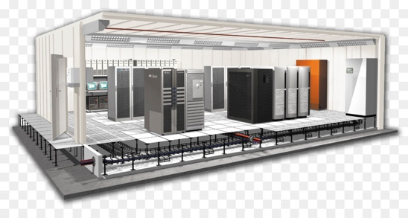

Fig 1: Datacentre Design [2]

Inside a datacentre, in addition to servers, there are various data storage systems, various IT systems for monitoring, controlling and managing machine, application and telecommunication infrastructures as well as all accessories connected to them. To ensure the operation and full efficiency of the machines, in addition to uninterruptible power supplies (UPS centres), the datacentre provide very special air conditioning and environmental control systems, fire prevention system and advanced safety system. [1][3]

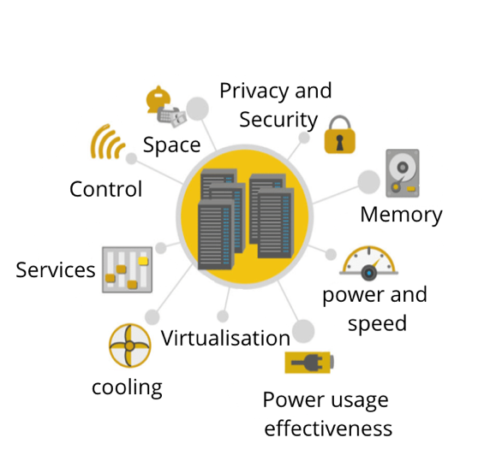

EQUIPMENT | STRUCTURE | INTELLIGENCE
SERVER  STORAGE  SWITCH  ROUTER  FIREWALL  APPLIANCE | Primary machine room  Secondary machine room  Wired building  In accordance  Protected  With dedicated personal | Application Systems  Monitoring Systems  Virtualisation  Auto-repairing systems  Measuring systems  Security System
INFRASTRUCTURE
CABLE UPS
TRUNK CRAC System (Computer Room Air Conditioner)
RACK HVAC System (Heating, Ventilating Air Conditioner)
CABINETS Exhaust systems
SHELVES Monitoring System and Control
CASE Surveillance systems
Fig 2 Datacentre concept

Datacentre classification

Designing a datacentre is extremely complex. Building a centralised, suitable and performance environment for the University of Manchester, equipment in good proportions high-level structures of safety, trustworthiness and efficiency when it comes to providing services is not easy. For this reason, a reference standard was created. The best practices for building a datacentre, follow the TIA-942 standard. In the TIA-942, are indications on the following definition of spaces and the design of the datacentres, on the realisation of the wiring, on the environmental conditions.
The guidelines also include a classification of datacentre according to 4 levels, called TIER mean the system for identifying the structure of a datacentre. The first is the basic one, in which operational continuity has deltas of interruption times of almost 30 hours a year. It seems like a small number, but it isn’t. Think about what is means for the University of Manchester to be unavailable even for only two or three hours of service, it may impact the university activities. It is therefore clear why, depending on the core business, it is necessary to aim for the higher levels. [4]

TIER I and II datacentre
To be classified as a Tier I datacentre, an IT infrastructure requires the use of a dedicated room separated from the office areas, plus a UPS to filter power peaks and drops, an air conditioning system operating 24 hours a day and a power generator. Therefore, these are the minimum requirements to define, nowadays, a datacentre capable of supporting a company that does not need high performance and security levels

By introducing the Tier II category, we start talking about redundant component and therefore real resistance to adverse circumstances: to be defined tier II, a datacentre requires partial redundancy in the field of electrical and cooling components but is not yet a level suitable for those companies that require rigorous uptime as each maintenance operation involves a reduction in capacity. [4] [5]

TIER III datacentre
Huge step forward in business continuity is offered by the TIER III datacentre, which add a redundance branch for both power and cooling including subsystems to the specifications of the underlying level, thus offering an average availability of 99.982% on an annual basis. TIER III introduces the concept of concurrent maintenance of components, which means being able to intervene on any component that is decisive for the purpose of the service without causing discontinuity. [4][5]

TIER IV datacentre
Finally, let’s talk about the TIER IV, the highest and most prestigious level, so much so that is has been assigned to only few datacentres throughout UK and true reference point for anyone who must host their mission critical application. Here too we start from the previous TIER specifications but add the concept of fault tolerance: in practice, a TIER IV datacentre must be able to tolerate the cumulative impact of failure on multiple systems and components, managing operational continuity without any human intervention, for an annual uptime level of 99.995%. [4][5]

DIFFERENT BETWEEN DATACENTRE AND CLOUD

Virtualisation-based private cloud software is rapidly being used in datacentres to provide automation, self-service, and invoicing / chargeback features to datacentre administration. Individual users will be able to supply workloads and other computing resources on demand without the need for IT administrators.

Datacentres are also increasingly able to communicate with public cloud providers. The hybrid usage of on-premises datacentres with Azure or other public cloud resources is emphasised by platforms like Microsoft Azure. In the end, datacentres are not eliminated but rather a dynamic environment is created that allows companies to execute workloads locally or in the cloud, or to transfer those instances to or from the cloud as needed. [6]

BACKGROUND
Throughout the following section, we will first provide a brief overview of datacentre technologies, highlighting the most important concepts.

Datacentres have existed since the 1940s and with the first computer systems such as the Electronic Numerical Integrator and Computer (ENIAC). A tangle of cables connected all the necessary components of these early machines. They were difficult to maintain and operate. Furthermore, the military made use of them, so specialised computer rooms were needed to store all the equipment and implement security measures. These required racks, cable trays, cooling mechanisms, and access restrictions. In the 1990s, as IT operations became more complex and inexpensive networking equipment became available, the term datacentre first became popular. It has become possible to store all the necessary servers of a company in one room within the company. These specialised computer rooms have been dubbed datacentres within companies and term has caught on. [7]

Around the time dot-com bubble in the late 1990s, the need for the internet speed and constant Internet presence for businesses required larger facilities to house the amount of network equipment needed. It was at this point that datacentre became popular and began to resemble the ones describe above. Throughout the history of computing, as computer became smaller and networks larger, datacentre has evolved and moved to accommodation the necessary contemporary technology. [8]

RESEARCH METHODOLOGY
In order to conduct this research, a vast amount of academic study has already been done on the role that allow us to recommend a suitable datacentre architecture that will promote the University of Manchester to centralise their IT operations. Inductive research methods were used in this study. It is based on particular observations that are then utilised to develop generalised hypotheses and conclusions from the research.

DATACENTRE TOPOLOGIES AND ARCHITECTURE
A datacentre networking is a cabling infrastructure layout and how servers are connected to switches should find the right balance between stability, efficiency, flexibility expandability and charge. It should also be capable of supporting both current and future application and speeds. The following are important consideration when choosing a datacentre architecture:

- Actual datacentre size
- Datacentre expansion is expected
- In case a new construction is being built or a system is being upgraded.

TOPOLOGIES
Currently, there are three primary types of datacentre topologies in use, each with its own set of pros and disadvantages. Indeed, larger datacentre may implement two or perhaps all three of them in the same datacentre.

- Centralised datacentre
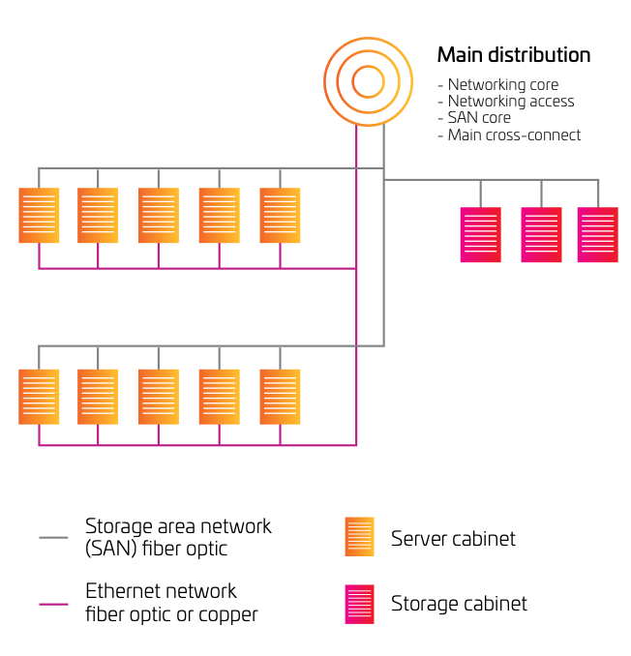
This is a good topology for smaller datacentres because it is centralised A space of less than 5,000 square feet. In the diagram, separate LANs are in use and SAN environments, The servers are tethered to the switches in the primary distribution area, which go to each of the server cabinets and zones in each environment.

Fig 3: Centralised datacentre [9]
As a result, port switches may be used more efficiently, and components can be managed and added more easily. While the centralised topology works well for smaller datacentres, its limitations make it difficult to expand. Because of the enormous number of long-distance cable lines necessary in larger datacentres, cable paths and cabinets become congested, increasing costs. However, while some bigger datacentres employ a zoned or rack-to-rack design for LAN traffic, they may also use one for the storage area network (SAN). SAN switches are cost-effective when their utilisation is high. This is particularly true when the ports are expensive.[10]

- ZONED

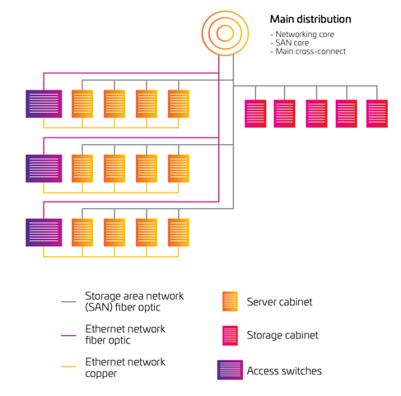
In a zoned network, switching resources are dispersed throughout the system. For example, end-of-row (EoR) switches could be used to support a single server cabinet, while middle-of-row switches are used to support numerous server cabinets. Datacentre Standards ANS/TIA-942 have advised the use of this approach because it is scalable and predictable. When it comes to cost-effectiveness, zoned architecture is usually the best choice, since it maximises switch and port utilisation while minimising cabling expenses.

Fig 4: Zoned datacentre [9]

In some instances, end-of-row switching gives performance advantages. In order to achieve low latency port-to-port switching, two servers (that exchange substantial quantities of information) might have their LAN ports put on the same switch. A possible downside of end-of-row switching is the need to run wire back to the end-of-row switching device. There might be additional cabling needed in a top-of-rack design if every server is connected to redundant switches.[11]
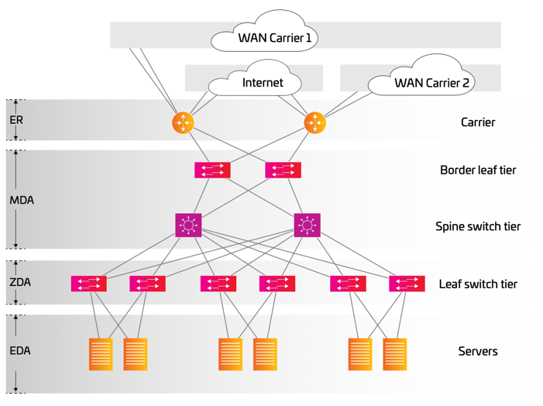
- TOP OF RACK
Two or more switches are installed on top of each server cabinet according to this design. This architecture can be used in dense 1RU server configurations. All servers in the rack are connected to both switches, ensuring redundancy. As a result, they are also connected to the next switch layer through uplinks. Consequently, cable management at the top of the rack has been greatly reduced, as has the necessity for cable containment.
Also, the uplink bandwidth will not be oversubscribed in the future, allowing fast port-to-port switching for servers in the rack.

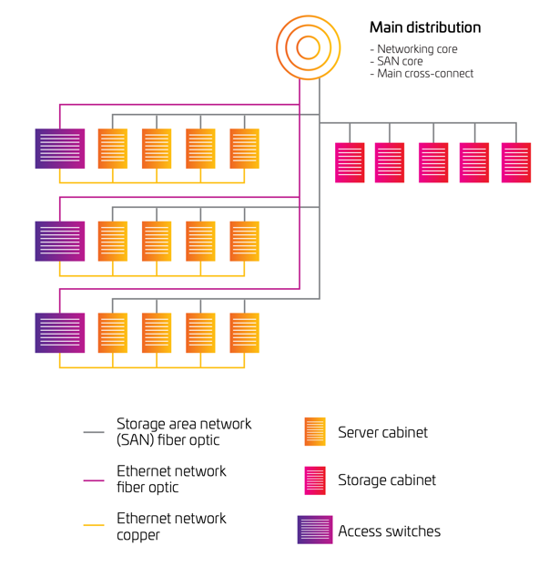

Fig 5: Top Rack datacentre [9]
A top-of-rack design makes better use of cabling. The downsides are frequently an increase in switch costs and a significant cost for port underutilisation. It can be challenging to monitor top-of-rack switching in most large deployments, and switch gears in server racks can overheat due to regional area network (LAN) traffic. So, some datacentres use top-of-rack switches in the middle or end of each row to maximise the number of ports accessible and to reduce the overall number of switches. [11][12]

ARCHITECTURE

- MESH TOPOLOGY

Mesh network architecture, often known as network fabric or leaf-spine, is made up of interconnected leaf-and-spine switches. This architecture is particularly suited for delivering universal cloud services because the mesh of network lines provides any-to-any connectivity with predictable capacity and decreased latency. The mesh network is naturally redundant for enhanced application availability, thanks to various switching resources scattered across the datacentre. When compared to very large, traditional centralised switching platforms, these dispersed network topologies can be significantly more cost-effective to construct and scale. [11][13]
Fig 6: Mesh topology [9]

- THREE-TIER AND MULTITIER

When it comes to complexity, multi-tier architecture is the most effective a widely used design. in a corporate datacentre There are three primary server tiers in this architecture: applications, database and web, which are based variety of platforms, including blade servers, 1RU servers, and mainframe systems.[14]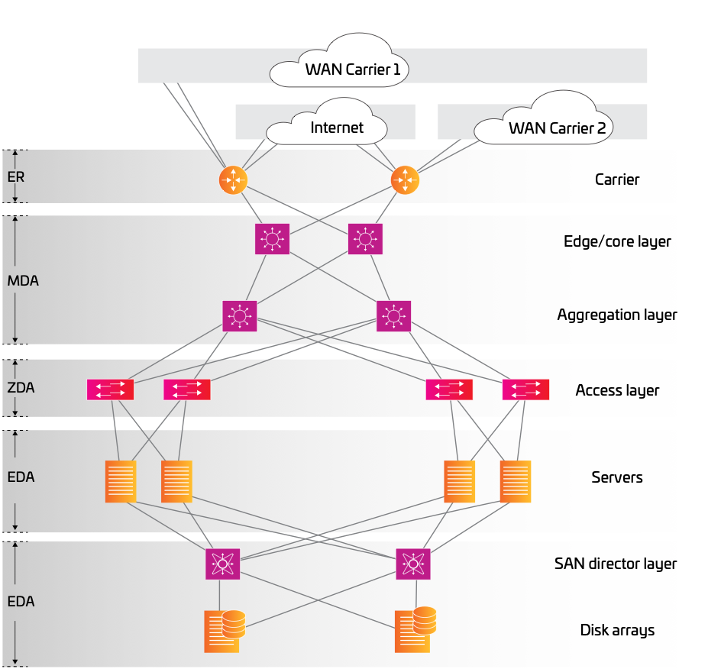

Fig 7: Three tier and multitier [9]

- POINT OF DELIVERY MESH
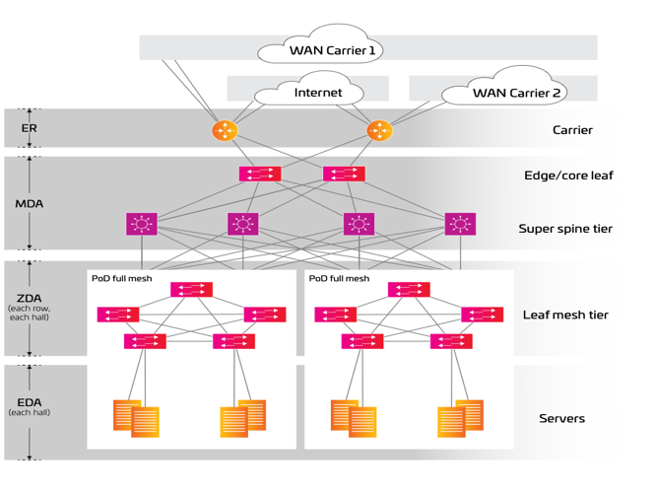
Multiple leaf switches are interconnected within the PoDs, with spine switches typically aggregated in a central primary distribution region in the mesh point-of-delivery design (MDA). Multiple PoDs may be connected
Fig 8: Point to point delivery [9]

effectively to a super-spine with this architecture, among other advantages. A three-tier topology can be simply extended by adding new infrastructure to allow low latency east-west data flow for cloud applications. It is possible to add low latency computation and storage resources to existing PoD networks without disturbing the current environment.

Hyperscale organisations that install large-scale datacentre infrastructures or campus-style datacentres often use super spine architecture.
In this way, vast amounts of data can be sent from east to west via data halls.[15]

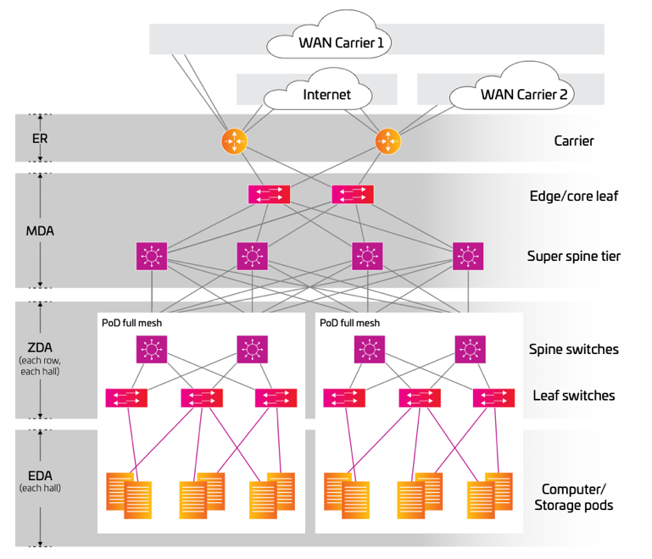

Fig 10: Spine architecture [9]

DATACENTRE CONNECTIVITY

Users expect optimal performance from the datacentre’s network, which connects the datacentre servers. In addition to datacentre dependability, network capacity, fault tolerance, latency, and routing efficiency are also impacted. There are a few common design goals of datacentre networks. They are high scalability and fault tolerance as well as low latency together with large network capacity.

Scalibilty

Physical scalability is essential to accommodate the growing demand for improved performance and services. Routing algorithms should also be adaptable and flexible to accommodate the new enhanced interconnectivity, as well. [16]

Fault Tolerance

Failsafe architecture allows systems to carry on with their present tasks even if they encounter problems. Good fault tolerance in network architecture may be achieved by redundant physical connections and fault-tolerant routing techniques such as Load Balancing. Detection of failures should also be rapid and accurate.[17]

LATENCY
Most of the network latency is caused by buffer queuing time at each hop, transmission delay, and propagation delay. A reduced network width that decreases latency should be provided as a regular feature of the network architecture in order for the datacentre to deliver quicker services.[18]

DATACENTRE MANAGEMENT

Technical and IT problems in the datacentre are the responsibility of a datacentre manager. Data protection, data security, and computer and server operations are all part of this. Typical datacentre management tasks include the following:

- Software, hardware upgrade and Operating System
- Data distribution and storage management
- When it comes to backup procedures,
- Technical assistance

Datacentre management components

Management tools are needed for datacentre infrastructure, such as network and power equipment as well as applications software and services. the tools that enable are the following:

- Automation of infrastructure modifications, while offering a single source of information and a consolidated view across all facilities, IT hardware, networks, and applications in a centralised location.
- Information about the datacentre status and any modifications to any systems or locations is monitored.
- A datacentre efficiency may be improved by collecting and analysing information on power, space, and capacity.
- Procedures for identifying disaster recovery strategies in case of failure, including failover procedures and processes. [19]

DATACENTRE EFFICIENCY
There are several subsystems and electrical components that make up datacentre power management, and they are the most major cost factor. They are also the most important factor when it comes to the uptime of the server farm's infrastructures.

Uninterruptible power supply (UPS) and power distribution unit make up the electrical distribution system in datacentres (PDU). As a result, each IT cabinet is fed a series of circuits via wiring housed in rigid or flexible tubes situated beneath the elevated floor. As a result of the redundancy, power chain is cloned within the datacentre according to the Tier III or Tier IV certification to which the datacentre refers. Static Transfer Switches are used in conjunction with preferred power routes and bypassing systems to provide this redundancy (STS). There is no interruption in the load since they may switch power lines without interrupting the load. [20]

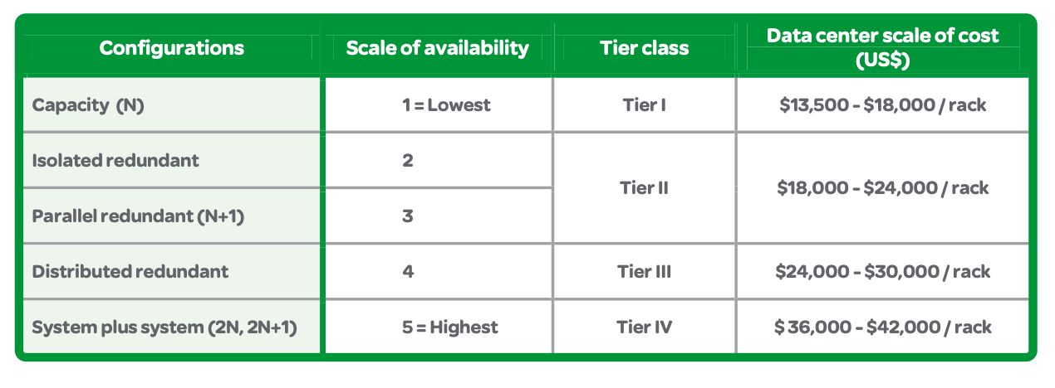
Fig 11: Datacentre scale cost [21]

Datacentres consume
According to a study published by the academic journal Science, a large datacentre located in a single building can consume 205 terawatt per hours

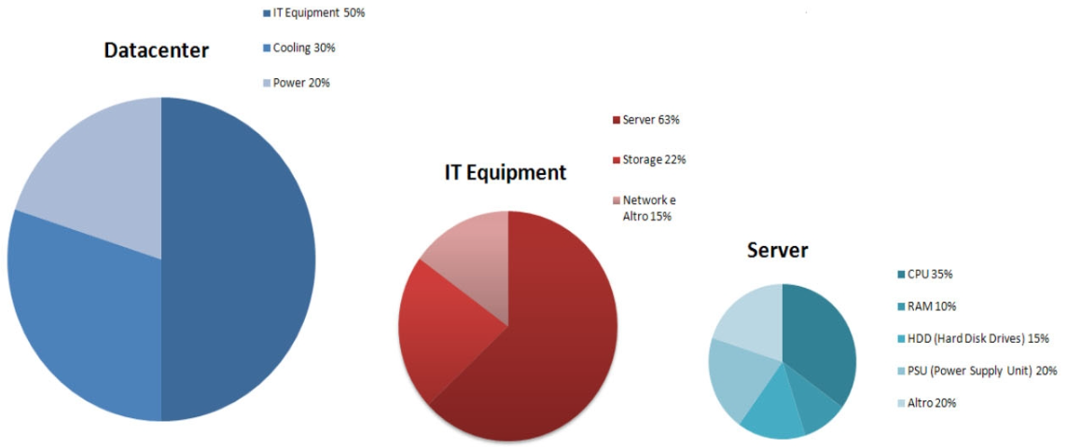
Fig 12: Datacentre consume [21]

Most of the consumption of a datacentre derives from the cooling system used to maintain a constant temperature of the rooms: between 20/22 ° C in both winter and summer. Systems that remove heat from datacentres include CRAC units (air conditioners for computer rooms). They also include associated subsystems, such as chillers, cooling towers, condensers, pipelines, pump assemblies, piping, and rack or row cooling systems.

PUE (Power Usage Effectiveness)
In order to determine how efficiently a datacentre uses the energy that supplies it, the PUE is employed as a unit of measurement. In terms of auxiliary services such as air conditioning or UPS losses, this parameter determines how much electrical power is allocated to powering the IT equipment.
In detail, the PUE is the ratio between the total power absorbed by the datacentre (PT) and that used only by the IT equipment (PIT). A PUE value of 1 (optimal measure) indicates that all the energy absorbed by the system is used for IT equipment.[21]

DATACENTRE SECURITY
Additionally, datacentre projects must employ rigorous security measures. In the design of doors and access corridors, for example, security is frequently reflected in the placement of large and heavy IT equipment as well as the ability of staff to access and repair infrastructure.

One of the main safety areas is fire control, which is hampered by the usage of sensitive, high-energy electrical and electronic devices. Datacentres, on the other hand, utilise environmentally friendly chemical fire suppression systems, which efficiently extinguish a fire by controlling oxygen and minimising collateral damage to the technology they contain. Comprehensive security measures, including badge access and video surveillance, are necessary since the datacentre is also a crucial corporate asset.
When it comes to the protection of logical information, data centres have implemented firewalls, intrusion detection systems (IDS) to monitor servers, and persistent monitoring systems for network services. As a governance asset, disaster recovery policies are also defined. Both of these technologies allow for the simultaneous and asynchronous replication of a datacentre onto a second infrastructure that is an identical clone of the original. " In order to ensure company continuity, the structure must be relocated to a new geographic region. [22]

PROPOSAL DATACENTRE ARCHITECTURE FOR THE UNIVERSITY OF MANCHESTER
after having carried out a complete study on the datacentres and showing all the characteristics that are composed to have an integrated system and thanks to the research we have conducted, according to the request from the University of Manchester, the architecture that will be compatible with their needs will be the Fabric datacentre.

Fabric Datacentre
Two and occasionally three layers of highly linked networks, called a fabric, are used in this contemporary datacentre design. By flattening the network architecture, unlike typical multi-tiered systems, a datacentre fabric reduces the distance between endpoints in the datacentre. As a result of this paradigm, it is extremely efficient and has a low latency.
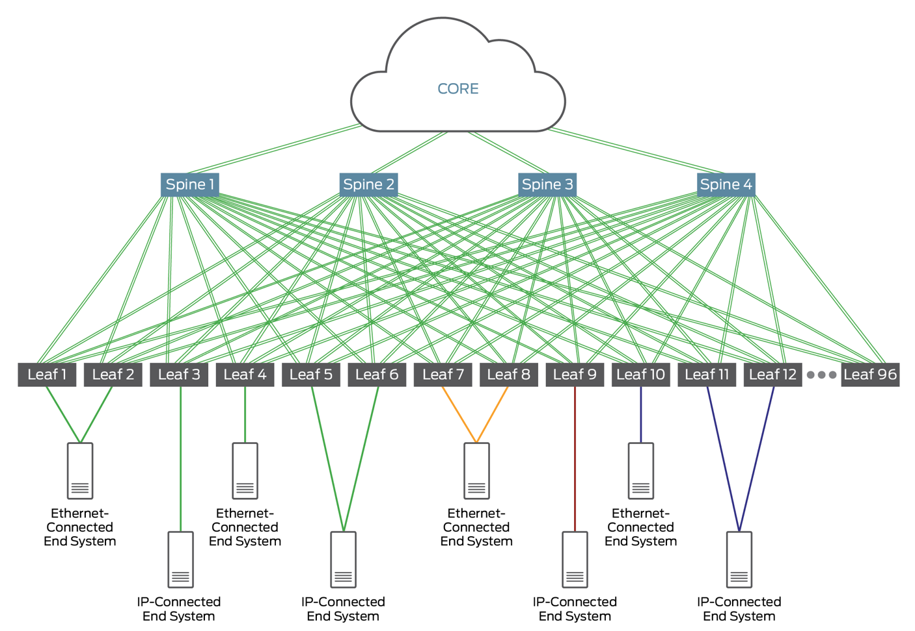
Fig 13: Fabric architecture [23]
All sorts of datacentre textiles have one thing in common: they're meant to be durable. A strong level of connection is provided in the physical network and the complexity of supplying network virtualisation, segmentation and workload mobility is transferred to an overlay that sits on top of the fabric, therefore simplifying the delivery of services. Underlay refers to the cloth itself when it is used in conjunction with an overlay.

Benefits of using Datacentre Fabric
It's no secret that datacentre traffic patterns are changing as applications transition from monolithic to disaggregated and microservice-based architectures North-South, between devices within and outside the datacentre, then east-west between devices inside the datacentre is where they flow.
While moving beyond monolithic apps, organisations take an agile IT approach, delivering applications quickly and in small increments, as well as keeping up with the rapid changes in the transportation industry. Virtual workloads, such as containers and virtual machines, are also used by many to allow quick capacity changes over time on a lower number of physical servers. In order to satisfy these demands, traditional hierarchical datacentre network architectures are not suited for use. Because of this, many companies are replacing their hierarchical networks with more flexible and flatter datacentre fabric structures.
Because the fabric has no network core, it alters the basic essence of network itself.

- A typical hierarchical network's intelligence can be brought to the core (for example, to apply policy), but a spine and leaf fabric's intelligence is pushed to the periphery. ToR switches, for example, or endpoints with fabric-connected devices implement it (workloads). Leaf devices use Plug devices as a transit layer. Spine-and-leaf fabrics easily adapt to places on the network where east-west traffic flows occur, which is not the case in a traditional hierarchical model.
- In a spine-and-leaf fabric that runs east-west or north-south, all traffic is identical. As many gadgets are used to process it. As a result of this mode, it is possible to create fabrics that have strict criteria for delay and jitter.

The capacity of a spine-and-leaf fabric, on the other hand, may easily be increased. In addition to the current plugs and Leaf devices, you may install any additional ones you require. With this technique, spine-and-leaf fabric can be "horizontally scaled" in the same way as servers and services can be by adding additional devices in parallel. On the contrary, in a conventional hierarchical paradigm, scaling-up involves adding additional capacity to existing devices in order to increase their performance.[24]

CONCLUSION
The IT industry is in the process of or during a development phase towards fully virtualized unified datacentres. This requires more than just server consolidation through virtualization technologies. Applications, servers, storage and network infrastructures should form an agile and flexible environment to quickly adapt to changes, thanks to the Fabric datacentre the University of Manchester can large their datacentre without requiring further deployment of their network needs in both the short and long term. The creation of a datacentre factory is therefore a critical step for the University, because will need high surveillance and monitoring system that can detect system failure and replicate service in other servers ensuring the continuity of all system that lecturer and students will need.

Reference
- Rethinking the Data Center Networking: Architecture, Network Protocols, and Resource Sharing", Ieeexplore.ieee.org, 2021. [Online]. Available: https://ieeexplore.ieee.org/document/6990724. [Accessed: 25- Aug- 2021].
- C. Tim Kuhlman, "Data Center Design: Weaving the Fabric Network - TEECOM", TEECOM, 2021. [Online]. Available: https://teecom.com/data-center-design-weaving-the-fabric-network/. [Accessed: 25- Aug- 2021].
- C. Sarka, (PDF) Data Center Network Design", ResearchGate, 2010. [Online]. Available:https://www.researchgate.net/publication/272677621_Data_Center_Network_Design. [Accessed: 25- Aug- 2021].
- M. Rashid, (PDF) Data Center Architecture Overview", ResearchGate, 2019. [Online]. Available: https://www.researchgate.net/publication/334374013_Data_Center_Architecture_Overview. [Accessed: 25- Aug- 2021].
- Demystifying Data Center Tier Ratings: Make An Educated Choice", phoenixNAP Blog, 2021. [Online]. Available: https://phoenixnap.com/blog/data-center-tiers-classification. [Accessed: 26- Aug- 2021].
- Businessnewsdaily.com, 2021. [Online]. Available: https://www.businessnewsdaily.com/4982-cloud-vs-data-center.html. [Accessed: 26- Aug- 2021].
- W. Tschudi, T. Xu, D. Sartor and J. E Sourc, Osti.gov, 2014. [Online]. Available: https://www.osti.gov/servlets/purl/838173. [Accessed: 26- Aug- 2021].
- Woods, "The evolution of the data center : Timeline from the Mainframe to the Cloud - SiliconANGLE", SiliconANGLE, 2014. [Online]. Available: https://siliconangle.com/2014/03/05/the-evolution-of-the-data-center-timeline-from-the-mainframe-to-the-cloud-tc0114/. [Accessed: 26- Aug- 2021].

- Commscope.com, 2018. [Online]. Available: https://www.commscope.com/globalassets/digizuite/2391-data-center-best-practices-ebook-ch3-co-110101-en.pdf. [Accessed: 26- Aug- 2021].
- E. Ottem, "The Demise of the Centralized Data Center - Western Digital Blog", Western Digital Corporate Blog, 2019. [Online]. Available: https://blog.westerndigital.com/demise-of-centralized-data-center/. [Accessed: 26- Aug- 2021].
- Ftp.qbssoftware.com, 2011. [Online]. Available: http://ftp.qbssoftware.com/Public/Articles/enterasys/r.pdf. [Accessed: 26- Aug- 2021].
- B. Hedlund, "Top of Rack vs End of Row Data Center Designs", Brad Hedlund, 2021. [Online]. Available: https://bradhedlund.com/2009/04/05/top-of-rack-vs-end-of-row-data-center-designs/. [Accessed: 26- Aug- 2021].
- K. Webb, K. Yocum and A. Snoeren, Cseweb.ucsd.edu, 2021. [Online]. Available: https://cseweb.ucsd.edu//~snoeren/papers/tswitch-hotice11.pdf. [Accessed: 26- Aug- 2021].
- Data Center Multi-Tier Model Design", Cisco, 2018. [Online]. Available: https://www.cisco.com/c/en/us/td/docs/solutions/Enterprise/Data_Center/DC_Infra2_5/DCInfra_2.html. [Accessed: 27- Aug- 2021].
- C. Elsen, "SDDC Architecture – Core and POD design", Edge Cloud, 2015. [Online]. Available: https://www.edge-cloud.net/2015/03/10/sddc-architecture-core-pod/#pod-and-core-design. [Accessed: 26- Aug- 2021].
- D. Bodenski, "data-center-scalability-why-it-matters-in-your-infrastructure", Belden.com, 2017. [Online]. Available: https://www.belden.com/blogs/data-center-scalability-why-it-matters-in-your-infrastructure. [Accessed: 26- Aug- 2021].
- What Makes a Data Center Fault Tolerant? | TRG Datacenters", TRG Datacenters, 2021. [Online]. Available: https://www.trgdatacenters.com/resource/what-makes-a-data-center-fault-tolerant/. [Accessed: 26- Aug- 2021].
- D. Popescu, "Latency-driven performance in data centres", Cl.cam.ac.uk, 2019. [Online]. Available: https://www.cl.cam.ac.uk/techreports/UCAM-CL-TR-937.pdf. [Accessed: 26- Aug- 2021].
- I. Sunbird Software, "What is Data Center Management? | How does DCIM Software Improve Data Center Management? | Sunbird DCIM", Sunbirddcim.com, 2021. [Online]. Available: https://www.sunbirddcim.com/what-is-data-center-management. [Accessed: 26- Aug- 2021].
- K. McCarthy, S. Electric and E. Victor Avelar, Download.schneider-electric.com, 2016. [Online]. Available: https://download.schneider-electric.com/files?p_Doc_Ref=SPD_SADE-5TPL8X_EN. [Accessed: 26- Aug- 2021].
- What Is PUE (Power Usage Effectiveness) and What Does It Measure?", Vertiv.com, 2021. [Online]. Available: https://www.vertiv.com/en-emea/about/news-and-insights/articles/educational-articles/what-is-pue-power-usage-effectiveness-and-what-does-it-measure/. [Accessed: 26- Aug- 2021].
- The Five Pillars of Data Centre Security - Farsight", Farsight, 2021. [Online]. Available: https://www.farsight.co.uk/blog/the-five-pillars-of-data-centre-security/. [Accessed: 26- Aug- 2021].
- Data Center Fabric Blueprint Architecture Components - TechLibrary - Juniper Networks", Juniper.net, 2021. [Online]. Available: https://www.juniper.net/documentation/en_US/release-independent/solutions/topics/concept/solution-cloud-data-center-components.html. [Accessed: 26- Aug- 2021].
- B. McGinley, "Data Center Fabrics – The What, When, How!", EPS Global, 2020. [Online]. Available: https://www.epsglobal.com/about-eps-global/blog/february-2020/data-center-fabrics-–-the-what,-when,-how!. [Accessed: 26- Aug- 2021].

