Hayley Clark
1907913

academic skills for students
ECGE4002P

Contents

Page 2…. What does success as a student teacher look like to me?
Page 3…. Mind map of resources available to me as a student
Page 4…. Skills audit
Page 5…. Critical thinking
Page 7…. Education in Wales
Page 9…. References

What does success as a student teacher look like to me?

For me success will be when I become a confident, knowledgeable student teacher who is able motivate learners to be confident, creative and ambitious. To achieve this, I will make full use of all the resources available to me as a student, such the library and the support of my lecturers. I will work on my critical reading skills so I can make as much use as possible of teaching related research and literature, and question these sources, as this will help me become the best teacher I can be. I will take full advantage of the skills and experience of the teachers and professional tutors I work with during my school placements and bridging days. During my time on the course I will support my fellow students as they support me; this will help me to complete my coursework to a higher standard. I will work hard to increase my own knowledge in all subject areas, especially in languages, mainly focusing on Welsh. I will learn new skills, for example I plan on learning the Ukulele, as this will increase my knowledge of music, and enable me to teach this as an extracurricular activity within a school. I believe that increasing my own skills and working with others will enable me to become a more confident and ambitious learner, which in turn will enable me to be a better role model and a successful teacher. “A successful teacher keeps on thinking and learning and learning never stops. And coupled with a genuine care and concern for the student, teachers are most likely to be successful.” (Low and Kim, 2011).

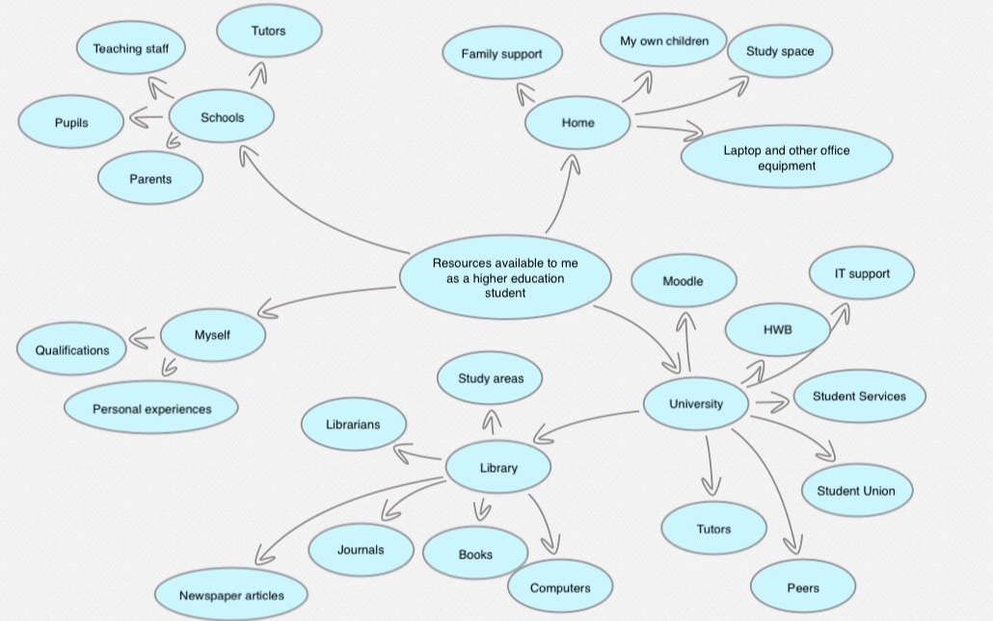
Resources available to me in university
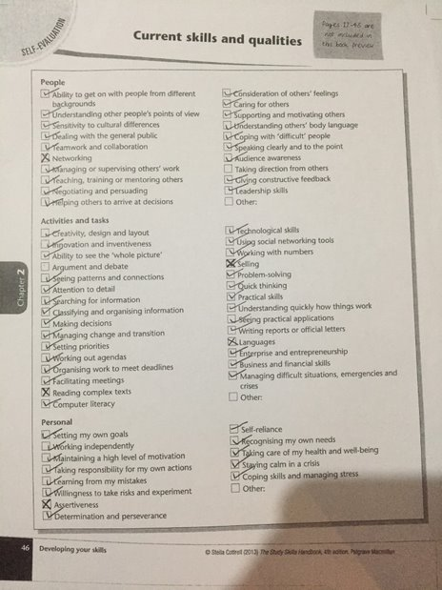
Below is a copy of the skills audit by Stella Cottrell I completed
Critical thinking

Critical thinking is analysing information in a logical way and forming a reasonable viewpoint without allowing your own bias, or the bias of the author, to affect the conclusion. Thinking critically helps you to focus more on what is relevant and accurate information. Critical thinking brings accuracy in the way you think and in the way you work. It is crucial that when making a judgement that you understand what critical thinking is, what skills are needed and the possible barriers to thinking critically. Good critical thinking skills are important to learning and aid good decision making, “seeing more easily through flawed reasoning, making choices from a more informed position and improving your ability to influence others.” (Cottrell, pp 16)
Critical thinking requires a range of skills in observation, reasoning and analysing to reach a decision, which can be persuasive to others. To be an effective critical thinker, a person must first learn to be sceptical and look at things in a detailed way paying attention to details. It is important that when analysing text that statistics are also scrutinised. It can be easy to see a number and assume that that proves something, but we must also investigate where the data has come from and what context it was collected. It is also important that critical thinkers are aware of their own influences that might affect an analysis. For example, political, social, and religious believes. A good critical thinker must be aware and question what they conceive as normal and acceptable, this will ensure that any presumptions don’t affect the analysis.
Although critical thinking can seem like a simple process, there are many barriers which can affect how well someone can work in a critical way. One common mistake would be to focus only on the negative aspects when analysing, when in fact it is a logical and factual process that included all the positives as well as the negatives. Another issue some people encounters is that they find it hard to criticise an expert, making an automatic assumption that, because they are an expert in their field, they must be right. This can lead to only positive comments, rather than a more accurate view. It can be easy to assume our own believe system to be the best, leading to a bias viewpoint. Thinking critically can seem like a dispassionate process, when it’s a matter which we are particularly passionate about, it can be hard not to allow our own emotions to get in the way. It is ok to give a passionate response if you remember not to ignore evidence against what you believe, a well-reasoned argument is more pervasive than a one-sided argument. Simply by being aware of these barriers will help you make a better judgement.
The thing that will challenge me the most will be not wanting to criticise an expert’s opinion, especially in a field where my subject knowledge is low. In subjects where I hold more knowledge and a stronger opinion it will also be difficult to separate my own views and analyse in a logical way. But by being aware of my weaknesses and questioning my own judgement this should help me become a more accomplished critical thinker and come to an accurate conclusion.
What I think about Education in Wales

In March 2014 the Minister for Education and Skills asked Professor Graham Donaldson to do a review of the curriculum and Assessment in Wales. “The case for change rests partly on concerns about perceived shortcomings in the present curriculum and assessment arrangements” (Donaldson, 2015, p.9). Even though the current national curriculum was established to entitle all children to an education with set knowledge and skills criteria, it is no longer delivering a good outcome. It was designed to establish common educational aims across Wales and enable mobility between different academic stages and schools. I think there still needs to be some structure, but I think the new curriculum is going to offer more freedom for teachers which will improve education standards across Wales.

Professor Graham Donaldson and his team visited schools and listened to the views of pupils, teachers, head teachers and parents to create his recommendations to present to the welsh government. Professor Donaldson’s report emphasises the importance of schools to the future success of every child and to society. The New curriculum has four main purposes, it wants pupils to be:
- Ambitious, capable learners who enjoy and want to learn.
- Healthy, conﬁdent individuals who have secure values, skills and knowledge, to go through life as independently as possible, and are ready to lead fulﬁlling lives as valued members of society.
- Ethical, informed citizens who can use evidence to form views, understand and consider the impact of their actions and are ready to be citizens of Wales and the world.
- Enterprising, creative contributors who connect and apply their knowledge and skills to create ideas and think creatively.
(Welsh Government, 2019)
“In their entirety they should underpin all teaching and learning in Wales” (HWB, 2019).
As well as the four purposes, it also has 6 subject areas. Instead of the traditional subject areas for lessons, subjects will be broader and cross over. This will give teachers more freedom over the topics they cover and how they teach. The 6 new subject areas will be
- Expressive arts
- Health and wellbeing,
- Humanities,
- Language, literacy and communication
- Mathematics and numeracy
- Science and technology
Professor Donaldson’s report emphasises the importance and of the Welsh language and culture, and he has made some recommendations of how improvements could be implemented. “Welsh-medium schools should be enhanced by developing them as hubs for language learning across wider communities of schools.” (Donaldson, 2017, pp 13)
The current curriculum in Wales is very rigid in respect of what teachers must teach and how it should be delivered. The problem with the current curriculum is that its not preparing children for the society we live in. It does not put enough emphasis on independence and creativity, all skills which are important for learners to grow and the skills which the new curriculum are trying to improve. With the increase use of technology within the workplace and at home children need to be competent with new technological advances so they are prepared for work and life; the new curriculum outlines this as being fundamental. I think the current curriculum is outdated and restricts teachers using their own knowledge and experience to deliver the best education. I believe, if everything in the new curriculum is delivered, then children will become more independent, creative learners. Which will lead them to be innovative, independent, creative and confident members of society.

References

HWB (2019), A Guide to Curriculum for Wales 2022.
Available at: https://hwb.gov.wales/draft-curriculum-for-wales-2022/a-guide-to-curriculum-for-wales-2022.
(Accessed on the 22nd October 2019)

Welsh Government (2015), The four purposes of the curriculum for Wales.
Available at https://gov.wales/sites/default/files/publications/2018-03/the-four-purposes-of-the-curriculum-for-wales.pdf.
(Accessed on the 22nd October 2019)

Donaldson, G. (2017) ‘A Systematic Approach to Curriculum Reform in Wales’, Wales Journal of Education, pp.7-20.

Low, Cheng and Kim, Patrick “Global Education Journal (Volume 2011 Issue 3)” Page 44.

Cottrell, S. (2013) The Study Skills Handbook 4th Edition. Basingstoke: Palgrave Macmillan, pp. 1-34.

Donaldson, G. (2015) Successful Futures: Independent Review of Curriculum and Assessment Arrangements in Wales.
Available at https://gov.wales/sites/default/files/publications/2018-03/succesful-futures-a-summary-of-professor-graham-donaldsons-report.pdf.
(Accessed on the 04th November 2019)

