MARKETING FUNDAMENTALS ANALYSIS AND EVALUATION

- Marketing Fundamentals -
LCBB4004

CARMEN MARILENA TIRZIU
(2021003)

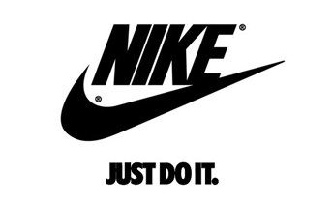
(Fig. 1, Source: Internet)

Table of Contents
INTRODUCTION 4
HISTORY 4
PROCESS AND STAGES OF MARKETING INCLUDING THE ROLE OF THE MARKETING MIX ACCORDING TO NIKE 5
ANALYSIS 5
SWOT ANALYSIS 5
PORTER’S FIVE FORCES 8
OBJECTIVES 9
STRATEGY 10
MARKET SEGMENTATION, TARGETING AND POSITIONING PROCESS 10
Market Segmentation 10
MARKETING MIX 12
THE ANSOFF MATRIX OF NIKE (Blythe, 2014) 16
RECOMMANDATION 17
CONCLUSION 17
References 18

MARKETING FUNDAMENTALS
INTRODUCTION
Markeng is a process of creang, communicang, delivering products from manufacture to
consumer. That is a procedure by which individuals and groups sasfy their needs and wants
through creang, and exchanging valued products with others [Kotler P 2015].
HISTORY
Nike is an American multinational corporation that is engaged in the design, development,
manufacturing, and worldwide marketing and sales of footwear, apparel, equipment, accessories,
and services. The company is headquartered near Beaverton, Oregon, in the Portland
metropolitan area. Company was made to 25 jenuary1964 like Blue Ribbon Sport from Bill
Bowerman and Phil Knight and become official Nike to 30 may1978. Nike has acquired and
sold several apparel and footwear companies over the course of its history.
In order to refocus its business lines, Nike began divesting itself of some of its subsidiaries in the
2000.February 2021, Nike acquired Datalogue, a New York based company focused on digital
sales and machine learning technology.
Nike aims is the mission to drives and to do everything possible to expand human potenal.
They do that by creang groundbreaking sport innovaons, by making their products mor
MARKETING FUNDAMENTALS
INTRODUCTION
Markeng is a process of creang, communicang, delivering products from manufacture to
consumer. That is a procedure by which individuals and groups sasfy their needs and wants
through creang, and exchanging valued products with others [Kotler P 2015].
HISTORY
Nike is an American multinational corporation that is engaged in the design, development,
manufacturing, and worldwide marketing and sales of footwear, apparel, equipment, accessories,
and services. The company is headquartered near Beaverton, Oregon, in the Portland
metropolitan area. Company was made to 25 jenuary1964 like Blue Ribbon Sport from Bill
Bowerman and Phil Knight and become official Nike to 30 may1978. Nike has acquired and
sold several apparel and footwear companies over the course of its history.
In order to refocus its business lines, Nike began divesting itself of some of its subsidiaries in the
2000.February 2021, Nike acquired Datalogue, a New York based company focused on digital
sales and machine learning technology.
Nike aims is the mission to drives and to do everything possible to expand human potenal.
They do that by creang groundbreaking sport innovaons, by making their products mor
MARKETING FUNDAMENTALS
INTRODUCTION
Markeng is a process of creang, communicang, delivering products from manufacture to
consumer. That is a procedure by which individuals and groups sasfy their needs and wants
through creang, and exchanging valued products with others [Kotler P 2015].
HISTORY
Nike is an American multinational corporation that is engaged in the design, development,
manufacturing, and worldwide marketing and sales of footwear, apparel, equipment, accessories,
and services. The company is headquartered near Beaverton, Oregon, in the Portland
metropolitan area. Company was made to 25 jenuary1964 like Blue Ribbon Sport from Bill
Bowerman and Phil Knight and become official Nike to 30 may1978. Nike has acquired and
sold several apparel and footwear companies over the course of its history.
In order to refocus its business lines, Nike began divesting itself of some of its subsidiaries in the
2000.February 2021, Nike acquired Datalogue, a New York based company focused on digital
sales and machine learning technology.
Nike aims is the mission to drives and to do everything possible to expand human potenal.
They do that by creang groundbreaking sport innovaons, by making their products mor
MARKETING FUNDAMENTALS
INTRODUCTION
Markeng is a process of creang, communicang, delivering products from manufacture to
consumer. That is a procedure by which individuals and groups sasfy their needs and wants
through creang, and exchanging valued products with others [Kotler P 2015].
HISTORY
Nike is an American multinational corporation that is engaged in the design, development,
manufacturing, and worldwide marketing and sales of footwear, apparel, equipment, accessories,
and services. The company is headquartered near Beaverton, Oregon, in the Portland
metropolitan area. Company was made to 25 jenuary1964 like Blue Ribbon Sport from Bill
Bowerman and Phil Knight and become official Nike to 30 may1978. Nike has acquired and
sold several apparel and footwear companies over the course of its history.
In order to refocus its business lines, Nike began divesting itself of some of its subsidiaries in the
2000.February 2021, Nike acquired Datalogue, a New York based company focused on digital
sales and machine learning technology.
Nike aims is the mission to drives and to do everything possible to expand human potenal.
They do that by creang groundbreaking sport innovaons, by making their products mor
MARKETING FUNDAMENTALS
INTRODUCTION
Markeng is a process of creang, communicang, delivering products from manufacture to
consumer. That is a procedure by which individuals and groups sasfy their needs and wants
through creang, and exchanging valued products with others [Kotler P 2015].
HISTORY
Nike is an American multinational corporation that is engaged in the design, development,
manufacturing, and worldwide marketing and sales of footwear, apparel, equipment, accessories,
and services. The company is headquartered near Beaverton, Oregon, in the Portland
metropolitan area. Company was made to 25 jenuary1964 like Blue Ribbon Sport from Bill
Bowerman and Phil Knight and become official Nike to 30 may1978. Nike has acquired and
sold several apparel and footwear companies over the course of its history.
In order to refocus its business lines, Nike began divesting itself of some of its subsidiaries in the
2000.February 2021, Nike acquired Datalogue, a New York based company focused on digital
sales and machine learning technology.
Nike aims is the mission to drives and to do everything possible to expand human potenal.
They do that by creang groundbreaking sport innovaons, by making their products more

INTRODUCTION

Marketing is the method of developing, contacting, and distributing goods from the producer to the customer. This is the process by which individuals and organizations meet their needs and desires by making and sharing goods with others. (Kotler P. 2015)

HISTORY

Nike is an American worldwide organization that works in the plan, assembling, and trading of pieces of clothing, footwear, vehicles, items, and administrations, just as worldwide promoting and dispersion.

On January 25, 1964, the organization was established. Nike has gained and sold various clothing and footwear brands throughout its set of experiences.

Nike is by all accounts generally worried about the headway of human potential. They will likely do it through the presentation of forefront sports innovation, the movement of their items toward more prominent supportability, the foundation of a comprehensive corporate group, and the advancement of positive changes in networks that address their subject matter. (Wikipedia, 2021)

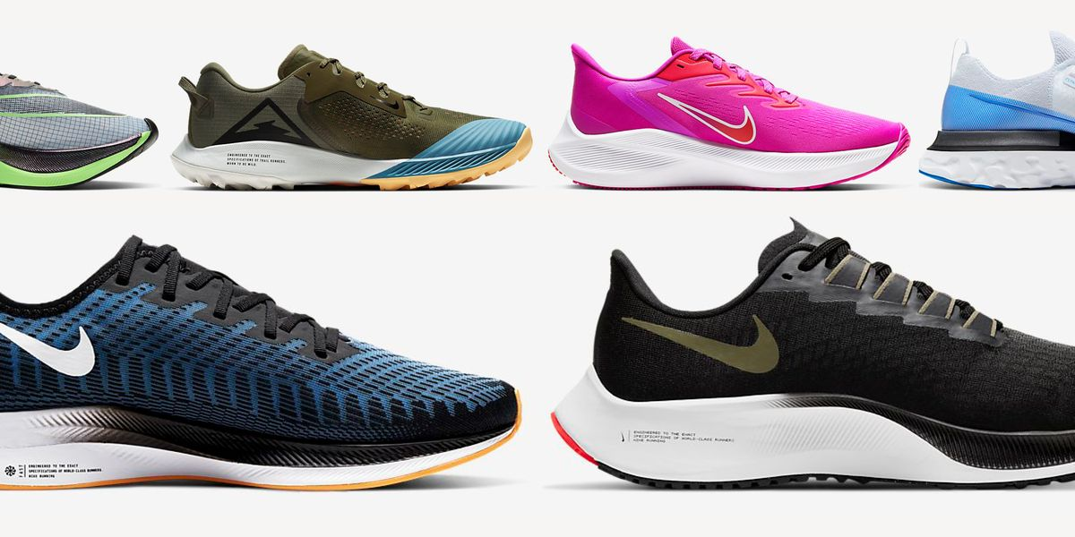

(Fig. 2, Source: Nike Website)

PROCESS AND STAGES OF MARKETING INCLUDING THE ROLE OF THE MARKETING MIX ACCORDING TO NIKE

Marketing, according to Philip Kotler, is "the act of satisfying needs and desires by an exchange process." Marketing can be described in this sense as "the management process that aims to maximize shareholder returns by building partnerships with valued consumers and establishing a competitive advantage." (Kotler P., 2017)

Diagram of maketing process

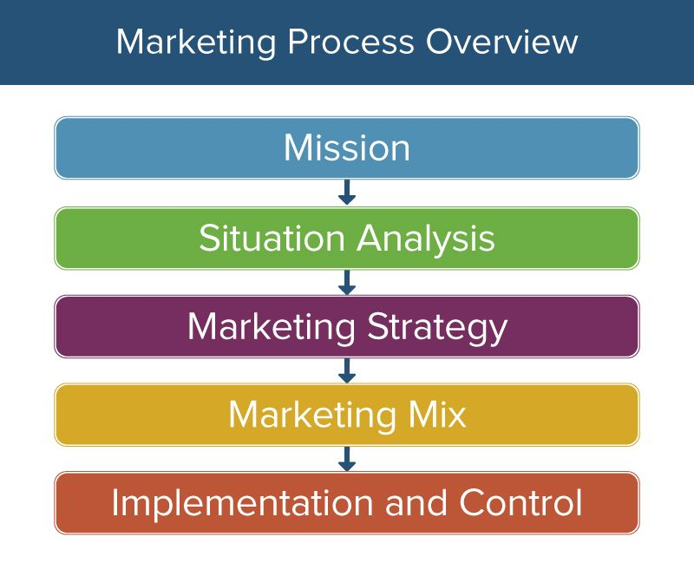

(Fig. 3, Source: smartsheet.com)

ANALYSIS

Situation analysis is a technique of analyzing a company's internal and external factors. PESTLE, SWOT, and PORTER'S FIVE FORCES are a few examples of scenario analysis tools (Company, Competitors, Customers, Collaborators, Climate).

SWOT ANALYSIS

A SWOT analysis (or SWOT matrix) is a strategic strategy tool used to assist an individual or company in identifying capabilities, vulnerabilities, openings, and risks in competitive competitiveness or project planning. (D., 2016)

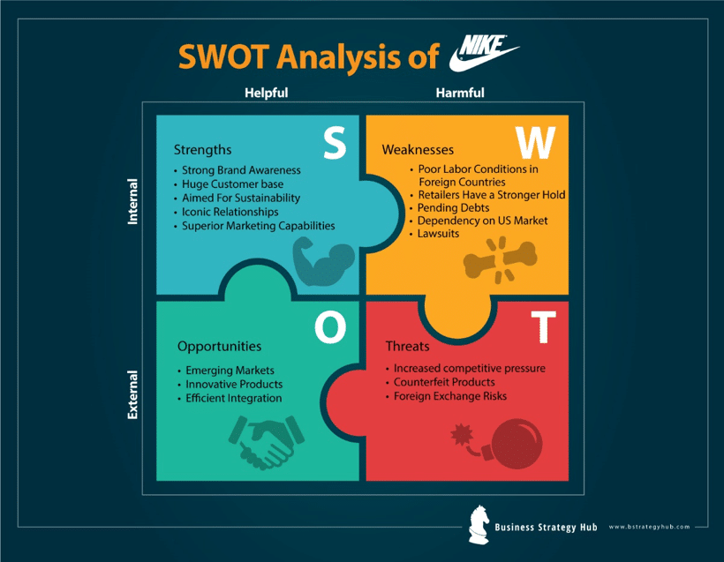
(Fig. 4, Source: Pinterest)

Strengths (Gupta, 2020)

Cost Structure: Nike's structure is driven by core values that are clear. Their central goal is to keep a very good quality contribution by successive item improvements.

Dealer Community: Nike's structure is driven by core values that are clear. Their central goal is to keep a very good quality contribution by successive item improvements.

Financial Position: Investigators are associated with Nike's working overall revenue notwithstanding profit and income.

Weaknesses (Gupta, 2020)

Poor Labour Conditions in Foreign Countries: Nike has been reliably chastised for its helpless work conditions throughout the long term. Kid work, constrained work, hazardous (truly, frightening) working conditions, and helpless wages are on the whole instances of this.

Pending Debts: Despite Nike's case to possess and rake in some serious cash, the utilization of their monetary record totally adjusts the story. The organization is presently confronting monetary troubles.

Lack of Diversification: Nike is too centered around running tennis shoes, which prompts an absence of expansion. This pandemic has caused the wiping out of get-togethers and wearing competitions, and if the circumstance doesn't improve rapidly, Nike will bring about significant monetary misfortunes.

Opportunities (Gupta, 2020)

Web: The quantity of web clients worldwide has expanded, which implies that Nike has a chance to grow their online presence by drawing in with their clients through the web.

Web-based Media: The three online media destinations that have encountered the most expansion in month to month dynamic clients are Facebook, Twitter, and Instagram. Nike utilizes web-based media to assist fans with building up a lifestyle and a feeling of having a place. Its tweets are short, punchy, and enticing, with the hashtag #justdoit or other neighborhood hashtags, for example, #nikewomen regularly included.

Mechanical Developments: Innovation benefits different workplaces in various zones. It depends on the possibility that it is effectively spending assets in imaginative work to discover approaches to improve the exhibition of its merchandise and clients. Innovativeness and Nike are inseparably interwoven, from the front line advancements used to help Nike-subsidiary gaming prodigies to the innovation utilized in the running shoes you can buy on the web.

Threats (Gupta, 2020)

Suppliers: Nike is the world's greatest maker of activewear and footwear, with more than $40 billion in income. By far most of its products come from China, Vietnam, Indonesia, and Thailand. Among the principle providers are Pou Chen, PT Pan Brothers, Fulgent Sun International, Delta Galil, and Eagle Good.

New entrants: Nike's greatest adversaries incorporate Anta, lululemon athletica, VF Corporation, Adidas, Reebok, ASICS, FILA, Puma, Under Armor, Skechers, and New Balance. At the point when new participants enter a market offering comparable products or administrations, the earnestness of an organization is imperiled. Regardless, Nike profits by the advancement of inventive plans and energizing joint endeavors at reasonable rates.

Increasing competition: There has been an uptick in cost-cutting rivalry inside the business. Nike's pay could be diminished in the event that it doesn't react to the worth changes, or it could lose a slice of the pie in the event that it does.

PORTER’S FIVE FORCES (Rowland, 2017)

Porter's Five Forces is a market analysis model that helps to explain why multiple projects should support varying degrees of profit. The concept was sold in Michael E. The five forces are occasionally used to measure the competition intensity, attraction, and benefit of a business or sector.

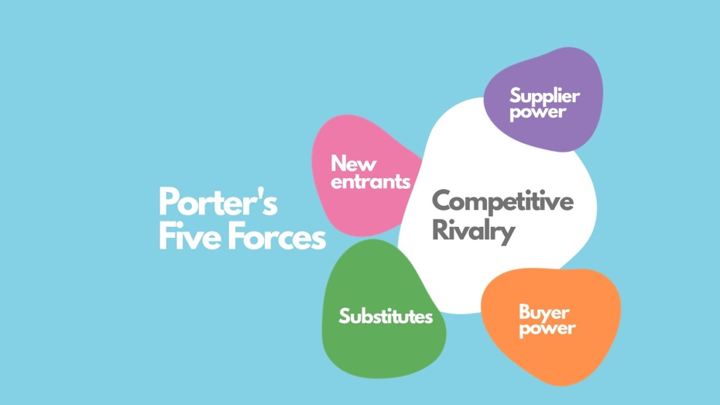
(Fig. 5, Source: Management Weekly)

Competitive Rivalry

The level of rivalry among existing firms is proportional to the level of serious rivalry. Extreme dissatisfaction can restrict benefits and result in serious measures such as cost cutting, expanded publicizing uses, or spending on assistance/item enhancements and development. Adidas, FILA, Puma, and Reebok are among Nike's rivals.

1. Threat of New Entrants (low)

- Economies of size are exceptionally hard to reach in the market in which Nike works. This makes it workable for those giving a lot of ability to acquire an expense advantage. It additionally builds the speed at which new opponents will enter the market. This suggests that new players are being threatened as a more delicate force.

- Within the market, the item separation is high, with organizations offering partitioned merchandise as opposed to a normalized ware. Explicit items can likewise be looked for by customers. Advancement and buyer rewards are vigorously accentuated. These factors address a sensitive impact inside this industry that frightens away new contestants.

- When high uses might be presented in, the capital requirements inside the market are high, making it outlandish for new contestants to make associations. As a result of the significant expenses of investigation and advancement, cash is as yet being utilized broadly. These factors address a more weak force inside this field to new members.

- Potential participants will effortlessly access scattering organizations and will set up their movement stages and join the market. With a couple of bargain retailers offering the thing structure, any conceivable adversary will effortlessly get their thing on the rack. These components pass on a profound feeling of prevalence in this industry over future opponents.

2. Bargaining Power of the Supplier (low)

- Almost all organizations in the Textile - Apparel Footwear and Accessories industry source their crude materials from an assortment of sources. Driving suppliers can restrict the advantages NIKE, Inc. will accomplish keeping watch. Awesome Consumer Goods producers utilize their exchange mastery to eliminate more over the top expenses from Textile - Apparel Footwear and Accessories firms. Higher supplier haggling power diminishes absolute Textile - Apparel Footwear and Accessories quality.

3. Bargaining Power of the Buyer (low to moderate)

- Purchasers are regularly the ones that put in a bundle request. They should buy the best accessible gifts while keeping the base expense as low as could be expected. This focused on NIKE, Inc's. drawn out benefit. The humble and noteworthy NIKE, Inc's. client base, the better the customers' arranging power and want to search out new limits and offers.

4. Threat of Substitute Products or Service (low to moderate)

- Nike considers substitution to be as representing an unobtrusive risk. This is because of the way that many opponent brands sell comparable or organizing items. Rather than Nike, there are a couple of brands in both the homegrown and worldwide business sectors that produce ease footwear. Nike's rivals offer cheaper alternatives. This danger is influenced to some extent by Nike's item quality and nature. By and large, the danger presented by replacement items is moderate.

5. Rivalry Among Existing Firms (strong)

- The degree of rivalry in the games business is high. Adidas, Under Armor, and Puma are a portion of Nike's fundamental rivals. The business has advanced, and the current players are occupied with savage rivalry for more profound market infiltration and to take a cut of the pie from each other. Brands put vigorously in publicizing and different types of advancement. In spite of the way that Nike's top stars and direct contenders are not many, the opposition is furious. As a rule, the degree of rivalry in the business is high.

OBJECTIVES

Nike Inc's. essential mission and vision proclamations advance to explicitly address the association's job as the main supplier of wearing shoes and attire in the worldwide business.

The corporate assertion of goal of an association describes the particular objectives of the organization, particularly as far as inspiration. Nike's announcement of plan prompts the organization to help contenders' undertakings in this affiliation examination occasion.

Nonetheless, an organization's essential vision explanation illustrates the organization's target future condition. Nike's main goal is engaged around brand strength and advancement.

STRATEGY

The Nike business methodology is straightforward: invest in building your reputation through passionate ads and sports VIP sponsorship, produce products of outstanding quality and market-driving creativity, and buy out competing sports brands.

MARKET SEGMENTATION, TARGETING AND POSITIONING PROCESS

The separation is the process of isolating the industry into distinct segments. According to (Procter, 2012), division entails dividing the industry divisions into more manageable portions dependent on segment, psychographic, socioeconomic, and geographic areas.

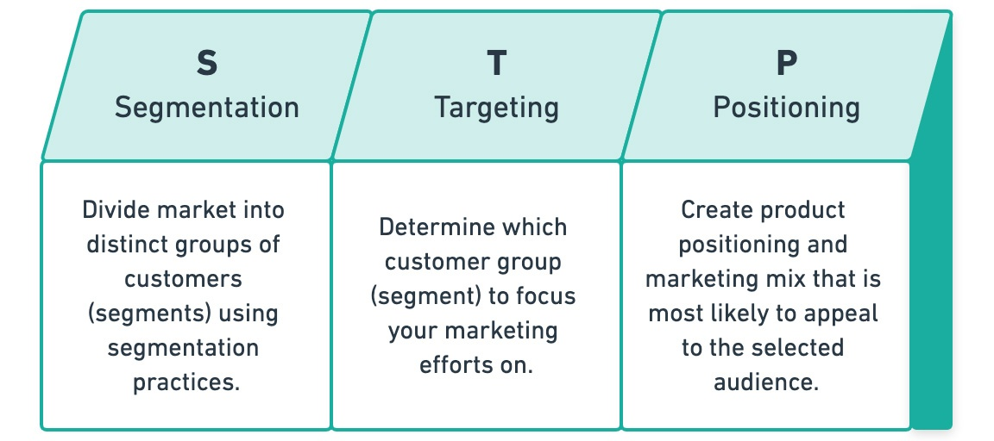
(Fig. 7, Source: Internet)

Market Segmentation (Oberoi, 2020)

Nike's frequently utilized methodology is segment division, which is on the grounds that the characteristics are easy to recognize and rough.

Sexual orientation - Nike will portion their product offerings relying upon an individual's sex. They make wellness garments and decorations for the two people.

Age - Nike will make garments for individuals, all things considered, from kids to the older. Nonetheless, their essential client base in the UK ought to be between the ages of 11 and 45.

Nike utilizes psychographic segmentation. Nike expects to target dynamic individuals who love games, exercise consistently, are competitors, and are stimulated by sports, which would all be useful to their lives by and large. Nike has worked really hard. Individuals' lifestyle is joined with their exercises, wants, and conduct, making a remarkable "feeling," and they at that point purchase practically identical articles. Nike utilizes sports-driven methodology in convincing, pushing, and really cooperating with all adversaries with its items. Nike's case "to carry motivation and movement to each adversary in the world" just as "Run with me" supports a wide range of adversaries to get the organization together with endurance and the feeling that they are important for a comparable family.

Geographic is simple, yet powerful segmentation basis. Nike segments market
based on world and country region, city and popularity density in different way.
In particular, Nike promotes different campaigns in the United States of
America, in Europe, in Asia, in Australia as well as in Africa because sports
differentiate by region, even cities. For instance, all the commercials in the
United States are around football and baseball, while in Europe,
advertisements refer to soccer.
The cycle of geographical segmentation is simple. Nike portioned the market in various manners dependent on worldwide and public region, district, and universality thickness. Nike explicitly propels various missions in the United States of America, Europe, Asia, Australia, and Africa since sports are isolated by area, including metropolitan territories. For instance, in the United States, the entirety of the promotions spin around football and baseball, while plugs in Europe center around soccer.

Behavioral segmentation. According to one perspective, Nike is worried about how its items cause shoppers to feel. Clearly, the association takes the course "On the off chance that you have a body, you are a contender" and "On the off chance that you are a contender, Nike's items cause you to feel athletic."

Targeting. Target advancing is the following degree of division estimation where the organization chooses the parts that will empower it to accomplish its objectives all the more viably and effectively. Nike assesses its objective market dependent on scale, reachability, quantifiability, and conduct. Nike has a specialty market to serve. The organization intends to pull in talented adversaries and dynamic individuals by furnishing them with elite and creative items. About the way that the interest for dress and sports can be wide, Nike generally targets shoppers matured 15 to 40. The organization respects the two sorts of opponents similarly and is zeroing in a growing place on tweens and youngsters to make long stretch brand reliability. Therefore, Nike utilizes separated focusing on.

Positioning. The last development of STP as far as investment opportunities is the situating. Nike has set up itself as the business chief in athletic gear by and large, giving top caliber and imaginative innovativeness. Moreover, Nike has persuaded its clients that it is a serious and productive organization through the swoosh and the brand name "Do what needs to be done," just as through exceptional activities that liken Nike's image with splendid accomplishments of outstanding opponents. It ought to be noticed that Nike has changed from thing center to manner throughout the long term. Nike "talks" to adversaries' souls by remarkable and earth shaking notions, which recognizes the association from others.
MARKETING MIX (Pratap, 2017)

Nike Inc's. displaying mix (4Ps) chooses the advantage and improvement of the athletic footwear, attire, and stuff business.

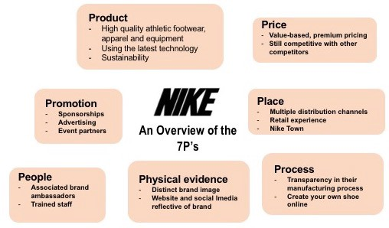

(Fig. 8, Source: plasto-tech.com)

Product

This piece of the promotion blend portrays the definitive yields made accessible to target clients. The item blend is the amount of these yields. Nike Inc's. advancement is joined by enhancements in the item blend. For instance, the organization keeps up its interest in imaginative work to create new items and refreshed renditions of existing things. Initially a shoe distributer, the organization likewise makes arranged adornments, attire, and hardware for different games. Nike's product line incorporates footwear, dress, just as gear and frill.

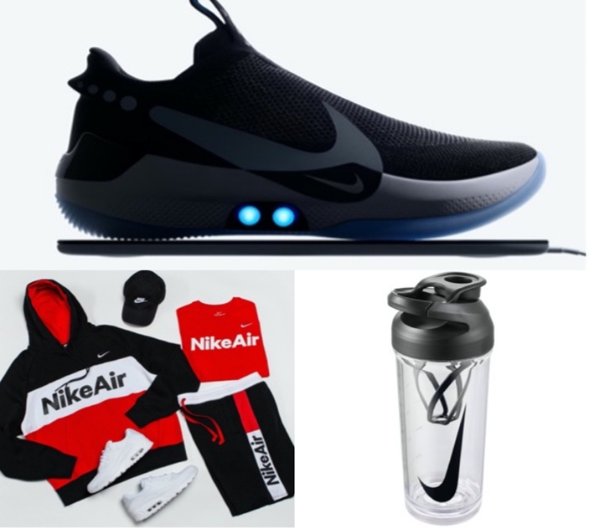

(Fig. 9, Source: Nike’s Website)

Branding strategies (O'Leary, 2017)

- Inspiring Advertising - Phil Knight was never a major aficionado of advancement toward the start. He considered that to be a misuse of cash and he could never show where the cash goes. This started to develop as he looked to scale the organization and occupied with conversations with supporting associations. The Wieden and Kennedy Advertising Agency's brand name "Get it done" passed on Nike on a worldwide scale. Shockingly, the brand name is one that everybody would declare to themselves while endeavoring to satisfy a need they had once had. Nike and customer characters were abruptly laced, with Nike tending to the individual mission towards remarkable human accomplishment.

- Innovative and Stylish Products - Nike required their pieces to be both all around arranged and smooth. They created an assortment of shoe plans in an assortment of tones, which customers worshiped. Contending shoes were limited and needed character and refinement on those occasions. Nike's attractive shoes drew consideration from customers, who were anxious to wear shoes that would make them stick out. The presentation of the shoes was additionally significant, and the cases for the shoes were likewise incredible. Nike had the option to remain in front of the opposition because of predictable item development and circulation stages. They considered their to be as post-current craftsmanship and endeavored to make shoes that would change the shoe business.

- Celebrity Endorsement - Nike has picked a wide assortment of VIP endorsers for their items throughout the long term. They primarily adhere to the games field, with names like Kobe Bryant, Michael Jordan, and Tiger Woods being inseparably connected to the Nike brand. The organization has received the benefits of this methodology. Kids, indeed, admire their holy people and try to dress and stroll in similar shoes as their good examples. It gives them the feeling that they are in a genuine manner from their perspective.

Price

This piece of the promoting blend comprehends the dangers that the organization utilizes to build benefits while pulling in the ideal part of the worldwide market. Nike's interest in imagination is connected to a strategy for selling its items at a more exorbitant cost than anticipated. Regardless, the organization considers genuine financial conditions while deciding its worth concentrations and worth reaches. Considering these contemplations for this 7P variable, Nike Inc's business utilizes the accompanying assessment systems: worth-based assessing plan, premium esteeming method.
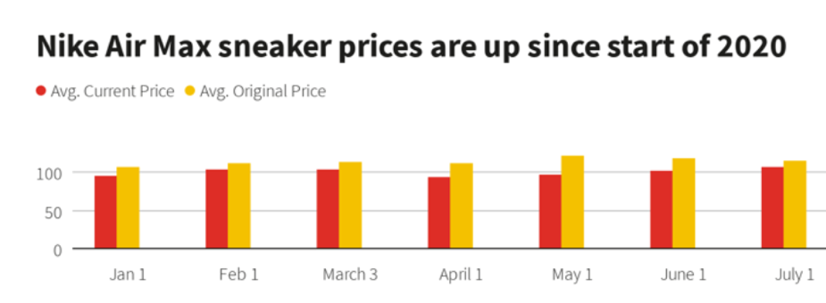
(Fig.10, Source: StyleSage)

Place

This piece of the advancing blend tracks the areas where the association's products are advertised, gotten, or communicated. Nike Inc. sells its games, shoes, apparel, and equipment through an enormous scope of retailers around the world. These items, for instance, are accessible at significant retail outlets.

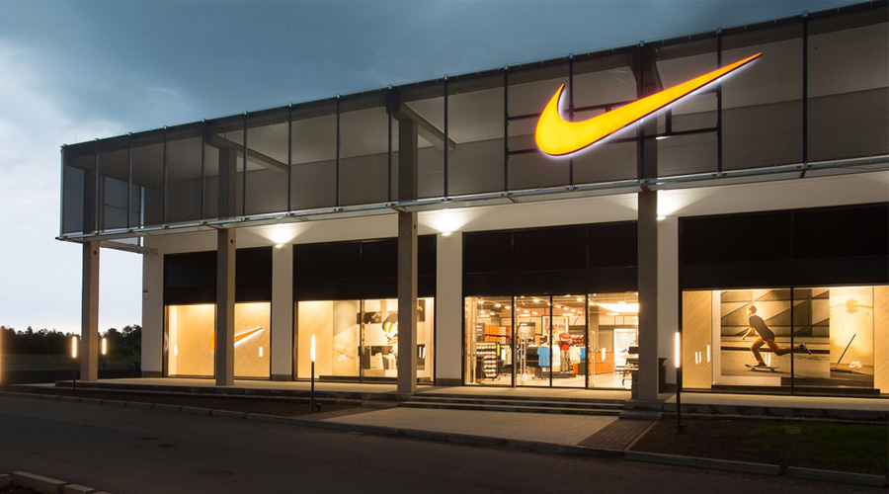
(Fig. 11, Source: Nike)

Promotion

This part of the special mix is otherwise called the featuring exchanges mix, and it includes the strategies that Nike utilizes to speak with its objective market areas. The partnership relies upon the practical development of its items to keep a solid brand picture, which is one of the ascribes decided in Nike Inc's SWOT examination. The organization utilizes brief timeframe strategies to speak with target crowds on items and convince them to buy them. Following that are Nike's extraordinary activities, recorded arranged by significance: advancement, individual deal, direct promoting, contract advances, and ad. (Pratap, 2017)

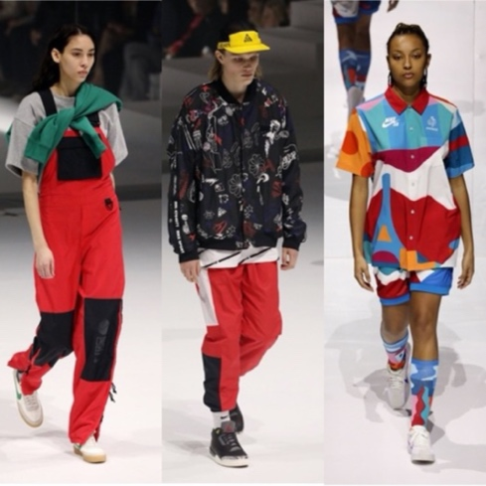
(Fig. 12, Source: Footwear News)

People

Human resource the executives has arisen as a principal zone of the twenty-first century. Associations should zero in their endeavors on adapting to their human resources to keep up their upper hand. It is because their family are their essential wellspring of benefit that an organization's other central benefits are based. Starting in 2020, the organization utilized 75,400 individuals. (Pratap, 2017)

Process

Nike has re-appropriated practically the entirety of its creation to outsider providers. It opens up the organization to zero in on a wide assortment of essential market measurements. The association's accentuation on showing has brought about quicker development and market extension. The organization is fundamentally worried about showing, spreading, and putting away exercises. Nike has worked on the worth chain to expand yield and speed up development. Consistently, it makes a critical interest in urging comparably imaginative work to accomplish more noteworthy development. The association's accentuation on higher effectiveness of market activities has additionally supported it in keeping up its development power. (Pratap, 2017)

Physical Evidence

Nike is a worldwide organization that sells its items on pretty much every mainland. Beside the items and the association's own construction, the association's packaging is likewise the genuine proof of its corporate practices. Nike is a genuine organization, so you'll run over a ton of genuine proof while diving into its plan of action. (Pratap, 2017)

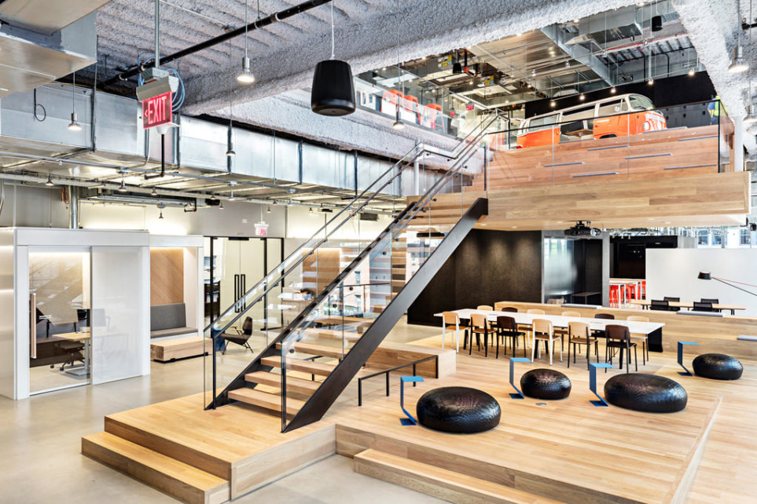
(Fig. 13, Source: www.dsvdedommel.com)

THE ANSOFF MATRIX OF NIKE (Blythe, 2014)

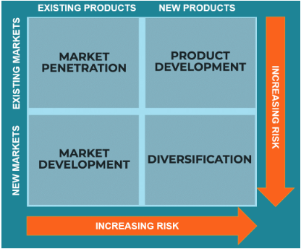
(Fig. 14, Source: corporatefinanceinstitute.com)

Market extension alludes to the presentation of new merchandise into created markets. Nike achieves this by effectively circulating its image through an assortment of showcasing and promoting systems. It upholds athletic rivalries by showing its logo and product. Notices are scattered through print, portable, and online media. Any of Nike's persuasive strategies under the Ansoff framework and classifications are itemized underneath.

Market Penetration (Gregory, 2017)

Reduce operational costs

Nike is utilizing progressions that consider fast prototyping of new plans, just as robotization, to produce shoes all the more rapidly and productively.

Lower working expenses would bring about less bills being passed down to customers, making Nike's items really engaging and moderate.

Partnerships and joint ventures

Despite the Nike and Jordan marks, our completely possessed subs Vodafone and Telefónica consented to share their adaptable association. Cole Haan (extravagance tennis shoes, sacks, additional items, and coats); Converse (athletic and lifestyle boots, pieces of clothing, and embellishments); Hurley (movement sports and youth lifestyle footwear, garments, and ruffle); Nike Golf, and Umbro are helper brands.

Increased frequency of consumption

Nike should now start interchanges and promoting pointed toward growing the repeat of utilization of the products in current industry areas. Expanded utilization repeat would trigger a for the most part broadened use.

Market development (Gregory, 2017)

Research and development

Nike depends on their ability and analysis to make the best thing for rivals and, thus, the best thing for clients. These notable mentors and adversaries are then utilized in Nike's advancing and trades campaign since they are known by the client and can help describe the thing story.

New customer segments

The organization will distinguish new item uses and features and target new buyer sections for existing items, permitting it to benefit from new industry markets and new interest patterns inside an offered market to help in development and extension.

Brand awareness

Nike needed customers to recollect that Nike items would consistently assist them with accomplishing their objectives and practice at the following stage for this understanding to be express. Nike's message will live on for customers as they purchase new shoes or brandishing attire because of this excursion and the exertion they made.

RECOMMANDATION

Worries over rivalry, work systems, pantomime, and patent confirmation ought to be tended to by the organization. Accordingly, it is suggested that Nike Inc. alter its projects around there. The organization ought to likewise work together with government offices to determine patent affirmation concerns.

CONCLUSION

As can be seen from the first discussion, firms today face a tireless and squeezing need for development to outflank profit. This can be cultivated by building up a huge buyer base through helpful and persuasive publicizing, a wide assortment of items, acknowledgement of variety, and consolation of it. The size of the crowd focused, for instance, assumes a significant part in this cycle. The Ansoff Matrix comes right into it here, which helps and coordinates firms in satisfying shopper requests.
References

Kotler P., Armstrong G., Principles of Marketing, Global Edition, 7th Edition, London: Pearson; 2017

Wikipedia, 2021. Wikipedia. [Online] Available at: https://en.wikipedia.org/wiki/Nike,_Inc. [Accessed 14 March 2021].

Blythe J., Principles and Practice of Marketing, 3rd edition, London: Sage; 2014

Baines P., et. al., Marketing. 2nd edition, London: Oxford; 2014

Jobber D., Principles and Practice of Marketing. 8th edition, McGraw Hill; 2016

Housden, M., Marketing Information and Research. Butterworth Heinemann Publications; 2010

Gregory, L., Panmore Institute, 2017. [Online] Available at: http://panmore.com/nike-inc-five-forces-analysis-porters-model [Accessed 14 March 2021].

Perch, D., 2020. The Social Grabber. [Online] Available at: https://thesocialgrabber.com/positioning-and-segmentation-strategies-of-nike/ [Accessed March 14 2021].

Pratap, A., 2017. Notesmatic. [Online] Available at: https://notesmatic.com/nike-marketing-mix/ [Accessed 14 March 2021].

Bush, T., 2016. [Online] Available at: https://pestleanalysis.com/pestle-analysis-of-nike/ [Accessed 14 March 2021].

Gregory, L., 2018. [Online] Available at: http://panmore.com/nike-inc-marketing-mix-4ps-product-place-promotion-price-analysis [Accessed 14 March 2021].

O'Leary, K., 2017. [Online] Available at: http://bxtvisuals.com/the-marketing-branding-strategies-nikes-success/ [Accessed 14 March 2021].

Gregory, L., 2017. Panmore. [Online] Available at: http://panmore.com/nike-inc-generic-strategy-intensive-growth-strategies [Accessed 14 March 2021].

Gupta, S., 2020. Bussiness Strategy Hub. [Online] Available at: https://bstrategyhub.com/swot-analysis-of-nike-nike-swot-analysis/ [Accessed 14 March 2021].

Rowland, C., 2017. Panmore. [Online] Available at: http://panmore.com/nike-inc-five-forces-analysis-porters-model [Accessed 14 March 2021].

Oberoi, M., 2020. Market Realist. [Online] Available at: https://marketrealist.com/2019/10/nikes-target-markets-everything-you-need-to-know/ [Accessed 14 March 2021].

