ECED7004 Assignment 3
A portfolio for Children and Young People (CYP) Carmarthenshire Community Mental Health Advocacy Organisation.

Introduction
Organisation overview:
CYP Carmarthenshire Community Mental Health Advocacy is a well-established non-statutory community advocacy service in Carmarthenshire. This organisation provides advocacy for children and young people who are experiencing mental ill health such as anxiety and depression, but do not satisfy the requirements to receive statutory advocacy services outlined by The Welsh Government (Social Services and Well-being (Wales) Act 2014) and as stipulated in The Welsh Government (Mental Health (Wales) Measure 2010).
We connect with our clients in way that suits them, offering services face-to-face or via webchat and WhatsApp (Hollis et al, 2017). We ensure that our partners wishes and feelings are represented, whilst ensuring their rights are upheld and help them secure services they are entitled to (Unicef, 2017; UKAN, 2001; NDTI, 2018). We work closely with National Youth Advocacy Service (nyas, 2023) and ensure local schools are aware of our advocacy service as we recognise the benefits to children and young people’s mental health and access to services when services and schools work in collaboration (Rothi & Leavey 2006). We recognise that as an advocacy we do not offer our children and young people advice or give our opinions on matters and signpost them to other organisations should it appear they are looking for advice not advocacy (mind, 2018; Advocacy QPM, 2014).
Independent youth community mental health advocacy is greatly needed due to the unforeseen impact of covid 19 restriction measures on young people’s well-being and mental health (Edmonds et al, 2022; PSB, 2021; Welsh Government, 2020). Murata et al (2021:223) state that ‘The COVID‐19 pandemic is associated with increased rates of clinically significant psychiatric symptoms’. Experiences of anxiety, depression and grief are widespread post pandemic are noted as being more prevalent in children than in adults, along with Carmarthenshire having one of the highest suicide and self-harm rates, thus creating a need for urgent early intervention and prevention for youth and child mental health issues (Murata et al, 2021; Carmarthenshire County Council, 2021).
Communicating with services for mental health can be intimidating and overwhelming for children and young people (mind, 2023). Under the UNCRC, article 12 children have the right to have the right to express their views, wishes and feelings and for these to be taken seriously (Unicef, 2017). Advocacy is a way of achieving that right for children and for helping the adults around them to better understand their situation and wishes (Kumari & Brooks, 2004; Advocacy QPM, 2014). The role of the independent advocate is therefore crucial in helping children and young people to express their wishes and feelings, feel listened to and empowered (Boylan & Dalrymple, 2009; Advocacy QPM, 2014), linking closely to the aims and objectives of CYP Carmarthenshire Community Mental Health Advocacy as found in the organisation pen picture below.
Pen Picture of the Organisation
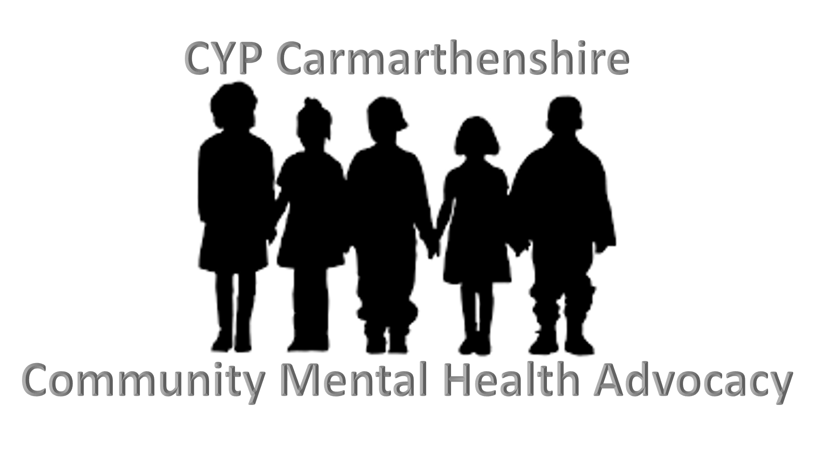
Who are we?
CYP Carmarthenshire Community Mental Health advocacy is a well-established, free and independent service for children and young people affected by mental health issues in Carmarthenshire. Our partners can be assured that our independence makes us loyal and accountable to them, and that we value their involvement in evaluation of our services to direct future improvements (Henderson & Pochin, 2001). The role of our advocates is to help children and young people to find their voice and use it to communicate effectively to help enable them to make informed decisions about their mental health (Advocacy West Wales, 2023; Advocacy QPM, 2014). Our staff are friendly and approachable and actively listen to the children and young people they are advocating for (Davies & McGillivray, 2010).
Aims: Our aim is to ensure children and young people experiencing mental health issues have their wishes and feelings are expressed and their rights are represented (Henderson & Pochin, 2001; Unicef, 2017; Hoadley et al, 2017).
Objectives: To empower young people by making them aware of their rights and by promoting their voice to challenge any injustices and to enable their participation when accessing mental health services (Boylan & Dalrymple, 2009; Jones & Walker, 2011; Advocacy QPM, 2014).
Client group: Our advocacy partners are children and adolescents in Carmarthenshire experiencing difficulties with their mental health such as anxiety, depression and prolonged stress. They may experience barriers accessing advocacy services as statutory advocacy is only provided to children and young people if they meet the requirements outlined in The Welsh Government (Social Services and Well-being (Wales) Act 2014) and The Welsh Government (Mental Health (Wales) Measure 2010). Therefore, our community mental health advocacy helps to reach those children who are not eligible for statutory advocacy but are experiencing mental health issues. Newbigging, Chastey and Brandon (2015) explain that children and young people may not be aware of their rights or have the confidence to act upon this knowledge and to express their views and therefore they require and advocate to act as their representative. Research conducted in America found that children’s advocacy centres increased access to mental health services (Schreier et al, 2022). However, this study was limited to research on victims of abuse and Children and Young people actually often feel a stigma attached with accessing mental health services and should be noted as a potential barrier to them accessing our advocacy organisation to aid their access to such services (Buckingham et al, 2016). These barriers are why we are applying for funding to enable us to provide a drop-in service for our children and young people.
Geography: Our services are offered to children and young people experiencing mental health issues in Carmarthenshire only. NHS Wales (2016-2019: p14) recognise the mental health of children and young people to be a priority in the Hywel Dda area which covers Carmarthenshire, because ‘10% of people aged 5 to 16 years old have mental health disorders’ and ‘7% of children under 12 years old deliberately self-harm’. Mental health issues in Carmarthenshire have seen an increase due to the ongoing effects of the covid-19 pandemic and lockdown restrictions that were in place (Carmarthen County Council, 2021).
Services offered: We offer a face-to-face advocacy service, telephone advocacy, webchat and WhatsApp services to our advocacy partners. While we recognise that many children and young people still prefer to go to parents and friends for help and advice (Spears, 2018), Hollis et al (2017) explain that offering services to children and young people in this digital way is seen to improve uptake and accessibility of mental health services. We are seeking funding as we are looking to expand our services in order to offer drop-in service at local youth centres in strategic places in Carmarthenshire including Carmarthen, Llanelli and Ammanford and we want to take on volunteers who will need their expenses paid. Drop-in services offer more accessibility for our children and young people and act as an aid in prevention of further decline of mental health (The Children’s Society, 2020).
Organisation structure: We currently have 9 paid employees and 3 voluntary trustees, each with clear and defined job roles to ensure work is coordinated and divided to create the formal structure seen below (Boddy, 2020; Advocacy West Wales, 2023b).
Please see figure 1 for organisation structure:
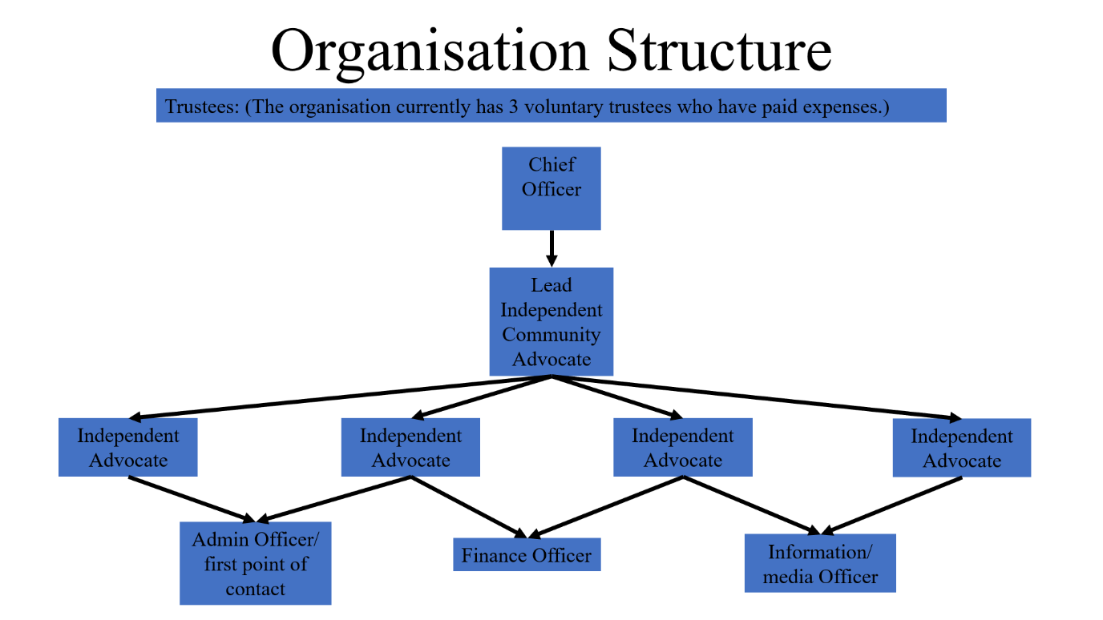
Figure 1: Organisation structure (Advocacy West Wales, 2023b).
Figure 1 shows our current organisational structure. Structurally the addition of the proposed job role of community mental health advocate would work alongside our other independent advocates. We are also seeking volunteers to work under the direction of our admin and finance officers.
We are fortunate to have a charismatic leader as our chief officer with a clear vision to take the organisation further and motivates the team to succeed (Williams, 2013). It is noted that having emphasis on long term planning, such as our leader’s clear vision may be of detriment to the organisation, as the vision may become of prime focus without the option of flexibility (Courtney, 2013). However, charismatic leadership ensures our advocates are committed, motivated and share the organisations values due to their meaningful forward vision (Rowden, 2000; Conger, 2012; Callan, 2003). Our organisation values team working and the importance of investing in and upskilling the team through continuous training and progression to improve employee knowledge, quality and effectiveness, for the overall benefit of the children and young people accessing our advocacy service (Gray, Field & Brown, 2010; Steven et al, 2018). As well as professional development opportunities our advocates have the opportunity for regular supervision in line with professional standards ensuring our team are adhering to the professional standards of advocacy and relevant legislation and equally to recognise and reward the good work that they continue to do (Donninson, 2009; Advocacy QPM, 2014).

Costs
The following is a brief outline of the current costs that the organisation incurs on an annual basis:
Item: | Cost:
Wages:
Chief Officer | £40,588
Lead Advocate | £30,832
Independent Advocate (full-time) | £23,836
Independent Advocate (full-time) | £23,836
Independent Advocate (part-time) | £15,890.67
Independent Advocate (part time) | £15,890.67
Admin officer/ first point of contact (full-time) | £20,245
Finance Officer (part-time) | £20,245
Information/media officer (part-time) | £20,245
Other expenses:
Trustee expenses | No expenses recorded for this year.
Monthly meeting room hire | £840 (£70 per day rate)
Working from home top up wage supplement | £2808 (£312 per staff member)
Equipment (employee laptops) | £2700 (£300 per staff member)
CPD training | £4050 (£450 per staff member)
Expenditure total: | £222,006.34 per annum

(Advocacy West Wales, 2023; glassdoor, 2023; nyas, 2023b; Swansea University, 2023)
The proposed additional funding will allow us to fund a new employee and expenses for volunteers adding costs of £23,386 for the new employee and approximately £2000 for volunteer expenses, to the above current costings outline (glassdoor, 2023).

Conclusion
CYP Carmarthenshire Community Mental Health Advocacy is a vital service to children and young people in Carmarthenshire experiencing mental health issues but do not fall within the statutory guidance found in The Welsh Government (Social Services and Well-being (Wales) Act 2014) and The Welsh Government (Mental Health (Wales) Measure 2010) in order to be offered statutory advocacy. We aim to empower, whilst ensuring children are educated about their rights and we listen to our advocacy partners to promote their wishes and feelings when accessing services (Boylan & Dalrymple, 2009; Jones & Walker, 2011, Unicef, 2017; Hoadley et al, 2017).
A SWOT analysis (Qwest, 2012) will follow this conclusion, providing information on the organisations strengths, weaknesses, opportunities and threats of our advocacy organisation CYP Carmarthenshire Community Mental Health Advocacy to aid our strategic course for development (Wijngaarden et al, 2012; we rise, 2023).
There will be an exploration of a funding bid linked to the above pen picture for CYP Carmarthenshire Community Mental Health Advocacy in Assessment 2. The funding bid aims to acquire funding to fund our new role of Community advocate to provide a drop-in advocacy service in youth centres across Carmarthenshire. The funding will also fund volunteer expenses that may occur in recruiting and retaining volunteers.

SWOT Analysis of CYP Carmarthenshire Community Mental Health Advocacy
(Qwest, 2012)
 | Positive | Negative
Internal | Strengths | Weaknesses
Internal | - Our advocates have received City and Guilds level 4 training in Independent Advocacy Practice (City and Guilds, 2021) as well as in house training on safeguarding, equality and diversity, professionalism and continuous professional development to ensure we have well trained and knowledgeable staff (Gray, Field & Brown, 2010; Steven et al, 2018).  - Our advocacy partners like that our advocates have a friendly and approachable manner and that they feel listened to (Davies & McGillivray, 2010).  - We communicate well as a team and have regular meetings to review our practice (Gray, Field & Brown, 2010; Steven et al, 2018).  - We offer digital services to our children and young people so that they can communicate with us via webchat or WhatsApp if they desired (Hollis et al, 2017). | - We do not offer a flexible face to face option for children and young people. It is by appointment only after the advocacy partner has made an appointment via phone, email or WhatsApp.  - Our advocacy partners can complain that we do not offer an advice service alongside our advocacy (mind, 2018; Advocacy QPM, 2014).  - We do not offer a drop-in service like our competitors (Advocacy West Wales, 2023).  - We currently do not have any volunteers that add value to charity services, communities and have greater social benefits such as providing the volunteers for skills for employment (Cordery et al, 2013).
External | Opportunities | Threats
External | - The Covid 19 Pandemic has seen an emergence in children and young people experiencing mental health issues such as anxiety and depression that our advocacy organisations cater for (Edmonds et al, 2022; PSB, 2021; Welsh Government, 2020; Murata et al 2021).  - Adding advocacy as a statutory service in The Welsh Government (Social Services and Well-being (Wales) Act 2014) and The Welsh Government (Mental Health (Wales) Measure 2010), has increased the knowledge of advocacy services. We believe this will encourage more people to use our service.  - Our service links with youth centres, schools and other statutory youth mental advocacy services as collaboration benefits children and young people accessing services (Rothi & Leavey 2006). We can sometimes get self-referrals that require statutory service that we would then need to signpost our partners to, and they sometimes get people requiring a non-statutory service (nyas, 2023).  - The fact that we offer digital services such as webchat and WhatsApp is valuable to our advocacy partners because it makes our service more accessible (Hollis et al, 2017). | - Our competitors offer a drop-in service and one also offers advice alongside their advocacy services which our service users may desire (Advocacy West Wales, 2023).  - Due to the ongoing need to secure funding we are financially vulnerable meaning we have a high turn over of staff as they do not have job security (Dayson, 2013). This means we have to train new staff at a further cost.  - The professionalisation of advocacy services could impact our organisation as there will be more regulation, inspection which could impact systemic changes advocacy can make (Care inspectorate Wales, 2019; Brubaker & Keegan, 2018). The legislation found in The Welsh Government (Social Services and Well-being (Wales) Act 2014) and The Welsh Government (Mental Health (Wales) Measure 2010), stipulates when someone can have advocacy which could mean the non-statutory services we offer are seen as less valuable as they are nor written in these laws.

References:
Advocacy West Wales (2023), Home. Available at: https://advocacywestwales.org.uk/ (Accessed: 24 February 2023)
Advocacy West Wales (2023b) Staff Profiles Available at: https://advocacywestwales.org.uk/about-us/staff-profiles/ (Accessed: 11 March 2023)
Advocacy QPM (2014) Advocacy Code of Practice. Recognising Quality in independent advocacy. Action for Advocacy. Available at: https://qualityadvocacy.org.uk/wp-content/uploads/2018/05/Code-of-Practice-1.pdf (Accessed: 6 March 2023)
Boddy, D (2020) Management Using Practice and Theory to Develop Skill. 8th edn. Harlow: Pearson Education Limited.
Boylan, & Dalrymple, J. (2009). Understanding Advocacy for Children and Young People. Open University Press.
Brubaker and Keegan (2018) “Suddenly Everyone’s an Expert in Our Field”: Campus Victim Advocates and the Promise and Perils of Professionalization. Violence Against Women, 25(9), 1116–1137. https://doi.org/10.1177/1077801218807096 (Accessed: 11 March 2023)
Buckingham et al (2016). Collaboration, Empowerment, and Advocacy: Consumer Perspectives about Treatment Engagement. Journal of Child and Family Studies, 25(12), 3702–3715. https://doi.org/10.1007/s10826-016-0507-5 (Accessed: 11 March 2023)
Callan. (2003). Charismatic Leadership in Contemporary Management Debates. Journal of General Management, 29(1), 1–14. Available at: https://doi.org/10.1177/030630700302900100 (Accessed: 6 March 2023)
Care inspectorate Wales (2019) Inspection Framework for Regulated Advocacy Services. Available at: https://www.careinspectorate.wales/sites/default/files/2019-11/191128-inspection-framework-for-regulated-advocacy-services-en.pdf (Accessed: 11 March 2023).
Carmarthen County Council (2021) Mental Health Update. Social Care and mental health scrutiny committee. Carmarthneshire.gov.uk. Available at: https://democracy.carmarthenshire.gov.wales/documents/s51009/Report.pdf (Accessed 24 February 2023)
City and Guilds (2021) City & Guilds Level 4 Independent Advocacy Practice (3614-04) Qualification Handbook. Available at: https://www.cityandguilds.com/-/media/productdocuments/health_and_social_care/care/3614/centre_documents/3614-04_l4_independent_advocacy_practice_handbook_v1-1-pdf.ashx#:~:text=To%20achieve%20the%20City%20%26%20Guilds,credits%20from%20the%20optional%20units. (Accessed: 11 March 2023).
Conger, J (2012) The Oxford Handbook of Leadership. London: Oxford University Press
Cordery, C et al (2013). Towards communicating the value of volunteers: lessons from the field. Public Money & Management, 33(1), 47–54. Available at: https://doi.org/10.1080/09540962.2013.744894 (Accessed: 6 March 2023)
Courtney, R (2013) Strategic Management in the Tthird Sector. Hampshire: Palgrave Macmillan
Dayson. (2013). Understanding financial vulnerability in UK third sector organisations: methodological considerations and applications for policy, practice and research. Voluntary Sector Review, 4(1), 19–38. https://doi.org/10.1332/204080513X663796 (Accessed: 11 March 2023
Davies, H, & McGillivray, G. Brotherton ed, (2010). Working With Children, Young People andFfamilies. London: SAGE.
Donninson, D (2009) Speaking to Power. Advocacy for Health and Social Care. Bristol: Policy Press
Edmonds et al (2022). Protecting the Mental Wellbeing of our Future Generations: learning from COVID-19 for the long term. A Mental Wellbeing Impact Assessment Approach. Executive Summary. NHS: Public health Wales. Available at: https://phw.nhs.wales/publications/publications1/protecting-the-mental-wellbeing-of-our-future-generations-learning-from-covid-19-for-the-long-term-main-report/ (Accessed: 11 March 2023)
Glassdoor (2023) Independent Mental Health Advocate Salaries in United Kingdom. Available at: https://www.glassdoor.co.uk/Salaries/independent-mental-health-advocate-salary-SRCH_KO0,34.htm (Accessed: 11 March 2023)
Gray, I, Field, R and Brown, K (2010) Effective Leadership, Management and Supervision in Health and Social Care. Exeter: Learning Matters Ltd
Henderson, R and Pochin, M (2001) A right result? Advocacy, justice and empowerment. Bristol: The Policy Press
Hoadley, B et al (2017). Incorporating Children and Young People’s Voices in Child and Adolescent Mental Health Services Using The Family Model. Social Inclusion, 5(3), 183–194. https://doi.org/10.17645/si.v5i3.951 Available at: https://www.proquest.com/docview/2002254627?accountid=130472&parentSessionId=qduzKihY7BtNZE%2BdF3OtnUKMk6veEPm4YU%2B5ufVP6y8%3D&pq-origsite=primo (Accessed: 6 March 2023)
Hollis, C et al (2017). Annual Research Review: Digital health interventions for children and young people with mental health problems – a systematic and meta‐review. Journal of Child Psychology and Psychiatry, 58(4), 474–503. https://doi.org/10.1111/jcpp.12663 Available at: https://web-p-ebscohost-com.ezproxy.uwtsd.ac.uk/ehost/pdfviewer/pdfviewer?vid=0&sid=95db44dd-7e68-4499-be3d-c7c149464af4%40redis (Accessed: 7 March 2023)
Jones, P and Walker, G ed(2011) Children’s Rights in Practice. London: Sage
Kumari, V & Brooks, S. ed. (2004). Creative Child Advocacy: Global Perspectives. London: SAGE Publications.
Mental Health (Wales) Measures 2010. (SI 2010/ nawm 7). Available at: https://www.legislation.gov.uk/mwa/2010/7 (Accessed: 11 March 2023)
Mind (2018) Advocacy in Mental Health. Available at: https://www.mind.org.uk/information-support/guides-to-support-and-services/advocacy/what-is-advocacy/ (Accessed: 7 March 2023)
Mind (2023) Understanding Advocacy for 11-18 Year Olds. Available at: https://www.mind.org.uk/information-support/for-children-and-young-people/advocacy-and-mental-health/understanding-advocacy/ (Accessed: 24 February 2023

Murata et al (2021). The psychiatric sequelae of the COVID‐19 pandemic in adolescents, adults, and health care workers. Depression and Anxiety, 38(2), 233–246. Available at: https://doi.org/10.1002/da.23120 (Accessed: 11 March 2023)
NDTI (2018) The Advocacy Charter . National Development Team for Inclusion. Available at: https://www.advocacyproject.org.uk/wp-content/uploads/2020/11/Advocacy-Charter-A3.pdf (Accessed: 7 March 2023)
Newbigging, K., Chastey, K., & Brandon, T. (2015). Independent Mental Health Advocacy : the Right to be Heard : Context, Values and Good Practice. Jessica Kingsley Publishers.
NHS Wales (2016-2019) ‘Our Health, Our Future’ Hywel Dda Interim Integrated Medium Term Plan Summary 2016/17 to 2018/19. Available at: https://primarycareone.nhs.wales/files/hywel-dda-uhb-resources/cluster-newsletter-and-other-links/our-health-our-future-imtp-2016-2019-pdf/ (Accessed: 11 March 2023)
Nyas (2023) National Youth Advocacy Service. Available at: https://www.nyas.net/ (Accessed 11 March 2023)
Nyas (2023b) Current Vacancies. Available at: https://nyas.current-vacancies.com/Careers/NYAS-Jobs-VSP-1837/?cid=1837 (Accessed: 12 March 2023)
PSB (2021) Carmarthenshire Assessment of Local Wellbeing. Carmarthenshire: Public Services Board. Available at: https://www.thecarmarthenshirewewant.wales/media/jkcbckz0/draft-assessment-of-local-well-being-2021.pdf (Accessed: 11 March 2023)
Qwest (2012) QWEST: Quality, Work, Employability, Skills and Training (Blaenau Gwent, Caerphilly and Torfaen) Formative Evaluation Report October 2012. Cotyledon, Community Interest Company: University of Wales, Newport.
Rothi, & Leavey, G. (2006). Child and adolescent mental health services (CAMHS) and schools: inter-agency collaboration and communication. The Journal of Mental Health Training, Education, and Practice, 1(3), 32–40. https://doi.org/10.1108/17556228200600022
Rowden, R. (2000). The relationship between charismatic leadership behaviors and organizational commitment. Leadership & Organization Development Journal, 21(1), 30–35. https://doi.org/10.1108/01437730010310712
Schreier et al (2022). Financing mental health services at Child Advocacy Centers for victims of child sexual abuse and their families. Aggression and Violent Behavior, 65, 101638–. Available at: https://doi.org/10.1016/j.avb.2021.101638 (Accessed: 7 March 2023)
Social Services and Well-being (Wales) Act 2014. (SI 2014/anaw 4). Available at: https://www.legislation.gov.uk/anaw/2014/4/contents (Accessed: 11 March 2023)
Spears, B (2018) Using Technology to Promote Mental health and Wellbeing in Children and Young People. The International Journal of Emotional Education, 10(1), 1–4. Avaiable at: https://www.proquest.com/docview/2039808401/fulltextPDF/75351D5DFC6A4C5CPQ/1?accountid=130472 (Accessed: 2 March 2023)
Steven, A et al (2018). The value of continuing professional development: A realistic evaluation of a multi-disciplinary workshop for health visitors dealing with children with complex needs. Nurse Education Today, 67, 56–63. Available at: https://doi.org/10.1016/j.nedt.2018.04.021 (Accessed: 6 March 2023)
Swanse University (2023) Parc Dewi Sant – Meeting Rooms for Hire. Available at: https://www.swansea.ac.uk/health-social-care/enterprise-and-innovation/parc-dewi-sant-meeting-rooms/ (Accessed: 12 March 2023)
The Children’s Society (2020) The Case for Open Access Emotional Health and Wellbeing Services. London: The Children’s Society. Available at: https://www.childrenssociety.org.uk/sites/default/files/2021-01/The-Case-for-Open-Access-Hubs.pdf (Accessed: 2 March 2023)
UKAN (2001) A clear Voice, A clear vision. The advocacy reader. Ed Mullins, G and Wood, P. Sheffield: UK Advocacy Network.
Unicef (2017) A Summary of the UN Convention on the Rights of the Child. Available at: https://www.unicef.org.uk/rights-respecting-schools/wp-content/uploads/sites/4/2017/01/Summary-of-the-UNCRC.pdf - accessed 24/02/23
Welsh Government (2020) Review of the Together for Mental Health Delivery Plan 2019-2022 in Response to covid-19. Available at: https://www.gov.wales/sites/default/files/publications/2020-10/review-of-the-together-for-mental-health-delivery-plan-20192022-in-response-to-covid-19_0.pdf (Accessed 11 March 2023)
We rise (2023) Friends, Foes and Forces: A SWOT Analysis. Available at: https://werise-toolkit.org/en/system/tdf/pdf/tools/friends-foes-and-forces-a-swot-analysis_0.pdf?file=1&force=#:~:text=Overview%3A%20A%20SWOT%20analysis%20enables,goals%2C%20objectives%2C%20and%20activities. (Accessed: 11 March 2023)
Wijngaarden, V et al (2012). Strategic analysis for health care organizations: the suitability of the SWOT-analysis. The International Journal of Health Planning and Management, 27(1), 34–49. https://doi.org/10.1002/hpm.1032
Williams, C (2013) Principles of Management. 7th edn. International Edition. Canada: South Western Cenage Learning

