  Component One:  What are the key skills required when working in the housekeeping team? 750 words (+/- 10%)  Contribution to Overall Module Assessment: 25% | Student No: | 2026638
 | Student name : Adina Vasilica Ichim  Module Title: opera | Operating Hotel Facilities
 | Module Code: | 4006
 | Lecturer: | Katherine Flynn
Introduction
The housekeeping department in a hotel is one of the most crucial units in the hospitality industry today. Without them, a hotel cannot run its operations seamlessly as their job role demands the utmost attention. As per their job task, they are solely responsible for maintaining the hotel’s reputation and enhancing recognition within the global market. The following discourse will discuss the key roles and responsibilities of a housekeeping associate. Moreover, the necessary skills and abilities will be elaborated on in this write-up in order to fully comprehend their contribution. Furthermore, it will also present a reflective journal of mine as an intern at Hilton Hotel and Resorts highlighting my learning experiences (Hilton, 2023).
Discussion
There is no denying that housekeeping staff is of utmost significance within a hotel and can remarkably contribute to the enhancement of customer satisfaction. As per the definition of the job role, their primary obligation is to keep the hotel neat and clean and maintain hygiene. Hence, the position necessitates a wide range of proficient skills and qualities to ensure that organisational objectives are achieved thoroughly (Jones, 2010). However, to mention in detail, the hotel rooms, regardless of the type, must facilitate everything the visitor has paid and asked for. The employee must cultivate physical agility as they need to be fast to attend to the guests and carry heavy equipment to facilitate service. During my internship at Hilton Hotels and Resorts, I realised how important it is to be physically fit and active as I had to rush from spot to spot to attend to the customers (Rogers, 2008). Alongside this, it was imperative to maintain correct posture and look refined in order to create a good impression on the guests. This helps to develop an impressive outlook of the hotel. As an intern, I needed to remain attentive and receive all the calls to report. Additionally, I also comprehended how important it is to maintain effective communication among other staff to keep myself updated about the guest’s arrival and departure (Sharma et al., 2019). While working as a subordinate, I needed to gather information from the front desk associate and act accordingly. My first and foremost job was to escort the guests to their rooms and provide them with all necessary information regarding the room service. This made me realise that cultivating interpersonal communication skills is vital in order to comprehend their problems, preferences and requirements. Along with this, comes the ability to listen ability which provides me with elaborate insights about the tasks I must undertake. Additionally, attaining accurate knowledge regarding cleaning different surface areas according to their types is very crucial (Wood, 2013). Utilising the precise cleaning agents and applying the correct method can profoundly help the associate to make the rooms and other spaces germ–free. The regular customer of Hilton Hotels are quite precise about their demands and visit frequently due to its standard service policy. Hence, it becomes more important that the quality of the hotel is maintained throughout the year. Furthermore, considering the demand and popularity today, I had to cultivate a handful of knowledge about the technology and software utilised in the hotel. On the very first day, I first got familiar with the hotel infrastructure to ensure a seamless manoeuvre of the operations (Vallen and Vallen, 2012). However, in order to provide the best room service I had to communicate with other departments as well and report them. This interdependency is quite necessary for the hospitality business as every job relies on the other. Thus, no miscommunication or misunderstanding occurs regarding tasks, I tried to share a good bond. Furthermore, I started appreciating and learning about other cultures as the hotel possesses a culturally diverse working staff. Regular maintenance of assets and facilities leads to a longer lifespan, reducing the need for frequent replacements and repairs. There are multiple health, safety, and hygiene regulations that apply to the hospitality industry (Tesone, 2010).
Conclusion
Performing housekeeping duties in a hotel has a major influence on expense management especially today. The implementation of effective inventory management techniques, efficient resource utilisation, and proactive maintenance strategies can effectively mitigate expenses. Consistently following established cleanliness protocols through periodic inspections can help maintain good standing in the industry and prevent punishment. The above reflective essay has provided a brief overview of the Hilton Hotel and Resort and its various service. Along with that, distinctive skills that I have gained during the course have also been elaborated thoroughly in the mid part of the write-up. Lastly, the overall importance of these skilled housekeeping workers in the hospitality industry has also been highlighted in the last part of this essay.
Word Count | 778

Component Two:
Contribution to Overall Module Assessment: 25%
In this scenario – You have just been promoted to team leader for a floor within the hotel. A guest complains that on their arrival, their room had not been properly cleaned. Create an action plan and answer the following questions.

Problem | Why did it happen? | What are you going to do? | How will you prevent this from happening in the future? | What measures would you introduce to improve team effectiveness?
Misconduct and misbehaviour of the staff | The staff in charge and the guest got involved in a heated argument regarding some room service issue. This is assumed that the guests were having some trouble as to how control a technological device or equipment. After addressing the issue, the staff, however, was unable to comprehend the problem accurately which further led to petty disagreement. However, while conversating the staff might have addressed the cultural background of the visitor unethically which infuriated the customer leading him lodging a complaint. | After I am informed of the dispute, I will immediately rush to the spot and will try to resolve the problem. At first, I will dismiss the staff and will politely conversate with the guest to gain some insights of the matter from their point of view. I will make them sure that necessary steps will be taken to show that the hotel does not entertain such behaviour at all. Afterwards, I will also listen to the staff member’s perspective to analyse the matter and identify the guilty one. Evaluating both testimonies I will take actions and will report the higher authority so look into the matter. | As the team leader of the housekeeping department, I will assume the role with more seriously and maintain my professionalism while handling the matter. I will reflect over the entire dispute and the point of views I have gained to come up with effective decisions. However, I will terminate or suspend the staff for the risking the reputation of the hotel. Otherwise, I will relocate the job role of the staff in the back office where the personnel will not have to interact with the guests. Additionally, I will set an example by incorporating penalty method so, the staff become conscious while repeating the same. | I will arrange a meeting with the administration and will address the issue to attain others’ opinion on the matter. Apart from that, I will introduce monthly training program to disseminate proper guidance regarding the importance cultural behaviour and impact of misconduct in business.
Stained bedsheets and drapes | Entering the room, the first thing that caught the attention of the guest was the unclean and stained bedsheet. The staff who was attending the guests tried to misled them to cover the mistake but failed to do so. Thus, they made a complaint against the room service. | I will immediately respond to the complaint and personally attend the respective visitors in order to remove the confusion. Utilising my communication skill, I will try to convince them about the working policies of the hotel and will make sure that they feel at ease and do not cancel their booking. During their stay, I will provide them especial attention and complementary service to compensate the inconvenience. | I will immediately talk to the staff in charge to address the mistake and problem they have caused. Additionally, I will guide the personnel to differentiate between ethical and unethical practice in hotel industry. I will revaluate the cv of the employee. | As the team leader, at first I will make sure that proper cleaning agents are utilised by the laundry departments. Moreover, I will ensure that professional staff is hired whoever have the better knowledge reading washing different types of fabrics. I will also organise a training session to highlight the major mistakes that could be done in any hotel entity and will discuss proper solutions for them.
Late room service | As per the complaint, from the moment the guests had checked-in, they were not properly attended which made them confused. They had t wait for hours to get to the room even after successfully checked in, lost in the hotel to find room and their meals were also delivered late. This happened due to the lack of communication among the members timely and actions were not taken promptly. | I will immediately call up a departmental meeting to address the issue and will try to gain proper knowledge regarding this. I will ask every personnel on duty in order to identify the barriers that was hampering the work progress. Afterwards I will come up with effective solutions and assist them accordingly. | As the team leader I will assume the job role upon myself and lead the team to provide a demonstration as to how a tasks is accomplished. I will also try to find out if the staff is sharing an amicable relationship among them. | As per the requirements of my job role, I will make arrangements that the employees receive sufficient training on interaction and communication. Additionally, I will make sure that the technology-powered devices that help to build seamless communication working properly.

Component Three:
Contribution to Overall Module Assessment: 50%
Your task is to create and prepare a presentation following the detailed scenario provided below.

As the floor housekeeping manager and given the recent guest complaints you need to put together a basic training presentation for your colleagues within the housekeeping team to get the best out of them, ensure that brand standard is being achieved and that Health and Safety procedures are also being followed.

Figure: 1

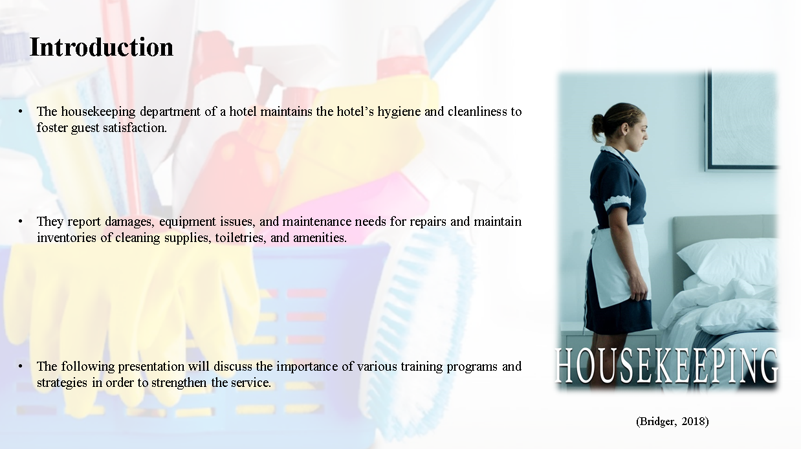
Training Notes:

Introduction
The housekeeping department of a hotel maintains the hotel’s hygiene and cleanliness to foster guest satisfaction. Their tasks include changing linens, making beds, organising, furnishing, vacuuming, dusting, cleaning bathrooms, restocking amenities, and maintaining tidy rooms. Moreover, hotel housekeepers’ upkeep public areas like lobbies, corridors, elevators and spaces as well as clean and keep the areas germs-free. They report damages, equipment issues, and maintenance needs for repairs and maintain inventories of cleaning supplies, toiletries, and amenities. Receiving numerous complaints and negative feedback regarding the housekeeping service is quite common but of utmost importance that every housekeeping manager must address. The following presentation will discuss the importance of various training programs and strategies in order to strengthen the service. However, it will explicate the techniques and its implication that will impart valuable knowledge regarding their job role to lead the hotel to success. Along with this, an employee engagement model will also be elaborated in order to maintain the brand reputation and standards regarding health safety and hygiene.

Figure: 2

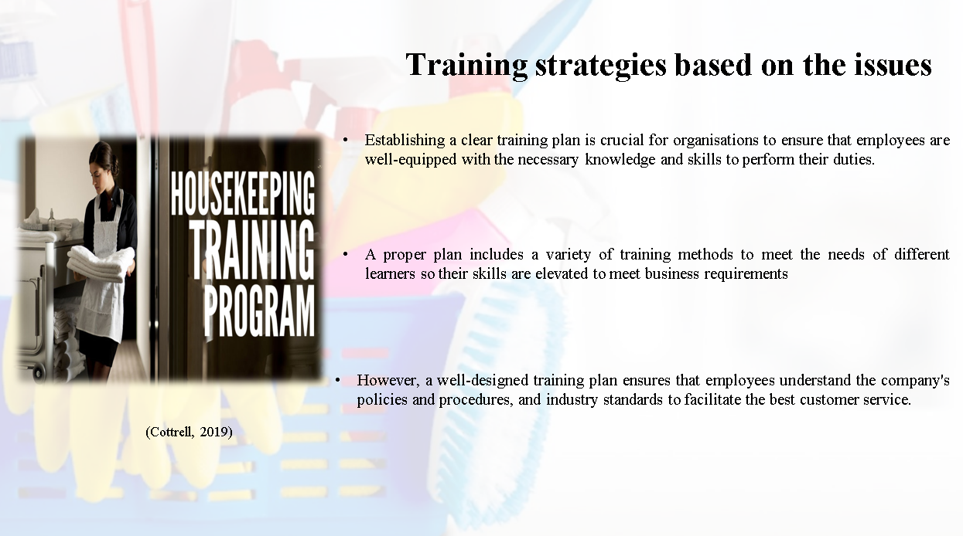

Training Notes:

Training strategies based on the issues
Establishing a clear training plan is crucial for organisations to ensure that employees are well-equipped with the necessary knowledge and skills to perform their duties. A clear training plan helps employees to understand their responsibilities and expectations, reduces confusion, and minimizes the risk of errors or accidents. A proper plan includes a variety of training methods to meet the needs of different learners so their skills are elevated to meet business requirements (Bridger, 2018). Following a strategic method to accomplish the tasks, a manager can achieve the aims and objectives of the entity. This will help the man in charge to identify the objectives of each session and evaluate each employee's performance. However, a well-designed training plan ensures that employees understand the company's policies and procedures, and industry standards to facilitate the best customer service. Additionally, it can help employees improve their job performance, increase their motivation and engagement, and boost their confidence (Cottrell, 2019).

Figure: 3

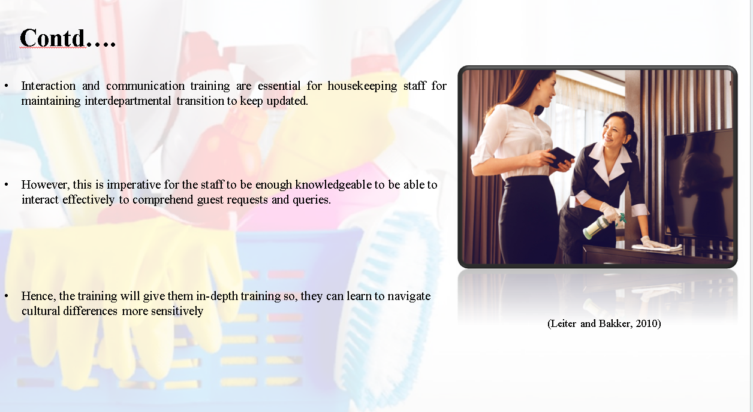
Training Notes:

Interaction and communication training are essential for housekeeping staff for maintaining interdepartmental transition to keep updated. This skill is considered to be the backbone of providing excellent customer service as the staff needs to interact with the visitors daily (Leiter and Bakker, 2010). However, this is imperative for the staff to be enough knowledgeable to be able to interact effectively to comprehend guest requests and queries. Additionally, housekeeping staff members come into contact with guests from different cultures and backgrounds as well as nationalities. Hence, the training will give them in-depth training so, they can learn to navigate cultural differences more sensitively (Mullins and Dossor, 2013).

Figure: 4

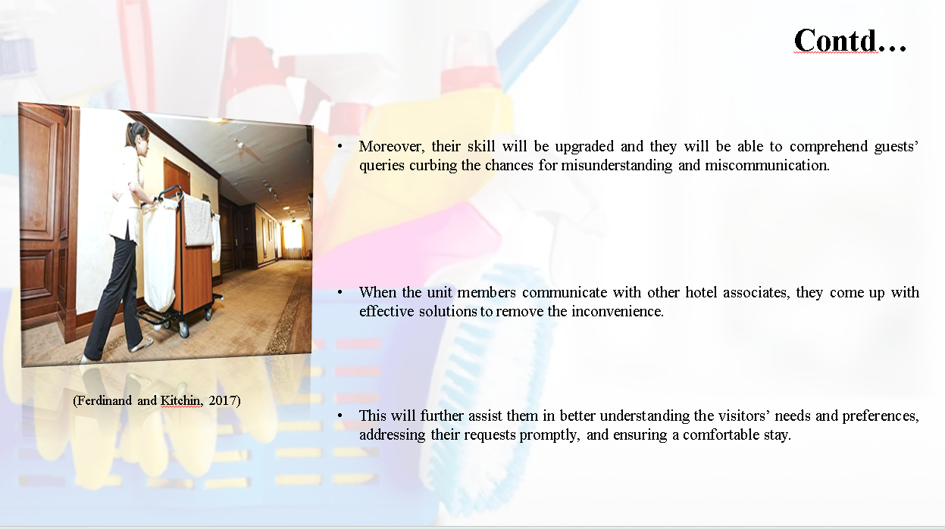
Training Notes:

Moreover, their skill will be upgraded and they will be able to comprehend guests’ queries curbing the chances for misunderstanding and miscommunication. Furthermore, the job role demands team effort and good collaboration with other departments in order to manoeuvre tasks seamlessly. When the unit members communicate with other hotel associates, they come up with effective solutions to remove the inconvenience (Ferdinand and Kitchin, 2017). The training sessions primarily aim at providing proficient training and learning techniques that will help them develop their cognitive power. This will further assist them in better understanding the visitors’ needs and preferences, addressing their requests promptly, and ensuring a comfortable stay. Interaction and communication training can significantly improve the performance of housekeeping staff, enhance the guest experience, and promote job satisfaction and retention (Johnston et al., 2012).

Figure: 5

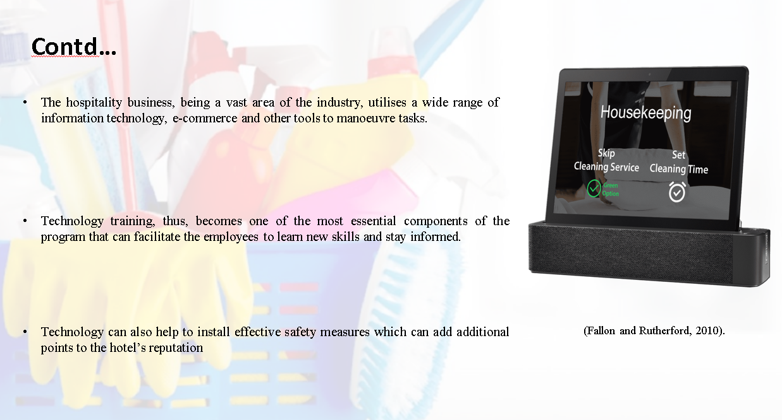
Training Notes:

The hospitality business, being a vast area of the industry, utilises a wide range of information technology, e-commerce and other tools to manoeuvre tasks. However, the sole purpose of incorporating this facility is primarily to enhance the overall hospitality customer experience during their stay. Technology training, thus, becomes one of the most essential components of the program that can facilitate the employees to learn new skills and stay informed. Moreover, with the advancement of technology and networking, it becomes imperative that the housekeeping staff members receive adequate practice and lessons regarding the subject. Technology can also help to install effective safety measures which can add additional points to the hotel’s reputation (Fallon and Rutherford, 2010).

Figure: 6

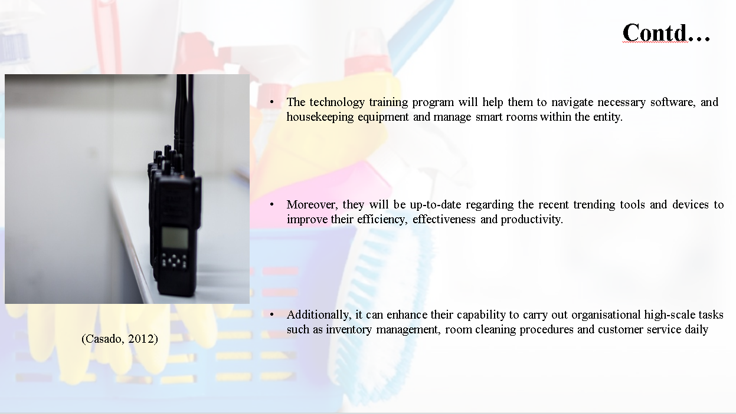
Training Notes:

The technology training program will help them to navigate necessary software, and housekeeping equipment and manage smart rooms within the entity. Furthermore, it will induce in them a better understanding of the utilisation of technology along with handling housekeeping software and smart rooms. Moreover, they will be up-to-date regarding the recent trending tools and devices to improve their efficiency, effectiveness and productivity. They can further assist the visitors in navigating technology–powered devices and systems to make their stay as comfortable as possible. Additionally, it can enhance their capability to carry out organisational high-scale tasks such as inventory management, room cleaning procedures and customer service daily (Casado, 2012).
Figure: 7

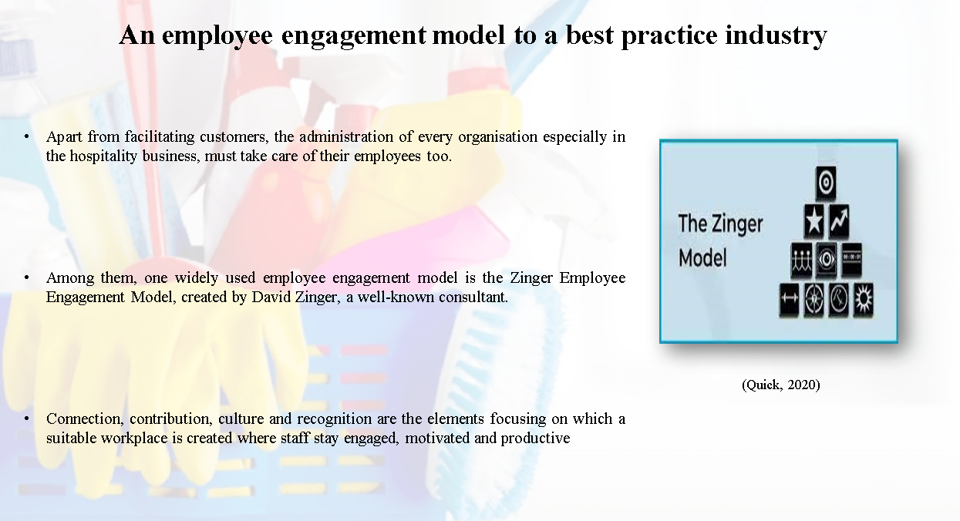
Training Notes:

An employee engagement model to a best practice industry
Apart from facilitating customers, the administration of every organisation especially in the hospitality business, must take care of their employees too. However, this concern stirred the minds of many theorists and scholars and they came up with various structures that imply specific models to achieve the goal (Quick, 2020). Among them, one widely used employee engagement model is the Zinger Employee Engagement Model, created by David Zinger, a well-known consultant. The model is basically in the form of a pyramid that comprises four distinctive layers. This effective framework or approach aims at fostering employee engagement and productivity within the entity. Typically, the design encompasses four interconnected key elements to induce a positive approach among the staff members of the housekeeping department. Connection, contribution, culture and recognition are the elements focusing on which a suitable workplace is created where staff stay engaged, motivated and productive (Raghubalan and Raghubalan, 2016).
Figure: 8

Training Notes:

Conclusion
The above presentation has covered the dynamics of housekeeping staff members and the types of necessary training need to facilitate for them. As per the need of the hotel industry and scrutinising the kinds of common complaints they receive, the presentation aims at demonstrating several training strategies. Following the Zinger employee engagement model, the discourse has discussed the importance of technology, communication and planning training to ensure the seamless progress of the tasks. Alongside this, the functions, implications and benefits are discussed to ensure the guests’ good health and safety.

References

Bridger, E. (2018) Employee engagement: a practical introduction. 2nd ed. HR Fundamentals. London: CIPD and Kogan Page.
Casado, M. (2012) Housekeeping Management. London: Wiley.
Cottrell, S. (2019) The Study Skills Handbook. 5th ed. London: Red Globe Press.
Fallon, M. & Rutherford, D. (2010) Hotel Management and Operations. London: Pearson.
Ferdinand, N. and Kitchin, P. (2017) Events Management - An International Approach. 2nd ed. London: SAGE Publications Ltd.
Hilton, (2023). About Us. [Online] Available at: https://www.hilton.com/en/locations/united-kingdom/hilton-hotels/ [Accessed 3 June 2023].
Johnston, R., Clark, G. & Shulver, M. (2012) Service Operations Management. London: Pearson.
Jones, T. (2010) Professional Management of Housekeeping Operations. London: Wiley.
Leiter, M. P. and Bakker, A. B. (2010) Work Engagement: A Handbook of Essential Theory and Research. Hove [England]: Psychology Press.
Mullins, L. and Dossor, P. (2013) Hospitality Management and Organisational Behaviour. 5th ed. Harlow: Pearson.
Quick, L. (2020) Managing Events. Real Challenges, Real Outcomes. London: SAGE Publications Ltd.
Raghubalan, G. and Raghubalan, S. (2016) Hotel Housekeeping - Operations And Management. 3rd ed. India: Oxford University Press.
Rogers, T. (2008) Conferences and conventions a global industry (2nd ed., Events management series). Oxford; Boston: Butterworth-Heinemann.
Sharma, N., Chaudhary, N. and Singh, V. (2019) Management Techniques For Employee Engagement In Contemporary Organizations. Hershey, Pennsylvania: IGI Global.
Tesone, D. (2010) Principles Of Management For The Hospitality Industry. 1st ed. London: Routledge.
Vallen, G. & Vallen, J. (2012) Managing Hotel Operations. London: Pearson.
Wood, R. (2013) Key Concepts in Hospitality Management. London: Sage.

