Analysing the work of two author-illustrators who tackle difficult themes

Student number:2305407
Course: BA illustration
Tutor: Delyth Lloyd-Evens
Word count:2,723

Within this essay I will be Analysing the work of author illustrators who have illustrated picture books about difficult, sensitive and sometimes shocking themes. The author-illustrators' works I’ll be analysing are The Red Tree by Shaun Tan and Death, Duck, and the Tulip by Wolf Erlbruch. The Red Tree is a story about a young girl dealing with depression, and the illustrations show her emotions in a powerful and strange way. Death, Duck, and the Tulip tells the story of a duck who meets death and explores the topic of dying in a gentle and thoughtful way.

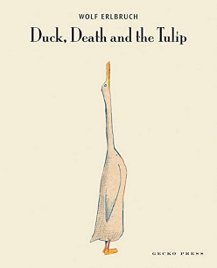… 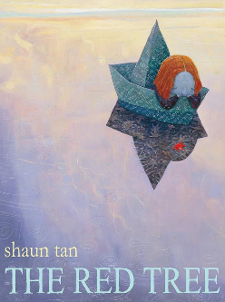

Figure 1: Wolf Erlbruch and Chidgey, C. (2018). Duck, death and the tulip. / Tan, S. The red tree, (2016).

I explored several books on children's literature and picture books, where I came across the works of four influential theorists: Jane Doonan, Martin Salisbury, D.W. Winnicott, and Nicholas Tucker. One of the quotations from my research that I resonated with was “there is an important stage in a person's aesthetic development that depends upon having insights about the ways in which pictures may be interpreted” (Doonan, 1993, p.8). Where during my research I found this quote fits well with the essay question because we are analysing the work of author illustrator from different perspective and that each perspective may be different from one another’s.

Death, Duck, and the Tulip by Wolf Erlbruch

In Death, Duck, and the Tulip, Erlbruch tells a thoughtful story about life and death, a topic that many people find hard to talk about and often fear. While Death is usually illustrated as a fearful character in other stories, Erlbruch makes Death calm, gentle, and kind. This different way of showing Death helps readers think about it in a less frightening way and makes the subject easier to understand.

In the story, Death follows the duck and interacts with her throughout her daily life. Erlbruch uses a lot of white space in the illustrations, rather than detailed backgrounds, which creates a peaceful and calm feeling. This helps give the story a safe and comforting tone, even as we see the duck slowly approaching the end of its life.
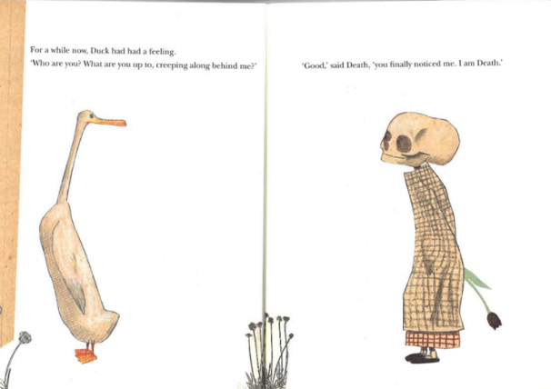

Figure 2: Wolf Erlbruch and Chidgey, C. (2018). Duck, death and the tulip.

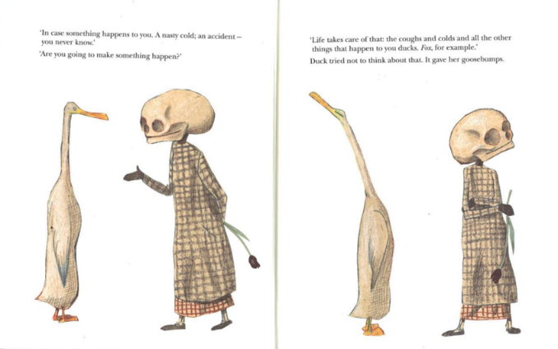
Figure 3: Wolf Erlbruch and Chidgey, C. (2018). Duck, death and the tulip.

A quote that I found by Doonan helps strengthen the way that Erlbruch illustrates death as a kind character although people fear death as a subject “pictures are expressive, being vehicles for the artists expression as well as artifacts that stimulate personal expressive response in the beholder” (Doonan, 1993, p.8). We as people oftens see death as a sad and scary subject and often see death as a dark figure but Erlbruch illustration of death changes the readers perspective of death as an inviting and kind character.
within this page duck is swimming in the pond with death and later goes to sleep offering to hug death while she sleeps offering to keep him worm, once Duck wakes up she is relieved that she did not die and then she wakes death up to continue their day to day life.
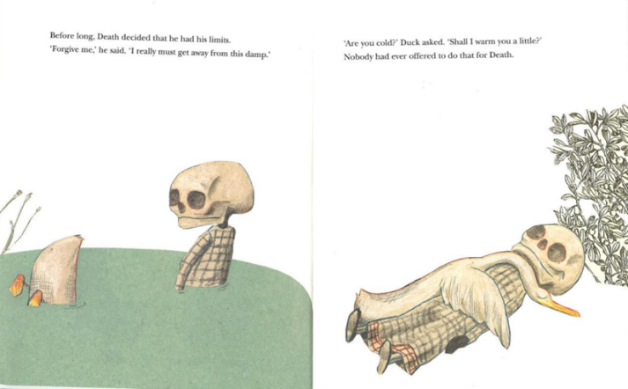
Figure 4: Wolf Erlbruch and Chidgey, C. (2018). Duck, death and the tulip.

These pages show the way duck view life and how she seems happy that she wake up and how she wake-up death pocking him in the ribs and saying “I’m not dead yet” she quacked delighted. Erlbruch illustrated duck looking unbothered by deaths presence and how death look happy that duck is awake and alive and how he responds by saying “I’m pleased for you” said death while stretching. The interaction shows a playful, light-hearted approach to life and death.
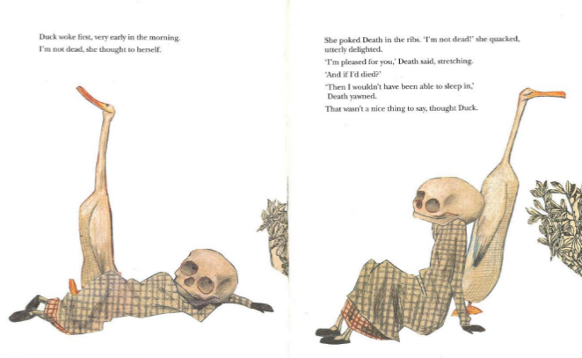
Figure 5: Wolf Erlbruch and Chidgey, C. (2018). Duck, death and the tulip.

In one of the pages of the picture book, there is an image of the duck and Death sitting together in a tree, while a black crow flies past. Crows are often seen as symbols of death and the afterlife. They carry both positive and negative meanings, depending on different cultures and beliefs. In some cultures, crows are seen as bad omens, while in others, they are considered messengers or signs of transformation. Erlbruch use of the crow adds an extra layer of depth to the story, inviting readers to reflect on the many ways death can be understood.

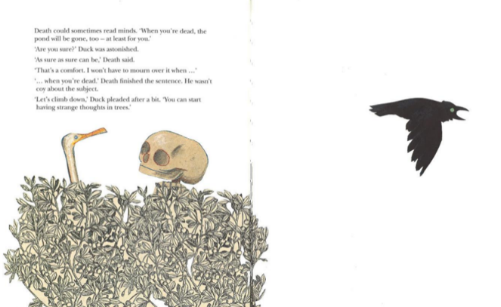
Figure 6: Wolf Erlbruch and Chidgey, C. (2018). Duck, death and the tulip.

Towards the end of the story, as summer comes to a close, Duck and Death spend less time at the pond and more time on the grass. They speak little, and as a cool wind ruffles Duck’s feathers, she feels the chill for the first time, saying to Death, “I’m cold,” one evening. “Will you warm me up a little?” In this moment, Erlbruch illustrates Duck and Death holding hands, with nothing but white space surrounding them and having only death and duck withing the double page spread alone together and show how duck trust death.
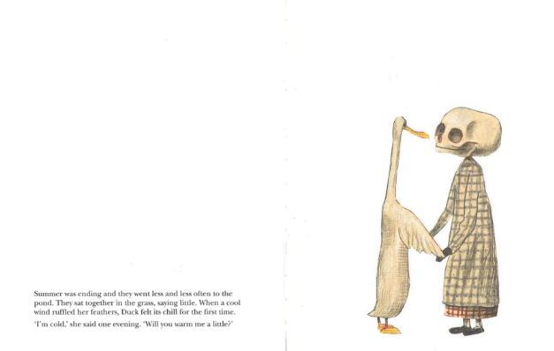
Figure 7: Wolf Erlbruch and Chidgey, C. (2018). Duck, death and the tulip.

In this illustration, the reader can sense that Duck understands what’s coming next. Duck sees Death not as an enemy, but as a friend, accepting that death is near without fear. By asking Death to keep her warm in the cold wind, Duck shows trust and comfort. Erlbruch choice to use minimal words and focus on the image speaks volumes, leaving the reader to imagine what happens next, adding depth to the story’s emotional and peaceful conclusion.

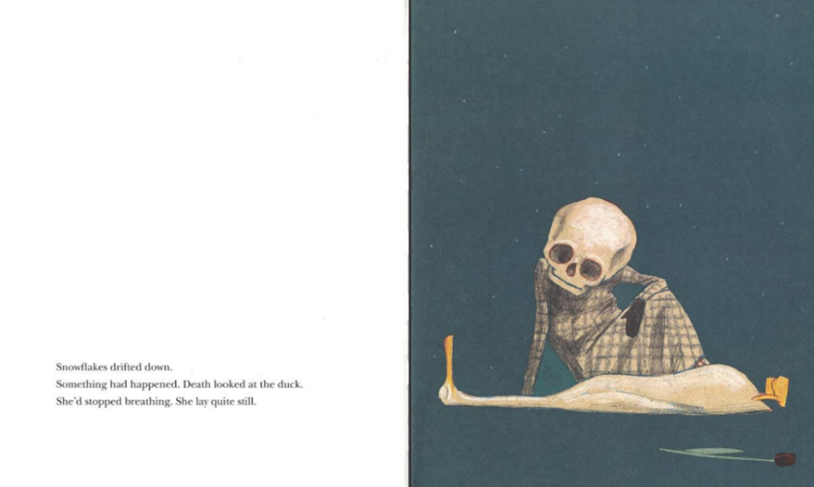
Figure 8: Wolf Erlbruch and Chidgey, C. (2018). Duck, death and the tulip.

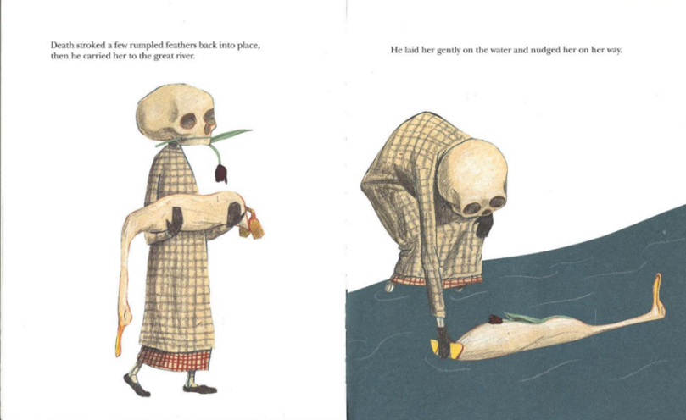
Figure 9: Wolf Erlbruch and Chidgey, C. (2018). Duck, death and the tulip.

As duck sadly passes away death is sitting beside her watching over her as she drifts off and as she slowly stops berthing. Erlbruch places the text on one page surrounded by white space and on the other is a beautiful illustration of duck laying down while death is sitting idly beside her watching over her and a dark coloured tulip placed next to her. Erlbruch incorporates a blue background for this scene sowing the sadness and loss and other emotions that the reader may feel about this illustration.

The next pages show death carrying duck in his arms with the tulip in his mouth as duck is lying in his arms lifeless but at peace. This illustration is such a powerful image of emotions where the readers can see how death cares for duck while he carries her to where she will lay to rest peacefully in her in her eternal sleep.

To where in the next scene he lays her down safely in a flowing river and places the tulip on her chest and softly pushed her down the river, so she floats down the river moving along with the flow of the river. In this illustration Erlbruch once again places duck in a blue colour background and death has the white space behind him as a reader, when I look at the illustration of Duck in the river, where the reader could see the flowing water as a powerful symbol of the way life moves.

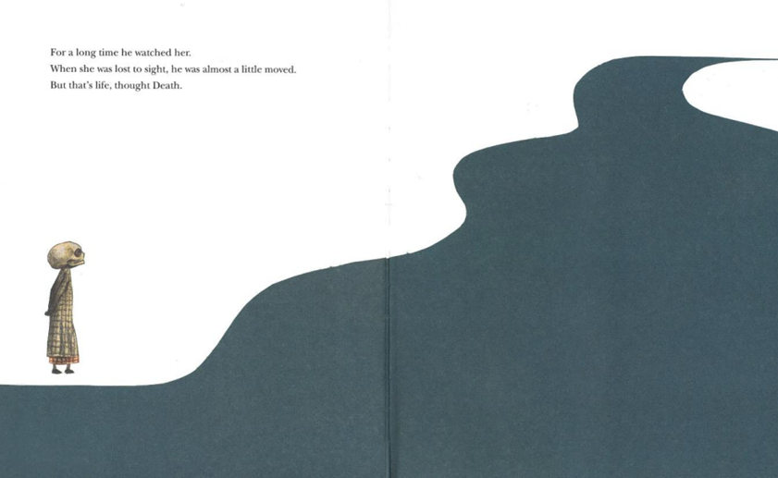
Figure 10: Wolf Erlbruch and Chidgey, C. (2018). Duck, death and the tulip.

The final double-page spread before the last page marks the end of the story. In this scene, Death stands by the river, watching Duck peacefully float away, slowly disappearing from view. "He was almost a little moved, but that's life," Death thinks.

Erlbruch creates a powerful image by combining the white space with the flowing blue river, which fills both pages. Death is depicted as a small figure standing still, watching the river flow, while Duck is no longer visible, symbolizing the quiet passage of life. The vastness of the empty space and the movement of the river evoke a sense of finality, showing Death’s calm acceptance of life’s natural end.
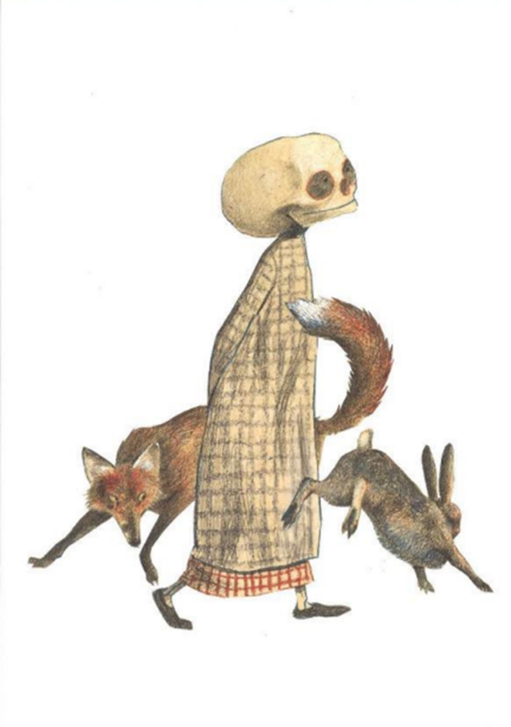
Figure 11: Wolf Erlbruch and Chidgey, C. (2018). Duck, death and the tulip.

The final page of the story shows Death walking alongside a fox, with a hare or rabbit playfully running around him. This illustration symbolizes that life goes on, with death quietly and always near, patiently watching over us until we meet one day. Erlbruch portrays death in such a beautiful and gentle way, showing the reader that death isn't something to fear. Rather, it’s an inevitable part of life. By depicting death as calm and companionable, the story encourages readers to reflect on life with a new perspective, embracing the natural flow of life without fear.

The illustation is simply yet has a powerfull meaning behind it, the illuation alone is beautful but the story gives meaning to it showing the reader a diffount aspect of life and how all living thins meet death one day.

Shaun Tan-The Red Tree
The Red Tree by Shaun Tan tells the story of a young girl struggling with depression, capturing emotions that are often hard to express in words. Tan uses dark, surreal illustrations that not only hide many details within the artwork but also symbolize the complex feelings and inner turmoil the girl is experiencing. Through these vivid, layered images, Tan conveys the girl’s struggles in a way that words alone cannot, creating a powerful visual representation of emotional pain and isolation.
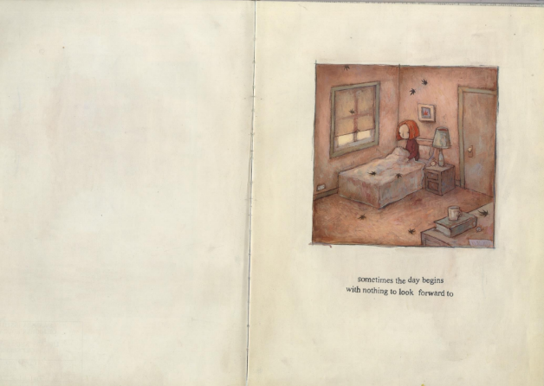
Figure 12: Tan, S. The red tree, (2016).

At the beginning of The Red Tree, the young girl wakes up in her room, where black leaves are falling outside. She struggles with the feeling of waking up, thinking, “Sometimes the day begins with having nothing to look forward to.” The illustration is placed on the right side of the page, in a small square at the top centre, with the text beneath it. The left side of the page is left empty, filled only with white space. This use of minimalism in the layout highlights the girl's sense of isolation and emptiness, reflecting her internal struggle and setting the tone for the story.
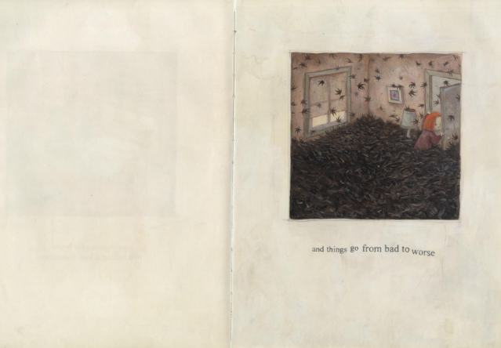
Figure 13: Tan, S. The red tree, (2016).

On the next page the girl’s room is filled with black leaf’s and still falling from nowhere as she leaves her room saying, “and thing go from bad to worse”. These two illustrations show how she struggles with her emotions about the day that just began and how the black leaf’s show her dark thoughts taking over her mood for the day preventing her from enjoying her day before she even leaves her room. And where in the first page the room has bright colour tones to then move on to the next page where the bright colour is now more saturated, and the room is slowly filling with black leaf’s.

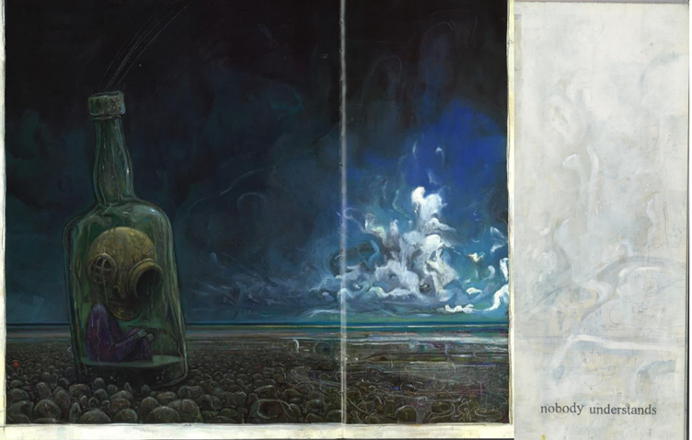
Figure 14: Tan, S. The red tree, (2016).

On this page tan illustrates the girl on the beach surrounded by dark and stormy clouds while the girl is sitting inside a glass bottle with an old scuba helmet while there is rainwater filling the bottle slowly where she is sitting in a puddly of water. On the right side of the page there is a small break in the clouds with bright colours shining through yet it too far away while the girl is surrounded by darkness where she’s thinking to herself “nobody understands”. The illustrations show the dark and depressive thing she is going through thinking she all alone and there’s nobody there that can understand her.
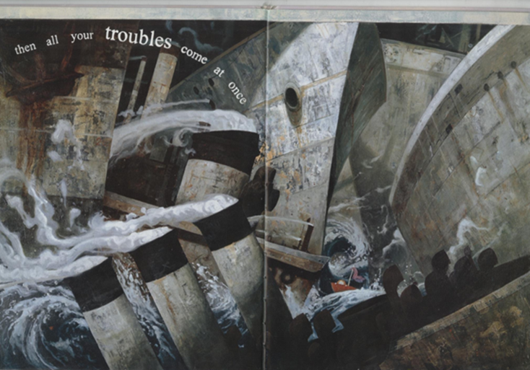
Figure 15: Tan, S. The red tree, (2016).
On the right side of the page, there are small hints of colour on the ground, barely visible unless the reader looks closely. The bright clouds and colours in this area symbolize happiness, showing that although it is nearby, it remains just out of reach for the girl. This subtle detail emphasizes the girl's emotional distance from any sense of joy, further illustrating her struggle to connect with happiness despite its proximity and emphasizes struggle she has with depression.

On this page, Tan creates an overwhelming and frightening illustration that captures the girl's emotions and dark thoughts taking control of her. The image conveys how she feels everything is spiralling out of control, with her troubles clashing together like huge ships crashing in a storm. This chaotic scene reflects her sense of helplessness, as she feels unable to control the forces around her, emphasizing the overwhelming nature of her emotions and the loss of control she experiences.

On the double-page spread, Tan illustrates the girl as a small figure in a tiny boat, surrounded by enormous ships and chaotic waves. The ships overlap one another, symbolizing how her emotions are overwhelming her. The realistic portrayal of the ships makes them even more frightening, adding to the sense of danger and helplessness. In contrast, the girl is depicted with brighter colour tones, allowing the reader to spot her amidst the dark, grey, and unsettling scene, highlighting her vulnerability in the face of such overwhelming emotions.
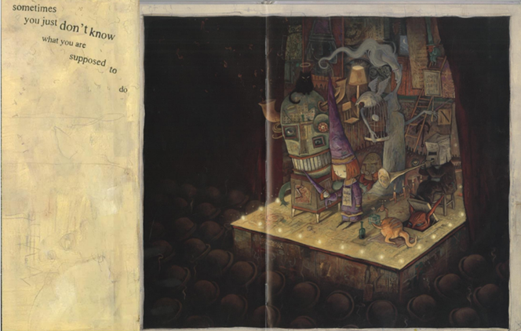
Figure 16: Tan, S. The red tree, (2016).

In this illustration, the girl appears as though she is on display, surrounded by a crowd that seems to be watching her every move. This creates an overwhelming feeling of being constantly observed, as if everyone is judging her. Tan captures this sense of discomfort by illustrating the girl dressed as a wizard, with long, pointy shoes and a hat, holding a hand puppet of herself dressed in the same way. The puppet adds to the feeling of being mocked or ridiculed, highlighting how the girl sees herself as the subject of others' attention and criticism.

On the stage, Tan includes several other figures that contribute to the surreal, unsettling atmosphere of the illustration. One figure is a man with a paper bag on his head, holding a long horn-like instrument, adding to the sense of confusion and disorientation. There’s also a black cat with a halo above its head, symbolizing that it is no longer alive, while also referencing the common belief that black cats are bad omens.

Additionally, a tall, elderly woman with hair like smoke is holding a birdcage, which represents how the girl feels trapped, unable to escape her emotions or situation. This complex illustration powerfully reflects the girl's inner turmoil, showing how she often feels lost and uncertain about what she is supposed to do.
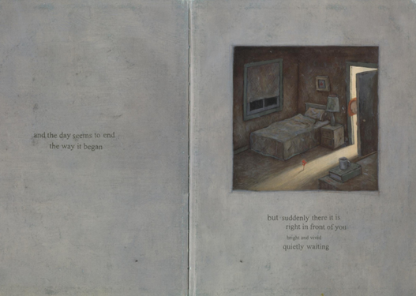
Figure17: Tan, S. The red tree, (2016).

These are only a few of the illustrations from Shaun tans picture book The Red Tree that as a reader they understand the emotion and depressive thoughts and feeling that the girl went through. And how beautifully shun tan illustrated this picture book using different component such as collage and how he incorporates so many hidden things within his illustrations such as in one he illustrates houses made of cardboard with faces within then such as the windows as eyes.

At the end of the story, the girl returns home to find a red tree standing in the centre of her room. On the first page of the ending, the red tree is a small sapling, and she thinks to herself, “And the day seems to end the way it began, but suddenly there it is, right in front of you, bright and vivid, quietly waiting.” As she opens the door and enters her room on the next page, the red tree is fully grown.
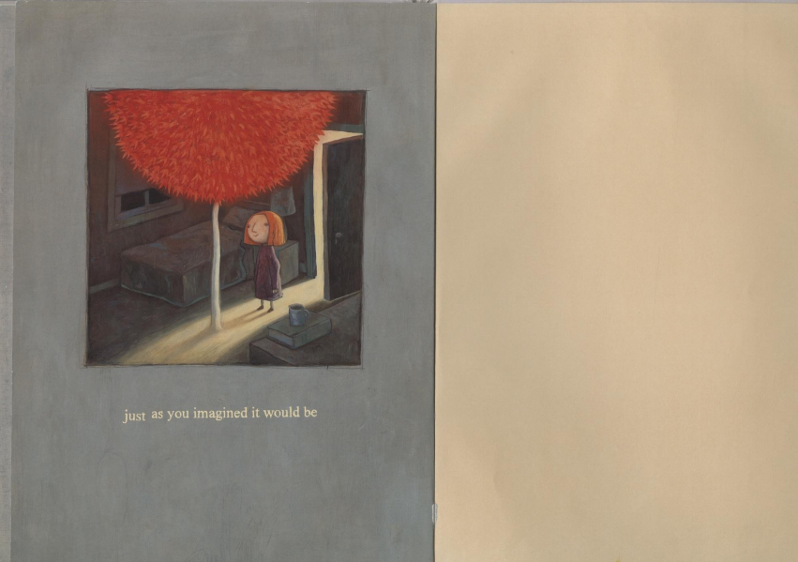

Figure10: Tan, S. The red tree, (2016).

She reflects, “Just as you imagined it would be.” These two powerful yet subtle moments convey deep meaning, showing how the girl feels less overwhelmed and more at peace. The red tree represents a sense of safety and calm, symbolizing the comfort and reassurance of being home, a place where she can finally find peace.

Both Erlbruch and tan brilliantly illustrated these two difficult subjects that people often tend to avoid. Where Erlbruch tackles showing others that death isn’t something that they need to fear but understand that it’s something that everyone will someday meet in a meaningful and powerful way, and how tan beautiful show how hard it is to deal with depression through his beautiful surreal illustrations in his picture book.

In the theory book The child and the book: a psychological and literary exploration where according to Tucker.N
“The art of picture-books then rests on the interaction between illustrations and text, and the way in which the results can both find favour with children, and also leads them on to new levels of response”
(Tucker. N,1991 page 47).

Where both tan and Erlbruch used minimum text for the story in their picture book and how both of them used the text in different way such as tan used the text by illustrating the text within the illustration such as make the text big or small and some where flowing down the page along the illustration and where Erlbruch placed the text on the other side of the page to where the illustration is or on some the texts was beneath the illustration, these two different approaches of using the texts help readers see the story in a different way to how you would if a picture book had Plaine text placed on the page. In conclude both tan and Erlbruch illustrated these two difficult topics in incredible and inspiring ways for both the reader and future illustrator to encourage them to not advised these hard topics but to approach them in a different light and teaches children about the difficult topics in a positive way.

Reference List/Bibliography

Doonan, J. (1993). Looking at pictures in picture books. Stroud: Thimble Press.
Nikolajeva, M. and Scott, C. (2006). How picturebooks work. Routledge.
Salisbury, M. and Styles, M. (2015). Children’s picturebooks : the art of visual storytelling. London: Laurence King Publishing.
Tan, S. (2016). The red tree. Sydney, Nsw: Lothian Children’s Books.
Tucker, N. and University Of Cambridge (1991). The child and the book : a psychological and literary exploration. Cambridge (England): Cambridge University Press.
Winnicott, D.W. (2005). Playing and reality. London ; New York: Routledge.
Wolf Erlbruch and Chidgey, C. (2018). Duck, death and the tulip. Wellington, New Zealand: Gecko Press.

