Report on Effective Teamworking for Team Success

Effective Teamworking and Communication
Module BMSW 4002

Dami Pokubo

Rahela Begum (1818336)

October 2021

Table of Contents
Introduction...............................................................................................3
Developing an Effective Team/Tuckmans Model.........................................4
Forming, storming, norming, performing and adjourning..................................................................................................5
Wheelans Developmental Model................................................................6
Impact and Barriers of an Effective Teams..................................................7
Types of Roles needed to Create a Cohesive and Effective Team..........................................................................................................8
Belbin Team Roles......................................................................................9
Conclusion................................................................................................10
Reference List................................................................................................................11

Introduction

The following report will evaluate and conclude the importance of effective teamwork for team success as a student at the University of Wales Trinity Saint David.
Within this report we will examine the roles and models we have used as students to work part of a team to bring success to the tasks we have been involved in.This report will detail the importance of a diverse group of students of how we overcame the challenges and barriers working towards accomplishing our end goals. According to a survey carried out by software engineers (Marsicano, G., da Silva, F.Q.B., Seaman, C.B. et al., 2020), concluded the adequacy of team composition and structure to achieve team goals are both needed to obtain an effective team.
However, as students we need to define the differences between a team and a group of people.
What is a Group?
Groups can consist of a few or many individuals who have come together for a certain purpose, this can be a social event or through an organization. Individuals all are different in terms of personalities, interests and demographics.
There are two types of groups, formal and informal:
Formal groups are defined by an organization and have a strong structure. Special assignments and tasks are assigned to the group for a successful outcome
Informal Group, there is no direction in this group by an organization neither is there any structure e.g., football matches, cinemas, congregations etc.
What is a Team?
Teams are a limited number of committed people put together to achieve an objective they have set out to do. Trust is crucial within a team, as demonstrated by (Hudnet et al,2017) when trust is established, members work quickly and efficiently to achieve the best work.
Example football team, the objective is to win the match and every player will have an input and their actions will determine the result.
Teams are a group of individuals working together to achieve an outcome best to their ability for success. All the team members vision is the same, success. This is crucial to achieve a favorable outcome. The group goes through a sequence of stages before an effective team is formed.
Based on the case study of the University of Wales Trinity St David, for students in order to develop a successful team you need to be diverse in your selection of members. The team starts off as a group with everyone displaying their own characteristics and personalities and testing the water with uncertainty. Eventually breaking away to form a team.

Below are two developmental models that map this process, Tuckmans (1965) and Wheelans (1999).
Based on Tuckmans Model theory there are five stages a team passes through these are as follows:
- Forming
- Storming
- Norming
- Performing
- Adjourning

Figure 1: Tuckmans Team Development Stages
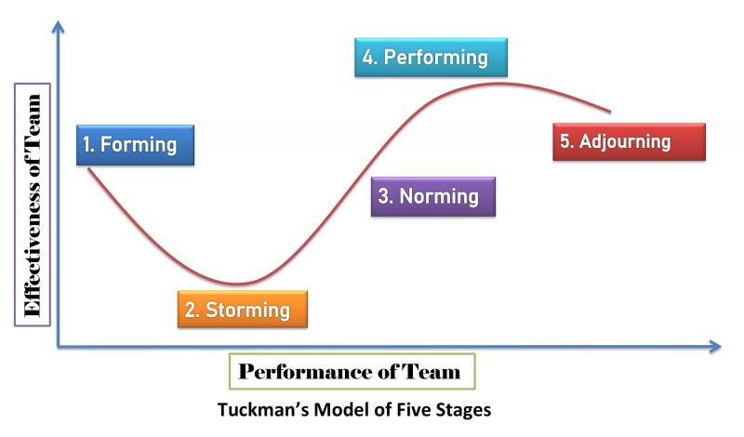
Source: Kobirruzzaman (2019)

Below you will find the explanation of each stage.
Forming Stage– The forming stage is when the students of the cohort are selected, each person can contribute their own skill and knowledge. Members are friendly, talkative and a relaxed atmosphere is created. However, everyone is still decisive if the group is a safe place to be themselves and a slow approach is taken. Everyone is polite to each other while the members are getting to know each other (Cresswell-Yeager,2020).
Selecting a team leader with a strong personality is chosen at this stage, Ground rules are set, and each member is defined a task to be completed independently.
This stage can be known as the calm before the storm.
Storming Stage- The storming stage is where all the members share their ideas for the upcoming task. Each member will have different views and will not be shy about airing them. Turbulence within the team starts forming, hostility towards each other leads to inter conflict.
Team leaders may find it difficult to control the situation as members personality clash, reserved members start coming out of their shell and may become argumentative, hierarchy begins. Team leader needs to start taking control of the situation.
Norming Stage - The norming stage, at this stage the team will start to stabilize. Accepting everyone's viewpoints, realizing the way forward is to work together to achieve the success they have set out to do. Teams become more cohesive because they have shared common experiences together (Urick, 2021). Students will start respecting each other and begin to bond. Peace resumes.
Performing Stage -Trust is restored within the team, the relaxed atmosphere makes each member to start working efficiently and at a high level of standard.
Adjourning Stage - The final stage of Tuckmans Model, success is achieved as each members contributions are recognized on delivering the outcome of the task. Victory is celebrated as each member is proud of their contribution.
Now members are hit by a range of emotions, happiness due to achievement of reaching the end goal and sadness as they depart.

However, Tuckmans Model is an old developmental model dated 1965. In 2016 Susan Wheelan developed a model mapping out fewer stages.

Fig 2: Wheelan Developmental Model (2016)
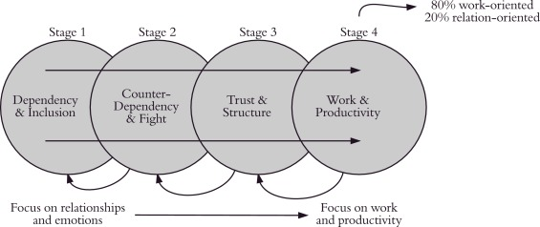

Source; ScienceDirect (2021)

The above model shows Susan Wheelans, a professor in psychology, four stage group developmental stages for an effective team, these are as follows:
- Dependency and Inclusion
- Counter-Dependency and Fight
- Trust and Structure
- Work and Productivity
Dependency and Inclusion – Team forms and starts to work simultaneously with caution. Leaders are expected to make decisions and are often looked on for direction. According to ( Mattison and Wennerback,2018), objective for this stage is to create a sense of belonging and establish loyalty to the group.
Counter-Dependency and Fight – Members are confident enough to express their views openly, yet arguments and disagreements are inevitable. Leaders need to take control, this is a crucial step for the team to move forward.
Trust and Structure – Trust is established within the team; each member has their role and starts to work. Retaining structure is key for a successful outcome.
Work and Productivity – The team is working efficiently and professionally. Team leaders are coaching the team and driving them to produce work to the highest quality. According to (Huster and Zwillinger, 2017) with direct clear instructions the team divides responsibility for achieving and sustaining an excessive satisfactory outcome.

Impact of Effective Teamwork and Success
Working together facilitates creativity and boosts morale of members. Different minds can resolve a problem should it arise. Working as a team you have a support network as the workload is distributed. Clear communication is critical within the team, defining each member a task will enable them to complete it efficiently and within the allocated time frame. Effective teamworking goes above and beyond the borders of a member's attainment (Gogidze and Orjonikidze, 2015).
Within my job as a playworker and working with special needs children as part of a small team of three, routine is vital. Keeping the children engaged with “Wake up, shakeup” while the other members set up the daily activities for the morning. Planning small lessons makes sure the time limits do not exceed ten minutes due to the children's attention span. This is successful for a productive day making it less stressful for the children and staff.

Barriers to Effective teamwork
Teams will face several barriers in order to be effective. These can determine if a team fails or succeeds, one being, Diversity. (Inegbedion ‘et al, 2020) states ‘Diversity within various academics/institutes is significant for effective results. Students at the university are all from various backgrounds, ethnicities, ages, dialects, genders, religious beliefs, academic levels and employment status. Differences can cause challenges within the team.
Detailing a few below:
Age factor, older members may feel inferior to the younger students due to their knowledge of the world, this can cause friction. Youth would be more in touch with technology and knowledgeable, their ideas would be more up to date. Gender battle, alpha males may use their egos to try leading the team over the females. Dialect can be a problem for someone with less understanding of the English Language.
All these barriers can be broken with communication and respect for everyone also to treat others as individuals, every student has something they can bring to the presentation.

Types of Roles Needed to Create a Cohesive and Effective Team
Within the team there are many roles that are needed to create an effective team. A great model reference guide for the students to follow is the Belbin diagram below:

Figure 3: Belbin Team Roles
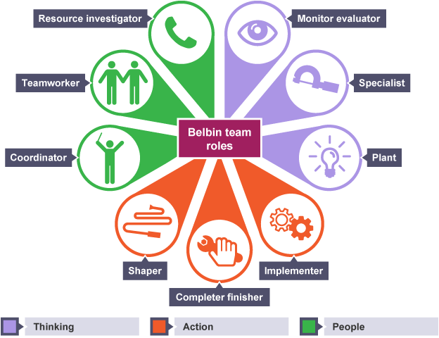
Source: Nguyen (2017)

Belbin's team, nine roles are divided into three categories, these are:
1.Thinking -Specialists, Monitor Evaluator and Plant
2.Action - Shaper, Implementor and Finisher
3.People- Team worker, Coordinator and Investigator
Three roles consist within each category.
Thinking roles are given to individuals who can come up with devised ideas regarding the task. Several people may be assigned and there must be a balance of personalities within these roles. My place of work these roles are the Head of year groups who generate ideas, they work with Teaching Assistants for creative and interactive ideas to make lessons fun for students.

Action roles consist of shapers who are taking charge, they push the team encouraging and enticing them to work at their best, taking don a hands-on approach. These roles are allocated to the teachers who push for the best ideas for lessons and activities. Implementors ensure the ideas are implemented and followed through. Finally, all details of the tasks are completed by the finishers of the team. Within my place of employment this will be the Headteachers role.
Social roles contain team leaders, they coordinate and organize while the team workers keep motivation going. Investigator's research and forward plans. This would be the business manager within my institute of work.
A solid team should have balanced roles, each member meeting specific needs without repeating with other roles, (Bao, 2019). These are the methods for direct results.

Figure 4: Graph of Belbin Team Roles
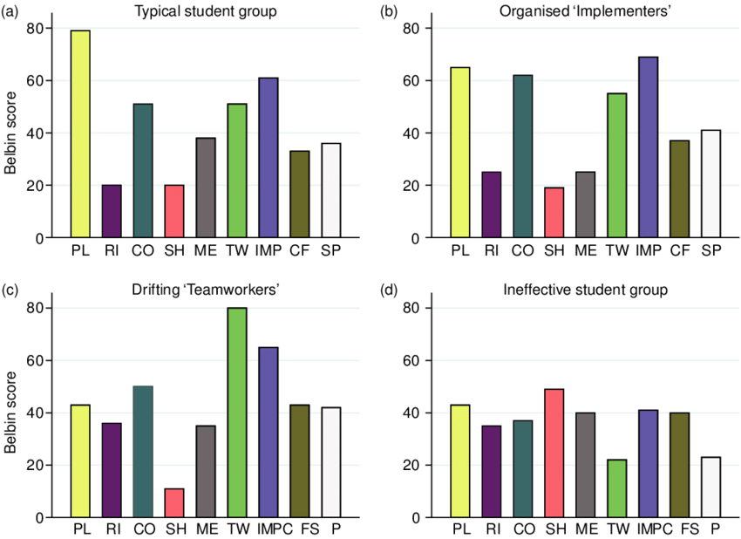
Source:(Smith,et al,2012)
The above graphs show organized teamwork alongside a dysfunctional team of students.

Conclusion
Achieving an effective team is a complex ordeal, especially if the group are strangers. Many factors are taken into consideration, but with the help of following illustrated examples and developmental models they can thrive.
However, many theories are outdated, Tuckmans model was established in 1965 so his theories were based on following different characteristics from that period. Many teams can stay in the storming stage, where no solution can be found. The model offers no quick fixes if the storming stage and differences are not resolved, one reason why Bruce Tuckmans theory can fail. Nether less, a study conducted by (Jones,2019) revealed the new Jones LSI model which is more significant in value to face the increasing speed changes of today and the future for challenges teams face. One trait that makes for a successful team is diversity, a cross functional team debating ideas in a positive and healthy way.
Students at the university will have to work harmoniously together, overcoming barriers, putting differences aside. (Grubbs,2019) wrote an innovation team should always clarify timelines ahead of a project, phases must be met on time otherwise the team can burn out and could lead to a fall.
They need to collaborate and engage to compose a strong presentation. Moving from potential to an impressive high performing team. Developmental models are constantly revised, to succeed in choosing one best suited for an effective team.

Reference / Bibliography List
Bao,R. (2019). Research on the Relationship between Team Roles Theory and Team Effectiveness. School of Management, Beijing Normal University, Zhuhai, China.

Cresswell-Yeager,T.(2020). Forming,storming,norming and performing using the semester-long problem based learning project to apply small group communication principles. Communication Teacher.

Huster,T & Zwillinger,E. (2017). Nursing Management.:Springer house. Volume 48-issue 12-p26-34.

Inegbedion, H., Sunday, E., Asaleye, A. & Lawal, A. (2020). Managing diversity for organizational Efficiency. Journal: sage.

Jones,A.(2019).Journal of Mangment.UAE:SSRN.

Kobiruzzaman,M M. (2019). Tuckman Theory-Tuckman's Theory of group Development:.Newsmoor.

Marsicano,G,Silva,F,Fabio,Q & Seaman,C.(2020). The Teamwork Process Antecedents. Empire Software Engineering: SpringerLink.

Nguyen,M. (2017). Learn Belbin Team Roles through Reflection. Wordpress.

Orjonikidze, N. & Gogidze, M. (2015). The advantages of Teamwork Approach during Personnel Management. Journal of Business, 4(1).

Smith, M., Polglase, G. and Parry, C., 2012. Construction of Student Groups Using Belbin: Supporting Group Work in Environmental Management. Geography in Higher Education, 4(36), pp.1-17.
Urick,MJ(2021). Teamwork, A Managers Guide to using the force: Leadership Lessons. Bingley: Emerald.pp.21-30.
Warne,J. (2011). Wheelan Developmental Model: Science Direct.

