Rachid Aboulachouaq (2237654)
University of wales trinity saint david
Artificial intelligence and Machine Learning
ACCA6011
Word Count - 1949

Contents
Abstract 2
Introduction 2
Problem Statement & Literature 2
Methodology 2
Dataset 2
Pre-processing 2
Supervised Learning Models 2
Hyperparameter Tuning 2
Unsupervised Learning 2
Experiments 2
Base models 2
Tuned Models 2
Clustering 2
Results 2
Decision Tree Results 2
SVM (Support Vector Machine) 2
Comparison 2
Clustering Results 2
Discussion 2
Conclusion 3
References 4

Predicting Player Engagement Using Machine Learning Techniques

Abstract
Understanding player engagement is key for improving retention, monetisation, and game design. This study used supervised and unsupervised machine learning on the Predict Online Gaming Behaviour dataset to predict engagement levels and group players by behaviour. Decision Tree and SVM models were tested, with tuning done through Grid Search.
The tuned Decision Tree performed best, reaching 90.2% accuracy, while the SVM achieved 88.4%. K-Means clustering identified five meaningful player groups with different play patterns and engagement levels.
Overall, combining prediction models with behavioural clustering gives useful insights for developers, helping personalise player experiences, spot disengagement early, and design more targeted content. The results show how machine learning can support smarter, data-driven decisions in the gaming industry.

Introduction
The gaming industry is one of the most profitable industries in the world, with massive companies dominating the market such as EA, 2k Games, and numerous indie studios estimated to be worth $159.3 billion in 2020 alone, a 9.3% increase from 2019 [1]. Like any, it must have consumers, this is even more true for live service/online video games, therefore player engagement with the game is itself a revenue stream. As such, it is prudent to further understand player engagement to retain customers as well as improve in areas that may disengage players [1][2].
With this key performance indicator (KPI) in mind, it is possible to use machine learning to analyse behavioural data of player and therefore identifying potential patterns that humans may not be able to discern from vast amounts of data, allowing areas to be targeted to increase player engagement, loyalty and therefore revenue for the company.
This study will focus on predicting player engagement levels and identifying any behavioural trends within a large dataset of online player behaviour activity. Behaviour is a complex term in this context to describe the multiple features found in the dataset such as PlayTimeHours, Age, AchievementsUnlocked etc.
By applying supervised learning techniques such as Decision Tree and Support Vector Machine (SVM) classifier, it may be possible to build an accurate predictive model able to categorise players as High, medium and low engagement. Unsupervised learning, specifically K-Means clustering, can also be used to look into the natural grouping of players based on other demographic features (E.G age).

Problem Statement & Literature
Player engagement has become a core focus of the modern gaming industry as retaining players is often closely tied to the success of the company, especially for online gaming. Engagement as a KPI also influences other gaming metrics such as play time, purchasing behaviour and ‘churning’ (customer attrition). [2][3]
The primary problems addressed in this study:
- To develop predictive models capable of classifying players into High, Medium, or Low engagement categories, and
- To discover underlying behavioural clusters within the player population using unsupervised learning.
These objectives aim to support decision-making related to game design, retention strategies, and content delivery.
Zhong and Xu analyse millions of gameplay records from DOTA 2 to understand how different types of game updates influence player engagement. They compare major, minor, and irrelevant updates and find that major, infrequent updates produce the strongest increases in engagement, while minor updates often have weak or even negative effects [1]. This relates to the behavioural aspect of the study as well as how areas of improvements could lead to increases in engagement.
Liao examine how real-world psychological need satisfaction shapes gamer loyalty, which is closely tied to sustained engagement [2].
Romero-Mendez apply supervised deep learning to classify players into skill-based behavioural segments using gameplay elements. They integrate this into a dynamic difficulty adjustment system to keep players in optimal challenge zone [3]. This links to the study as they utilise machine learning to drive player engagement.
By capitalising on the use of machine learning in identifying behavioural patterns to increase engagement, the study aims to provide a comprehensive framework for understanding engagement, player behaviour and identifying meaningful behavioural segments that can inform design and decisions of the comapny.

Methodology

Dataset
The analysis uses the Predict Online Gaming Behaviour dataset from Kaggle, containing 40,034 player records and 13 features describing demographic characteristics.
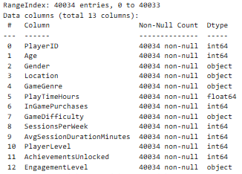
The target variable in this instance will be ‘Engagement Level’, categorising players into ‘High’, ‘Medium’ and ‘Low’.

Pre-processing
Pre-processing of the dataset revealed no missing values (nulls). The PlayerID attribute was removed from data as this would not be useful in predicting engagement. Categorical variables were converted to support the machine learning models and the target variable was converted to numeric.
As the dataset contains features on differing scales (e.g., hours vs. counts), all numerical attributes were standardised using StandardScaler, which is important for distance-based algorithms such as SVM and K-Means. The dataset was split into training and testing sets using an 80/20 stratified split to preserve class distribution across engagement categories.

Supervised Learning Models
The classification algorithms were selected based on their suitability for behavioural prediction tasks:
- Decision Tree Classifier

  - Decision Trees are interpretable models capable of capturing non-linear relationships without requiring feature scaling. They are commonly used in player analytics due to their transparency and low computational cost.

- Support Vector Machine (SVM) with RBF Kernel

  - SVMs are effective for high-dimensional, non-linear classification problems. The radial basis function (RBF) kernel enables the model to learn complex boundaries between engagement classes, making it suitable for behavioural data that may not be linearly separable. Scaling input features is crucial for performance.

Hyperparameter Tuning
Hyperparameter optimisation was performed using Grid Search with 3-fold cross-validation and an averaged F1 score as the optimisation metric, ensuring equal weighting across the three engagement classes.
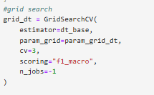
For the Decision Tree, the tuned parameters included:
- max_depth,

- min_samples_split,

- min_samples_leaf,

- splitting criterion.
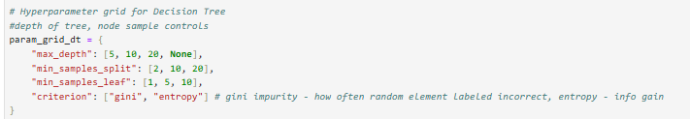
For SVM, tuning focused on the regularisation parameter C and kernel coefficient gamma. Due to computational and time cost on the full dimensional dataset, tuning for SVM was conducted on a 10,000-sample subset.
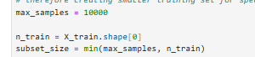
After which the best parameters were used to retrain the model on the full training set.
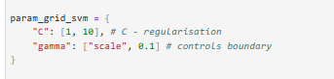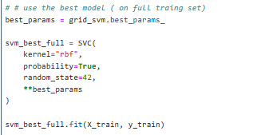

Unsupervised Learning
To identify behavioural segments, K-Means clustering was applied to the scaled feature set. The best number of clusters was determined by analysing inertia (Elbow Method) and silhouette score for k values from 2 to 9.
Based on the highest silhouette score, k = 5 was selected. The final model was fitted to the full dataset, and cluster labels were assigned to each player for further profiling.

Experiments

Base models
The first stage the experiment involved training base versions of the Decision Tree and SVM classifiers using default hyperparameters. Both models were trained on the pre-processed training set and evaluated on the test set using accuracy, precision, recall, F1-score, confusion matrices and AUC-ROC. These initial results served as a reference point for assessing the impact of hyperparameter tuning.
The Decision Tree showed reasonable performance but exhibited limitations in generalisation across engagement classes. The SVM, using the RBF kernel, achieved substantially stronger predictive performance, suggesting non-linear decision boundaries in the engagement data, but was significantly slower.

Tuned Models
To enhance model performance, Grid Search was applied to both classifiers.
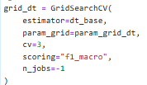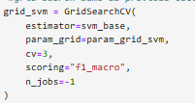
For the Decision Tree, the parameter grid included variations of max_depth, min_samples_split, min_samples_leaf, and criterion. The search identified a more balanced model that improved classification metrics and reduced overfitting compared to the untuned tree.
SVM focused on the regularisation term and kernel coefficient (gamma).

Clustering
Unsupervised learning was used to identify natural behavioural segments in the player population. Players were assigned cluster labels for subsequent behavioural and engagement analysis. To visualise the segments, PCA was used to reduce the feature space to two dimensions, highlighting the relative separation and overlap between clusters.

Results

Decision Tree Results
The base Decision Tree achieved an accuracy of 83.6%, with a macro-averaged F1-score of 0.83. Results showed stronger performance for the High and Medium engagement categories compared to Low, reflecting some class imbalance and overlapping behavioural features. The confusion matrix revealed notable misclassifications between the Low and Medium categories, suggesting limitations in the model’s ability to learn subtle behavioural differences.
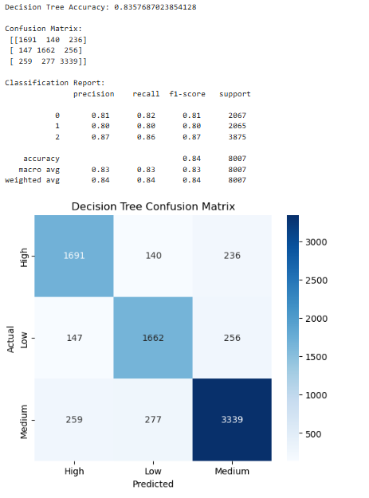
Figure 1: Baseline Decision Tree results

After hyperparameter tuning, the Decision Tree showed improved generalisation. (Insert tuned DT accuracy/F1 values here once available.)
The tuned model reduced overfitting and achieved more balanced precision and recall across all engagement classes.
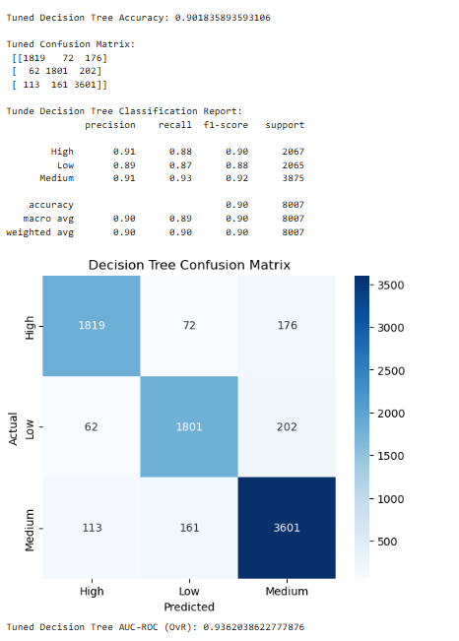
Figure 2: Tuned Decision Tree Results

SVM (Support Vector Machine)
The SVM outperformed the Decision Tree across all metrics. The base model achieved an accuracy of 88.4%, a macro F1-score of 0.88, and an AUC-ROC of 0.939, indicating excellent class separability. The classification report showed particularly strong performance for the ‘medium’ engagement class, with recall reaching 0.93, while performance on the Low engagement class was slightly lower but still decent.
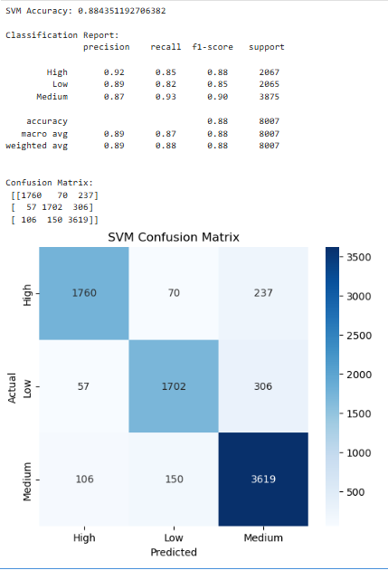
Figure 3: SVM Base Results
Tuning SVM looked variations of the regularisation coefficient and gamma. The best performing parameters were C = 1 and gamma = [ 'scale', 01] matching the baseline configuration. When retrained on the full training set, the tuned SVM achieved an accuracy of 88.4%, a macro F1-score of 0.88, and an AUC-ROC of 0.939, almost identical to the baseline. This indicates that the SVM was already operating near optimal performance and that further tuning did not yield substantial improvements, likely due to the model’s strong ability to capture the non-linear structure of the engagement behaviours.
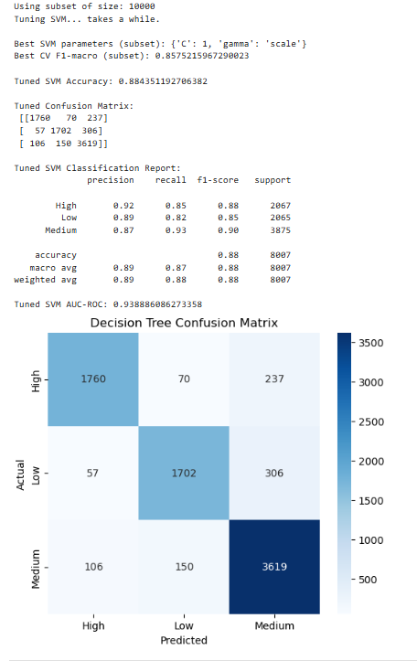
Figure 4: SVM Tuned results

Comparison
Model | Accuracy | Macro F1 | AUC-ROC
Decision Tree (Base) | 0.836 | 0.83 | 0.871
Decision Tree (Tuned) | 0.902 | 0.90 | 0.936
SVM (Base) | 0.884 | 0.88 | 0.939
SVM (Tuned) | 0.884 | 0.88 | 0.939

The base Decision Tree achieved the lowest performance across all models, with an AUC-ROC of 0.871. However, after tuning the model improved substantially, achieving 0.902 accuracy and an AUC-ROC of 0.936.
In comparison, the SVM exhibited strong baseline performance with an AUC of 0.939 but did not improve any further with tuning, indicating that the model was already near optimal. These findings demonstrate the importance of hyperparameter optimisation and reveal that a well-regularised Decision Tree can outperform SVM under certain conditions.

Clustering Results
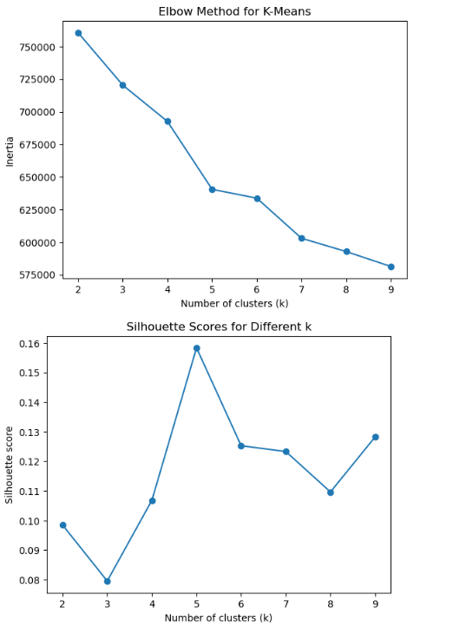
Figure 5: Clustering Results
K-Means clustering was applied using k = 5, which produced the highest silhouette score (0.158) among the values. Although silhouette values were modest, the relative difference indicated that five clusters offered the strongest structure.

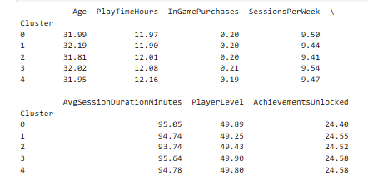
The resulting clusters displayed clear differences. The largest cluster consisted of players with moderate playtime, average session duration, and balanced achievement progression, while other clusters reflected distinct high-engagement, low-engagement, and high-purchase behaviours.
The distribution of EngagementLevel across clusters further validated the segmentation, with certain clusters dominated by High-engagement players and others by Low-engagement players.
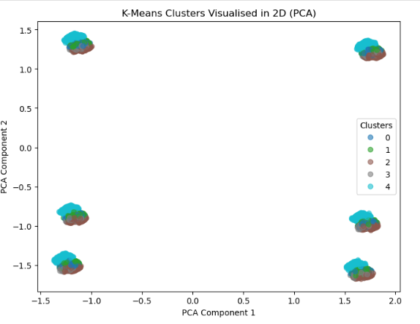
Figure 6: PCA Visual of K-Mean Clusters
The PCA visualisation shows a projection of cluster separation, showing partial overlap but grouping consistent with the silhouette evaluation.

Discussion
The results show clear differences in how well the models predicted player engagement. The SVM performed best at baseline, with high accuracy and AUC scores, confirming that it handles the non-linear patterns in player behaviour well. However, hyperparameter tuning did not improve the SVM, suggesting it was already close to its best performance.
The Decision Tree, however, improved a lot after tuning, becoming more accurate and less overfitted showing that simple models benefit from better depth and size controls.
The clustering analysis added an unsupervised view of the data. Although overall separation between clusters was modest, using five clusters produced the clearest structure. These clusters reflected different types of players, from highly engaged users with long play sessions to lower-engagement players with shorter activity and fewer achievements. These patterns matched what the supervised models suggested, supporting the validity of the segmentation.
Together, the supervised and unsupervised methods provided a fuller picture: the classifiers identified what drives engagement, while clustering showed how players naturally group based on behaviour. This combination offers useful insights for improving retention, balancing difficulty, and personalising player experiences.
The results from both the supervised and unsupervised models offer clear, practical ways to improve player retention, game balance, and monetisation.
The tuned Decision Tree, with its high accuracy, shows that reliable engagement prediction is possible. Such a model could flag players who are likely to become less active, allowing the game to respond early with personalised rewards, easier difficulty, or targeted messages to keep them engaged.
The K-Means clusters also help identify different types of players. Highly engaged players could be offered special content or competitive events to strengthen loyalty. Lower-engagement players might need better onboarding, easier challenges, or short-term incentives to keep them from leaving. Mid-level players present growth opportunities through personalised goals, rewards, or recommended activities as suggested by the literature around player engagement.
Together, these insights can guide content updates and balancing choices. Features linked to strong engagement, such as like longer sessions or achievement activity, can be emphasised in future designs.

Conclusion
This study used both supervised and unsupervised machine learning to predict player engagement and identify different types of player behaviour. The models both performed well, with the tuned Decision Tree doing the best at 90.2% accuracy. This demonstrates that tuning and using straightforward models can effectively capture what drives engagement. Five clear groups of players were identified, each with different play styles and engagement levels. These clusters matched the patterns seen in the supervised models, adding confidence to the results.
Overall, combining prediction models with behavioural segmentation proved useful for understanding players and making data-driven design decisions. The insights can help personalise retention strategies, shape content updates, and spot disengaging players early. Future improvements could us time-based data, deep learning, or different clustering methods to refine predictions and player groupings even further.

References

[1] X. Zhong and J. Xu, "Measuring the effect of game updates on player engagement: A cue from DOTA2," vol. 43, pp.100506, 2022, doi: 10.1016/j.entcom.2022.100506. Available at: https://www.sciencedirect.com/science/article/pii/S1875952122000301.
[2] G. Liao, T. T. L. Pham, T. C. E. Cheng and C. Teng, "Impacts of real-world need satisfaction on online gamer loyalty: Perspective of self-affirmation theory," Comput.Hum.Behav. vol. 103, pp.91–100, 2020, doi: 10.1016/j.chb.2019.09.016. Available at: https://www.sciencedirect.com/science/article/pii/S0747563219303449.
[3] E. Romero-Mendez, P. Santana-Mancilla, M. Garcia-Ruiz, O. A. Montesinos-López and L. E. Anido-Rifón, "The Use of Deep Learning to Improve Player Engagement in a Video Game through a Dynamic Difficulty Adjustment Based on Skills Classification," vol. 13, no. 14, 2023, doi: 10.3390/app13148249.

