 SCHOOL OF ENGINEERING
thermofluid mechanics | STUDENT NAME: QUAN ZHOU  STUDENT NUMBER: 1805150  DEGREE BEING STUDY: AUTOMATIVE ENGINEERING  DATE: 04/04/2019  MODULE NAME AND CODE: M5X00406

Index
Contents
1.Abstract 3
2.experimental principle 3
3.experimental facilities 7
4.experimental content 10
5.typical experimental calculations 10
6.experimental results 13
7.analyzation of results 18
8.conclusion 23
9.prospective 23
10.Bibliography 25

Abstract
In order to give students a deeper understanding of thermofluid mechanics, heat exchanger is chosen to be the experimental object. A heat exchanger is a device used to transfer heat between two or more fluids. Heat exchangers are used in both cooling and heating processes. (WIKIPEDIA, 2019) In almost any nuclear, chemical, or mechanical system, heat must be transferred from one place to another or from one fluid to another. Heat exchangers are used to transfer heat from one fluid to another. A basic understanding of the mechanical components of a heat exchanger is important to understanding how they function and operate. Through the experiments on the heat exchanger, recording the experimental data to complete the relevant calculations to deepen the understanding of the thermal convection and thermodynamic formula, learn to use the heat exchanger and understand the function of the heat exchanger.

Experimental principle
Taking water as the research object:
The density of water is as followed (Song, 2013):
$$ρ_{W}=\frac{999.839+16.952T-7.990ⅹ{10}^{-3}T^{2}-46.241ⅹ{10}^{-6}T^{3}+105.846ⅹ{10}^{-9}T^{4}-281.030ⅹ{10}^{-12}T^{5}}{1+16.887ⅹ{10}^{-3}T} (1)$$
Water has a maximum density at approximately 4 degrees celsius, decreasing as temperature increases or decreases from this value. From equation (1) we can make Figure 1 to find water density over the range of temperatures used with the heat exchangers, for a unit mass and a constant pressure.

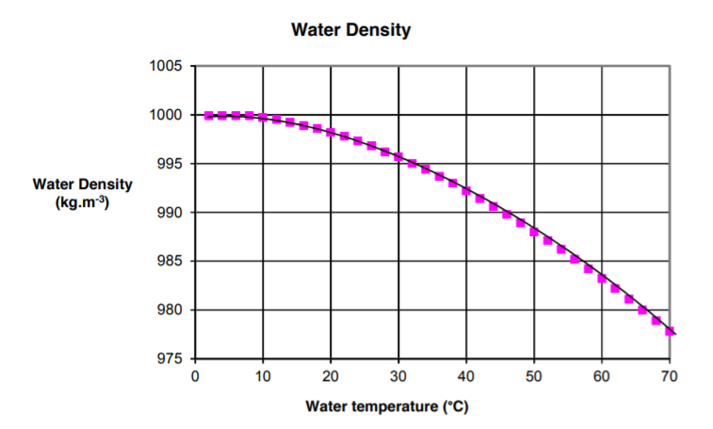
Figure 1. water density vs temperature
The water mass flow rate${ \dot{m}}_{W}$:
$${ \dot{m}}_{W}=ρ_{W}q_{W}/60000 (2)$$
Where: $q_{W}$ is the volume flow rate $(L/min)$
The water heat capacity$c_{W}$:
$$\frac{c_{W}}{c_{W}(15℃)}=0.996185+0.0002874{(\frac{T+100}{100})}^{5.26}+0.01116ⅹ{10}^{-0.036T} (3)$$
From the test the specific heat capacity of water at 15℃ is 4185.5$J•{kg}^{-1}K^{-1}$. The general heat capacity is shown in figure 2.
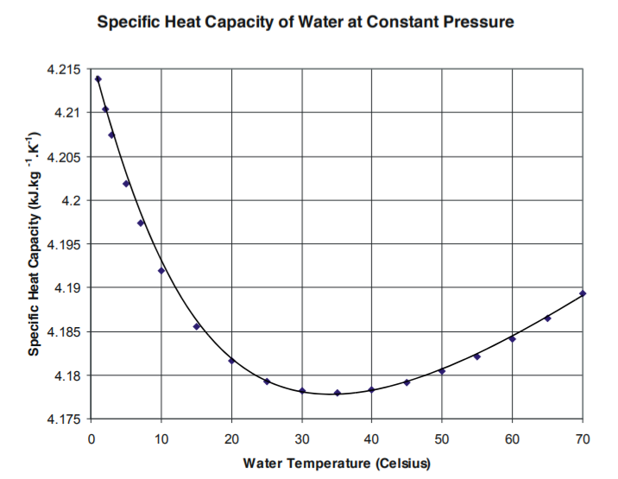
Figure 2. water heat capacity vs water temperature
The water power ${\dot{Q}}_{W}$is:
$${ \dot{Q}}_{W}={\dot{m}}_{W}ⅹc_{W}ⅹΔT_{W} (4)$$
Where: $ΔT_{W}$ is the difference of the water temperature (℃).
The water efficiency $η_{W}$is:
$$η_{W}=\frac{ΔT_{W}}{T_{W1}-T_{A1}}ⅹ100\% (5)$$
Taking air as the research object:
The density $ρ_{A}$of air is as followed:
$$ρ_{A}=\frac{PM}{RT} (6)$$
Where: P is the ambient pressure (Pa). M is the air molar mass (g/mol). R is the gas constant (J/mol•K).
From equation (6), we can get figure 3 as followed:
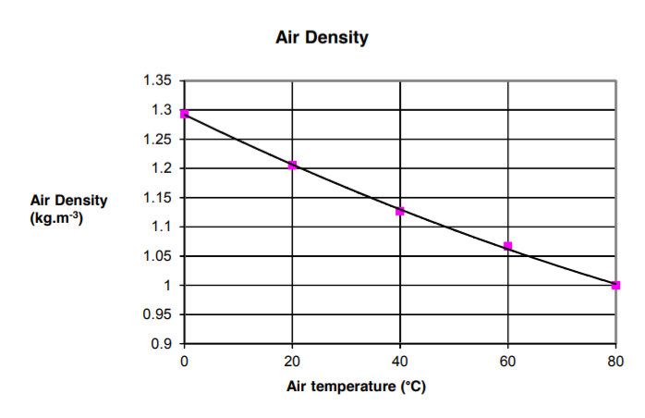
Figure 3. air density vs temperature
The air mass flow rate${ \dot{m}}_{A}$:
$${ \dot{m}}_{A}=C_{d}A_{O}\sqrt{Δpⅹ2ⅹρ_{A}} (7)$$
Where: $C_{d}$ is the orifice discharge coefficient. $A_{O}$ is the area of the orifice $(m^{2})$. $Δp$ is the pressure drop across the inlet orifice $(Pa)$.
The air specific heat capacity $c_{A }$remains reasonably constant at around 1005$J•{kg}^{-1}K^{-1}$ at normal atmospheric pressure and for the temperature ranges used in the heat exchangers.
The air power ${\dot{Q}}_{A}$is:
$${ \dot{Q}}_{A}={\dot{m}}_{A}ⅹc_{A}ⅹΔT_{A} (8)$$
Where: $ΔT_{W}$ is the difference of the air temperature (℃).
The air efficiency $η_{W}$is:
$$η_{A}=\frac{ΔT_{A}}{T_{W1}-T_{A1}}ⅹ100\% (9)$$
Other relative calculation:
Mean temperature efficiency:
$$\overline{η}=\frac{η_{A}+η_{W}}{2} (10)$$
Logarithmic Mean Temperature Difference (LMTD) is a measure of the heat driving force that creates the heat transfer. It is a logarithmic average of the temperature difference between the hot and cold circuits at each end of the heat exchanger:
$$LMTD=\frac{ΔT_{W}-ΔT_{A}}{ln⁡({T_{W2}-T_{A2}}/{T_{W1}-T_{A1}})} (11)$$
Heat Transfer Coefficient (U) is the heat transfer coefficient for the wall and boundary layers. It is a measure of how well the heat exchanger works. A good heat exchanger will give a high coefficient, therefore this value is important to engineers:
$$U=\frac{{\dot{Q}}_{W}}{AⅹLMTD} (12)$$
Where: A is the heat exchange area $(m^{2})$.

Experimental facilities
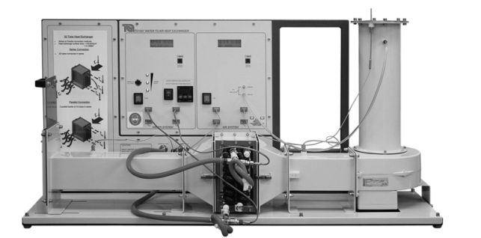
Figure 4. the water to air heat exchanger(TD1007)
A heat exchanger (HX) is a component that allows the transfer of heat from one fluid (liquid or gas) to another fluid. Many thermodynamic applications use water to air heat exchangers. Examples include using circulated water to heat or cool air in a HVAC installation, or to cool hot water using a flow of air, as in the radiator of combustion engine.
The main part is a compact frame that holds the water circuit and an air duct with fan. It has instruments to measure and display water and air conditions, such as air pressure, water flow and temperature.
To record experiment results automatically and save time, the equipment works with TecQuipment’s Versatile Data Acquisition System(VDAS).
The frame holds a horizontal, rectangular section air duct, fed from an electric centrifugal fan. From the user’s position, air passes from right to left along the equipment. Starting at the right hand side(inlet or upstream end), the air passes vertically down a circular inlet duct to the fan, the fan accelerates the air, turns it through 90 degrees and forces it along the horizontal rectangular section duct. The air passes through the heat exchanger and leaves the duct through an adjustable slide valve. The slide valve allows the user to adjust the air flow through the duct(the optional VDAS calculates this automatically). Thermocouples along the air duct measure the ambient air temperature at the inlet and before and after the heat exchanger.
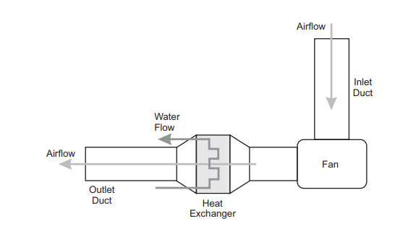
Figure 5. flow path
Toggle clips hold the heat exchanger securely in the midsection of the air duct. They also allow the user to change the heat exchanger easily. The outlet duct can slide along to help when changing heat exchangers. A panel to the left of the main frame allows the student to attach the magnetic ‘MIMIC’ sheet supplied with each heat exchanger. The MIMIC helps the student understand how to connect the water pipes to the heat exchanger.
The water circuit has a flow sensor to measure and display the flow rate and an electric heater tank to heat the water. An adjustable controller sets the tank temperature and keeps it relatively constant(to within +/- 2 degrees for most experiments). The heater tank has water level float sensors connecter to three lamps to show you how much water is in the tank. A ‘press to fill tank’ button on the front panel works a solenoid valve that allows the user to add more water to the tank from the cold supply when needed. A pump in the water circuit recirculates hot water from the tank, through a hand-adjusted WATER SUPPLY valve, through the heat exchanger and back to the tank.
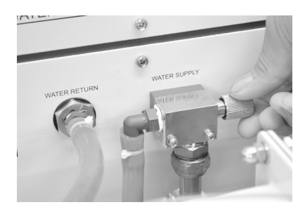
Figure 6. water supply valve
The tank has a thermal safety switch that cuts off the power to the heater to keep the water temperature within suitable limits if the controller is set incorrectly or in the unlikely case of a control failure. The tank ‘full’ float sensor disconnects the tank filling solenoid, so you cannot overfill the tank.
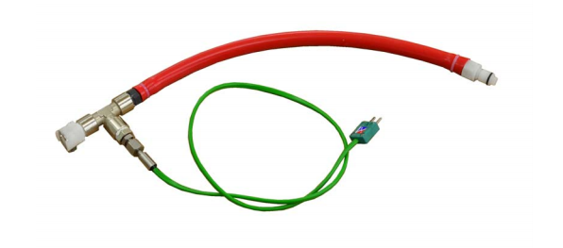
Figure7. SERIES ADAPTOR
Flexible pipes with quick-release self-sealing connectors connect the water supply to the heat exchangers. Thermocouples on the connectors measure the water temperature at the inlet and outlet of the heat exchangers. An extra water tube with thermocouple(SERIES ADAPTOR) allows you to measure water temperature at the mid point on the 32 tube heat exchanger.
The water and air temperature thermocouples connect to the two display panels with multiline displays showing the water and air temperatures. The displays also show the water flow rate and air pressure change at the orifice plate for air flow calculations. (TD1007 user guide, 2014)

Experiment content
For experiment 1, we connect and set up the standard 32 tube heat exchanger, set a heater tank temperature of 60℃. Water enters the bottom of the heat exchanger and exits from the top. We took notes of the ambient air pressure and inspect the orifice and check its diameter. We switched on the fan and use the slide valve to set the airflow to give an orifice pressure drop of 250 Pa(+/- 5 Pa tolerance). we switched on the pump and use the hand operated water supply valve to set the water flow to 2.25 L/minute (+/- 0.01 L/minute). We waited for 5 minutes for the heat exchanger temperatures to stabilize, then record all readings. We repeated the procedure for lower water flow rates of 1.75, 1.25, 0.75, 0.25 L/min.
For experiment 2, we set a heater tank temperature of 60℃. Water enters the bottom of the heat exchanger and exits from the top. We took notes of the ambient air pressure and inspect the orifice and check its diameter. We switched on the fan and use the slide valve to set the airflow to give an orifice pressure drop of 250 Pa(+/- 5 Pa tolerance). we switched on the pump and use the hand operated water supply valve to set the water flow to 0.25 L/minute (+/- 0.01 L/minute). We waited for 5 minutes for the heat exchanger temperatures to stabilize, then record all readings. We repeated the procedure for lower air flow rates of 200, 150, 100, 50 Pa pressure drop.
For experiment 3, we set a heater tank temperature of 45℃ and repeat the other steps of experiment 2.

Typical experiment calculation
The equations and formulas are introduced in the experimental principle part.
Experiment 1- the effect of varying water flow rate
Typical calculation-water
Volume water flow $q_{W}= 2.25L/min$ (take this water flow as example)
$$T_{W1}=60.1℃ T_{W2}=56℃ ΔT_{W}=-4.1℃ Average T_{W}=58.05℃$$
According to the figure 1, water density is $ρ_{W}=983.5kg/m^{3}$.
Mass water flow ${\dot{m}}_{W}=\frac{ρ_{W}q_{W}}{60000}=0.03688kg/s$
According to the figure 2, water heat capacity is $c_{W}=4184J•{kg}^{-1}K^{-1}$
Water power ${ \dot{Q}}_{W}={\dot{m}}_{W}ⅹc_{W}ⅹΔT_{W}=632.6757W$
Water efficiency $η_{W}=\frac{ΔT_{W}}{T_{W1}-T_{A1}}ⅹ100\%=11.1717\%$
Typical calculation-air
$$T_{A1}=23.4℃ T_{A2}=29℃ ΔT_{A}=5.6℃ Average T_{A}=26.2℃$$
The density $ρ_{A}$of air is
$$ρ_{A}=\frac{PM}{RT}=\frac{100300*29}{8.31*(273.15+26.2)}=1.16928kg/m^{3}$$
The air mass flow rate${ \dot{m}}_{A}$:
$${ \dot{m}}_{A}=C_{d}A_{O}\sqrt{Δpⅹ2ⅹρ_{A}}=0.6*\frac{pi}{4}*{0.10011}^{2}*\sqrt{250*2*1.169}=0.114175$$
Air heat capacity $c_{A}=1005J•{kg}^{-1}K^{-1}$
Air power ${ \dot{Q}}_{A}={\dot{m}}_{A}ⅹc_{A}ⅹΔT_{A}=642.5758W$
Air efficiency $η_{A}=\frac{ΔT_{A}}{T_{W1}-T_{A1}}ⅹ100\%=15.2589\%$
Other calculation
Mean temperature efficiency $\overline{η}=\frac{η_{A}+η_{W}}{2}=13.2153\%$
$$LMTD=\frac{ΔT_{W}-ΔT_{A}}{ln⁡({T_{W2}-T_{A2}}/{T_{W1}-T_{A1}})}=\frac{27-36.7}{ln⁡(27/36.7)}=31.60228$$
Heat Transfer Coefficient:
$$U=\frac{{\dot{Q}}_{W}}{AⅹLMTD}=\frac{632.6757}{0.1558*31.60228}=-175.345$$
Experiment 2- the effect of varying air flow rate
Typical calculation-water
Air pressure drop $Δp=250Pa$ (take this pressure drop as example)
$$T_{W1}=61.1℃ T_{W2}=37.3℃ ΔT_{W}=-23.8℃ Average T_{W}=49.2℃$$
According to the figure 1, water density is $ρ_{W}=987.8kg/m^{3}$.
Mass water flow ${\dot{m}}_{W}=\frac{ρ_{W}q_{W}}{60000}=0.004116kg/s$
According to the figure 2, water heat capacity is $c_{W}=4180.5J•{kg}^{-1}K^{-1}$
Water power ${ \dot{Q}}_{W}={\dot{m}}_{W}ⅹc_{W}ⅹΔT_{W}=409.5085W$
Water efficiency $η_{W}=\frac{ΔT_{W}}{T_{W1}-T_{A1}}ⅹ100\%=64.3243\%$
Typical calculation-air
$$T_{A1}=24.1℃ T_{A2}=27.3℃ ΔT_{A}=3.2℃ Average T_{A}=25.7℃$$
The density $ρ_{A}$of air is
$$ρ_{A}=\frac{PM}{RT}=\frac{100300*29}{8.31*(273.15+25.7)}=1.171237kg/m^{3}$$
The air mass flow rate${ \dot{m}}_{A}$:
$${ \dot{m}}_{A}=C_{d}A_{O}\sqrt{Δpⅹ2ⅹρ_{A}}=0.6*\frac{pi}{4}*{0.10011}^{2}*\sqrt{250*2*1.17}=0.11427$$
Air heat capacity $c_{A}=1005J•{kg}^{-1}K^{-1}$
Air power ${ \dot{Q}}_{A}={\dot{m}}_{A}ⅹc_{A}ⅹΔT_{A}=367.4932W$
Air efficiency $η_{A}=\frac{ΔT_{A}}{T_{W1}-T_{A1}}ⅹ100\%=8.6486\%$
Other calculation
Mean temperature efficiency $\overline{η}=\frac{η_{A}+η_{W}}{2}=36.4865\%$
$$LMTD=\frac{ΔT_{W}-ΔT_{A}}{ln⁡({T_{W2}-T_{A2}}/{T_{W1}-T_{A1}})}=\frac{37-10}{ln⁡(37/10)}=20.63695$$
Heat Transfer Coefficient:
$$U=\frac{{\dot{Q}}_{W}}{AⅹLMTD}=\frac{409.5085}{0.1558*20.63695}=-127.365$$
Experiment 3- the effect of varying temperature
Typical calculation-water
Air pressure drop $Δp=250Pa$ (take this pressure drop as example)
$$T_{W1}=48.8℃ T_{W2}=33.6℃ ΔT_{W}=-15.2℃ Average T_{W}=41.2℃$$
According to the figure 1, water density is $ρ_{W}=992kg/m^{3}$.
Mass water flow ${\dot{m}}_{W}=\frac{ρ_{W}q_{W}}{60000}=0.004133kg/s$
According to the figure 2, water heat capacity is $c_{W}=4178.3J•{kg}^{-1}K^{-1}$
Water power ${ \dot{Q}}_{W}={\dot{m}}_{W}ⅹc_{W}ⅹΔT_{W}=262.5087W$
Water efficiency $η_{W}=\frac{ΔT_{W}}{T_{W1}-T_{A1}}ⅹ100\%=61.7886\%$
Typical calculation-air
$$T_{A1}=24.2℃ T_{A2}=26.6℃ ΔT_{A}=2.4℃ Average T_{A}=25.4℃$$
The density $ρ_{A}$of air is
$$ρ_{A}=\frac{PM}{RT}=\frac{100300*29}{8.31*(273.15+25.4)}=1.172414kg/m^{3}$$
The air mass flow rate${ \dot{m}}_{A}$:
$${ \dot{m}}_{A}=C_{d}A_{O}\sqrt{Δpⅹ2ⅹρ_{A}}=0.6*\frac{pi}{4}*{0.10011}^{2}*\sqrt{250*2*1.17}=0.114328$$
Air heat capacity $c_{A}=1005J•{kg}^{-1}K^{-1}$
Air power ${ \dot{Q}}_{A}={\dot{m}}_{A}ⅹc_{A}ⅹΔT_{A}=275.7584W$
Air efficiency $η_{A}=\frac{ΔT_{A}}{T_{W1}-T_{A1}}ⅹ100\%=9.7561\%$
Other calculation
Mean temperature efficiency $\overline{η}=\frac{η_{A}+η_{W}}{2}=35.7724\%$
$$LMTD=\frac{ΔT_{W}-ΔT_{A}}{ln⁡({T_{W2}-T_{A2}}/{T_{W1}-T_{A1}})}=\frac{24.6-7}{ln⁡(24.6/7)}=14.00341$$
Heat Transfer Coefficient:
$$U=\frac{{\dot{Q}}_{W}}{AⅹLMTD}=\frac{262.5087}{0.1558*14.00341}=-120.321$$

Experimental results
The typicle experimental calculation part just shows one group of data of each experiment. They are just examples to show how I handle with the data I collected from the experiments. I put the formulas in excels to make the calculations as shown in figure 8, figure 9, figure 10.(The data I used in typical experimental calculations part is marked with green shading)
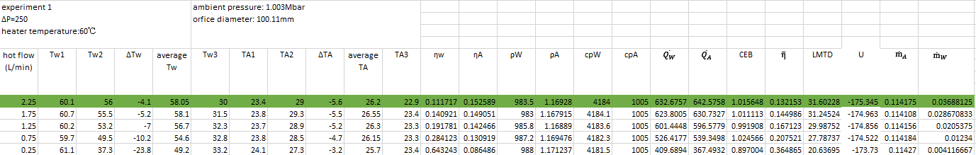
Figure 8. experiment 1 data
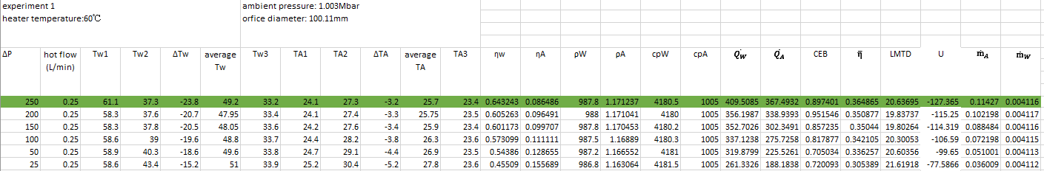
Figure 9. experiment 2 data
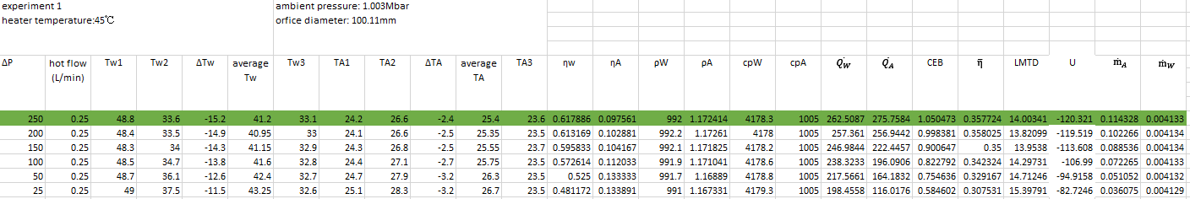
Figure 10. experiment 3 data
For experiment 1, I plot the heat emitted by the heat exchanger and the power absorbed into the air (Watts) as figure 11. I plot the air, water and mean temperature efficiencies as figure 12. I plot the overall heat transfer coefficient U as figure 13.
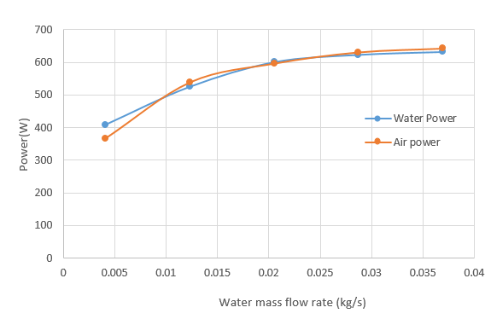
Figure 11. heat emitted and absorbed vs water flow
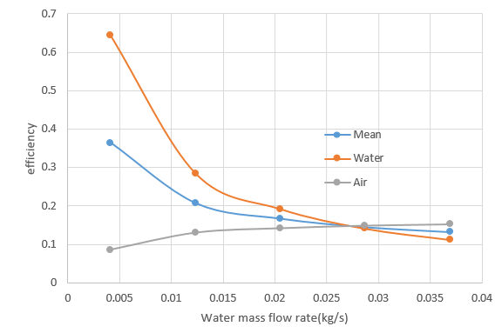
Figure 12. efficiency vs water flow
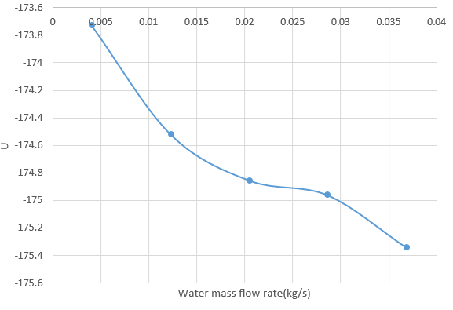
Figure 13. U vs water flow
For experiment 2, I plot the heat emitted by the heat exchanger and the power absorbed into the air (Watts) as figure 14. I plot the air, water and mean temperature efficiencies as figure 15. I plot the overall heat transfer coefficient U as figure 16.
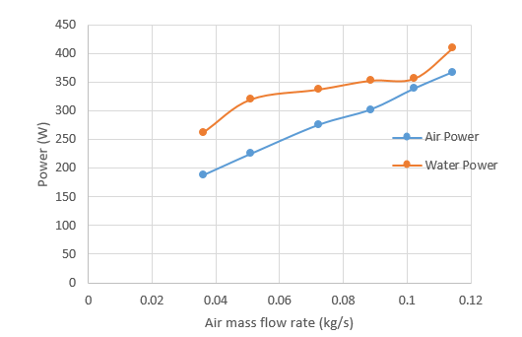
Figure 14. heat emitted and absorbed vs air flow(60℃)
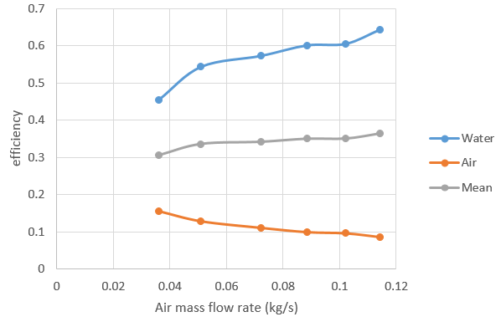
Figure 15. efficiency vs air flow(60℃)
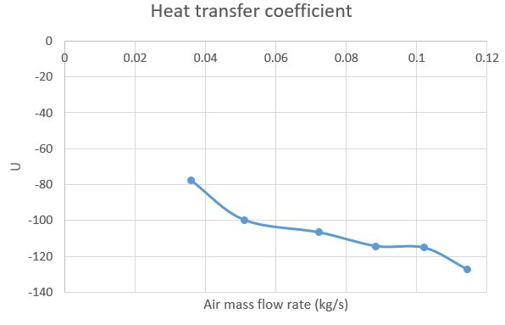
Figure 16. U vs air flow(60℃)
For experiment 3, I plot the heat emitted by the heat exchanger and the power absorbed into the air (Watts) as figure 17. I plot the comparison between water power of 45℃ and water power of 60℃ as figure 18. I plot the air, water and mean temperature efficiencies as figure 19. I plot the overall heat transfer coefficient U as figure 20.
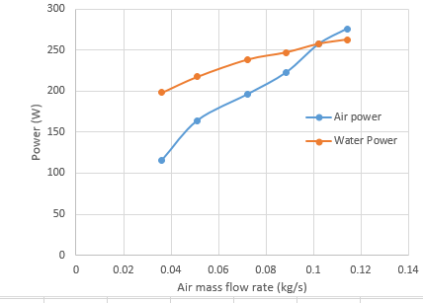
Figure 17. heat emitted and absorbed vs air flow(45℃)
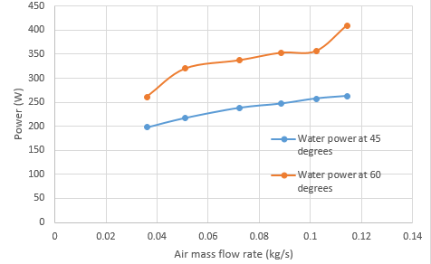
Figure 18. comparison of two tank temperature(45℃)
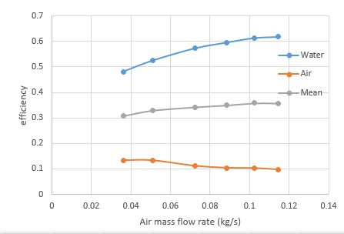
Figure 19. efficiency vs air flow (45℃)
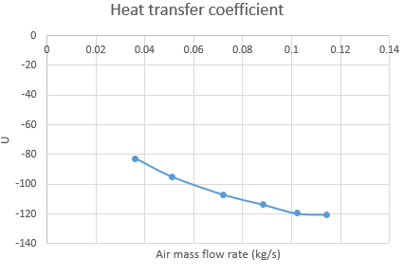
Figure 20. U vs air flow (45℃)

Analyzation of results
Analyzation for experiment 1:
Figure 11. heat emitted and absorbed vs water flow
As is shown in figure 11, as the water mass flow rate increases, the water emitted power and the air absorbed power increase. Meanwhile, the value of the emitted power and absorbed power are almost the same means there is little heat loss or absorption from surroundings. Let’s come back to the formulas.
Water and air power formula is as followed(the red value is almost constant value):
$${ \dot{Q}}_{W}={\dot{m}}_{W}ⅹc_{W}ⅹΔT_{W}$$
$${ \dot{Q}}_{A}={\dot{m}}_{A}ⅹc_{A}ⅹΔT_{A}$$
As the water mass flow rate ${\dot{m}}_{W}$increases, $ΔT_{W}$ decreases (as data we collected), but ${\dot{Q}}_{W}$ increases. After thinking, we can understand that the larger water flow increases the heat transfer power of the heat exchanger, but reduces the heat transfer efficiency because the water temperature difference $ΔT_{W}$is reduced which means the same amount water emits less heat.
Figure 12. efficiency vs water flow
As is shown in figure 12, it shows the analyzation for figure 11 is right. As the water mass flow rate increases, the water efficiency decreases. As the water mass flow rate increases, the heat power increases so the temperature difference of air becomes bigger so the air efficiency increases.
Figure 13. U vs water flow
As is shown in figure 13, as the water mass flow rate increases, the heat transfer coefficient increases. That’s consistent with the analyzation for figure 11 and figure 12 because as the water mass flow rate increases, the heat power increases, so the heat transfer coefficient increases.
Analyzation for experiment 2:
Figure 14. heat emitted and absorbed vs air flow(60℃)
As for figure 14, the value of water power is obviously bigger than the value of air power which means heat is emitted to surroundings. As air mass flow rate increases, the water emitted power and air absorbed power increase. Let’s come back to formulas:
Water and air power formula is as followed(the red value is almost constant value):
$${ \dot{Q}}_{W}={\dot{m}}_{W}ⅹc_{W}ⅹΔT_{W}$$
$${ \dot{Q}}_{A}={\dot{m}}_{A}ⅹc_{A}ⅹΔT_{A}$$
As the air mass flow rate ${\dot{m}}_{A}$increases, $ΔT_{A}$ decreases (as data we collected), but ${\dot{Q}}_{A}$ increases. After thinking, we can understand that the larger air flow increases the heat transfer power of the heat exchanger, but reduces the heat transfer efficiency because the air temperature difference $ΔT_{A}$is reduced which means the same amount air emits less heat.

Figure 15. efficiency vs air flow(60℃)
As is shown in figure 15, as the air mass flow rate ${\dot{m}}_{A}$increases, the air efficiency decreases but the water efficiency increases which means the analyzation for figure 14 is right.
Analyzation for experiment 3:
As for experiment 3, I think it is similar to experiment 2 because it just changes the tank temperature. As a result, figure 17, figure 19, figure 20 shows the same trend with figure 14, figure 15, figure 16. So the analyzation is the same as experiment 2.
As for figure 18, it shows the water power decreases as the tank temperature decreases. It’s easy to understand because the lower temperature of surroundings makes it easier to emit heat so the water power increases.

Figure 18. comparison of two tank temperature(45℃)

Conclusion
From the analyzation part, I make conclusions as followed:
- When two fluids exchange heat, A fluid flow rate is constant, and B fluid flow rate increases, the heat exchange power of A and B increases, heat transfer coefficient increase.
- When two fluids exchange heat, A fluid flow rate is constant, and B fluid flow rate increases, the heat exchange efficiency of A increases but the heat exchange efficiency of B decreases.

Prospective
As is shown in figure 14, I was not quite sure about the curve.
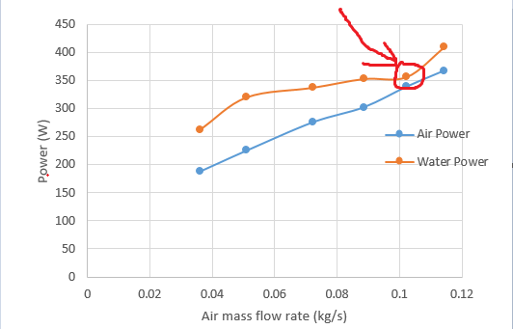
This point(from experiment 2) is different from other point because it has little heat exchange with surroundings. There are 2 possible reasons: first is this point is a wrong data. Second is under this condition, the air flow rate is 0.1 kg/s made the system have little heat exchange with surroundings. I think the second reason is more likely to be the reason because from experiment 1 I can find that when the air flow rate is close to 0.1 kg/s, the system has little heat exchange with surroundings. So next time I will find out this reason. If the assumption is right, I will find out how to find the exact value to make the system have no heat exchange with surroundings.
As for figure 13, the range is too small. The difference between maximum and minimum is only 1.6. I think it is because the water flow rate at which we collected the data is too small.
Figure 13. U vs water flow

Bibliography
Song, C. (2013). Thermal foundation. Mechanical Industry Press.
TD1007 user guide. (2014). TecQuipment.
WIKIPEDIA. (2019). Retrieved from https://en.wikipedia.org/wiki/Heat_exchanger

