Academic skills assignment; the benefit of moto gp shifting
By: harvey merrett
Student number: 2204827
29th of November hand it date
ACHA4005
INTRDUCTION:
In this assignment I will be talking about the differences between normal motorcycle shifting and Motorcycle GP shifting. This will be in depth research looking at the mechanical side of using these modifications and the performance side. The mechanical side being how Moto GP shifting is performed on bikes and how it is installed and the performance side being track related. It is important that we look at the difference as it can tell us if it benefits Motorcycle racers in any way or hinders their performance.

LITERATURE REVIEW:
Standard motorcycles have always had a normal way of shifting gears. This has been the standard shift pattern from 1st gear down to 6th gear up. In Moto GP, many riders have what is called GP shifting. This is the opposite way that the shift spindle has been turned to do the opposite of standard motorcycle shifting. This would mean that you click up into first gear and down into second gear, which has many benefits while racing, but many occurrences which may hinder riders. Only reports by “tunedtrends”. They have a discussion of how Moto GP shifting helps racers. The user state that many road motorcycles go with the standard gear pattern, but most racers Use the reverse spindle technique, also known as race or Moto GP shifting, to get a better shift time and hold higher rpms. I highly benefit the research as I am a motorcycle racer myself and use Moto GP shifting. I can say myself that I do prefer using moto GP shifting on a track as it is easier to change gear whilst cornering. But there are many downsides to using GP shifting, Some of these being dangers come by not being trained to use GP shifting and using the standard gear shifting pattern on a wrong corner can cause many problems and sometimes be catastrophic. Moto GP shifting is fairly easy to be modified. This is done by flipping the shift spindle round 180 degrees so that it is now facing forwards and wrapping the clutch lever around the gear spindle. This means the gear shifting pattern will be opposite to what it is which means it is now GP shift. Due to another article with “tunedtrends” we can see that 99% of riders use GP shifting which means there is a big positive benefit that comes from it, this mainly being ease of moving up a gear around corner.

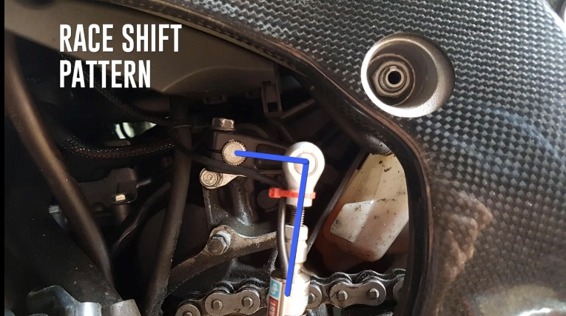
here we can see a shift spindle in my own sports bike! It is facing left as that is the way the spindle needs to be facing to have a reverse gear patter or Moto GP shift. The way I did this was by removing the gear spindle from the clutch and rotated it 180 degrees so that its facing the front of the bike and the gear lever is facing left. This makes the chain automatically think its starting in 6th gear when its secretly in 1st gear! ! (I hope you appreciate the picture I had to take my bike apart for this!)

DISCUSSION:
Race shifting is key in the Motorcycle racing world and is one of the main benefits to riders. The main reason as to why riders use Moto GP shifting is the ease ability of changing up a gear around a tight corner. Due to gravity and lateral stress on the body, it will be very difficult to change up a gear of your taking or right corner as you would have to move your whole foot upwards to reach the gear lever. It is important that we also look at the hindrances of motor GP shifting and we can see that when you are going round the corner, changing down again will be more difficult as that is now moving the gear lever upwards. But as I explained, not many riders coming off of a corner will slow down, so that means that it is a statistical play to have Moto GP shifting as it allows the rider to have better shifting upwards around and off corners. Moto GP helps riders navigate through turns and tight corners so that they are able to position themselves better for more easy gear change and this is important as it means the riders can be quicker in the transfer out of a corner and changing gear. It is also good for general gear changing on straights as changing up a gear is a more natural movement for the ankle. . There are still a few racers who haven’t adapted to this skill of using the Racing pattern also known as Moto GP shifting. These riders are usually the more experiences riders who are old in age and are refusing change. Moto gp shifting became greatly popular in the early 2000’s in Moto GP. So switching gearing patterns seems fairly simple, would you use if it you were a racer? Its helping all younger races get faster track times and they are also able to leave corners more quickly as they have a few tenths of a second to change up gears quicker. Faster lap times are being set more regularly and many researches are to do with gearing patters and relates rpm ratios.
CONCLUSION:
To conclude I believe that Moto GP shifting has many benefits when it comes to racing. The pros being faster lap times, ease of changing gear whilst cornering and being able to leave the corner faster than before. This is the reason why many motorcycle riders tend to use moto GP shifting as its seen as the more aggressive racing style. The cons being that the rider may struggle to control the bike when they are changing down an gear as it means it will be an uneven position for the rider on the bike as the now need to click the gear lever upwards to change down a gear. Also coming to terms with a new gearing system may take a few times to the adjust to so I feel like it has the potential to be one of the outcomes where if you can learn to use that skill it will benefit you once you know it. Due to all the points addressed I thoroughly believe that Moto GP shifting is a lot different compared to standard road shifting but I also believe that it has many factors which will benefit racers in Moto GP and smaller competitions around the world and this is why 99% of the population of riders have already been introduced to this system. WHAT WOULD YOU CHOOSE, STABILITY OR SPEED?
REFERENCES:
TUNED TRENDS“GP shifting on motorcycles explained”, Francisco M, March 17th 2019

