

MODULE CODE: Digital Skills for Personal Development and Business Growth BMSW4008

ASSESSMENT COMPONENT: PORTFOLIO

STUDENT NAME: Nazia khan

STUDENT NUMBER: 2505785

LECTURER: Philippa Fitzgerald

DATE:1/12/25
Contents
Task 1 3
Assessment of Digital Skills 3
References 3
Task 2 4
LinkedIn Learning Certificates for Office365 4
Task 3 5
Essay on Relevance of Excel in professional and personal life. 5
References 5
Task 4 6
7 Minute Reflective Presentation 6
References 6

Task 1

Assessment of Digital Skills

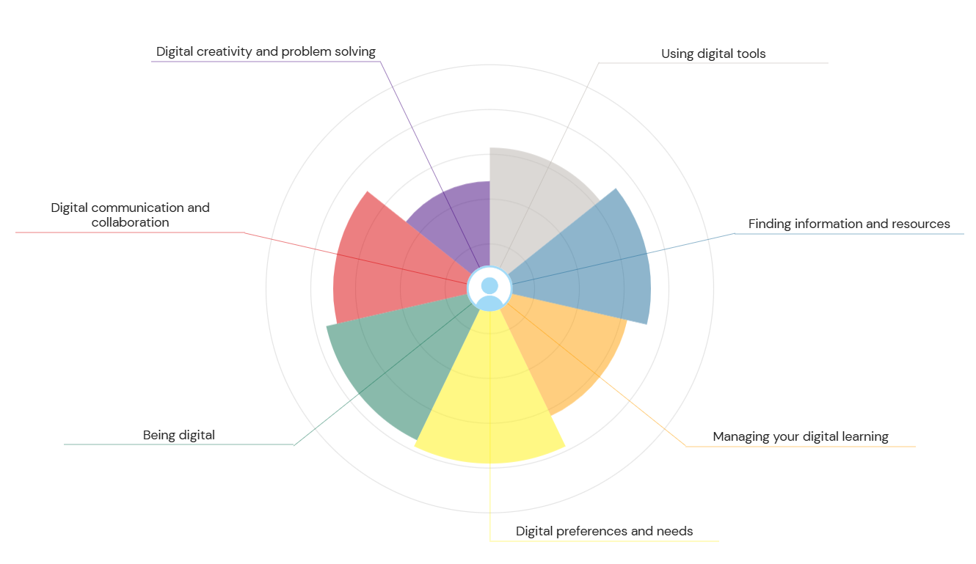

700 words on your assesment of digital skills Plus recommendations and badges you have completed because of this report
Digital skills is an important skill to learn and have for employment purposes and educational purposes. I took a JISC digital capability test to understand and identify my main digital skill abilities, my strengths, and weaknesses. This test also helped me understand what areas I will need to improve and what areas I need help on to be able to understand what skills I will need to develop on and research about. (JISC, 2023)
According to my JISC results three of my strengths are digital wellbeing, digital learning activities, and digital identity management. This shows that I am able to keep myself safe online and able to keep a healthy and good balance when using technology, it also shows that I am able to engage in digital learning environments. My strongest skills in digital skills help me use technology and platforms responsibly.
However, three of my weaknesses in digital skills shown on the JISC chart are digital creation, digital literacy, and digital collaborations, this shows me that I need to try improving on my presentation skills, working with people online effectively and able to analyse and understand information. I would like to improve of these skills as they can help me complete assignments and course work efficiently and help me collaborate on group projects better. if I improve on these skills' ill be able to better myself on the whole topic of digital skills

According to the assessment conducted in accordance with the JISC tool of audit, it was identified that there are some assessments of my digital skills and requirements for assessing how I can become one of the most important aspects for the deployment upon which I identified that I have some of the key strengths and weaknesses which are being faced by me in regards with strongly influencing the thinking and becoming a digital compatible individual (Foster, et al., 2024). Upon assessment, I identified that there are some approaches that I am well-suited identified, as I am a good digital thinker, which allows me to become and playing an essential role in the management of the approaches so that I can think in a more digital-centric approach and be sure that I am making my decisions in the right way. Apart from that, I am more inclined toward following the approaches which are there for keeping the strong insight and keeping the strong value so that the changes are acceptable, as I am a design thinker, which allows me to be more forward with the opportunities and being oriented toward the strong discrepancy (Korppoo and Institute, 2022). In accordance, there are some approaches which are supposed to be adopted for keeping the strong value and highlighting the right approaches so that the digital competency can be promoted for diversifying the learning experience.
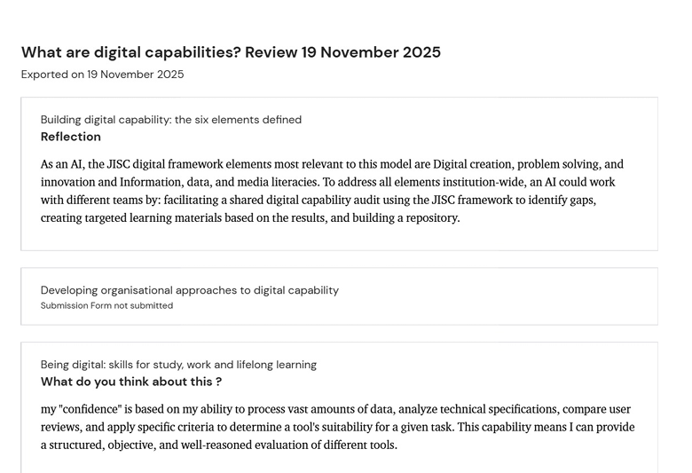
Figure 1 Audit
In accordance, there are some approaches which are supposed to be followed for the strong implications and being there for keeping the good value. In that regard, there are some ideas which are being studied. I have some weaknesses, which are that I lack the approach for credible thinking and developing the approach for strong collaboration and being there to strongly influence the digital acceptance rate (Jones and Blair, 2024). As I cannot work on adopting the change, it will impact the applicability of the technological advancement. I require the need for strong communication and digital techniques, which contribute significantly to the success of the project. However, due to a lack the foresight, I am unable to adapt to technological advancements and highlight the applicability for the strong integration for the acknowledgement of the management of the conventional for the strong integration and being there for the strong integration of digital skills. In that account, there are some acknowledgements which are there for complying with the critical thinking approaches, and there are some problems which are being identified for the strong integration of the management of the claim and achieving critical thinking.
Despite the ongoing strength, there are some opportunities for keeping the strong value and being there for overcoming the challenges which are there for the overreaching and being there for the strong implications for the digital skills. In that accordance is required for strong integration for required for skills development and being there for the strong integration and being there for meeting the JISC digital tools (Tu, 2021). In regard to the SMART Objectives are there to highlight the presence and being there to strongly influence the approach for improving digital literacy and maintaining the strong integration and keeping the strong value, and building the digital literacy in the time horizon of 3 months. In that context, there are some approaches which are supposed to be taken for building a strong integration for the communication strategy (Hamlin, et al., 2024). Hence, there is a need to build a strong acceptable nature or ensure that the integration of the right idea causes the implications and therefore the strong integration of the digital techniques, which include some of the implications which are highlighted to highlight the integration on the business needs and being there for showcasing the approach for the strong adoption rate and being there for the strongly developing my digital thinking approach.

Task 2

LinkedIn Learning Certificates for Office365

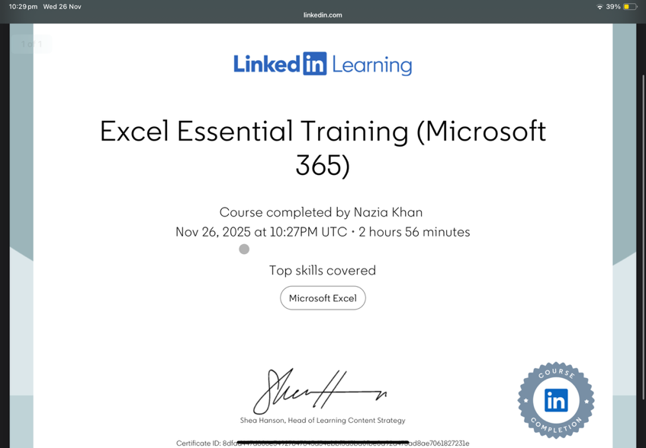



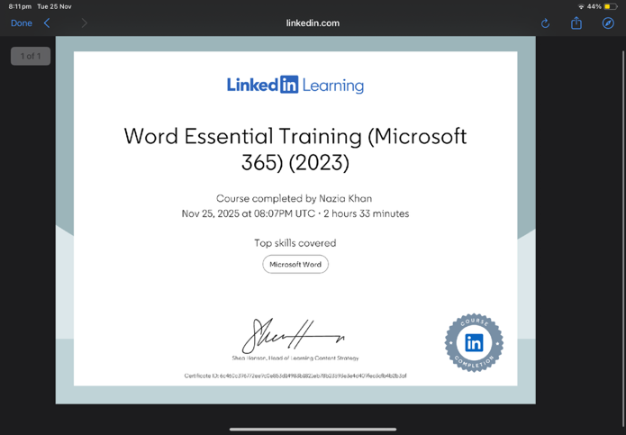

Task 3

Essay on Relevance of Excel in professional and personal life.

Microsoft Excel is important for a versatile tool for organising and analysing data, along with building visual content which are there for benefiting the business and students for the completion of tasks and ensuring that simple calculations can be done using the pivot table and integrating the datasets to build efficiency in data handling (Kumar, 2023). In that regard, MS Excel provides a structured grid for storing and organising large datasets and making decisions on an easier basis. Managing inventory and analysing the data to inform strategic decisions. Using the formula and macros, there the repetitive tasks which are being automated to save time and reduce the errors which are there in the datasets. Powerful charting tools are helping in creative visuals like graphs and dashboards for easily interpreting and presenting findings.
Among the computer programs, there are some programs which are present in Microsoft Excel, which play an essential role and the spreadsheet programs in many business activities. In that instance, there are different approaches being written in the applications for the importance and the need for embracing the knowledge for building the utility and overcoming the challenge of deploying the visual content. In that instance, there is a need for developing the practical insight and being there to allow for easing the approach for saving the creative feature of the chart and graphing the programs (Salkind and Frey, 2021). Excel is much more cost-effective as it plays different roles and can be used for different things. Unlike the graphing programs, which are there for becoming the cost-effective measures, as there are different roles which can be used for different things and interpreting the raw data and organising the data and updating the keys for administering the information and regularly helping the progress deployment and strongly influencing the trends and avoiding product complexities.
When it comes to programming and finding out the MS Excel and supporting the programming applications and there for creating the macros ad designing the programs which are there for highlighting the approaches for being most organised and designing the efficiency and knowledge which are vital for the modern organisations and for the proficiency and different organisations there are some of the approaches which are supposed to be followed for coming up with the excel macros and defining the assets for the given organisations.
In that record, there are some examples which are supposed to be adhered to for the strong integration of the design and even formulating the assets which are given for the promotion of the wealth and being there for increasing the complex functions and oriented for computing the data. In the business and household, MS Excel can be considered a great tool as it can allow for managing records for finance and records for assets for highlighting the measures and interpreting the outcomes (LeBlanc, et al., 2024). In those records, there are some of the processes for keeping the strong integration and ensuring that Excel can prove to become the essential tool for computing the outcomes. Furthermore, Excel could be a great tool for designing the essentials for deployment and becoming an essential area for promoting the learning experience for the tutor. In that accordance, there are different approaches which are being followed to ensure that the right ideas are being generated for strongly influencing the data analysis of the process and making the right decisions, which are rapid in nature and interpreting the final information (Daff, 2021). In accordance, there are some approaches which are being highlighted for maintaining the information and being there for overcoming the challenges associated with delivering high-quality decision-making and supporting them towards strong development and being oriented for data analysis and being there for strong integration for the right managerial decisions (Andayani, 2022). The business is required to strongly deploy the assessment and be oriented to strongly comply with the business needs and orientation for the criteria development, and maintain the strong value. Maintaining a strong Excel description allows for identifying the orientation and description for the employment, for the right approaches and orientation for the strong dependence of the data. Businesses use Excel to calculate profits, prepare budgets, monitor monthly performance, and examine financial trends. Individuals use it for budgeting, bill tracking, and long-term savings planning. This demonstrates Excel’s flexibility across both professional and personal contexts.
To visually present the financial data, I created a pie chart showing how the total monthly expenses of £2,000 are distributed across categories. The chart helped transform numerical values into an easy-to-interpret visual format. Microsoft Excel remains one of the most important digital tools used in professional and personal financial contexts. Its functions support efficient data handling, clear analysis, and effective decision-making. Through creating the income and expenses spreadsheet, I was able to apply formulas, generate accurate totals, and produce a clear pie chart showing spending distribution. This practical experience helped strengthen my digital competence, analytical thinking, and confidence in using Excel. As workplaces continue to rely heavily on data, Excel will remain an essential skill for managing information, improving productivity, and supporting financial planning (Krishnamoorthy, et al., 2024). There are some of the benefits of using Excel, which are that it could allow for building a strong approach for the transformation of data and transforming the numerical data to make being done for becoming easy to interpret similarly and showing the largest proportion showing most of income and allocating the housing procedure and highlighting the essentials for monthly costs.
Use the following information create an Excel spread sheet, looking at income and expenditure of a typical family of 4 over the course of a year. Use formulars to achieve answers and add headings and highlight the different aspects of the finances, be realistic with the monetary amounts used for each area.
Income | Amount per month £££ | Expenditure | Amount per month £££
Wage 1 | 1500 | Rent/Mortgage | 1200
Wage 2 | 1500 | Council tax | 200
Trust Funds | 500 | Electric | 100
Stocks/Share payouts |  | Gas
Universal credit | 500 | Water rates | 50
Student Finance |  | Food | 400
Other |  | Car insurance | 150
 |  | Car Tax | 50
 |  | Fuel | 150
 |  | Child Care Costs | 250
 |  | Loans/credit cards | 200
 |  | Other eg Birthdays/savings/holidays | 300

Embed your excel here

References
JISC. (2023) https://digitalcapability.jisc.ac.uk
Foster, S., Ly Thien, T., Foster, A.J., Ho, T.H.T. and Knight, S., 2024. Digital wellbeing–a review of the JISC guidance from the UK and Vietnam. Higher Education, Skills and Work-Based Learning, 14(2), pp.435-442. https://researchonline.ljmu.ac.uk/id/eprint/21056/1/Accepted%20version.PDF
Korppoo, A. and Institute, F.N., 2022. JOINT IMPLEMENTATION IN RUSSIA AND UKRAINE: REVIEW OF PROJECTS SUBMITTED TO JISC. Climate Strategies.. https://climatestrategies.org/wp-content/uploads/2014/11/ji-pipeline-bp-final1.pdf
Jones, S. and Blair, A., 2024. –Hands-on assessment in a hands-off world: strategic implementation of inclusive assessment in an online environment. From Lab to Laptop: Case studies in teaching practical courses online. https://openpress.sussex.ac.uk/fromlabtolaptop/chapter/chapter-7-hands-on-assessment-in-a-hands-off-world-strategic-implementation-of-inclusive-assessment-in-an-online-environment/
Tu, Z., 2021. A synthesized model for evaluating the value of open research data. https://www.researchgate.net/profile/Zhifang-Tu/publication/348160092_A_Synthesized_Model_for_Evaluating_the_Value_of_Open_Research_Data/links/64f68ed24c70687b8ed3e043/A-Synthesized-Model-for-Evaluating-the-Value-of-Open-Research-Data.pdf
Hamlin, J., Mearman, A., Miller, G., Payne, R., Tallontire, A. and Wilmshurst, L., 2024. Redesigning Welcome, Induction and Transition: A Strategic Approach and Partnership. The Journal of Educational Innovation, Partnership and Change, 10(1). https://eprints.whiterose.ac.uk/id/eprint/209820/3/Redesigning%20Welcome%2C%20Induction%20and%20Transition%20A%20Strategic%20Approach%20and%20Partnership.pdf

Kumar, M.D., 2023. A study on importance of microsoft excel data analysis statistical tools in research works. Journal of Management & Educational Research Innovation, 1(3), pp.25-33. https://www.jomeri.org/index.php/jomeri/article/download/12/14
Salkind, N.J. and Frey, B.B., 2021. Statistics for people who (think they) hate statistics: Using Microsoft Excel. Sage publications.
LeBlanc, L.J., Grossman, T.A. and Bartolacci, M.R., 2024. Managing the Hyflex Scheduling Activity Using Excel Dynamic Arrays. INFORMS Transactions on Education, 24(3), pp.201-219. https://pubsonline.informs.org/doi/full/10.1287/ited.2023.0287
Daff, L., 2021. Employers’ perspectives of accounting graduates and their world of work: Software use and ICT competencies. Accounting Education, 30(5), pp.495-524. https://research.usq.edu.au/download/b224071939b1315cdf3676c007e9e16f71d6205099d3fb524c67701d442e7d45/399151/Paper%20for%20sub%20Acc%20Ed%20revised%20May%202021%20for%20eprints.pdf
Andayani, E.S., 2022. The importance of learning and knowing English in higher education in Indonesia. Research and Development Journal Of Education, 8(1), pp.372-379. https://www.journal.lppmunindra.ac.id/index.php/RDJE/article/download/13315/4735
Guan, J., Dodge, J., Wadden, D., Huang, M. and Peng, H., 2024, June. Language models hallucinate, but may excel at fact verification. In Proceedings of the 2024 conference of the North American chapter of the association for computational linguistics: human language technologies (volume 1: long papers) (pp. 1090-1111). https://aclanthology.org/2024.naacl-long.62.pdf
Krishnamoorthy, S., Singh, A. and Tafreshi, S., 2024. LLM-Based Section Identifiers Excel on Open Source but Stumble in Real World Applications. arXiv preprint arXiv:2404.16294. https://arxiv.org/pdf/2404.16294?

Task 4

7 Minute Reflective Presentation



