Understanding your child’s cognitive development

(Aleli Dezmen,2021)

Piaget’s theory of Cognitive Development

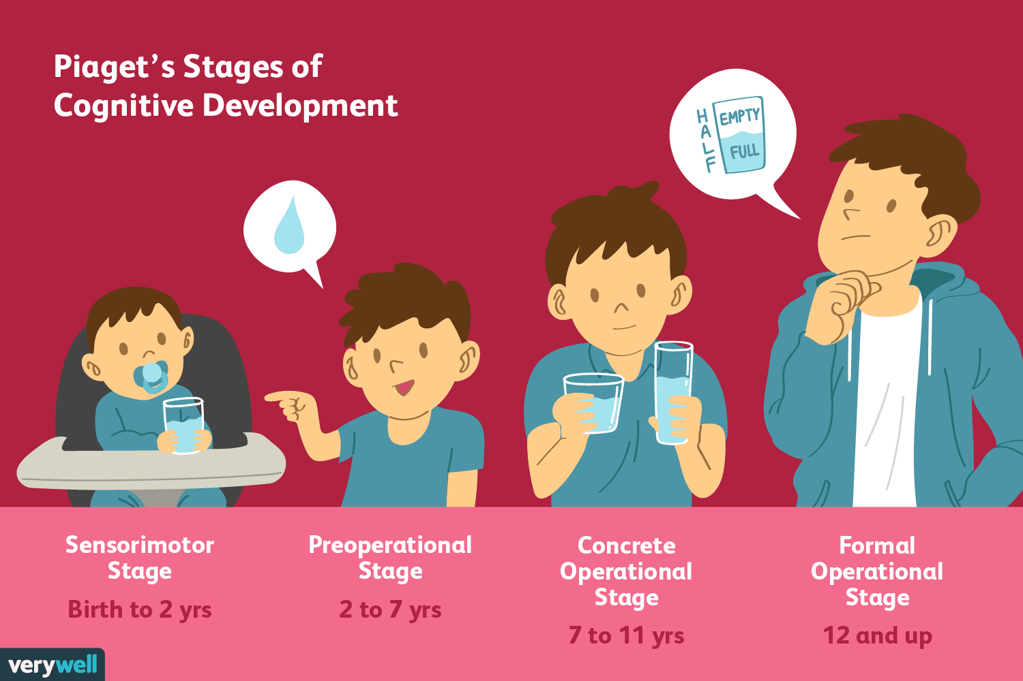
(Joshua Seong,2020)

According to Piaget's theory of cognitive development, children's intellect changes as they get older (McLeoud,2020). In addition to information acquisition, children's cognitive development also involves the building or growth of a mental model of the world from their point of view. As I'll detail below, children go through a range of phases in their cognitive development as a consequence of a mix of supportive tactics and contextual factors.

First stage

Sensorimotor stage (aged birth to 2 years approximately)

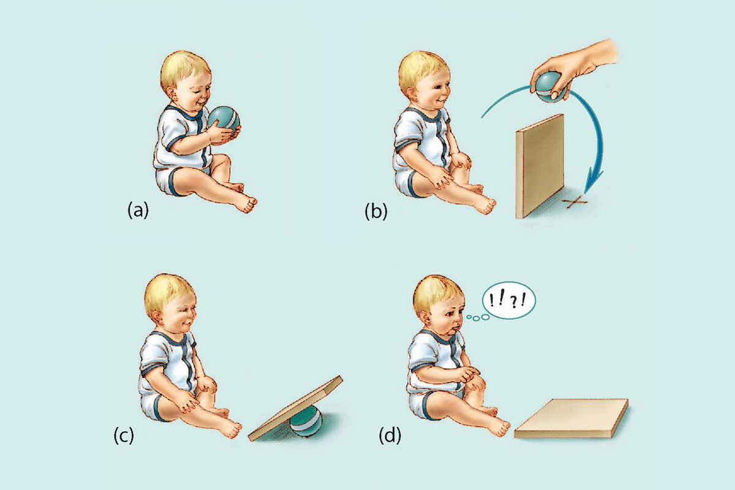

(Hernandez,N.D)

The first of four stages in Piaget's theory of cognitive development is known as the sensorimotor stage. This period, which lasts from birth to about two years, is also one of rapid cognitive growth. During this period, infants build their perception of the world by fusing motor actions like reaching and touching with sensory experiences like seeing and hearing.

According to (Mcleod, 2018), the main development during the sensorimotor era is the knowledge that objects exist and events happen in the world independently of one's own actions (also known as "the object notion" or "object permanence"). In 1963, Piaget performed research known as the blanket and ball study to find out when kids start to understand the permanence of objects. Piaget conducted a research in which he concealed a toy behind a blanket while the kid watched and noted whether or not the youngster looked for the object. By looking for the hidden toy, the search showed object persistence. According to Piaget, a youngster can only discover a hidden thing if they have a mental image of it. It was also determined that babies who are approximately 8 months old have object permanence since they can visualise the thing in their minds.

Second stage

Pre operational stage (2-7 years)

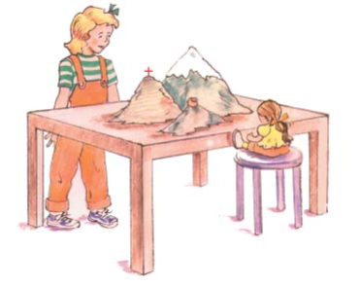
(H.Bee&D.Boyd,2002)

According to (Mcleod,2018) The second stage in Piaget's theory of cognitive development is the preoperational stage. Beginning around age two and lasting until around age seven, this stage. During this phase, children process ideas through visuals even if they are not yet capable of cognitive activities. The child's thinking is in its early stages at this point. This suggests that the youngster is incapable of using logic, adapting, combining, or separating concepts.

Conservation is the idea that something has the same quantity even while it changes in appearance. In other words, the ability to understand that distributing a substance has no impact on its mass, amount, or volume. The ability to address these and other "conservation" challenges heralds the start of the following stage.

There are a number of related conclusions which Piaget drew as I will illustrate below.

1) These circumstances are "perception bound" in terms of comprehension. The infant assumes that something has changed when the materials appear to have changed.

2) One component of the circumstance is 'focused' in one's mind. Changes in the level of water or the length of clay are noticed by children without recognising that other features of the circumstance have altered at the same time.

3) The focus of thinking is on states rather than changes. Children don't keep track of what happens to things and instead make intuitive decisions based on how they seem 'now.'

4) Because thinking is "irreversible," the child is unaware that reversing the change would restore the substance to its original condition. Reversibility is an important component of later stages' logical cognition.

The Three Mountains Task

Jean Piaget utilised the three mountains test to determine whether or not kids were egocentric. Egocentric children think everyone will perceive the three mountains the same way they do. By the age of seven, a child's thinking is no longer egocentric since they can see beyond their own point of view, according to Piaget. The child who was seated at a table with three mountains in front of it completed this investigation. The tops of the three mountains varied; one had snow on it, another had a cabin, and the third had a red cross. The youngster would next circle the model, examine it, and then take a seat next to it.

The infant would then be given 10 photographs of mountains taken from various perspectives and was instructed to select the image that best represents the view of the doll. If the toddler correctly recognised the card describing the perspective of the doll, Piaget believed that the youngster was not egocentric. The young person selected the card that represented their own egocentric point of view.

It has been proposed that Piaget's tests at this time may have faked the child's capacity due to a number of factors, including sophisticated language, new materials, a lack of context, and adolescents misinterpreting the experimenter's meaning.

Third stage

Concrete operational stage

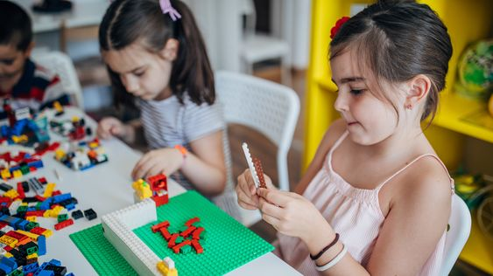
(Lewis,2020)
According to (McLeod,2021) The third stage in Piaget's theory of cognitive development is the concrete operational stage. Between the ages of seven and eleven, this stage is notable for the growth of organised and logical thought. Piaget (1954a) considered the concrete stage to be a critical turning point in a child's cognitive development since it signifies the start of comprehending logical or operational reasoning. The youngster has reached the developmental stage where logic can be used, but only to concrete objects.

Children acquire their abilities in the areas of conservation number, area, volume, direction, reversibility, seriation, transitivity, and class inclusion. Similar to adults, children can grasp problems logically but are unable to reason hypothetically.

Classification

The classifying process has two steps. Putting things in categories is one. Your youngster has already established two distinct categories for flowers and animals.

They have more room to move at this point. They comprehend that there are subclasses within a group, such as red and yellow flowers or flying and swimming animals.

Conservation

This is the realisation that something may remain the same in amount even though it changes in appearance. The number of that play dough ball remains the same regardless of whether it's flattened or rolled into a ball.

Decentration
It has to do with conservation. For them to properly preserve, your youngster must learn decentration. It all comes down to focusing on numerous things at once.

No matter how far apart you space them, a row of five paper clips remains a row of five paper clips. Due to their ability to simultaneously manage length and quantity at this point, your child understands this.

Reversibility

Understanding that acts may be undone is necessary for this. similar to mental exercise. Here, your infant may understand that your vehicle is an Audi, that an Audi is a vehicle, and that a vehicle is a car.

Seriation

It ultimately comes down to mentally placing a collection of items in some kind of order. Now your youngster can arrange the items in descending order of height or width, for instance.

Sociocentric

This is the last attribute. Your youngster is no longer egotistical and entirely self-absorbed. Kids have the capacity to comprehend that mom has her own ideas, feelings, and schedule.

Kids are far less egocentric when they are in the concrete operational stage. It takes place between the ages of 7 and 11 and is distinguished by more careful and logical symbol manipulation. The main objective at this stage is for a youngster to start conceptualising things. Children may solve problems without having to deal with them physically thanks to a process known as operational thinking.

Fourth stage - Formal operational stage

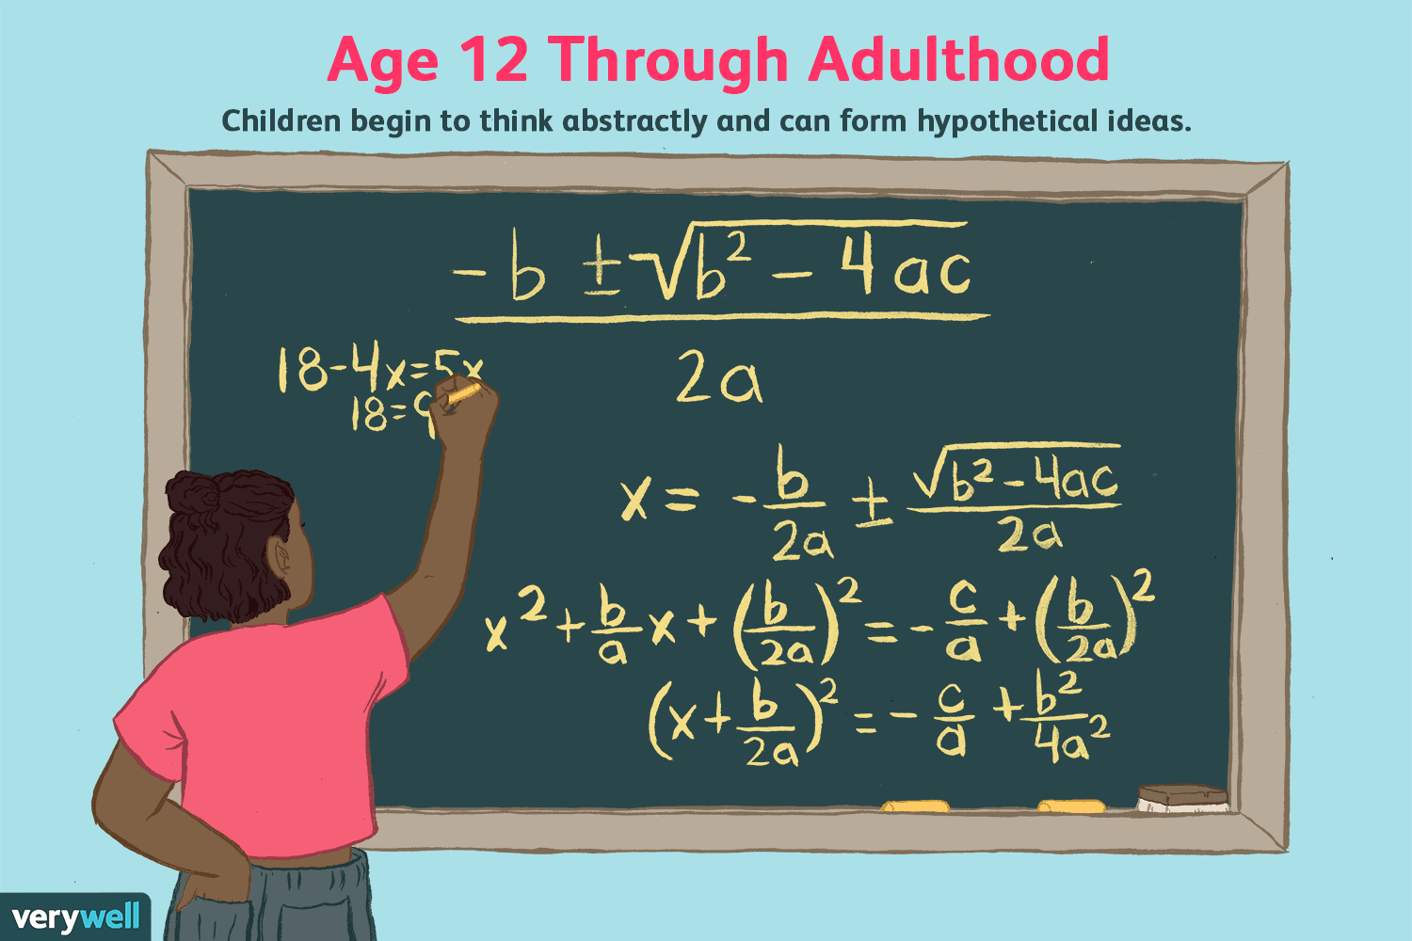
(Gilmartin,2021)

According to (McLeod,2010) At the age of twelve, the official operational phase begins and lasts until maturity. At this phase, adolescents learn to think abstractly by playing with ideas in their thoughts rather than depending on physical manipulation (Inhelder & Piaget, 1958). He or she is capable of reasoning abstractly, making mathematical computations, and visualising the results of various actions.

The answer to the question "Who is tallest?" serves as an example of the difference between the concrete and formal operational stages. Kelly is taller than Ali, and Ali is taller than Jo. This is an illustration of inferential reasoning, which refers to a child's capacity to think about and draw conclusions from ideas regarding things they haven't really encountered.

Whereas kids who have to use objects or draw pictures are still in the concrete operational stage, kids who can mentally reason out the answer are in the formal operational stage.

A variety of formal operational thinking tests were created by Piaget in 1970. One of the most fundamental was the "third eye issue". The kids were asked where and why they would put their third eye if they could have one.

Schaffer claims that when 9-year-olds were asked about this, they all agreed that the third eye should be on the forehead (1988). While 11-year-olds were more creative, they suggested that a third eye on the hand may be beneficial for looking around corners.

Formal operational thinking has also been empirically assessed in the pendulum task (Inhelder & Piaget, 1958). The procedure involved the use of some weights and a piece of string. Participants had to take into account the length of the string, the weight's weight, and the force of the push. The objective was to determine which factor most significantly affected the pendulum's swing speed. The pendulum string's mass and length could be changed by participants. To gauge the pendulum's speed, they can count the swings made each minute.

The subject must comprehend the experimental design, which involves changing one variable at a time, in order to provide the correct response (e.g. trying different lengths with the same weight). A person is likely to receive the incorrect answer if they experiment with various lengths and weights.

Children who were in the formal operational stage approached the task systematically, trying with one variable (such the length of the string) at a time to see how it influenced the result. On the other hand, younger kids frequently experimented with different adjustments at random or changed two things at once. Piaget came to the conclusion that the systematic approach showed that the children were reasoning logically, abstractly, and were able to make connections between objects. These characteristics exist in the formal operating stage.

References

Dezmen, A.Z. (2021). Getty Images. Verywellmind.CognitiveDevelopmentalMilestones. https://www.verywellmind.com/cognitive-developmental-milestones-2795109 (Accessed25/03/2022)

Gilmartin, B.G. (2021).Age 12 Through Adulthood,Verywellmind. https://www.verywellmind.com/formal-operational-stage-of-cognitive-development-2795459(Accessed25/03/22)

H.Bee&D.Boyd(2002)Lifespandevelopment,3rd ed.Boston.Allyn&Bacon,p.158https://www.pearsonhighered.com/assets/samplechapter/0/2/0/5/0205314112.pdf(accessed25/03/22)

Hernandez, J.H (n.d.) ObjectPermanence.Pinterest https://www.pinterest.co.uk/pin/620019073690735757/(Accessed25/03/2022)

Lewis, R.(2020).The Concrete Operational Stage Of Cognitive Development.Healthline. https://www.healthline.com/health/childrens-health/concrete-operational-stage?epik=dj0yJnU9ZXhKakdhak40VlU4LU9DMmdtNGZmaV9CWjJydjdPZkYmcD0wJm49WXBWN0JNdUxZNUNIbG5iMzcxdXhMUSZ0PUFBQUFBR0pGNFFB(Accessed26/03/22)

Lewis, R.L(2020)Concreteoperationalstage,Healthline. https://www.healthline.com/health/childrens-health/concrete-operational-stage?epik=dj0yJnU9ZXhKakdhak40VlU4LU9DMmdtNGZmaV9CWjJydjdPZkYmcD0wJm49WXBWN0JNdUxZNUNIbG5iMzcxdXhMUSZ0PUFBQUFBR0pGNFFB(Accessed(26/03/22)

McLeod, S. A. (2018). Object permanence. Simply Psychology. www.simplypsychology.org/Object-Permanence.html(Accessed(25/03/2022)

McLeod, S. A. (2018). Preoperational stage. Simply Psychology. www.simplypsychology.org/preoperational.html(Accessed(25/03/22)
Piaget, J. (1954b). The child's conception of number. Journal of Consulting Psychology, 18(1), 76.(Accessed26/03/22)

Piaget, J. (1970). Science of education and the psychology of the child. Trans. D. Coltman. https://www.simplypsychology.org/formal-operational.html (Accessed26/03/22)

Seong,J.S.(2020)PiagetsStagesofCognitiveDevelopment.VeryWellMind.The4StagesofCognitiveDevelopment. https://www.verywellmind.com/piagets-stages-of-cognitive-development-2795457(Accessed(25/03/2022)

