Charlotte Allington: Fieldwork journal
08/02/18: Lecture – Maps

Types
- Ordinance Survey (topography)
- Geological (Rock and sediment – this can given an expectation of what can be found)
- 2 types of information shown
- Shows solid Geology and deposits
- Soils
- Hydrological

Scales
- Level of detail
- 1:50000 are most common
- Higher detail = lower ratio
- Common scales: 1:50000/1:25000/1:10000/1:5000
- GIS (Geographical information software) allow comparison of data/maps
- Digital maps made up of series of layers

Grid reference
- Allows easy pinpointing in a place
- British national grid (dictated by ordinance survey) divides Britain into 100km2
- Each country has own system
- Internal grid reference for each square
- 4 figure: accurate to 1km/6 figure: accurate to 100sqm/8 figure: accurate to 10sqm/ 10 figure: accurate to 1sqm

4 Figure Grid Ref |  | 6 Figure Grid Ref
8553 |  | 842528
Horizonal | Vertical | Horizontal | Specific Horizontal | Vertical | Specific Vertical
Accurate to 1km |  | Accurate to 100sqm

Elevation
- Contour lines (faint)
- Spotite indicates m above sea level
- Ordinance datum (O.D) point that all maps come from (0m above sea level) – Newlyn Cornwall
- Docks are exception (lowest tide mark used, nautical maps reflect this)
- Ports can have -100m below sea level as their 0
- 0 points differ in different countries
- Benchmarks (example below) show ft above sea level (put my ordinance survey. Spotites not benchmarks, just useful)
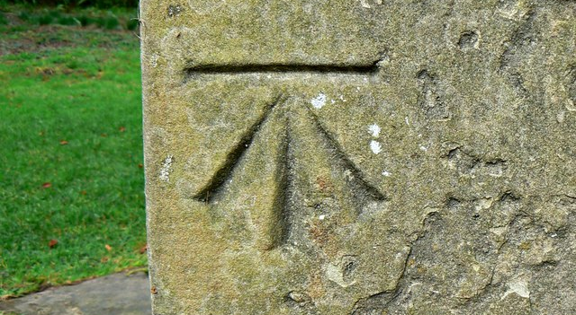

In Archaeology
- Grid set out first, can be arbitrary or lined up to national grid
- Grids set out w/ wooden grid pegs and string
- Spacing depends on site
- Features drawn to scale (usually 1:20 but can very with subject (i.e 1:10 for bones)

Further reading:
- Labelled map in context (Renfrew & Bahn, 2016)
- Topography in context (Renfrew & Bahn, 2016)
- Maps (Carver, 2009)

15/02/18 Part 1 – Elevation/grid lecture

Measuring a grid
- Use Pythagoras

3m
9m

4m

- Nail in ground, measure 4m
- Measure 9m diag and 3m up to make right angle
- Add other right angle
- Add height as needed
- MUST BE PRECISE – otherwise risk of compound mistakes
- Best to use 3 people
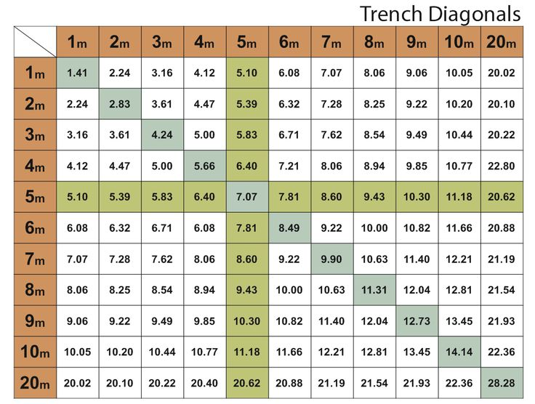
(Trench diagonal tables)

Elevation
- Topography of site elevation important
- Ordinary maps aren’t usually detailed enough
- Manual level
- Use OD data as reference or create own (i.e need consistent 0 even if it is not actually at 0)

Measuring elevation to make graph
(I did forget my own copy of the map and question sheet, but I gained a good understanding through my efforts to help Flavia to understand, as found some of the words used difficult to translate)

- Draw X/Y line across the important parts
- Place a piece of paper with corner at X, edge lying along X/Y line
- Put mark at each point that the elevation lines meet the paper (note the elevation as you go to make it easier)
- Create graph vertical axis labelled with elevation
- Lay paper along horizontal axis and copy markings at appropriate elevation
- Join marks on graph to represent elevation

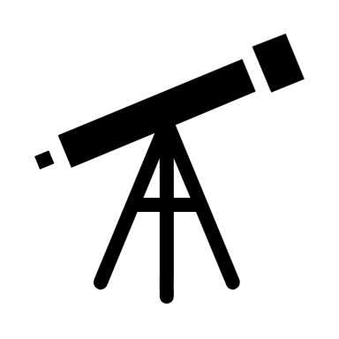
Scope
Point to measure
Static point

- Place level where static point and point to measure both visible
- Make sure horizontal in both direction (crosshairs describe horizontal plane)
- Staff put where you want it at known point
- Value read off to find telescopic elevation
- Move staff to point to measure
- Take reading
- Height of scope – measured height = correct ehight
- If elevation too high, move scope so it can see staff and benchmark (keep staff in place but move scope)

- Companies often hire out equipment (better to do so than pay for initial cost + maintenance)
- Can record sites via drawings – best to do calculations in the field to avoid confusion later

Further reading:
- (Carver, 2009)

Part 2 - Campus exercise
Instructions: Create site drawing in/around arts building
Completed with: Alex & Fawwaz
Method: Due to neither Alex nor Fawwaz caring to decide on where to start, I chose the bridge over the river as a static point to begin. Alex’s past history as a plumber gave him a decent sense of estimated length, so he would give an estimated length in metres for the map. Standing facing the direction we were drawing and using a scale of 1m=2mm, we outlined the paths leading to the carpark and the outside of tucker building. We did not manage to get much further than this.
I believe I need to build on my map drawing skills in both accuracy and in speed, as I was holding the pencil and it took me a lot longer than it should have to sketch out the paths.

22/2/18 – Graveyard Survey Prep (St Peters Church)
Powerpoint: Overview of series of questions and notes on how to collect data
- Questions suggestions useful but limited for myself in particular as I had already decided to focus on Iconography of the tombstones (did show other options such as material, monuments, condition, form, location, patterns, spacing and class as ideas)
- Suggestion to read Graveyard Recording by Harold Mytum (myself, Fawwaz and Alex went to the library immediately after to find the book – Karen had got there first – have renamed Karen the library ninja because damn that was fast)
- Introduced to record sheet including ideas of what to include in order to complete the report of your particular question (I intend to include: basics, grave no, occupants, others named, age, mason, sketch/photo no, style, size, comp., material and condition or as many as the available information will allow)
- Created plan with Alex and Fawwaz in order to work in a trio to cover more ground. Have tasked Alex with finding a birds eye view of the graveyard for us to use as a starting point, as he worked very often with maps in his metal detecting. Fawwaz and I will photograph and record the graveyard while Alex notes the graves position and number. Hopefully this will let us have enough to work with in order to complete all of our individual questions. Fawwaz later texted mentioning he was considering using the question of typology.
- May take cursory walk around grave yard during reading week if time allows

26/2/18 – Initial walk of churchyard and beginning report

Initially decided to walk around graveyard to see if a particular area would serve the needs of myself, Fawwaz and Alex’s chosen questions (Alex still not decided on one as of entry). Identified area with greatest examples in variation of iconography and typology as the side of the church nearest to home (note to self: bring compass next time because you have 0 sense of direction) Will adjust plan as and when I know what Alex wants to investigate. Also noticed recurring motif, looks somewhat like a willow tree? Will look that up in Book of Symbols (Taschen)

Report begun. Initial question: How does the iconography of the town change over time and with differing genders? May change later. Still can’t find online copy of graveyard survey book. Will check American sites.

8/3/18 – Campus exercise - surveying

Worked with Alex, Fawwaz, Rebecca & 1 other (name unknown)

Task: Survey one of the mounds
Intro given by Martin, Ros, Quentin
Advice given: Identify features before start, set tripod back from measuring/out of footfall/no obstructions

Took charge again as others seemed unsure. Set Rebecca to hold static point on concrete block on other side of river, Alex & other girl to do the poles, Fawwaz to do maths, me recording raw data. Stretched tape over mound, tried to keep key points (50cm etc) at key inclines to make it easier. Put staffs in. Set up tripod/dumpy level to suit Fawwaz’s height to ensure we could confirm measurements. Added dumpy level (removed from case, screwed onto top of tripod, lined up bubbles, spun 90 degrees to check). Used crosshairs to take BS (0.68m). BM = 100m. Used 50cm spaces. Adjusted distance to take into account curvature of mound. Ros suggested Alex & Other help line it up. Took measurements. Confirmed measurements with Fawwaz for posterity. Checked maths back in classroom while warming up.

Results taken from measurements
Cm | Raw (m) | Actual (m)
0 | 1.50 | 99.18
50 | 1.52 | 99.16
100 | 1.52 | 99.16
150 | 1.51 | 99.17
180 | 1.50 | 99.18
200 | 1.46 | 99.22
250 | 1.35 | 99.33
300 | 1.26 | 99.42
350 | 1.24 | 99.44
400 | 1.28 | 99.40
450 | 1.38 | 99.30
500 | 1.57 | 99.11
530 | 1.65 | 99.03
580 | 1.68 | 99.0

*Note to self: Get skills passport – intro to teamwork & health & safety covered*

1 5/3/18 – Geophysical & reading the environment

Part 1: Graphs drawn based on results
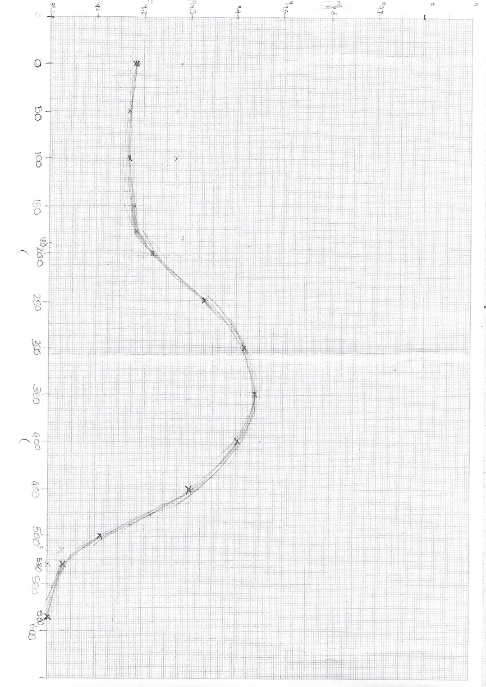
The above graph resulted from the measurements taken. The scale is drawn on both sides as a 1m:1cm, reflecting the true proportions of the image.
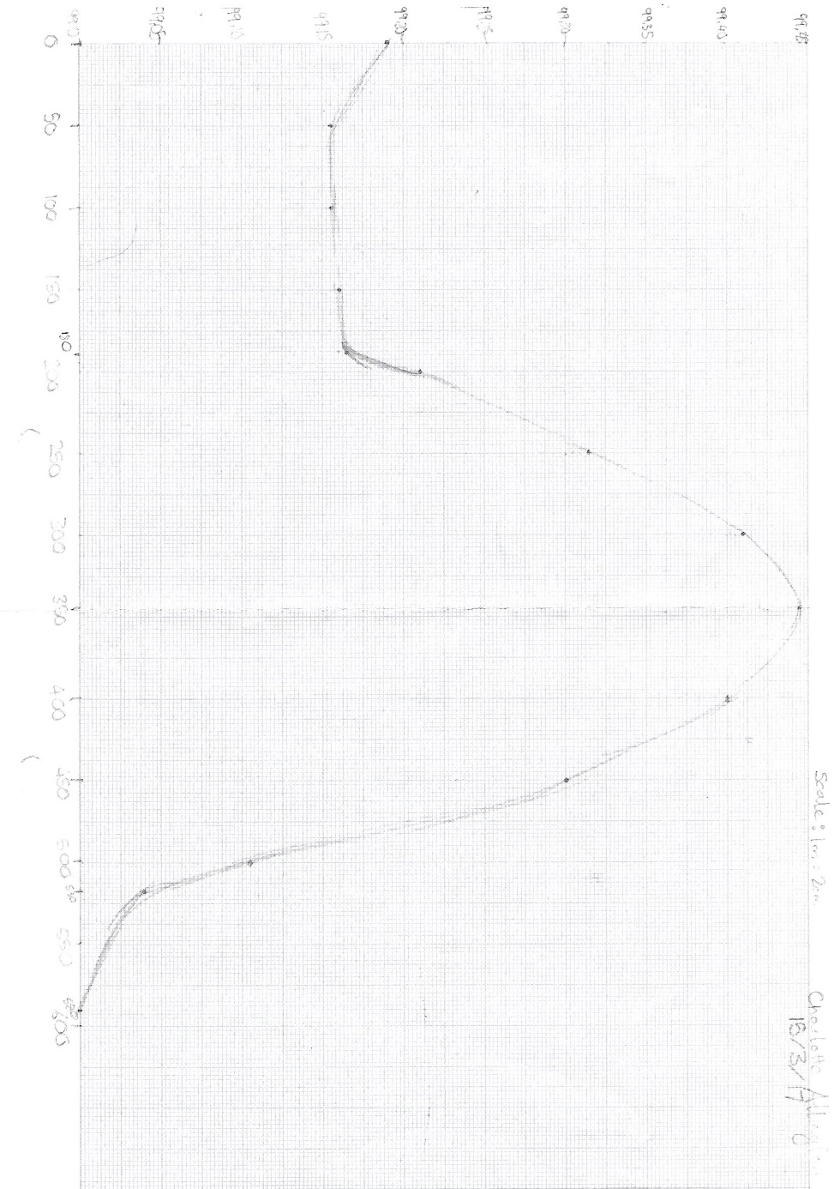
The diagram above was made from the same measurements in the first, but with an exaggerated height scale. I chose to do this because Martin noted that exaggerated scale is easier to see but can distort natural line of image. The rise and fall of the mound we measured are represented in sharper contrast but not a realistic one.

Conventions in diagrams
- Always mark north (or site north if true north unavailable)
- Always add date & person who did it
- Weather
- Site name
- Label features
- Any other info required
- Hachures
- 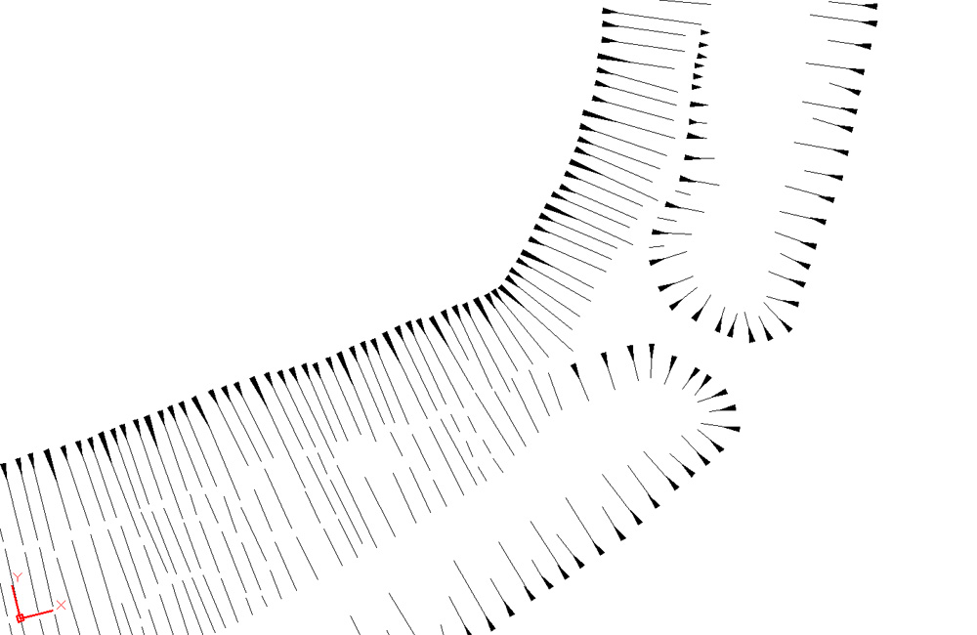
- More hachures = steeper incline
- Alter direction to show all sides of a slope
- Can be used in stratigraphy cross section (marks impression)
- Open hachure = shows undercut

Campus exercise: Choose incline and draw
Worked with Melissa, Rebecca, Alex, Fawwaz and Harriet(?), paired with Melissa. Noted that Harriet seemed reluctant to get involved, but myself, Melisa and Fawwaz were naturally taking the lead, (although Alex and Rebecca did seem happy to help so I think I might just scare her a bit)

Chose the slope outside of 1822. I drew, Melissa measured rough length of area using paper (paper roughly 30cm long). Once length of area was attained and scale drawn, we worked out the rough length of the incline added the hachures for steepness
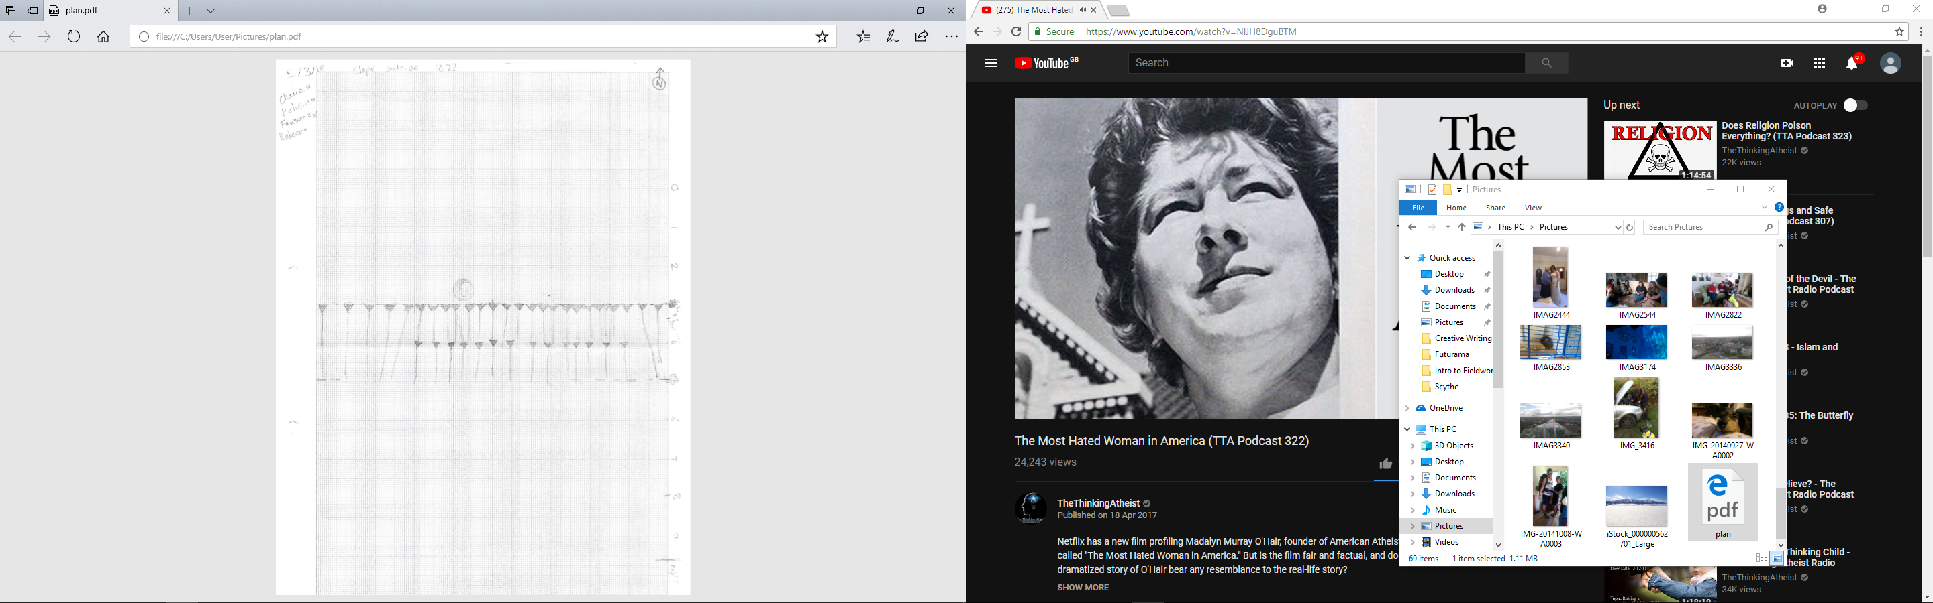
Diagram of the slope outside 1822, drawn with Fawwaz, Rebecca, Alex and Melisa

Further reading:
- Example of hachures (Carver, 2009)
- (Carver, 2009)

22/3/18 – Drawing to Scale

Benefits of drawing to scale: - Can capture/emphasise key features
- Personalise it
- Forces you to look closer/in more detail at the feature

Drawing to scale: Want to avoid multiple sheets of paper as drawing boards only so big
Need to plan ahead of drawing in order to find best size of board/paper/scale

Conventions -
- Actual Scale 1:1
- Building !:100
- More detail 1:50
- Field arch/trenches 1:20
- Bodies/finds/features 1:10

*Always use metric graph paper. Always add scale, N, name, date, location, weather etc

Guidelines on BAJR – useful under standard circumstances but not always possible
Rapid survey: Can use approximate values from known factors (i.e telephone poles, sheep)
Scale up little things for more detail
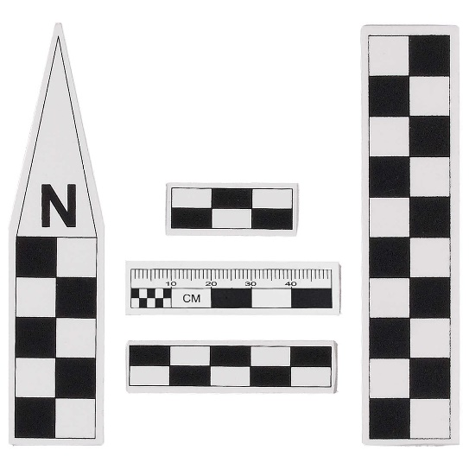<- Scales

*Note to self: Get triangular ruler*

‘Converting reality into manageable depiction.’

Practical: Drawing to scale
Worked with: Alex, Rebecca and Melisa.

Nominated Alex to be ‘body’. Initially set up a single scale along the height of his body. On advice from Martin we added a width scale at his feet. It took three tries to get the form represented below.
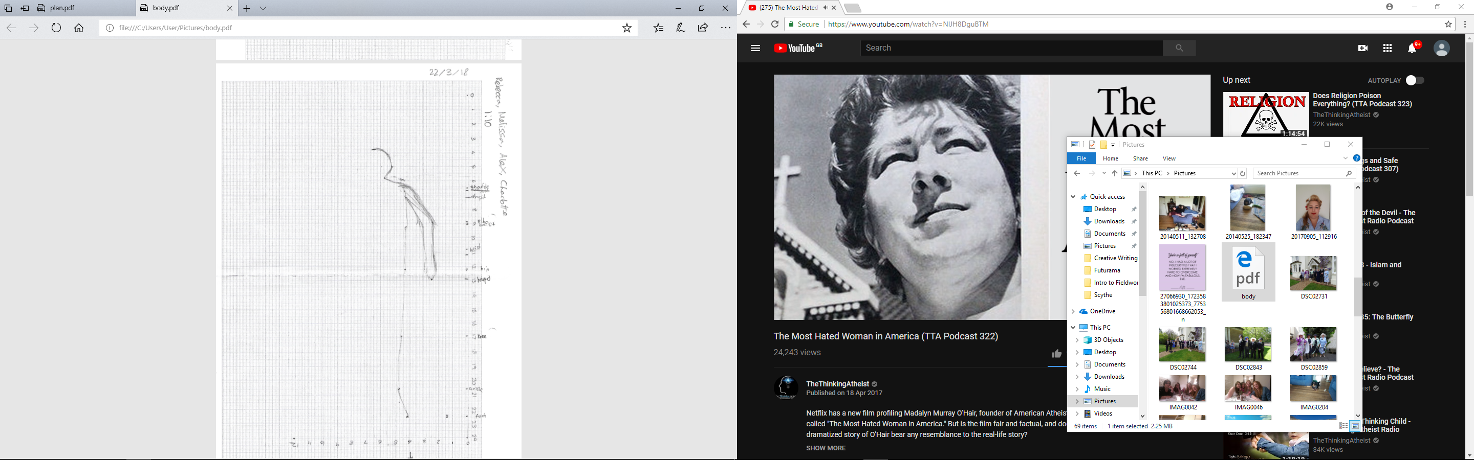
Diagram of Alex drawn with Melisa and Rebecca
Using a third tape measure we measured distance at key points on her body (foot, ankle, knee etc), taking into account distance from vertical measure and horizontal distance. Each point was marked on the graph and joined them up to form the diagram above.

If I was speaking honestly, I would have preferred to do this activity without help. Melisa and Rebecca were helpful in a certain sense, but I am sure if I had been on my own I could have worked quicker and more accurately as I wouldn’t have had to explain and instruct every movement.

Further Study: (Carver, 2009)

