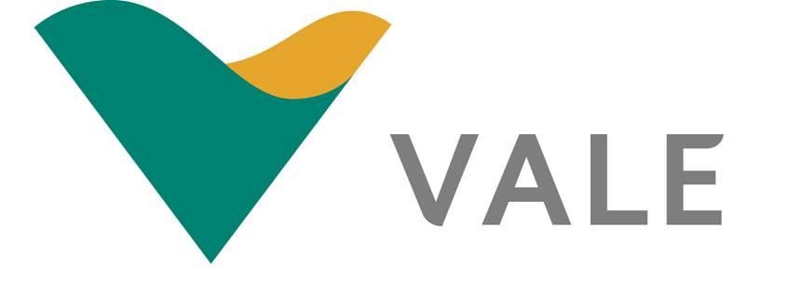

Purchasing and Inventory Management
Title: Purchasing in Practice

Author: David Whitmore
Email: David.Whitmore@vale.com
Number: 01792 841331
Address:
Vale Europe Limited,
Clydach Refinery,
Clydach,
Swansea,
SA6 5QR



- Introduction
This paper will critically evaluate the issues that Voyager Logistics are experiencing with their recently outsourced security provider, Lightfinger Security Limited. Since entering into the contract 3 months ago there have been three significant issues of concern:
- Gates are locked between midnight and 6.00am so vehicles are unable to enter the site, and drivers turning up for work cannot commence their shifts.
- On six separate occasions, there has been no security presence on site and the security barriers have been wide open.
- Vehicles and trailers have been vandalised and one occasion a brand-new truck was stolen.
However, the author believes the overriding issue appears to be the initial strategy adopted by the Voyager Logistics Purchasing department when tendering and procuring the service contract.
The case study states that the contract award was conducted from an adversarial position, adopting a price driven, win-lose approach during negotiations. This type of supplier relationship is typically used on individual transactions or with short term contracts and not with outsourced contracts which are typically long term.
Because of this transactional approach during the acquisition process the author believes that key elements, essential for a good service were either omitted or stripped back by Lightfinger Security to win the tender. The author will now discuss these key elements and how the three main issues can be managed through a service level agreement to ensure a higher standard of service.

- Key Considerations for SLA and Improved Performance.

- Compensation
The Voyager procurement team should have ensured that all vendors had benchmarked their remuneration package against the current market. Voyager should encourage or even work with Lightfinger to provide adequate benefits such as company uniform, holiday and sick pay. This will reduce the potential turnover of staff therefore helping to retain key, experienced personnel as it would promote increased loyalty from the guards to both the company and the client.
The turnover/retention of staff should form part of the SLA and be monitored through a KPI (see Appendix 1)

- Training
Training requirements are often under budgeted and the author would suggest that Lightfinger were guilty of this in their winning proposal. Unfortunately, this has led to them providing low quality, inadequately trained and unmotivated personnel. A factor that undoubtedly contributes to the issues of there being no security presence on site and the security barriers have been wide open and vehicles and trailers have been vandalised and one occasion a brand-new truck was stolen.
Initial checks that the security personnel had the required pre-assignment training should have been made followed up with site specific training and the development of a training/competency matrix. Some guards should cross trained especially for specialist activities such as administrative work, front of house security or use of the security technology.
Involvement with in-house training will get the guards accustomed with Voyager Logistics policies and procedures and will encourage the building of a partnership relationship by making the guards feel part of the company. By developing a partnership relationship both parties will understand and accept the benefits of investing in an effective training program for the guards.
A training matrix should be developed, entered into the SLA and again monitored through a KPI (see Appendix 1)

Improved Management and Supervision.
Lack of communication and visibility from management and supervisory staff can instil a feeling of unimportance in the role the security personnel are performing therefore resulting in a poor performance when executing the required tasks. An improvement in this area will impact the performance and help to eradicate issues 2 and 3 above
One management improvement could be to introduce a security manual that can be easily accessed by all personnel. The manual will contain key information on the security policies and activities together with the emergency procedures. This would be a fluid document that would be regularly updated to include any new or pertinent details.
Increased Supervision would encourage the guards to execute their duties in a timely and professional manner. This could be performed either by on-site /field supervisors making regular routine visits to conduct inspections, respond to or discuss any problems and to deliver any required training.
The effectiveness of Lightfinger’s management and supervision team to perform their duties and their interaction with both the customer and their own team should be documented and tracked through a mutually agreed monitoring system such as a KPI (see Appendix 1)
- Improved Technology
A Guard Tracking System that will monitor, record and produce a report on exactly when, where and what activities the guards have performed when on duty. This will allow for improved supervision of the guards whilst ensuring their assigned task are performed. This places more accountability on the guard to perform their duties. The introduction of this system would greatly improve the three issues above especially issues 2 and 3 as the guards will be more visible on site as a whole, with a heightened presence on key highlighted areas.
Remote monitoring could be implemented, with CCTV, improved lighting and motion sensors that can trigger a predetermined response such as calling the police, contacting a phone or mobilising a local patrol. This would certainly reduce the likelihood of vehicles and trailers being vandalised or stolen.

Another technical solution that could be adopted is a licence plate or electronic tag recognition system, where the gates or barrier will automatically open when an approached by an authorised vehicle. A similar system has been operating efficiently at the Severn Bridge crossing for several years. This could be an effective solution to issue 1 above.

- Conclusion.
When developing the SLA, it is important to be mindful that the best outcome is a long lasting and mutually beneficial relationship with Lightfinger as a service provider. Lamming, Cousin and Notman (1996) express that a mutual benefit will only be realised if both the customer and the supplier provide input into the performance measurement system
“When designing a service-based business process employing loosely coupled services, one is not only interested in guaranteeing a certain flow of work, but also in how the work will be performed. This involves the consideration of non-functional properties which go from execution time and costs, to trust and security. Ideally, a designer would like to have guarantees over the behaviour of the services involved in the process. These guarantees are the object of Service Level Agreements.” (Journal of Systems and Software Volume 84, Issue 8, August 2011, Pages 1351-1363)
A well-prepared SLA should include the following elements:
- It should state the objectives to be achieved in the provision of the services.
- It should detail the service deliverables.
- It should define the performance citeria and the customer expectations of the services provided.
- It should provide an ongoing monitoring system for measuring the expected performance standards.
- It should provide a tool that facilitates remedial action where performance standards are not achieved, whilst also promoting the service provider to maintain a high level of performance.
- It should provide a process for review and change to the service levels over the course of the contract.
- Finally, it should also give the customer the option to terminate the contract where performance standards have fallen consistently below an acceptable level.
Koele-meijer et al. (1993) found that the stronger the relationship between a buyer and seller in terms of partnership, the more likely it is that high quality services are offered. But Goodwin (1996) counters that when a relationship has gone beyond a commercial exchange and has developed into a communal (friendship) relationship, customer sacrifice in obtaining the service may actually increase, as communal behaviours can often interfere with the efficient delivery of the core service.
If, as Baxter suggests, the procurement department of Voyager Logistics had considered the total acquisition cost (TAC) when compiling the tender specification and subsequent contract then most of the above recommendations would have been captured upfront. By focusing their strategy on the lowest price they neglected to consider the detail of the service they required and the total cost of acquiring, operating and maintaining it.

5.0 References

- Bove, L.L. and Johnson, L.W. (2001) Customer relationships with service personnel: do we measure closeness, quality or strength? Journal of Business Research. Vol.54, No.3, pp. 189-­‐197
- Goodwin C, Gremler DD. Friendship over the counter: how social aspects of service encounters influence consumer service loyalty. In: Swartz TA, Bowen DE, Brown SW, editors. Advances in services marketing and management (vol. 5). London: JAI Press, 1996. pp. 247 – 82.
- Journal of Systems and Software Volume 84, Issue 8, August 2011, Pages 1351-1363
- Koelemeijer K, Lemmink J, Wetzels M. Distribution channel structure, supplier power, relationship and service quality: the case of an international food distributor. Marketing for New Europe: dealing with complexity. The 22nd EMAC Conference, Barcelona, 1993. pp. 669 – 81
- Lamming, R., Cousins, D., Notman, D., (1996) Beyond vendor assessment. European Journal of Purchasing & Supply Management Vol. 2, No. 4, pp. 173-­‐181
- Van Weele, A. (2010) Purchasing and Supply Chain Management. Singapore:Seng Lee Press

APPENDIX 1a

