

Assessment Component 2
Individual Report.

Student Name: Daniel Ifeanyichukwu Odunze
Student ID: 2010426
Module Name: Psychology for Health and Social Care
Module Code: (BMHP4003_LON)
Lecturer Name: Bianca Sanfilippo
Word Count: 1500 (+ - 10%).

Table of contents:
1. Introduction……………………………………………………………………………3
2. Erikson’s psychosocial Theory……………………………………………………. 3

3. The Stages of Erikson Theory…………………………………………………. .4-11
4. Role of health care practitioners………………………………………………. 12-13
5. Reflection. (Erikson’s theory in health and social care setting) ……………….14
6. Conclusion……………………………………………………………………………14
7. References……………………………………………………………………….15-16

1. Introduction
Erikson's Psychosocial Theory is discussed in this report, as well as its significance and use in healthcare.
2. Erikson’s Psychosocial Theory.
The Erikson Psychosocial Development Stage is a concept from the 1950s, established by Erik Erikson, a psychologist and psychiatrist. It is built on Freud's psychosexual development theory, by connecting infancy phases, adding the effects of human relations, and extending developmental psychology into adulthood. It argues that biological, psychological, and social variables influence eight phases of individual social development over the course of a lifetime. These phases are characterised by a conflict between two opposing tendencies. One is negative while the other is positive. Erikson's theory suggests that people must manage crises successfully to go into the next stage without any effect on future developments. On the other hand, if the crisis is not successfully overcome, that will have a negative impact on the overall and the likelihood of moving towards the next level. Human beings gain virtue when the positive tendency effectively overcomes the negative one. (Orenstein and Lewis, 2020).

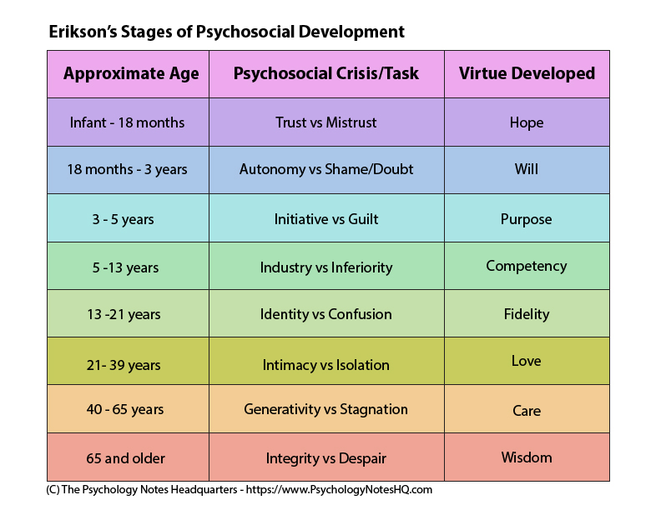
3. The stages of Erikson Theory.

(a). Trust vs mistrust – Infant (0-1.5)

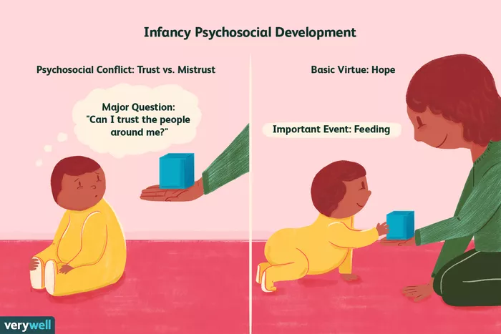
Verywell / Nusha Ashjaee

In this early stage of development, children develop a sense of trust when carers offer consistent care and affection. If this is not done, there will be mistrust. According to Erickson, no child will ever have a total sense of trust or doubt, and that healthy development is all about finding a balance between the two opposing forces.
Success and failure in stage one.
Children acquire hope when their needs are met. In contrast, if crises are not resolved, fear, anxiety, future uncertainty, low trust in others, and low esteem will arise. (Cherry, 2018).

(b). Autonomy vs. shame and doubt (1.5 – 3)

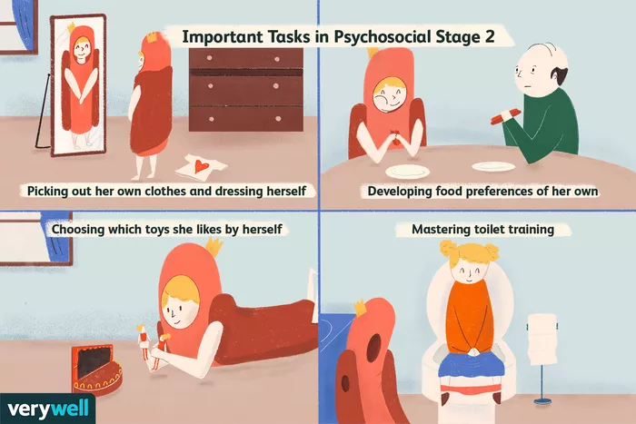
Verywell / Nusha Ashjaee

Erikson believes that children at this age are concerned with building greater self-control. They start to learn on their own, giving them a sense of ownership and a basic confidence in their talents.
Success and failure in this stage.
Autonomy will be developed if the caregivers enable the youngster to take risks, make mistakes, and be responsible. If the child is criticised throughout this stage, he or she will develop an attitude of shame. If the crisis is resolved successfully, it will result in the development of virtue of will. The child will develop self-confidence and a willingness to study more. (Cherry, 2011).

(c). Initiative vs. Guilt (3-5)

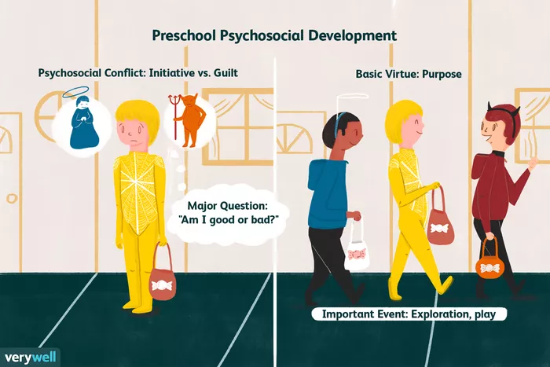
Verywell / Nusha Ashjaee

During this time, the child's development occurs swiftly. By interacting with others, the youngster gets to learn via experimentation and observation. Children should be given the opportunity to explore things on their own, develop their social skills, and have fun.
in this period, success and failure are inevitable
If given this opportunity, children will begin to see themselves as responsible for their actions and as leaders in their communities. The development of virtue is a goal. A child will develop a sense of guilt on the contrary. (Cherry, 2019).

(d). Industry vs. inferiority (5-12)

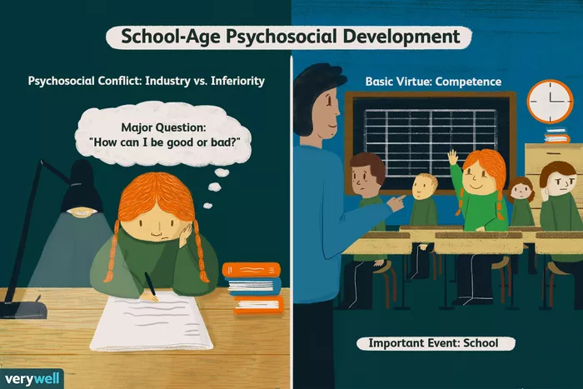
Verywell / Nusha Ashjaee
At this stage, the kid begins to master his or her individual abilities, such as reading and writing (literacy), as well as math, athletics. They become popular with their colleagues, the group becomes important, and the child identifies himself or herself with the group. Teachers provide a vital function at this period as supporting the child to improve their abilities and personality.
In this period, success and failure are possible.
Children will learn to work if they are given opportunities to learn new talents. In fact, they will develop a sense of inferiority if they are criticised. Competency is the evidence of virtue when the stage is successfully completed. (Cherry, 2020)

(e). Identity vs. Role Confusion (12-18)

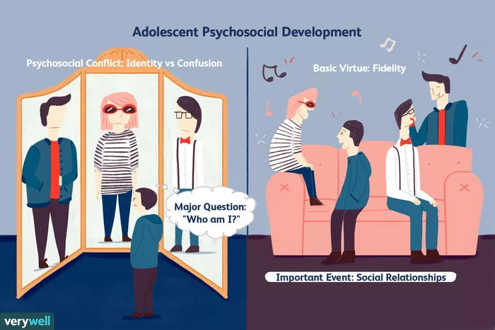
Verywell / Nusha Ashjaee

It is a time in one's life to figure out their identity. A phase during which people start to consider their future and their career goals.
At this stage, success and failure go hand in hand.
Successfully solving this crisis will allow adolescents to value others even if they have different points of view.
Children gain a feeling of initiative and a confidence in their capacity to lead others when they are given this opportunity. (Cherry, 2019).

(f). Intimacy vs. Isolation (21-39).

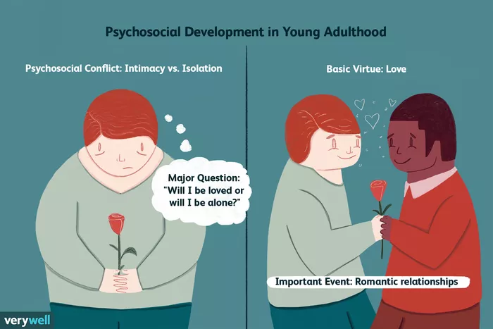
Verywell / Nusha Ashjaee

The process of building intimate and loving relationships with others occurs throughout this phase. People begins their professional career and are no longer under the control of their parents. This is the time when you have a lot of transitions like starting a family and going into the work force. Commitment and happy relationships are possible when this stage is successfully completed.
Fear of closeness, not wanting to become involved, and keeping a distance from others might make you sad and lonely. Achieving success in this level will allow one to experience the virtue of love. (Cherry, 2011).

(g). Generativity vs. Stagnation (40-65)

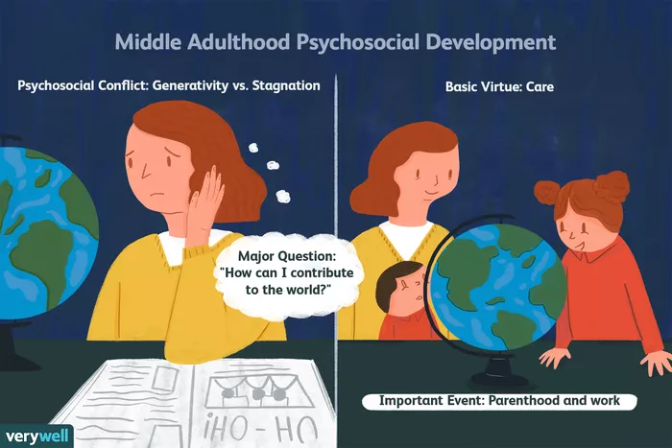
Verywell / Nusha Ashjaee

During this time, people are likely to be firmly established in their communities, either raising children, or are working for a prolonged amount of time.
In this period, success and failure are inevitable
The feeling of usefulness and accomplishment follows from success, whereas the shallow involvement in the world is the result of failure.
(h). Ego Integrity vs. Despsir (65+).

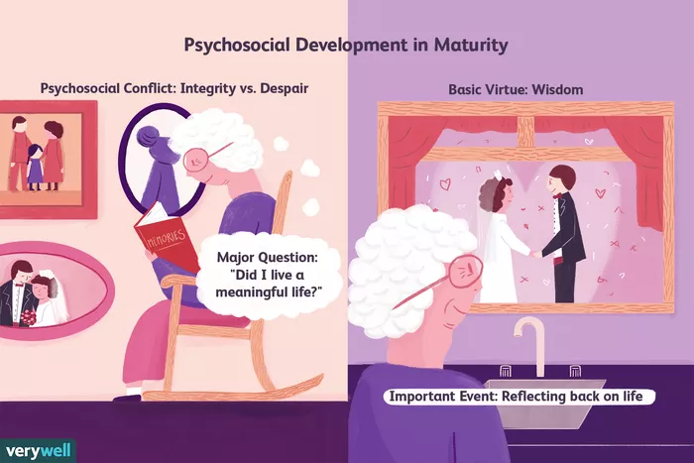
Verywell / Nusha Ashjaee

This phase refers to an individual's ability to feel accomplished and fulfilled at the end of their life. If you do well in this stage, you will achieve the virtue of knowledge, and if you fail, you will experience despair. (Cherry, 2011).

3. The Impact of Erikson’s Theory on the Role of Healthcare practitioners in supporting the wellbeing of individuals in health and social care settings.

An understanding of two important concepts supports psychological ideas. First, theories explain or characterise a behaviour, and then they provide predictions about future behaviour during a given developmental stage (Cherry, 2020).
Erikson's theory describes many life-stage challenges that a person will face in his or her lifetime. To support healthcare providers, this encourages them to gain better understanding of the many stages of person's life and enables them to accurately forecast future behaviour.

The practitioners will be able to help and offer care plans that meet the needs of all life stages. To give structure to the situation, theory assists practitioners to make decisions. For instance, Erikson's theory describes the need to ensure that there is a crucial individual in early childhood settings. By leaving the children in a nursery, parents are allowing them to establish a feeling of trust.
Demonstrating empathy is critical for healthcare workers, especially doctors and nurses (Moudatsou et al, 2020). Empathy can be defined as the ability to understand others' experiences, which includes feeling the emotions of others. This also includes putting oneself in someone else's shoes.

Erikson's theory can be said to benefit healthcare practitioners who are striving to develop and demonstrate empathy by outlining the problems each life stage faces. Since healthcare practitioners would be able to identify the problems that service users confront, they will be able to support them.

Having the ability to effectively communicate, Healthcare practitioners can apply Erikson's theory to update their communication skills to aid service users in their overall health and well-being. In the life stage industry, the significance of communication skills is paramount, whereas inferiority might be an issue (5-12 years old). The youngster will acquire feelings of inferiority when criticised via negative communication. (Moudatsou et al, 2020).

Erikson's theory helps support healthcare providers to comprehend mental diseases (Orenstein and Lewis 2020). It is because of Erikson's theory that individuals who fail to cultivate the positive tendency in a life stage will go on to develop a disorder, such as mistrust toward others/adults from infancy to age 18, shame from early childhood through age 3, guilt from age 3 through age 5, inferiority from age 5 through age 12, role confusion from age 12 through age 18, isolation from age 21 through age 39, stagnation from age 40 through age 65, and despair from age 65 and up.

The proper intervention, such as counselling or cognitive behaviour therapy, will be provided by healthcare providers such as psychologists.

Erikson's theory is relevant to healthcare providers, who can assist clients to maintain or improve their health and well-being through empowering them to succeed in their crises.

4. Reflection: How I will apply Erikson’s Psychosocial Theory in my own practice.

I would use this theory to modify my communication abilities to fulfil the needs of the service users. I will develop a care plan and organise activities to assist their physical and mental wellbeing. Example, stablishing a steady routine, basic principles, and primary care.

5. Conclusion.

Erikson's psychosocial theory is a highly effective instrument for self-awareness and progress, as well as educating and assisting others. It highlights the sequential importance of the eight stages of development that comprise the crisis. The concept is also useful for infant and adult growth. Erikson's theory helps us to comprehend how life is a range of learning and challenges. In the future, I hope to work in the field of mental health. Erikson's theory will help me comprehend the problem as it unfolds for service users. This will improve my capacity to identify the causes of mental illness and give appropriate treatment. For example, when I interact with teenagers who exhibit problematic behaviour and poor mental health, I am aware that this might be due to a crisis of identity versus role confusion. As a result, I will be able to assist adolescents in overcoming the crisis and achieving positive identity.

6. References.
Cherry, K. (2020) Types of Psychological Theories. (online). Available at: https://www.verywellmind.com/what-is-a-theory-2795970 (Accessed: 12/08/2021).

Moudatsou, M., Stavropoulou, A., Philalithis, A., & Koukouli, S. (2020) ‘The Role of Empathy in Health and Social Care Professionals’, Healthcare, 8(1), 26.

Orenstein, G.A, Lewis L. (2020) Eriksons Stages of Psychosocial Development. (online). Available at: https://www.ncbi.nlm.nih.gov/books/NBK556096/ (Accessed: 12/08/2021).

Reference list
Cherry, K. (2011a). Autonomy vs. Shame and Doubt in Psychosocial Stage 2. [online] Verywell Mind. Available at: https://www.verywellmind.com/autonomy-versus-shame-and-doubt-2795733 [Accessed 13 Aug. 2021].
Cherry, K. (2011b). Integrity vs. Despair in Psychosocial Development. [online] Verywell Mind. Available at: https://www.verywellmind.com/integrity-versus-despair-2795738 [Accessed 13 Aug. 2021].
Cherry, K. (2011c). Intimacy vs. isolation: Psychosocial stage 6. [online] Verywell Mind. Available at: https://www.verywellmind.com/intimacy-versus-isolation-2795739 [Accessed 13 Aug. 2021].
Cherry, K. (2018). Trust vs. Mistrust: Learning to Trust the World Around Us. [online] Verywell Mind. Available at: https://www.verywellmind.com/trust-versus-mistrust-2795741 [Accessed 13 Aug. 2021].
Cherry, K. (2019). Identity vs. role confusion. [online] Verywell Mind. Available at: https://www.verywellmind.com/identity-versus-confusion-2795735 [Accessed 13 Aug. 2021].
Cherry, K. (2020). Industry vs. Inferiority in Psychosocial Development. [online] Verywell Mind. Available at: https://www.verywellmind.com/industry-versus-inferiority-2795736 [Accessed 13 Aug. 2021].
Cherry, K. and Cherry, D. (2021). Erik Erikson’s stages of psychosocial development. [online] VeryWell Mind. Available at: https://www.verywellmind.com/erik-eriksons-stages-of-psychosocial-development-2795740 [Accessed 7 Aug. 2021].
Cherry, K. and Susman (2021). Erik Erikson’s stages of psychosocial development. [online] VeryWell Mind. Available at: https://www.verywellmind.com/erik-eriksons-stages-of-psychosocial-development-2795740 [Accessed 7 Aug. 2021].
Davis, B. (2021). What are roles and responsibilities of a health care professionals? – Mvorganizing.org. [online] www.mvorganizing.org. Available at: https://www.mvorganizing.org/what-are-roles-and-responsibilities-of-a-health-care-professionals/ [Accessed 7 Aug. 2021].
Essay, N. (2020). Application of Erikson’s Psychosocial Development Theory in Patient Care Plan. [online] NursingAnswers.net. Available at: https://nursinganswers.net/essays/application-of-eriksons-psychosocial-development-theory-in-patient-care-plan.php#citethis [Accessed 7 Aug. 2021].
Orenstein, G.A. and Lewis, L. (2020a). Eriksons Stages of Psychosocial Development. [online] PubMed. Available at: https://www.ncbi.nlm.nih.gov/books/NBK556096/?report=classic#article-21284.r10 [Accessed 7 Aug. 2021].
Orenstein, G.A. and Lewis, L. (2020b). Eriksons Stages of Psychosocial Development. [online] PubMed. Available at: https://www.ncbi.nlm.nih.gov/books/NBK556096/ [Accessed 13 Aug. 2021].
(Ehlman K, Ligon M. The application of a generativity model for older adults. Int J Aging Hum Dev. 2012;74(4):331-44. doi:10.2190/AG.74.4.d

